



REPUBLIC OF THE PHILIPPINES PROVINCE OF LAGUNA
MUNICIPALITY OF LOS BANOS BARANGAY MALINTA
OFFICE OF THE SANGGUNIANG BARANGAY

C E R T I F I C A T E O F
I N D I G E N C Y
This is to certify that {{NAME}} legal age and a resident of Brgy. Malinta, Los Baños, Laguna. . This certifies further that the name belongs to indigent families of this barangay.

This certification is being issued upon the request of {{REP_NAME}} ({{REP_AGE}} YEARS OLD) . as a requirement for {{PURPOSE}} Assistance.

Given this {{DAY_ORD}} day of {{MONTH}} {{YEAR}}.

Certified By:

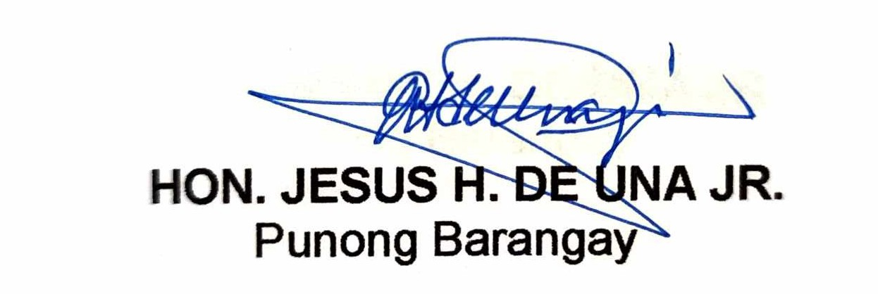

HON. JESUS H. DE UNA JR.
Punong Barangay

NOT VALID WITHOUT DRY SEAL

ADDRESS:
SAN LUIS AVENUE PUROK 2, BARANGAY MALINTA,LOS BAÑOS, LAGUNA 4030
TEL. NO. (049) 502-4396

