Hello,

We have reviewed the links and wanted to provide feedback. Our review found that the flow of the site is kinda choppy. Without a seamless or complete flow, it will be difficult for the user to navigate through the dashboard. Also, the fields where the user initially inputs the consumer/residents info seems to be outdated. We would like the information to be directly entered into the template or dashboard fields; this would be similar to how information is entered in the grid for an excel sheet.

Please see the feedback below

Login Credential: [admin@opat.com](mailto:admin@opat.com) ADMINISTRATOR

Is the educational level field for the subscriber?

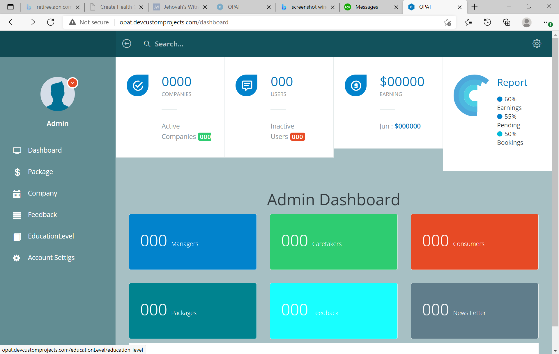

Login Credential: [hist@yopmail.com](mailto:hist@yopmail.com) SUBSCRIBER/COMPANY OWNER????

Who has access to the Company Dashboard? Compared to the Manager dashboard below there is less data here. Perhaps either company dashboard be eliminated or Manager dashboard be combined to company dashboard.

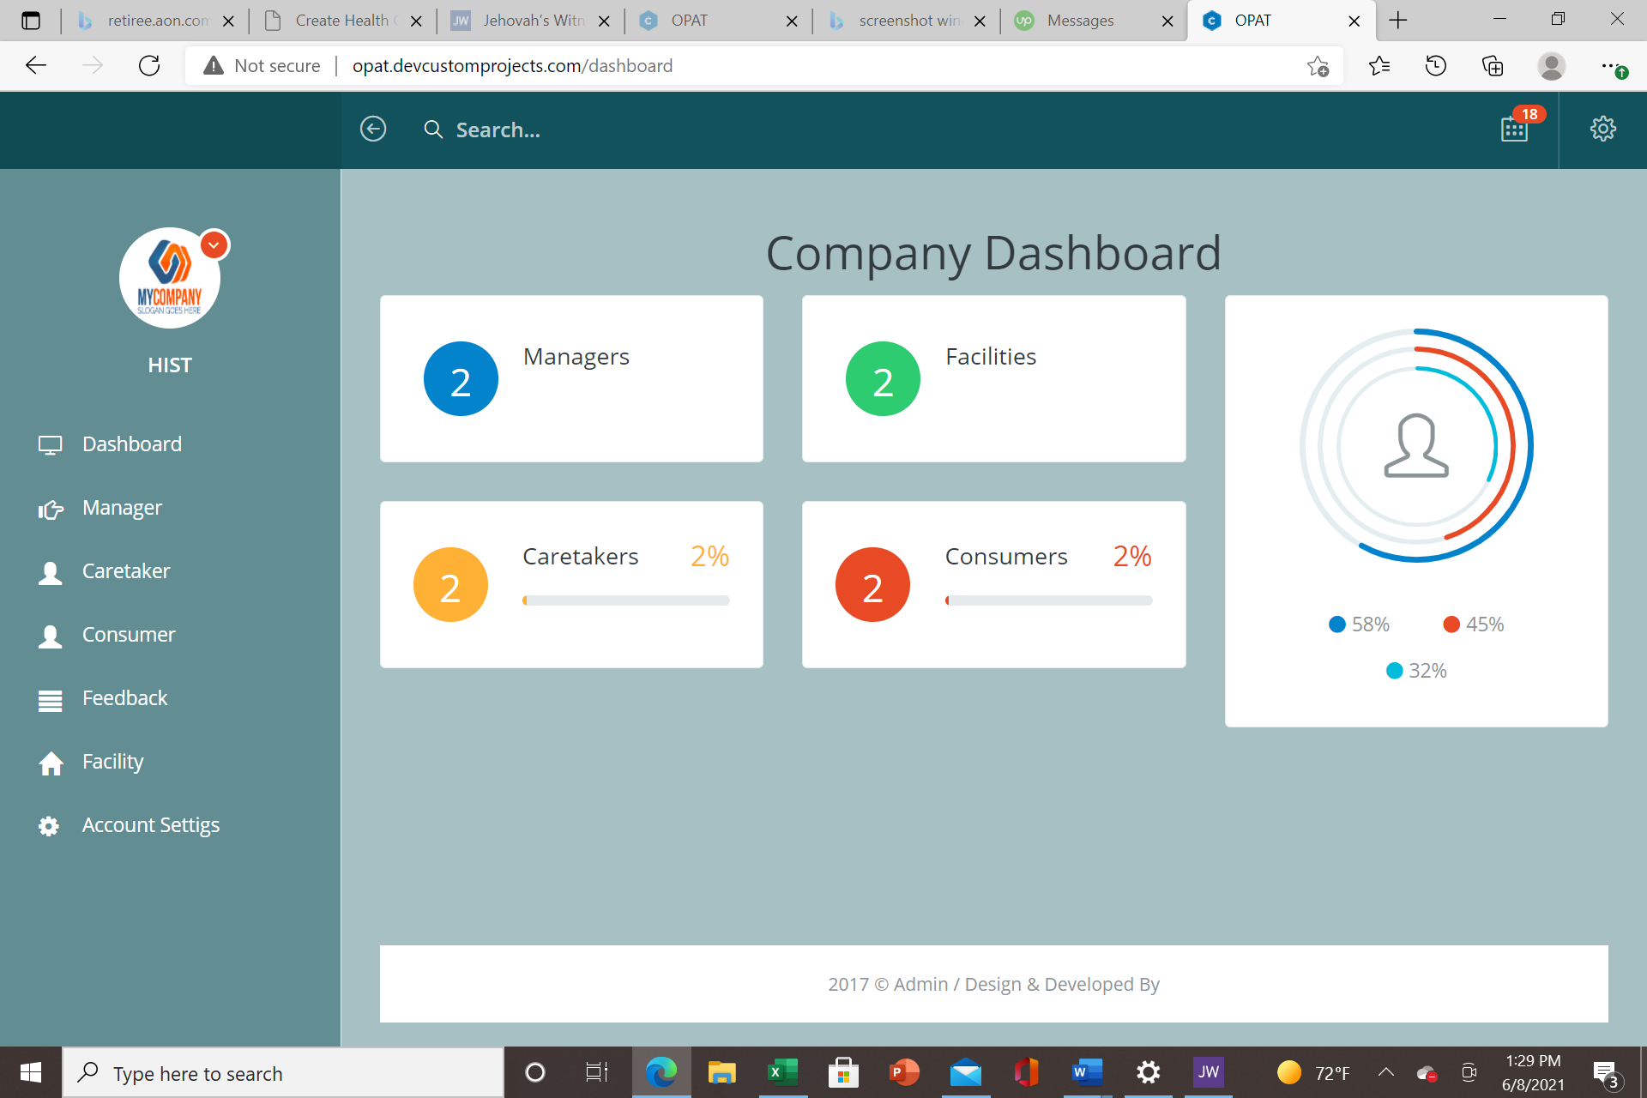

Login Credential: [histmanager1@yopmail.com](mailto:histmanager1@yopmail.com) MANAGER

This contains all the pertinent information for the manager and company that is subscribing. Should this be integrated with the company dashboard?

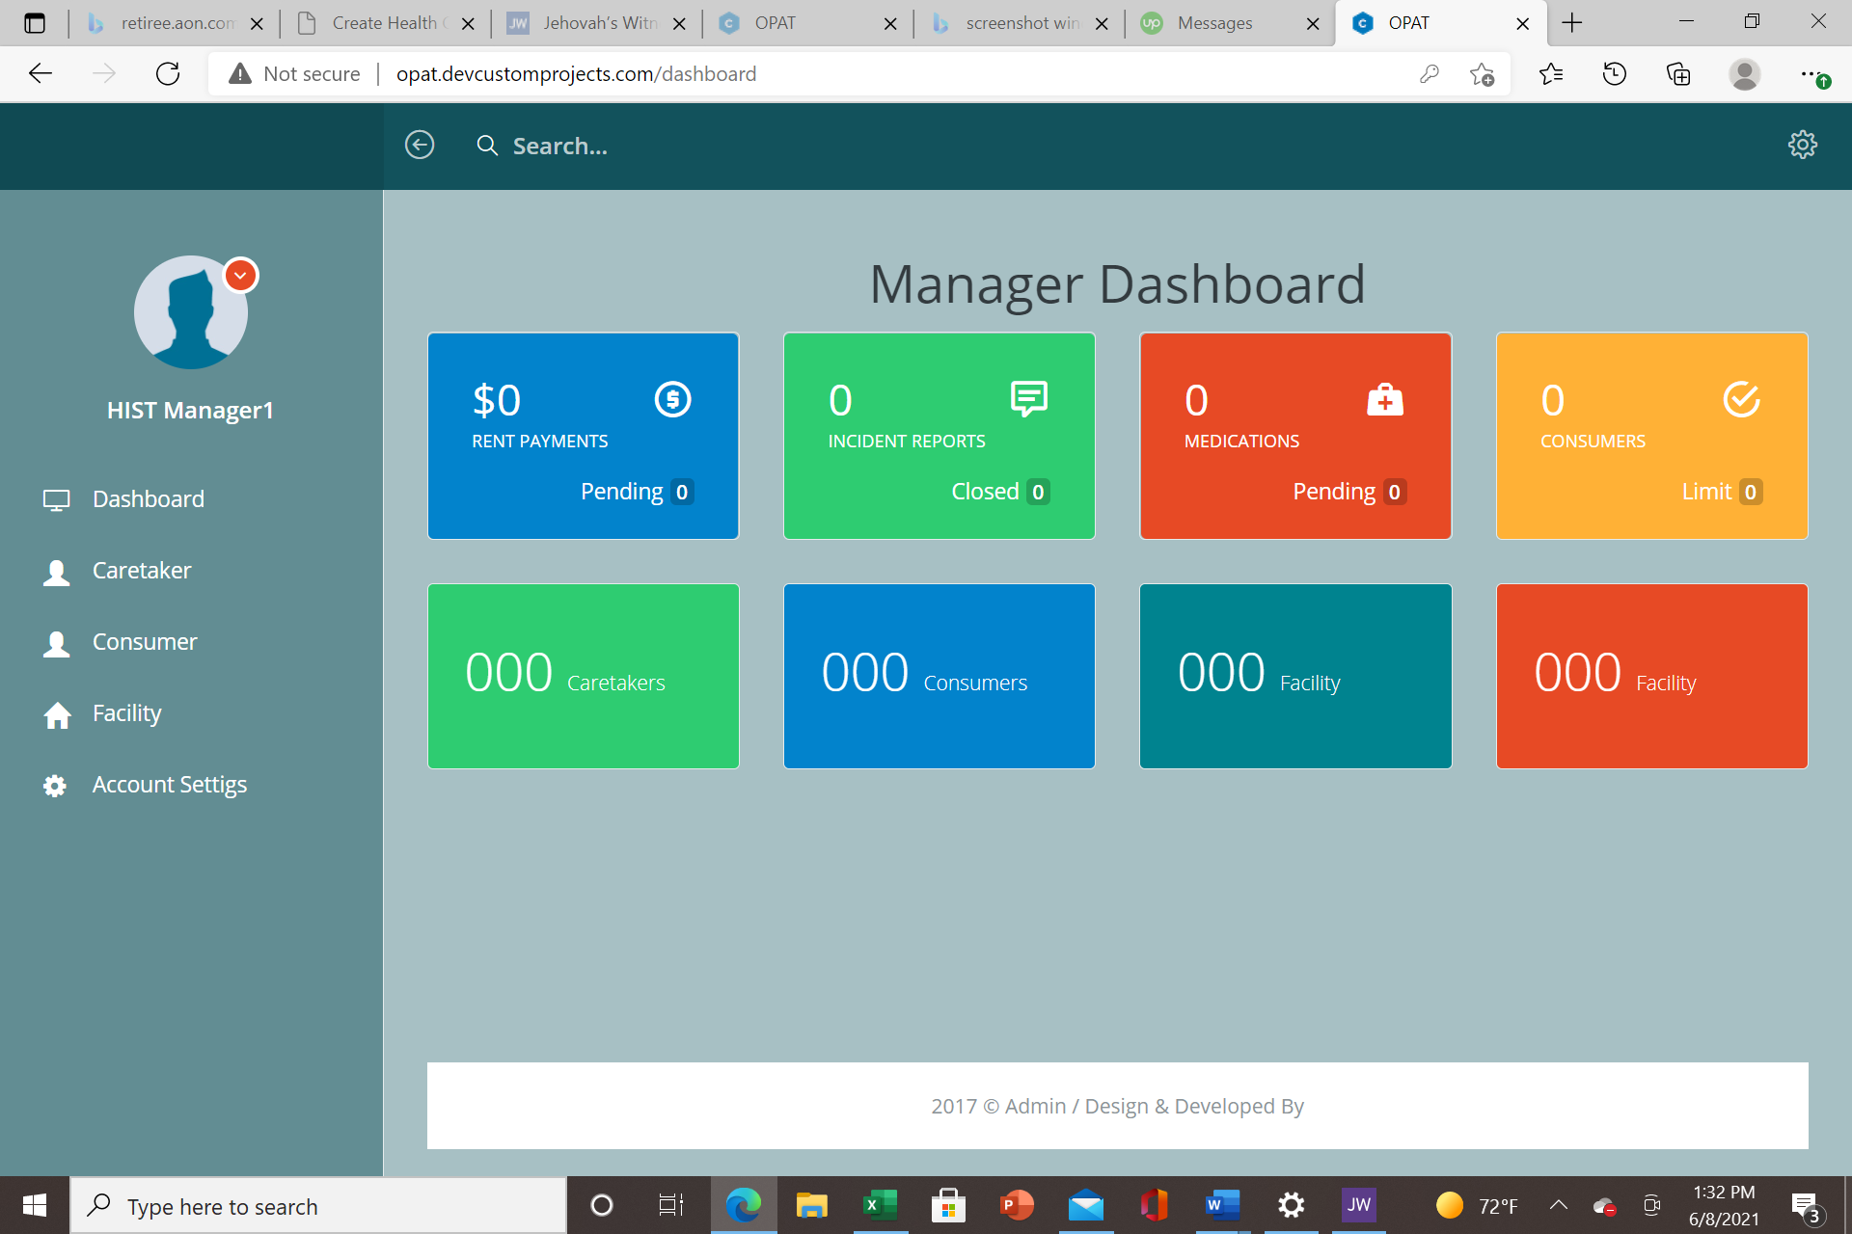

Can Caretakers be linked to a facility?: And Facility linked to a Caretaker?

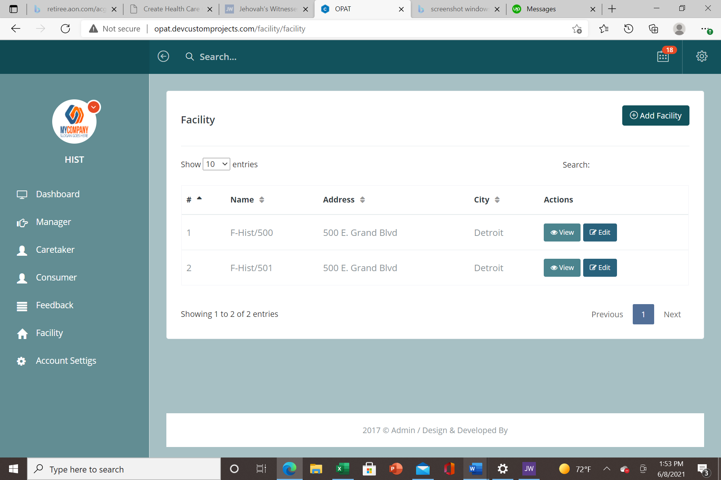

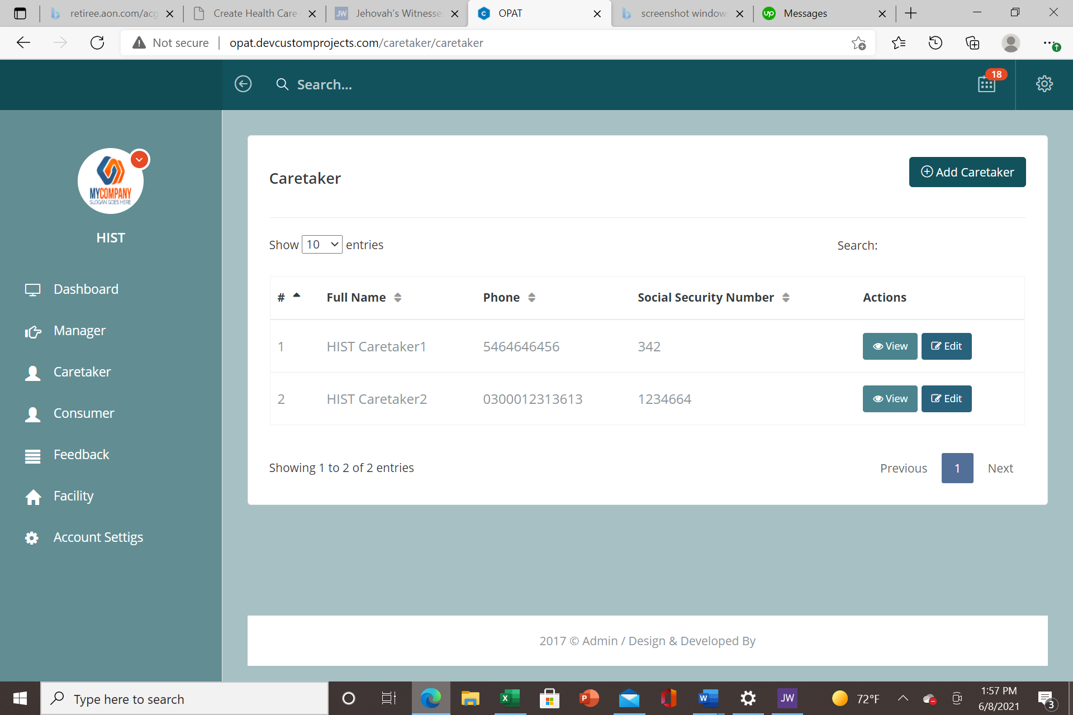

Login Credential : histcaretaker1@yopmail.com CARETAKER

Should the rent payment field be on the caretaker dashboard? Can we substitute these with Doctor’s visit tab

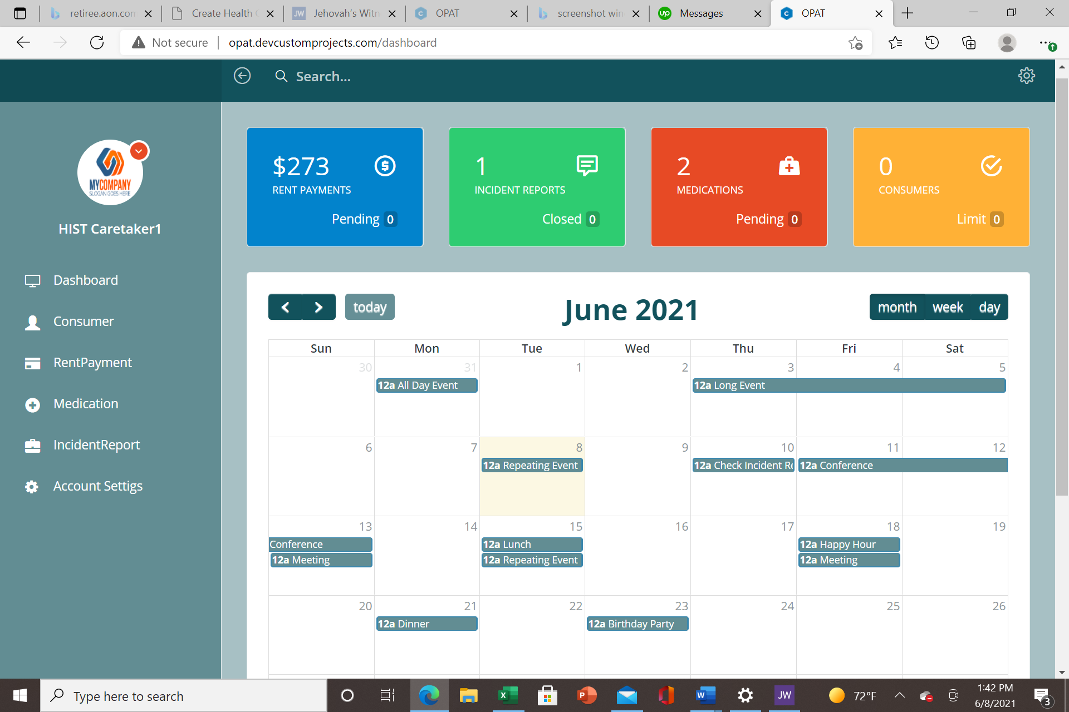

Login Credential: [histconsumer1@yopmail.com](mailto:histconsumer1@yopmail.com) CONSUMER

Is this a logon for Consumers/Residents to view the dashboard?

Can this data be merged with the manager and caretaker views and also include a consumer status report (i.e. released, violated parole,)

