* 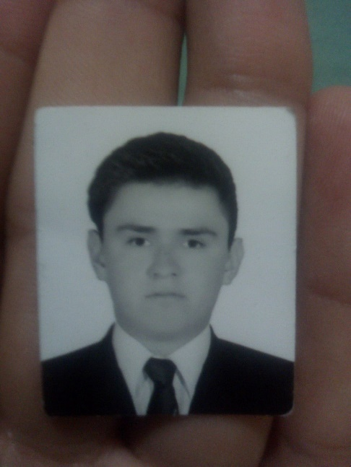**Manuel Velázquez Martínez**
* **Street Gudelio Morales No. 38 Col. Solidaridad**
* **C.P 38623 Acámbaro, Guanajuato.**
* **Birthdate: 26-02-1997**
* **Age: 21 years old.**
* **Civil Status: Single**
* **Phone number: 417 177 22 05 Other: 417 172 08 16**
* **Email:** [**akiaseruygo@gmail.com**](mailto:akiaseruygo@gmail.com)**.**
* **CURP: VEMM970226HGTLRN07**
* **Nationality: Mexicana**

**Professional Objective:**

Develop my skills acquired in the work environment, put them in practice to perfect them with the time and keep me updated in new technologies.

**Academic Formation:**

* **Técnico Superior en Tecnologías de la Información y Comunicación Área Multimedia y Comercio Electrónico.**

**Carretera Acámbaro – Tarandacuao Km.8 San Miguel El puerto, Gto.**

**September 2015 – August 2017**

* **Ingeniería en Tecnologías de la Información y Comunicación Área Multimedia y Comercio Electrónico.**

**Carretera Acámbaro – Tarandacuao Km.8 San Miguel El puerto, Gto.**

**September 2017 – Currently studying.**

**Work Experiences:**

I have work programming a Website with HTML, CSS, PHP, JQUERY and BOOTSTRAP to the high school “Miguel Hidalgo y Costilla” to advertise it during the period of my practices that have a duration of 3 months, and I will want work in more projects to improve my ability developing products more professionals.

Complementary Information:

Stencil Curse

Skills and knowledges:

* 3D Animation in blender
* Support and maintenance of computation
* Multimedia Guides with Adobe Director
* A Web Connection Simulation (In Cisco Packet Tracer)
* Web Pages Develop in Php, Css, HTML5, jquery, Boostrap, Codeigniter and Wordpress.
* Informatics auditory.

References

|  |  |  |  |  |  |
| --- | --- | --- | --- | --- | --- |
| Name | Address | Phone number | E-mail | Occupation | Time to meet you |
| Alejandra Guadalupe Rosillo Plaza | Cuauhtémoc No.61 Colonia sur  Parácuaro, Gto | (417) 113 48 33 | Wonderl4nder@gmail.com | Student | 2 years |
| Jose Alfredo Armenta Blanco | Calle 21 No.9 Col. Lazaro Cardenas  Maravatio, Michoacan. | (447) 119 10 63 | Fredie.ab@gmail.com | Student | 2 years |