**RPIPL / RT / Quote <<invoice_number>>**

**<<client_name>>**

<<client_address>>

<<client_number>>

<<client_email>>

<<client_eb_no>>

**Subject: Quotation for** <**<project_name>>**

Dear **<<client_name>>,**

Thank you for placing enquiry on solar roof top solar system, we are glad to submit our quotation for Engineering, Supply, Installation and Commissioning of <**<project_details>>**

System in your premises.

We are glad to submit our competitive quote for your kind considerations.

* We will be using High standard solar panels for the best generation with 25 year of performance warranty by manufacturer.
* We will be using High Efficiency solar inverters to achieve maximum output by latest MPPT technology with 7 years of manufacturers Performance warranty.
* Our Latest planning and execution methods will reduce duration and cost of installation.
* We also provide annual maintenance contract at mutually agreed price.

We thank you once again for you interest towards working with us and this opportunity, we look forward to join with you in this project.

Yours Thankfully

**Company Profile**

We are one of the leading solar system integrators, providing wide range of solar based systems as solar photo voltaic systems, solar water heater systems and Ground mounted solar power plants in Tamilnadu.

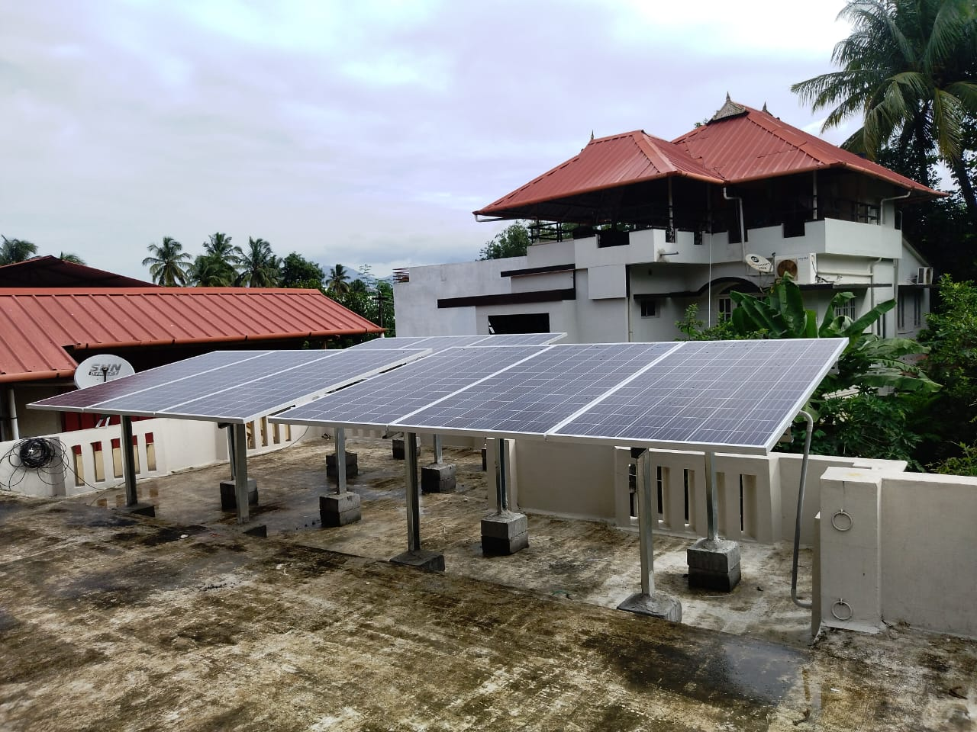

**Low Rise Structure**

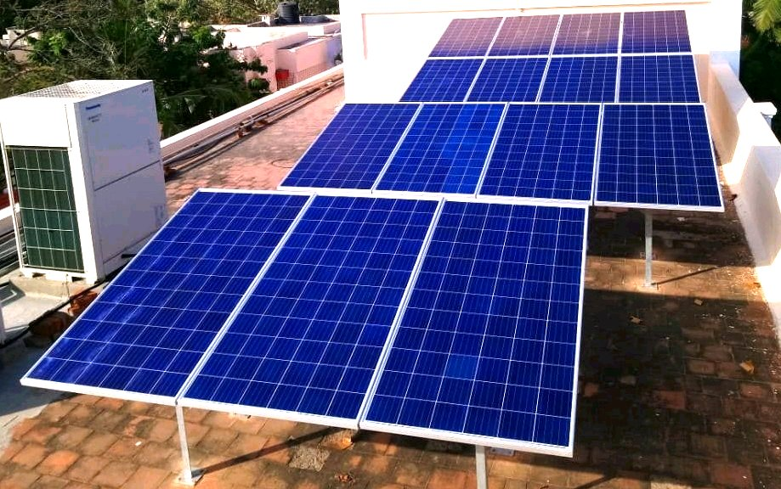

**Standard Flat Roof Structure**

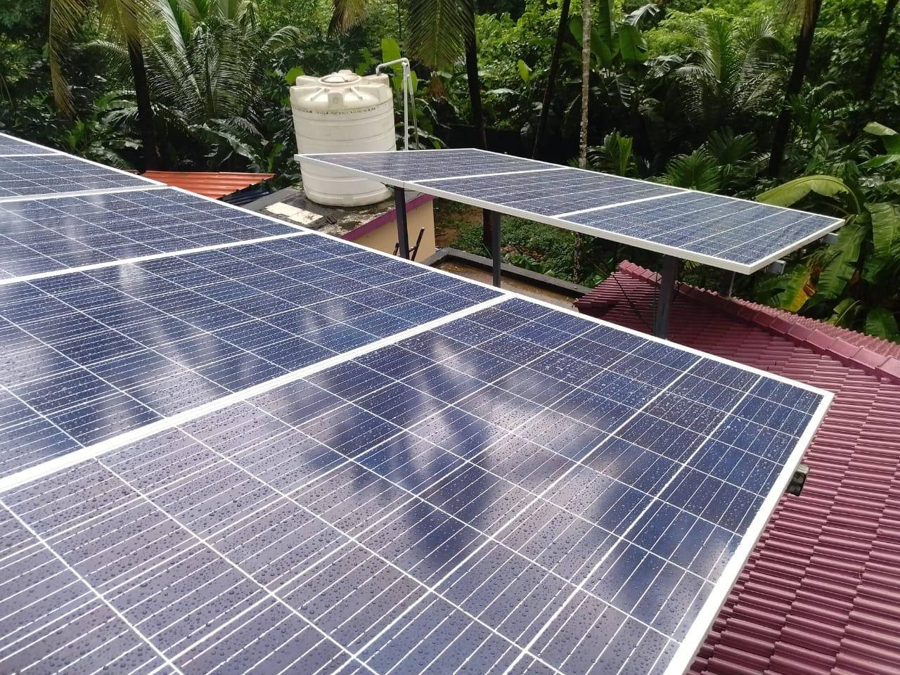

**Sheet Mounted Roof-Top**

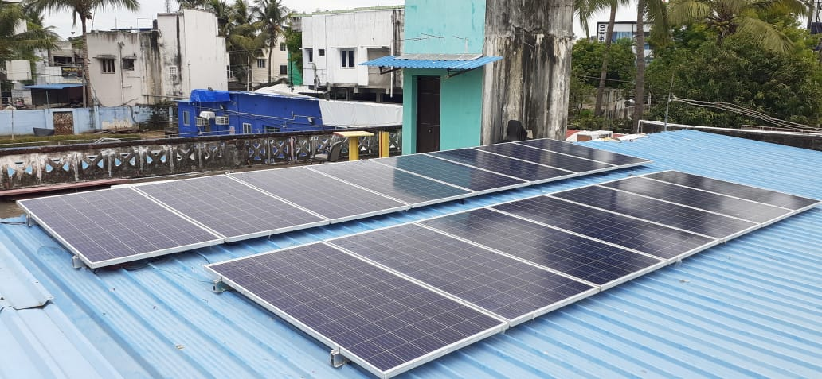

**Roof-Top Structure**

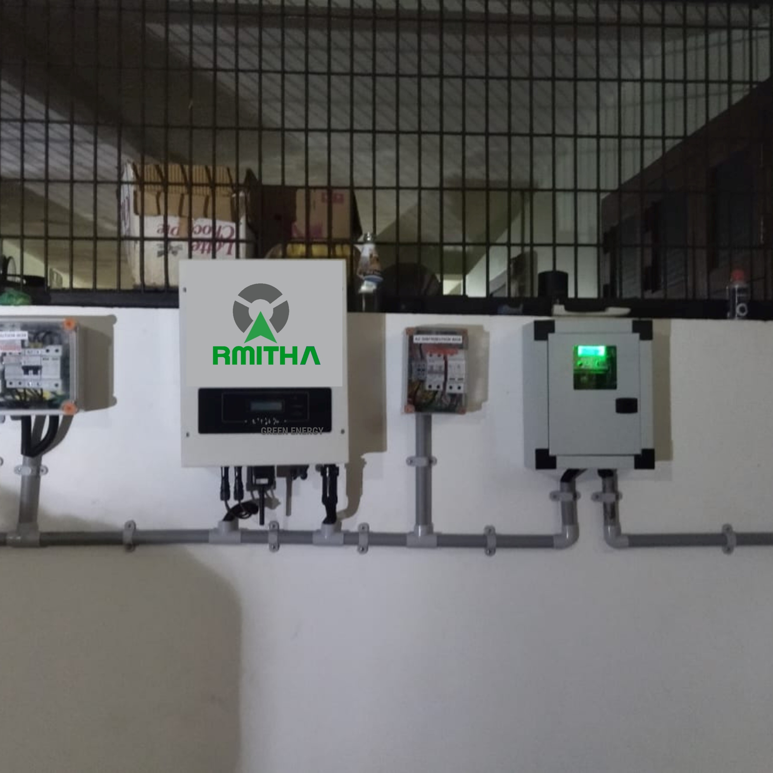



**czxzxzx**

**01. - <<project_power_kw>>Kw/ <<Project_Phase>> <<on_grid_off_grid>> /NDCR/MONO /SPG system for RCC Roof Top (Basic) Rs. <<total_cost>>**

|  |  |
| --- | --- |
| Solar PV module: <<Solar_PV_module>>Wp, Monocrystalline | <<Solar_PV_module_no>> |
| Module mounting structure RCC/GI | <<RCC_GI_Lot>> |
| 1AJB, 1 I/P 1O/P, WITH FUSE, SPD TYPE II | <<SPD_TYPE>> |
| Grid Connect Solar Inverter (1X2kW,230V AC, 50Hz, MPPT), | <<Solar_Inverter>> |
| ACDB with SPD 1ph | <<ACDB_with_SPD>> |
| 1C X 4 Sq.mm. EB XLPE Cu. cable | <<Cu_cable>> |
| 3CX2.5sqmm Cu Cable | <<sqmm_Cu_cable>> |
| Earthing kit 1.5M, 14.2mm Dia, copper B | <<copper_B>> |
| 1CX10 sq mm AL single strand Earth cable | <<Earth_cable>> |
| LIGHTENING ARRESTOR- HEIGHT 2 Mtrs CONVE | <<LIGHTENING_ARRESTOR>> |
| Installation kit (Comm. Cable etc.) | <<Installation_kit>> |
| MC-4 Cable Couplers (Male & Female Pairs) | <<MC_4_Cable>> |

**Payment Terms:**

* 80% - Advance

All payment must transfer from customer’s account to Rmitha Power & Infra (OPC) Private Limited through RTGS. A/C No: 032463300000099, IFSC Code: YESB0000324

**Our Scope of Work:**

Supply, Transportation, Unloading, Erection, Testing and Commissioning of the following,

* Solar Modules
* Solar Inverters
* Earthing and Lightning protection for the Plant
* Testing and commissioning of the Solar Power Plant.

**Client** **Scope:**

* EB Related Expenses.
* Structures of low rise, high rise and concrete block will be on client scope. (Civil work & Fabrication)

**Terms and Conditions:**

* This offer is valid for 15 days from the date of this offer.
* Taxes are extra at actual at the time billing.
* Electricity and water supply at site will be provided by the customer while installation.
* Storage space for safekeeping of the supplied material will be provided by customer.
* Separate AMC will be entered for maintenance at mutually agreed price.
* Payment has to be paid as per PO terms within 10 days.
* Warranty will be honored only if full payment is made and work completion report is signed by client.

**Time for completion:**

The total capacity of <<project_power_kw>> shall be installed, commissioned and start operations within a period of a maximum of 15 days.

**Warranty and Service:**

One-year complete system warranty will be provided from the date of commissioning. Manufacturer warranty is available for Solar Panels (15 years) and Inverters (7 years).

Solar Panels Performance warranty 25 Years.