Tested On: Mozilla Firefox 53.0.2 (32-bit) Windows 8.1 & Google Chrome 58.0.3029.96 (64-bit)
Nothing happens when below icons are clicked . Believe they should navigate to respective tabs as they are being highlighted when cursor is placed.
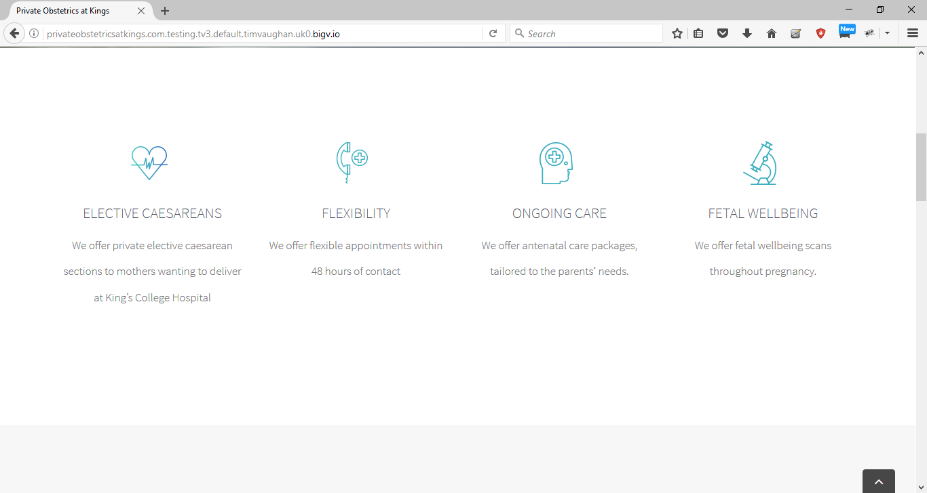
Don’t require that much of empty space between the content.
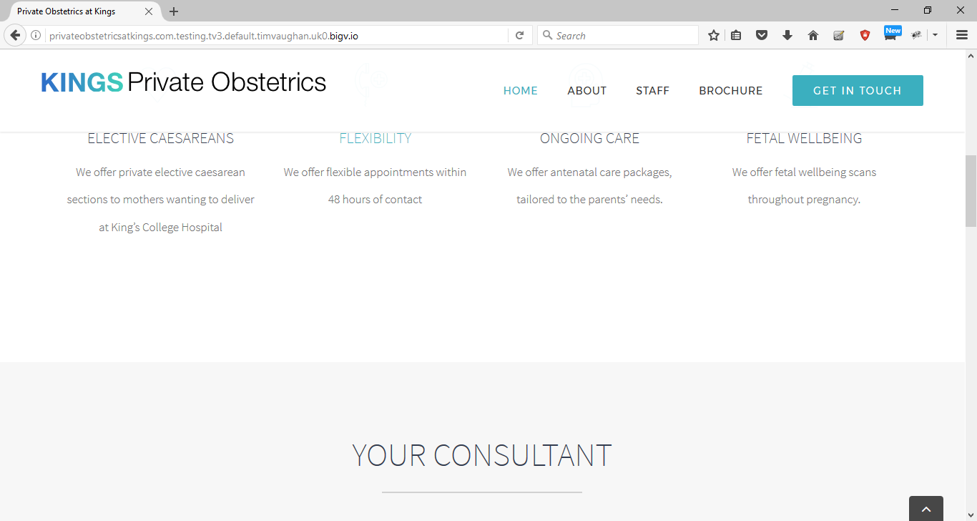
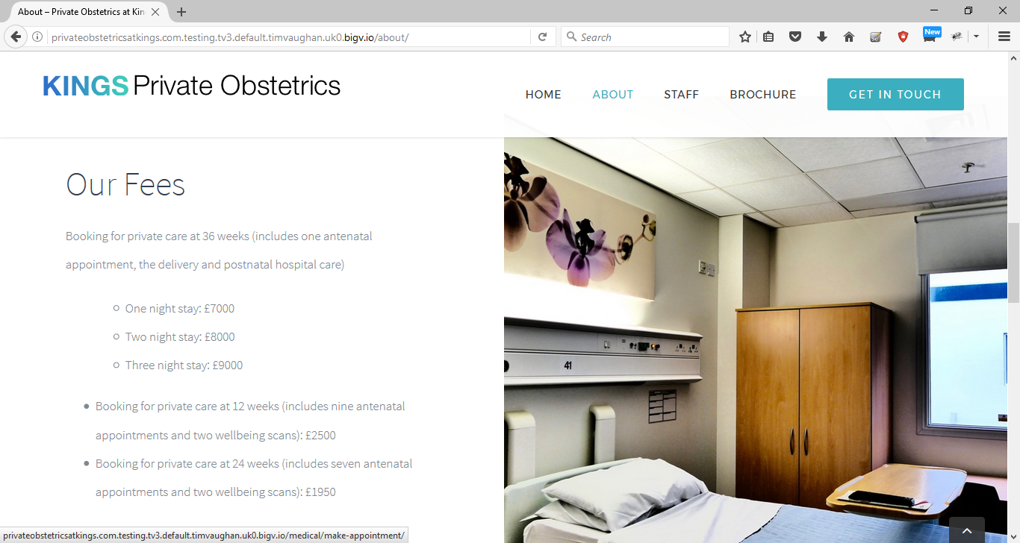
When clicked on any of the images in the “http://privateobstetricsatkings.com.testing.tv3.default.timvaughan.uk0.bigv.io/about/” it navigates to error page as shown in below image.
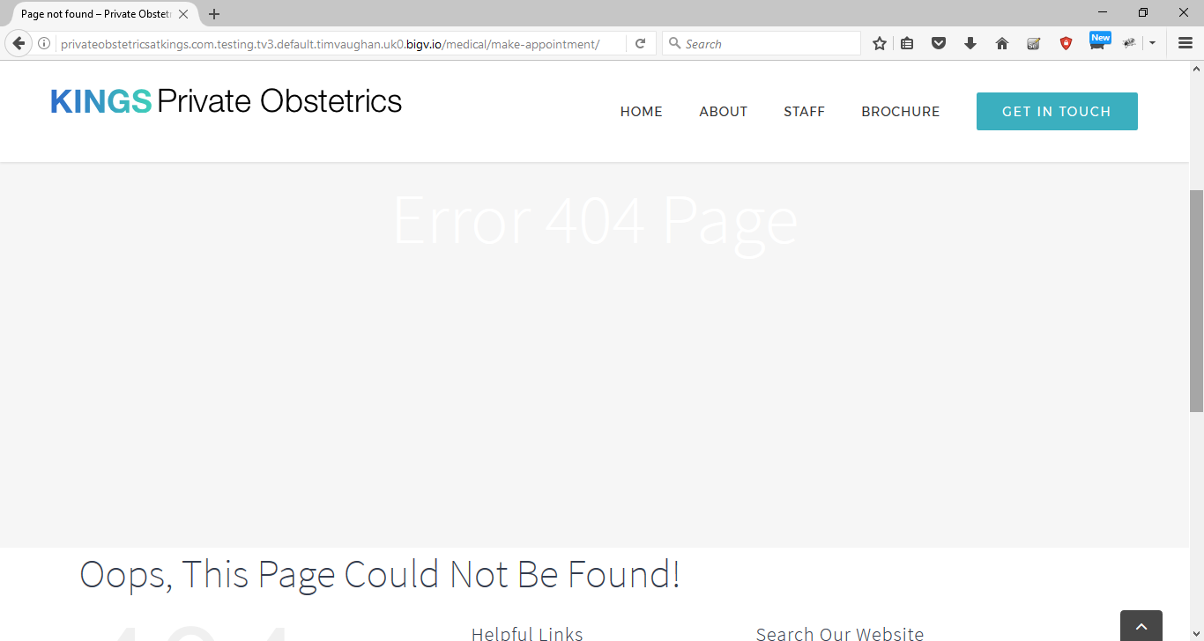

Contant Us page / get in touch page: Validation is missing on Name , Phone Number fields :
Name – accepts any type of data and eny length
Phone number- Accepts aplhabets and symbols and also no limit on the data.
Message – No limit of data entry.
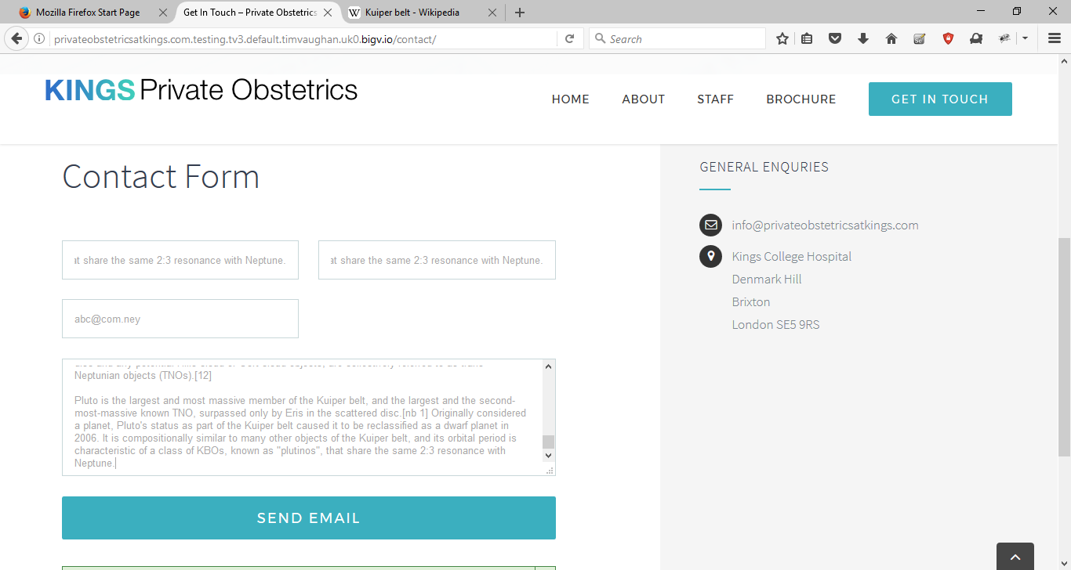
The Private Services on contact number mentioned is wrong as its only 8 digits(+44(0)32993297 as apposed to the number mention on the brochure : 44(0)20 3299 3297
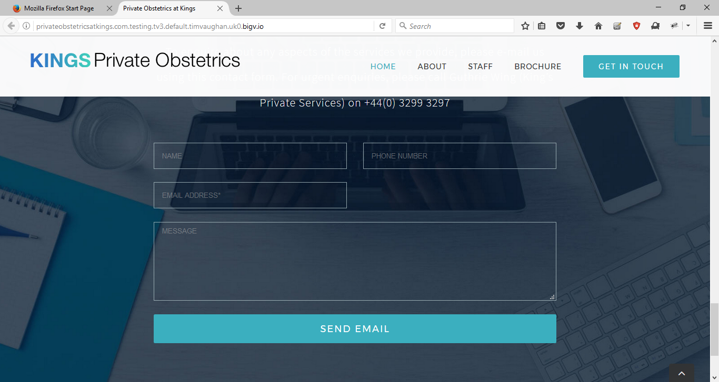
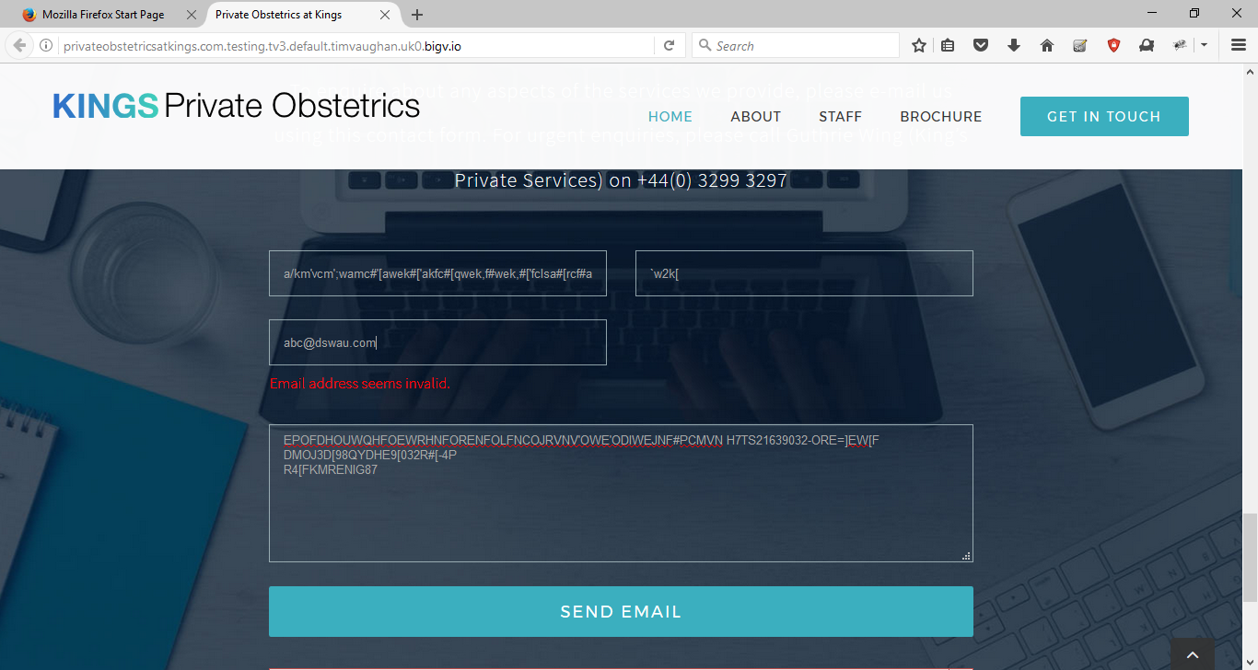

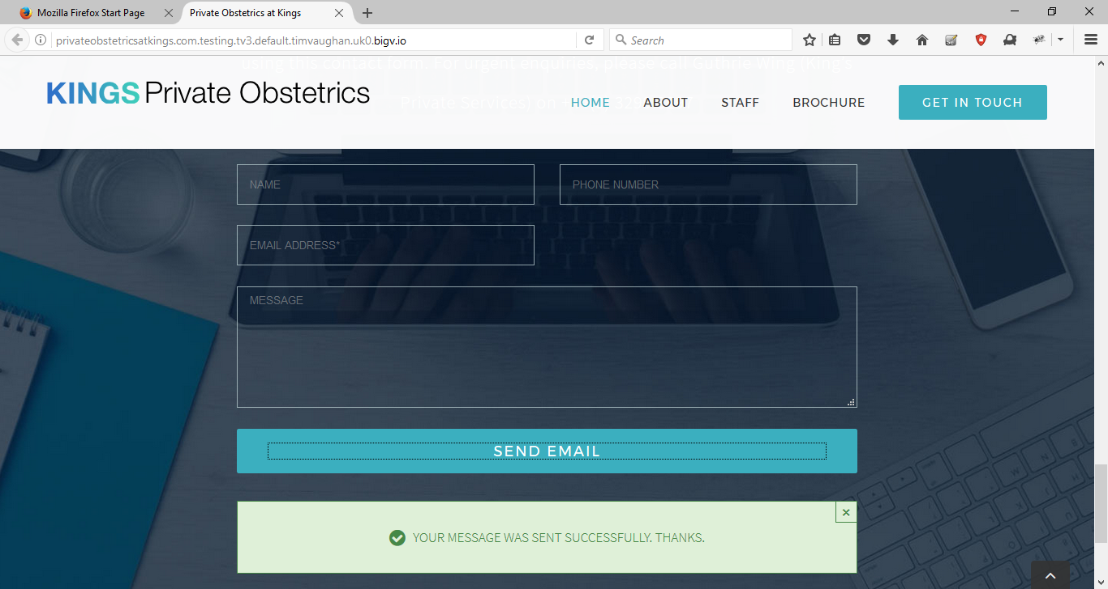

Name Field – is not indicated as mandatory but still it doesn’t allow to proceed without data.
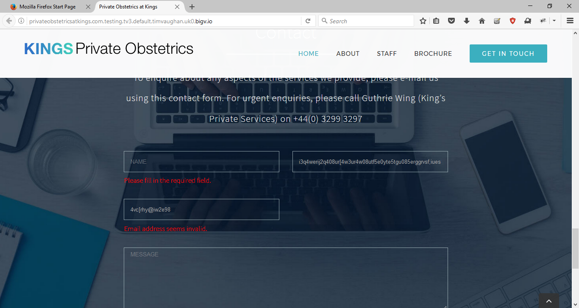

MAC Book:
There are some alignment issues in Mac book compared to image shown in windows and firefox.
