Can create new department with user input, using a scanner and creates text files with info about this department



When user tries creating a Department without a Dean:

Adding to department with addToDept(int deptNum) method

Trying to add to an inexistent department:

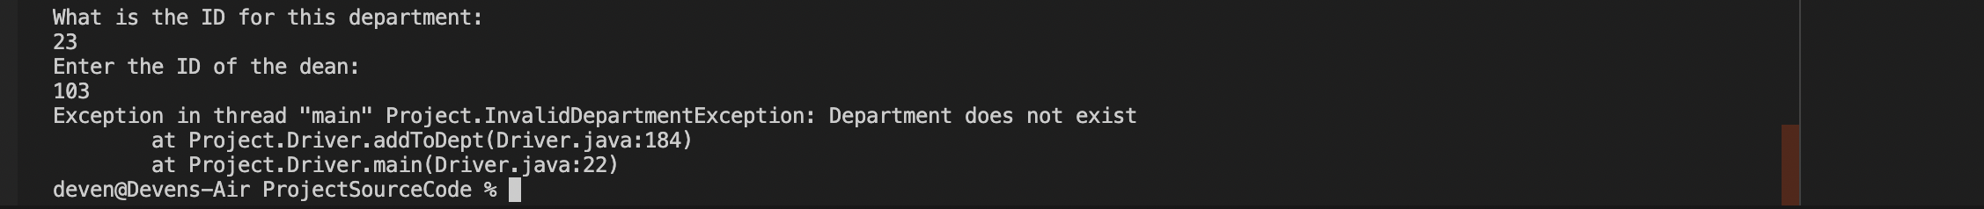

Trying to add a Person that’s already in a Department

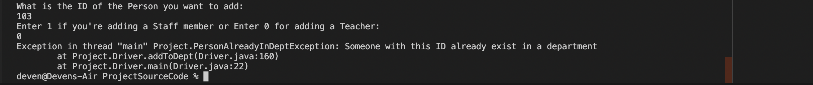

Teacher with ID 103 (Alex Hones) is the Dean in PhysicsDept so you can’t add him twice

What is uncomplete?

* Can only add one teacher or staff to a dept.
* Can only add a Person to the dept you just created