NEWSLENS AI
PUBLIC DOCUMENTATION

DEVELOPER REFERENCE
NewsLens AI
Code Explanation and Developer Guide
Module-by-module architecture, algorithms, extension points, tests and viva preparation
Field | Value
Product | NewsLens AI
Document status | GitHub-ready public documentation; publication pending owner action
Author and developer | Deven Gaikwad
Copyright | © 2026 Deven Gaikwad. All rights reserved.
Runtime | Streamlit · Python 3.12 · app.py
Model boundary | Linguistic credibility-risk estimate; not a verified fact-check
Repository | Intended canonical repository: https://github.com/DevenGaikwad/NewsLens-AI (not yet created)
Document updated | 25 August 2026

CODE · METHODS · EVIDENCE · RESPONSIBLE USE

Table of Contents
Section | Rendered page
1-2. Architecture and folder map | 3
3-4. Configuration and ingestion | 5
5-7. Preprocessing and summarizers | 6
8. Offline training pipeline | 7
9. Prediction and explainability | 8
10-11. SQLite and Streamlit orchestration | 10
12-13. Visualisation, exports and tests | 12
14-16. Modification, deployment and errors | 13
17-18. Viva and acceptance checklist | 16

Page references match the packaged render; headings remain Word-native for navigation and future TOC updates.

Core invariant: Summarization and classification are independent. `predict_credibility` always receives the original cleaned article, never only `SummaryResult.summary`.

1. How to read the project
Start with app.py and pages/ for user flow, then inspect src/ for reusable business logic. training/ is an offline pipeline that writes models/ and reports/results/. Streamlit reads those artifacts; it does not train. tests/ verify both isolated functions and page startup.
presentation -> ingestion -> NLP -> independent AI branches
-> explanation/result objects -> persistence/export
offline training -> saved Joblib + JSON/CSV/PNG artifacts -> runtime loading
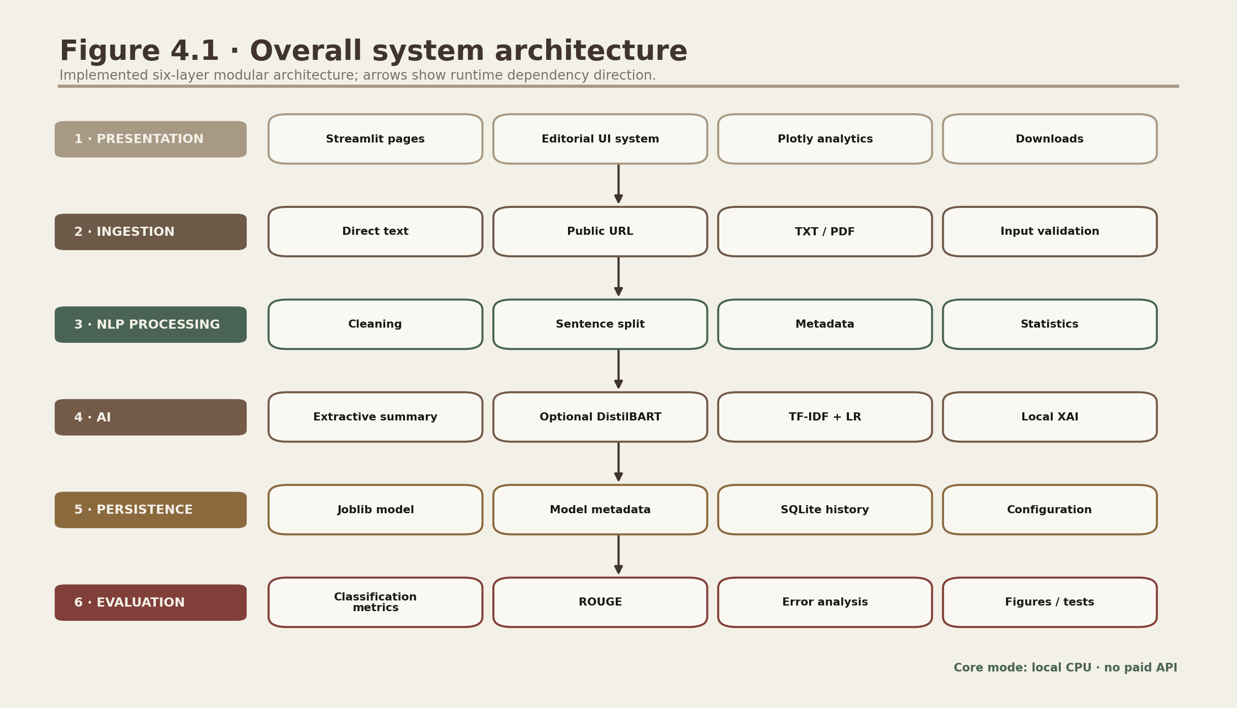
Figure D.1. Layered source architecture.
Each layer exposes small typed functions; Streamlit orchestrates but does not own model logic.
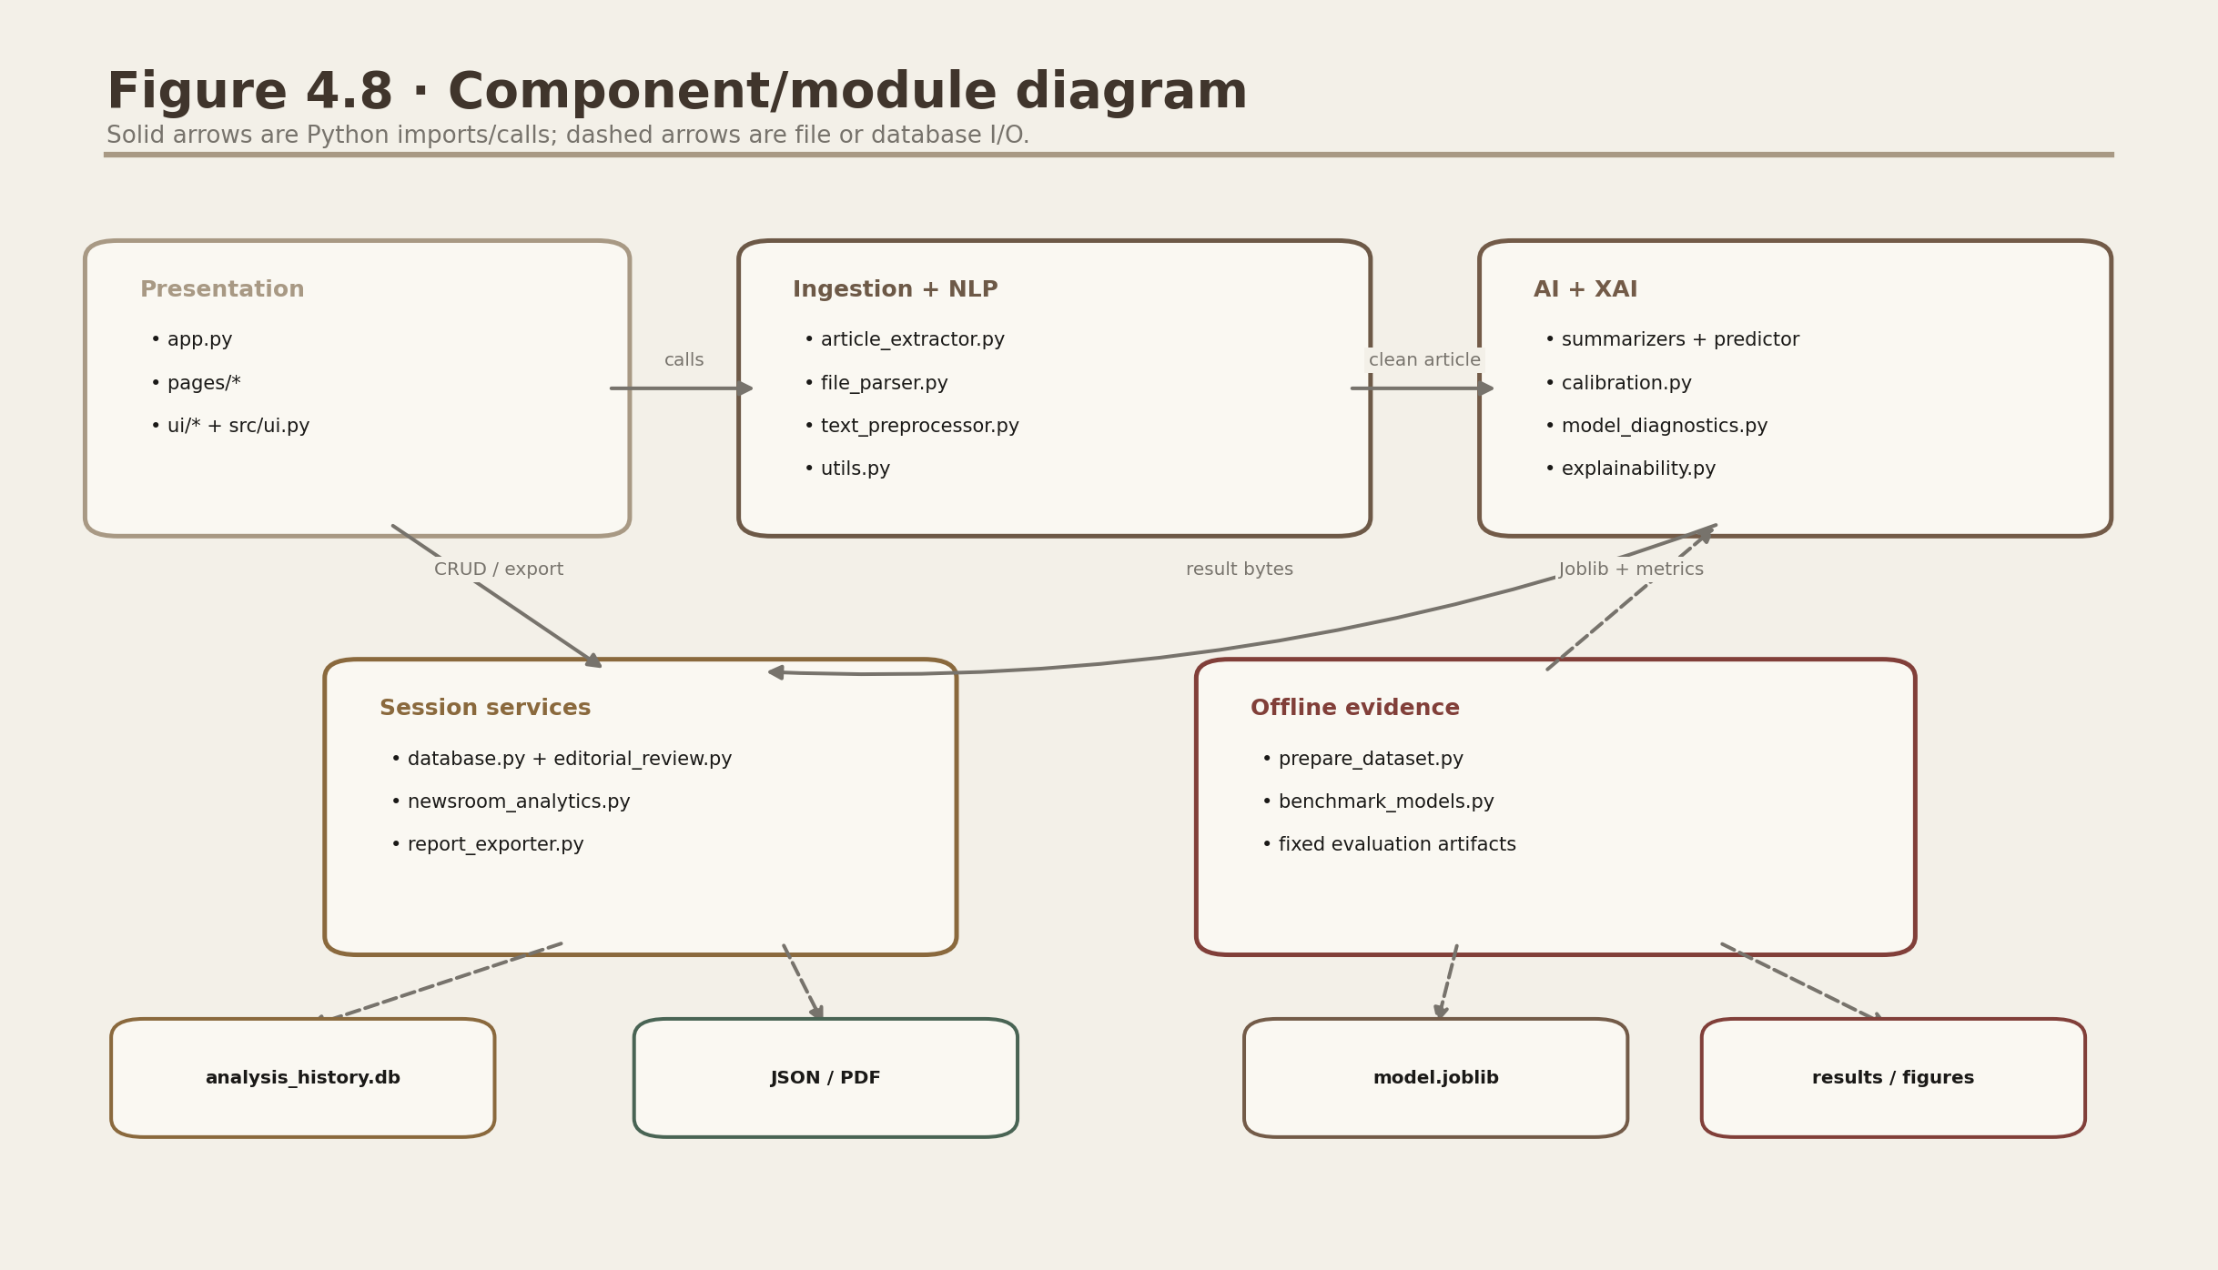
Figure D.2. Component/module dependencies.
The offline component writes identified artifacts. Runtime modules read them through central configuration.

2. Folder and file purpose
File / group | Purpose
app.py | st.Page registry and native same-tab st.navigation router
pages/00_News_Desk.py | News Desk, measured headline cards and scientific boundary
pages/01_Analyse_Article.py | End-to-end input, independent AI calls, result cards, private history and exports
pages/02_Model_Performance.py | Measured Model Accountability and ROUGE views
pages/03_Dataset_EDA.py | Dataset Analysis, EDA and leakage disclosure
pages/04_Analysis_History.py | Session-private Editorial Archive search/filter/read/export/delete
pages/05_Research_About.py | Paper matrix and responsible-AI context
src/session_history.py | Safe session SQLite adapter; trusted-local persistent opt-in
src/config.py | Portable paths, thresholds, model name and disclaimer
src/utils.py | Hashing, word/reading statistics, JSON helpers
web/ | Next.js presentation shell and responsive Streamlit iframe
training/*.py | Download, prepare, tune, evaluate and save
tests/*.py | Deterministic unit/integration/smoke tests
docs/*.md | Model, dataset, architecture, deployment and release records
scripts/*.py | Documentation, audit and screenshot reproducibility helpers

3. Central configuration
src/config.py derives PROJECT_ROOT from its own file, so paths remain portable. MODEL_PATH and CALIBRATION_PATH may be overridden privately; the default public history mode is fail-closed per-session SQLite. Configuration records the 40-word minimum, bounded uploads/network requests, model version isot-tfidf-lr-v1.0.0, 56 expected packaged checks and exact responsible outcome labels. Runtime code reads fitted artifacts and never calls fit().
MODEL_PATH = Path(os.getenv('NEWSLENS_MODEL_PATH', MODELS_DIR / 'fake_news_pipeline.joblib'))
CALIBRATION_PATH = Path(os.getenv('NEWSLENS_CALIBRATION_PATH', MODELS_DIR / 'confidence_calibration.json'))
EXPECTED_PACKAGED_CHECKS = 56
# NEWSLENS_HISTORY_MODE defaults to session; runtime loads artifacts and never retrains.

4. Ingestion modules

4.1 Public URL extraction
_validate_public_target parses and length-bounds the scheme/host, rejects credentials, malformed or obfuscated authorities and local names, and requires every DNS answer to be globally routable. _download_public_html disables environment proxies and automatic redirects, independently validates every redirect, caps the chain at five hops, blocks loops, compares an observable peer address with the validated DNS set, and streams at most 5 MB. extract_article then tries Trafilatura metadata-aware extraction before its BeautifulSoup fallback.
def extract_article(url: str) -> ArticleData:
html, final_url, headers = _download_public_html(url)
document = trafilatura.bare_extraction(html, with_metadata=True)
# Every requested hop was validated; response bytes were bounded.
# If extracted text is too short: BeautifulSoup article/main/p fallback

4.2 File parser
parse_uploaded_file accepts a filename and bytes so it is independent from Streamlit UploadedFile. TXT decoding tries UTF-8 variants, CP1252 and Latin-1. PDF uses pypdf page extraction and rejects protected, malformed, scanned/too-short or over-10-MB input with FileParseError.

4.3 Data contracts
Dataclass | Important fields
ArticleData | text, title, author, date, URL/domain, extractor, word/read counts
SummaryResult | summary, method, length, counts, compression, time, selected sentences
PredictionResult | raw/calibrated probabilities, calibrated confidence/band, exact outcome, review state/reasons, diagnostics, artifact ID and time

5. Text preprocessing
clean_article_text is conservative for display: HTML entities, controls, URLs, whitespace and optional source markers are handled without destroying punctuation. text_for_model lowercases, maps digits to a shared token and removes unsupported characters. The same model transformation runs during training and inference. split_sentences uses deterministic regex rules and needs no NLTK download.
display_text = clean_article_text(raw, remove_source_markers=False)
model_text = text_for_model(display_text) # marker mitigation + lowercase + number token
Design choice: No stemming/lemmatisation is applied. The linear model can use readable n-grams, negation and style; the UI can display original sentences.

6. Extractive summarizer
summarize_extractive filters sentences, builds a sentence-level TfidfVectorizer, calculates cosine similarity to the mean centroid, adds lead/density bonuses, chooses k from length-specific fraction/cap, sorts indices and returns a frozen SummaryResult. Empty and two-sentence inputs follow explicit low-complexity paths.
LENGTH_FRACTIONS = {'Short': .18, 'Medium': .30, 'Detailed': .45}
MAX_SENTENCES = {'Short': 3, 'Medium': 6, 'Detailed': 10}
chosen = sorted(np.argsort(scores)[-target:].tolist())

6.1 Complexity
For S sentences and V sentence vocabulary, sparse TF-IDF construction is approximately proportional to observed tokens. Centroid similarity is sparse matrix-vector multiplication. The implementation caps selected sentences but does not require a transformer context window.

7. Abstractive summarizer
load_transformer_pipeline imports optional dependencies lazily, then creates a Hugging Face summarization pipeline for sshleifer/distilbart-cnn-6-6. pages/01 wraps it in st.cache_resource. summarize_abstractive tokenizes full sentences, forms context-safe chunks with one-sentence overlap, summarizes each chunk and optionally summarizes the concatenated first pass.
chunks = sentence_aware_chunks(text, tokenizer, max_tokens, overlap_sentences=1)
first_pass = [pipeline(chunk, ...)[0]['summary_text'] for chunk in chunks]
if tokens(join(first_pass)) > max_tokens:
final = hierarchical_reduce(first_pass)
Dependency compatibility: requirements.txt keeps Transformers below major release 5 because the summarization pipeline API used here is not available in that release.

8. Training pipeline
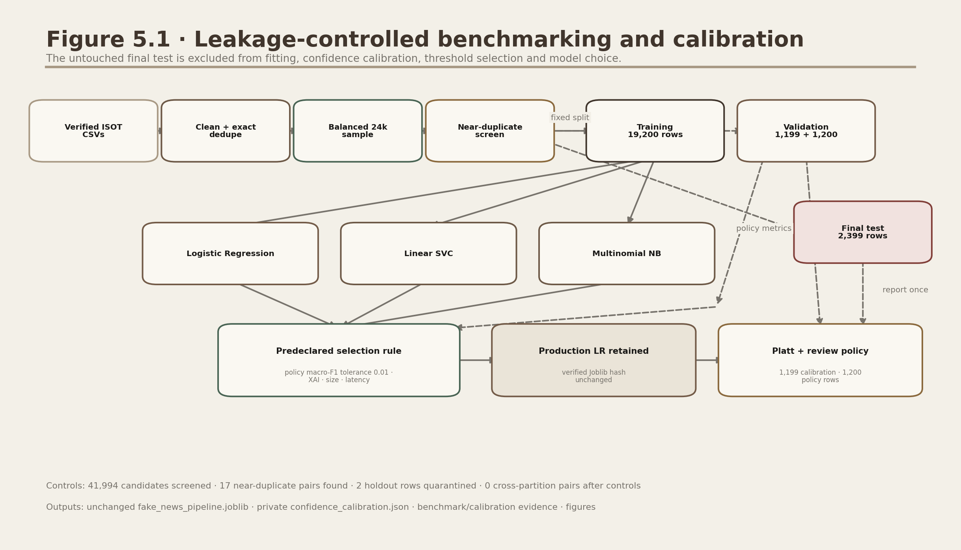
Figure D.3. Offline model training.
The Pipeline boundary is the leakage boundary: vectorizer fitting occurs only within training data/folds.

8.1 Dataset preparation
load_isot_dataset assigns labels from the private checksum-verified CSV filenames, normalises text, rejects short/conflicting rows, removes exact duplicate model-text hashes and draws a balanced seed-42 sample. benchmark_models.py then applies a deterministic word-five-gram candidate screen with exact Jaccard verification so detected near-duplicate groups remain within one partition.

8.2 Candidates and tuning
The controlled release benchmark uses 19,200 training rows, 1,199 Platt-calibration rows, 1,200 validation-policy rows and an untouched 2,399-row final test. Logistic Regression C=2.0, LinearSVC C=1.0 and MultinomialNB alpha=0.1 share the same TF-IDF configuration. The validation-policy macro-F1 difference (0.002500) is below the predeclared 0.01 retention tolerance, so the verified packaged Logistic Regression remains unchanged.

8.3 Production-artifact verification and private calibration
assert sha256(MODEL_PATH) == accepted_model_sha256
production = joblib.load(MODEL_PATH) # unchanged verified artifact
# Platt parameters are fitted offline and stored in private confidence_calibration.json.
# Streamlit loads both matching artifacts; it never calls fit().
The benchmark summary records source/model checksums, exact partition hashes, leakage-screen counts, candidate metrics, policy selection, calibration evidence and final-test results. The private calibration artifact binds its coefficient/intercept and 0.59 review threshold to the exact production-model SHA-256.

9. Prediction and explainability
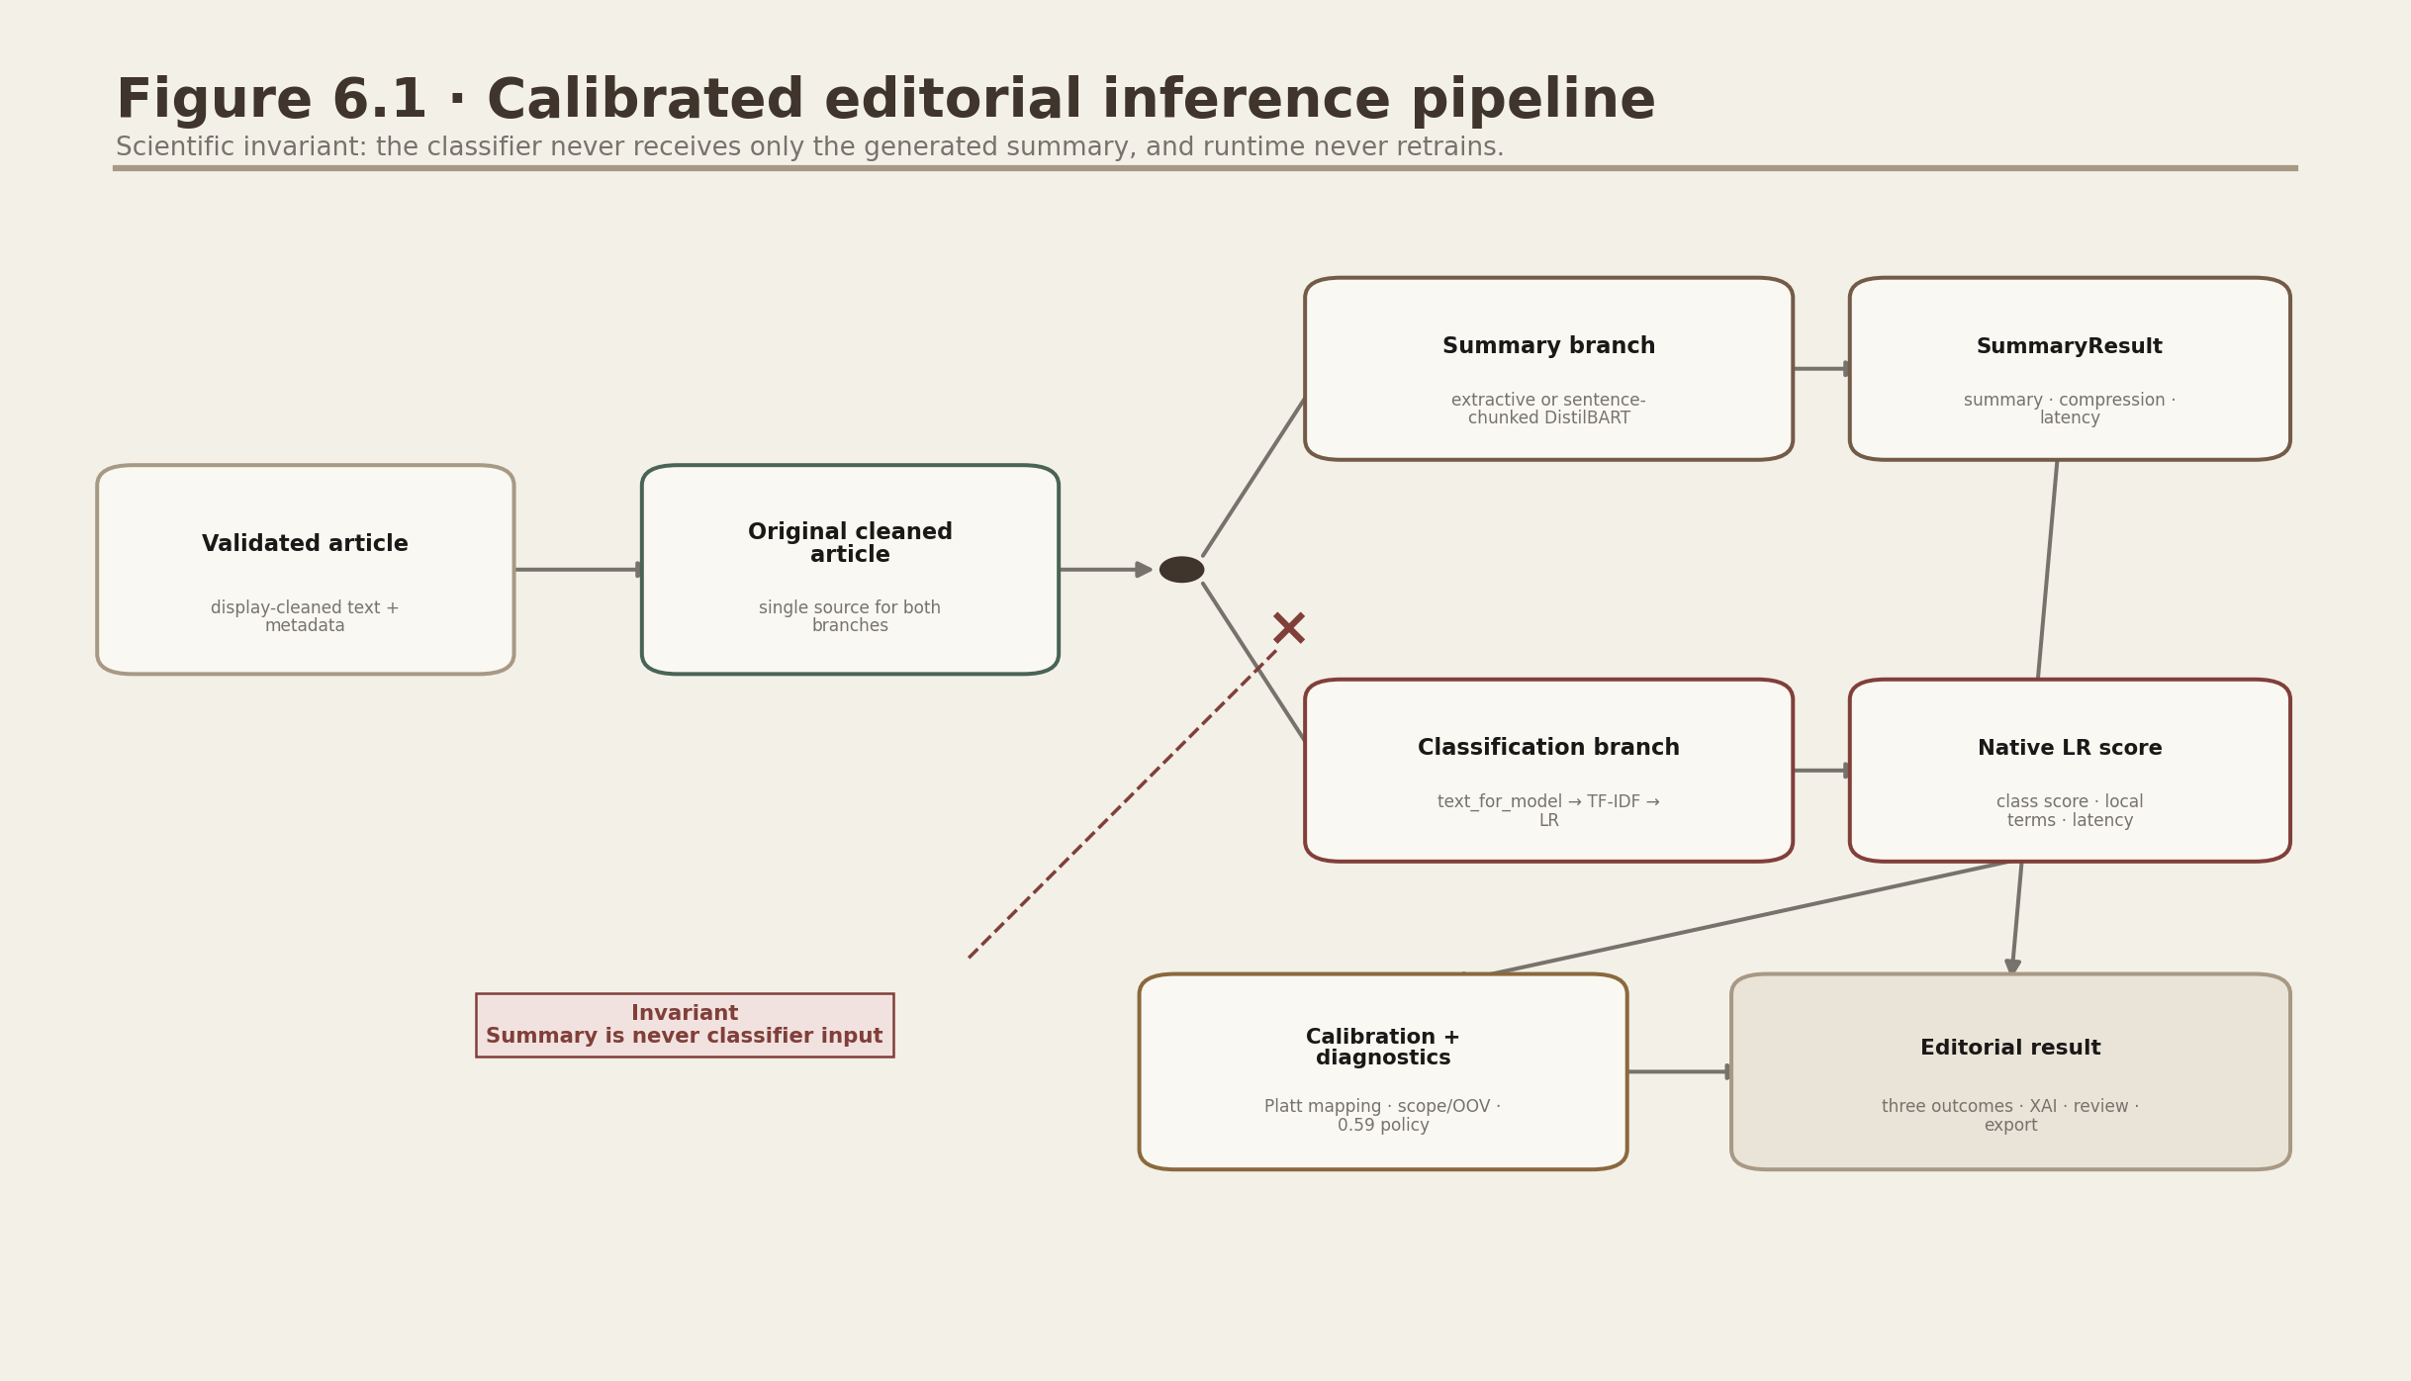
Figure D.4. Runtime inference contracts.
Both branches share the original cleaned text, but neither consumes the other's output.

9.1 Model loading
load_model checks existence, catches incompatible Joblib failures and verifies predict/named_steps. The page-level cached_model wrapper guarantees one load per Streamlit process.

9.2 Calibrated probability and outcome policy
predict_credibility converts the production decision_function through the verified Platt mapping. It returns calibrated reliable/misleading probabilities, calibrated confidence, a band and review reasons. Confidence below 0.59 or supported mismatch/quality conditions yield Editorial review required; otherwise the result uses the exact lower- or higher-risk outcome text.

9.3 Calibration, abstention and artifact binding
src/calibration.py refuses missing, incomplete, out-of-range or model-hash-mismatched calibration data. Platt parameters transform a one-dimensional decision score only; they do not alter classifier coefficients or retrain the model. The review threshold is a communication/abstention policy derived from separate validation-policy rows.

9.4 Local linear contribution
x = tfidf.transform([model_text])
contribution_j = x_j * classifier.coef_[0, j]
# sort observed non-zero terms by signed contribution
Only terms present in the article are shown. Direction and magnitude describe the model's log-odds contribution, not semantic truth, evidence quality or causality.

9.5 Input diagnostics and editorial review
src/model_diagnostics.py compares article length and unigram vocabulary coverage with saved reference quantiles and adds lightweight language/domain mismatch warnings. src/editorial_review.py validates bounded notes, statuses and up to eight public HTTP(S) supporting URLs. The workflow records a human assessment; it never presents the model result as evidence.

10. SQLite operations
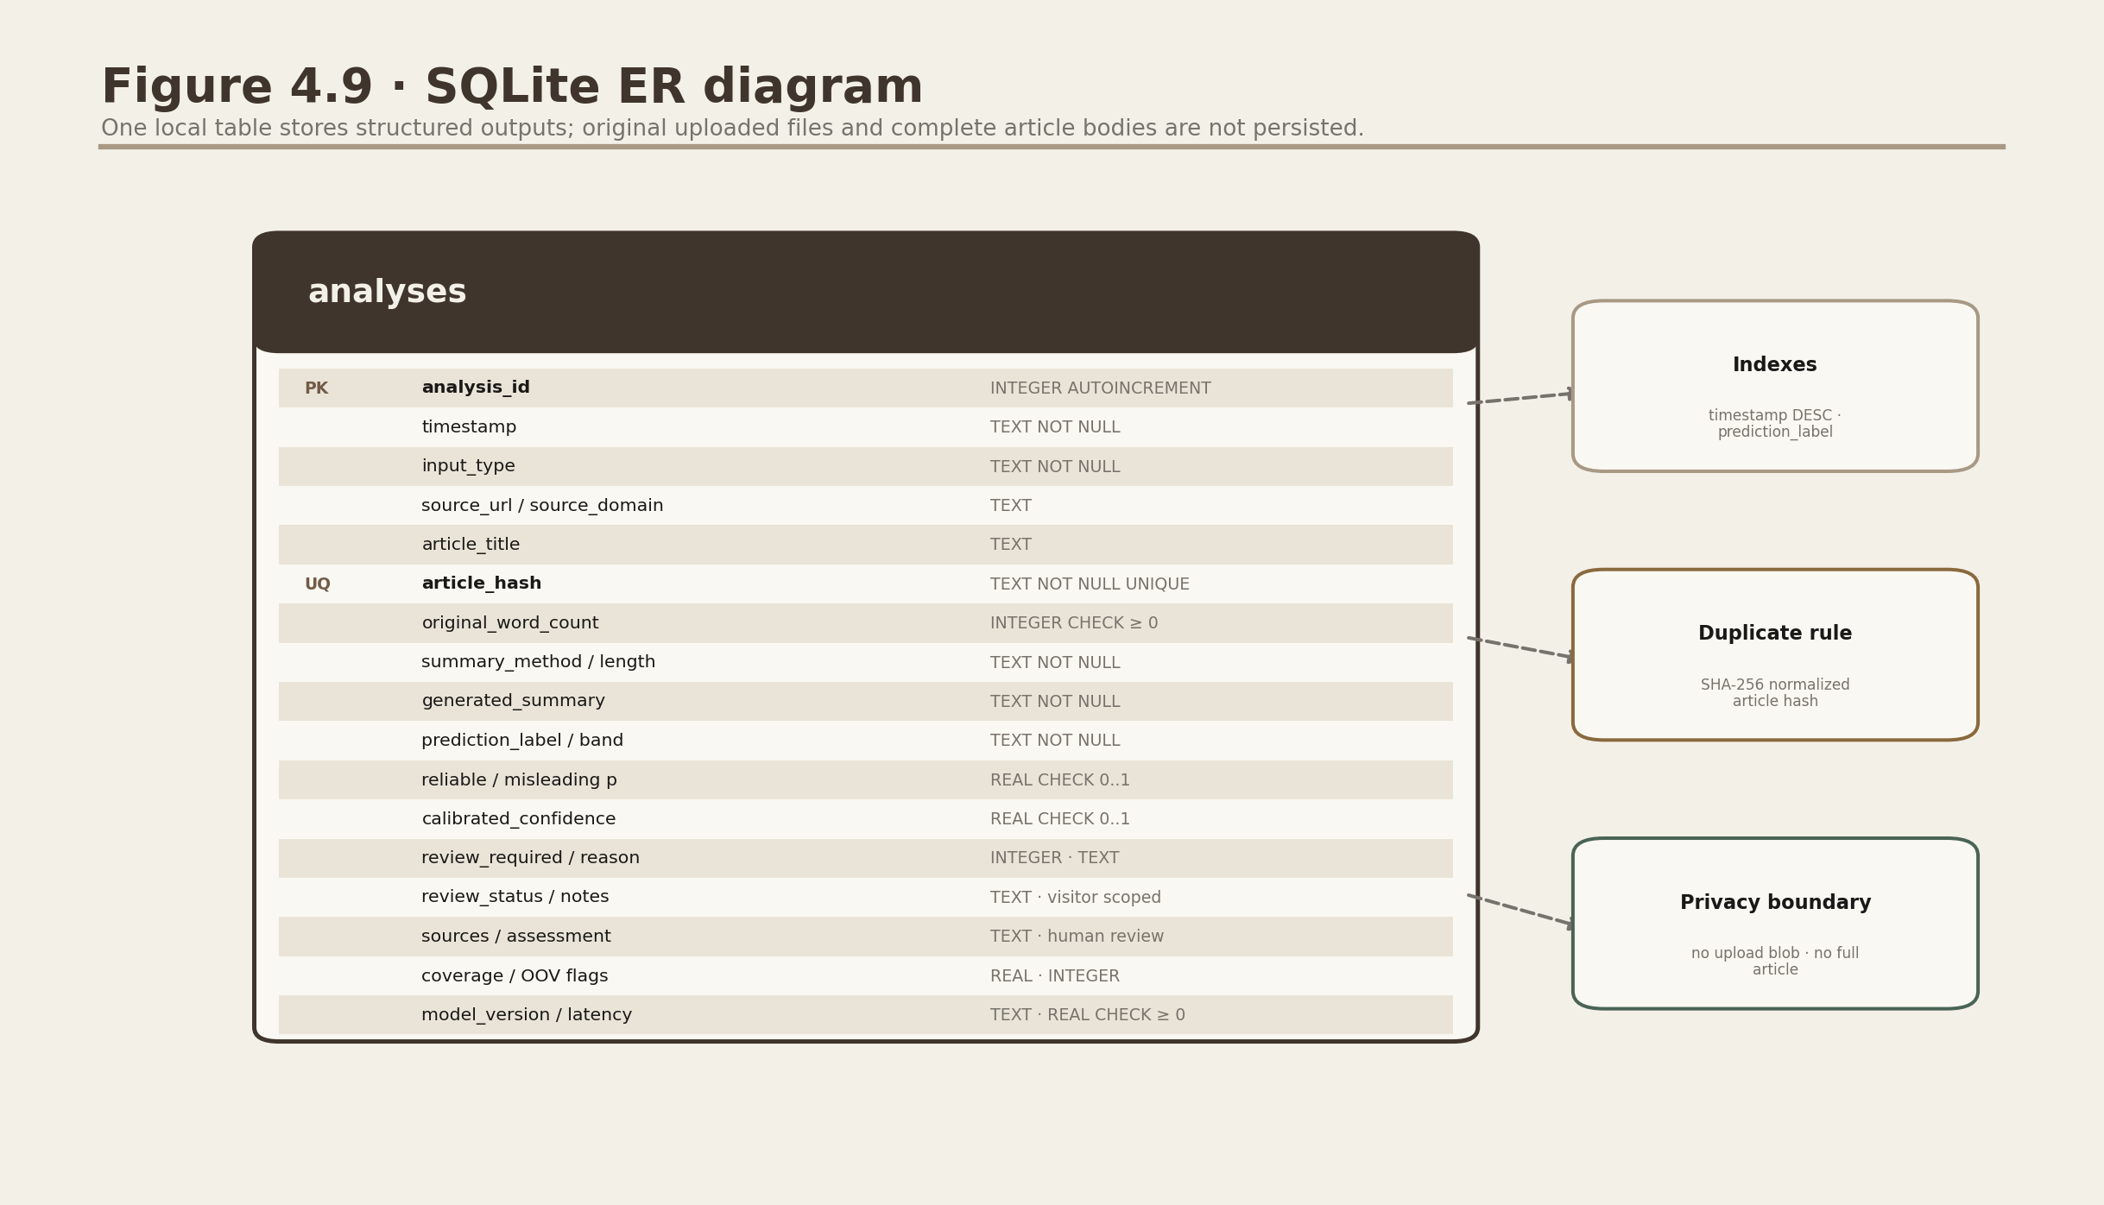
Figure D.5. Local analyses table.
The unique article_hash performs duplicate detection without retaining the complete source article. Structured rows include calibrated confidence, review status/reasons, public supporting-source URLs and aggregate-safe coverage/mismatch fields. In public mode the database file remains unguessable and visitor-scoped.

10.1 Lifecycle
- connect creates the parent folder and enables foreign keys.
- initialize_database executes idempotent schema/index statements.
- insert_analysis attempts one insert and catches only the unique-hash IntegrityError.
- list_analyses constructs parameterised search/label clauses and a capped limit.
- get_analysis, delete_analysis and clear_history use parameterised SQL.

10.2 Privacy
Stored fields include title, domain, summary and probabilities, but not the full article or uploaded file. Public UI sessions map an opaque random session token to a hashed temporary SQLite filename, so a second visitor cannot list the first visitor's records. A trusted single-user local runtime may explicitly set NEWSLENS_HISTORY_MODE=persistent. SQLite is unencrypted and Community Cloud local storage is temporary; neither is presented as a durable multi-user store.

11. Streamlit orchestration
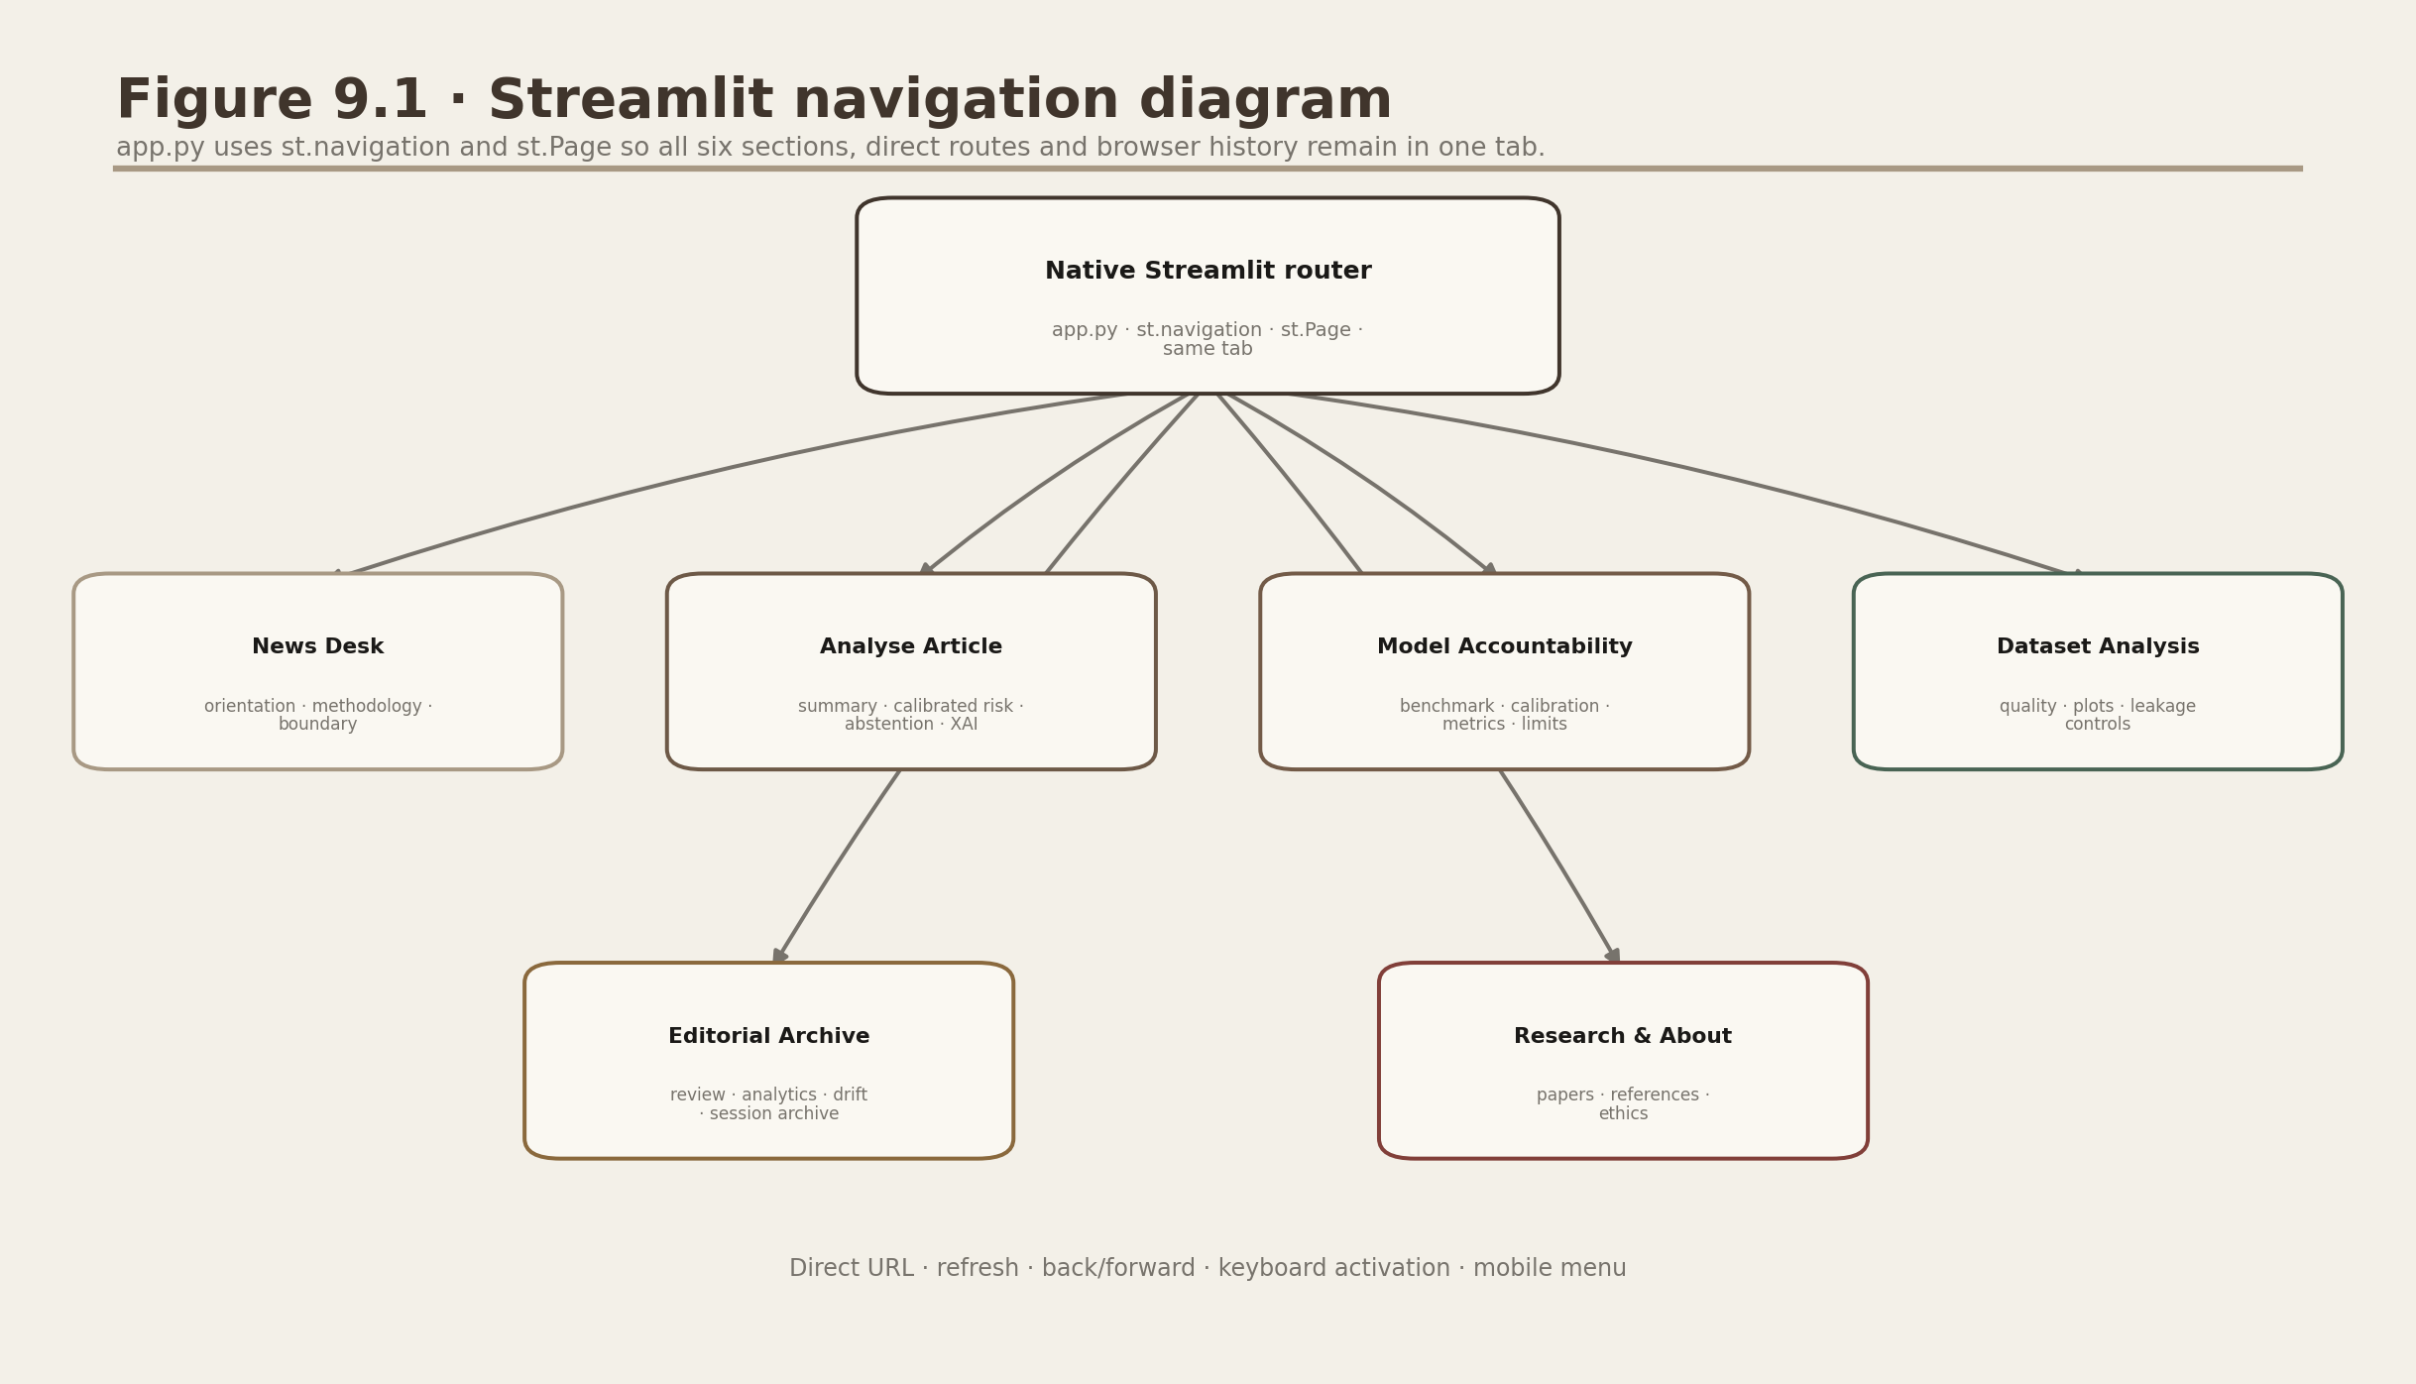
Figure D.6. Native same-tab navigation.
app.py registers all six source files with st.Page; st.navigation owns direct routes, active state and browser history.

11.1 Session state
loaded_sample carries the sample button across rerun; last_analysis retains the completed payload; last_duplicate controls the warning; and _newslens_private_history_id selects the visitor's non-guessable temporary SQLite path. Only serialisable result fields are stored. Changing a widget causes a normal Streamlit rerun, but cached models and the visitor's session analysis remain.

11.2 Resource and data caching
- st.cache_resource: Joblib classifier and optional transformer pipeline.
- Stable JSON/CSV/PNG result files: read directly because they are small and immutable during one demonstration.
- SQLite queries: not globally cached, so delete/insert changes are visible immediately.

11.3 Editorial shell, CSS and accessibility
ui/theme.py defines one maintainable warm paper palette, serif/sans typography pairing, spacing/radius tokens, focus-visible controls, reduced-motion handling and responsive grids. app.py and Streamlit's native navigation render the top routes; ui/navigation.py supplies only the branded masthead; ui/components.py uses st.page_link for same-tab calls to action and provides the remaining editorial components. Plotly charts use the same muted publication palette and retain text labels/directional legends.

11.4 Error containment
User-correctable exceptions (ArticleExtractionError, FileParseError, ModelLoadError, AbstractiveDependencyError and ValueError) are shown directly. An unexpected exception receives only a stable generic message in the public interface, avoiding path, stack or implementation-detail leakage while preventing a full page crash.

12. Visualisation and exports
confidence_gauge and risk displays use calibrated probabilities and exact bounded outcome language. The contribution chart remains a signed correlation view. Newsroom analytics export only aggregate counts/rates; review/history exports apply spreadsheet/PDF escaping. All views use the shared warm editorial palette and visible text labels.
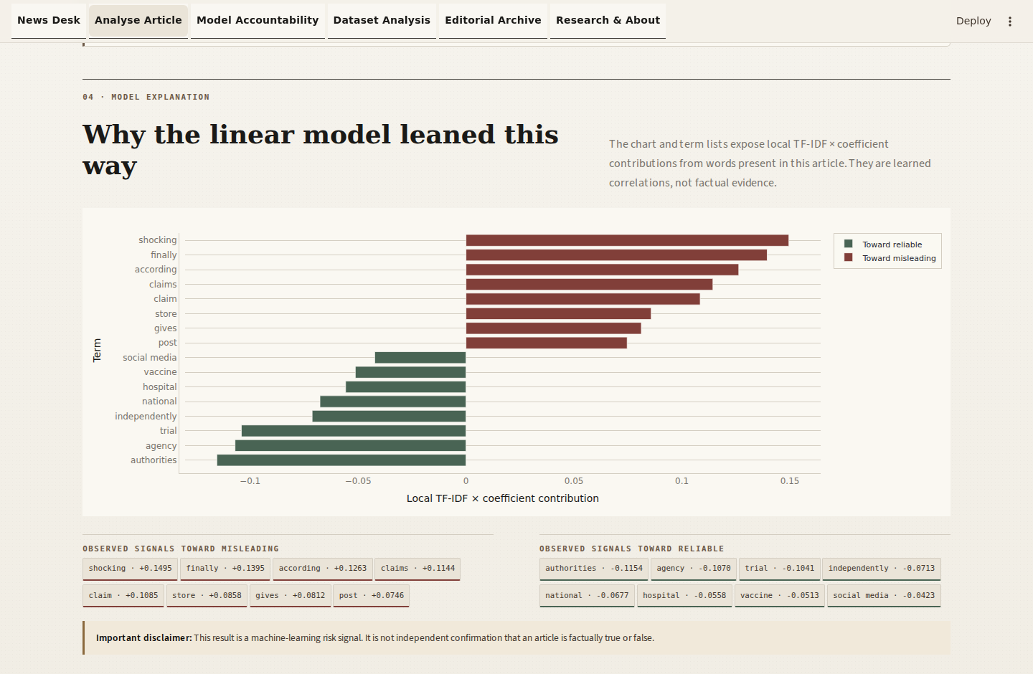
Figure D.7. Explanation and export surface.
The UI keeps interpretability, limitation text and downloadable evidence in one viewport.

13. Tests
Test file | Coverage
test_preprocessing.py | cleaning, sentence split, stats, hash, language hint
test_summarization.py | compression, ordering, length, empty and long input
test_prediction.py | Joblib load, probabilities, labels, XAI shape, missing model
test_database.py | CRUD, search, duplicate hash and clear
test_article_extractor.py | obfuscated/private targets, public-to-private redirects, loops, DNS/peer mismatch, size cap and fallback
test_file_parser.py | TXT success, upload failures and path-traversal filenames
test_exports.py | JSON, valid escaped PDF and spreadsheet-formula-safe CSV
test_app_smoke.py | AppTest startup for all six Streamlit scripts
test_editorial_ui.py | assets, warm tokens, navigation, shared shell and responsible wording
test_release_policy.py | attribution, proprietary files, deployment gate, no runtime training and web headers/sandbox
test_placement_enhancements.py | calibration/hash binding, abstention outcomes, diagnostics, editorial review, analytics, drift readiness and privacy isolation

python -m pytest -q # Expected collection: 56 checks, including 29 established checks
For a new feature, add a unit test at the business-logic level and one integration/smoke assertion if it affects UI orchestration. Mock network and filesystem boundaries; do not make deterministic tests depend on a public news site.

14. Safe modification recipes

14.1 Change UI colours or spacing
- Open ui/theme.py for tokens and global CSS; use ui/components.py for shared presentation patterns.
- Edit shared tokens rather than page-local HTML.
- Keep result text labels; do not rely on colour alone.
- Run AppTest and capture every page at 1440 x 1000 plus the 390 x 844 mobile scenarios.

14.2 Change the classifier
- Add a candidate that supports sparse text in training/model_candidates().
- Define a small reproducible grid and macro-F1 scoring.
- If probabilities are absent, add validated calibration rather than treating margins as probabilities.
- Update explainability for the new estimator or disable it explicitly.
- Retrain, regenerate artifacts, update MODEL_CARD.md and rerun all tests.

14.3 Add a dataset
- Document source, licence, schema, label policy and annotation quality.
- Map to full article text and binary labels only with justified semantics.
- Deduplicate across datasets and group by publisher/event/time before splitting.
- Keep a test set from unseen groups and report domain-specific errors.
- Record hashes and artifact identifiers, then update DATASET_CARD.md.

14.4 Add a summarizer
- Return the existing SummaryResult contract.
- Respect sentence/token limits and CPU fallback.
- Cache resources, not per-user content.
- Evaluate on fixed reference data and add factual/coherence review.
- Never feed the new summary into the classifier unless a separate experiment is explicitly designed.

15. Deployment guidance
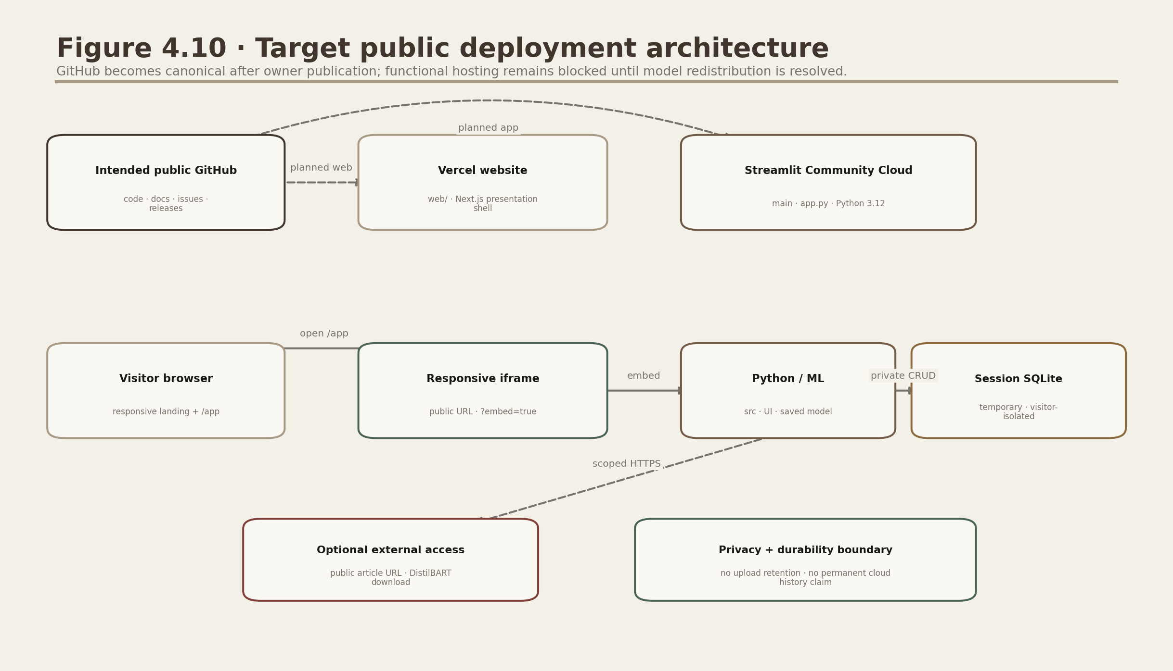
Figure D.8. Target public deployment architecture.
Vercel is the intended editorial presentation shell while Streamlit Community Cloud would run the unchanged Python/ML application from app.py. Neither service is claimed live in this staging document.
The public Streamlit UI defaults to temporary per-session SQLite and makes no durable-history promise. https://github.com/DevenGaikwad/NewsLens-AI is the intended canonical repository, but it has not yet been created. Public push and functional hosting remain blocked because the ISOT-derived Joblib and matching calibration redistribution basis is unresolved. The public staging archive excludes both artifacts; no runtime retraining or mock classifier is used.

16. Common code errors

Import works in notebook but not terminal
Run from project root or preserve the project-root sys.path block used by training scripts.

Model predicts opposite class
Inspect pipeline.classes_; never assume probability column order.

Leakage after refactor
Keep TF-IDF inside Pipeline/GridSearch and deduplicate before split.

Streamlit retrains repeatedly
Never call training functions from pages; load Joblib under cache_resource.

Empty Plotly explanation
Estimator may not expose coef_ or article terms may be outside vocabulary; keep an empty-state chart.

Locked SQLite file
Keep connections inside context managers and avoid long transactions.

Transformer cuts sentences
Chunk by tokenizer length at sentence boundaries; reserve generation tokens.

Wrong relative path
Import paths from src.config rather than constructing cwd-specific strings.

17. Viva questions and concise answers

Why combine the two tasks?
They help readers triage news, but remain independent because compression and credibility estimation answer different questions.

Why classify original text?
A summary may remove hedging, sourcing, contradictions or style features used by the classifier.

Why TF-IDF?
It is fast, sparse, reproducible and interpretable on a CPU.

Why Logistic Regression over the slightly better SVM?
On the validation-policy partition, Linear SVC's macro-F1 advantage was 0.002500, below the predeclared 0.01 tolerance. The unchanged Logistic Regression remains for direct signed explanations, compact deployment and a verified artifact hash; its confidence is separately Platt-calibrated.

What prevents data leakage?
Deduplication before split, metadata exclusion, marker neutralisation and TF-IDF fitting inside training folds.

Why is 99.21% final-test accuracy not universal?
The 99.21% value is accuracy against 2,399 final-test ISOT labels after leakage controls; ISOT still carries outlet, topic, time and style correlations, so this is not an external-domain truth score.

What is macro-F1?
The mean of per-class F1 values, giving equal weight to both labels.

What does ROC-AUC measure?
Ranking discrimination across thresholds; it does not establish calibrated probability or fairness.

What is PR-AUC useful for?
Positive-class precision/recall trade-offs, especially under imbalance.

What is local contribution?
Observed TF-IDF value multiplied by a linear coefficient.

Is it a fact-checker?
No. It predicts linguistic credibility risk and retrieves no evidence.

Why low ROUGE?
XSum references are highly abstractive one-sentence summaries; extractive overlap is intentionally difficult.

How are long transformer inputs handled?
Sentence-aware token chunks, one-sentence overlap and hierarchical reduction.

What is SSRF?
A server being tricked into requesting private/internal addresses; the URL validator blocks those ranges.

Why SQLite?
Portable, zero-admin local persistence suitable for a semester project.

How are duplicates detected?
A SHA-256 hash of case/whitespace-normalised article text has a UNIQUE constraint.

What happens without PyTorch?
The complete lightweight extractive/classification path still works.

How would you improve generalisation?
Publisher/event/time group splits and external-domain evaluation.

How would you add real fact-checking?
Claim extraction, trusted evidence retrieval, entailment and source/citation presentation with human review.

Main ethical risk?
False or biased misinformation labels causing reputational or political harm.

18. Developer acceptance checklist
- No model fit call in Streamlit pages.
- Both AI branches receive original cleaned text.
- Every user input has a size/type/length or URL safety check.
- Every probability maps through explicit class order.
- All stored SQL uses parameters and closes promptly.
- New measured values come from scripts, not constants in UI.
- MODEL_CARD.md and DATASET_CARD.md match the packaged artifacts.
- python -m pytest -q passes and every page is visually inspected.
- The disclaimer and uncertainty state remain visible.
- Calibration loads only when its model SHA-256 matches the active Joblib.
- Review rows, notes and analytics remain isolated to one visitor session in public mode.
- Drift readiness waits for at least 20 observations and never retrains the model.
- The final audit will execute all 56 checks and write the authoritative JUnit record.
- The final ZIP excludes raw copyrighted/large datasets and transient caches.

