NEWSLENS AI
PUBLIC DOCUMENTATION

MINI PROJECT REPORT
NewsLens AI
AI-Based News Article Summarization and Fake News Detection System
Field | Value
Product | NewsLens AI
Document status | GitHub-ready public documentation; publication pending owner action
Author and developer | Deven Gaikwad
Copyright | © 2026 Deven Gaikwad. All rights reserved.
Runtime | Streamlit · Python 3.12 · app.py
Model boundary | Linguistic credibility-risk estimate; not a verified fact-check
Repository | Intended canonical repository: https://github.com/DevenGaikwad/NewsLens-AI (not yet created)
Document updated | 25 August 2026

CODE · METHODS · EVIDENCE · RESPONSIBLE USE

NewsLens AI · Publication-staging documentation
Document updated: 25 August 2026
Runtime: Streamlit · Python 3.12 · app.py
PUBLICATION-STAGING NOTE
This sanitized public report documents the NewsLens AI research application, its implementation, measured evidence, limitations and deployment architecture. Personal academic identifiers and signature fields are intentionally excluded.
NewsLens AI was designed and developed by Deven Gaikwad. © 2026 Deven Gaikwad. All rights reserved. The intended canonical repository is https://github.com/DevenGaikwad/NewsLens-AI; it has not yet been created. Functional public hosting remains blocked until documentary permission or an explicit applicable licence confirms that the ISOT-derived model and calibration artefacts may be redistributed and hosted.

RESPONSIBLE-USE DECLARATION
NewsLens AI estimates linguistic credibility risk from patterns learned in its training data. It does not retrieve evidence, determine objective truth, infer author intent or replace professional fact-checking.
Sources, datasets, papers and tutorial references are acknowledged. Measured model and summarization results come from committed artifacts; limitations, uncertainty and the need for independent verification remain part of the product boundary.

ACKNOWLEDGEMENT
NewsLens AI's original project components were authored and developed by Deven Gaikwad. The project acknowledges the University of Victoria ISOT Research Group, the Edinburgh NLP Group, the authors represented in the research matrix, and the open-source Python community.
The two supplied videos were treated as conceptual tutorial references only. Their baseline ideas were re-engineered into an original layered application with leakage controls, model persistence, local explanations, SQLite history, testing and responsible-AI boundaries.

ABSTRACT
The rapid volume of online news creates two related but scientifically distinct needs: concise reading and credibility assessment. This project implements NewsLens AI, a local-first Streamlit application that ingests direct text, public URLs, TXT files and text-based PDFs; cleans and characterises the article; generates a selectable summary; and independently estimates credibility risk from the original cleaned article.
The lightweight summarizer uses TF-IDF centroid sentence ranking with lead-position and information-density bonuses; CPU-compatible DistilBART remains optional. The packaged Logistic Regression artifact isot-tfidf-lr-v1.0.0 was reproduced against its established 4,800-row holdout and then kept byte-for-byte unchanged. A controlled private benchmark used 19,200 training rows, 1,199 calibration rows, 1,200 validation-policy rows and an untouched 2,399-row final test after quarantining two near-duplicate holdout rows. On that final test, Logistic Regression achieved 0.992080 accuracy, 0.992080 macro-F1, 0.999481 ROC-AUC and 0.999423 PR-AUC.
The extractive summarizer was evaluated on 150 fixed-seed XSum test articles, producing ROUGE-1/2/L F1 of 0.153559/0.027824/0.102530, 70.6572% mean compression and 3.368 ms mean latency. The application adds Platt-calibrated confidence, a validation-policy-derived editorial-review threshold, input diagnostics, local feature contributions, a session-isolated review/archive workflow, privacy-safe newsroom analytics, drift-readiness indicators, JSON/PDF/CSV exports, 15 current responsive interface screenshots and 56 packaged checks, including the 29 established checks.
Keywords: automatic summarization; credibility-risk classification; TF-IDF; Logistic Regression; DistilBART; explainable AI; Streamlit; SQLite; responsible AI
Interface design: The application and every frontend figure use the same warm ivory, beige, brown and charcoal editorial newsroom design.

Table of Contents
Section | Rendered page
Chapter 1: Introduction | 10
Chapter 2: Literature Survey | 12
Chapter 3: Requirements and Feasibility | 16
Chapter 4: System Analysis and Design | 18
Chapter 5: Dataset and Data Preprocessing | 29
Chapter 6: Methodology and Algorithms | 40
Chapter 7: Implementation | 43
Chapter 8: Testing and Results | 45
Chapter 9: Graphical User Interface | 54
Chapter 10: Project Management | 71
Chapter 11: Limitations, Ethics and Future Scope | 72
Chapter 12: Conclusion | 73
References | 74
Appendices A-E | 76

Page references match the packaged render; headings remain Word-native for navigation and future TOC updates.

List of Figures
- Figure 4.1 Overall system architecture
- Figure 4.2 End-to-end data flow
- Figure 4.3 DFD Level 0
- Figure 4.4 DFD Level 1
- Figure 4.5 Use-case diagram
- Figure 4.6 Activity diagram
- Figure 4.7 Sequence diagram
- Figure 4.8 Component/module diagram
- Figure 4.9 SQLite ER diagram
- Figure 4.10 Deployment diagram
- Figure 5.1 Machine-learning training pipeline
- Figure 5.2 Class distribution
- Figure 5.3 Article-length distribution
- Figure 5.4 Title-length distribution
- Figure 5.5 Average sentence length
- Figure 5.6 Missing-value heatmap
- Figure 5.7 Duplicate-record analysis
- Figure 5.8 N-gram comparison
- Figure 5.9 Numerical-feature correlations
- Figure 5.10 Subject leakage risk
- Figure 6.1 Combined inference pipeline
- Figure 8.1 Model comparison
- Figure 8.2 Confusion matrix
- Figure 8.3 ROC and precision-recall curves
- Figure 8.4 Global feature coefficients
- Figure 8.5 Calibration reliability
- Figure 9.1 Streamlit navigation
- Figures 9.2-9.16 Current desktop/mobile application, review, benchmark, analytics and drift screenshots

List of Tables
- Table 2.1 Literature survey comparison
- Table 3.1 Functional requirements
- Table 3.2 Software and hardware
- Table 5.1 Dataset comparison
- Table 5.2 Cleaning audit
- Table 8.1 Model comparison
- Table 8.2 Champion metrics
- Table 8.3 Test cases
- Table 10.1 Project risks
- Table A.1 Dataset schema
- Table B.1 Function reference

List of Abbreviations
Abbreviation | Meaning
AI | Artificial Intelligence
NLP | Natural Language Processing
TF-IDF | Term Frequency-Inverse Document Frequency
LR | Logistic Regression
SVM | Support Vector Machine
XAI | Explainable Artificial Intelligence
ROUGE | Recall-Oriented Understudy for Gisting Evaluation
DFD | Data-Flow Diagram
CRUD | Create, Read, Update and Delete
SSRF | Server-Side Request Forgery
CPU | Central Processing Unit
UI | User Interface

Chapter 1: Introduction

1.1 Background
Online news readers face an attention problem and an evidence problem. Summarization can reduce reading time, but it does not establish truth. Text classification can detect learned linguistic patterns, but it cannot verify claims without external evidence. Treating these tasks as interchangeable is scientifically unsafe.

1.2 Problem statement
Tutorial implementations commonly demonstrate a single model in a notebook or a minimal interface. They seldom combine robust ingestion, long-text handling, independent AI branches, probability communication, local explanations, persistent history, reproducible evaluation and responsible-use warnings in one student-maintainable system.

1.3 Motivation
The project provides an accessible engineering baseline for students while exposing rather than hiding uncertainty. It demonstrates how a model moves from dataset audit to saved Pipeline, how leakage can inflate metrics, and how interface language influences ethical use.

1.4 Research gap
Existing work often optimises one benchmark component. A practical gap remains for an offline, CPU-friendly news intelligence application that summarises long articles and presents an interpretable credibility-risk estimate without misrepresenting it as fact verification.

1.5 Aim
To design, implement and verify an integrated NLP system for article summarization and responsible credibility-risk classification using modular Python, Streamlit and locally persisted artifacts.

1.6 Scope
The implemented scope is English news-style text, public web extraction where technically accessible, TXT/text-PDF ingestion, extractive and optional abstractive summarization, binary credibility-risk classification, local linear explanations, SQLite history, plots and downloads. Evidence retrieval, OCR, multilingual modelling and production moderation are explicitly out of scope.

1.7 Innovation and expected outcomes
The original contribution is the engineering integration: independent classification of original text, source-marker mitigation, a preloaded saved model, confidence abstention language, feature contributions, session-isolated duplicate-aware history, measured accountability views, complete tests, and documentation suitable for academic examination.

1.8 Objectives
- Accept four input forms and fail gracefully.
- Generate short, medium and detailed summaries.
- Compare at least three classifiers using macro-F1 and more than accuracy.
- Persist the fitted vectorizer-classifier Pipeline outside Streamlit.
- Explain observed local term contributions and always show a verification disclaimer.
- Store compact structured history without retaining uploaded files.
- Calculate real classification, ROUGE, latency and test evidence.
- Deliver code, model, cards, notebooks, diagrams, screenshots, spreadsheet and Word guides in one ZIP.

1.9 Applications
- Academic demonstrations of classical NLP and transformers.
- News-reading assistance where users still verify claims independently.
- Model-risk and dataset-bias teaching through visible examples.
- A baseline for later evidence retrieval, multilingual and multimodal research.

Chapter 2: Literature Survey

2.1 Review methodology
The review searched primary IEEE Xplore and ACL records for summarization, transformer generation, fake-news detection, explainability, dataset bias and generalisation. Ten peer-reviewed papers were selected; six have IEEE Xplore records. DOI, author, year, venue and access status were checked. Public preprints or mirrors were used when available. Publisher-formatted copies requiring institutional access are not represented as fully reviewed.

2.2 Paper-wise review

[1] Text Summarization using Transformer Model (2022)
Jaishree Ranganathan; Gloria Abuka. Fine-tuned T5-small text-to-text transformer for abstractive summarization. Dataset: UCI Drug Reviews with manually created summaries for reviews of 500 drugs; BBC News used as an additional benchmark. Reported average ROUGE-1/2/L scores were 45.62/25.58/36.53 on drug reviews and 69.05/59.70/52.97 on BBC News, showing a large dependence on domain and reference-set size. Limitation: Only 500 drug groups received labor-intensive human summaries; full IEEE access depends on institutional entitlement. Metadata and an author-uploaded copy were reviewed; users should verify the publisher-formatted IEEE copy through their institute. Relevance: Supports the optional CPU-oriented T5/BART-family abstractive branch and the use of ROUGE plus repeated evaluation.

[2] Text Summarization using NLP Technique (2022)
N. Balaji; Deepa Kumari; N. Bhavatarini; N. Megha; P. Sunil Kumar; A. Shikah Rai. Pretrained T5 abstractive summarization pipeline. Dataset: BBC News Summary dataset: 2,225 articles across business, entertainment, politics, sport and technology. The paper reports F1 scores of 0.68, 0.60 and 0.67 for ROUGE-1, ROUGE-2 and ROUGE-L respectively on its BBC test setting. Limitation: Input length was constrained to 512 words; single historical BBC corpus limits domain coverage. IEEE access is institution-dependent; the author-uploaded copy and metadata were reviewed. Relevance: Motivates reference-summary evaluation, explicit context-window handling and a transparent transformer fallback.

[3] Explainable Detection of Fake News on Social Media Using Pyramidal Co-Attention Network (2024)
Fazlullah Khan; Ryan Alturki; Gautam Srivastava; Foziah Gazzawe; Syed Tauhid Ullah Shah; Spyridon Mastorakis. Pyramidal sentence-comment co-attention with top-k check-worthy sentence/comment explanations. Dataset: FakeNewsNet: PolitiFact and GossipCop news with user comments; items with at least three comments. The full text reports a 5.56% relative F1 improvement over a comparison method and gains of 16.4% NDCG and 22.1% precision for top-k comment explanations. Limitation: Requires social comments that may be unavailable, delayed, noisy or manipulable; explanation rankings are not causal evidence. Relevance: Directly motivates showing influential text while separating a risk prediction from verified truth.

[4] Explainable Fact-Checking Through Question Answering (2022)
Jing Yang; Didier Vega-Oliveros; Taís Seibt; Anderson Rocha. BART-large question-answer generation, extractive QA, MPNet answer comparison and question attention. Dataset: Fool-Me-Twice (FM2), 12,968 claims with associated gold evidence. The explainable attention model reached 73.43±0.83 test accuracy, close to the 74.58±1.66 black-box baseline, while exposing question/answer comparisons. Limitation: Uses gold rather than retrieved evidence; repetitive or incorrect generated questions remain possible. Relevance: Defines the stronger evidence-based direction beyond linguistic classification and supports explicit explanation boundaries.

[5] Advancing Fake News Detection: Hybrid Deep Learning With FastText and Explainable AI (2024)
Ehtesham Hashmi; Sule Yildirim Yayilgan; Muhammad Mudassar Yamin; Subhan Ali; Mohamed Abomhara. Supervised/unsupervised FastText with ML/DL models; CNN-LSTM champion; LDA and LIME explanations. Dataset: WELFake, FakeNewsNet and FakeNewsPrediction. The paper reports CNN-LSTM accuracy around 0.99 on WELFake and FakeNewsNet, outperforming cited 0.97 baselines, and uses LIME to inspect decisions. Limitation: Very high within-dataset results may still reflect topical/outlet artefacts; deep hybrids are heavier than a student-laptop linear baseline. Relevance: Supports model comparison, hyperparameter tuning, local explanations and cautious interpretation of high benchmark scores.

[6] Understanding the Use and Abuse of Social Media: Generalized Fake News Detection With a Multichannel Deep Neural Network (2024)
Rohit Kumar Kaliyar; Anurag Goswami; Pratik Narang; Vinay Chamola. Multichannel 1D-CNN with multiple n-gram resolutions and dense layers. Dataset: PHEME, FN-COV and CoAID. Reported MCNN accuracy was 90.10% on PHEME, 98.20% on FN-COV and 90.10% on CoAID; dataset-specific variation remained substantial. Limitation: Text-only, binary, model-oriented evaluation; testing several datasets is not the same as training on one publisher group and testing on an unseen group. Institute access should be verified. Relevance: Reinforces multi-dataset generalisation analysis and reporting more than accuracy alone.

[7] BART: Denoising Sequence-to-Sequence Pre-training for Natural Language Generation, Translation, and Comprehension (2020)
Mike Lewis; Yinhan Liu; Naman Goyal; Marjan Ghazvininejad; Abdelrahman Mohamed; Omer Levy; Veselin Stoyanov; Luke Zettlemoyer. Denoising encoder-decoder Transformer with bidirectional encoder and autoregressive decoder. Dataset: Multiple generation/comprehension benchmarks, including CNN/DailyMail and XSum summarization. BART's text-infilling and sentence-permutation pretraining produced strong results across generation tasks and established the architecture behind DistilBART. Limitation: Large pretrained models add download size, memory, latency and potential hallucination; benchmark overlap does not ensure factuality. Relevance: Provides the technical foundation for the optional DistilBART branch and justifies an extractive fallback.

[8] Automatic Fake News Detection: Are Models Learning to Reason? (2021)
Casper Hansen; Christian Hansen; Lucas Chaves Lima. Controlled claim-only, evidence-only and claim-plus-evidence experiments with neural fact-checking models. Dataset: Political fact-checking datasets with claims and evidence. Evidence-only input often performed best; including the claim was negligible or harmful, revealing dataset/evidence shortcuts rather than assured reasoning. Limitation: Focuses on specific political fact-checking benchmarks and does not itself solve robust evidence retrieval. Relevance: Directly supports source-shortcut mitigation, independent module boundaries and a prominent generalisation warning.

[9] Don’t Give Me the Details, Just the Summary! Topic-Aware Convolutional Neural Networks for Extreme Summarization (2018)
Shashi Narayan; Shay B. Cohen; Mirella Lapata. Topic-aware convolutional encoder-decoder for extreme abstractive summarization. Dataset: XSum: 226,711 BBC articles from 2010–2017 with one-sentence summaries. Introduced a news benchmark deliberately unfavorable to extractive strategies and reported gains over extractive and abstractive baselines. Limitation: Single broadcaster and historical period; one-sentence references can penalize useful extractive summaries and encourage aggressive abstraction. Relevance: Provides the legitimate reference-summary dataset used for the measured 150-row evaluation.

[10] ‘Liar, Liar Pants on Fire’: A New Benchmark Dataset for Fake News Detection (2017)
William Yang Wang. Text baselines and a hybrid CNN combining statement text with metadata. Dataset: LIAR: 12.8K decade-spanning, manually labelled PolitiFact short statements with metadata. Introduced a public six-label benchmark and showed that combining metadata with text can improve a text-only deep model. Limitation: Short political claims are not full news articles; metadata can become a shortcut and six labels require mapping for binary use. Relevance: Explains why LIAR was evaluated but ISOT was selected for full-article binary classification.

2.3 Literature-survey comparison
No. | Year | Venue | Paper | Gap carried forward
1 | 2022 | IEEE | Text Summarization using Transformer Model | Needs larger, news-specific, diverse reference sets and explicit factual-consistency/latency evaluation.
2 | 2022 | IEEE | Text Summarization using NLP Technique | Long-document chunking, cross-domain validation, factual consistency and laptop latency require direct engineering treatment.
3 | 2024 | IEEE | Explainable Detection of Fake News on Social Media Using Pyramidal Co-Attention Network | A local, article-only explanation is needed when social context is unavailable, with explicit user-facing uncertainty.
4 | 2022 | IEEE | Explainable Fact-Checking Through Question Answering | End-to-end evidence retrieval, calibration and human evaluation must be integrated before claims can be fact-checked reliably.
5 | 2024 | IEEE | Advancing Fake News Detection: Hybrid Deep Learning With FastText and Explainable AI | Publisher/event-separated external validation and explanation-fidelity studies are required for real-world trust.
6 | 2024 | IEEE | Understanding the Use and Abuse of Social Media: Generalized Fake News Detection With a Multichannel Deep Neural Network | Stronger cross-event/cross-publisher protocols, multimodal context and calibrated abstention are still needed.
7 | 2020 | ACL | BART: Denoising Sequence-to-Sequence Pre-training for Natural Language Generation, Translation, and Comprehension | Long-input, factuality-aware, CPU-efficient inference needs additional engineering beyond the base architecture.
8 | 2021 | ACL | Automatic Fake News Detection: Are Models Learning to Reason? | Benchmarks and splits must test reasoning and unseen domains rather than reward stable annotation artefacts.
9 | 2018 | ACL | Don’t Give Me the Details, Just the Summary! Topic-Aware Convolutional Neural Networks for Extreme Summarization | ROUGE should be paired with factual-consistency, coherence, latency and domain-diversity evaluation.
10 | 2017 | ACL | ‘Liar, Liar Pants on Fire’: A New Benchmark Dataset for Fake News Detection | Full-article, source-diverse, event-grouped labels with transparent annotation and licensing remain scarce.

Final gap: Benchmark performance is not equivalent to reasoning or fact verification. This project therefore combines lightweight engineering with visible model limits and leaves evidence-based claim verification as future work.

Chapter 3: Requirements and Feasibility

3.1 Functional requirements
ID | Requirement
FR-01 | Accept direct text, public URL, TXT and text-based PDF
FR-02 | Extract text/metadata with fallbacks and validation
FR-03 | Generate selectable extractive/optional abstractive summary
FR-04 | Classify original cleaned article and report probabilities
FR-05 | Show confidence band, local terms, model artifact ID and disclaimer
FR-06 | Store, search, export and delete local analysis history
FR-07 | Export one analysis as JSON or PDF
FR-08 | Expose real model, EDA, ROUGE and error-analysis artifacts

3.2 Non-functional requirements
- CPU-first lightweight mode; the core workflow requires no paid API, while hosting, network, compute and third-party terms may still carry costs.
- Portable relative paths and Windows/VS Code compatibility.
- Deterministic seed and no automatic retraining at app startup.
- Clear accessibility contrast and color-independent text labels.
- User-correctable errors rather than stack-trace crashes.
- Local privacy: no permanent uploaded-file storage.
- Reproducible metrics and primary-source citations.

3.3 Software and hardware
Category | Minimum | Recommended
Operating system | Windows 10 / modern Linux / macOS | Windows 11 or Ubuntu LTS
Python | 3.12 | Tested CPython 3.12, 64-bit
RAM | 4 GB for extractive mode | 8-16 GB for DistilBART
CPU | Dual-core | Modern 4+ core CPU
Storage | 1 GB lightweight | 5+ GB with caches/datasets
Software | VS Code, browser, pip | Git and Jupyter optional

3.4 Feasibility
Technical feasibility is demonstrated by a 0.8 MB packaged classical model, measured sub-millisecond inference, 56 packaged checks (the 29 established checks plus 27 hardening checks), and browser/a11y audit workflows. Operational feasibility comes from a guided six-section interface, calibrated abstention, human review, synthetic samples and visitor-isolated archives. Hosting and third-party service terms may still impose costs. Ethical feasibility depends on maintaining the evidence boundary and blocking deployment while the derived-model redistribution basis is unresolved.

Chapter 4: System Analysis and Design

4.1 Existing versus proposed system
Aspect | Tutorial-scale baseline | Proposed NewsLens AI
Structure | Single script/notebook | Layered modules and six-page experience
Inputs | Pasted text or one URL | Text, URL, TXT, text-PDF
Models | One summarizer or classifier | Independent summary and risk branches
Persistence | Often none | Saved Pipeline and SQLite history
Evaluation | Example output | Held-out, CV, ROC/PR, ROUGE, latency, errors
Responsibility | Binary claim | Risk labels, uncertainty, XAI and disclaimer

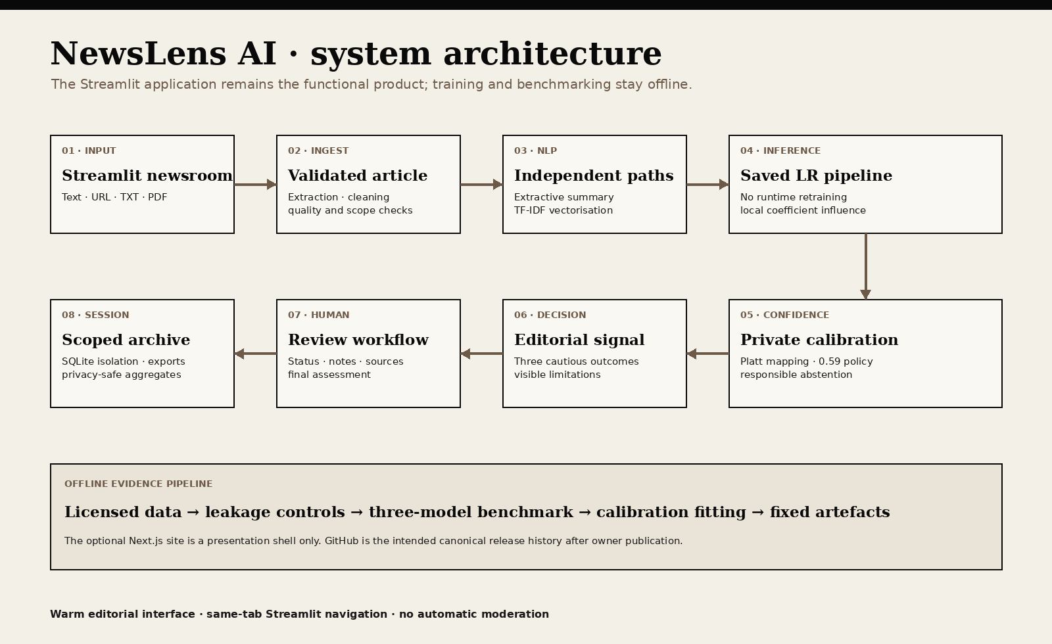
Figure 4.1. Overall system architecture.
Six layers isolate UI, ingestion, NLP, AI, persistence and evaluation so a student can test or replace one concern without rewriting the application.
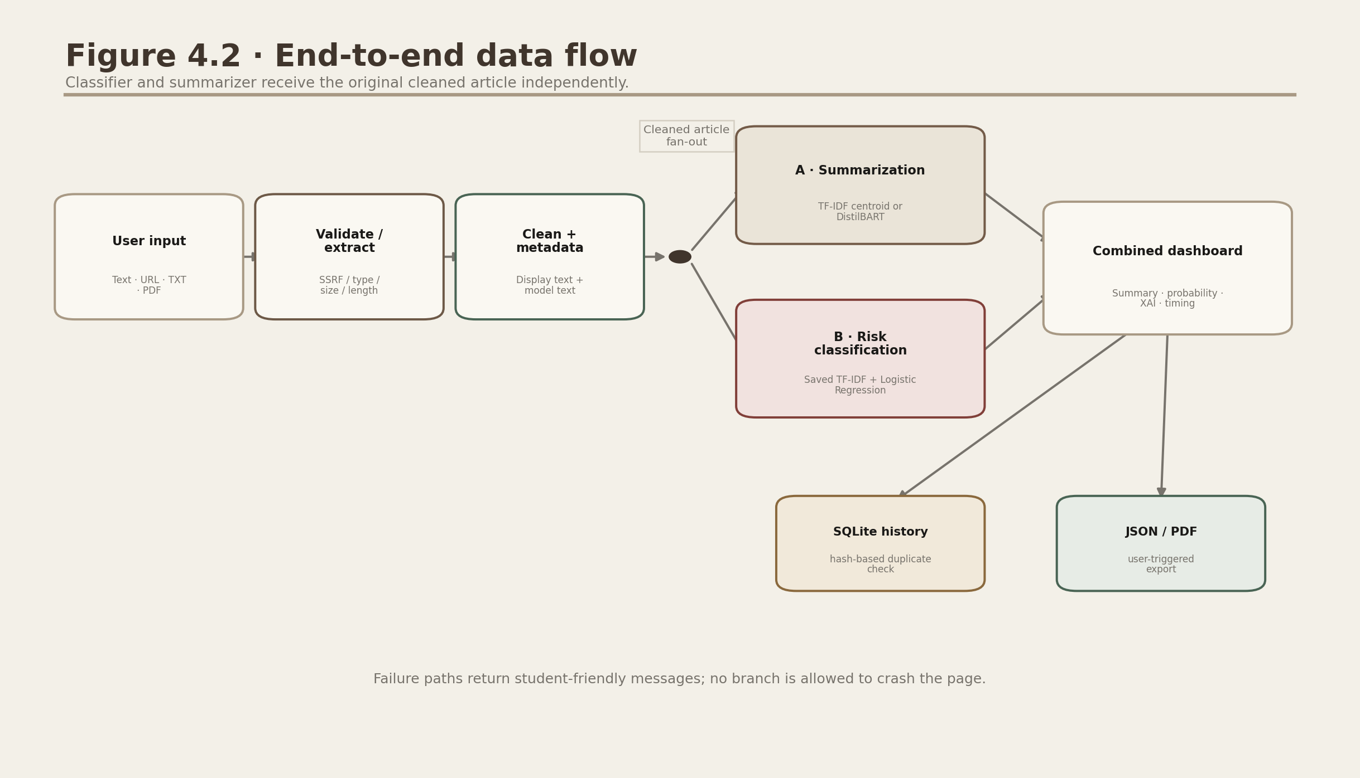
Figure 4.2. End-to-end data-flow diagram.
The original cleaned article fans out to the summary and classifier. Only their result objects merge in the final editorial report.
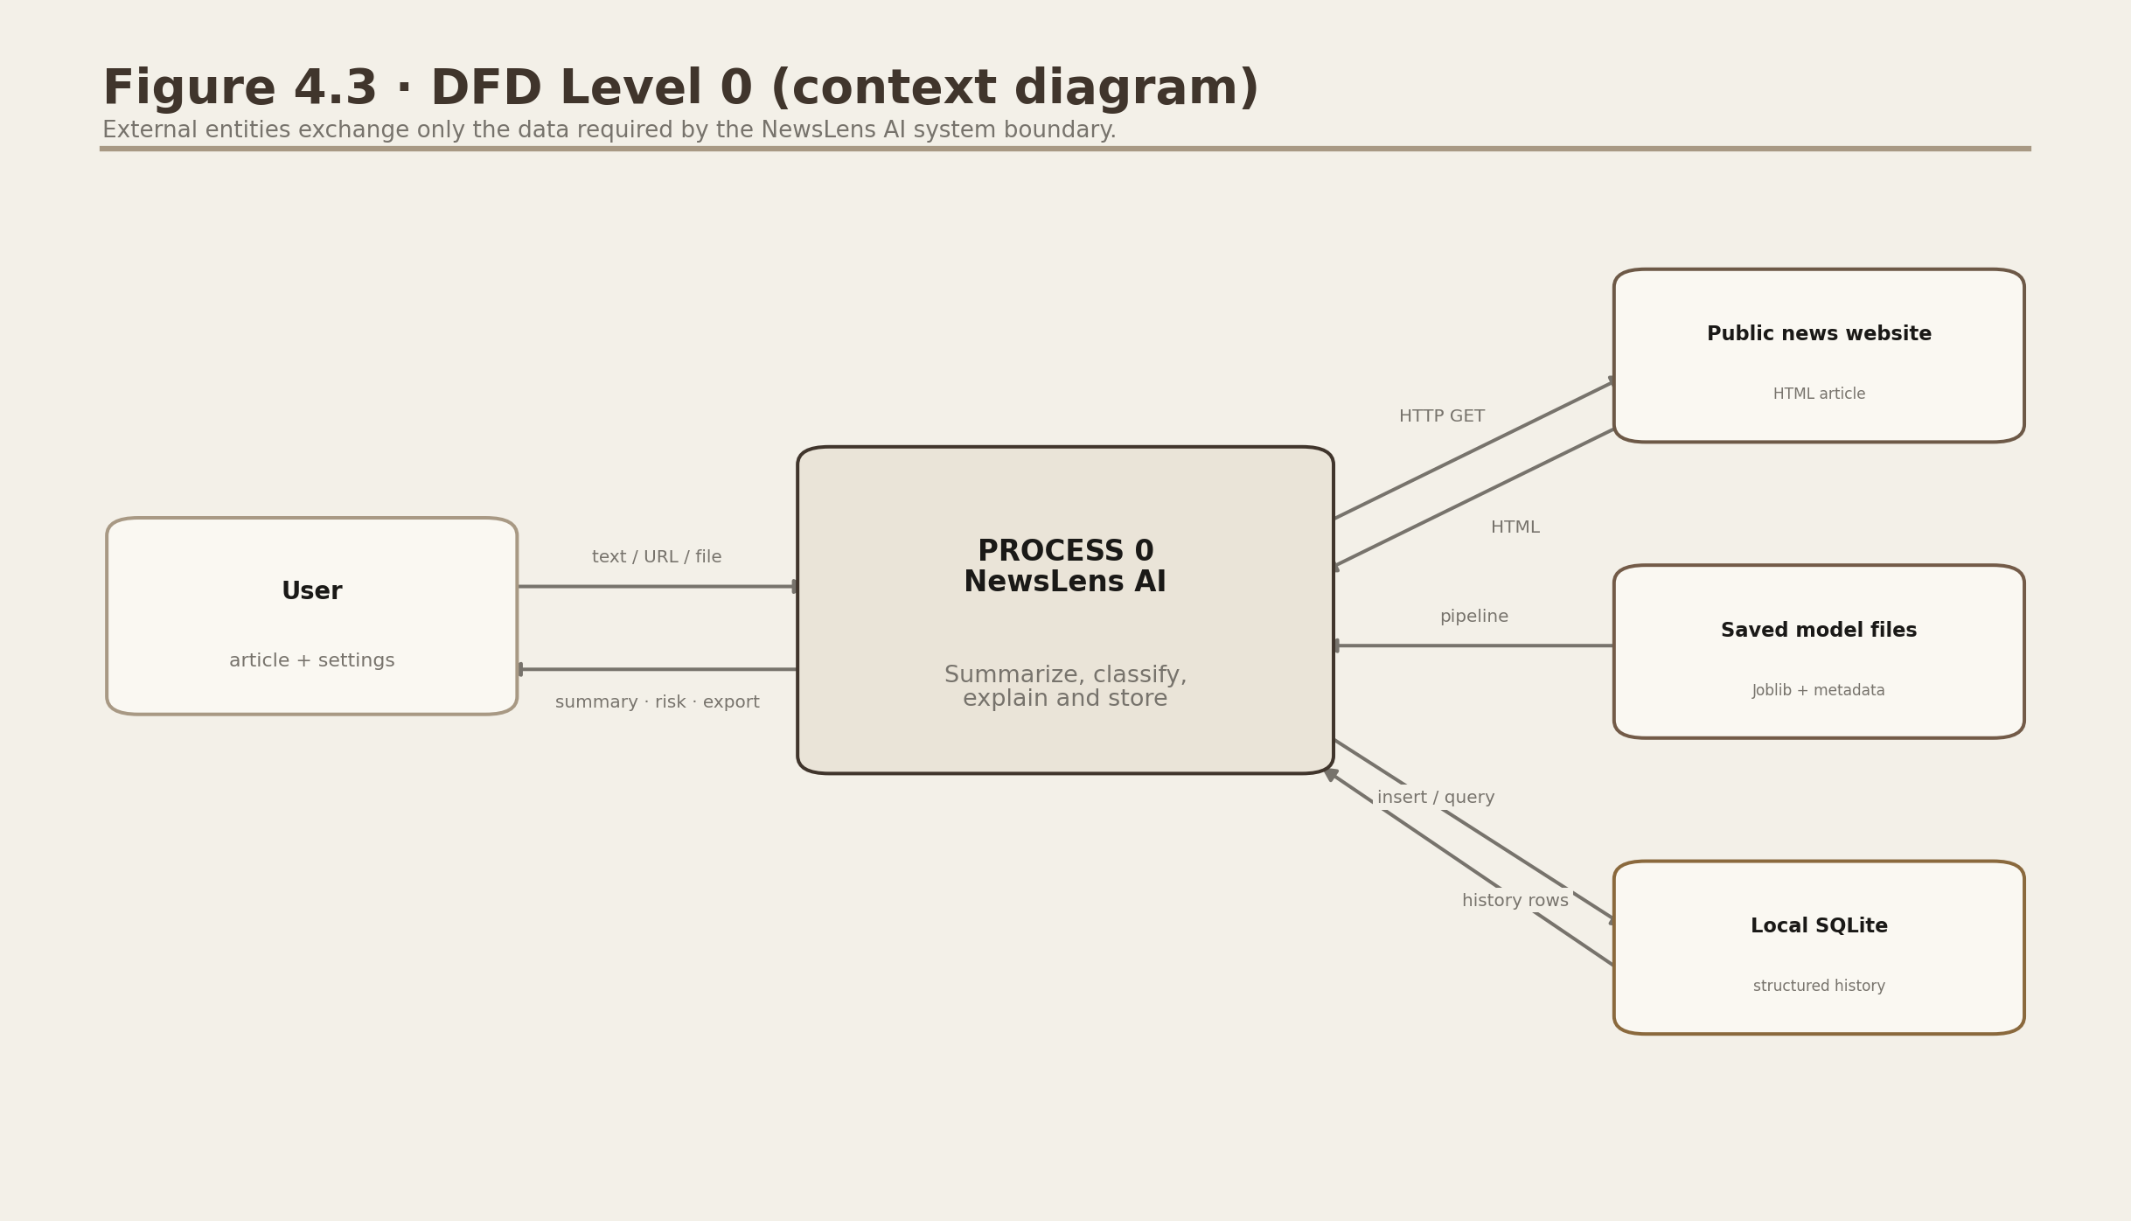
Figure 4.3. DFD Level 0 context diagram.
The user interacts with one system boundary; a public website, saved model and local SQLite store are explicit external data sources.
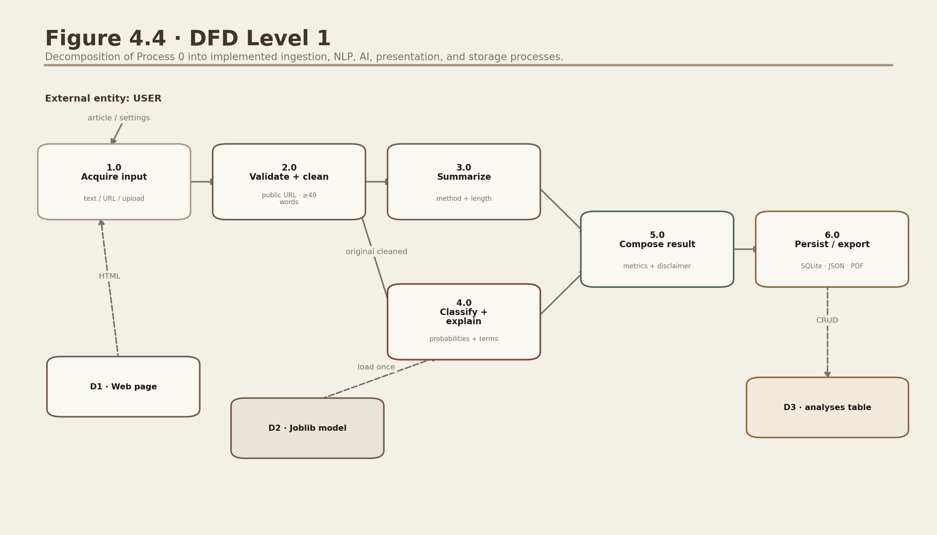
Figure 4.4. DFD Level 1.
Process 0 is decomposed into acquisition, cleaning, independent AI tasks, composition and persistence/export.
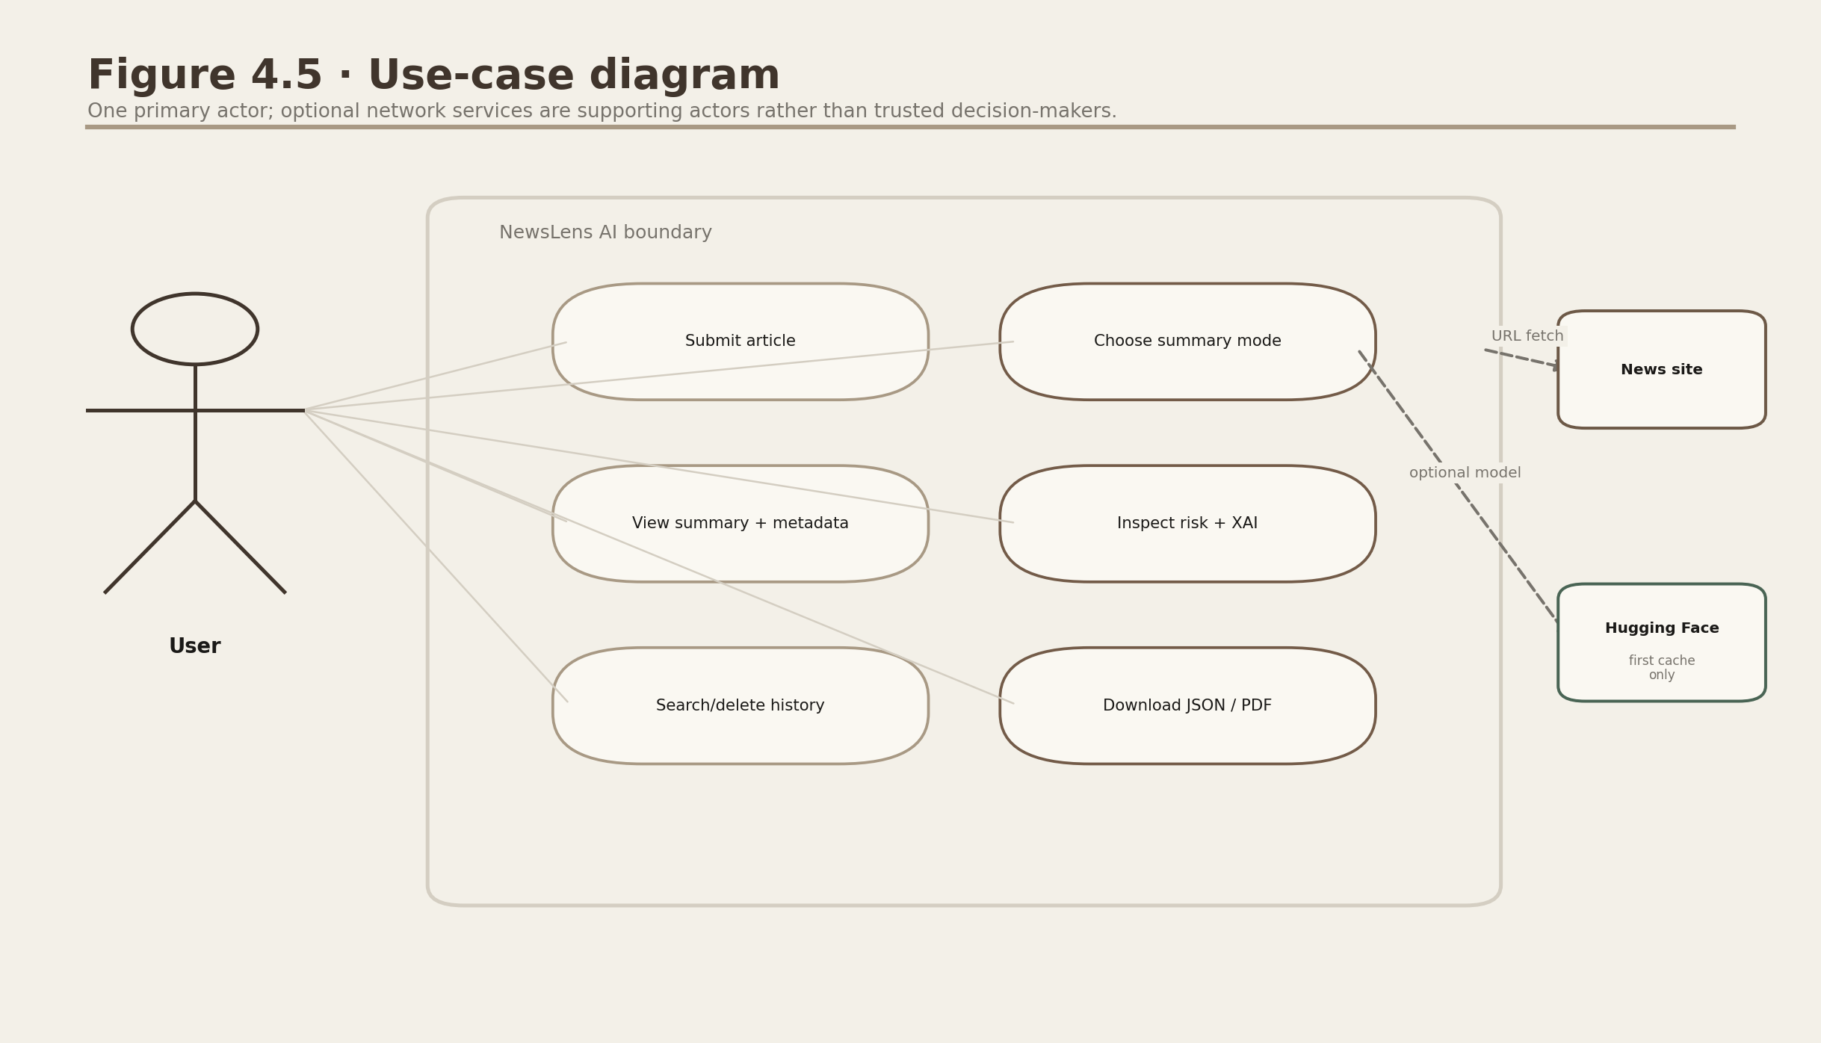
Figure 4.5. Use-case diagram.
The user can submit, configure, inspect, revisit and export. Network actors provide content/models but do not determine truth.
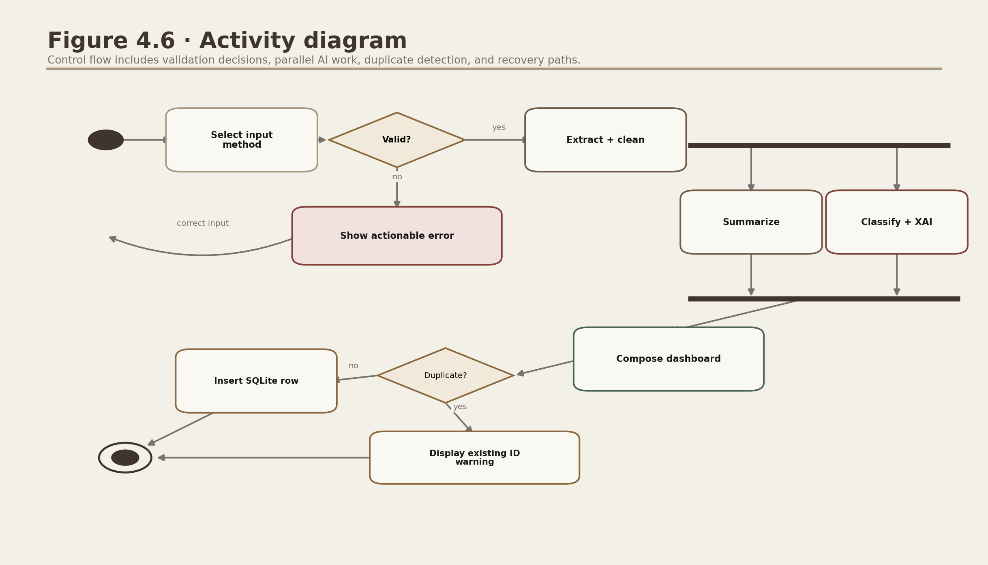
Figure 4.6. Activity diagram.
Validation failure returns to input. Valid content reaches parallel AI activities, then a duplicate-aware storage decision.
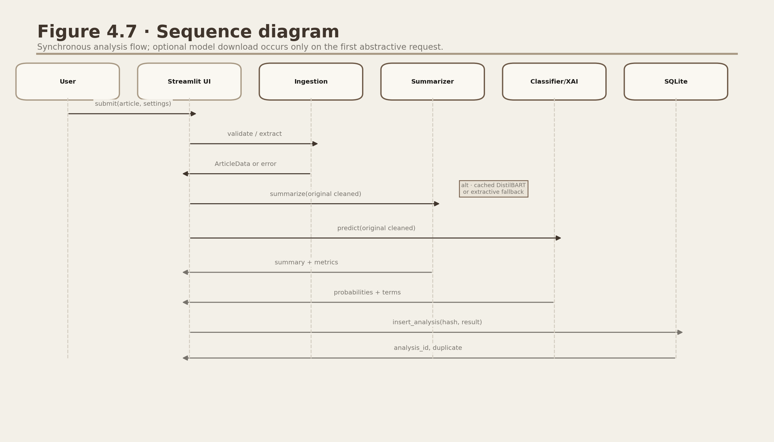
Figure 4.7. Sequence diagram.
The sequence makes caching, independent calls and SQLite insertion order explicit.
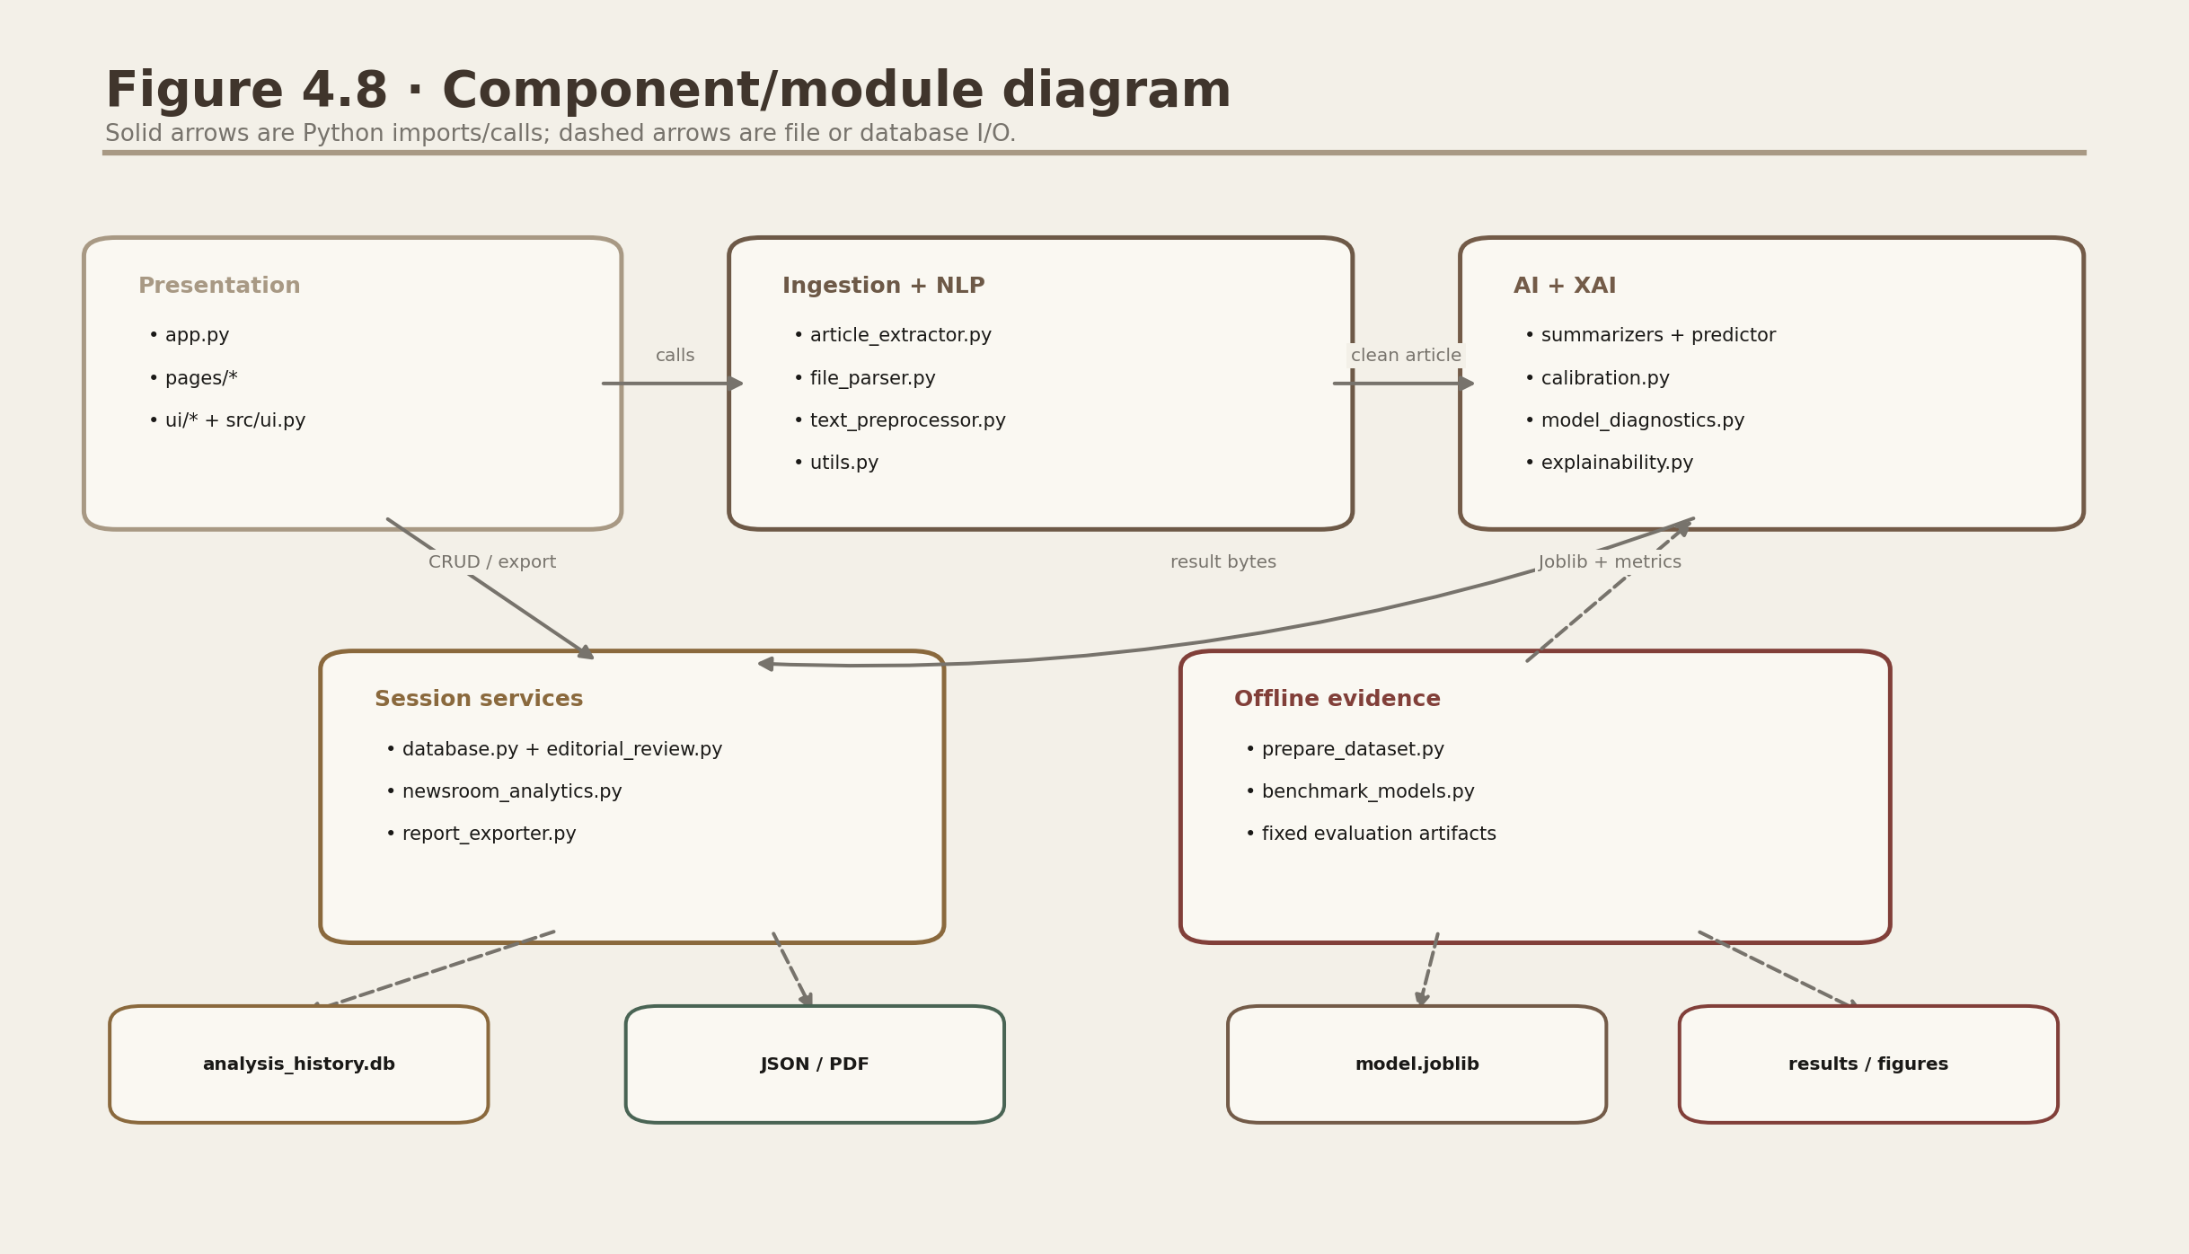
Figure 4.8. Component/module diagram.
Python modules depend inward on reusable business logic; offline training writes identified artifacts consumed at runtime.
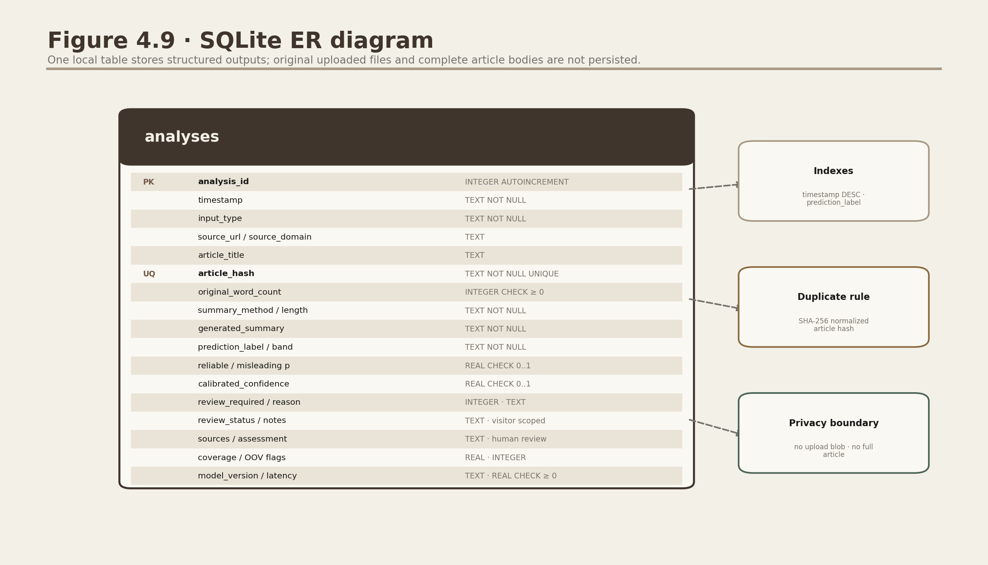
Figure 4.9. SQLite ER diagram.
The single analyses entity uses a unique SHA-256 article hash and probability/time CHECK constraints.
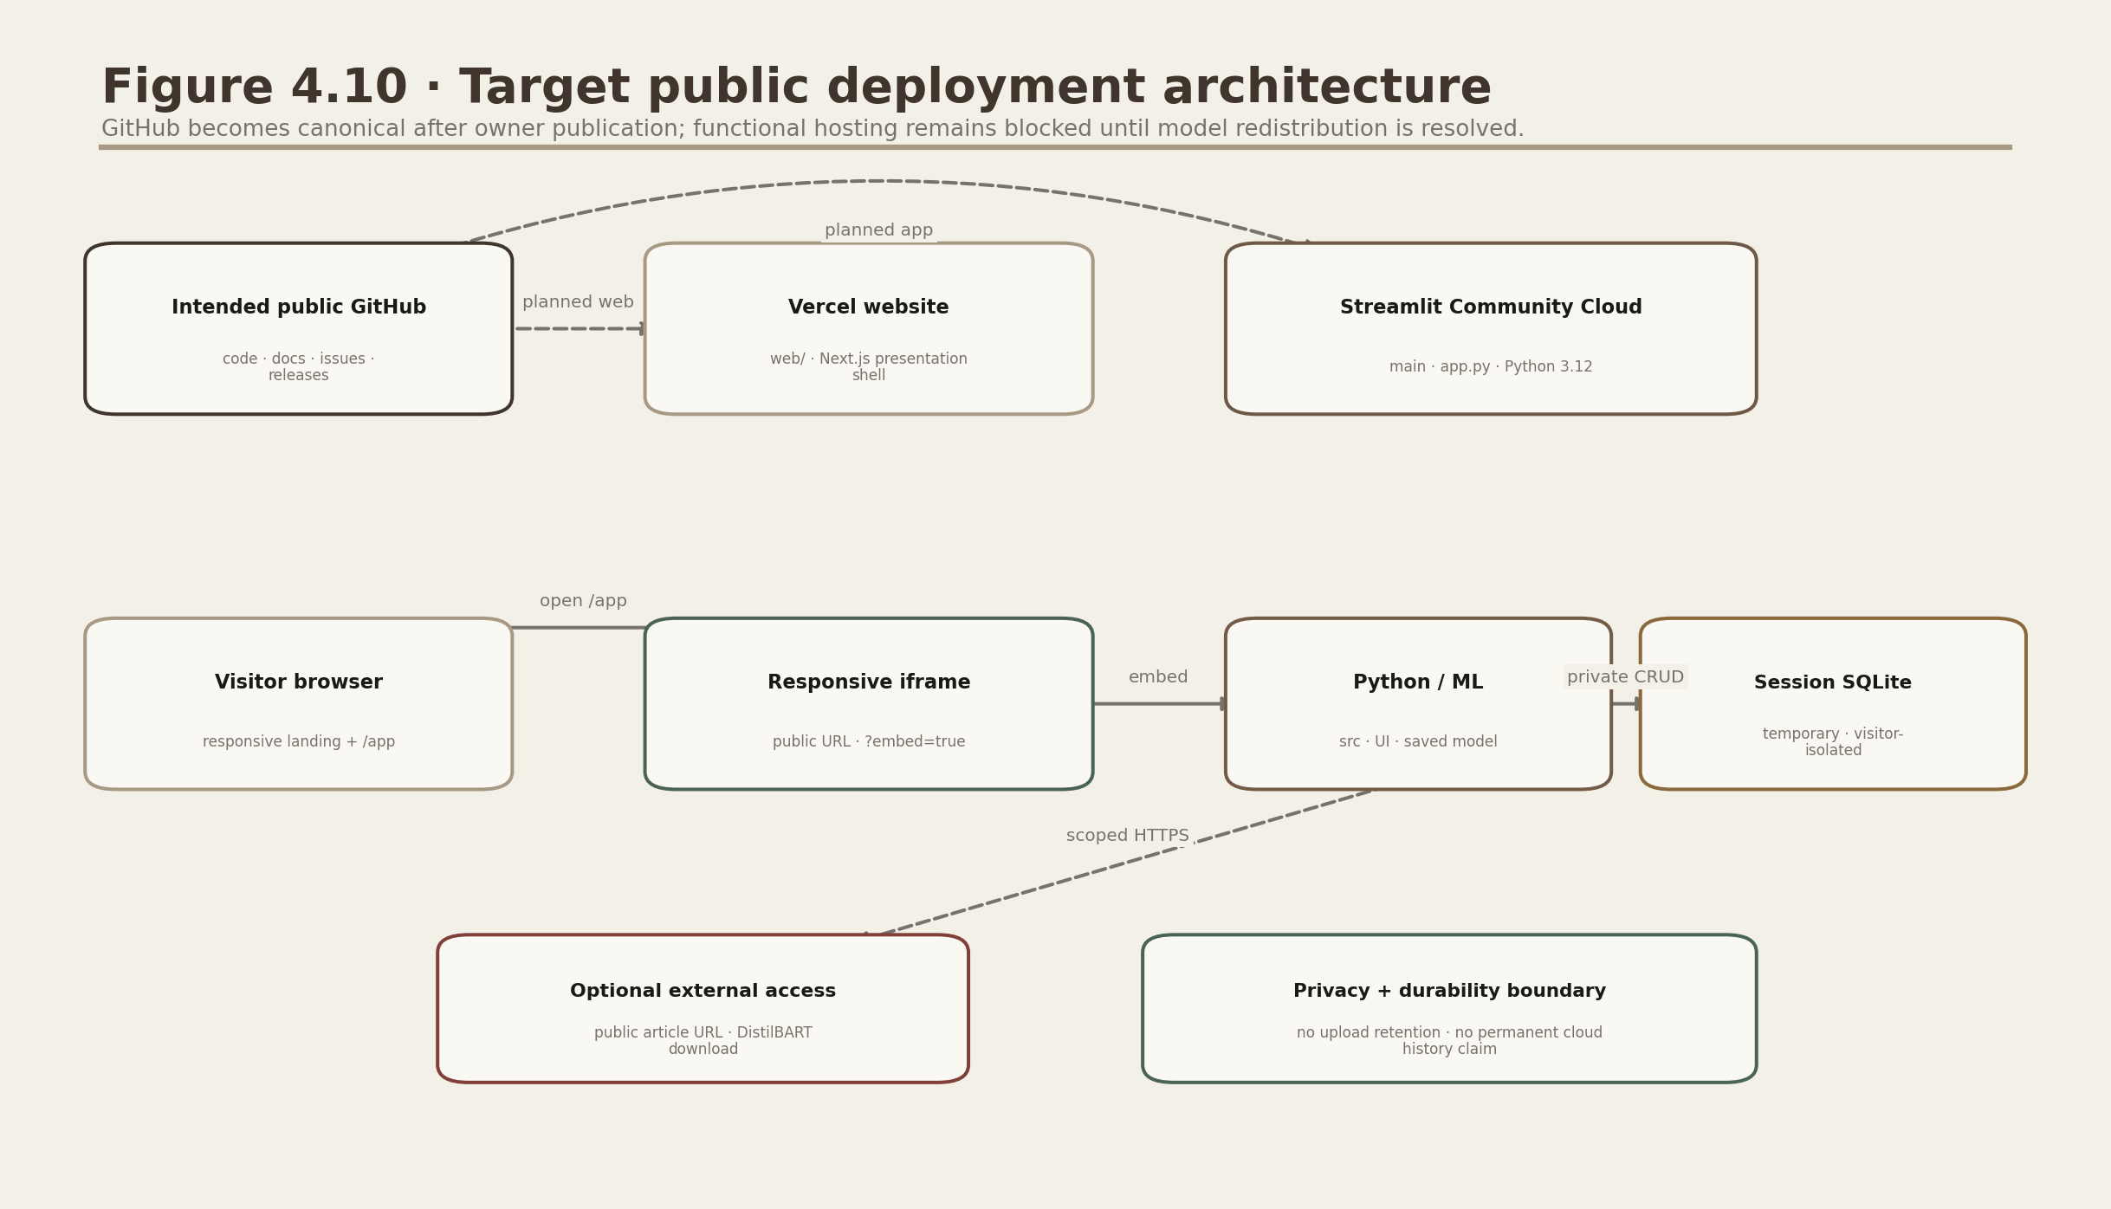
Figure 4.10. Target public deployment architecture.
After owner publication, https://github.com/DevenGaikwad/NewsLens-AI is intended to be canonical for code, documentation, issues, releases and deployment history. Vercel is only the presentation shell and Streamlit Community Cloud would run app.py with temporary visitor-isolated SQLite. This architecture is a target, not a live-deployment claim; functional hosting is blocked by the model-redistribution decision record.

Chapter 5: Dataset and Data Preprocessing

5.1 Dataset comparison and selection
Dataset | Size/content | Strength | Constraint | Decision
ISOT | 44,898 full articles | Binary, accessible, full text | Severe outlet/topic leakage risk | Selected with controls
LIAR | 12.8K short claims | Manual PolitiFact labels | Six labels; not full articles | Literature comparator
FakeNewsNet | News + social context | Publisher and interactions | Collection/API/reproducibility friction | Future extension
XSum | 226,711 BBC article-summary pairs | Human one-sentence references | Highly abstractive; single broadcaster | Summary evaluation

5.2 Schema and cleaning
ISOT provides title, text, subject and date. The source filename defines the binary label. Title and body are joined for modelling; subject, date and source identity are excluded. Missing values are normalised, short rows removed, explicit URLs/control bytes cleaned, Reuters/byline markers neutralised, and exact hashes deduplicated before sampling or splitting. Stemming and aggressive lemmatisation are intentionally avoided because style and negation can be predictive and because display text must remain readable.
Audit item | Measured rows
Raw rows | 44,898
Eligible unique corpus | 37,883
Exact duplicates removed | 5,713
Short/empty removed | 1,302
Balanced working sample | 24,000
Reliable / misleading | 12,000 / 12,000

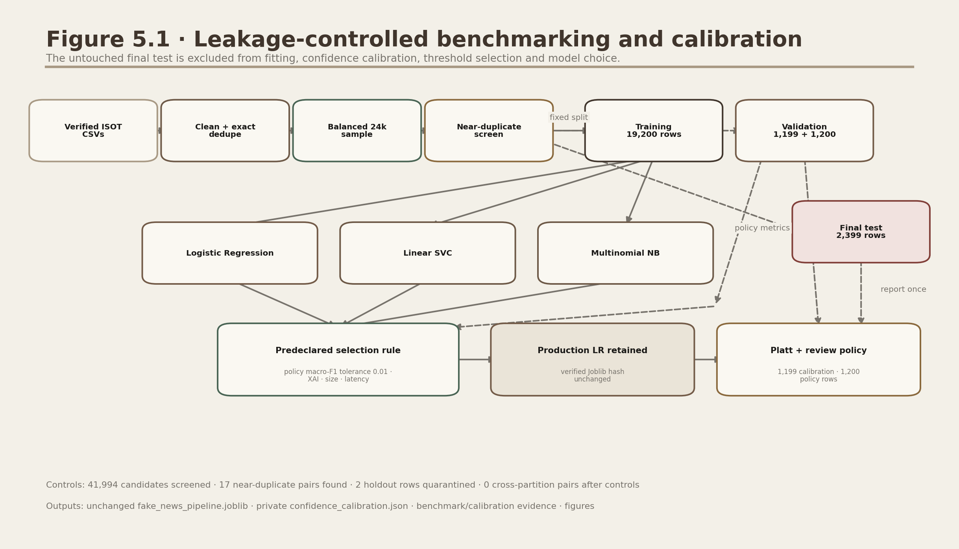
Figure 5.1. Machine-learning training pipeline.
Exact deduplication and a deterministic word-five-gram near-duplicate screen precede partition use. The screen compared 41,994 candidates, found 17 near-duplicate pairs, quarantined two holdout rows that crossed the training boundary and left zero detected cross-partition pairs. The 2,399-row final test is excluded from model fitting, Platt calibration, model-retention policy and review-threshold selection.
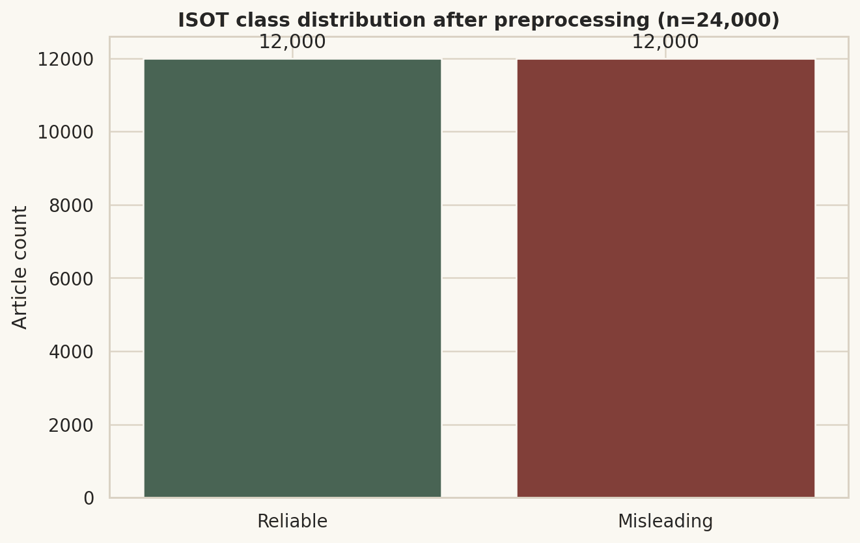
Figure 5.2. Class distribution after preprocessing.
The 24,000-row working set is balanced by design, preventing a majority-class accuracy shortcut.
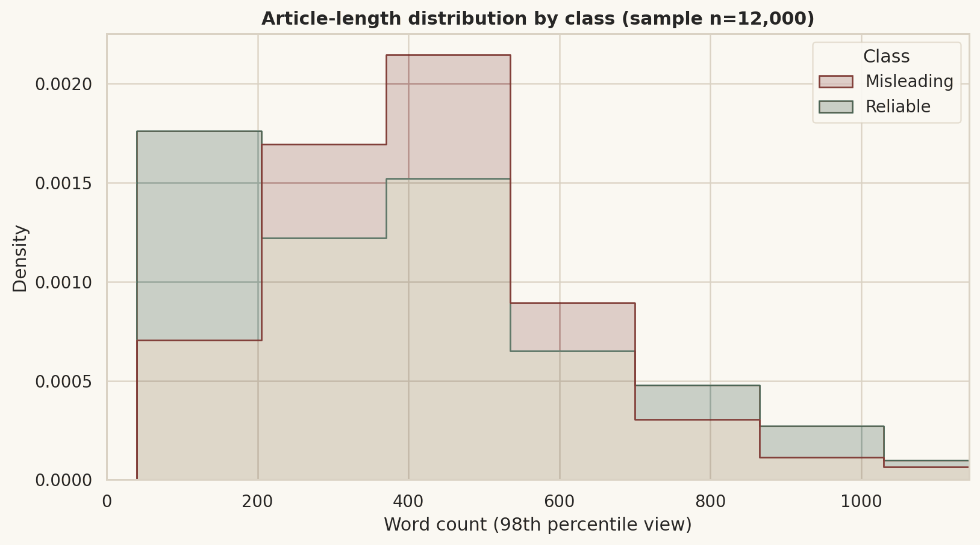
Figure 5.3. Article word-count distribution by class.
Length profiles differ, indicating collection-style effects that may persist after text cleaning.
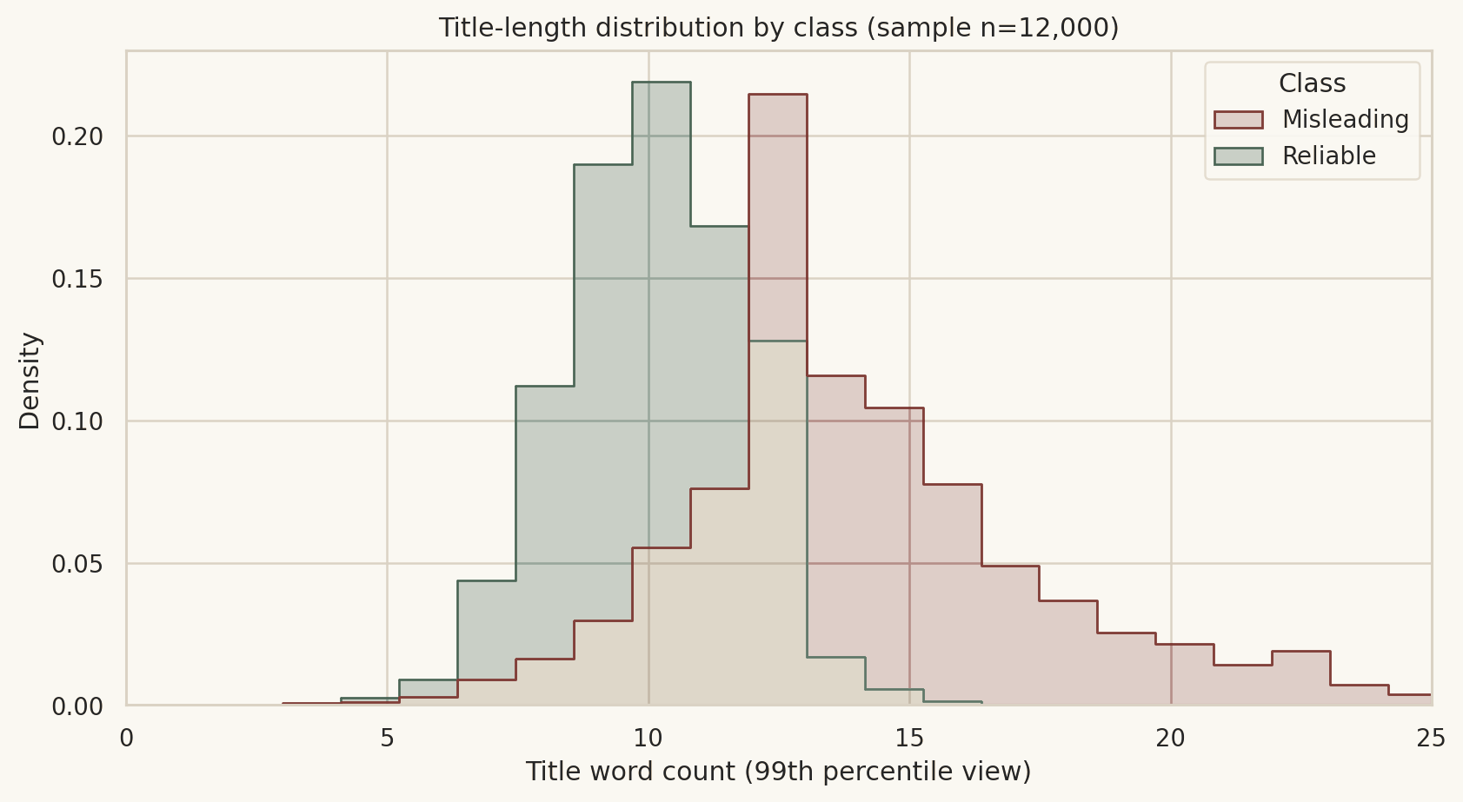
Figure 5.4. Title-length distribution.
Misleading-labelled titles are substantially longer on average; title length is disclosed as a possible shortcut.
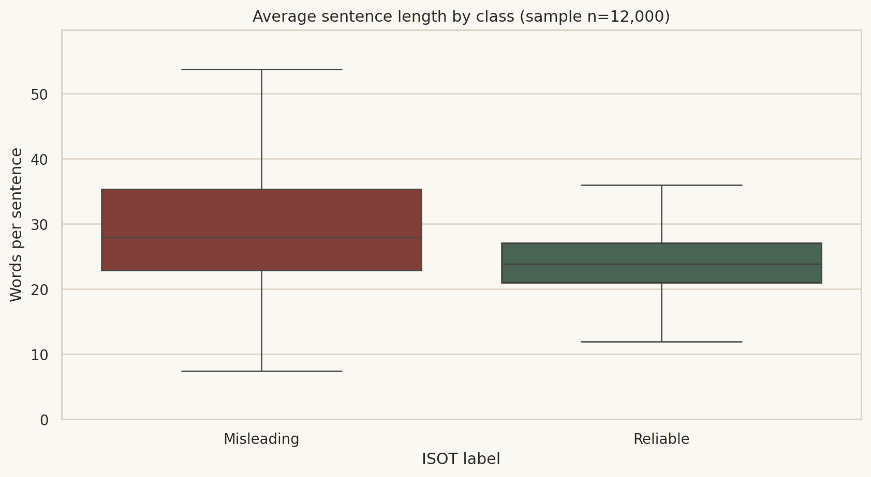
Figure 5.5. Average sentence length.
Sentence length differs across labels, consistent with outlet and editing-style variation.
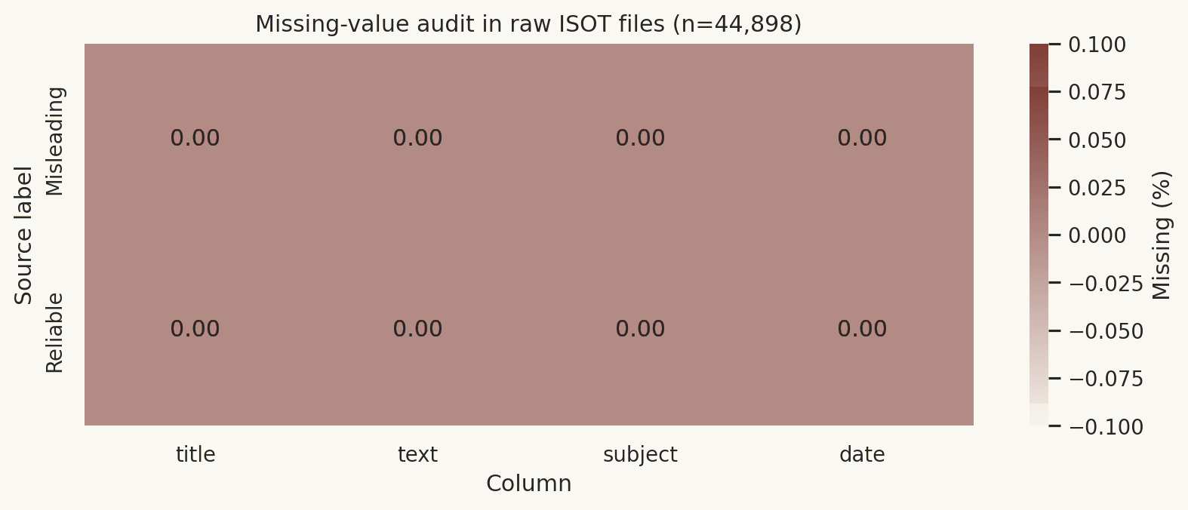
Figure 5.6. Missing-value heatmap.
The raw CSV fields contain no direct NaN values in this run; separate short/blank-content rules still remove unusable rows.
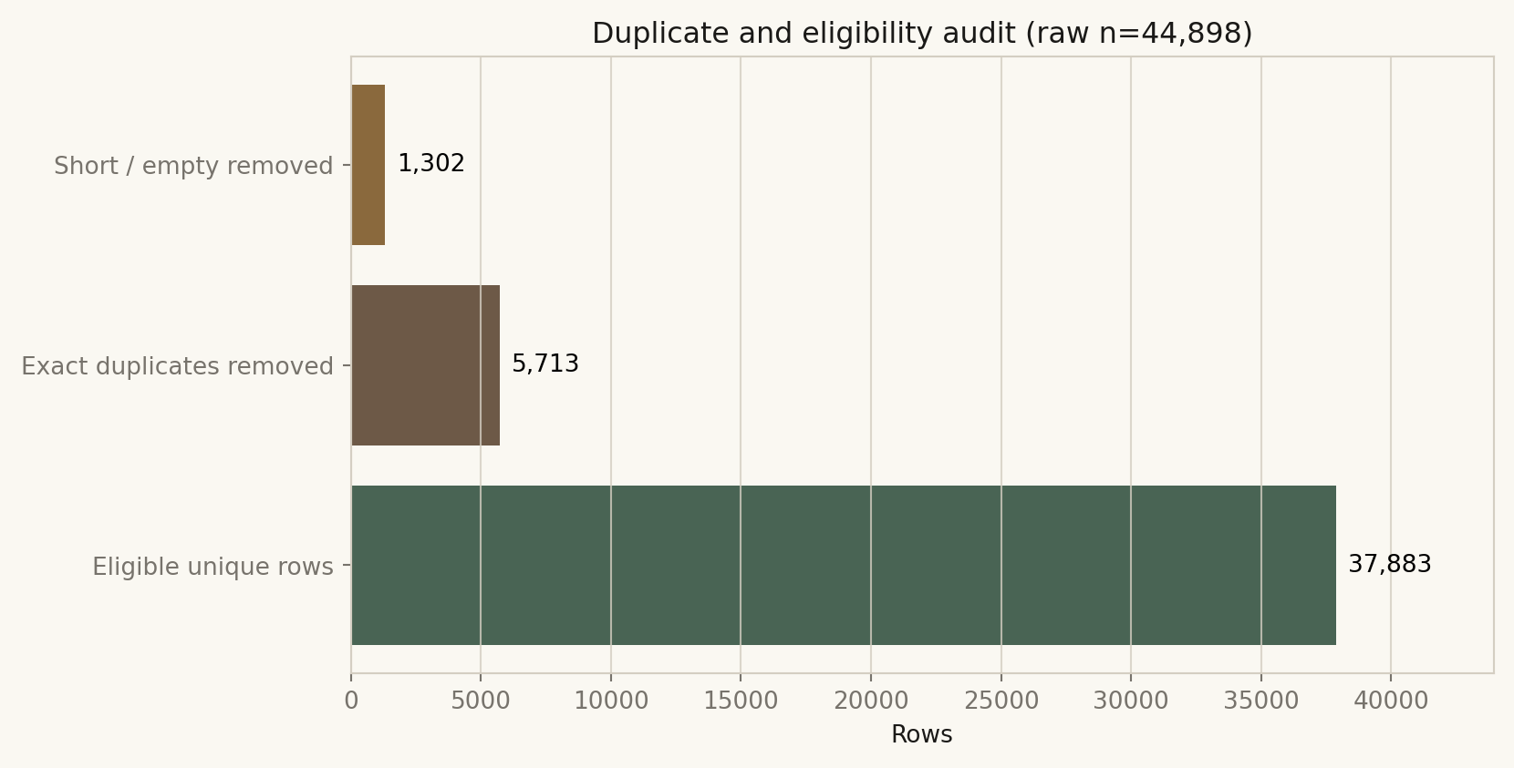
Figure 5.7. Duplicate-record and eligibility audit.
Removing 5,713 duplicates before splitting prevents identical text from appearing in train and test.
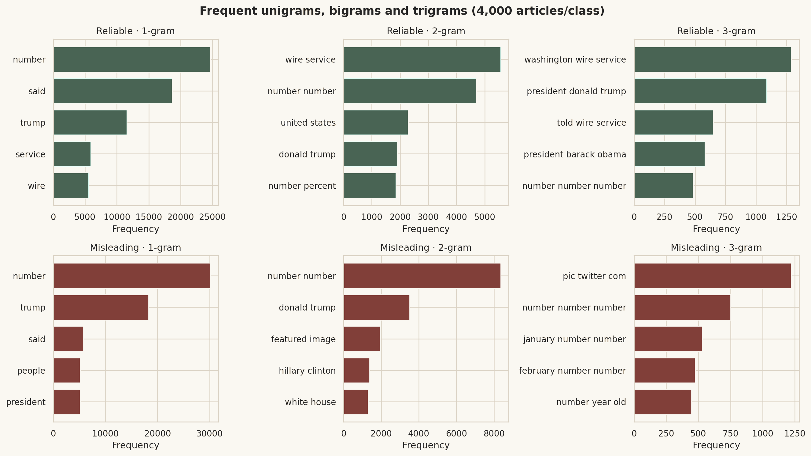
Figure 5.8. Frequent unigram, bigram and trigram comparison.
Terms such as wire-service and date patterns reveal residual collection signatures; explicit markers are neutralised but not every proxy is removable.
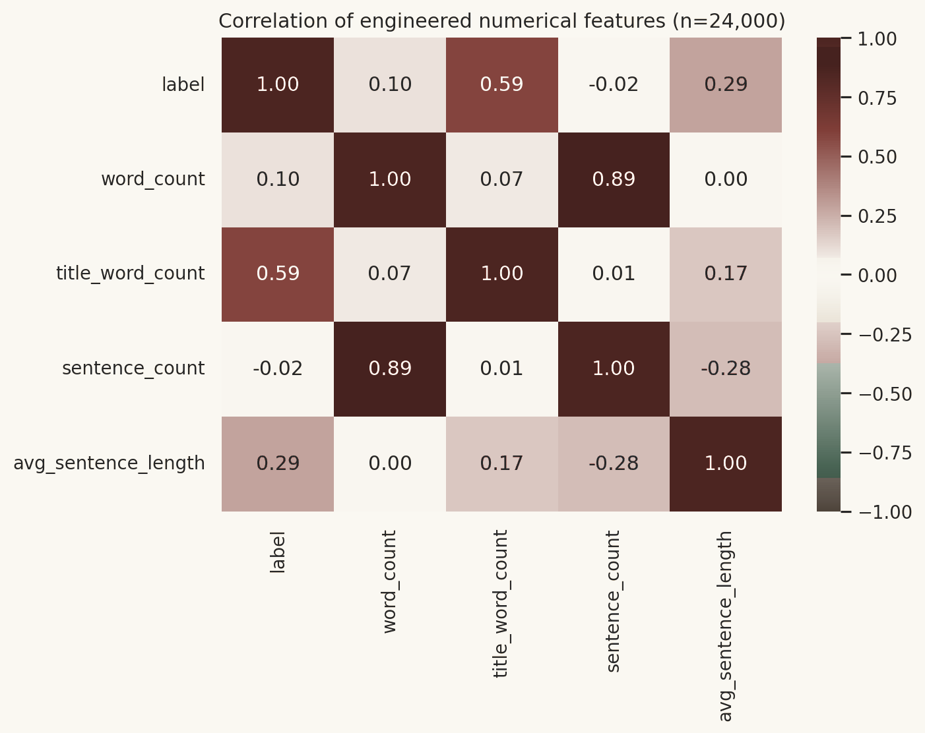
Figure 5.9. Correlation of engineered numerical features.
Title length correlates with label (0.59), a strong warning that high random-split accuracy may not generalise.
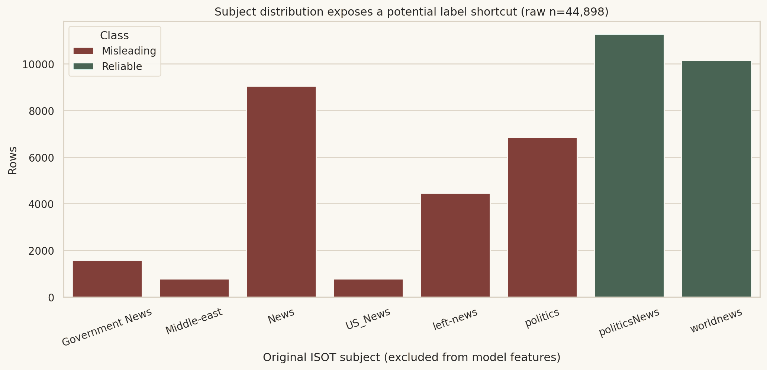
Figure 5.10. Original subject distribution.
Subject categories are almost label-specific and therefore excluded completely from model features.

5.3 Split and leakage prevention
- Remove exact duplicates and group detected near-duplicates before partition use.
- Use seed 42, stratification and group-aware validation/test partitioning.
- Use 19,200 training rows; keep the 1,199 calibration and 1,200 policy rows outside fitting.
- Keep the 2,399-row final test untouched until one reporting pass.
- Place TF-IDF and classifier in one scikit-learn Pipeline and exclude source, subject and date.
- Apply identical source-marker neutralisation in training and inference; verify the packaged Joblib SHA-256.
- Report remaining outlet/topic/time artefacts and non-exhaustive near-duplicate screening as limitations.

Chapter 6: Methodology and Algorithms

6.1 Extractive sentence ranking
The article is segmented with a deterministic punctuation-aware splitter. Sentences shorter than four words are discarded. A word 1-2 gram TF-IDF matrix is fitted on sentences, its mean vector becomes the document centroid, and cosine similarity ranks each sentence. A 0.12 exponentially decaying lead bonus reflects news inverted-pyramid structure; a capped 0.04 density bonus favours informative sentence length. Top sentences are restored to source order.
score_i = cosine(tfidf(sentence_i), centroid)
+ 0.12 * exp(-position_i / scale)
+ 0.04 * clip(words_i / 24, 0, 1)
summary = join(sorted(top_k_sentence_indices))

6.2 Abstractive summarization
The optional model is sshleifer/distilbart-cnn-6-6, selected as a smaller DistilBART CNN/DailyMail checkpoint. Streamlit caches the pipeline. Long input is divided at sentence boundaries by tokenizer length, adjacent chunks overlap by one sentence, and chunk summaries are hierarchically summarised if their concatenation still exceeds the context window. Dependency or download failure returns users to extractive mode rather than breaking the core application.

6.3 Compression and ROUGE
Compression Ratio (%) = (1 - Summary Word Count / Original Word Count) * 100
ROUGE-1 and ROUGE-2 measure unigram and bigram overlap; ROUGE-L uses longest common subsequence. Precision, recall and F1 are reported separately. ROUGE cannot by itself measure factuality, coherence or usefulness.

6.4 TF-IDF and classifiers
TF-IDF(t,d) = TF(t,d) * log(N / (DF(t) + 1))
p(misleading|x) = 1 / (1 + exp(-(w^T x + b)))
The controlled comparison fixes the established deployment-compatible settings: Multinomial Naive Bayes alpha 0.1, Linear SVC C=1.0 and the unchanged production Logistic Regression C=2.0. A Platt mapping is fitted for each candidate on 1,199 calibration rows. On the 1,200-row validation-policy partition, Linear SVC's macro-F1 advantage over Logistic Regression is 0.002500, below the predeclared 0.01 tolerance; Logistic Regression is retained for direct coefficient explanations, compact deployment and preservation of the verified production artifact.

6.5 Evaluation formulas
Precision = TP / (TP + FP)
Recall = TP / (TP + FN)
F1 = 2 * Precision * Recall / (Precision + Recall)
Accuracy = (TP + TN) / (TP + TN + FP + FN)
Accuracy alone can remain high when a majority class dominates. Macro-F1 weights each class equally; PR-AUC emphasises positive-class retrieval under imbalance; class-wise recall exposes missed misleading articles; timing and interpretability matter for a student laptop and responsible interface.

6.6 Confidence and local explanation
The production decision score is transformed by a private Platt calibration artifact whose model SHA-256 must match the active Joblib. A calibrated confidence below 0.59, inadequate input, unsupported-language hint or domain-mismatch heuristic returns 'Editorial review required'. Otherwise the exact outcomes are 'Lower misleading-content risk indicated' or 'Higher misleading-content risk indicated'. Local TF-IDF coefficient contributions describe learned correlations, never evidence that an article is true or false.
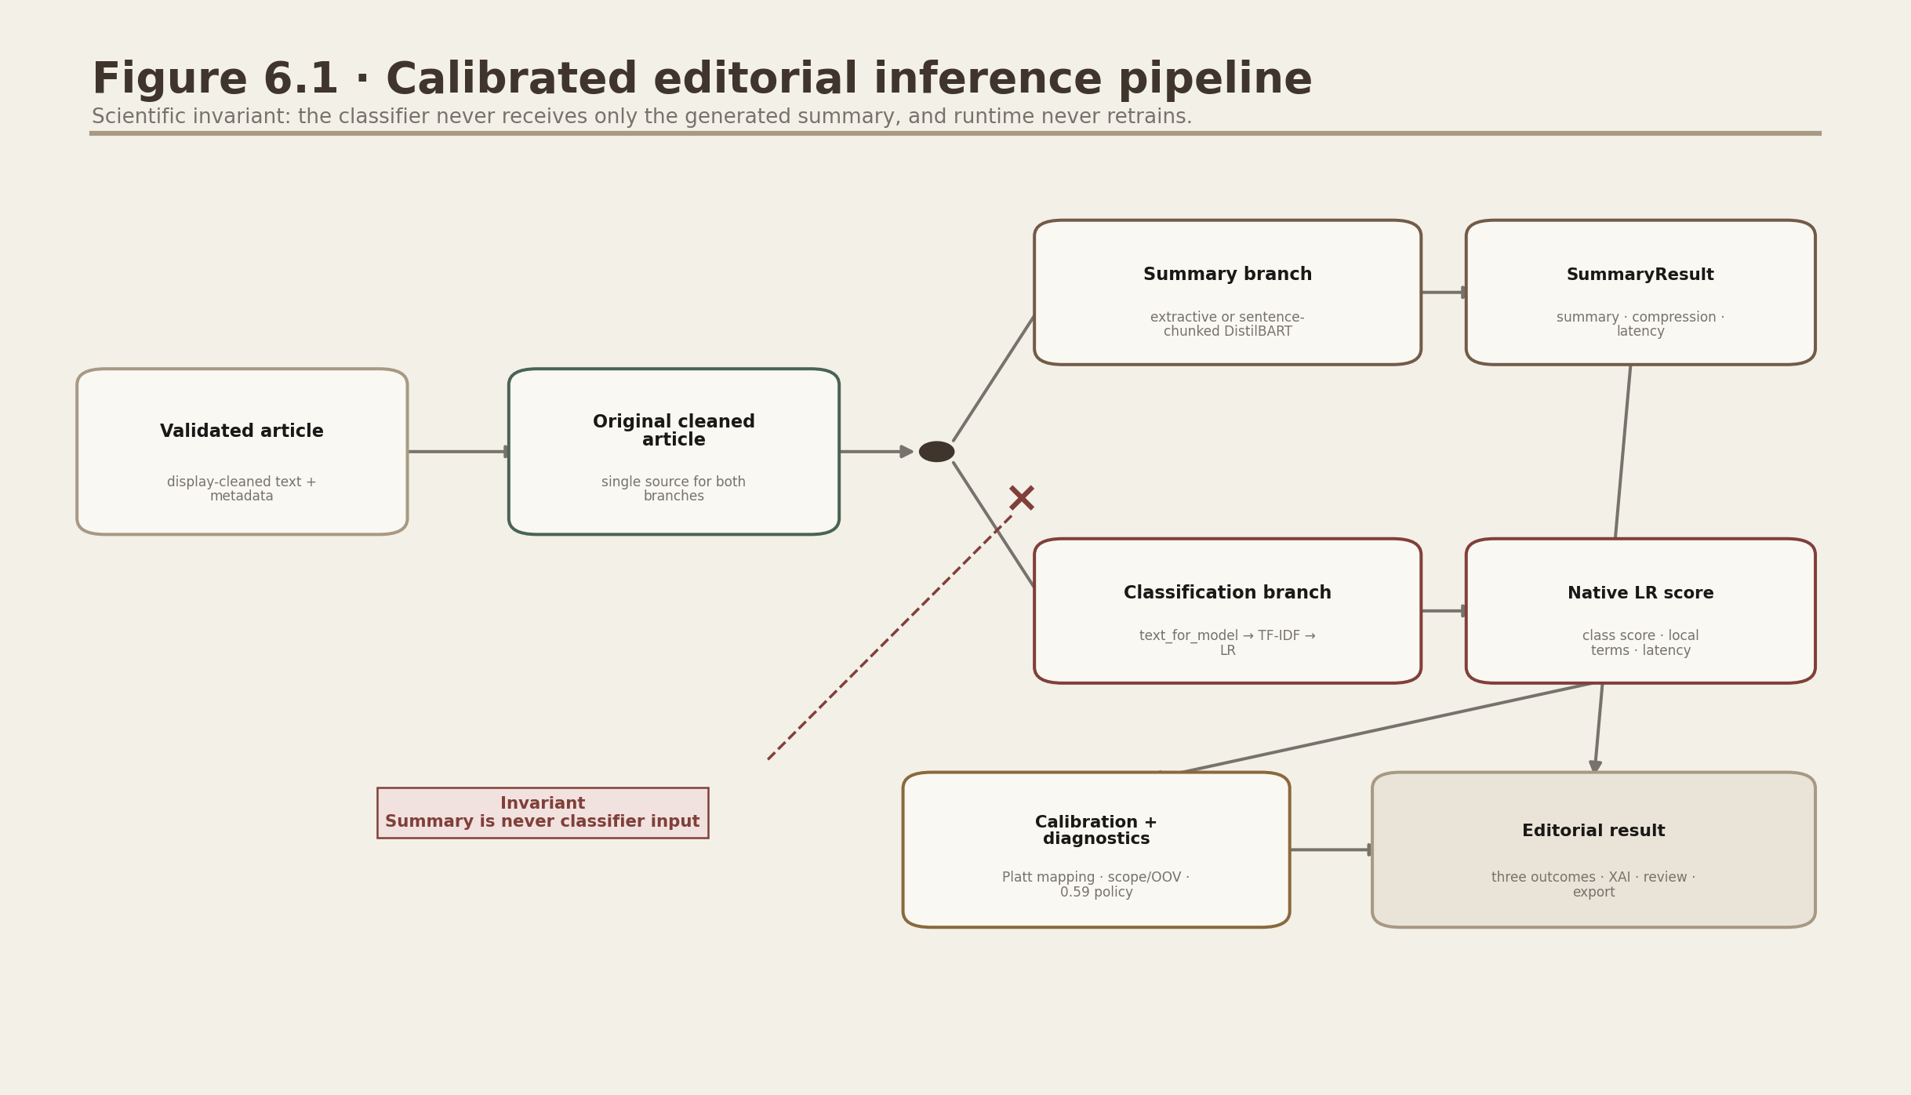
Figure 6.1. Combined inference pipeline.
The no-feedback-loop annotation records the core scientific requirement: the summary never replaces the original classifier input.

Chapter 7: Implementation

7.1 Development environment
Python 3.12 is the tested public-release runtime. The verified build used Streamlit 1.59.2, pandas 2.2.3, NumPy 2.3.5, scikit-learn 1.8.0, Joblib 1.5.3, Plotly 6.9.0, Matplotlib 3.10.8, Seaborn 0.13.2, Requests 2.34.2, BeautifulSoup 4.15.0, Trafilatura 2.1.0, pypdf 6.15.0, ReportLab 4.4.9 and pytest 9.0.3. Transformers is pinned below major release 5 for the summarization pipeline API.

7.2 Folder structure
NewsLens-AI/
app.py · pages/ · ui/ · assets/ · src/
training/ · models/ · data/sample/
notebooks/ · tests/ · database/
reports/{figures,diagrams,screenshots,results}/
docs/ · scripts/ · web/ · requirements*.txt

7.3 Module responsibilities
Module | Responsibility
article_extractor.py | Public URL validation, SSRF blocking, Trafilatura and BeautifulSoup fallback
file_parser.py | 10 MB TXT/text-PDF parsing and friendly failures
text_preprocessor.py | Shared source-marker-aware cleaning and deterministic sentence split
extractive_summarizer.py | TF-IDF centroid ranking and compression metrics
abstractive_summarizer.py | Cached pipeline, tokenizer-aware chunks, overlap and hierarchy
fake_news_predictor.py | Verified model/calibration loading, calibrated probabilities, abstention outcomes, diagnostics and PredictionResult
explainability.py | Local observed term contributions and global coefficients
database.py | Schema, duplicate-aware insert, search, read, delete and clear
session_history.py | Fail-closed visitor isolation for the public session archive
report_exporter.py | In-memory JSON and printable PDF exports
visualizations.py | Warm publication-style Plotly figures
app.py + ui/* | Native same-tab routing, editorial tokens and reusable page/result components

7.4 Representative implementation
@st.cache_resource
def cached_model():
return load_model()
summary = summarize_extractive(cleaned, summary_length)
prediction = predict_credibility(cleaned, cached_model())
The model is loaded through resource caching and never retrained at page start. ArticleData, SummaryResult and PredictionResult dataclasses make interfaces explicit. Portable Path objects replace user-specific paths. Recoverable errors have user-facing exception classes; an unexpected exception is contained behind a generic message and optional technical detail.

7.5 URL and file safety
- Only bounded HTTP(S) URLs with resolvable public hosts are accepted.
- Credential-bearing, localhost, private, loopback, link-local, reserved, numeric and obfuscated hosts are rejected.
- Every redirect is requested manually and independently validated; loops and chains beyond five hops are blocked.
- Every DNS answer must be globally routable and the observed peer address must match the validated set where the transport exposes it.
- Timeout, status, HTML content type, declared length and a streamed 5 MB response cap are enforced.
- Upload names reject traversal; encrypted PDFs, PDFs over 200 pages and extracted text over two million characters are rejected.
- CSV user fields are formula-neutralised and ReportLab Paragraph content is escaped.
- No uploaded file is stored in SQLite.

7.6 Caching and performance
The Joblib classifier is small and loaded once. Plot/data artifacts are read from stable files. DistilBART is downloaded only when requested and then cached by Hugging Face and Streamlit. Extractive mode remains the dependable offline path. SQLite uses indexed timestamp and label columns, and history queries cap results.

Chapter 8: Testing and Results

8.1 Test strategy
Verification is layered. The release package defines 56 packaged pytest checks, including the 29 established checks and 27 calibration, review, privacy, analytics and release-hardening checks. The final execution record is written only after the comprehensive audit completes. Browser automation covers all six sections, direct routes, refresh, back/forward, keyboard activation, same-tab navigation, text analysis, summarization, classification, calibrated confidence, explanations, review updates, downloads, analytics, drift readiness and cross-visitor archive isolation at 360, 390, 768, 1366 and 1920 pixel widths.
Verification boundary: Passing checks demonstrates the specified behaviour in the tested environment; it does not prove factual correctness or cross-domain generalisation. Re-run python -m pytest -q and the two optional browser audit scripts after dependency, hosting or interface changes.
Model | Accuracy | Macro-F1 | ROC-AUC | PR-AUC | Brier / ECE
Linear SVC | 0.994581 | 0.994581 | 0.999851 | 0.999848 | 0.004059 / 0.004451
Logistic Regression | 0.992080 | 0.992080 | 0.999481 | 0.999423 | 0.006292 / 0.005295
Multinomial Naive Bayes | 0.960817 | 0.960815 | 0.991564 | 0.992097 | 0.029562 / 0.009859

8.2 Champion selection
On the 1,200-row validation-policy partition, Linear SVC reached 0.997500 macro-F1 and Logistic Regression reached 0.995000, a 0.002500 advantage below the predeclared 0.01 retention tolerance. Logistic Regression therefore remains the production family for direct signed explanations, compact deployment and an unchanged verified artifact. The untouched final test is used for reporting, not this decision.
Metric | Final-test value
Accuracy | 0.992080
Macro-F1 | 0.992080
ROC-AUC | 0.999481
PR-AUC | 0.999423
Calibrated Brier score | 0.006292
Ten-bin ECE | 0.005295
Editorial-review threshold | 0.59 calibrated confidence
Final-test rows | 2,399

Final-test Logistic Regression: 2,399 rows; accuracy 0.992080; macro-F1 0.992080; ROC-AUC 0.999481; PR-AUC 0.999423; calibrated Brier score 0.006292; ten-bin ECE 0.005295; median-run inference 0.503 ms/article; model size 819,447 bytes.
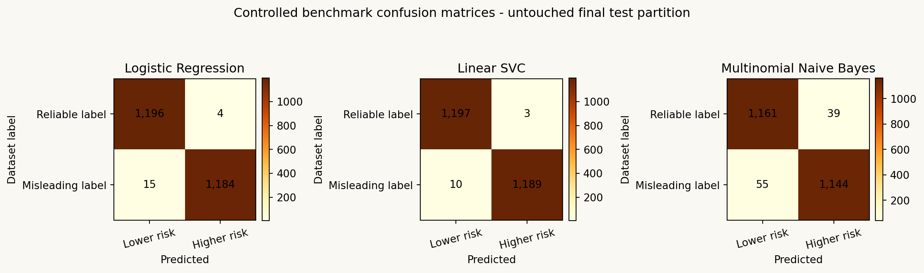
Figure 8.1. Controlled candidate confusion matrices on the untouched final test.
All candidates use the same 19,200 training rows and private Platt-calibration protocol. Final-test differences are reported for transparency and do not retroactively tune the selection or review policy.
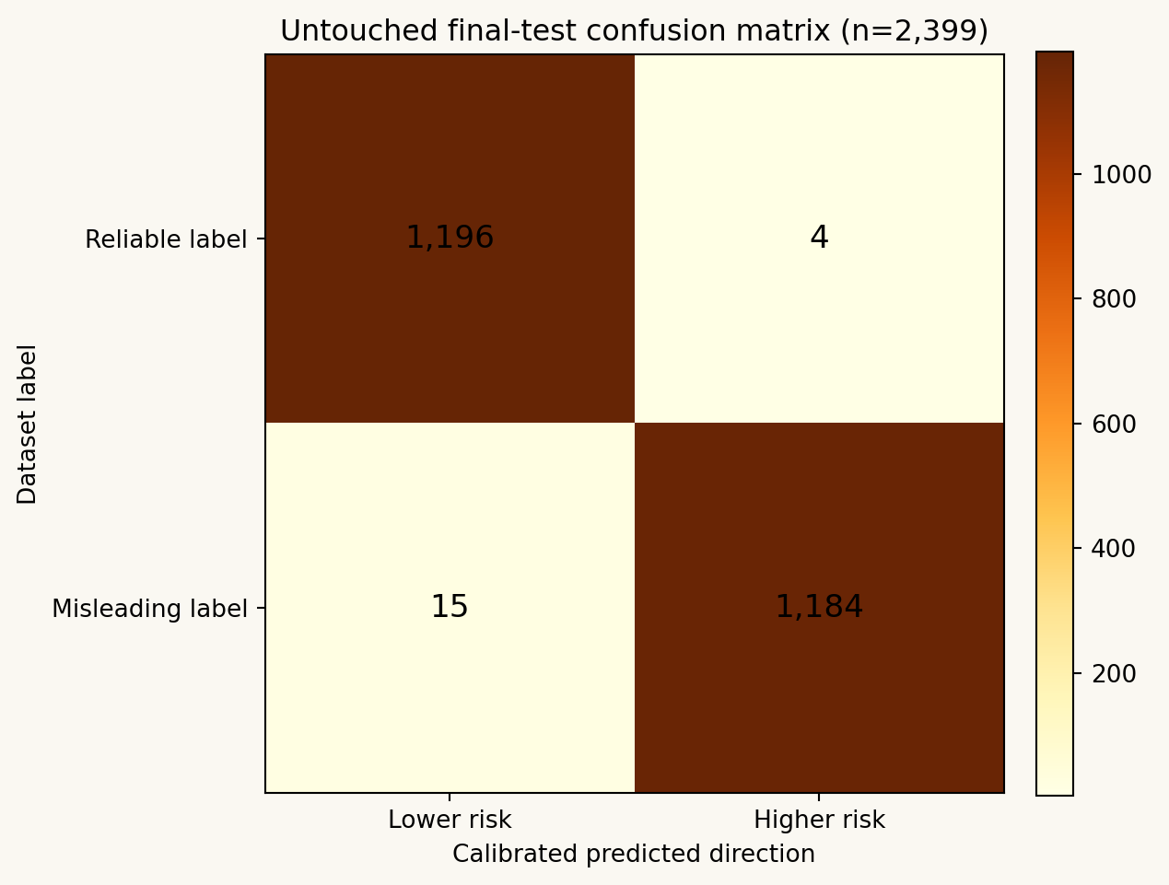
Figure 8.2. Production Logistic Regression final-test confusion matrix.
Among 1,200 reliable-labelled and 1,199 misleading-labelled final-test rows, the production model produced 1,196 true negatives, 1,184 true positives, four false positives and 15 false negatives.
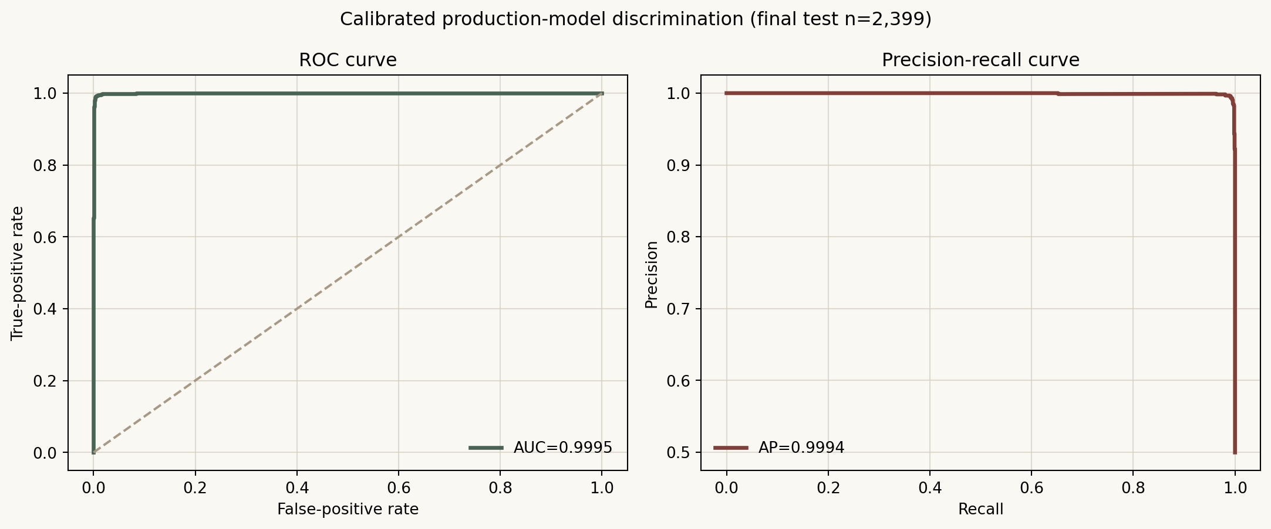
Figure 8.3. Calibrated ROC and precision-recall curves on the final test.
Near-perfect curves on ISOT should be interpreted with the disclosed source/style shortcut risk.
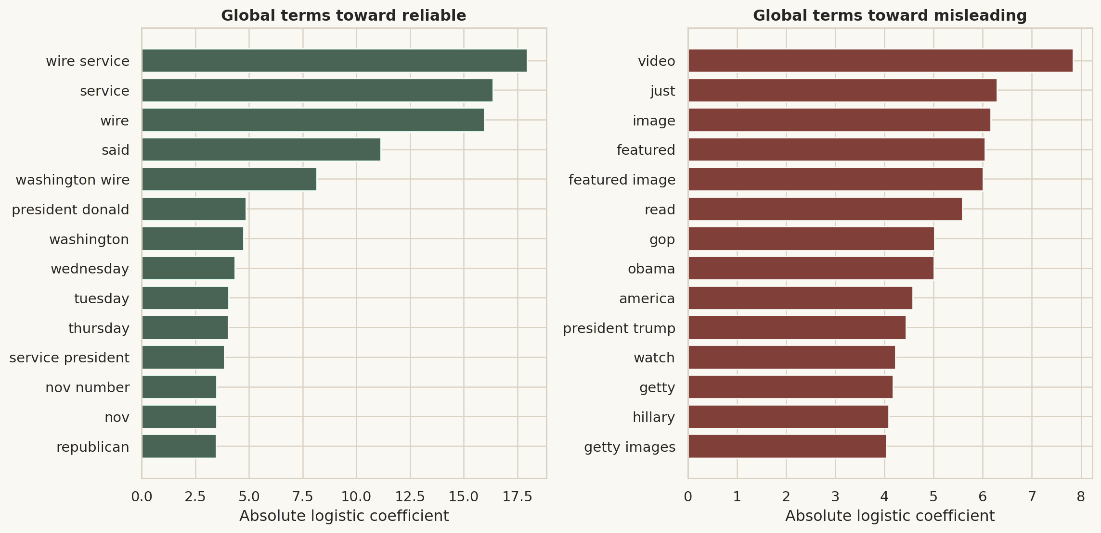
Figure 8.4. Global Logistic Regression coefficients.
Global coefficients reveal which dataset terms are associated with each class and help audit suspicious shortcuts.

8.3 Leakage-controlled evidence protocol
The unchanged production artifact first reproduced the established 4,800-row holdout accuracy and macro-F1 exactly. For the new study, 41,994 near-duplicate candidates were screened; 17 pairs met the 0.90 five-gram Jaccard rule; two contaminated holdout rows were quarantined; and zero detected near-duplicate pairs crossed the final train, validation and test boundaries. Candidate generation is approximate and does not claim semantic-duplicate exhaustiveness.

8.4 Calibration and editorial-review policy
Platt scaling is fitted on 1,199 calibration rows. The 1,200-row validation-policy partition applies the predeclared 0.01 model-retention tolerance and selects 0.59 as the lowest confidence threshold meeting at least 80% coverage and a 95% Wilson lower accuracy bound of at least 99%. On the untouched final test, calibrated Brier score is 0.006292 and ten-bin ECE is 0.005295, compared with 0.010464 and 0.044799 for native Logistic Regression probabilities. The review rate is 0.167%, automatic-decision coverage 99.833%, selective accuracy 99.290% and its 95% Wilson lower bound 98.866%. These values are relative to ISOT labels and do not verify facts.
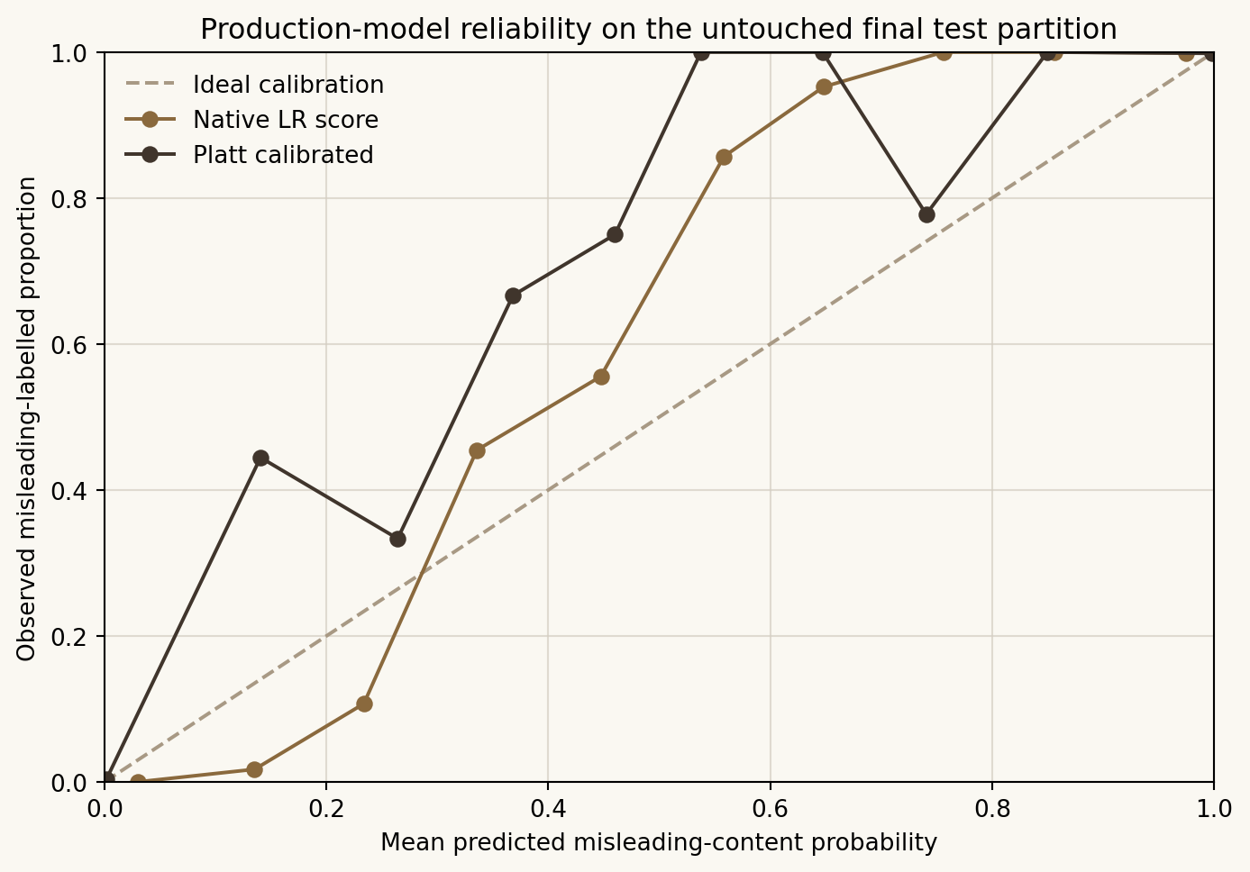
Figure 8.5. Production-model reliability before and after Platt calibration.
Calibration substantially reduces Brier score and expected calibration error on the untouched final test, while remaining a dataset-relative confidence study rather than a truth-probability claim.

8.5 Summarization evaluation
Metric | Precision | Recall | F1
ROUGE-1 | 0.098031 | 0.439227 | 0.153559
ROUGE-2 | 0.017256 | 0.089341 | 0.027824
ROUGE-L | 0.065309 | 0.297377 | 0.10253

Evaluation used 150 XSum test articles selected with seed 42. Mean compression was 70.6572% and mean latency 3.368 ms. XSum references are professionally written, single-sentence and highly abstractive; an extractive system can be coherent and faithful while receiving low lexical overlap. Qualitative consistency still requires human review.

8.6 Packaged demonstration analyses
Synthetic sample | Words | Summary | Compression | Displayed outcome | Calibrated misleading p | Band
misleading_style_article.txt | 143 | 28 | 80.42% | Higher misleading-content risk indicated | 99.29% | High
reliable_style_article.txt | 158 | 41 | 74.05% | Lower misleading-content risk indicated | 15.38% | Moderate
uncertain_style_article.txt | 135 | 38 | 71.85% | Editorial review required | 49.89% | Review

These are synthetic UI demonstrations, not ground-truth evaluation. They exercise the reliable, misleading and uncertainty display paths without republishing labelled news text.

8.7 Test-case summary
ID | Module | Expected | Actual | Status
TC-01 | Preprocessing | Source shortcut, URL, and control byte removed | All assertions passed | Pass
TC-02 | Preprocessing | Deterministic normalised model text/hash | All assertions passed | Pass
TC-03 | Summarization | Short summary is non-empty and compressed | Summary compressed and order preserved | Pass
TC-04 | Summarization | Detailed output is at least as long as short | Length relation passed | Pass
TC-05 | Summarization | No crash; empty/long handling works | Both cases passed | Pass
TC-06 | Prediction | Load without fitting; valid calibrated probabilities, outcome/review state and explanation | Model loaded and assertions passed | Pass
TC-07 | Prediction | Actionable ModelLoadError | Expected error returned | Pass
TC-08 | Database | One row; second insert returns original ID | Duplicate detected | Pass
TC-09 | Database | CRUD operations succeed | All CRUD assertions passed | Pass
TC-10 | URL validation | Reject with safe user-facing error | All blocked | Pass
TC-11 | URL extraction | BeautifulSoup fallback extracts title/author/body | Fallback extracted 40+ words | Pass
TC-12 | File upload | Return cleaned article text | Text parsed | Pass
TC-13 | File upload | Raise FileParseError | Both rejected | Pass
TC-14 | Export | Round-trip parse | Parsed with matching title | Pass
TC-15 | Export | Valid PDF with at least one page | pypdf opened output | Pass
TC-16 | Streamlit startup | No uncaught Streamlit exception | Started | Pass
TC-17 | Streamlit startup | No uncaught Streamlit exception | Started | Pass
TC-18 | Streamlit startup | No uncaught Streamlit exception | Started with measured artifacts | Pass
TC-19 | Streamlit startup | No uncaught Streamlit exception | Started with measured figures | Pass
TC-20 | Streamlit startup | No uncaught Streamlit exception | Started | Pass
TC-21 | Streamlit startup | No uncaught Streamlit exception | Started | Pass
TC-22 | Installed baseline suite | All 29 established checks remain included | 29 established plus 27 hardening checks collected; final run pending | Pending final audit
TC-23 | Classifier evaluation | Metrics calculated and saved | Macro-F1 0.992080; ROC-AUC 0.999481; Brier 0.006292; ECE 0.005295 | Pass
TC-24 | Editorial assets | All local assets exist and are non-empty | Static assertions passed | Pass
TC-25 | Editorial theme | Required ivory, brown, charcoal, and semantic tokens present | Static assertions passed | Pass
TC-26 | Editorial palette integrity | Only the approved warm paper and restrained semantic visual system is used | Static assertions passed | Pass
TC-27 | Top navigation | Every page is linked by the reusable navigation | Static assertions passed | Pass
TC-28 | Shared page shell | Every page calls configure_page with the correct active state | Static assertions passed | Pass
TC-29 | Responsible result language | Bounded risk outcomes, editorial-review state and verification warning remain explicit | Static assertions passed | Pass

8.8 Error analysis
False positives and false negatives are retained as hashes, probabilities and word counts in error_analysis.csv. Manual inspection should focus on satire, opinion, short event reports, outlet-specific phrasing and topics near the training boundary. A low numerical test error does not remove the need for cross-publisher and temporal validation.

Chapter 9: Graphical User Interface
NewsLens AI uses a calm newsroom system: warm ivory paper surfaces, charcoal text, muted brown rules, serif display headings, sans-serif reading text and restrained semantic colours. app.py registers all six sections with st.Page and st.navigation; native Streamlit links preserve a single browser tab, direct routes and browser history without duplicating business logic. Focus indicators, reduced-motion handling, colour-independent result labels and stacked narrow-screen layouts support accessibility.
Screenshot set: Figures 9.2-9.16 document the current warm beige Streamlit interface, including calibrated abstention, model benchmarking, newsroom analytics, drift readiness and human editorial review. Dimensions and SHA-256 hashes are recorded in the screenshot manifest.
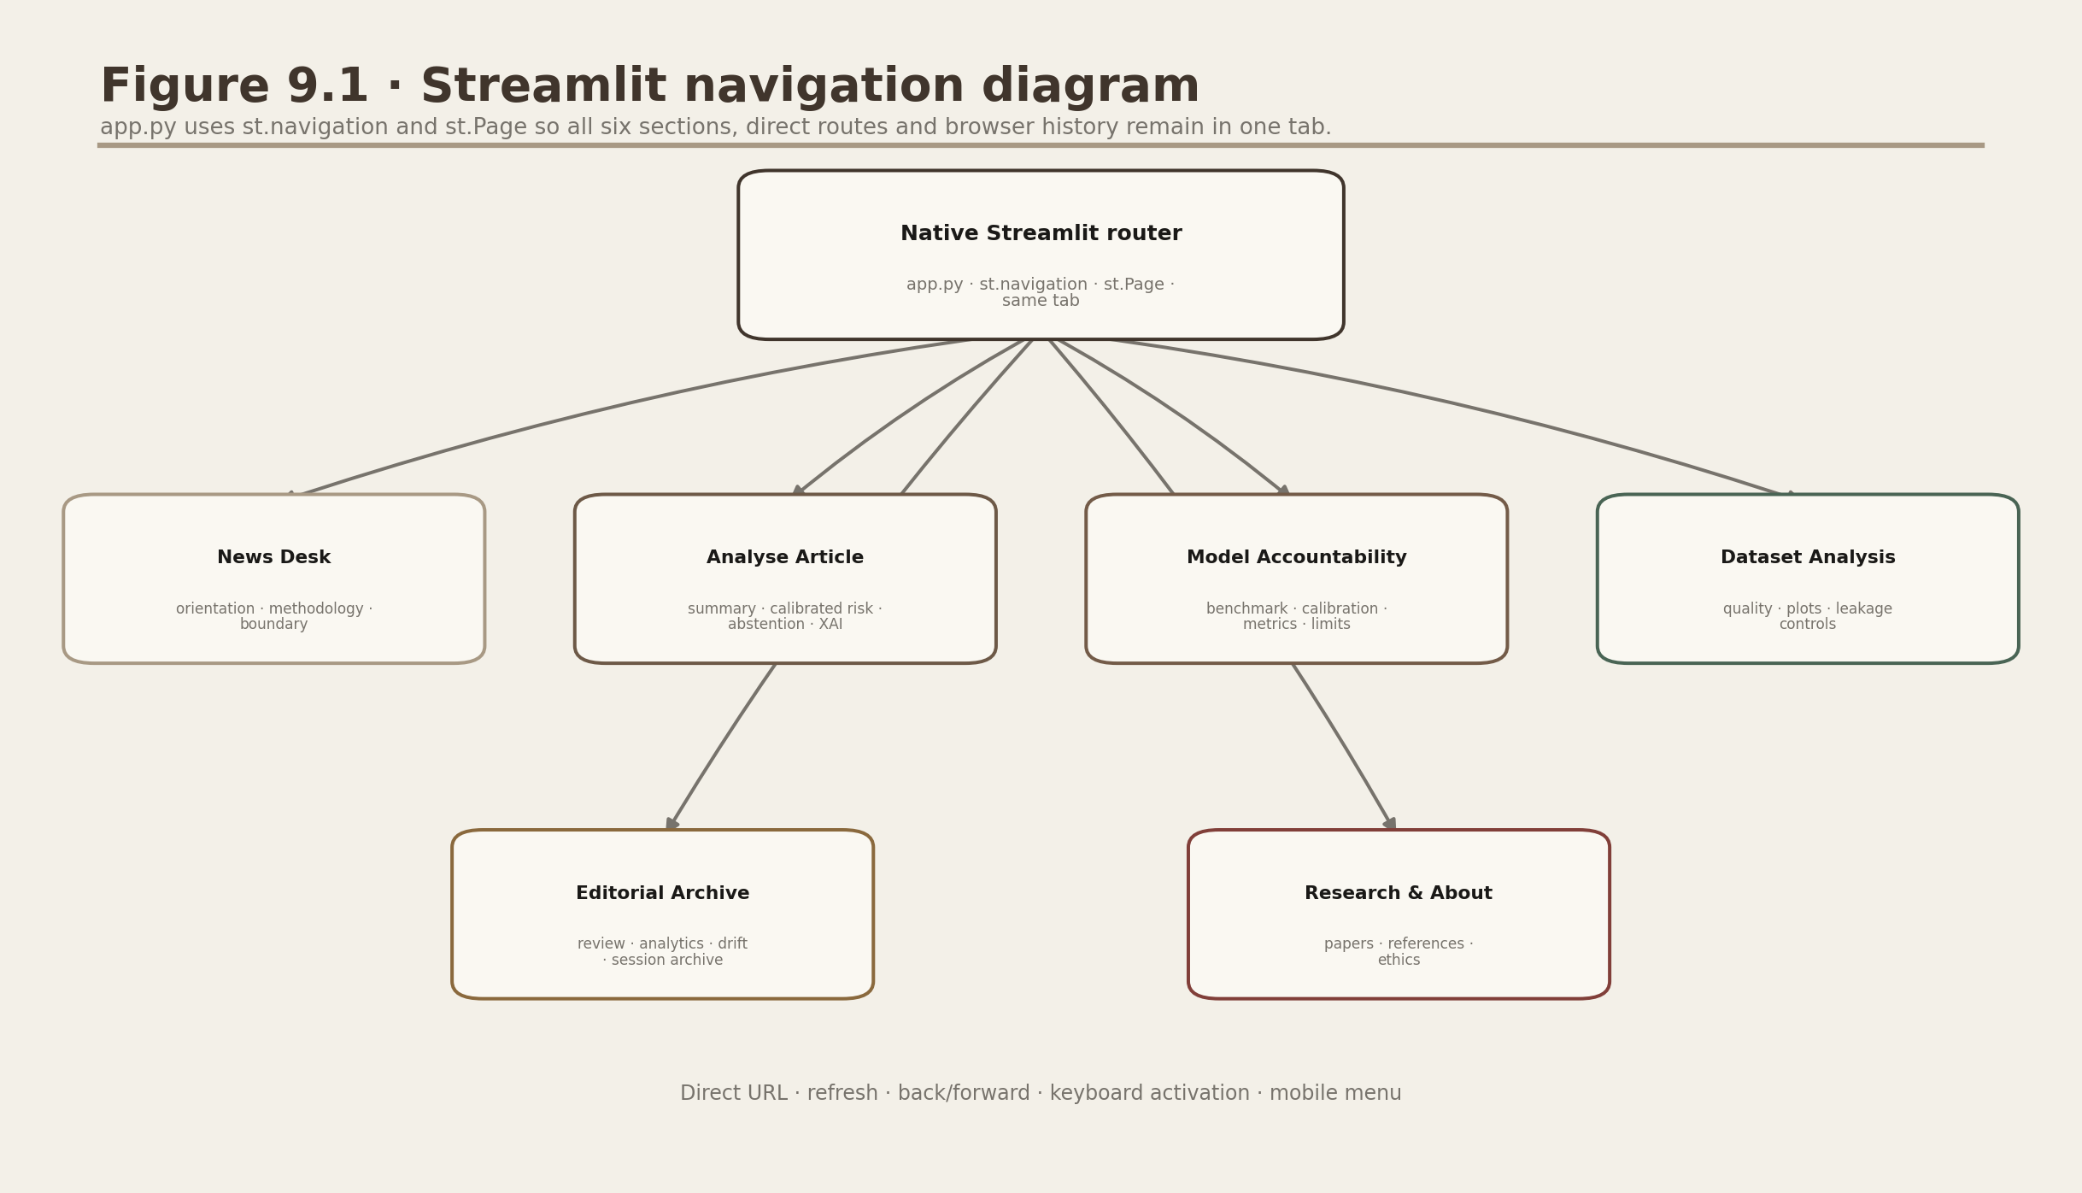
Figure 9.1. Streamlit navigation diagram.
The responsive top navigation exposes News Desk, Analyse Article, Model Accountability, Dataset Analysis, Editorial Archive and Research & About.

Figure 9.2. News Desk.
The landing page states the scientific boundary before users see a prediction.
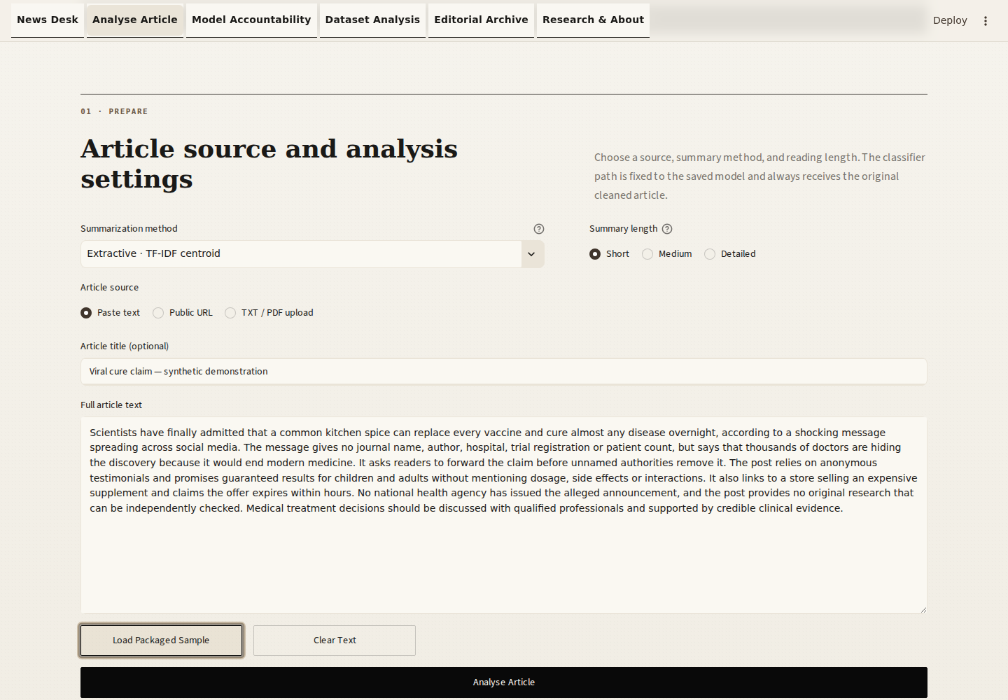
Figure 9.3. Article input.
Input method, title, full text and summary settings are visible. URL and file alternatives use the same validation pipeline.
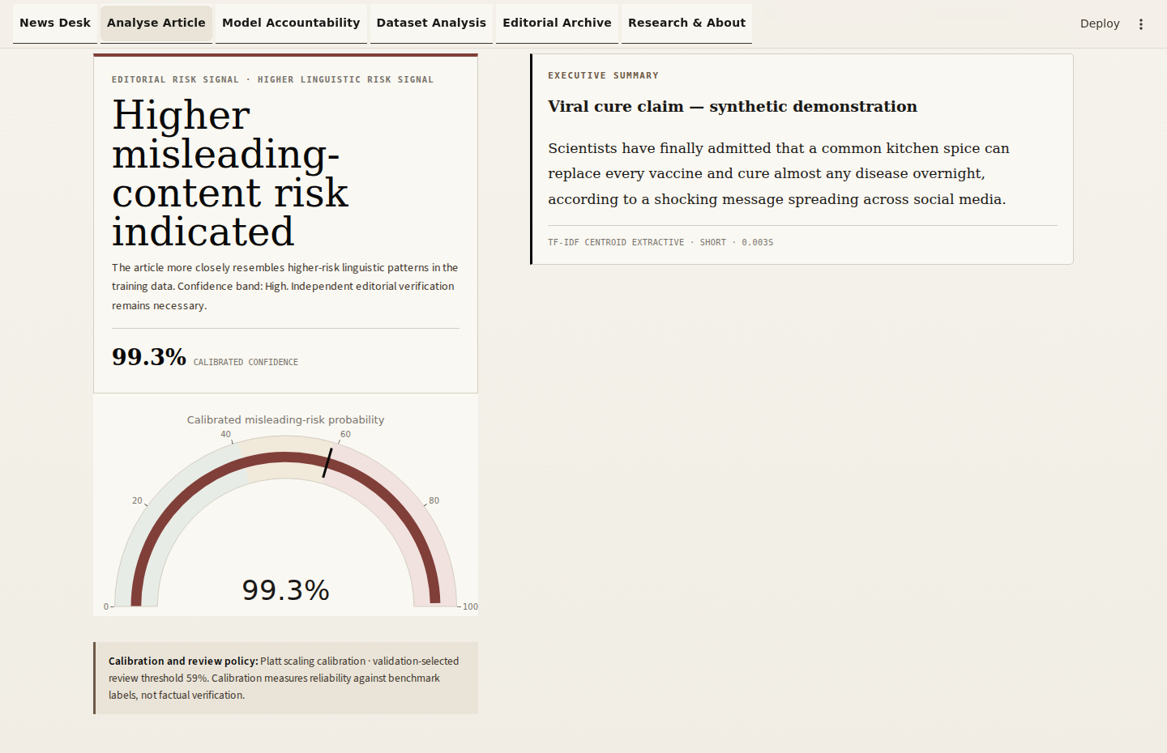
Figure 9.4. Summary and credibility-risk result.
The synthetic higher-risk demonstration produced a 28-word summary, 80.42% compression and 99.29% calibrated confidence in the higher-risk direction. It is a workflow sample, not a factual adjudication or benchmark row.
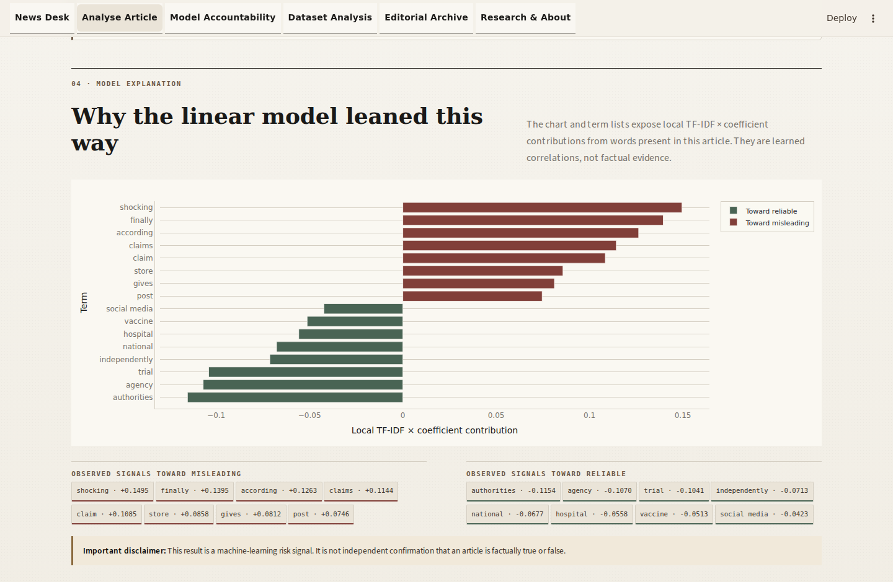
Figure 9.5. Explanation and exports.
Observed TF-IDF contributions appear on both sides of zero; the warning and export controls remain adjacent.
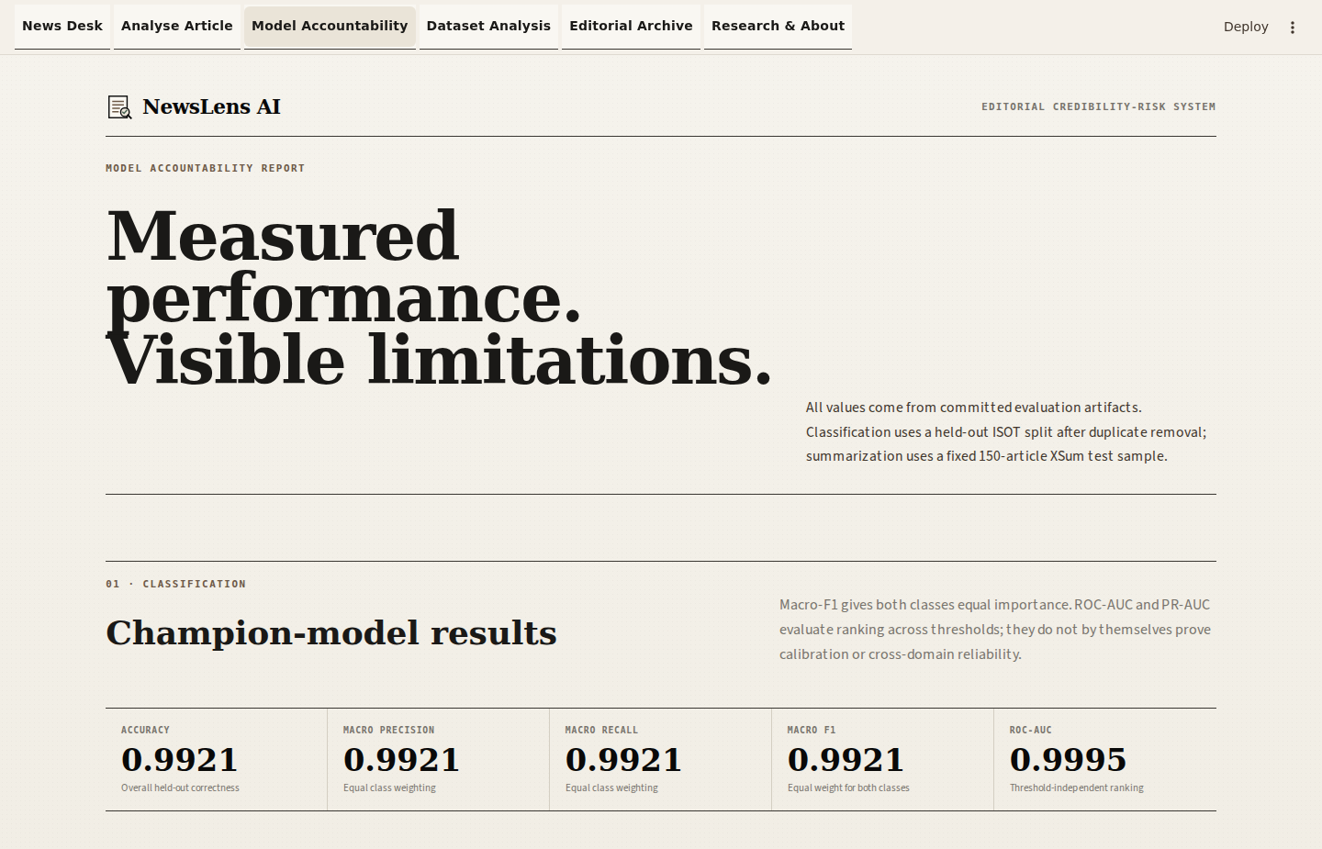
Figure 9.6. Model Accountability.
Cards and charts are populated from saved measured artifacts rather than hard-coded values.
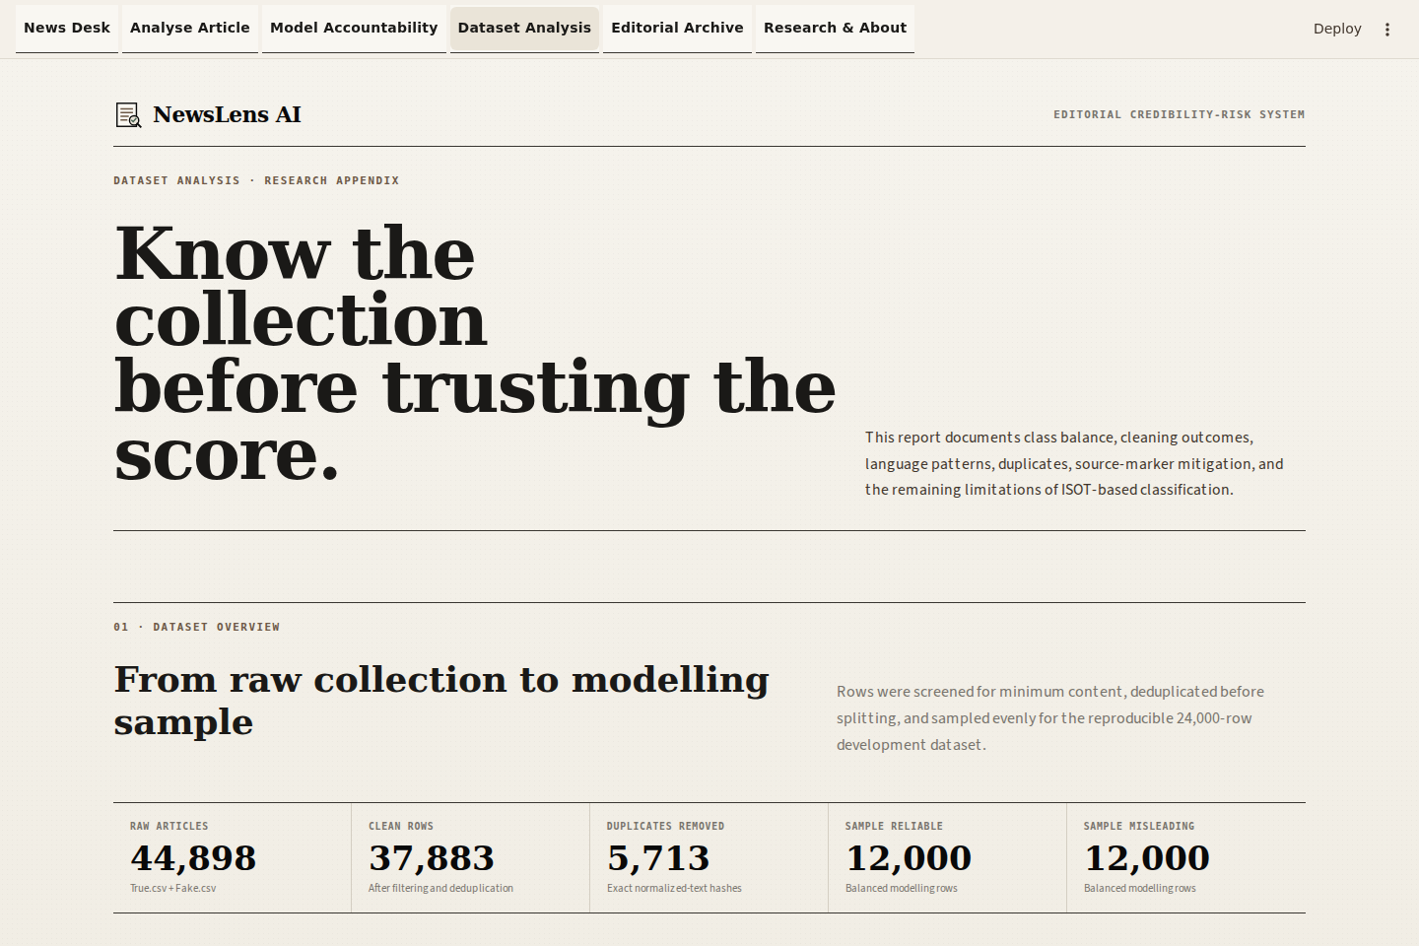
Figure 9.7. Dataset Analysis.
Data quality, distributions and leakage disclosures are organised as a numbered research appendix.
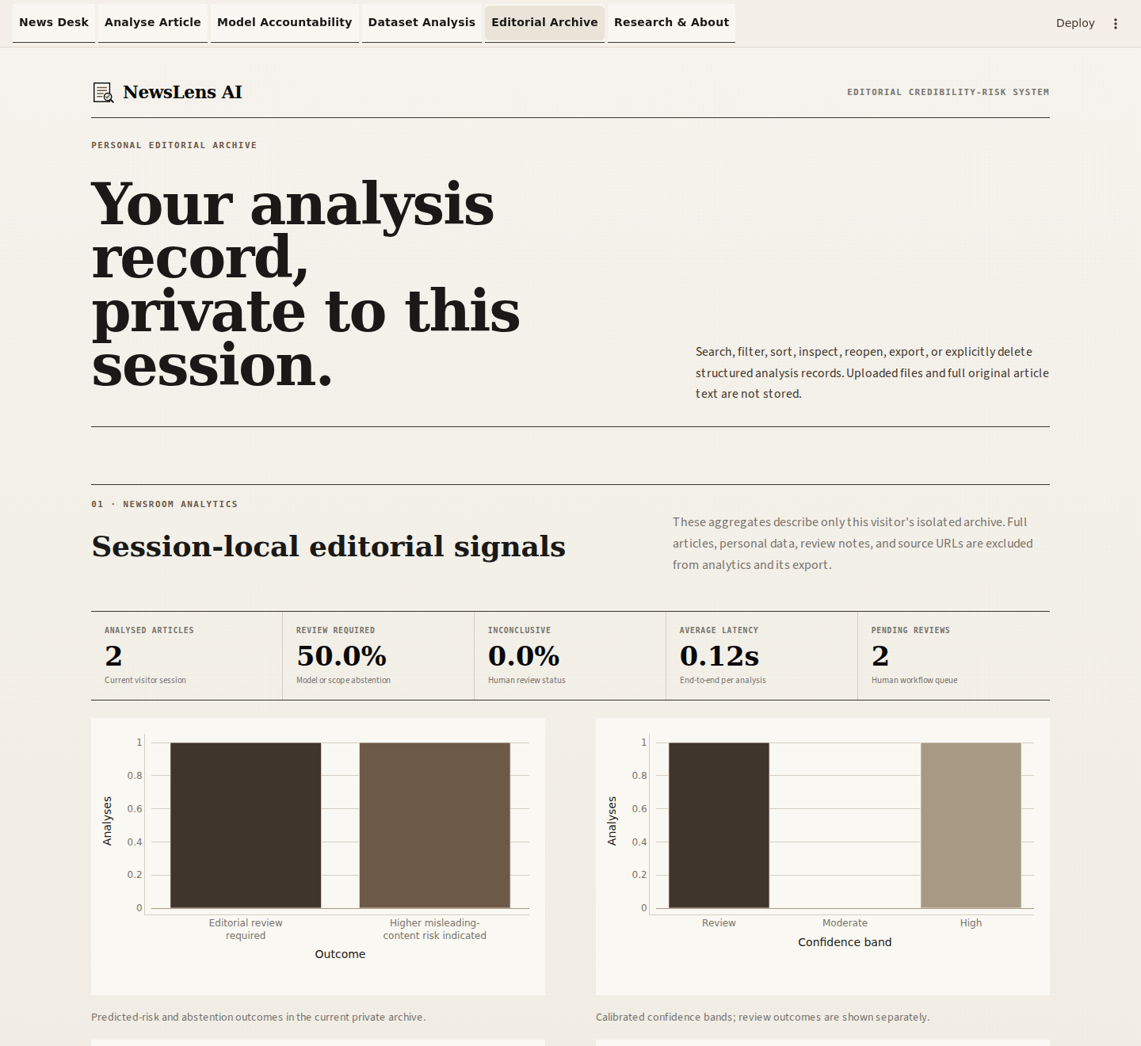
Figure 9.8. Editorial Archive.
Session-private rows can be searched, filtered, inspected, exported and deleted. Public-cloud SQLite is temporary and is not presented as durable history.
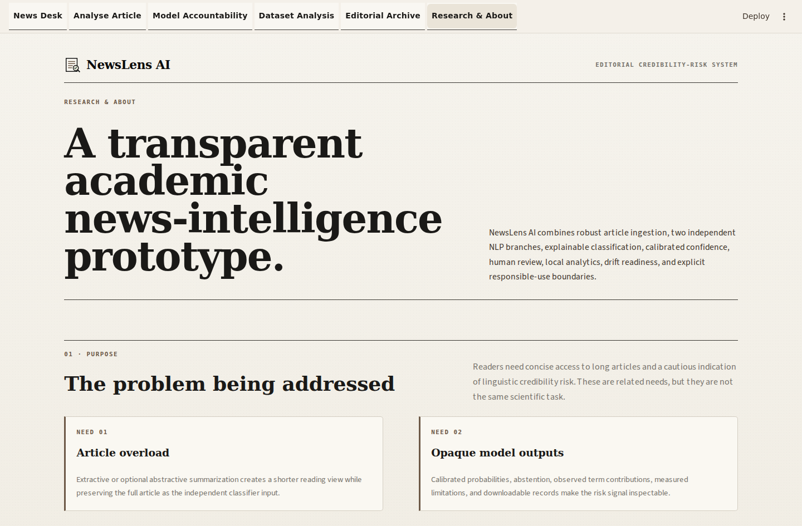
Figure 9.9. Research & About.
Verified paper metadata and responsible-use boundaries remain visible in the application.

Figure 9.10. Mobile News Desk.
The masthead, navigation and editorial hierarchy adapt to a 390-pixel viewport without horizontal clipping.
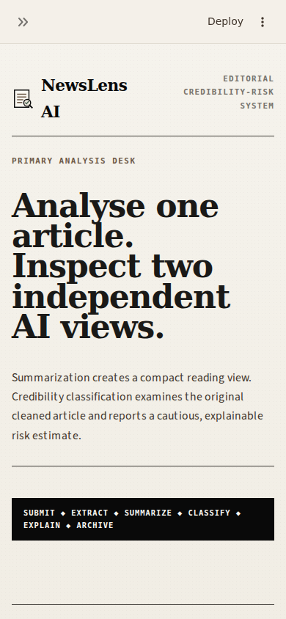
Figure 9.11. Mobile article workflow.
Input controls stack into a single readable column and retain accessible labels and touch-sized actions.
Capture record: The 15 interface images are genuine local Streamlit captures produced with the current ui/theme.py design and populated synthetic/session-safe evidence. The manifest records filename, dimensions, capture time and SHA-256; no image was repainted to simulate application output.
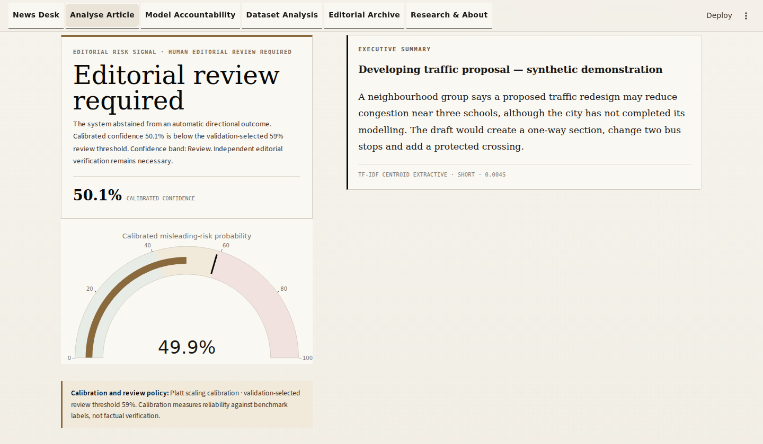
Figure 9.12. Calibrated abstention and editorial-review-required state.
Low calibrated confidence and supported mismatch conditions route the article to review instead of forcing a binary risk outcome.
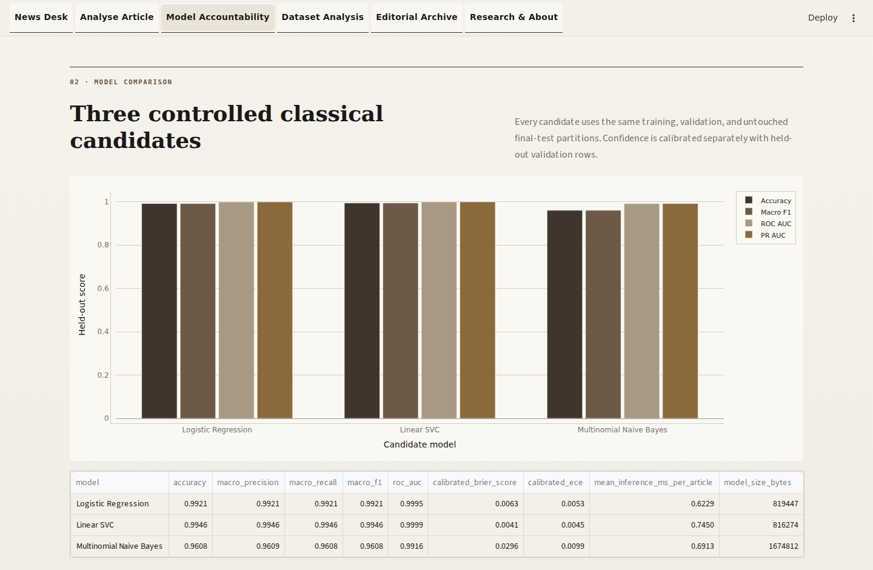
Figure 9.13. Controlled model benchmarking evidence.
Candidate metrics, fixed partition counts and the unchanged production-model decision are visible in Model Accountability.
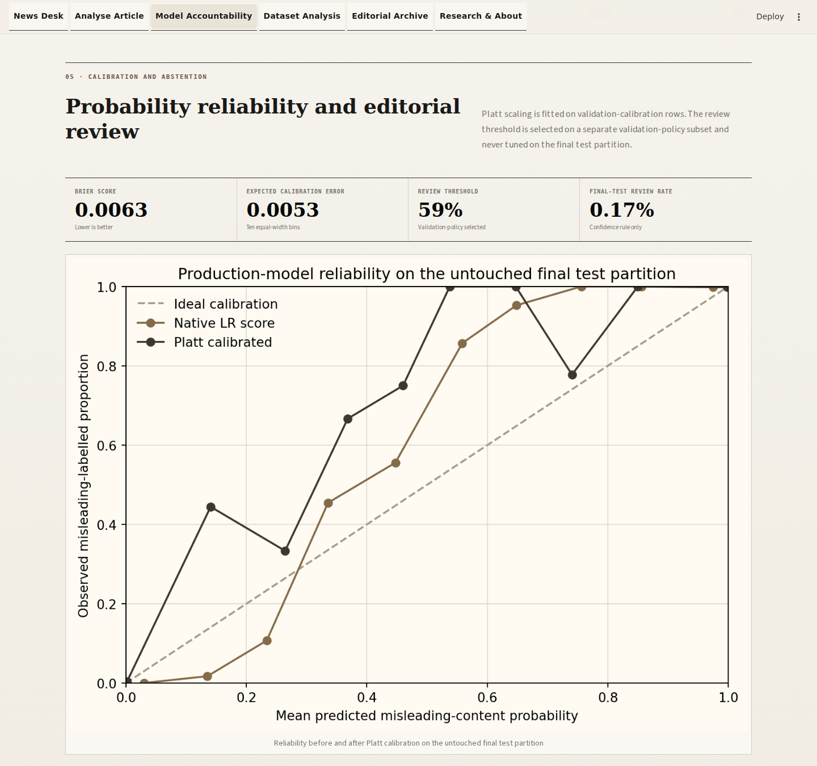
Figure 9.14. Calibration reliability and abstention-policy evidence.
Brier score, ECE, reliability curves and the dataset-relative interpretation accompany the calibrated confidence display.
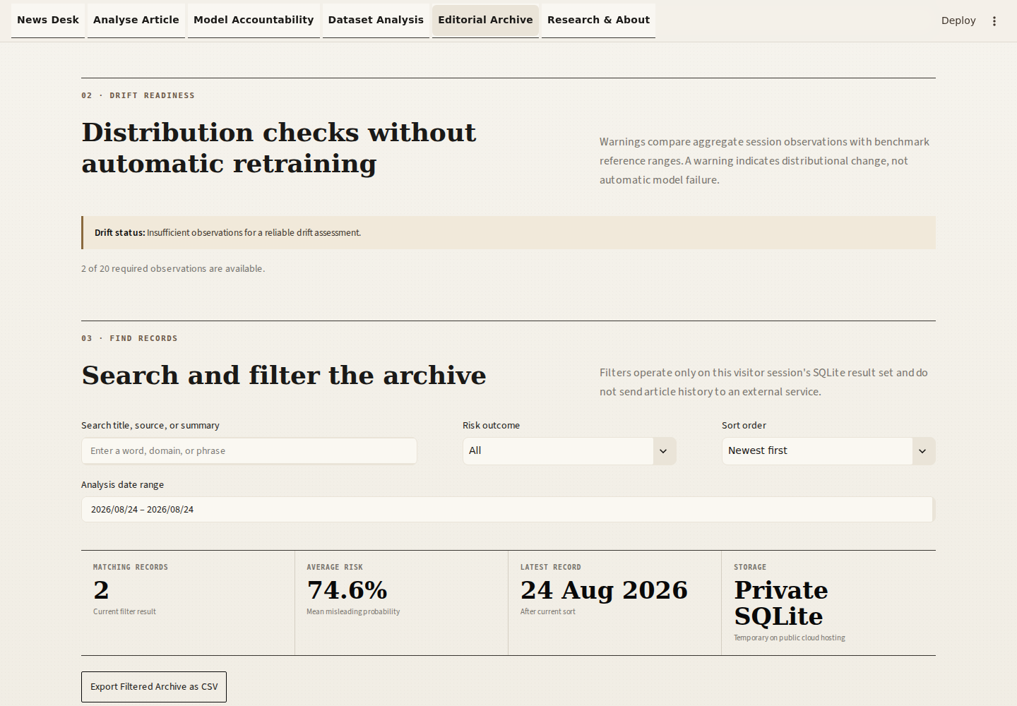
Figure 9.15. Privacy-safe drift-readiness indicators.
Session aggregates are compared with reference ranges only after the minimum observation count; warnings indicate change, not automatic failure.
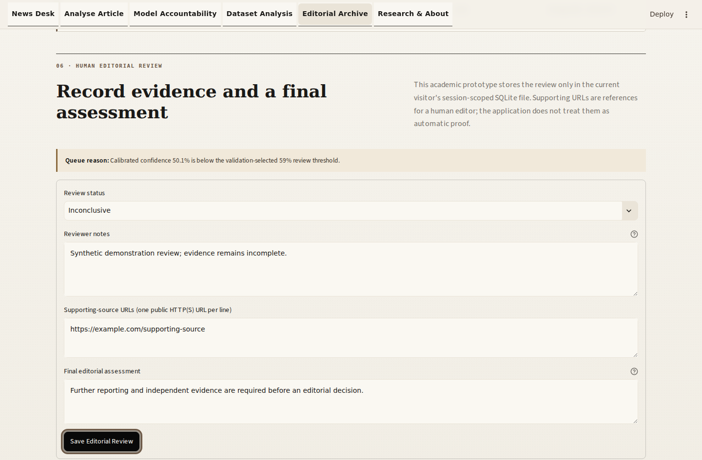
Figure 9.16. Human editorial-review workflow.
A visitor can record status, bounded notes, public supporting URLs and a final assessment inside the same isolated session archive.

Chapter 10: Project Management

10.1 Work breakdown and timeline
Phase | Weeks | Outputs
Research and requirements | 1-2 | Scope, papers, dataset comparison, risk register
Data engineering and EDA | 3-4 | Cleaning audit, visualisations, split protocol
Model development | 5-6 | Three tuned classifiers, champion artifact, error analysis
Summarization and ingestion | 7-8 | Extractive/optional abstractive modules, URL/file fallbacks
Application and storage | 9-10 | Streamlit pages, SQLite, exports, XAI
Testing and documentation | 11-12 | 56 checks (including 29 established), responsive screenshots, diagrams, report and guides

10.2 Risks and mitigation
Risk | Impact | Mitigation
Dataset source leakage | Inflated accuracy | Remove duplicates/metadata/markers; disclose residual risk; future group split
Transformer download/RAM | Slow or unavailable mode | Extractive fallback; lazy cache; lighter checkpoint
Paywall/anti-bot URL | No extractable body | Layered extractor and direct-paste guidance
False misinformation label | Reputational/ethical harm | Risk language, abstention, XAI and permanent disclaimer
Dependency drift | Startup failure | Pinned tested requirements and Python 3.12 guide
Scanned PDF | No text | Explain OCR requirement; do not crash

10.3 Cost and resources
The core workflow requires no paid API. A suitable computer and network access for installation/downloads are still required; hosting, compute, bandwidth and third-party service terms may impose costs. Local operation avoids a mandatory production-platform dependency but is not represented as universally cost-free.

Chapter 11: Limitations, Ethics and Future Scope

11.1 Technical and dataset limitations
- ISOT is outlet-, topic-, period- and style-specific; random splitting may be optimistic.
- English-only TF-IDF does not model multilingual meaning or cross-lingual misinformation.
- The classifier does not retrieve evidence, reason over claims or inspect images/video.
- Satire, parody, opinion, clickbait and evolving events can cross the learned boundary.
- DistilBART may hallucinate or omit details; extractive summaries may be disfluent or redundant.
- URL extraction cannot defeat paywalls, consent walls or browser-only rendering reliably.

11.2 Ethical considerations
Dataset labels and model outcomes can amplify political, regional and publisher bias. False positives may damage legitimate reporting; false negatives may create false reassurance; calibrated percentages may be mistaken for factual probabilities; and feature contributions may be mistaken for evidence. NewsLens AI therefore uses bounded risk language, supports abstention and documented human review, keeps each public visitor's archive isolated, and requires independent verification for consequential claims.

11.3 Future enhancements
- Claim segmentation with evidence retrieval from trusted primary sources.
- Publisher-, topic-, event- and time-grouped external evaluation.
- External-domain calibration, publisher/time-group evaluation and threshold revalidation without touching the existing final test.
- Multilingual models and language-specific evaluation.
- OCR and multimodal image/video consistency analysis.
- Human-in-the-loop explanation usefulness and fairness audits.
- Factual-consistency metrics and human scoring for summaries.
- Authenticated team history with encryption and retention policy only if deployment requires it.

Chapter 12: Conclusion
NewsLens AI demonstrates an end-to-end editorial NLP system rather than two disconnected snippets. Summarization and linguistic credibility-risk classification consume the original cleaned article independently. The Streamlit layer adds calibrated confidence, explainability, abstention, session-private review/history, privacy-safe analytics, drift readiness and exports without runtime retraining. The final audit is configured to execute all 56 packaged checks; same-tab routing, responsive layouts, browser history, downloads and visitor isolation are included in the browser audit boundary.
The leakage-controlled final-test ISOT performance is technically strong but scientifically bounded by dataset artefacts. The low extractive XSum ROUGE is also reported rather than hidden. The central conclusion is not that the system determines truth: it supplies an inspectable linguistic credibility-risk signal and concise summary while preserving the need for evidence, external validation and human judgement.

References
[1] Jaishree Ranganathan; Gloria Abuka, 'Text Summarization using Transformer Model,' IEEE, Ninth International Conference on Social Networks Analysis, Management and Security (SNAMS), pp. 1–5, 2022, doi: 10.1109/SNAMS58071.2022.10062698. https://doi.org/10.1109/SNAMS58071.2022.10062698
[2] N. Balaji; Deepa Kumari; N. Bhavatarini; N. Megha; P. Sunil Kumar; A. Shikah Rai, 'Text Summarization using NLP Technique,' IEEE, International Conference on Distributed Computing, VLSI, Electrical Circuits and Robotics (DISCOVER), pp. 30–35, 2022, doi: 10.1109/DISCOVER55800.2022.9974823. https://doi.org/10.1109/DISCOVER55800.2022.9974823
[3] Fazlullah Khan; Ryan Alturki; Gautam Srivastava; Foziah Gazzawe; Syed Tauhid Ullah Shah; Spyridon Mastorakis, 'Explainable Detection of Fake News on Social Media Using Pyramidal Co-Attention Network,' IEEE Transactions on Computational Social Systems, vol. 11, no. 4, pp. 4574–4583 (early access 2022), 2024, doi: 10.1109/TCSS.2022.3207993. https://par.nsf.gov/servlets/purl/10406319
[4] Jing Yang; Didier Vega-Oliveros; Taís Seibt; Anderson Rocha, 'Explainable Fact-Checking Through Question Answering,' IEEE ICASSP 2022, 2022, doi: 10.1109/ICASSP43922.2022.9747214. https://arxiv.org/abs/2110.05369
[5] Ehtesham Hashmi; Sule Yildirim Yayilgan; Muhammad Mudassar Yamin; Subhan Ali; Mohamed Abomhara, 'Advancing Fake News Detection: Hybrid Deep Learning With FastText and Explainable AI,' IEEE Access, vol. 12, pp. 44462–44480, 2024, doi: 10.1109/ACCESS.2024.3381038. https://doi.org/10.1109/ACCESS.2024.3381038
[6] Rohit Kumar Kaliyar; Anurag Goswami; Pratik Narang; Vinay Chamola, 'Understanding the Use and Abuse of Social Media: Generalized Fake News Detection With a Multichannel Deep Neural Network,' IEEE Transactions on Computational Social Systems, vol. 11, no. 4, pp. 4878–4887 (early access 2022), 2024, doi: 10.1109/TCSS.2022.3221811. https://doi.org/10.1109/TCSS.2022.3221811
[7] Mike Lewis; Yinhan Liu; Naman Goyal; Marjan Ghazvininejad; Abdelrahman Mohamed; Omer Levy; Veselin Stoyanov; Luke Zettlemoyer, 'BART: Denoising Sequence-to-Sequence Pre-training for Natural Language Generation, Translation, and Comprehension,' Association for Computational Linguistics, ACL 2020, pp. 7871–7880, 2020, doi: 10.18653/v1/2020.acl-main.703. https://aclanthology.org/2020.acl-main.703/
[8] Casper Hansen; Christian Hansen; Lucas Chaves Lima, 'Automatic Fake News Detection: Are Models Learning to Reason?,' ACL-IJCNLP 2021, Short Papers, pp. 80–86, 2021, doi: 10.18653/v1/2021.acl-short.12. https://aclanthology.org/2021.acl-short.12/
[9] Shashi Narayan; Shay B. Cohen; Mirella Lapata, 'Don’t Give Me the Details, Just the Summary! Topic-Aware Convolutional Neural Networks for Extreme Summarization,' EMNLP 2018, pp. 1797–1807, 2018, doi: 10.18653/v1/D18-1206. https://aclanthology.org/D18-1206/
[10] William Yang Wang, '‘Liar, Liar Pants on Fire’: A New Benchmark Dataset for Fake News Detection,' ACL 2017, Short Papers, pp. 422–426, 2017, doi: 10.18653/v1/P17-2067. https://aclanthology.org/P17-2067/
[11] University of Victoria ISOT Research Lab, 'Fake News Detection Datasets,' official dataset page, https://onlineacademiccommunity.uvic.ca/isot/2022/11/27/fake-news-detection-datasets/.
[12] Edinburgh NLP Group, 'XSum Dataset,' https://github.com/EdinburghNLP/XSum.
[13] NeuralNine, 'Summarize News Articles with Machine Learning in Python,' YouTube conceptual reference, https://youtu.be/z4DQYprjPSs.
[14] 'Fake News Detection in Python,' YouTube conceptual reference supplied with the project brief, https://youtu.be/ZE2DANLfBIs.
[15] scikit-learn developers, 'Pipeline, TfidfVectorizer, model selection and metrics documentation,' https://scikit-learn.org/.
[16] Streamlit, 'Streamlit documentation,' https://docs.streamlit.io/.

Appendix A: Installation and User Manual
py -3.12 -m venv .venv
.venv\Scripts\activate
python -m pip install --upgrade pip
pip install -r requirements-lite.txt
streamlit run app.py
- Open Analyse Article from the top navigation.
- Choose Paste text, Public URL or File upload.
- Select summary method and length.
- Provide at least 40 words and select Analyse Article.
- Read the summary, calibrated probabilities, outcome/review state, diagnostics, local term contributions and disclaimer.
- Download JSON/PDF or reopen the item in Editorial Archive.

Appendix B: Dataset Schema
Field | Origin | Use
title | ISOT CSV | Combined with body
text | ISOT CSV | Primary content
subject | ISOT CSV | EDA only; excluded from model
date | ISOT CSV | EDA only; excluded from model
label | True/Fake filename | 0 reliable; 1 misleading
document | XSum | Summary input
summary | XSum | ROUGE reference
id | XSum | Stable sample identifier

Appendix C: Function Reference
Function | Input | Output
extract_article | public URL | ArticleData
parse_uploaded_file | filename + bytes | clean text
clean_article_text | raw text | display-clean text
summarize_extractive | text + length | SummaryResult
summarize_abstractive | text + pipeline + length | SummaryResult
predict_credibility | original text + Pipeline | PredictionResult
insert_analysis | record dict | ID + duplicate flag
analysis_pdf_bytes | analysis dict | PDF bytes

Appendix D: Research Matrix
The complete 16-column matrix is supplied as NewsLens_AI_Research_Paper_Matrix.xlsx with Overview, Literature Matrix and Coverage Map sheets. It includes access status, dataset, method, metrics, major findings, limitations, relevance and identified gap for all ten papers.

Appendix E: Reproduction Checklist
- Verify Python 3.12 and activate the virtual environment.
- Install requirements-lite.txt for the core path.
- Run python -m pytest -q and confirm all 56 checks pass, including the 29 established checks.
- Launch streamlit run app.py and analyse all three packaged samples.
- For training, download official ISOT files and compare SHA-256 metadata.
- For ROUGE, download XSum and rerun the fixed 150-row seed-42 evaluation.
- Never report synthetic sample labels as truth or benchmark accuracy.

