NEWSLENS AI
PUBLIC DOCUMENTATION

PRACTICAL GUIDE
NewsLens AI
Setup and Run Guide
Beginner-friendly installation, first run, retraining, testing and troubleshooting
Field | Value
Product | NewsLens AI
Document status | GitHub-ready public documentation; publication pending owner action
Author and developer | Deven Gaikwad
Copyright | © 2026 Deven Gaikwad. All rights reserved.
Runtime | Streamlit · Python 3.12 · app.py
Model boundary | Linguistic credibility-risk estimate; not a verified fact-check
Repository | Intended canonical repository: https://github.com/DevenGaikwad/NewsLens-AI (not yet created)
Document updated | 25 August 2026

CODE · METHODS · EVIDENCE · RESPONSIBLE USE

Table of Contents
Section | Rendered page
1-3. Prerequisites, Python and VS Code | 3
4-6. Extract, virtual environment and interpreter | 4
7-9. Dependencies and Streamlit startup | 5
10. First sample analysis | 6
11-15. Operations, datasets and retraining | 10
16-17. Tests and public deployment | 12
18. Troubleshooting | 12
19-20. Demo checklist and commands | 14

Page references match the packaged render; headings remain Word-native for navigation and future TOC updates.

Recommended path: Use the tested Python 3.12 runtime and requirements-lite.txt first. It runs the complete extractive summary, saved classifier, explanations, session-private history and exports without PyTorch.

1. What you need
- A 64-bit Windows 10/11 computer (Linux/macOS also work).
- At least 4 GB RAM for lightweight mode; 8 GB or more for DistilBART.
- About 1 GB free space for lightweight mode; several GB for datasets and transformer caches.
- Internet for installation/downloads. Core analysis is local after installation.
- The core workflow requires no paid API; hosting, network, compute and third-party terms may still carry costs.

2. Install Python
- Visit https://www.python.org/downloads/ and choose Python 3.12.x for Windows.
- Run the installer and tick 'Add python.exe to PATH'.
- Choose Install Now.
- Open Command Prompt and run the verification command below.
py -3.12 --version
Expected: Python reports 3.12.x. Do not use a Microsoft Store alias if VS Code points to a different interpreter.

3. Install VS Code and the Python extension
- Download Visual Studio Code from https://code.visualstudio.com/.
- Install and open VS Code.
- Open Extensions (Ctrl+Shift+X).
- Install the Microsoft 'Python' extension.
- Optionally install Jupyter to open the packaged notebooks.

4. Extract and open the project
- Clone the public NewsLens-AI repository or download its source archive.
- Extract it to a short path such as C:\Projects when using a ZIP.
- In VS Code select File > Open Folder.
- Open the NewsLens-AI folder that directly contains app.py.
- Choose Terminal > New Terminal.
Common folder mistake: If the terminal cannot find app.py or requirements-lite.txt, you opened the parent extraction folder. Open the folder containing those files.

5. Create and activate a virtual environment
py -3.12 -m venv .venv

5.1 Windows PowerShell
.venv\Scripts\Activate.ps1

5.2 Windows Command Prompt
.venv\Scripts\activate.bat

5.3 Linux or macOS
python3.12 -m venv .venv
source .venv/bin/activate
A successful activation normally shows (.venv) at the left of the terminal prompt.

6. Select the VS Code interpreter
- Press Ctrl+Shift+P.
- Run 'Python: Select Interpreter'.
- Choose the interpreter inside .venv.
- Open a new terminal and confirm the path.
python --version
python -c "import sys; print(sys.executable)"

7. Upgrade pip and install dependencies
python -m pip install --upgrade pip
pip install -r requirements-lite.txt
The lightweight file installs Streamlit, pandas, NumPy, scikit-learn, Joblib, Plotly, Matplotlib, Seaborn, URL/PDF libraries, ReportLab and pytest. It excludes PyTorch and Transformers.

8. Optional abstractive dependencies
pip install -r requirements.txt
First-use download: Selecting Abstractive - DistilBART downloads sshleifer/distilbart-cnn-6-6. Keep Extractive selected if the download, disk, RAM or CPU time is unsuitable.

9. Start Streamlit
streamlit run app.py
If the `streamlit` command is not recognised, run the module form below. Both commands start the same application.
python -m streamlit run app.py
Open http://localhost:8501 if the browser does not open automatically. Keep the terminal running while using the application.
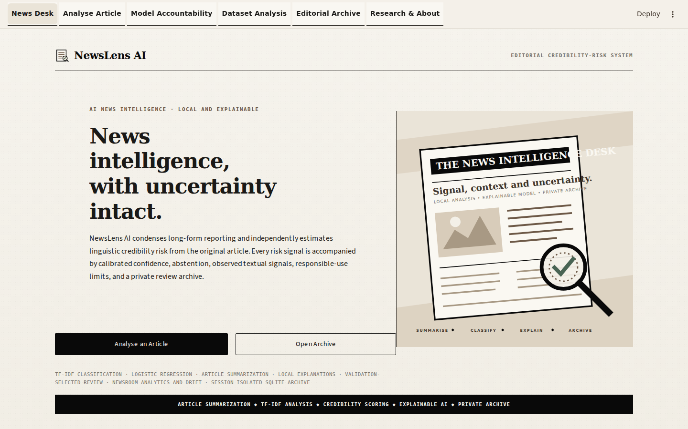
Figure S.1. News Desk.
The landing view presents the masthead, exact project boundary, primary/archive actions, original local artwork and technical information strip.

10. Analyse the first sample article
- Select Analyse Article in the top navigation.
- Keep Paste text selected.
- Select Load packaged sample or paste one of the files from data/sample.
- Choose Extractive - TF-IDF centroid and Short.
- Select Analyse Article.
- Read the summary and credibility verdict together.
- Inspect local terms and the disclaimer.
- Download JSON or PDF, then open Editorial Archive.
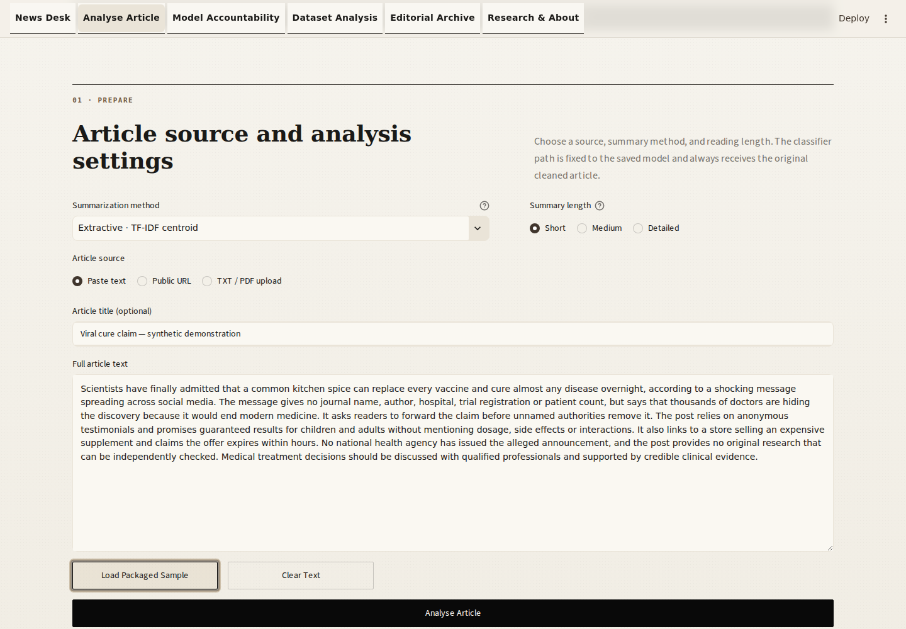
Figure S.2. Populated article input.
Input method, article fields and summary controls share one responsive editorial workspace.
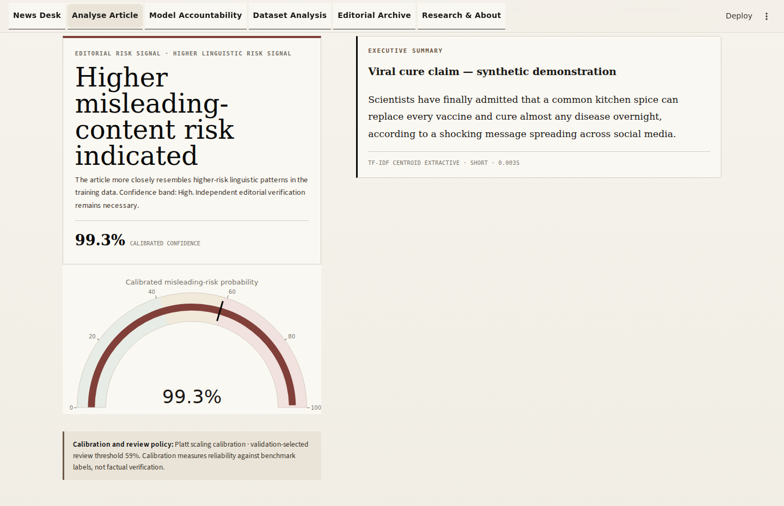
Figure S.3. Analysis result.
Word counts, compression, executive summary, textual verdict, probability/confidence and responsible interpretation are presented as one editorial report.
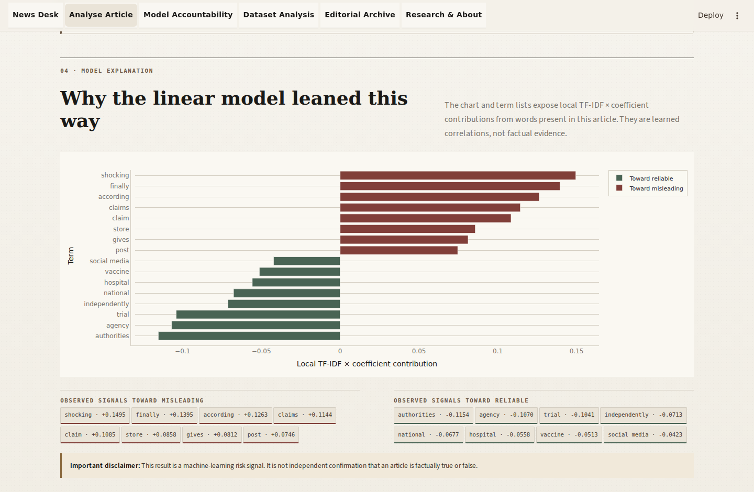
Figure S.4. Explanation and exports.
Muted green and oxblood bars oppose/support the misleading class; they are model correlations, not factual evidence.

11. Stop, restart and change the port
Press Ctrl+C in the Streamlit terminal to stop the server. Restart with the same run command after reactivating .venv. If port 8501 is busy, choose another port.
python -m streamlit run app.py --server.port 8502

12. Dataset download and placement
The private/local application runs with the packaged Joblib and its hash-matched private confidence_calibration.json. Runtime never retrains. Raw datasets are needed only for authorised offline reproduction and must remain Git-ignored/private.
python training/download_data.py --dataset all
The script places True.csv, Fake.csv and xsum-test.parquet in data/raw. Manual users may place files there with the exact names. Dataset sources and redistribution cautions are documented in docs/DATASET_CARD.md.

13. Optional offline training and controlled benchmark reproduction
# Offline development only; never called by Streamlit
python training/train_fake_news_models.py
# Controlled evidence run; CSVs stay outside the public repository
python training/benchmark_models.py --raw-dir /absolute/private/isot-directory
The original training command remains an offline research tool. The controlled benchmark first verifies the accepted production-model SHA-256 and 4,800-row reproduction evidence, then screens near-duplicates, preserves 19,200 training rows, uses 1,199 calibration and 1,200 policy rows, and reports once on a 2,399-row final test. It does not overwrite or retrain the packaged production model.

14. Evaluate summarization
python training/evaluate_summarizer.py --sample-size 150 --seed 42
This regenerates ROUGE-1/2/L, compression and latency on a fixed XSum test sample. Do not compare a different sample size without stating the change.

15. Optional offline retraining with newly licensed data
- Back up models/fake_news_pipeline.joblib and model_metadata.json.
- Map new trustworthy labels to 0 reliable and 1 misleading.
- Audit licence, duplicates, sources, topics, dates and annotation rules.
- Modify preparation only if the new schema is documented.
- Use group/time-aware validation where metadata permits.
- Run tests and inspect new error analysis before replacing the packaged model.

16. Run automated tests
python -m pytest -q
Verification evidence: The release defines 56 packaged checks; the final audit writes the authoritative pass/fail record. The 29 established checks remain included; 27 additional checks cover calibration, review, analytics, drift readiness, privacy isolation and release policy. Browser audits cover six sections, same-tab routing, direct routes, refresh, back/forward, keyboard use, analysis/review/download flows and five viewport widths.

17. Target public deployment (currently blocked)
After publication, https://github.com/DevenGaikwad/NewsLens-AI is intended to be canonical. The target Streamlit Community Cloud configuration is branch main, entrypoint app.py and root requirements.txt; Vercel uses web/ and exposes only NEXT_PUBLIC_STREAMLIT_APP_URL. The session history default is temporary visitor-isolated SQLite. No live deployment is claimed, and functional hosting must not proceed until the derived-model redistribution basis is documented.
# Local verification before either deployment
python -m pytest -q
python -m streamlit run app.py
# Vercel presentation shell
cd web
npm install
npm run build
Publication gate: do not publish secrets, visitor data, generated databases, raw datasets, the private Joblib or confidence_calibration.json. The public staging package intentionally cannot run classification; do not retrain, mock or replace the model to bypass this gate. Create the empty public repository and update live links only after the owner completes the documented repository and rights steps.

18. Troubleshooting

'streamlit' is not recognized
Activate .venv, then use `python -m streamlit run app.py`.

ModuleNotFoundError
Confirm the selected interpreter is .venv and rerun pip install -r requirements-lite.txt.

Wrong Python interpreter
Ctrl+Shift+P > Python: Select Interpreter > choose .venv.

PowerShell execution policy
Use Command Prompt activation, or run `Set-ExecutionPolicy -Scope Process Bypass` only for the current window if institutional policy permits.

Torch installation problem
Use requirements-lite.txt. Install the optional full file later; consult the official PyTorch selector for your CPU/OS.

Transformer download problem
Check internet/disk, retry later, set HF_HOME to a writable folder, or use extractive mode.

NLTK resource error
This project does not require downloaded NLTK tokenizers; ensure you are running the packaged code, not a tutorial copy.

Missing dataset
Run training/download_data.py or place exact filenames under data/raw.

Joblib model not found
Restore models/fake_news_pipeline.joblib or run the training script after downloading ISOT.

Port already in use
Use --server.port 8502 or stop the old terminal with Ctrl+C.

URL extraction failure
The site may be paywalled or blocking bots. Paste the article text directly.

Browser does not open
Visit http://localhost:8501 manually.

Blank Streamlit page
Hard refresh, inspect the terminal error, confirm project root, and clear only browser cache/session if needed.

Windows path problem
Extract to a short local path without OneDrive permission conflicts; do not run directly inside the ZIP.

PDF has no text
The PDF is scanned. Apply OCR outside the app, then upload a text-based PDF or TXT.

19. Beginner demonstration checklist
- News Desk loads without a red error.
- All six top-navigation destinations open.
- Desktop and mobile layouts avoid horizontal clipping.
- Reliable, misleading and uncertain synthetic samples run.
- Extractive summary changes with Short/Medium/Detailed.
- Calibrated probabilities sum to approximately 100%, and the three exact outcome states are reachable.
- The disclaimer is visible.
- JSON and PDF downloads open.
- Editorial Archive shows one row per unique article.
- Model Accountability and Dataset Analysis use real saved charts.
- python -m pytest -q passes all 56 checks, including the 29 established checks.

20. Exact quick-reference commands
py -3.12 -m venv .venv
.venv\Scripts\activate
python -m pip install --upgrade pip
pip install -r requirements-lite.txt
python -m pytest -q
python -m streamlit run app.py

