  - NEWSLENS AI

NewsLens AI Code Explanation and Developer Guide
Architecture, testing, security and release controls

All classifier training articles and entities are synthetic. This report documents a bounded ledger-consistency demonstration, not unrestricted real-world fact verification.

Prepared by
Deven Sachin Gaikwad
26 September 2026

Document control
Field | Value
Project | NewsLens AI
Phase | 5S release with 5T presentation maintenance
Author | Deven Sachin Gaikwad
Status | Phase 5T PDF and UI clarity correction with reconciled documentation

Architecture

Runtime
- Streamlit accepts pasted text, a public URL, or a TXT/text-based PDF.
- Input controls validate type, size, network destination, and minimum length.
- A deterministic extractive summarizer ranks original sentences locally.
- The public model parses visible fact blocks, appends auditable match/mismatch tokens, applies TF-IDF, and scores Logistic Regression.
- The bound Platt calibration converts the score; missing blocks or diagnostic concerns trigger review.
- For supported inputs, the interface exposes the summary, bounded outcome, Fields agree and Fields conflict calibrated probabilities, reference-comparison confidence, local contributions, disclaimer, and exports. Missing-ledger inputs show Outside supported comparison scope; the UI, PDF, and archive CSV withhold directional values while JSON retains compatibility-marked score fields. The PDF generator uses wrapping-aware ReportLab Paragraph cells, calculated A4 column widths, expanding row heights, top alignment, and padded cells. Phase 5T also uses a deliberate punctuation-free two-line News Desk headline, a bounded editorial SVG, one concise footer attribution, and no public publication-status banner.
- SQLite stores only a session-isolated structured result; full article text is not persisted.
Summarisation and classification are independent: the classifier never consumes the generated summary. Runtime never imports training modules or retrains the model.

Offline evidence pipeline
training/train_synthetic_model.py verifies the authoritative ZIP, consumes its authored event-grouped splits, compares three bounded candidates, fits calibration, selects the abstention policy, evaluates the locked test once, performs shortcut and counterfactual controls, and writes hash-bound artifacts and reports.

Security boundaries
- URL extraction blocks private/local network targets and bounds redirects and response sizes.
- Uploads are size- and type-restricted.
- Calibration fails closed on model-hash mismatch.
- Public release scanning rejects secrets, local paths, private artifact filenames, broken links, and artifact identity drift.
- Streamlit secrets are not required.

Selected measured figures
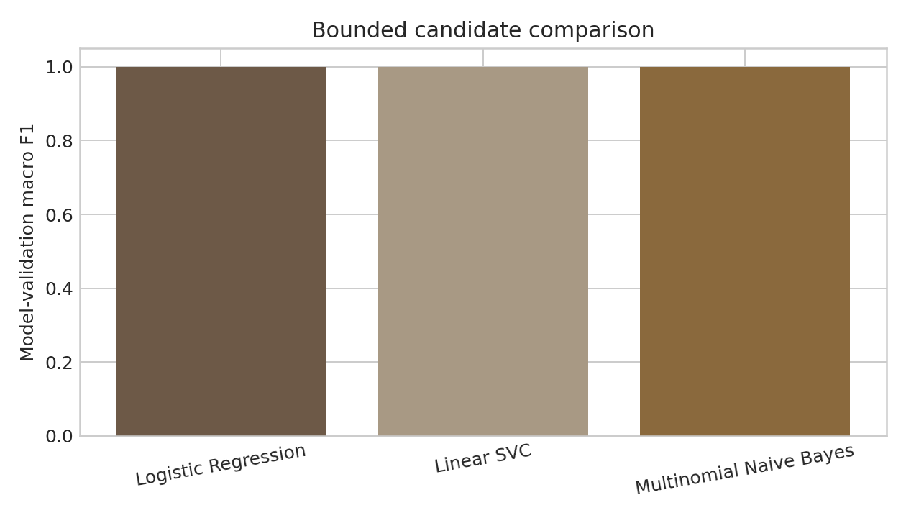
Model Comparison

Testing and Validation

Commands
python -m compileall -q app.py pages src ui tests scripts training synthetic_benchmark
python -m pytest -q --strict-markers --junitxml=reports/results/pytest_results.xml
python scripts/evaluate_packaged_samples.py
python scripts/audit_public_release.py --allow-publication-gates
python -m pip check
The web reference source is checked with npm ci, npm run lint, and npm run build from web/.

Coverage
Tests cover synthetic archive identity, authored split counts, event/content isolation, signal derivation, model loading, model-to-calibration binding, consistent and contradicting samples, abstention, preprocessing, summarisation, URL/file safety, exports, database/session behavior, UI contracts, analytics, drift readiness, legal records, secret scanning, and release fail-closed behavior.
The CI workflow runs the complete test suite with the public model. No private-artifact test is deselected.

Evaluation discipline
The final test is not used for candidate selection, calibration fitting, or threshold choice. Candidate selection uses model validation; Platt fitting uses calibration; policy selection uses abstention policy. Event pairs never cross partitions. Exact metrics and controls are in reports/model_benchmark_summary.json.

Interpretation
Passing tests establishes implementation and in-distribution benchmark behavior. It does not establish factual accuracy on real articles. Deployment smoke tests must separately validate public startup, supported paths, outside-scope withholding, fresh-session input isolation, probability helper wording, a newly downloaded overlap-free PDF, exports, error handling, responsive headline/illustration/footer behavior, banner removal, and absence of raw training-data exposure. Controlled diagnostics found no cache or mapping defect: similar 87–88% internal outputs on ordinary articles came from their shared unavailable-block signal and are now withheld from public presentation.

Public Release Audit
The release gate is implemented by scripts/audit_public_release.py and fails closed.
It checks:
- dataset archive path, 10,319,934-byte size, SHA-256, and Git blob;
- public model and calibration existence, size, SHA-256, and exact binding;
- synthetic-only manifest declaration and absence of historical private artifact paths;
- secret, key, personal-data, and absolute local-path patterns;
- forbidden runtime/cache/database files;
- local Markdown links and internal navigation controls;
- legal and attribution files;
- the remaining live Streamlit URL publication gate.
Before deployment the scan may run with --allow-publication-gates, which permits only the explicitly reported unresolved URL while preserving every safety and artifact-integrity gate. After deployment it must pass without that flag.
The sanitized machine-readable result is reports/results/public_release_scan.json. Finding contents are never printed to shared CI logs.

Phase 5S PR B File-Change Manifest

Added
- Public synthetic model and bound calibration.
- Artifact manifest and deterministic model-training workflow.
- Synthetic model contracts and locked evaluation evidence.

Updated
- Runtime configuration, prediction, calibration, diagnostics, explainability, visualizations, and Streamlit pages.
- Three original fictional packaged samples.
- CI and public-release integrity gates.
- README, dataset/model cards, architecture, setup, testing, deployment, licensing, privacy, ownership, audit, case-study, interview, Phase 5S, DOCX, and PDF reports.
- Next.js reference copy so it accurately describes the synthetic system and no Vercel requirement.

Removed
- External-dataset training/download/evaluation notebooks and scripts.
- Optional external transformer summarization path and dependencies.
- Superseded external-dataset figures and summarization benchmark artifacts.
- Historical permission-request file whose operational purpose ended when the private model was excluded.
Tracked removals are recoverable from Git history. No private artifact, historical release tag, Vercel deployment, or retained Dependabot pull request was modified.

