  - NEWSLENS AI

NewsLens AI Concepts, Methodologies and Terminology Guide
Synthetic data, linear NLP, calibration, leakage controls and responsible interpretation

All classifier training articles and entities are synthetic. This report documents a bounded ledger-consistency demonstration, not unrestricted real-world fact verification.

Prepared by
Deven Sachin Gaikwad
26 September 2026

Document control
Field | Value
Project | NewsLens AI
Phase | 5S release with 5T presentation maintenance
Author | Deven Sachin Gaikwad
Status | Phase 5T PDF and UI clarity correction with reconciled documentation

Dataset Card — NewsLens Synthetic Articles v1.0.0

Identity
- Repository path: data/synthetic/newslens-synthetic-articles-v1.0.0.zip
- Size: 10,319,934 bytes
- SHA-256: 3b6df1fa17615bfe1b67f6c9136909c668ec846e3fa8d205fa8e4aa2a80526cc
- Git blob: cb0d5e57407be10fecefb34762e586bacd38dd56
- Generator version: 1.0.0
- Generator seed: 20260916
- License: CC BY 4.0 to the extent applicable rights subsist; project code and application retain their separate notices.

Provenance
The corpus was independently generated for NewsLens AI from project-authored fictional vocabularies, templates, entities, and event records. Functional compatibility is limited to label, schema, interface, objective, and application behavior.
The archive contains only project-authored fictional source material. No row, copied phrase, close paraphrase, transformation, translation, summary, or reconstruction from an external copyrighted article dataset was used as generation material.

Structure
The 24,000 rows represent 12,000 event pairs. Each pair contains one synthetic_ledger_consistent and one synthetic_ledger_contradicting article. Both expose a Reference note and an Article account with eleven comparable fields.
The CSV includes article and event IDs, title, text, label, topic, template family, mutation family, authored split, generator version, seed, and content SHA-256. The archive also includes event records, generation metadata, a manifest, and documentation.

Quality and leakage controls
- Exact row duplicates: 0.
- Cross-partition event overlap: 0.
- Cross-partition content-hash overlap: 0.
- Balanced labels: 12,000 each.
- Authored partition counts: 18,000 / 2,400 / 1,200 / 1,200 / 1,200.
- Completed generator reproducibility, schema, label-balance, paired-event, phrase-screening, and human-review evidence remains under reports/.

Appropriate and inappropriate use
Appropriate uses include deterministic ML demonstrations, leakage teaching, calibration exercises, regression tests, and portfolio review. Inappropriate uses include representing the corpus as real reporting, attributing its entities to real people, or claiming it measures unrestricted real-world fake-news detection.

Selected measured figures
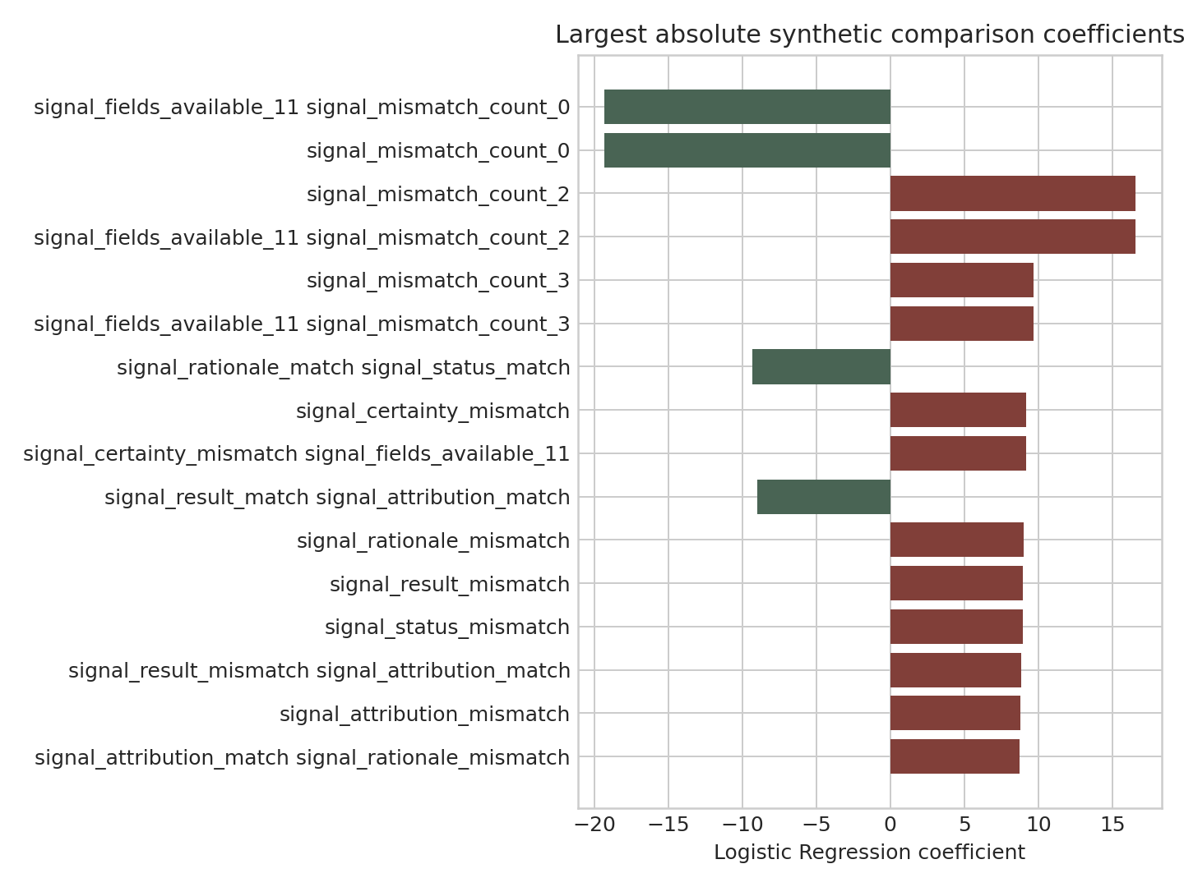
Feature Importance
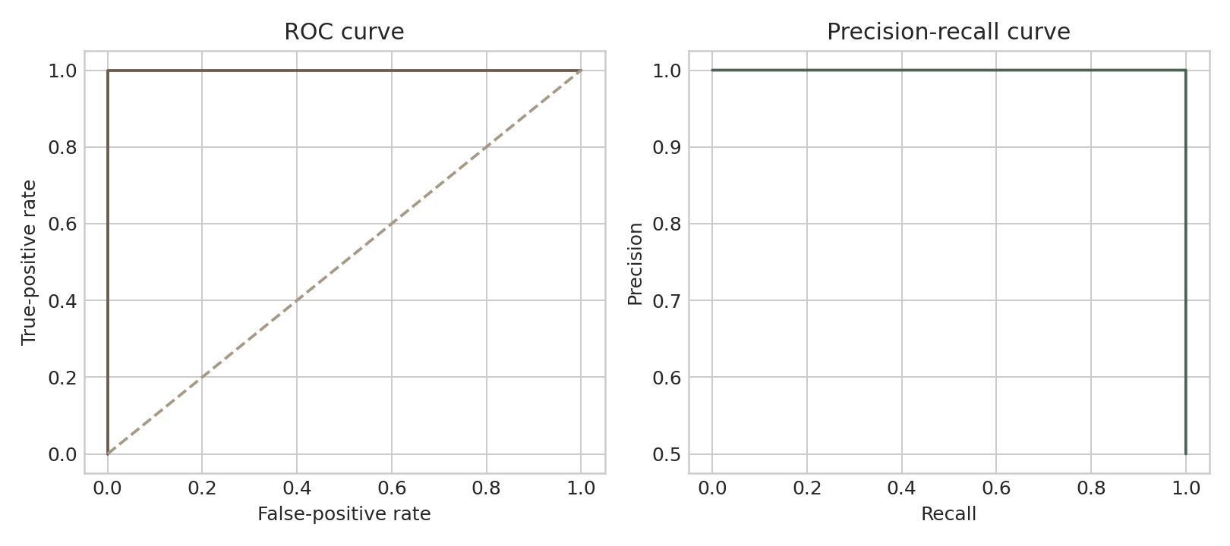
Roc Pr Curves

Model Card — NewsLens Synthetic TF-IDF v1.0.0

Summary
NewsLens AI packages a Logistic Regression classifier over word/bigram TF-IDF features and transparent, label-independent fact-comparison tokens. All training articles, entities, events, names, places, organizations, and reported facts are synthetic.
- Artifact ID: newslens-synthetic-tfidf-v1.0.0
- Positive class: synthetic_ledger_contradicting
- Model SHA-256: c1ad8c044cd95bc7bf25a94716010ddbe21fbae2ec92a0c1cefb01f5c3c979c6
- Calibration: Platt scaling
- Calibration SHA-256: adcf03a860ef8fb41058b3a4dcc80351dbd02e05f81e0fc1e7f971624af6ab77
- Editorial-review threshold: 0.50
- Random seed: 42

Intended use
The model demonstrates a reproducible classification and calibration workflow. It compares the values in two visible structured lines—Reference note and Article account—within an original fictional article. It may support classroom demonstration, portfolio review, software testing, and research discussion about leakage, calibration, abstention, and explainability.
It is not intended to determine whether ordinary news is true, rate publishers, infer author intent, guide high-stakes decisions, or replace professional fact-checking.

Training data
Only newslens-synthetic-articles-v1.0.0 was used. The archive contains 24,000 articles / 12,000 paired events. Event pairs and content hashes never cross partitions.
Partition | Rows | Purpose
Training | 18,000 | Fit candidates
Model validation | 2,400 | Select candidate
Calibration | 1,200 | Fit Platt mapping
Abstention policy | 1,200 | Select threshold
Final test | 1,200 | Locked evaluation

No external copyrighted article dataset or non-redistributable model/calibration artifact was accessed or used for this public package.

Selection and evaluation
Logistic Regression, Linear SVC, and Multinomial Naive Bayes were evaluated on model validation. Logistic Regression was retained within a declared 0.005 macro-F1 tolerance because it provides a compact CPU artifact, linear explanations, and a stable calibration score.
On the locked final test: accuracy, balanced accuracy, precision, recall, macro F1, ROC AUC, and average precision were all 1.0; the confusion matrix was [[600, 0], [0, 600]]. Calibrated Brier score was 1.4968608529442928e-06; 10-bin ECE was 0.0007422494250466733; automatic coverage at threshold 0.50 was 100%.

Shortcut and causal controls
- Surface text with both fact blocks removed: balanced accuracy 0.500.
- Locked model with both fact blocks removed: balanced accuracy 0.498.
- Metadata-only baseline: balanced accuracy 0.521.
- Swapping only the Article account block across each paired event: 100% prediction flips and 100% expected-label accuracy.
These controls support the conclusion that the model uses the authored comparison signal in this benchmark. They do not prove real-world generalisation.

Calibration and abstention
The Platt calibration file contains the exact model SHA-256, and runtime loading fails closed on a mismatch. Fields agree - calibrated probability and Fields conflict - calibrated probability are the two synthetic benchmark-class probabilities learned from the visible Reference note and Article account comparison patterns. Reference-comparison confidence is the calibrated confidence in the selected synthetic consistency class, not factual certainty. If either structured block is missing, the UI, PDF, and archive CSV show Outside supported comparison scope and withhold directional values; stable JSON score fields remain for compatibility and are explicitly marked withheld_outside_supported_scope. Controlled Phase 5T tests ruled out stale state, cache reuse, class-index reversal, and calibration misapplication. Similar 87–88% internal outputs on unrelated ordinary articles arose because all lacked the required pair and shared the dominant signal_fact_blocks_unavailable feature. Those internal values are not factual credibility scores.

Limitations and ethics
The task is intentionally regular and synthetic. Perfect results are expected to be easier than open-world factual reasoning. Confidence is conditional on the benchmark, not a truth probability. Users must independently verify important claims and should not use the output for legal, medical, financial, civic, or reputational decisions.

Privacy and Data Handling
The public Streamlit workflow is designed to minimize retained data.
- Pasted text and uploaded TXT/PDF content are processed for the active request.
- Uploaded files are not saved by application code.
- Full article text is not written to SQLite.
- The structured analysis archive uses a visitor-scoped temporary database in public hosting.
- Source URLs and reviewer notes remain within that visitor session.
- Privacy-safe analytics export only aggregates and excludes titles, summaries, URLs, notes, identifiers, and article text.
- URL fetching occurs only after the user supplies a public HTTP(S) URL; private and loopback targets are blocked.
- No paid AI API, authentication token, telemetry key, or Streamlit secret is required.
- Raw training rows and the dataset ZIP are not exposed through the interface.
Cloud infrastructure and GitHub/Streamlit remain subject to their own privacy terms. Users should avoid submitting confidential or personal material.

Placement Interview Guide — NewsLens AI

Thirty-second explanation
NewsLens AI is a Streamlit NLP portfolio project with two independent paths: deterministic extractive summarisation and a public classifier trained only on an original synthetic fact-consistency benchmark. I designed group-safe splits, separate calibration and policy partitions, shortcut baselines, a counterfactual test, exact artifact binding, abstention, explanations, security gates, and deployment evidence. I explicitly avoid claiming that synthetic consistency equals real-world truth detection.

Key technical decisions
- Why Logistic Regression? It matched the best bounded candidate within a declared tolerance, gives fast CPU inference, exposes linear coefficients, and provides a stable calibration score.
- Why five partitions? Training, selection, calibration fitting, threshold selection, and final evaluation must not reuse the same evidence.
- Why group by event? A consistent and contradicting article describe the same fictional event; separating them would leak paired content.
- Why Platt calibration? It maps the raw linear score to an empirically fitted probability and can be stored in a small, inspectable, hash-bound artifact.
- Why abstain? A confident internal score is unsafe outside the supported paired-ledger format. Missing blocks therefore show Outside supported comparison scope, and the UI, PDF, and archive CSV withhold directional values.
- How were shortcuts tested? Surface-only and metadata-only baselines, fact-block ablation, and a paired account-block counterfactual.
- How is supply-chain integrity enforced? SHA-256 manifest checks, calibration binding, pinned dependencies, CI, release scanning, branch protection, and exact-head verification.

Honest limitations
Perfect locked-test performance belongs to a deliberately structured synthetic task. It does not demonstrate factual reasoning, publisher assessment, multilingual robustness, or open-world misinformation detection. The application should be described as a responsible technical demonstration, not a production fact-checker.

