  - NEWSLENS AI

NewsLens AI Project Report
Synthetic-only classifier, calibration, evaluation and deployment evidence

All classifier training articles and entities are synthetic. This report documents a bounded ledger-consistency demonstration, not unrestricted real-world fact verification.

Prepared by
Deven Sachin Gaikwad
26 September 2026

Document control
Field | Value
Project | NewsLens AI
Phase | 5S release with 5T presentation maintenance
Author | Deven Sachin Gaikwad
Status | Phase 5T PDF and UI clarity correction with reconciled documentation

NewsLens AI
NewsLens AI is a noncommercial student and placement-portfolio demonstration built by Deven Sachin Gaikwad. It combines deterministic extractive summarisation with an explainable classifier trained exclusively on an independently created synthetic benchmark.
The classifier has a deliberately narrow purpose: compare the visible Reference note and Article account fields in the supported fictional format and indicate whether their ledgers are consistent or contradicting. It is not a general fake-news detector and does not establish real-world truth.

What is public
- 24,000 original synthetic articles representing 12,000 fictional paired events.
- Deterministic generator, manifest, audit evidence, and reproducibility tests.
- TF-IDF bigram + Logistic Regression public model.
- Platt calibration cryptographically bound to the exact model SHA-256.
- Group-safe training, validation, calibration, abstention-policy, and locked-test partitions.
- Streamlit interface with summarisation, classification, abstention, explanations, exports, session-local review, and aggregate monitoring.
All training articles and entities were independently authored for this project. No external copyrighted article dataset or non-redistributable model/calibration artifact is included.

Measured evidence
Measure | Result
Locked final-test rows | 1,200
Accuracy / balanced accuracy / macro F1 | 1.000 / 1.000 / 1.000
Confusion matrix | `[[600, 0], [0, 600]]`
Platt Brier score | 0.000001497
Expected calibration error | 0.000742
Counterfactual account-swap flip rate | 100%
Surface-text-only balanced accuracy | 0.500
Fact-block ablation balanced accuracy | 0.498
Metadata-only balanced accuracy | 0.521

Perfect in-distribution performance reflects a structured synthetic comparison task; it must not be interpreted as unrestricted news-veracity performance.

Run locally
Python 3.12 is the deployment target.
python -m venv .venv
source .venv/bin/activate
python -m pip install -r requirements-lite.txt
python -m streamlit run app.py
On Windows PowerShell, activate with .venv\Scripts\Activate.ps1.
No API key or secret is required. The packaged model and calibration are loaded from models/ without runtime training.

Reproduce the model package
The authoritative dataset archive is already versioned. The following command verifies its identity, trains on the authored training split, selects only on model validation, fits calibration, selects the abstention policy, and evaluates the locked final test once:
python training/train_synthetic_model.py
The accepted public artifacts are described in models/public_artifact_manifest.json. Re-running training in a materially different dependency environment can change serialized bytes; publication uses the recorded artifacts and hashes.

Validate
python -m compileall -q app.py pages src ui tests scripts training synthetic_benchmark
python -m pytest -q --strict-markers
python scripts/audit_public_release.py --allow-publication-gates
The release scan verifies the dataset ZIP, public model, calibration binding, legal package, secrets, private artifact exclusions, navigation, and local links.

Responsible use
- Inputs lacking both supported fact blocks are routed to Editorial review required.
- Fields agree - calibrated probability and Fields conflict - calibrated probability are the two synthetic benchmark-class probabilities learned from the visible Reference note and Article account comparison patterns. Reference-comparison confidence is the calibrated confidence in the selected synthetic consistency class, not factual certainty. If either structured block is missing, the UI, PDF, and archive CSV show Outside supported comparison scope and withhold directional values; stable JSON score fields remain for compatibility and are explicitly marked withheld_outside_supported_scope. Controlled Phase 5T tests ruled out stale state, cache reuse, class-index reversal, and calibration misapplication. Similar 87–88% internal outputs on unrelated ordinary articles arose because all lacked the required pair and shared the dominant signal_fact_blocks_unavailable feature. Those internal values are not factual credibility scores.
- The app does not expose raw training rows.
- Public history is isolated to a visitor session; full article text is not persisted.
- Human verification against independent primary sources remains necessary.
See docs/DATASET_CARD.md, docs/MODEL_CARD.md, docs/TESTING.md, and docs/DEPLOYMENT.md for the full evidence trail.
© 2026 Deven Sachin Gaikwad. All Rights Reserved. The synthetic dataset has the separate license described in its dataset card.

Selected measured figures
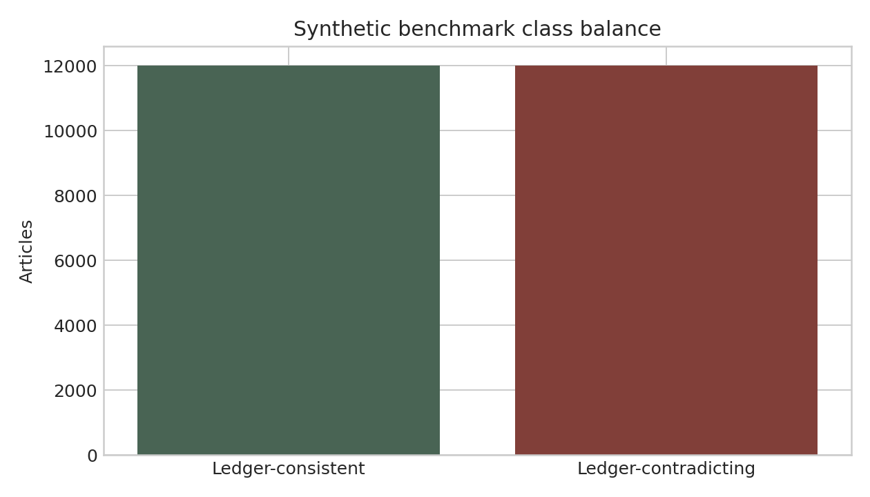
Class Distribution
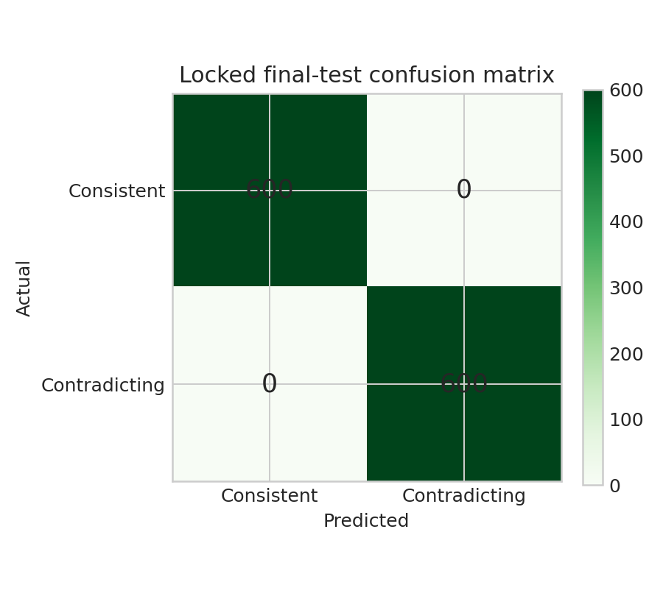
Confusion Matrix
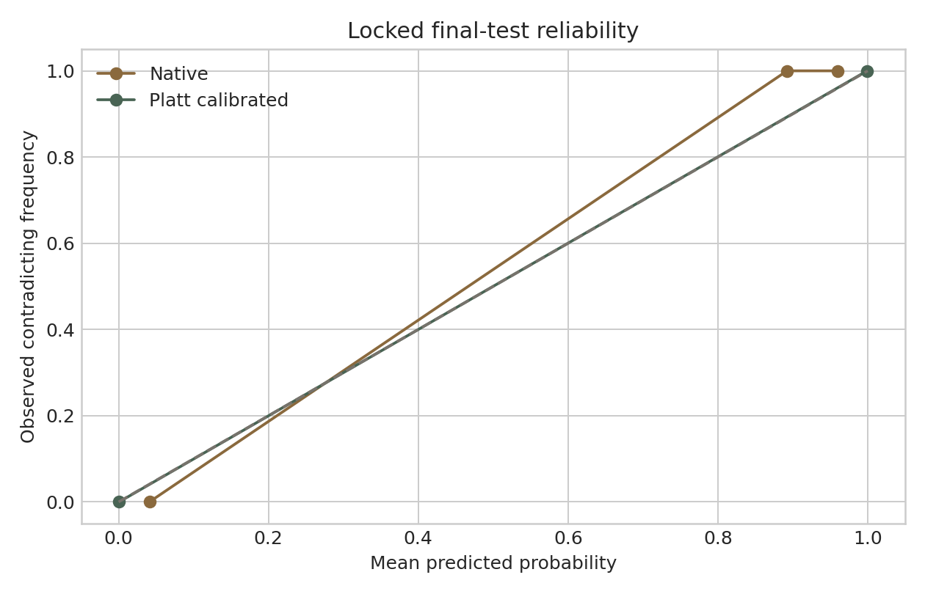
Calibration Reliability

NewsLens AI Phase 5S Deployment and Audit Report
Updated: 26 September 2026

Dataset release (PR A)
- PR: #44
- URL: https://github.com/DevenGaikwad/NewsLens-AI/pull/44
- Owner upload commit: e6031fa6ec193131be5fed4704722125104b066f
- Follow-up head: 326499bb6f58f0420a0cf36a00828a901836323d
- Squash merge: d3e77e6610c4a9c83d9137ca672a9aad4278285f
- Resulting tree: 520bad55ea12f1a8e48ad2e533af26312c62933d
- Signature: GitHub verified
- Merge time: 2026-09-25T12:14:59Z
- Required PR and exact-new-main checks: passed

Dataset identity
- Path: data/synthetic/newslens-synthetic-articles-v1.0.0.zip
- Size: 10,319,934 bytes
- SHA-256: 3b6df1fa17615bfe1b67f6c9136909c668ec846e3fa8d205fa8e4aa2a80526cc
- Git blob: cb0d5e57407be10fecefb34762e586bacd38dd56
- License: CC BY 4.0 to the extent applicable rights subsist
- Provenance: independently generated original fictional articles and entities

Model evidence
- Model: models/newslens_synthetic_pipeline.joblib
- Model SHA-256: c1ad8c044cd95bc7bf25a94716010ddbe21fbae2ec92a0c1cefb01f5c3c979c6
- Calibration: models/newslens_synthetic_calibration.json
- Calibration SHA-256: adcf03a860ef8fb41058b3a4dcc80351dbd02e05f81e0fc1e7f971624af6ab77
- Binding: exact model hash recorded in calibration and public manifest
- Training / validation / calibration / policy / test rows: 18,000 / 2,400 / 1,200 / 1,200 / 1,200
- Cross-partition event/content overlap: 0 / 0
- Locked accuracy, balanced accuracy, macro F1: 1.0 / 1.0 / 1.0
- Brier / ECE: 0.000001497 / 0.000742
- Coverage at threshold 0.50: 100%
- Counterfactual flip rate: 100%
- Surface-only / ablation / metadata balanced accuracy: 0.500 / 0.498 / 0.521

Publication boundary
Only the independently authored synthetic benchmark and its derived public artifacts are in the model, repository archive, and release. No external copyrighted article dataset or non-redistributable artifact is included, and noncommercial status was not used as a substitute for rights.

PR B and deployment
Model PR B #45 was validated at head 56f6e3e7137bd03fe45a0cd3e88978588968cdd1 and squash-merged as 214b22745736b25f4c1121822a1811c76687bb00 with tree 093cdbacf815be22791ae73bf5a581a9e84edd3d. Final evidence PR #46 merged as 4eb0fffef103c76e294a9d1d4d4a8df599ba2ef2, producing tree 7cd77ad091dac8e2df6de9a910b5871e656881d4. Exact-new-main CI and CodeQL passed, and the public Streamlit application was smoke-tested at https://newslens-ai-devengaikwad.streamlit.app/.
Vercel remains outside scope. Dependency pull requests are reviewed separately and are not merged merely to reduce their count.

Editorial AI Case Study: From Blocked Artifact to Synthetic-Only System

Problem
The original demonstration depended on a private classifier whose training-data redistribution position did not support public deployment. Publishing source without a working model would create a misleading portfolio artifact; publishing the private artifact would violate the project's evidence and rights policy.

Intervention
NewsLens AI introduced an independently authored fictional benchmark of 24,000 articles / 12,000 paired events. Each article exposes a Reference note and Article account. Consistent examples repeat the authored facts; contradicting examples alter one or more fields. Event-grouped partitions prevent paired variants from crossing training and evaluation boundaries.
Three candidates were compared on model validation. A compact Logistic Regression pipeline was retained, Platt calibration was fitted on a separate partition, and the review threshold was selected on another partition. The final test remained locked until all decisions were fixed.

Results
The locked test achieved 1.0 accuracy, balanced accuracy, and macro F1 with a [[600, 0], [0, 600]] confusion matrix. Brier score was 0.000001497 and ECE 0.000742. Surface text and fact-block ablation remained at chance, metadata was near chance, and swapping only Article account values flipped every paired prediction.

Product integration
The public model and calibration are hash-bound. Missing structured blocks force human review. Deterministic summarisation remains separate from classification. The app preserves explanations, exports, privacy-safe session history, responsive presentation, and honest limitations without an external checkpoint or paid API.

Lesson
The central engineering achievement is not a claim of universal fake-news detection. It is a traceable replacement of an unpublishable dependency with a bounded, reproducible, original, deployable system whose success criteria match its declared task.

Licensing Status

Current public package
NewsLens AI is a proprietary, source-visible student and portfolio demonstration. Original application code, interface materials, reports, and documentation are © 2026 Deven Sachin Gaikwad, All Rights Reserved, unless a file expressly states otherwise.
The independently created newslens-synthetic-articles-v1.0.0 dataset is offered under CC BY 4.0 to the extent applicable rights subsist. Its generator, provenance, and identity are recorded in docs/DATASET_CARD.md and data/synthetic/.
The public model and calibration were created exclusively from that dataset and are intentionally distributed with this demonstration under the repository's stated source-visible terms. Third-party Python and JavaScript packages retain their own licenses.

Excluded material
No external copyrighted article dataset is redistributed. No row, phrase transformation, non-redistributable classifier, calibration, vocabulary, coefficient, prediction, or evaluation artifact from an external article dataset is present. The earlier private-artifact redistribution question is resolved by replacement, not by assuming permission.
Noncommercial educational use is not treated as automatic copyright permission.

