1. Consider an ideal low pass filter with the cutoff frequency $ω_{c}=0.3π$. We want to approximate this filter using a frequency-sampling design in which we choose 40 samples.
2. Choose the sample at $ω_{c}=0.5$, and use the naïve design method to compute h(n). Determine the minimum stopband attenuation.
3. Now vary the sample at $ω_{c}$, and determine the optimum value to obtain the largest minimum stopband attenuation.
4. Plot the magnitude responses in dB of the preceding two designs in one plot; comment on the results.
5. Design a minimum-order linear phase FIR filter, using the Parks-McClellan algorithm, to satisfy the requirements given below.

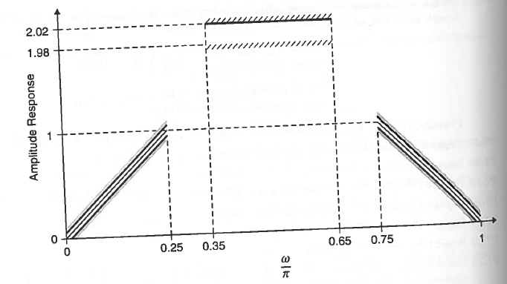

1. Provide a plot of the amplitude response with grid lines and axis labeling as show in the above figure
2. Generate the following signals:

$$x_{1}=\cos\left(0.25πn\right), x_{2}=\cos\left(0.5πn\right), x_{3}=\cos\left(0.75πn\right), 0≤n≤100$$

Process these signals through this filter to obtain the corresponding output signals $y_{1}\left(n\right), y_{2}\left(n\right) \& y_{3}\left(n\right).$ Provide stem plots for all input and output signals in one figure.