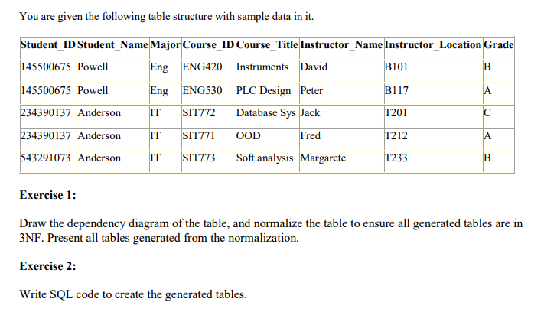

Please provide a solution to this.

Thanks