**QUESTION 6**

1. 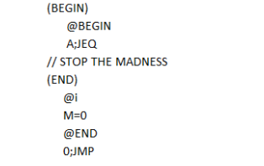

Consider the above snippet of Hack assembly code, translate them to machine instructions (binary instructions).First, construct the symbol table for all the symbols appeared in the code:

symbol                value









Then assemble the instructions (the number simulate the indexes in ROM)

0

1

2

3

4

5

6

Extra spaces are provided. Enter "N/A" if a blank is not in use.

Once compiled, how many words in ROM will be occupied (i.e., once assembled, how many lines of instructions are generated in ROM)?