**Q1. HMM**

Andrew lives a simple life. Some days he’s angry and some days he’s happy. But he hides his emotional state, and so all you can observe is whether he smiles, frowns, laughs, or yells.

We start on day 0 in the Happy state, and there’s one transition per day.

P(S0 = happy ) = 1 ,

Since we start on day 0 in the Happy state.

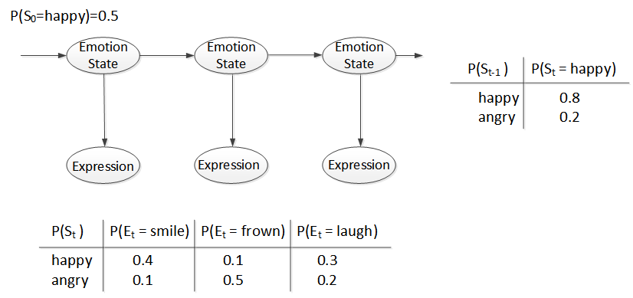

St = Emotion State on day t ∈ {*happy, angry*}

Et = Observation by Expression on day t ∈ {*smile, frown, laugh, yell*}

1. Compute P(*S2* = *angry*).
2. Compute P(*E2* = *frown*).
3. Compute P(*S2* = *happy | E2* = *frown*).
4. Compute P( *E100* = *yell*).
5. Assume that *E1* = *frown, E2* = *frown, E3* = *frown, E4* = *frown, E5* = *frown.*

What is the most likely sequence of states?

**Q2. Maximum Likelihood (ML) Learning**

The table shows the examples of SPAM and those of HAM messages which are consisted of some words whose dictionary size is twelve. Suppose that you’ve received SPAM messages for the 1st 3 days, then HAM messages for the next 5 days, i.e. a data as a sequence of message is <Spam, Spam, Spam, Ham, Ham, Ham, Ham, Ham >.

|  |  |
| --- | --- |
| *SPAM* | *HAM* |
| offer is secret | play golf tomorrow |
| click secret link | went play golf |
| secret golf link | secret golf event |
|  | golf is tomorrow |
|  | golf costs money |

1. Compute the ***maximum likelihood*** of *SPAM, i.e.* P(*SPAM*)=θ, using a *log-likelihood.*
2. In the Bayesian network of this ML parameter learning,
3. Draw the BN with the CPT of the required parameters (e.g. θ1, θ2, …..). -- You don’t have to compute the exact values of parameters yet.
4. How many parameters are required?
5. By ML-learning, compute a parameter value, P(“*secret*” | *SPAM*) and P(“*secret*” | *HAM*), respectively.
6. Now, the new message “*golf*” is received. What is the probability that this message is *SPAM*?
7. The new message “*secret is secret*” is received. What is the probability that this is *SPAM*?
8. For a new message, “*tomorrow is secret*”, what is the probability that the message is *SPAM* and *HAM*, respectively?