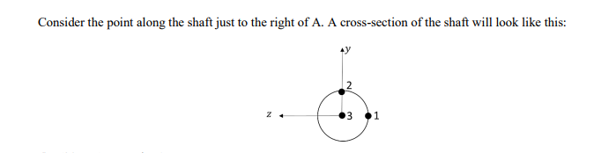

1. For point 1: A. Compute the stresses at point 1 due to bending, shear and torsion. B. Draw ALL the stresses in an infinitesimal element and label them correctly (𝜎𝑥, 𝜎𝑦, 𝜏𝑥𝑦,etc.). C. Draw separately how would this infinitesimal element deform due to bending, shear, and shear due to torsion (i.e. make three drawings of a deformed cube). Making a legible drawing of the combined deformation is not easy, but try to visualize the combined deformation in your head.
2. Repeat part 6, but considering point 2.
3. Repeat part 6, but considering point 3.
4. Based on your results, where is the most highly stressed point of the shaft i.e. where should we be targeting to remain below the yield strength? Note that finding this point (we call it the critical point for design) is the end-goal of the design exercise. If we exceed the yield strength in this point, we probably need to increase the diameter, change the material, or reduce our applied forces.
5. In part 2, we assumed the bearings are simple supports. This is a simplification. The shaft is inserted into the bearings by a certain length so this does not correspond to a simple support.

a) Draw the free body diagram of the beam from plane zx, discarding the assumption that the bearings are simple supports.

If you did a) correctly, you should have more unknowns than the 3 independent equilibrium equations. This is therefore a statically indeterminate problem, which is solved using deflection methods (Section 4.10; you might also have seen this in Mechanics of materials). Engineering handbooks (e.g. “Roark’s formulas for stress and strain”) can provide formulas for the reactions. The figure below, for example, is from Table A-9 of the book, and applies to a similar situation.

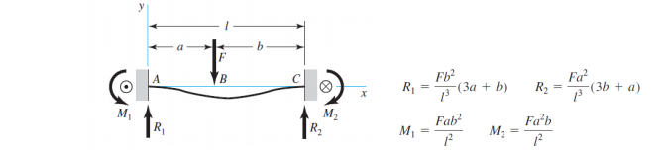

b) Knowing the real type of reaction at the bearings, roughly sketch (i.e. no values) shear, moment, and torque diagrams for the zx plane. Is the critical point for design likely to change?