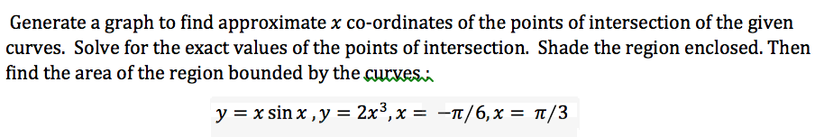

figure;

% %Creating anonymous function

h= @(x)x.*sin(x);

hh= @(x)2.*x.^3;

x=linspace(-pi/6,pi/3,1000);% -pi/6<x<pi/3

grid on

% %Generate a graph

plot(x,h(x),'m');

hold on

plot(x,hh(x),'g');

% formaiting a plot

xlabel('x-axis')

ylabel('y-axis')

title('Graph Q4 part b')

% Exact points of x and y intersection

% syms x

% Equation2= x.*sin(x)-(x)2.*x.^3;

% solution2=solve(Equation2,x)

% x_intercept(1)=double(solution2);

% x_intercept(2)=-double(solution2); %the graph is not symmetrical.

% plot(x_intercept,y(x_intercept),'k*')

%

% %Shade the region enclosed

% fill(x,h(x),'b') % fill area defined by lower curve

% fill(x,hh(x),'b') %fill area defined by upper curve

% legend('h=x.*sin(x)','hh=(x) 2.*cos(x)','','Shaded region enclosed')

% %The area of the region bounded by the curves

% Area=int(Equation2) % I SHOULD ADD BOUNDRY?