Objective: Given this image of the Connect Four game, your code must determine where the pieces are currently

located; a perfect image thresholding problem! In the image the physical game board is dark blue with red pieces for Player 1 and yellow pieces for Player 2.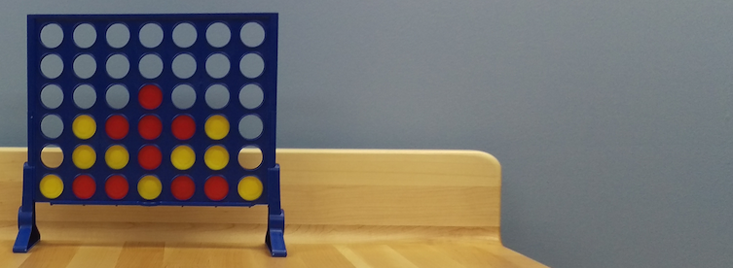

Your code should create a board layout in the form of a matrix that looks exactly like this:

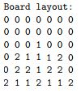

(Note that a 0 is an empty space, 1 is a red piece, and 2 is a yellow piece.)