PPTP VPN configuration in ubuntu

- Go to setting

- On the Network Connections menu click the "Add" button:

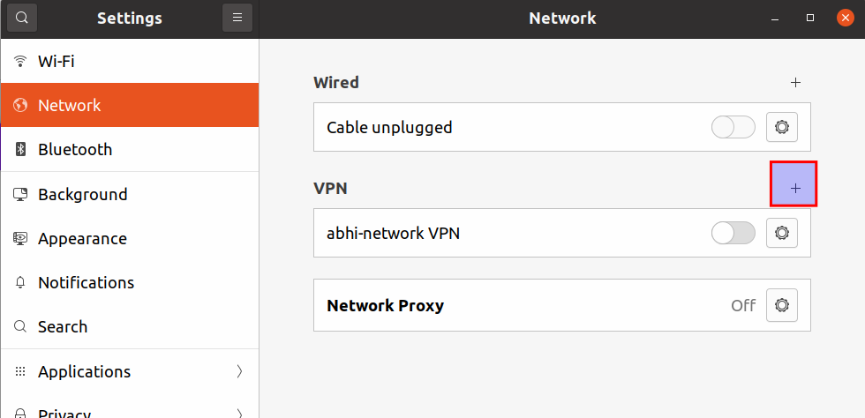
3. Then select the connection type as "Point-to-Point Tunneling Protocol (PPTP)"

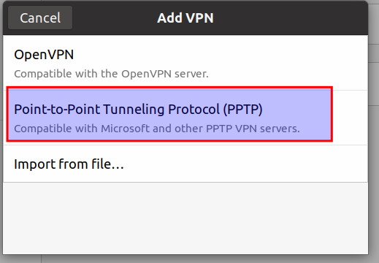

- After this configuration details window will appear, fill the VPN details (Gateway Username, Password) and click on Add.
- In the password field click on the User icon and click on store the password for all users

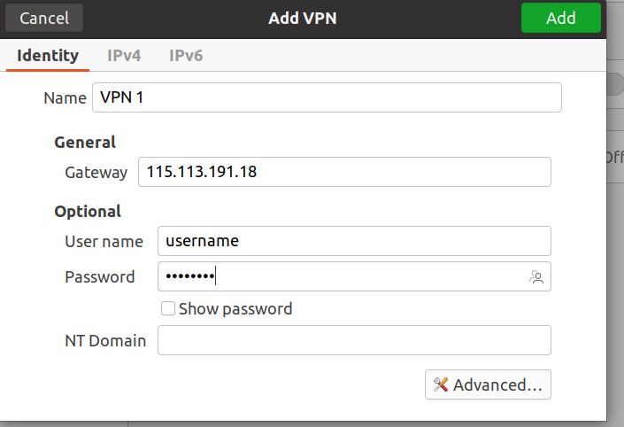

After clicking on Add button, enable vpn connection

