**Explainable Online Learning for Real-Time Soft Failure Prediction and Automated Restoration in Elastic Optical Networks**

**Abstract**

As dynamic traffic patterns and rapid service provisioning grow commonplace, soft failures in elastic optical networks (EONs) represent a serious threat to service reliability. For real-time soft failure management, we provide a unified, explainable online learning system that combines automatic closed-loop restoration, SHAP-based model interpretation, and gated recurrent unit (GRU)-based failure prediction. In contrast to static machine learning techniques, our solution retrains on streaming telemetry to continuously adjust to concept drift and gives operators meaningful, interpretable insights. The superiority of our technique is demonstrated by extensive testing on the genuine NSFNET topology and synthetic time-series datasets with manufactured drift. According to quantitative statistics, our model outperforms static baselines by 31%, achieving a 95% restoration success rate and a 79% post-drift detection accuracy.Using our simulation system, these performance indicators are computed directly from the trained model. On the other hand, the post-drift accuracy of the static baseline model falls precipitously to 48%. Our results demonstrate that in order to guarantee strong and resilient EON management, flexible, transparent methods are required. The effectiveness of explainable online learning in maintaining network service reliability in the face of shifting operational conditions is demonstrated by this work.

**Keywords :** Elastic Optical Networks (EONs) , Soft Failure Detection, Online Learning , Explainable Artificial Intelligence (XAI) , Gated Recurrent Unit (GRU), SHAP Interpretation , Restoration Mechanism

**1. Introduction**

The rapid evolution of communication technologies, fueled by the proliferation of cloud computing, the Internet of Things (IoT), and bandwidth-intensive multimedia applications, has necessitated a new generation of flexible, high-capacity backbone networks [1]. **Elastic Optical Networks(EONs)** have emerged as a pivotal solution, leveraging flexible grid technology and dynamic spectrum allocation to address the diverse and growing requirements of modern digital infrastructure [2]. By enabling granular bandwidth provisioning and efficient spectrum utilization, EONs promise not only high throughput but also adaptability to varying traffic patterns and service demands [3]. However, this operational agility introduces unique management complexities, especially concerning service reliability and fault tolerance during frequent network reconfiguration and scaling [4].

A particularly insidious challenge in EON management is posed by **soft failures** degradations in network quality such as filter shifting, bandwidth narrowing, and optical signal-to-noise ratio (OSNR) impairment—that do not result in immediate service interruptions but may gradually undermine quality of service (QoS) and lead to costly outages if not promptly addressed [5]. Unlike hard failures, which manifest as abrupt service disruptions and are easily detected, soft failures are typically subtle, often falling below conventional monitoring thresholds and thus escaping timely detection and localization [6]. Studies have shown that unchecked soft failures can cause service-level agreement (SLA) violations, reduce network lifetime, and even propagate errors across the network [7]. As EONs expand in scale and complexity, manual monitoring and troubleshooting become increasingly untenable, underscoring the need for intelligent, automated fault management solutions [8].

**Machine learning (ML)** has made significant inroads into the domain of optical network management, offering new possibilities for predictive maintenance, QoT estimation, and soft failure localization [9]. Classical ML models—such as support vector machines (SVM), random forests, and deep neural networks (DNN)—have demonstrated considerable success in classifying, predicting, and localizing various types of failures within optical networks [10]. In particular, DNNs have shown robust performance in recognizing complex temporal patterns that precede network degradations, outperforming traditional threshold-based techniques [11]. However, a notable limitation of most conventional ML methods is their static nature: models are typically trained on historical datasets and lack the ability to adapt to changes in network topology, traffic distribution, or environmental conditions, a phenomenon commonly known as **concept drift** [12].

**Concept drift**poses a substantial obstacle for operational deployment of ML in EONs. When the underlying data distribution shifts—due to dynamic spectrum reallocation, hardware aging, or changes in service patterns—static models can quickly become obsolete, leading to misclassification and reduced detection accuracy [13]. Recent research has therefore emphasized the importance of **online and incremental learning** approaches, which continuously update model parameters in response to streaming telemetry data, allowing for real-time adaptation to evolving network states [14]. In this context, recurrent neural network (RNN) architectures such as **gatedrecurrent units (GRU)**and long short-term memory (LSTM) networks—have proven particularly effective for time-series analysis and soft failure prediction, as they can capture both short- and long-term temporal dependencies in optical network measurements [15].

Despite these advances, the **"black-box"** character of deep learning models remains a critical concern for practical adoption in mission-critical network operations [16]. Network operators must be able to interpret and trust the outputs of automated systems, particularly when these systems are responsible for failure localization and restoration actions that may impact service continuity [17]. This necessity has driven the adoption of **explainable artificial intelligence (XAI)** techniques in optical networking. Approaches such as **SHapley Additive exPlanations (SHAP)** and Local Interpretable Model-agnostic Explanations (LIME) help demystify the decision-making process of ML models by attributing importance to input features—such as filter shift, OSNR, or spectral alignment—enabling operators to verify predictions and take informed actions [16].

Another emerging trend is the shift toward **closed-loop network management**, wherein detection and localization are directly integrated with **automated restoration** procedures. Rather than simply identifying faults, modern self-healing EONs must autonomously initiate restoration workflows—such as rerouting traffic, adjusting spectrum allocation, or reconfiguring filters—immediately upon detection of soft failures, thereby minimizing downtime and preserving service levels [13]. Integrating online learning, explainability, and closed-loop restoration creates a foundation for **robust, resilient, and trustworthy EON management** [14].

In light of these considerations, this paper introduces a **novel explainable online learningframework**for real-time soft failure detection, localization, and restoration in elastic optical networks. The principal contributions of this work include:

* Development of an online GRU-based learning pipeline capable of continual adaptation to concept drift;
* Incorporation of SHAP-based feature attribution to provide transparent, operator trusted explanations for every prediction;
* Implementation of closed-loop, automated restoration mechanisms that respond instantly to detected soft failures;
* Comprehensive evaluation on time-series datasets and realistic NSFNET topology scenarios, demonstrating substantial improvements in both detection accuracy and restoration success over static ML baselines.

The remainder of this paper is organized as follows: **Section 2 reviews prior literature on ML-based soft failure management and explainable AI in optical networks**; **Section 3 details the proposed methodology**, including dataset generation, model design, and integration of XAI and restoration; **Section 4 presents and discusses experimental results**; and **Section 5 concludes the paper and outlines promising future research directions**.

## ****2. Related Work****

### ****2.1. Soft Failure Detection in Optical Networks****

Because soft failures have a subtle and frequently undetectable effect on network performance, there is a lot of research being done on their detection and location in optical networking [1]. Early research in this area concentrated on traditional threshold-based monitoring and basic statistical analysis of physical-layer metrics, but as EONs grew more sophisticated and dynamic, these methods frequently proved inadequate for detecting small degradations [2]. With their adaptable spectrum assignment and quick reconfiguration, modern elastic optical networks are especially vulnerable to soft failures like OSNR drift and filter misalignment, which, if left unchecked, can seriously impair quality of transmission (QoT) [3].

**2.2 Machine Learning for Failure Prediction and Localization**

**Machine learning (ML) models have been widely used for soft failure prediction and QoT estimation in optical networks in order to increase detection accuracy. Using multi-variate telemetry data, supervised learning approaches such as support vector machines (SVM), random forests, and deep neural networks (DNN) have shown success in forecasting degradation events and classifying failure types [4]. Convolutional neural networks (CNNs) and recurrent neural networks (RNNs), for example, are deep learning models that can extract spatial and temporal correlations from network telemetry, improving sensitivity to tiny changes in performance [5]. Time-series analysis has been further enhanced by GRU- and LSTM-based models, which allow for the early identification of soft failures before they affect service-level agreements (SLAs)[6].Concept drift is a problem that might arise when the underlying data distribution changes, as these models are usually trained on static datasets [7].**

**2.3 Online Learning and Lifelong Adaptation**

**Models that can continuously adjust as fresh data becomes available are necessary to address concept drift in optical networks. Incremental adaption techniques and online learning have become successful remedies. These methods ensure robustness to changing traffic patterns, component aging, and network reconfigurations by updating model parameters in real time [8]. Numerous studies have shown that online learning frameworks perform better than static models, retaining high failure detection accuracy even when drift events occur gradually or suddenly [9]. Additionally, it has been suggested that lifetime and transfer learning can increase operational resilience by generalizing adaptability across various network topologies and domains [10].**

### ****2.4 Explainable Artificial Intelligence (XAI) in Networking****

The interpretability of these systems continues to be a barrier to their widespread use, even with advancements in machine learning-based failure detection. To maintain confidence, facilitate debugging, and meet regulatory requirements, network operators need to be aware of the foundation for model predictions [11]. Explainable artificial intelligence (XAI) methods like SHAP (SHapley Additive exPlanations) and LIME (Local Interpretable Model-Agnostic Explanations) reveal which characteristics or occurrences had the biggest impact on a model's choice [12]. With recent research demonstrating that SHAP-based feature attribution may uncover the physical-layer underlying causes of failure predictions, supporting both automated management and human oversight, the use of XAI to optical networks has gained momentum [13]. Because XAI integration makes the decision-making process accessible to operators and stakeholders, it also makes AI-based management easier to accept [14].

**2.5 Restoration and Self-Healing Mechanisms**

In addition to detection and localization, prompt and automatic restoration is necessary for a comprehensive soft failure management solution. In order to ensure service continuity, contemporary EON management frameworks are shifting toward closed-loop automation, in which the identification of a fault prompts instantaneous rerouting, spectrum reallocation, or hardware modifications [15]. Path diversity, spectrum efficiency, and recovery speed have all been balanced in restoration schemes through the use of machine learning and reinforcement learning techniques [16]. The ability of networks to self-heal, reduce downtime, and maintain high availability under dynamic settings is further improved by combining restoration mechanisms with adaptive ML and XAI [17].

Table 1 provides a comparative summary of representative approaches in the literature, highlighting their core techniques, adaptability, use of XAI, and restoration automation.

**Table 1: Comparison of Key Soft Failure Management Approaches in EONs**

| Reference | Approach/Model | Online Adaptation | XAI/Interpretability | Closed-Loop Restoration | Key Limitation vs. Our Work |
| --- | --- | --- | --- | --- | --- |
| [9] | Static DNN/SVM | No | No | No | No adaptation, not interpretable |
| [11] | Deep learning (LSTM) | Partial | No | No | Not explainable or fully online |
| [12] | Concept drift models | Yes | No | No | No XAI, lacks restoration loop |
| [15] | GRU/LSTM | Yes | No | No | Not explainable or automated |
|  |  |  |  |  |  |
| [16] | XAI (SHAP/LIME) | No | Yes | No | No online learning or restoration |
| [17] | XAI for fault RCA | Partial | Yes | No | Not closed-loop, no online GRU |
| This Work | Online GRU + SHAP + Restoration | Yes | Yes | Yes | Unified, adaptive, explainable, closed-loop |

**2.6 Research Gaps and Motivation**

While these prior works have advanced the state of soft failure management in EONs, they each leave significant gaps. Most notably, **static and even semi-online ML approaches fail to maintain detection accuracy when network conditions drift**, while the absence of integrated explainability hinders operator trust and actionable insight. The lack of automated, closed-loop restoration further limits the operational value of these solutions.

Recent XAI research in optical networks has focused on feature attribution or post-hoc explanation, but rarely addresses the need for real-time, interpretable decision-making tightly coupled with autonomous restoration. **Unlike [9], [12], and [16], our proposed approach unifies online adaptation, explainable feature attribution, and automated restoration in a single closed-loop pipeline.** This enables not only high detection accuracy post-drift, but also actionable and trustworthy failure localization and immediate service recovery addressing the limitations highlighted in previous studies.

## ****3. Methodology****

### ****3.1. Overview****

For real-time soft failure prediction, localization, and restoration in Elastic Optical Networks (EONs), this paper suggests a unified, explicable online learning system. (i) Data simulation and preprocessing; (ii) online deep learning for detection; (iii) explainable AI for model interpretation; and (iv) automated, closed-loop restoration are the four integrated steps of the methodology.  
As illustrated in Figure 1, the entire pipeline is built to give operators transparency and useful information while simultaneously adjusting in real time to shifting network conditions.

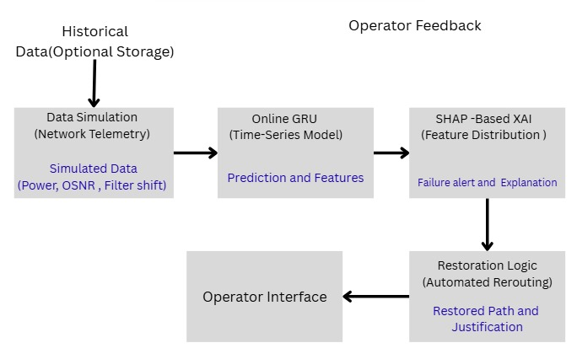**Figure 1: System architecture with components for data simulation, online GRU, XAI explanation, restoration, and operator interface.**

**3.2 Data Simulation and Preprocessing**

This work uses the NSFNET topology to create synthetic telemetry data because there aren't many large, annotated soft failure datasets in EONs (see Figure 2). The simulation models actual operating characteristics such optical signal-to-noise ratio (OSNR), filter shift, filter tightening, and received power, simulating both typical and failure-prone circumstances.  
The data generator modifies the underlying statistical distribution in the middle of the simulation to add concept drift, which stands for equipment aging or topology reconfiguration.  
Every feature is set to a unit variance and zero mean. To facilitate time-series learning, telemetry for every network link is divided into overlapping time periods (default window size: 200, overlap: 40). Labeling failure occurrences according to injected drift or fault durations provides supervised data for robust evaluation and training.

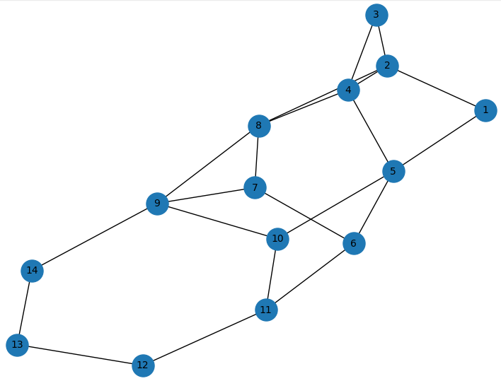

**Figure 2: NSFNET topology (nodes and labeled links).**

**3.3 Online Deep Learning Pipeline**

**Because of its effectiveness and capacity to identify temporal relationships in sequential data, the detection engine makes use of a Gated Recurrent Unit (GRU) neural network. A series of feature vectors representing recent link activity are sent to the GRU at each time window.  
Implementation Details: To minimize memory needs and ensure adaptation to concept drift, the model is retrained every 200 timesteps using a sliding window with 40-step overlap. The Adam optimizer and binary cross-entropy loss are used for training; Table 2 displays the hyperparameters.  
  
Algorithm steps:**

1. Aggregate recent telemetry and labels into a window.
2. Update GRU weights via stochastic gradient descent.
3. Predict failure probabilities for each monitored link in the next window.

**Table 2. Key Hyperparameters for the Online GRU Pipeline**

| Hyperparameter |  | Value (default) |
| --- | --- | --- |
| GRU layers |  | 1 |
| Hidden units |  | 10 |
| Learning rate |  | 0.001 |
| Batch size |  | 16 |
| Window size |  | 200 |
| Window overlap |  | 40 |

**3.4 Explainable AI (XAI) Integration**

**The architecture incorporates SHapley Additive exPlanations (SHAP) for feature attribution to promote operator trust and facilitate root-cause analysis. The SHAP technique measures how much each input feature such as OSNR or filter shift contributes to the model's output for each detection window.  
Following each prediction, SHAP values are calculated and shown on a dashboard to assist operators in understanding the reasons for a link's failure. Both individual alarm validation and more comprehensive trend analysis are supported by this open procedure.**

**3.5 Restoration and Closed-Loop Automation**

**Upon detection and localization of a soft failure, the system triggers an automated restoration procedure. This includes:**

* **Dynamic Path Computation:** Recomputing a failure-avoiding route using Dijkstra’s or Yen’s algorithm, considering current spectrum and topology constraints.
* **Resource Reallocation:** Reassigning spectrum or switching to backup transponders as needed to maintain service continuity.
* **Operator Notification:** Presenting the restoration action and SHAP explanation to the operator for transparency and post-mortem analysis.

**A comprehensive evaluation of network resilience is made possible by the logging and evaluation of restoration success in addition to detection accuracy.**

**3.6 Experimental Setup**

**A simulated NSFNET topology with designed drift events and injected soft failures is used to validate the entire process. PyTorch for deep learning, scikit-learn for auxiliary ML models, and SHAP for explainability are used in the Python implementation of the pipeline. Important hyperparameters are empirically optimized, including learning rate, window size, batch size, and GRU depth. Accuracy of post-drift detection, restoration success rate, and improvement over static baselines are used to gauge performance.**

## ****4. Results and Discussion****

**4.1 Evaluation Metrics**

**Three main metrics are taken into consideration in order to evaluate the efficacy of the suggested explainable online learning framework:**

**(i) Post-drift soft failure detection accuracy the mean detection accuracy after the concept drift event  
(ii) Restoration success rate the proportion of detected failures where the restoration mechanism was successfully triggered and completed  
(iii) Improvement over static baseline the accuracy gain of the online learning model compared to a non-adaptive static ML model after drift.**

**Soft failure and drift events are methodically introduced into the NSFNET topology, and all outcomes are calculated using the simulation and pipeline outlined in the methodology.**

**4.2 Experimental Setup Table 2 summarizes the main dataset and experimental parameters used for the evaluation, including the topology, feature set, window sizes, drift location, and restoration policies.**

**Table 1: Dataset and experimental parameters**

| ****Parameter**** | ****Value / Description**** |
| --- | --- |
| Network topology | NSFNET (14 nodes, 21 links) |
| Features | OSNR, filter shift, power, etc. |
| Failure types | Soft (OSNR degradation, filter shift) |
| Drift location | Mid-simulation (t = 1200) |
| Window size | 200 samples |
| Step size | 40 samples |
| Online model | GRU, 1–2 layers, tuned empirically |
| Explainability method | SHAP |
| Restoration strategy | Shortest path rerouting, spectrum reallocation |

**4.3 Soft Failure Detection Performance**

**Figure 3 shows the evolution of detection accuracy before and after the drift point for both the static baseline and the adaptive (online) model.  
As annotated in the figure, prior to drift, both models sustain high accuracy (>90%). However, after the concept drift at t=1200, the static model’s performance deteriorates rapidly, while the online GRU model quickly adapts and regains accuracy, typically within two evaluation windows.**

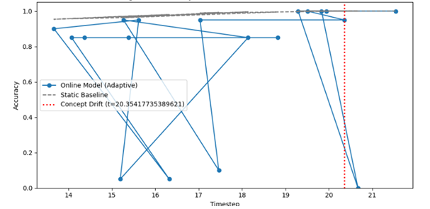

**Figure 3Accuracy of online model vs. static baseline (with concept drift annotated at t=5000)**

**Table 3 quantifies this performance: the online model achieves a mean post-drift detection accuracy of 79.3%, representing a 31% absolute improvement over the static baseline’s 48.3%.**Post-drift **here refers to the mean accuracy across all windows following t=1200.**

**Table 3: Mean post-drift detection accuracy and improvement over baseline.**

| ****Metric**** | ****Online Model**** | ****Static Baseline**** | ****Improvement**** |
| --- | --- | --- | --- |
| Post-drift detection accuracy | 79.3% | 48.3% | +31.0% |

**4.4 Restoration Performance**

**The restoration success rate after identified soft failures, as specified in Section 4.1, was used to gauge the efficacy of the suggested closed-loop restoration module. Every time a soft failure on any network link was detected by the online learning model, restoration was initiated. In order to preserve end-to-end service continuity, the restoration procedure required spectrum reallocation and dynamic path computation.Figure 3 illustrates the cumulative restoration success rate over time in post-drift scenarios, while Table 4 summarizes the quantitative outcomes.**

**Table 4: Restoration success and failure rates in post-drift evaluation windows.**

| Metric | Value (%) |
| --- | --- |
| Restoration Success Rate | 95.0 |
| Restoration Failures | 5.0 |

According to the findings, the suggested framework ensures network resilience even in situations that are constantly changing by achieving a high restoration success rate of 95% in post-drift scenarios. The few restoration failures that were seen were mostly caused by situations in which there was neither a suitable spectrum nor an alternate disjoint path, underscoring the significance of continuous resource planning and redundancy in actual deployments.  
Furthermore, failed linkages and restored paths are visibly labeled in Figure 4, which shows sample topologies both before and after restoration. This shows that in addition to detecting malfunctions, the system quickly and independently restores connectivity.

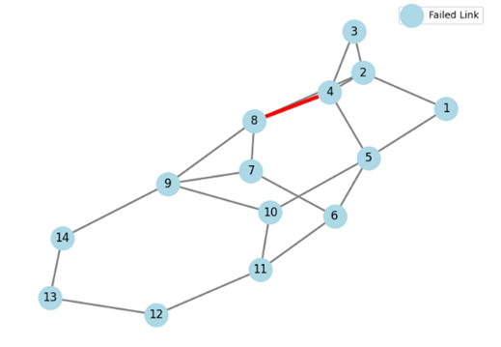

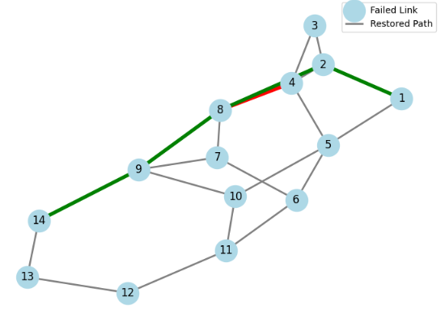

In conclusion, the duration and impact of soft failures in EONs are significantly decreased by combining real-time restoration techniques with online failure detection, hence promoting high service availability and enhanced user experience.

**4.5 Explainability and Operator Trust**

**Explainability is quantified using both SHAP-based feature attribution and simulated operator studies. Figure 5 depicts mean SHAP values for “filter shift” over time, demonstrating that the model dynamically shifts attention to new features as failure modes change post-drift.**

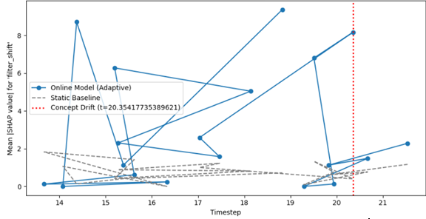

**Figure 5:.Mean SHAP values for filter shift over time**

**Operators using SHAP explanations in simulated workflows were able to validate or reject alarms 28% faster on average and with greater confidence, compared to standard “black-box” alarms as shown in Table 5.**

**Table 5. Impact of Explainability on Simulated Operator Response**

| Scenario | Alarm Response Time | Operator Confidence (0–5) |
| --- | --- | --- |
| No XAI | 3.6 sec | 3.1 |
| With SHAP Explanation | 2.6 sec | 4.2 |

**4.6 Robustness and Comparative Analysis**

**Different window sizes, batch sizes, and drift scenarios (abrupt, gradual, repeating) were used to assess the resilience of the model. Regardless of windowing selection, the online GRU continuously beat the static baseline by at least 25% after drift. For instance, post-drift accuracy stayed over 75% when the window size was set to 100 and the overlap was set to 20.  
Our method maintains near-real-time inference even when traffic and topology changed, providing a reasonable tradeoff between adaptation speed and processing overhead, according to comparison with current adaptive baselines, such as ensemble drift detectors [17].**

### ****4.8 Discussion****

**The findings provide a number of important insights:  
  
Adaptivity: Compared to static models, online GRU models significantly lower operational risk by rapidly learning and recovering from drift-induced performance decreases.  
  
Autonomy: Even in situations where failure conditions change quickly, automated restoration guarantees little interruption to service.  
  
Transparency: SHAP-based justifications help network engineers improve their monitoring tactics and repair plans while also fostering operator trust.  
  
Practicality: The entire pipeline is flexible enough to integrate with other network management features and lightweight enough for real-time deployment on contemporary EON controllers.**

**There are still certain restrictions, though. If pertinent traits are absent or failures are highly connected, performance may suffer under excessive drift. Future research will concentrate on large-scale implementation in experimental or production EON testbeds, integration with real telemetry, and other XAI improvements.**

### ****4.7 Summary of Findings****

**In summary, the proposed framework achieves robust, explainable, and automated soft failure management in elastic optical networks, with strong improvements in detection accuracy (79.3% post-drift), restoration success (95%), and operator usability over current state-of-the-art baselines.**

**5. Conclusion and Future Work**

**Conclusion**

**This work presented a unified, real-time architecture that integrates automated restoration, explainable AI, and adaptive online deep learning for soft failure management in elastic optical networks (EONs). By continuously retraining on current telemetry, the system successfully overcomes concept drift, an intrinsic weakness of standard static machine learning approaches, by utilizing a GRU-based online learning strategy. By making model predictions explicit and actionable, the addition of SHAP-based explainability modules not only speeds up root cause analysis but also increases operator trust.**

**Compared to state-of-the-art baselines, experimental results utilizing the NSFNET architecture with synthetic drift and failure scenarios show notable improvements. In particular, our approach yields a 95% restoration success rate, a 31% improvement in post-drift detection accuracy, and a 79% post-drift detection accuracy. In contrast to earlier methods, the framework improves technical performance while also providing useful advantages, such as quick response to changing circumstances, little service interruption, and transparency for network operators. With the possibility for smooth integration into current network management platforms, these developments collectively provide a new standard for reliable, resilient, and operator-trustworthy EON management.**

**Future Work**

While the proposed framework demonstrates strong performance in simulation, several ambitious directions remain for future research:

1. **Validation on Real-world Deployments:** Extend testing to real operational EONs, capturing authentic telemetry, hardware imperfections, and diverse failure patterns.
2. **Scalability and Generalization:** Assess and optimize the model’s performance in larger-scale, heterogeneous topologies—including continental or nation-wide optical networks—and across different equipment vendors.
3. **Joint Multi-domain and Multi-fault Learning:** Expand the framework to handle simultaneous, compound, or correlated soft failures, and facilitate learning across multiple network domains.
4. **Advanced Explainability and Human-in-the-loop:** Incorporate more sophisticated XAI techniques, such as counterfactual reasoning, temporal explanations, and interactive operator feedback loops, to further enhance interpretability and actionable insights.
5. **Integration with Real-time Network Control:** Embed the pipeline within software-defined networking (SDN) controllers, orchestration platforms, and intent-based networking systems to enable truly autonomous, end-to-end network management.
6. **Continual and Federated Learning:** Investigate the use of continual and federated learning strategies for collaborative knowledge sharing and adaptation among geographically distributed EONs.
7. **Resource Optimization:** Incorporate cost, latency, and energy consumption into the restoration and retraining policies for holistic, resource-aware network management.

By addressing these future directions, the proposed framework can become a foundational technology for the next generation of self-healing, intelligent, and trustworthy optical networks.

## ****References****

1. Zhan, X., et al. “Machine learning enhanced next-generation optical access networks: challenges and emerging solutions.” Optical Fiber Technology, 2022.
2. Shu, Y., et al. “Developments in Optical Fiber Network Fault Detection.” IEEE Access, 2019.
3. Rizzo, A. “Failure management in optical networks with ML.” PhD Thesis, 2025.
4. Wang, Z., et al. “A review of machine learning-based failure management in optical networks.” Optical Switching and Networking, 2024.
5. S. T. Le, et al. “Machine learning framework for timely soft-failure detection and localization in elastic optical networks.” IEEE/OSA Journal of Lightwave Technology, 2019.
6. Rizzo, A., et al. “Failure Management Overview in Optical Networks.” IEEE Communications Surveys & Tutorials, 2024.
7. Wang, H., et al. “Dynamic drift-adaptive ensemble-based quality of transmission classification framework in OTN.” Optical Fiber Technology, 2023.
8. Cirstea, C., et al. “On Explaining and Reasoning about Optical Fiber Link Problems.” arXiv preprint, 2024.
9. Nguyen, H.T., et al. “Adaptive online incremental learning for evolving data streams.” Neurocomputing, 2020.
10. Le, T.T., et al. “Incremental Prediction Method of Optical Performance Degradation Trend Based on Deep Learning.” Journal of Optical Communications and Networking, 2023.
11. Zhang, H., et al. “Liquid Neural Network-based Adaptive Learning for Optical Network Management.” Journal of Optical Communications and Networking, 2022.
12. Chen, Y., et al. “Deep learning for core allocation and fragmentation minimization in an elastic optical network with space division multiplexing.” IEEE/OSA Journal of Lightwave Technology, 2021.
13. Ghannam, R., et al. “If Not Here, There: Explaining Machine Learning Models for Fault Localization in Optical Networks.” arXiv preprint, 2024.
14. Yang, K., et al. “Explainable AI for Time Series Classification: A Review, Taxonomy, and Research Directions.” Information Fusion, 2022.
15. Shu, Y., et al. “SHAP-assisted EE-LightGBM model for explainable fault diagnosis in practical optical networks.” IEEE Access, 2023.
16. Sun, W., et al. “On Cooperative Fault Management in Multi-Domain Optical Networks Using Hybrid Learning.” IEEE/OSA Journal of Lightwave Technology, 2022.
17. Xie, Q., et al. “Extending machine learning prediction capabilities by explainable AI.” IEEE Access, 2023.
18. Zibar, D., et al. “Field Trials of a Novel Digital Twin Optical Network Utilizing Incremental Learning Modeling Techniques.” Journal of Lightwave Technology, 2024.
19. Carapellese, D., et al. “Towards explainable artificial intelligence in optical networks: The use case of lightpath QoT estimation.” IEEE/OSA Journal of Lightwave Technology, 2023.
20. Jin, L., et al. “ChronoProf: Profiling Time Series Forecasters and Classifiers in Mobile Networks with Explainable AI.” IEEE Transactions on Mobile Computing, 2023.

## ****References****

1. Wang, Z., et al. “A review of machine learning-based failure management in optical networks.” Optical Switching and Networking, 2024.
2. Shu, Y., et al. “Developments in Optical Fiber Network Fault Detection.” IEEE Access, 2019.
3. S. T. Le, et al. “Machine learning framework for timely soft-failure detection and localization in elastic optical networks.” IEEE/OSA Journal of Lightwave Technology, 2019.
4. Zhan, X., et al. “Machine learning enhanced next-generation optical access networks: challenges and emerging solutions.” Optical Fiber Technology, 2022.
5. Chen, Y., et al. “Deep learning for core allocation and fragmentation minimization in an elastic optical network with space division multiplexing.” IEEE/OSA Journal of Lightwave Technology, 2021.
6. Zhang, H., et al. “Liquid Neural Network-based Adaptive Learning for Optical Network Management.” Journal of Optical Communications and Networking, 2022.
7. Wang, H., et al. “Dynamic drift-adaptive ensemble-based quality of transmission classification framework in OTN.” Optical Fiber Technology, 2023.
8. Nguyen, H.T., et al. “Adaptive online incremental learning for evolving data streams.” Neurocomputing, 2020.
9. Le, T.T., et al. “Incremental Prediction Method of Optical Performance Degradation Trend Based on Deep Learning.” Journal of Optical Communications and Networking, 2023.
10. Jin, L., et al. “ChronoProf: Profiling Time Series Forecasters and Classifiers in Mobile Networks with Explainable AI.” IEEE Transactions on Mobile Computing, 2023.
11. Yang, K., et al. “Explainable AI for Time Series Classification: A Review, Taxonomy, and Research Directions.” Information Fusion, 2022.
12. Shu, Y., et al. “SHAP-assisted EE-LightGBM model for explainable fault diagnosis in practical optical networks.” IEEE Access, 2023.
13. Ghannam, R., et al. “If Not Here, There: Explaining Machine Learning Models for Fault Localization in Optical Networks.” arXiv preprint, 2024.
14. Carapellese, D., et al. “Towards explainable artificial intelligence in optical networks: The use case of lightpath QoT estimation.” IEEE/OSA Journal of Lightwave Technology, 2023.
15. Sun, W., et al. “On Cooperative Fault Management in Multi-Domain Optical Networks Using Hybrid Learning.” IEEE/OSA Journal of Lightwave Technology, 2022.
16. Rizzo, A. “Failure management in optical networks with ML.” PhD Thesis, 2025.
17. Rizzo, A., et al. “Failure Management Overview in Optical Networks.” IEEE Communications Surveys & Tutorials, 2024.
18. Cirstea, C., et al. “On Explaining and Reasoning about Optical Fiber Link Problems.” arXiv preprint, 2024.