**Standard Work for Python Unittest Framework**

| **Author:** | | | **For Review:** | **For Information:** |
| --- | --- | --- | --- | --- |
| Name | Date | Sign | Name | Name |
| Dayananda Kattupalli |  |  |  |  |

| **Revision History** | | | |
| --- | --- | --- | --- |
| ***Revision*** | ***Date (mm/dd/yy)*** | ***Author*** | ***Description*** |
|  |  |  |  |
|  |  |  |  |
|  |  |  |  |
|  |  |  |  |
|  |  |  |  |
|  |  |  |  |
|  |  |  |  |
|  |  |  |  |
|  |  |  |  |
|  |  |  |  |
|  |  |  |  |
|  |  |  |  |

**References:**

|  |  |
| --- | --- |
| **DOCUMENT TYPE** | **REFERENCE LINK** |
|  |  |
|  |  |

Table of Contents

1 Purpose 3

2 Scope 3

3 Installation of Python and Eclipse: 3

4 Creating test scripts for Automation: 3

4.1 Method 1 (Though IDLE): 3

4.2 Method 2(Using Eclipse) 4

5 Project Folder Structure for Implementation 5

6 Test Execution methods and generating reports: 6

6.1 Using Eclipse: 6

6.2 Using Test_Runner file: 8

# Purpose

Standard work to create automated test scripts using python for all types of automation like Web automation, BACnet automation and Mobile automation etc.

# Scope

To create common automation platform using Python libraries, writing test scripts for web application, BACnet and Mobile tests and execution.

# Installation of Python and Eclipse:

Download latest python version from <https://www.python.org/downloads/>

Step1: Install python installer (just click next …) Installation of python is done.

Step2: Set the python path in Environment Variables.

Download latest Eclipse Installer from <https://www.eclipse.org/downloads/packages/installer>

Step1: Install Eclipse installer (just click next…) Installation of Eclipse is done.

Step2: Download Pydev from within Eclipse.

Step3: Go to Help → Install New Software.

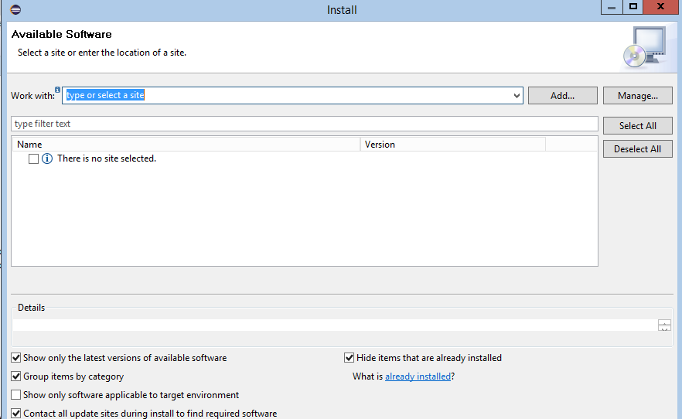

Step4: Enter http://pydev.org/updates in the Work with:

Step5: After several seconds, two options should appear. Select the PyDev for Eclipse option. Do not select the "PyDev Mylyn Integration" flag.

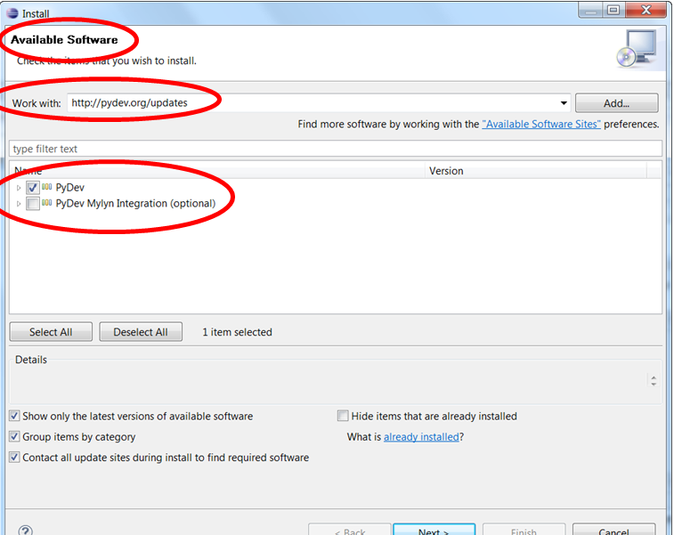

Step6: Click "Next" and "OK" to continue installing PyDev.

Step7: Select "I accept the terms of the license agreement", then click "Finish". The installer will begin to download the plug-in.

Step8: Configure PyDev, Go to Window → Preferences. In the Preferences window, expand PyDev and select Interpreter-Python.

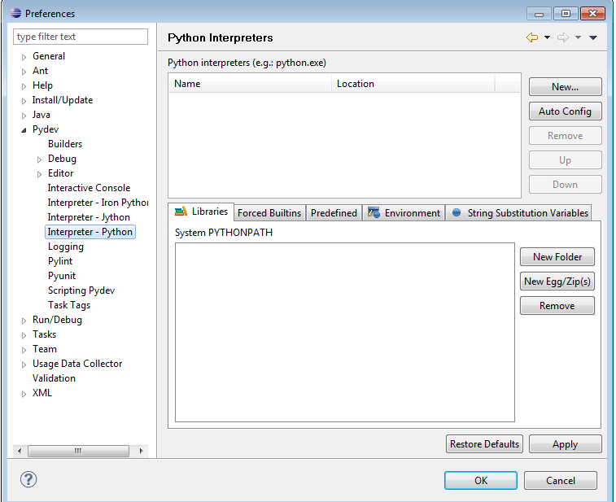

Step9: Click "New..." and type Python32 for the Interpreter name. For the Interpreter executable, browse to your copy of Python.

Now Eclipse with PyDev has successfully configured.

# Creating test scripts for Automation:

# Method 1 (Though IDLE):

1. Open the python IDLE then Navigate to File -> New File

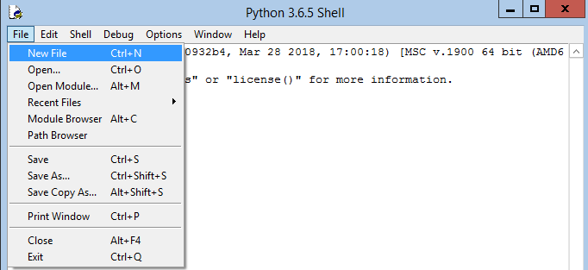

1. A blank file will be opened.

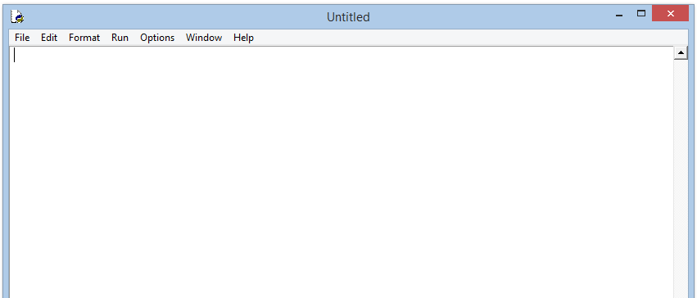

1. Write the Test script in the file and click on save.
2. The name must be given as “test_xxxxx.py”

# Method 2(Using Eclipse)

1. Open Eclipse editor
2. Navigate to File🡪New

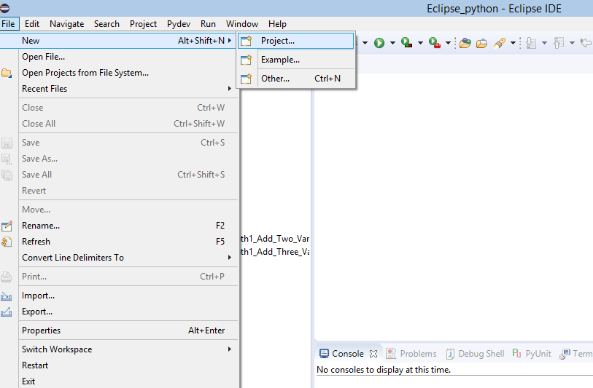

1. Click on New🡪select File

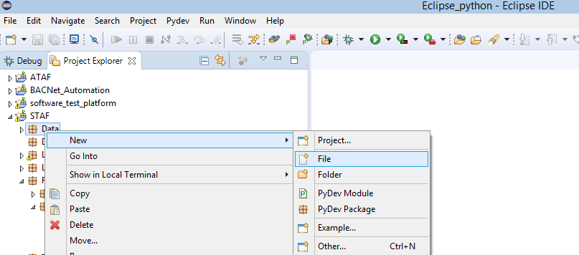

1. Enter a file name as test_xxx.py

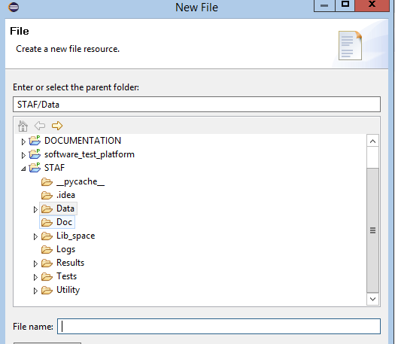

*Note: The filename must be short and ensure that no blank spaces are included in the filename.*

# Project Folder Structure for Implementation

Should have the following folders.

* **Lib_Space**: Contains all core automation Libraries (CCN, NI, BACNet, Web automation,

Mobile automation etc.)

* **Utility**: Will have basic test functionalities according to project usage (Can be modified as per usage).
* **Data** : Will have the configuration and test data according to project usage.
* **Logs**: Will have logs which project tests used logs module in the scripts.
* **Doc**: Will have documents related to developed python modules.
* **Tests:** Will have subfolders containing test scripts according to functionalities.
* **Test_Runner:** Will Run the test scripts under the Tests folder & generates report in to the Results folder.
* **Results:** Will have the generated reports Testsuite and individual file reports.

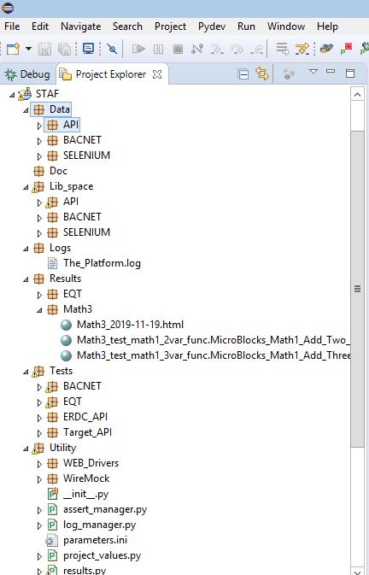

# Test Execution methods and generating reports:

# Using Eclipse:

* + 1. Configuration of Eclipse:
  + Open Eclipse
  + Go to File>>Properties>> Configure Python Interpreter.

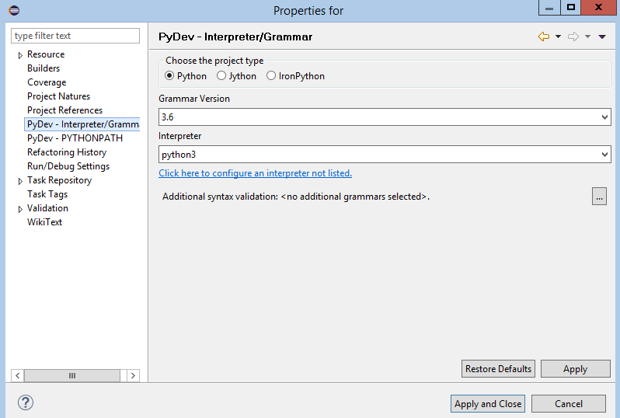

* + 1. Execution of test scripts at File level:
* Right click on the test script file in the project area, right click and select ‘Python Unit-test’ as Python Run

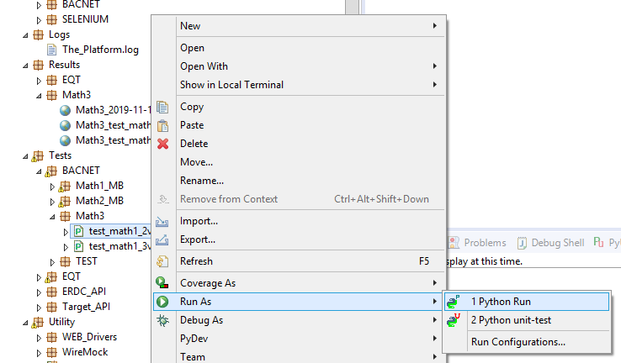

# Using Test_Runner file:

Execution of test scripts at Folder level, Execute Test_Runner.py by giving argument as Test scripts folder path from command line or use Terminal in Eclipse from STAF Location.

