BLUESTOCK FINTECH
Mutual Fund Analytics Platform
Final Capstone Report — End-to-End Data Engineering, ETL Pipeline & Interactive Dashboard
Prepared by: Devendra Gautam
Individual Capstone Project — Bluestock Fintech Pvt. Ltd.
August 2026
Data sourced from AMFI India, mfapi.in, NSE/BSE public data. Educational project — not financial advice.

Table of Contents
1. Executive Summary
2. Data Sources & Datasets
3. System Architecture & ETL Design
4. Technical Stack
5. Project Timeline — 7-Day Build Process
6. Exploratory Data Analysis — Findings
7. Fund Performance Analysis
8. Advanced Analytics & Risk Metrics
9. Interactive Dashboard
10. Limitations
11. Recommendations
12. Appendix A — Sample SQL Queries
13. Appendix B — Data Dictionary
14. Appendix C — Deliverables & Evaluation Checklist
15. Appendix D — Bonus Challenge: Monte Carlo NAV Projection

1. Executive Summary
This report documents the design, build, and findings of the Bluestock Mutual Fund Analytics Platform — a seven-day individual capstone project that takes raw, publicly-sourced Indian mutual fund data through a complete data engineering pipeline: extraction, cleaning, relational storage, exploratory analysis, performance/risk quantification, and an interactive four-page Power BI dashboard.
The project covers 40 real mutual fund schemes across 10 AMCs, built on roughly 46,000 NAV observations spanning January 2022 to May 2026, ~32,800 simulated investor transactions across 5,000 investors, and supporting industry datasets (AUM, SIP inflows, folio counts, category flows, benchmark indices, and portfolio holdings). All fund identifiers, NAV anchors, and AUM figures are sourced from real AMFI/mfapi.in data; investor transaction records are synthetically generated using realistic demographic and behavioural distributions.
Key outcomes:
- A 7-table SQLite star schema (dim_fund, dim_date, fact_nav, fact_transactions, fact_performance, fact_aum, fact_sip_industry) loaded via a reproducible Python ETL pipeline.
- 19+ exploratory and advanced-analytics charts covering NAV trends, AUM growth, SIP flows, investor demographics, correlation structure, and sector allocation.
- A full performance and risk-metrics suite — CAGR, Sharpe, Sortino, Alpha/Beta vs Nifty 100, Maximum Drawdown, and a composite 0–100 fund scorecard — plus advanced risk analytics (VaR/CVaR, rolling Sharpe, cohort analysis, SIP continuity, sector concentration/HHI, and a simple risk-based fund recommender).
- A 4-page interactive Power BI dashboard (Industry Overview, Fund Performance, Investor Analytics, SIP & Market Trends) with cross-filtering slicers on every page.
The single strongest finding across the whole project is a data-quality/behavioural insight rather than a market one: 97.8% of long-term SIP investors (6+ SIP payments) show an average gap of more than 35 days between consecutive SIPs — meaning the overwhelming majority of “regular” SIP investors in this dataset are not actually maintaining a disciplined monthly cadence. This has direct implications for AMC retention strategy and is discussed further in Section 8.

2. Data Sources & Datasets
All datasets are derived from publicly available sources: AMFI India (NAV, AUM, folio, SIP data), the mfapi.in REST API (live historical NAV, no authentication required), and NSE/BSE public benchmark index data. Ten pre-packaged CSV datasets were supplied as the primary input, supplemented by six additional live NAV pulls from mfapi.in for validation.

2.1 Dataset Inventory
Dataset | Rows | Description
01_fund_master.csv | 40 | Master list of 40 real schemes — AMFI codes, fund house, category, expense ratio, risk grade
02_nav_history.csv | ~46,000 | Daily NAV for all 40 schemes, Jan 2022 – May 2026
03_aum_by_fund_house.csv | ~90 | Quarterly AUM (Rs. crore) for 10 fund houses, 2022–2025
04_monthly_sip_inflows.csv | 48 | Month-wise SIP inflow, active SIP accounts, new registrations
05_category_inflows.csv | ~144 | Net inflows by fund category, FY 2024–25
06_industry_folio_count.csv | 21 | Total MF folios (crore), by Equity/Debt/Hybrid
07_scheme_performance.csv | 40 | 1/3/5yr returns, Sharpe, Sortino, Alpha, Beta, Max Drawdown
08_investor_transactions.csv | ~32,800 | Simulated SIP/Lumpsum/Redemption transactions, 5,000 investors
09_portfolio_holdings.csv | ~320 | Top equity holdings by stock, weight %, sector
10_benchmark_indices.csv | ~8,050 | Daily close values — Nifty 50/100/Midcap150, BSE SmallCap, CRISIL Liquid/Gilt

2.2 Key Real-World Data Points Embedded
- SBI Mutual Fund AUM (Dec 2025): Rs. 12.50 lakh crore — largest AMC in India.
- SIP inflow (Dec 2025): Rs. 31,002 crore — all-time high at time of project.
- Total MF folios (Dec 2025): 26.12 crore.
- Industry AUM (Dec 2025): Rs. 81 lakh crore.
Note: this project's own analytics operate on a 40-scheme sample rather than the full 1,908-scheme industry, so dashboard KPI totals (e.g. sample “Total AUM”) are proportionally smaller than the headline industry figures quoted above — see Section 10, Limitations.

3. System Architecture & ETL Design
The pipeline follows a standard Extract → Transform → Load → Analyse → Visualise architecture, mirroring real-world fintech data pipelines.

3.1 Extract
- 10 pre-packaged CSV datasets loaded and profiled (scripts/data_ingestion.py).
- Live NAV pulled from the mfapi.in REST API for 6 schemes (HDFC Top 100, SBI Bluechip, ICICI Bluechip, Nippon Large Cap, Axis Bluechip, Kotak Bluechip) via scripts/live_nav_fetch.py — no authentication required.

3.2 Transform
- Dates parsed to proper datetime types; NAV series sorted per fund and forward-filled across weekends/holidays.
- Duplicate rows removed; NAV values validated as strictly positive.
- Transaction types standardised to title case (SIP / Lumpsum / Redemption); transaction amounts validated as positive; KYC status values checked against expected categories.
- Performance metrics coerced to numeric, with expense ratios and Sharpe ratios flagged for out-of-range values.

3.3 Load — Star Schema
A star schema separates slow-changing descriptive attributes (dimensions) from fast-growing measurements (facts). dim_fund and dim_date describe “things” — a scheme, a calendar day — and change rarely. fact_nav, fact_transactions, fact_performance, fact_aum and fact_sip_industry record events and measurements, each referencing dim_fund via the amfi_code foreign key. This is the same pattern used by production BI systems at firms such as Zerodha, Groww and Paytm Money, and it is what allows Power BI to build clean relationships and cross-filter automatically across pages. Cleaned data is loaded into the schema via SQLAlchemy (scripts/load_to_db.py):
Table | Type | Rows
dim_fund | Dimension | 40
dim_date | Dimension | ~1,612
fact_nav | Fact | 46,000
fact_transactions | Fact | 32,778
fact_performance | Fact | 40
fact_aum | Fact | 90
fact_sip_industry | Fact | 48

3.4 Analyse & Visualise
Analysis was carried out across four Jupyter notebooks (EDA, Performance Analytics, Advanced Analytics) using pandas, NumPy, SciPy, Matplotlib, Seaborn and Plotly, with results surfaced in a 4-page Power BI dashboard built directly against the SQLite database and processed CSVs.

4. Technical Stack
The platform was built entirely on free, industry-standard tooling — no paid services or licences were required.
Category | Tool / Library | Purpose
Language | Python 3.13 | All data processing, ETL, analytics
Data manipulation | Pandas 2.x | DataFrames, cleaning, aggregation
Numerical computing | NumPy | Risk metrics, statistical functions
Statistics | SciPy | OLS regression for Alpha/Beta
Visualisation | Matplotlib / Seaborn | Static charts for the report
Visualisation | Plotly | Interactive charts within notebooks
Database | SQLite 3 | Local relational star-schema database
ORM | SQLAlchemy 2.0 | Python-to-SQLite interface
Notebooks | Jupyter (via VS Code) | EDA and analytics notebooks
Dashboard | Power BI Desktop | Interactive 4-page BI dashboard
API | mfapi.in REST API | Live historical NAV, no authentication
HTTP client | Requests | API calls from Python
IDE | VS Code | Code development, notebook execution
Version control | Git + GitHub | Code versioning, submission, v1.0 tag

5. Project Timeline — 7-Day Build Process
The project was executed as a structured 7-day sprint, with each day producing a self-contained, git-committed deliverable. This section summarises the actual build sequence.
Day | Focus | Key Deliverables
1 | Project setup & data ingestion | Folder structure, virtual environment, data_ingestion.py, live_nav_fetch.py, 16 raw CSVs, first GitHub commit
2 | Data cleaning & database design | 3 cleaned core datasets + 7 pass-through CSVs, 7-table star schema (schema.sql), bluestock_mf.db loaded, 10 SQL queries, data dictionary
3 | Exploratory data analysis | EDA_Analysis.ipynb with 19 charts (NAV trends, AUM growth, SIP flows, demographics, correlation, sector allocation)
4 | Fund performance analytics | CAGR, Sharpe, Sortino, Alpha/Beta, Max Drawdown per fund; composite fund scorecard; benchmark comparison chart
5 | Power BI dashboard | 4-page interactive dashboard (bluestock_mf_dashboard.pbix), PDF export, 4 page screenshots
6 | Advanced analytics & risk | VaR/CVaR, rolling 90-day Sharpe, investor cohort analysis, SIP continuity analysis, sector HHI, rule-based fund recommender
7 | Final report & presentation | This report, 12-slide deck, cleaned scripts, README.md, final GitHub push and v1.0 tag

A full breakdown of the sub-tasks completed on each day, including the exact acceptance criteria used to confirm each day's work, is preserved in the project's Git commit history.

6. Exploratory Data Analysis — Findings
Full detail is in notebooks/EDA_Analysis.ipynb, which contains 19 charts in total — exceeding the original 15-chart target with several supplementary views (folio mix by asset class, normalised NAV by category, expense ratio by plan, monthly flows by transaction type, and ranked category inflows). Headline findings, chart by chart:
- Raw NAV levels are not comparable across funds — schemes launched at very different NAV bases, so growth must be read via normalised/indexed returns, not absolute NAV (Chart 1).
- SBI Mutual Fund is the clear AUM leader across all four years (2022–2025), consistent with its real-world position as India's largest AMC (Chart 2).
- Monthly SIP inflows show sustained, near-linear growth, peaking at the real-world milestone of Rs. 31,002 crore in December 2025 (Chart 3).
- Category-wise inflow intensity is heavily skewed toward a small number of high-flow categories in any given month, visible as concentrated “hot cells” in the heatmap rather than an even spread (Chart 4).
- Investor demographics show fairly even SIP participation across age bands, with no single age group dominating investment volume (Chart 5).
- SIP contribution by state is led by a cluster of high-income and high-population states, with a broadly even T30 vs B30 city-tier split rather than one tier dominating (Chart 6).
- Total industry folio count nearly doubled over the sample window, from 13.26 crore (Jan 2022) to 26.12 crore (Dec 2025) (Chart 7).
- Return correlations across the 10 sampled funds are surprisingly low (mostly between -0.07 and +0.07), suggesting the sampled schemes' daily return movements are largely idiosyncratic rather than driven by a single shared market factor at the daily-return granularity used here (Chart 8).
- Equity portfolio holdings are concentrated in a handful of sectors (financial services, technology, and energy dominate), visible clearly in the sector-allocation donut (Chart 9).
- Direct plans consistently carry lower expense ratios than Regular plans across every fund family, confirming the expected distributor-commission effect (Chart 13).

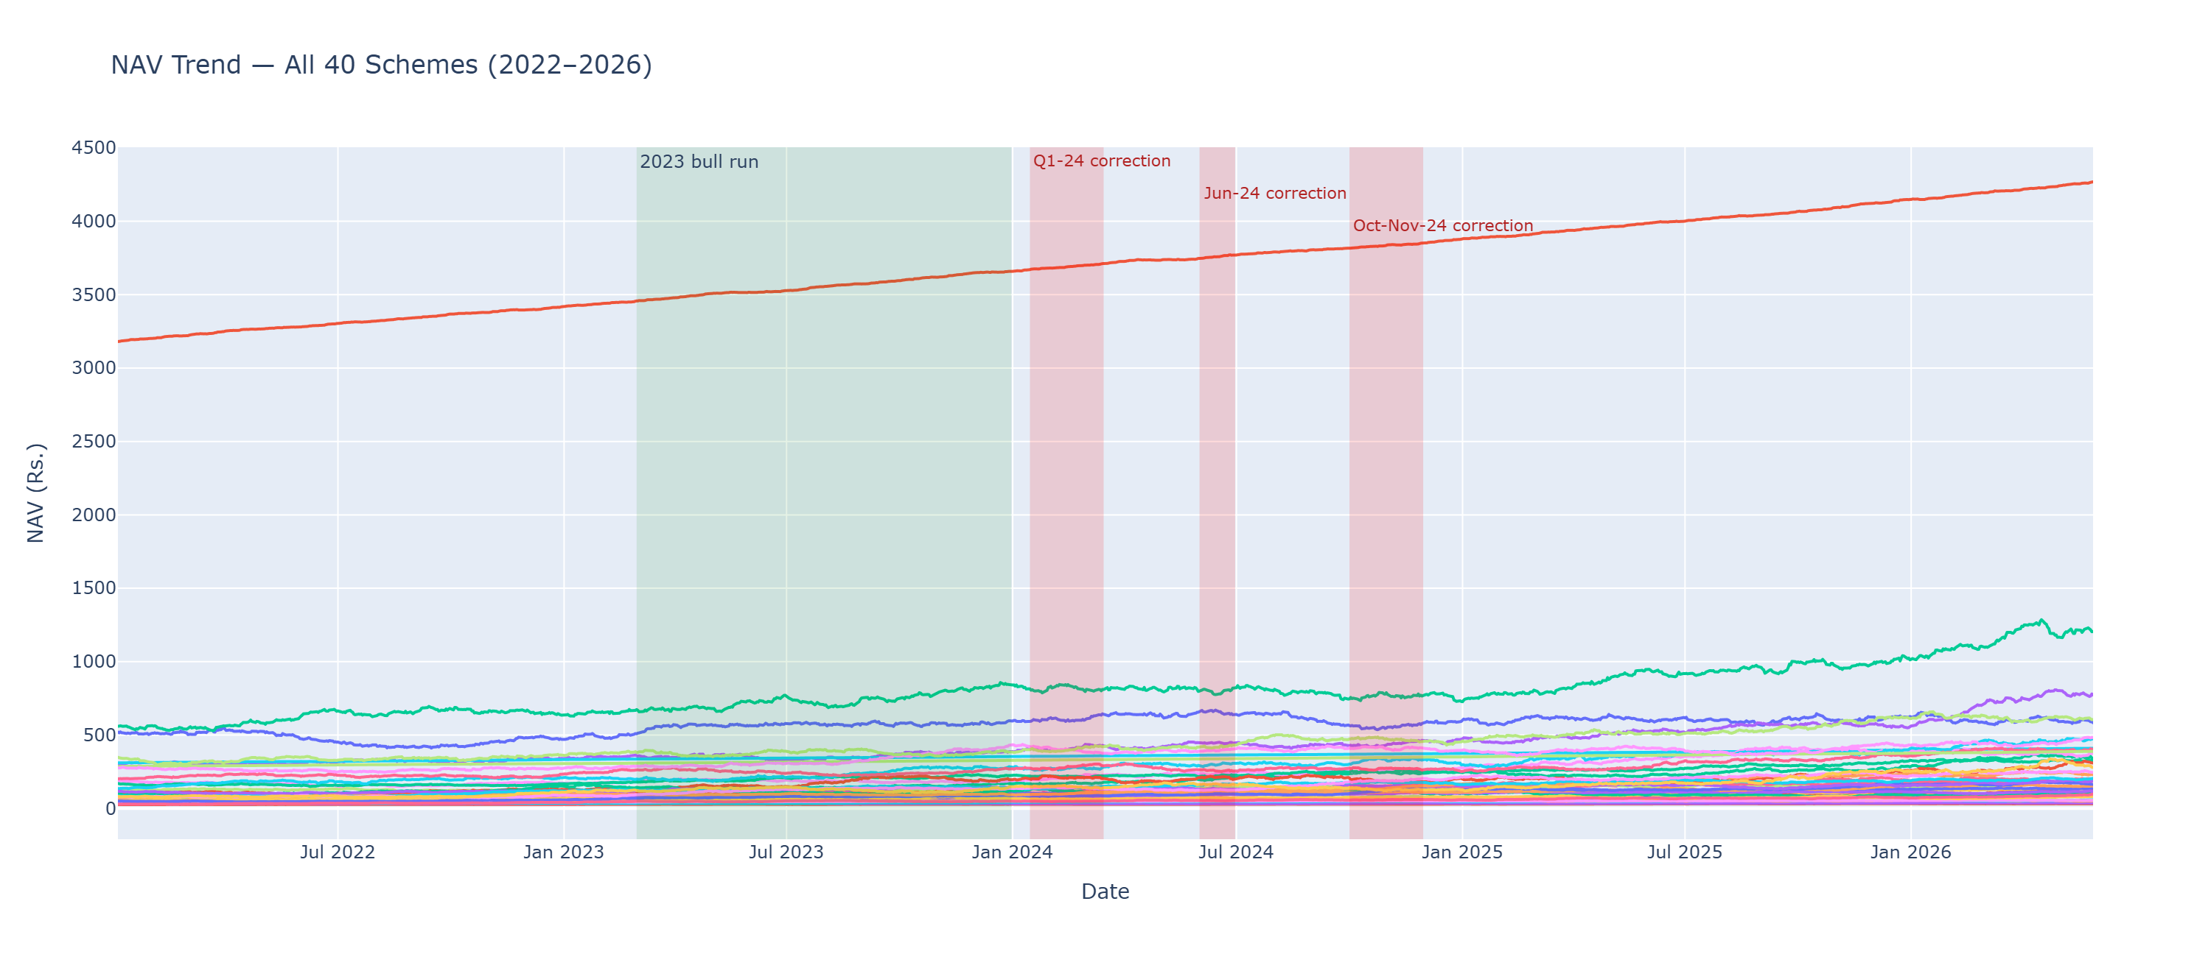
Chart 1 — NAV trend, all 40 schemes (2022–2026).
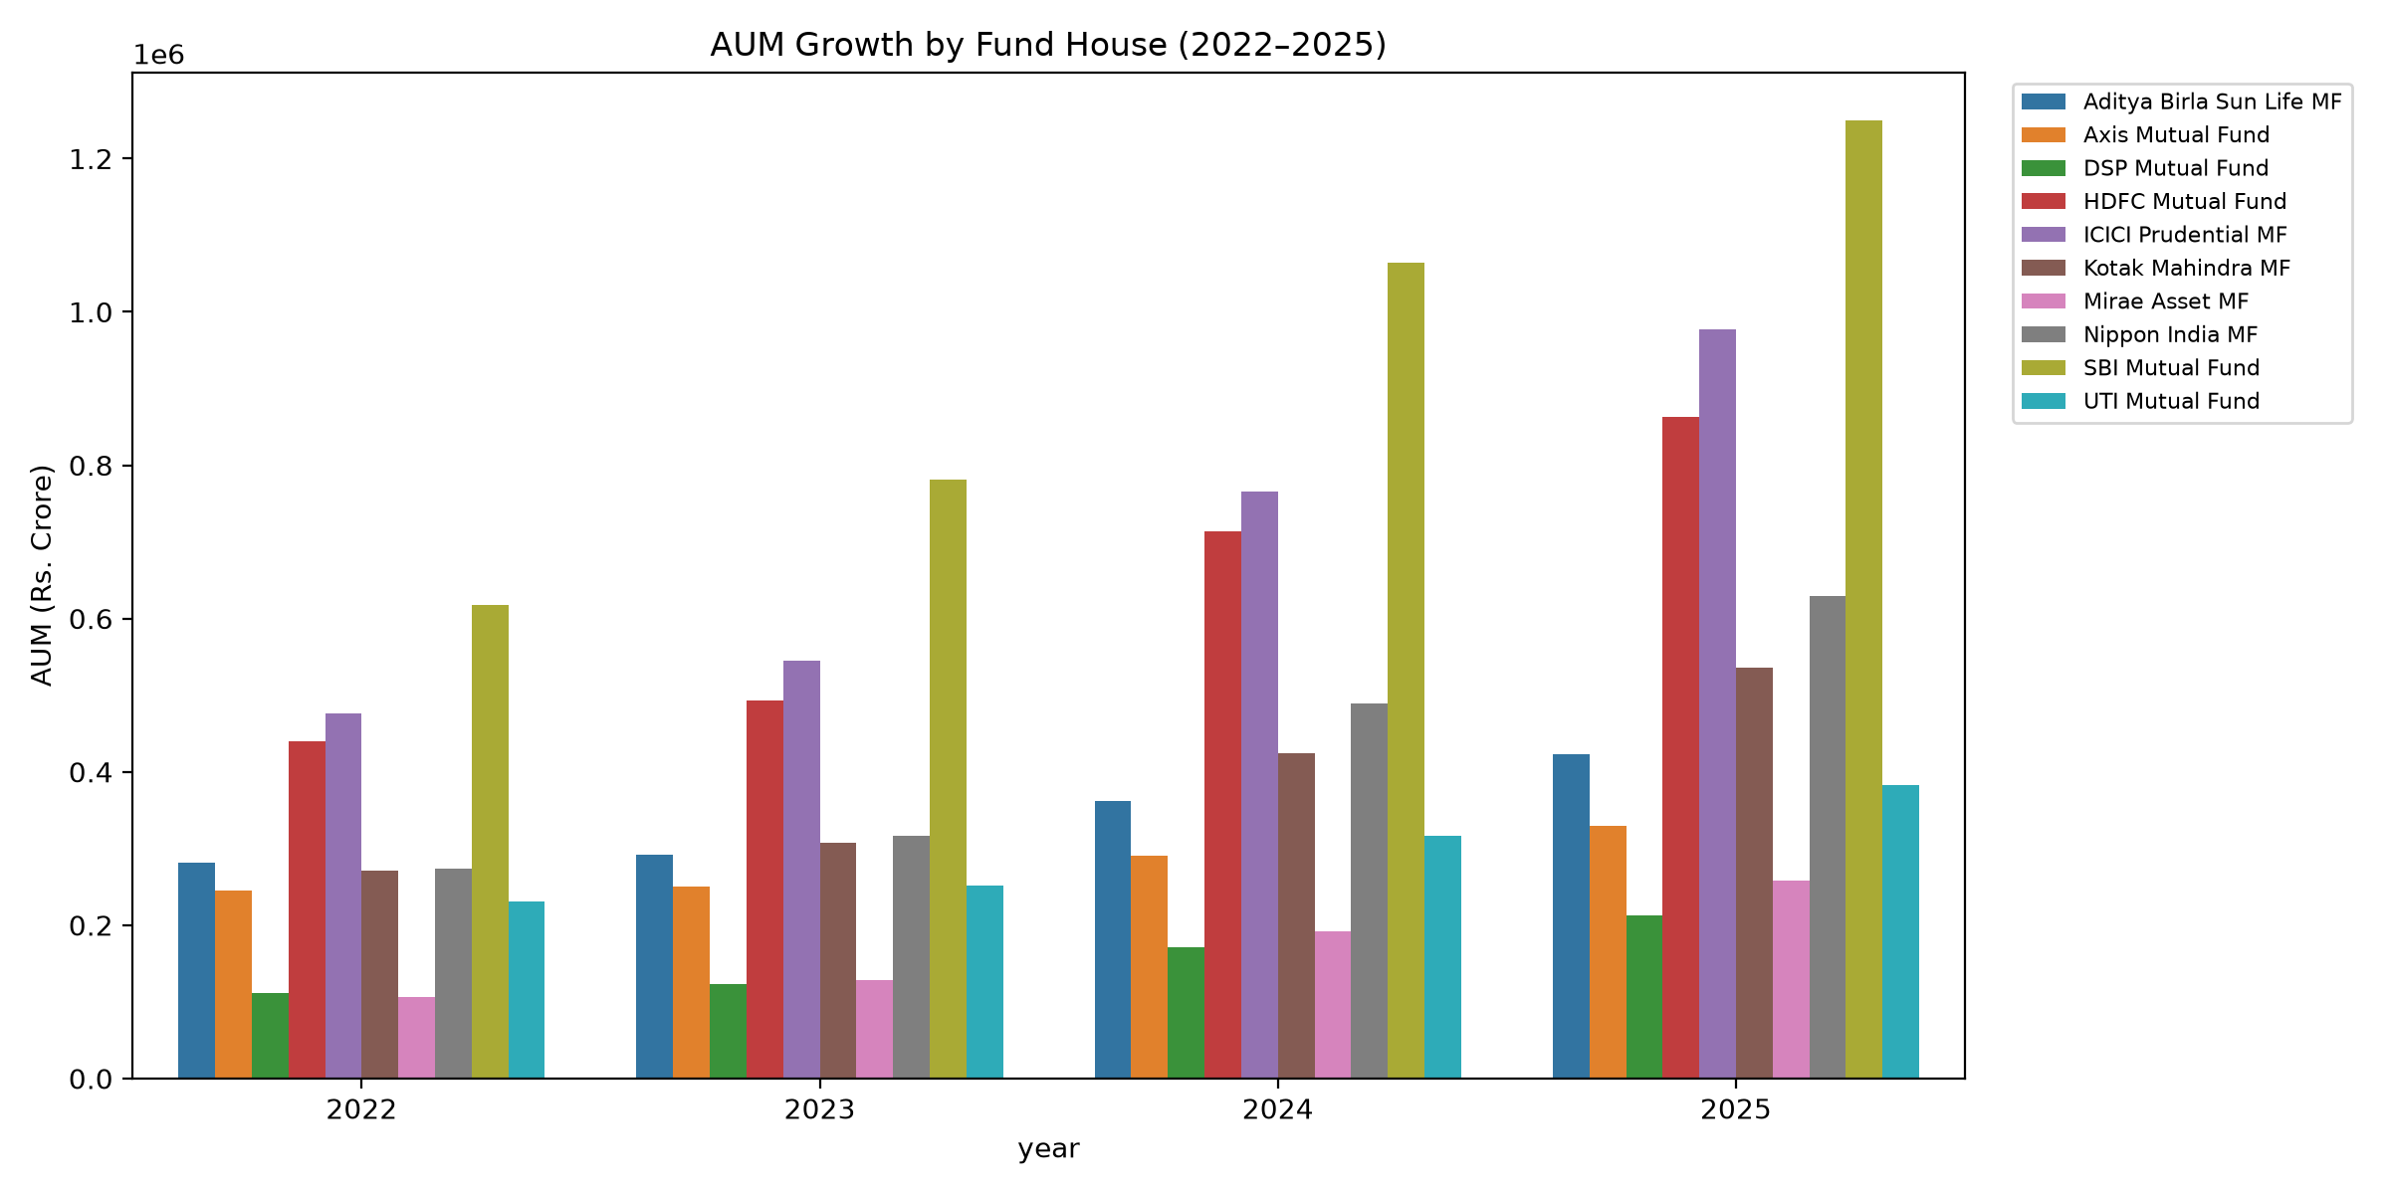
Chart 2 — AUM growth by fund house, 2022–2025. SBI Mutual Fund leads every year.

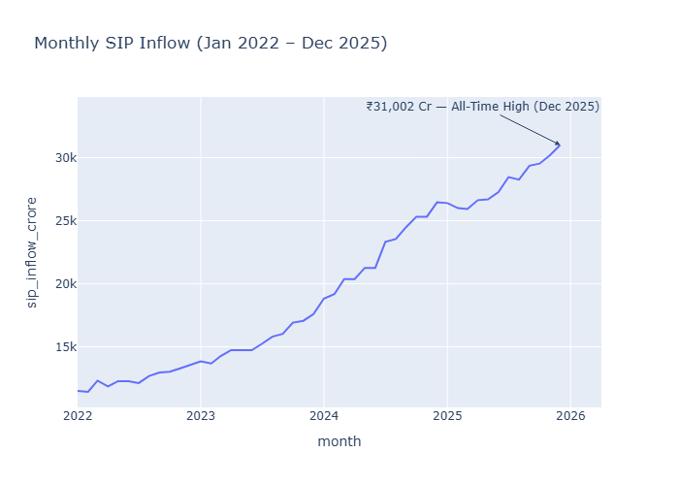
Chart 3 — Monthly SIP inflow trend, with the Dec-2025 all-time-high milestone annotated.
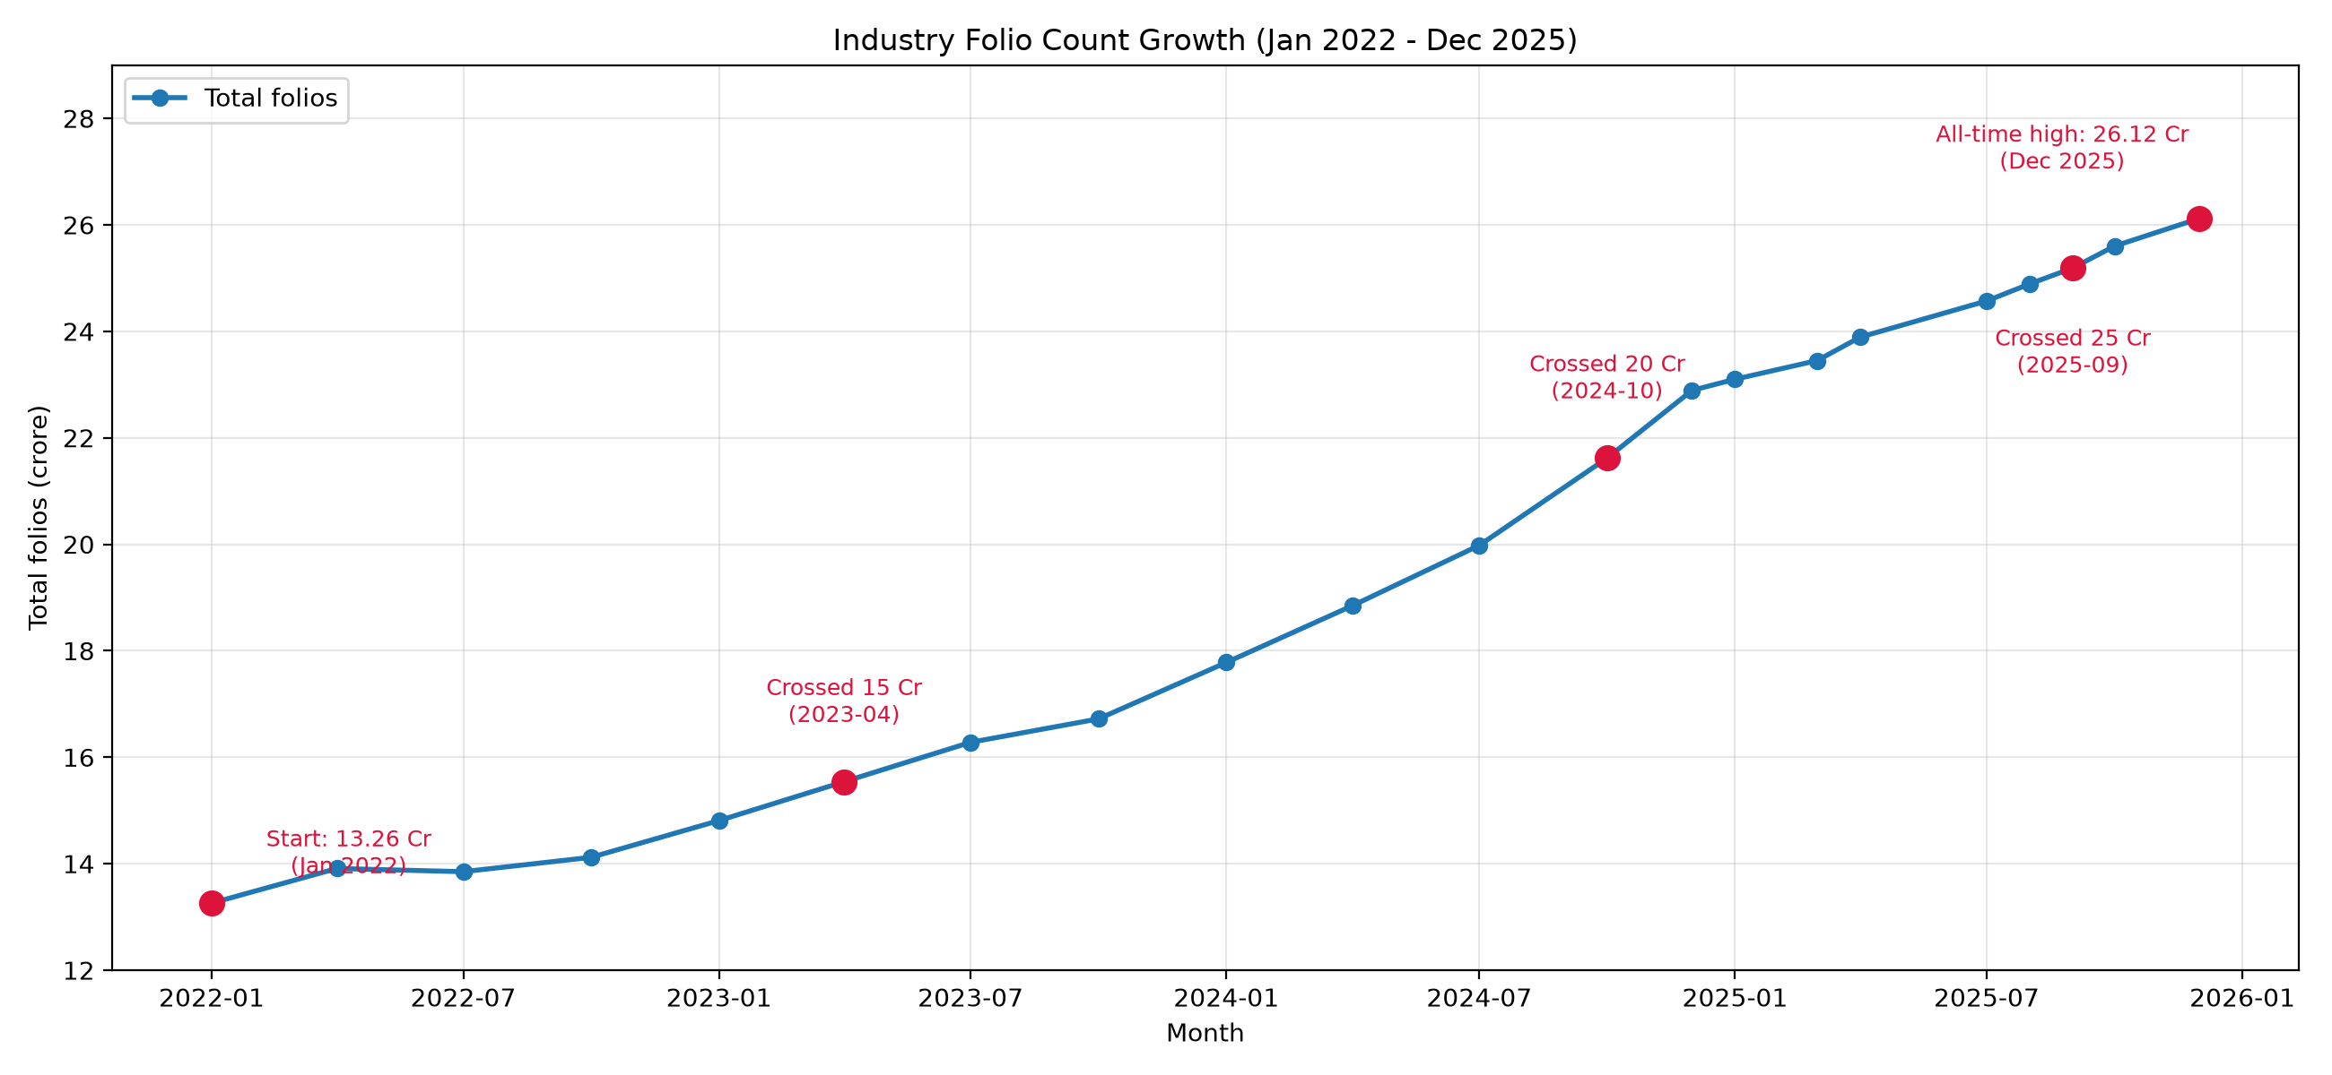
Chart 7 — Industry folio count growth with key milestones annotated.

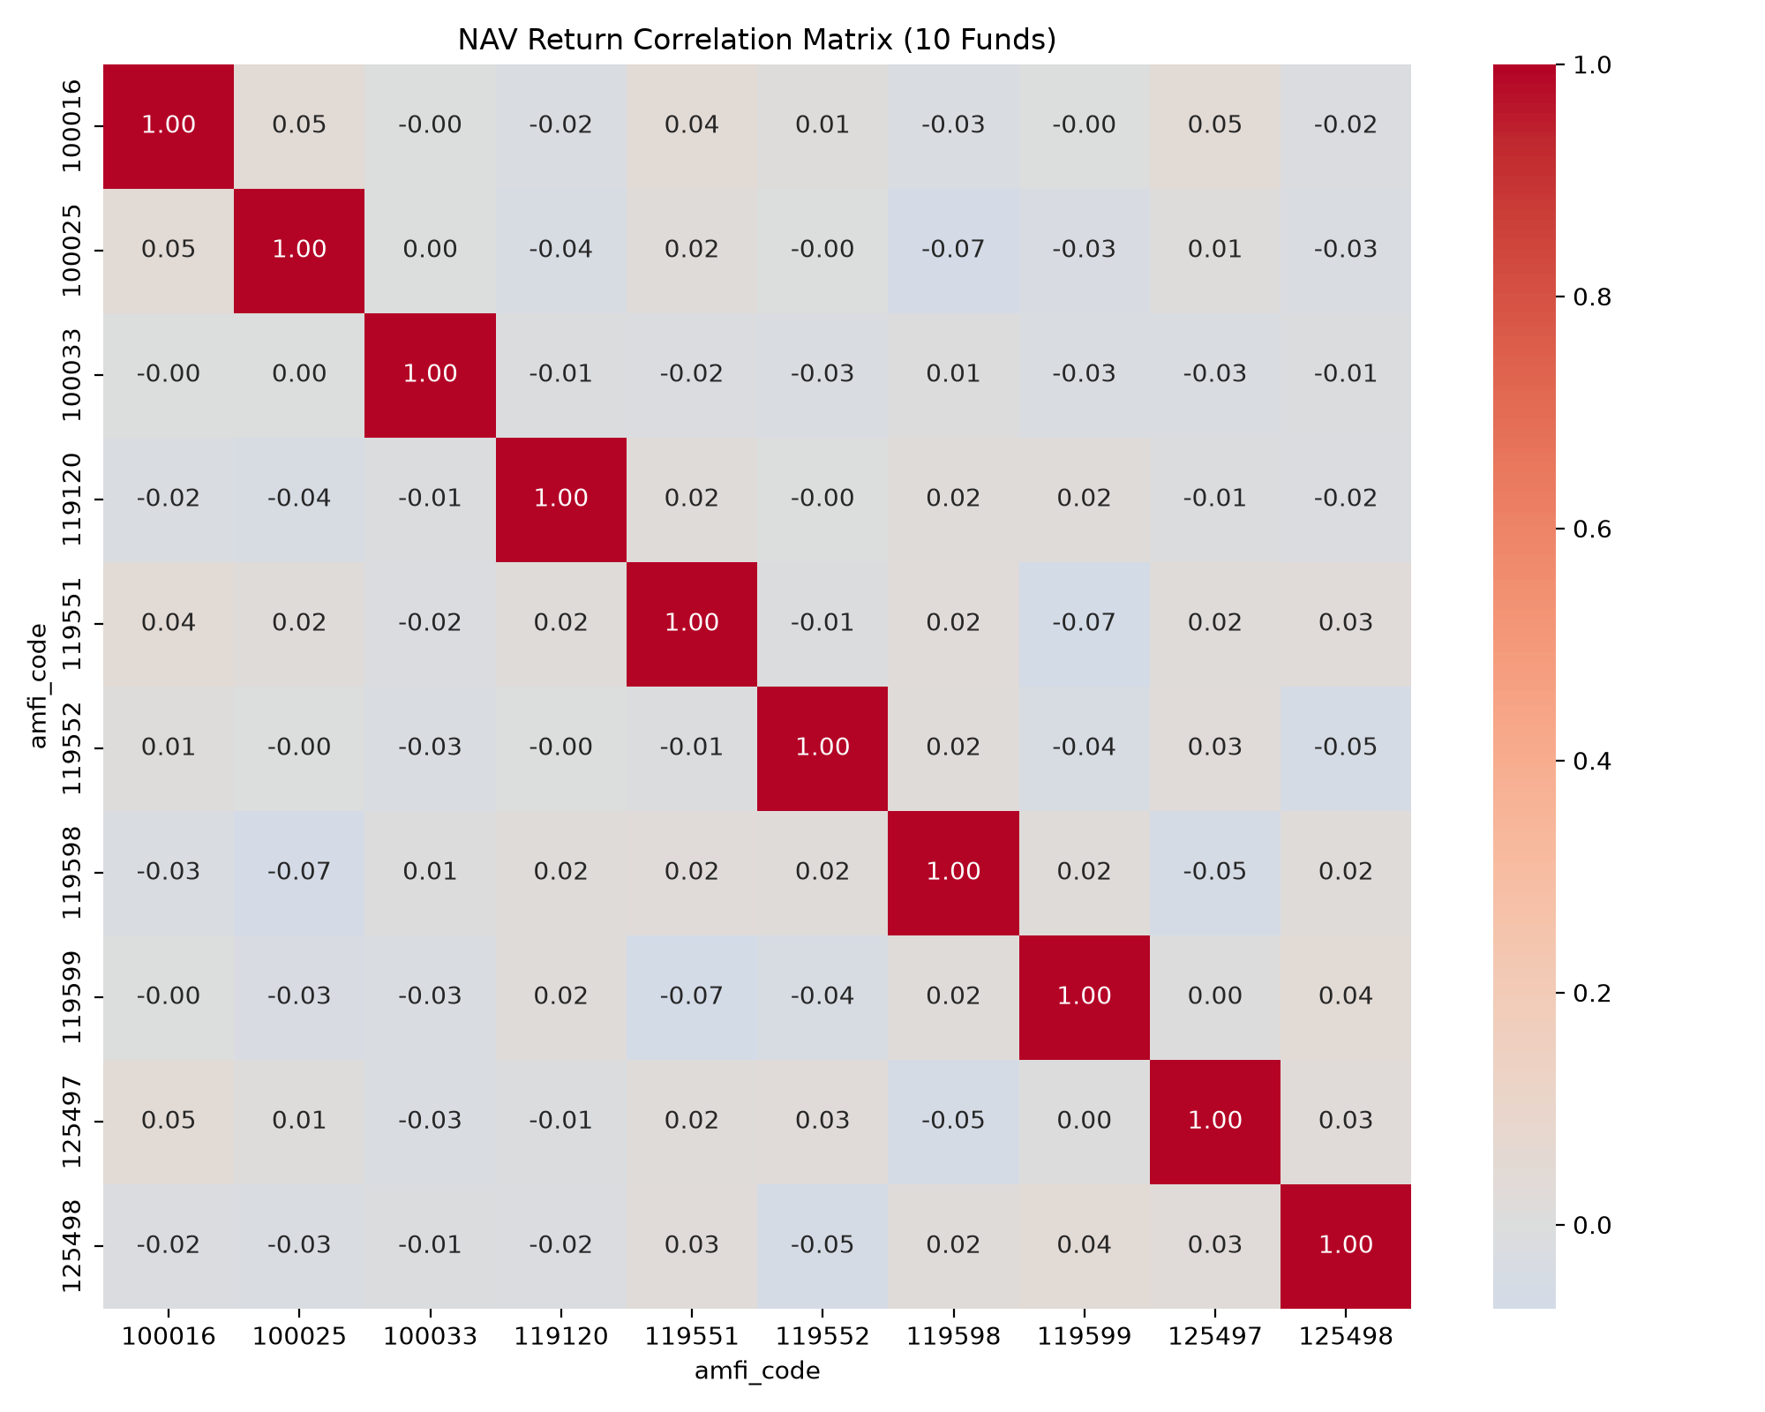
Chart 8 — NAV return correlation matrix (10 sampled funds).
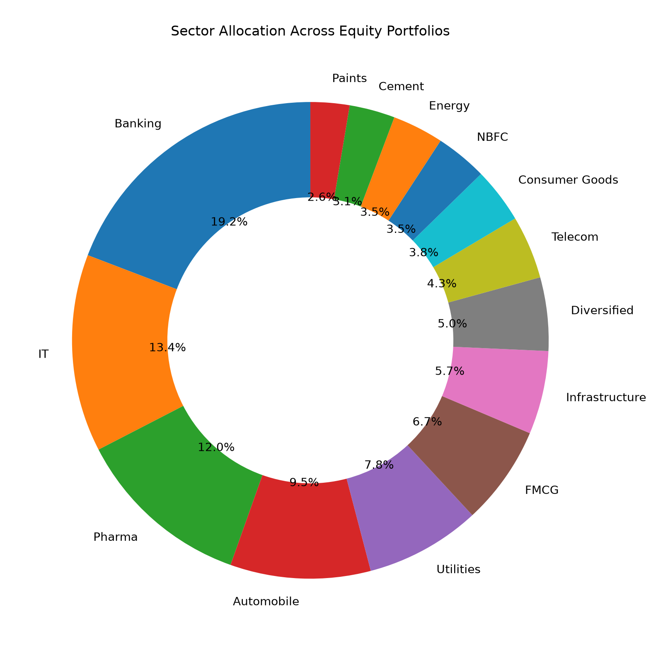
Chart 9 — Sector allocation across equity fund portfolios.

7. Fund Performance Analysis
Detail is in notebooks/Performance_Analytics.ipynb. Per-fund CAGR (1/3/5yr), Sharpe ratio, Sortino ratio, Alpha/Beta (via OLS regression against Nifty 100), and Maximum Drawdown were computed from daily NAV history, then combined into a composite 0–100 Fund Scorecard.

7.1 Methodology — Formulas Used
- Daily return: r_t = (NAV_t / NAV_(t-1)) − 1
- CAGR (n years): (NAV_end / NAV_start) ^ (1/n) − 1, using actual elapsed time between first and last observation in the window
- Sharpe ratio (annualised): ((mean(r) × 252) − Rf) / (std(r) × √252), with Rf = 6.5% (RBI repo-rate proxy)
- Sortino ratio: same numerator as Sharpe, but the denominator uses only the standard deviation of negative-return days (downside deviation)
- Alpha / Beta: OLS regression of fund daily returns on Nifty 100 daily returns; Alpha = intercept × 252 (annualised), Beta = regression slope
- Maximum drawdown: min(NAV / running_max(NAV) − 1) — the worst peak-to-trough decline over the observed period
- Fund Scorecard (0–100): 30% × percentile-rank(3yr return) + 25% × percentile-rank(Sharpe) + 20% × percentile-rank(Alpha) + 15% × percentile-rank(expense ratio, inverted) + 10% × percentile-rank(max drawdown, inverted)

7.2 Top 5 Funds — Composite Scorecard
Rank | Scheme | Score (0–100)
1 | Mirae Asset Large Cap Fund - Regular - Growth | 86.25
2 | ICICI Pru Midcap Fund - Regular - Growth | 82.25
3 | Kotak Flexicap Fund - Regular - Growth | 82.00
4 | HDFC Mid-Cap Opportunities Fund - Regular - Growth | 80.75
5 | ICICI Pru Bluechip Fund - Direct - Growth | 80.00

Cross-checking against the raw Sharpe-ratio leaderboard confirms the EDA observation above: pure Sharpe ranking is dominated by low-volatility Liquid funds (e.g. ICICI Pru Liquid Fund, Sharpe 7.68), while the composite scorecard — which blends return, Alpha, expense ratio and drawdown — surfaces genuinely strong actively-managed equity funds instead. This is a deliberate and important design choice: Sharpe ratio alone is a poor fund-selection signal when comparing across very different risk categories.

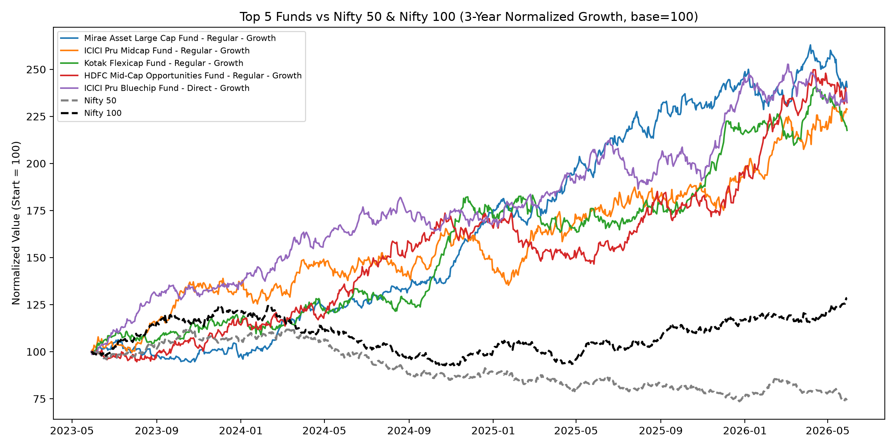
Top 5 scorecard funds vs Nifty 100, normalised 3-year growth (base = 100).
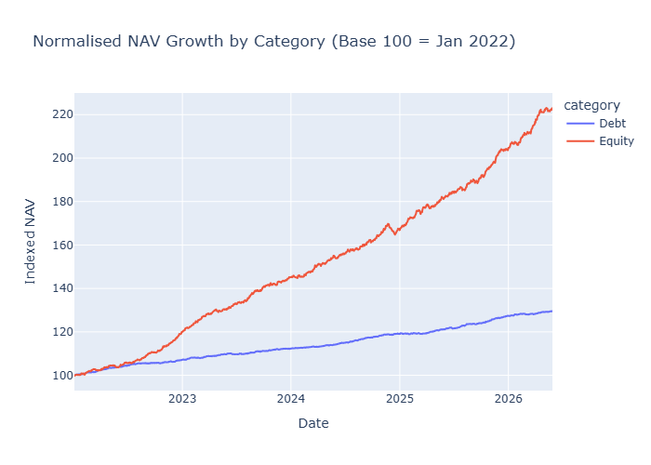
Normalised NAV growth by category (base 100 = Jan 2022) — Equity funds visibly outpace Debt over the sample window.

8. Advanced Analytics & Risk Metrics
Detail is in notebooks/advanced_analytics.ipynb (data/processed/var_cvar_report.csv, cohort_analysis.csv, sip_continuity.csv, sector_hhi.csv).

8.1 Value at Risk (95%) and Conditional VaR
Historical VaR was computed as the 5th percentile of each fund's daily return distribution; CVaR as the mean return below that threshold. The highest tail-risk funds are concentrated in the Small Cap category:
Scheme | VaR (95%) | CVaR (95%)
SBI Small Cap Fund - Direct Plan - Growth | -2.69% | -3.24%
Axis Small Cap Fund - Regular - Growth | -2.62% | -3.17%
ABSL Small Cap Fund - Regular - Growth | -2.60% | -3.25%

VaR at 95% confidence means there is a 5% historical chance of a single-day loss exceeding the stated figure; CVaR (Expected Shortfall) is the average loss on those worst 5% of days — a more conservative tail-risk measure than VaR alone, since it captures how bad the bad days actually get rather than just the threshold.

8.2 Rolling 90-Day Sharpe Ratio
Rolling Sharpe was tracked for 5 representative funds. All five show highly regime-dependent risk-adjusted performance, repeatedly swinging from strongly negative (as low as -5, mid-2023) to strongly positive (4–6, by 2025–26) — underscoring that short-window Sharpe ratios are unstable and should not be read as a stable fund characteristic.

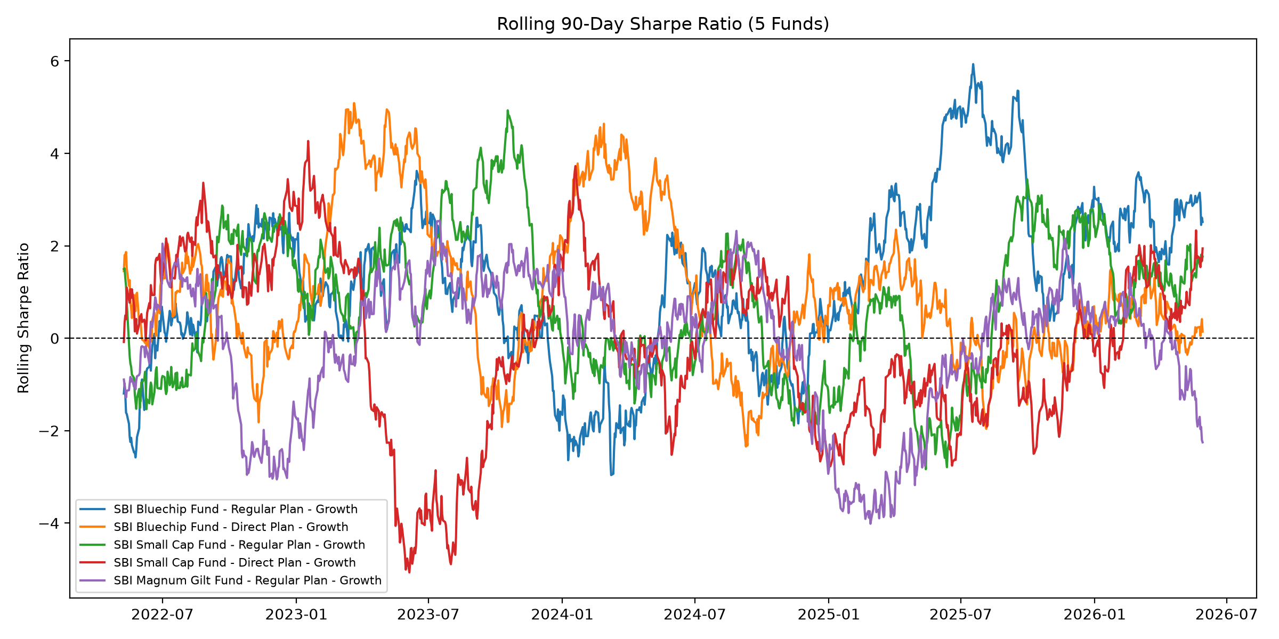
Rolling 90-day Sharpe ratio, 5 tracked funds.

8.3 Investor Cohort Analysis
Investors were grouped by the year of their first transaction. The 2024 cohort dominates both by count and capital:
Cohort Year | Avg SIP Amount | Total Invested | Investors | Top Fund (by code)
2024 | Rs. 10,997 | Rs. 21.50 crore | 4,624 | 125498
2025 | Rs. 13,505 | Rs. 22.55 lakh | 138 | 119599

The 2025 cohort's higher average SIP size (Rs. 13,505 vs Rs. 10,997) suggests newer investors in this dataset are committing larger monthly amounts per SIP — but their far smaller total headcount (138 vs 4,624) means 2024 remains the dominant year for both AUM contribution and platform reach.

8.4 SIP Continuity — Key Finding
For every investor with 6 or more SIP transactions, the average number of days between consecutive SIP payments was computed; investors averaging more than 35 days between SIPs were flagged “at-risk” for lapsing regularity.
Metric | Value
Eligible investors (6+ SIPs) | 1,362
At-risk investors (avg gap > 35 days) | 1,332
At-risk percentage | 97.8%

This is the most consequential finding in the project: despite being classified as “long-term” SIP investors by transaction count, the overwhelming majority are not sustaining a disciplined monthly cadence. This directly informs the retention recommendations in Section 11.

8.5 Sector Concentration (HHI)
The Herfindahl-Hirschman Index (HHI = Σ weight_i²) was computed per equity fund from sector-level portfolio weights, on a 0–10,000 scale where higher values indicate a portfolio concentrated in fewer sectors. Axis Bluechip Fund is the most sector-concentrated fund in the sample (HHI ≈ 2,968), followed by Mirae Asset Tax Saver Fund (≈2,550) and HDFC Mid-Cap Opportunities Fund Direct (≈2,532) — all indicating meaningfully reduced sector diversification relative to more balanced peers.
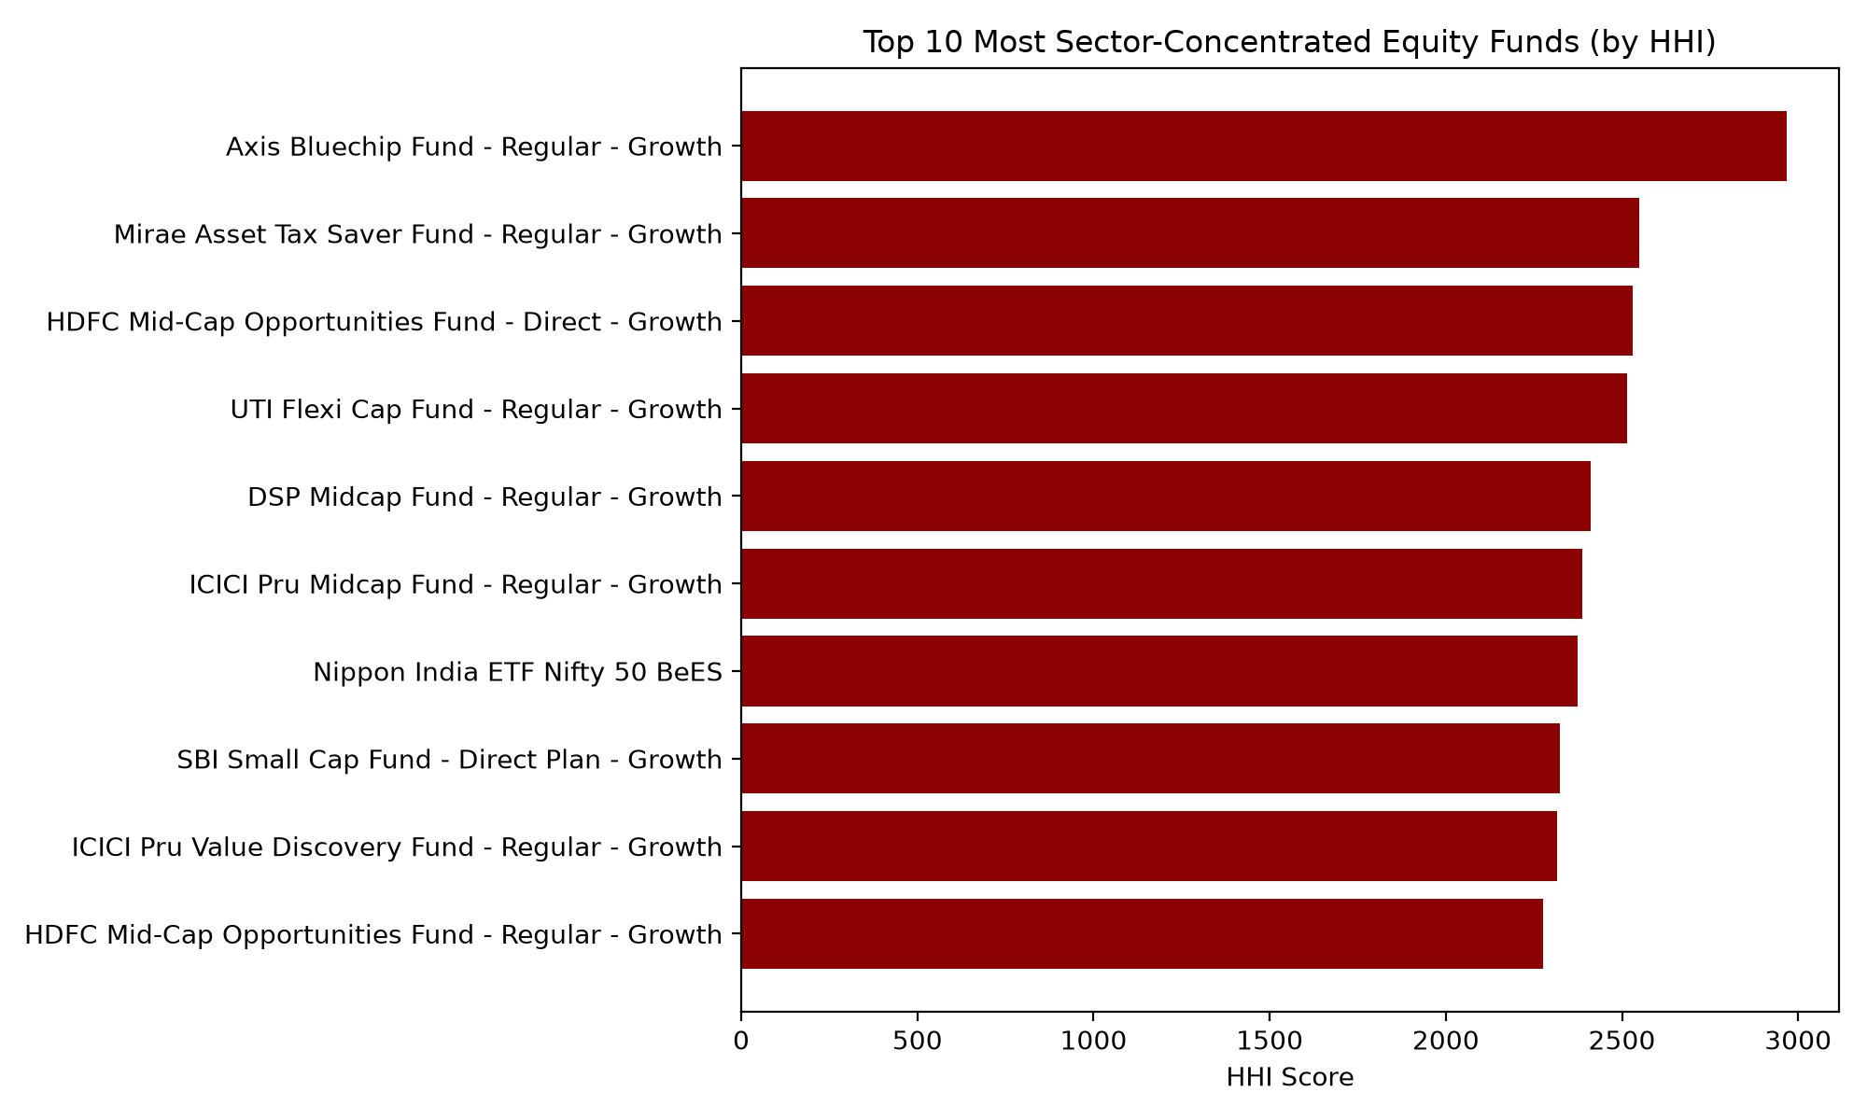
Top 10 most sector-concentrated equity funds by HHI.

8.6 Simple Fund Recommender
A rule-based recommender (scripts/recommender.py) maps investor risk appetite (Low / Moderate / High) to matching SEBI risk categories and returns the top 3 funds by Sharpe ratio within that band. Sample output:
Risk Appetite | Top Recommendation | Sharpe
Low | ICICI Pru Liquid Fund - Regular - Growth | 7.68
Moderate | HDFC Top 100 Fund - Regular Plan - Growth | 1.06
High | Kotak Emerging Equity Fund - Regular - Growth | 0.96

9. Interactive Dashboard
The Power BI dashboard (dashboard/bluestock_mf_dashboard.pbix) consists of 4 pages, each with interactive slicers and cross-filtering. All charts share consistent styling and were built directly against the SQLite database and processed CSVs, with several DAX measures created to pin KPI cards and trend charts to the latest available period (e.g. Total AUM (Latest), Latest SIP Inflow) rather than double-counting across historical quarters.

9.1 Page 1 — Industry Overview
KPI cards (Total AUM, Latest SIP Inflow, Latest Folios, Scheme Count), an industry AUM trend line, and an AUM-by-fund-house bar chart confirming SBI Mutual Fund's dominance.
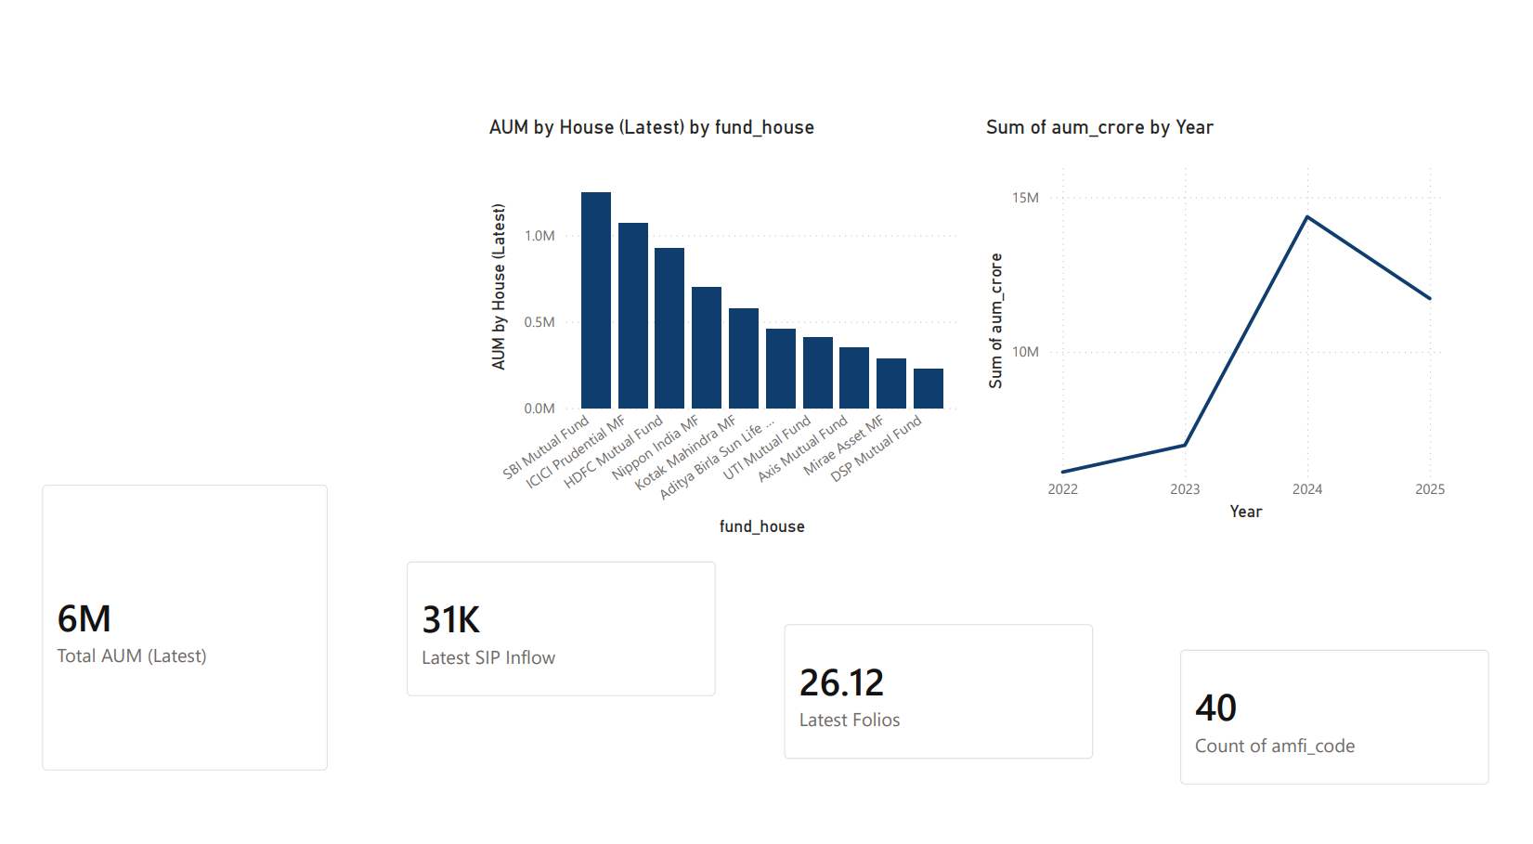
Dashboard Page 1 — Industry Overview.

9.2 Page 2 — Fund Performance
A sortable fund scorecard table, a return-vs-drawdown scatter plot, a NAV trend line, and slicers for fund house, category and plan.
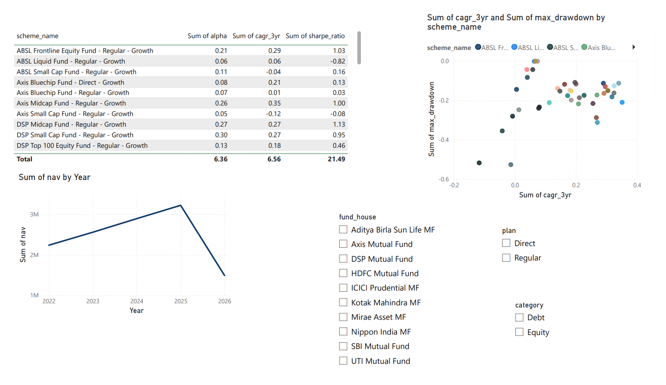
Dashboard Page 2 — Fund Performance.

9.3 Page 3 — Investor Analytics
Transaction amount by state, a SIP/Lumpsum/Redemption donut, average SIP amount by age group, and transaction-volume trend, with slicers for state, age group and city tier.
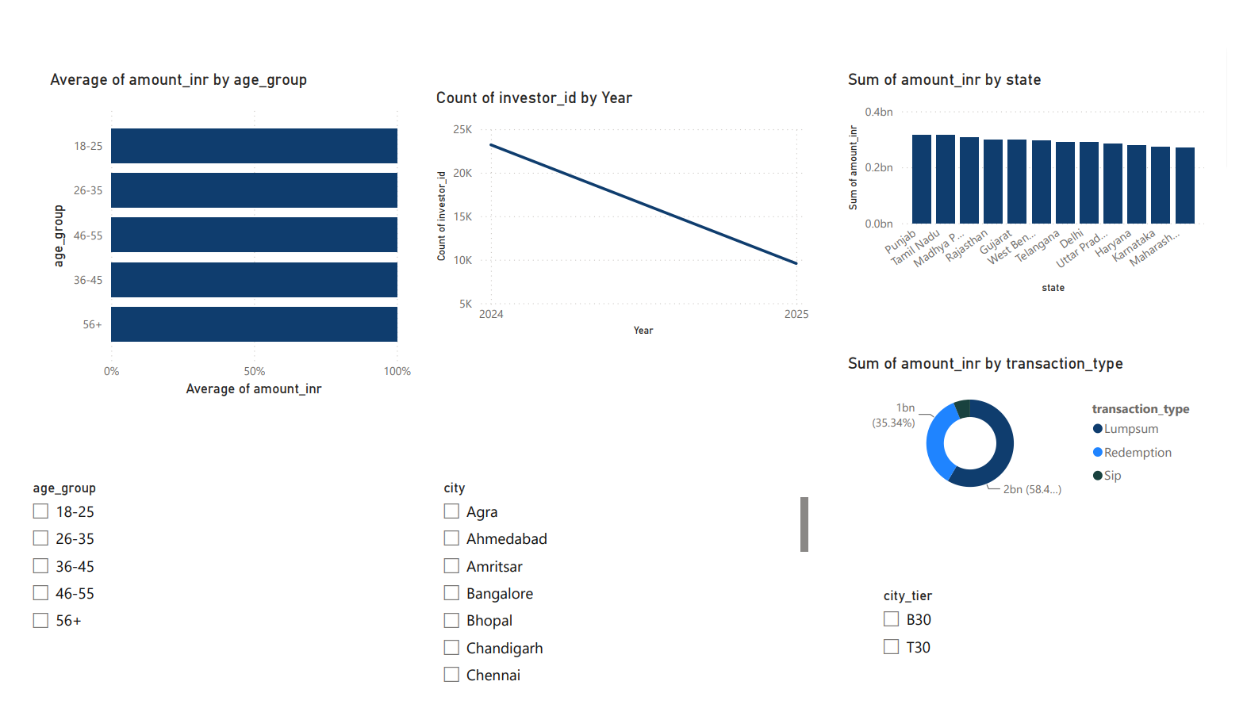
Dashboard Page 3 — Investor Analytics.

9.4 Page 4 — SIP & Market Trends
SIP inflow trend and Nifty 50 index level (shown as two time-aligned charts — see Section 10 on the dual-axis limitation), a category-inflow heatmap (Matrix visual with conditional background-colour formatting), and a Top-5-categories-by-net-inflow chart.
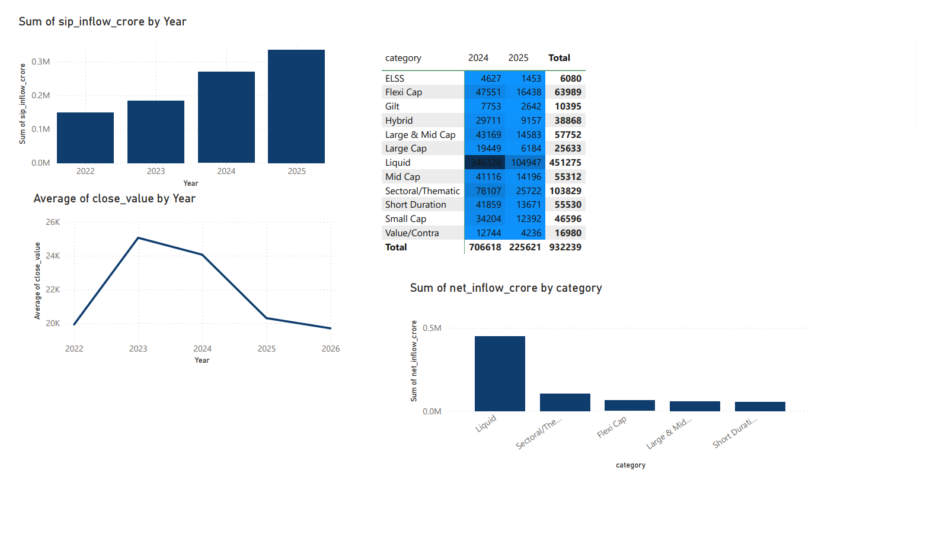
Dashboard Page 4 — SIP & Market Trends.

10. Limitations
- Sample scope: the platform analyses 40 schemes, not the full ~1,908-scheme Indian MF universe — dashboard KPI totals are proportionally smaller than the real industry headline figures quoted in Section 2.2.
- Simulated transactions: investor transaction data is synthetically generated (though built from realistic demographic/behavioural distributions), so investor-level findings (e.g. SIP continuity) describe patterns in the simulation rather than verified real-world investor behaviour.
- Dual-axis combo chart: Page 4 was originally intended to show SIP inflow and Nifty 50 as a single dual-axis combo chart. A cross-table relationship (linking monthly SIP data to daily benchmark data) was built but did not filter correctly inside the combo visual; the two series are instead shown as two time-aligned charts on the same page. This preserves the same comparison for the viewer without the single-visual mechanic.
- Drill-through was not implemented on the dashboard (time-boxed as an optional enhancement per the project brief) — noted here rather than left silently absent.
- A small fraction of transaction records reference amfi_codes outside the 40-scheme master list (identified during Day 1 data-quality checks); these do not join to fund-level detail and are excluded from fund-specific slicing.

11. Recommendations
- Prioritise SIP-continuity retention outreach: given 97.8% of long-term SIP investors show gaps >35 days, an AMC-side nudge/reminder programme targeting investors whose SIP gap exceeds ~35 days could materially improve retained AUM.
- Don't rank funds by raw Sharpe ratio alone across categories — use a composite, category-aware score (as built in Section 7) to avoid systematically favouring low-volatility Liquid funds over genuinely strong equity performers.
- Extend the risk dashboard with rolling VaR/CVaR (not just a single-window snapshot) given how much rolling Sharpe varies over time (Section 8.2) — a point-in-time risk metric can be misleading for fund selection.
- Flag high-HHI funds (Section 8.5) explicitly to retail investors comparing “similar” category funds, since sector concentration is not visible from category labels alone.
- For a production version, replace the simulated transaction dataset with real (anonymised) investor data to validate whether the SIP-continuity finding holds outside this simulation.

12. Appendix A — Sample SQL Queries
Ten analytical SQL queries were written and tested against the star schema (sql/queries.sql); three representative examples are reproduced below.

Top 5 funds by AUM
SELECT fund_house, aum_crore FROM fact_aum ORDER BY aum_crore DESC LIMIT 5;

Top 5 funds by Sharpe ratio (joined to fund names)
SELECT df.scheme_name, fp.sharpe_ratio FROM fact_performance fp JOIN dim_fund df ON fp.amfi_code = df.amfi_code ORDER BY fp.sharpe_ratio DESC LIMIT 5;

Average SIP amount by age group
SELECT age_group, AVG(amount_inr) AS avg_amount FROM fact_transactions WHERE transaction_type = 'Sip' GROUP BY age_group;
Full query set, including transactions-by-state, funds under 1% expense ratio, risk-category counts, and worst single-day NAV drops per fund, is available in sql/queries.sql.

13. Appendix B — Data Dictionary
Full detail is maintained in data_dictionary.md. Core table definitions:

dim_fund
Column | Type | Description
amfi_code | TEXT (PK) | Unique AMFI scheme code
fund_house | TEXT | AMC name
scheme_name | TEXT | Full scheme name
category / sub_category | TEXT | Equity/Debt; Large Cap/Mid Cap/etc.
plan | TEXT | Regular or Direct
expense_ratio_pct / exit_load_pct | REAL | Annual expense ratio %; exit load %
risk_category | TEXT | SEBI risk grade (Low – Very High)

fact_nav
Column | Type | Description
amfi_code | TEXT (FK) | Links to dim_fund
nav_date | DATE | NAV date
nav | REAL | NAV value in Rs.
daily_return_pct | REAL | Day-over-day % change (computed)

fact_transactions
Column | Type | Description
tx_id | INTEGER (PK) | Auto-generated transaction ID
investor_id / amfi_code | TEXT | Investor identifier; fund reference (FK)
transaction_type / amount_inr | TEXT / INT | SIP / Lumpsum / Redemption; amount in Rs.
state, city, city_tier | TEXT | Investor location, T30/B30
age_group, gender, annual_income_lakh | — | Investor demographics
payment_mode, kyc_status | TEXT | Transaction metadata

fact_performance
Column | Type | Description
amfi_code | TEXT (FK) | Fund reference
return_1yr_pct / 3yr / 5yr | REAL | Returns over each period
alpha, beta | REAL | Risk-adjusted performance vs benchmark
sharpe_ratio, sortino_ratio | REAL | Risk-adjusted return metrics
max_drawdown_pct | REAL | Worst peak-to-trough decline

14. Appendix C — Deliverables & Evaluation Checklist
Deliverable | Format | Status
ETL Pipeline Script | Python (.py) | Complete
SQLite Database | .db file (7-table star schema) | Complete
EDA Notebook | .ipynb, 19 charts | Complete
Performance Metrics | .ipynb + CSV | Complete
Interactive Dashboard | .pbix, 4 pages | Complete
Advanced Analytics | .ipynb + CSV + recommender.py | Complete
Final Report + Slides | .pdf + .pptx | Complete

All code, notebooks, SQL, processed data, dashboard file, charts, and this report are available in the public GitHub repository, tagged v1.0.

15. Appendix D — Bonus Challenge: Monte Carlo NAV Projection
As an optional bonus extension (Bonus Challenge B3), a 5-year Monte Carlo simulation was built to project NAV growth with uncertainty bands for the top 5 composite-scorecard funds (scripts/monte_carlo_simulation.py).

Methodology
- Daily log returns for each fund are estimated from its full historical NAV series (~4.5 years) as mean (μ) and standard deviation (σ).
- 2,000 independent 5-year price paths are simulated per fund using Geometric Brownian Motion: NAV_t = NAV_0 × exp(cumsum((μ − 0.5σ²) + σ × Z_t)), with Z_t ~ N(0,1) drawn independently per trading day.
- The median path and the 10th–90th percentile band (an 80% confidence interval) are plotted for each fund.
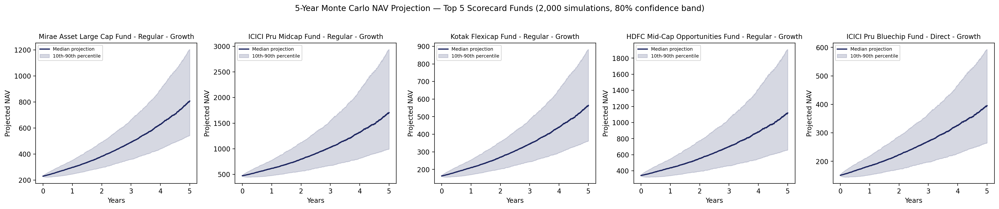
5-year Monte Carlo NAV projection, top 5 scorecard funds (2,000 simulations each, 80% confidence band).

Median 5-Year Projected Return
- Mirae Asset Large Cap Fund: +250.7% (80% CI: +136.0% to +423.2%)
- ICICI Pru Midcap Fund: +260.0% (80% CI: +110.2% to +520.0%)
- Kotak Flexicap Fund: +245.6% (80% CI: +121.9% to +440.5%)
- HDFC Mid-Cap Opportunities Fund: +227.1% (80% CI: +92.8% to +457.7%)
- ICICI Pru Bluechip Fund (Direct): +161.7% (80% CI: +75.3% to +292.3%)
Caveat: this simulation assumes daily returns are independent and identically Normal-distributed — a simplification, not a forecast. Real markets exhibit volatility clustering and fatter tails than a Normal distribution captures, so the width of these bands should be read as illustrative rather than a precise risk bound. Full output: data/processed/monte_carlo_summary.csv.

