Question 1)
Part a)
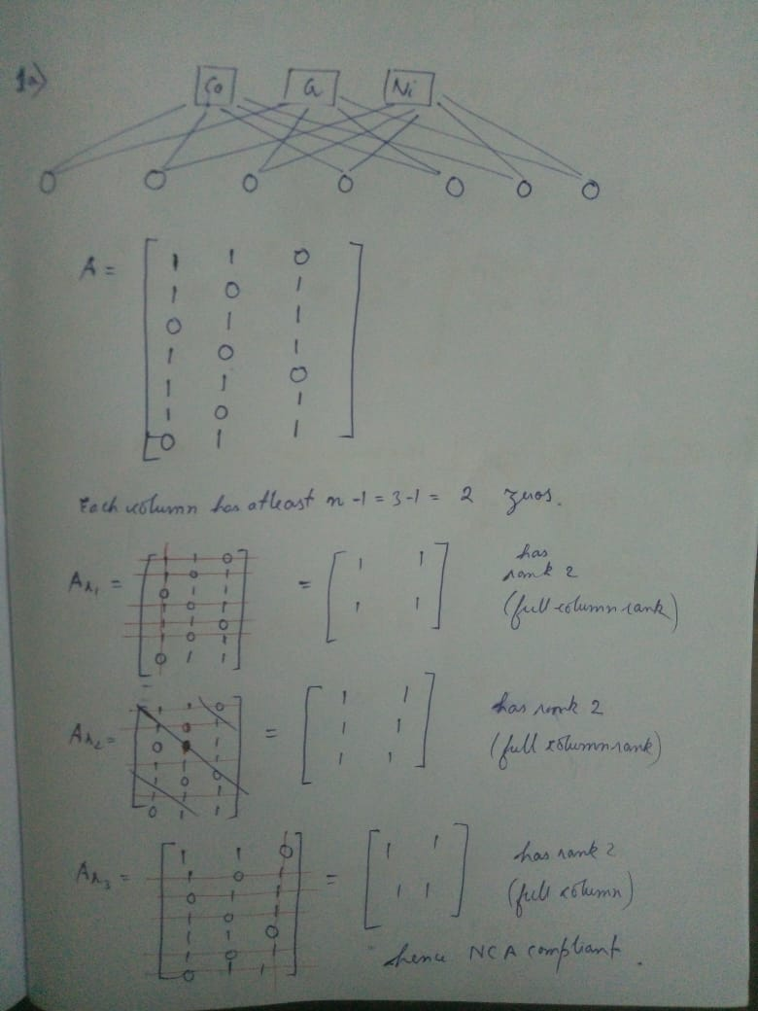

Part b) and partc)
clc
clear variables
load ncadata
B=pureabs;
C=measabs;
D=C/(176)^0.5;
%above statement calculates the scaled data because svd we nee covariance
%of yy'/N , so introduce N^0.5 here only
%[u,s,v]=svds(D);
[u,s,v]=svd(D,0);
% denoising using pca
% caluculating the percentage of variation captured
% as the number of independent components is 3 therefore 3 principal
% directions only
var_capt=(((s(1,1))^2)+((s(2,2))^2)+((s(3,3))^2))/trace(s*s')
% in this statement calculating denoised estimate using first three
% principal directions
Denoised_data=(176^0.5)*u(:,1:3)*s(1:3,:)*v';
disp("Denoised data");
disp(Denoised_data)
%no of independent componensts=3 given
Astruct=[1 1 0;1 0 1;0 1 1;1 0 1; 1 1 0;1 0 1;0 1 1];
% now u can use denoised_data=u1*s1*v1' and group it therefore u1*s1=Apca
% and v1 is S matrix lets say this as matrix p.
% calculating Apca
%scaling is important do not miss it
Apca=(176^0.5)*u(:,1:3)*s(1:3,1:3);
% now we have got some value of Apca and we have to adjust it so that Apca
% and Astruct have same structure for this. Z=AS therefore Z=(A1*M)*(M^-1*P)
% now we have to calculate that M for which A1*M and Astruct have the same
% structure.
% here M is multiplication matrix
M=[];
m=3;
for i =1:m
Ind_Zero_Ast=find(~Astruct(:,i));
%Apca(Ind_Zeros_Ast,:)*M(:,i)=0 solve this to get M(:,i)
A_1=Apca(Ind_Zero_Ast,:);
%can use svd to solve the equation Ax=0 as x is the null space of A
%therefore eigenvectors corresponding zeros singular value of A are the
%nullspace od A
[u1,s1,v1]=svd(A_1);
% do not do economic svd because array size will be different
M=[M;v1(:,m)];
A_1*v1(:,m) ;
end
% reshaping M matrix
M=reshape(M,[3,3]);
disp("Rotation matrix");
disp(M);
% using this M calculating M^-1*P
P=v(:,1:3)';
% getting A_new whose structure is similar to Astruct and corresponding
% true component matrix.
P_new=pinv(M)*P;
A_new=Apca*M;
%calculating the correlation between true component and calculated S ie P
% here we have calculated the overall correlation
correlation1=[];
for i=1:3
c1=cov(B(i,:)');
c2=cov(P_new(i,:)');
c3=cov(B(i,:)',P_new(i,:)');
correlation1=[correlation1;c3(1,2)/sqrt(c1(1,1)*c2(1,1))];
end
disp("Correlation matrix using only PCA");
disp(correlation1);
i=1:176;
figure
plot(i,P_new(1,:))
hold on
plot(i,P_new(2,:))
plot(i,P_new(3,:))
xlabel("x");
ylabel("Absorption")
title("Extracted pure components spectra using PCA ");
figure
plot(i,pureabs(1,:))
hold on
plot(i,pureabs(2,:))
plot(i,pureabs(3,:))
xlabel("x");
ylabel("Absorption")
title("Pure components spectra");
% doing part1c
% using NCA toolbox
[A,P,iter,ss]= gnca_fast(D,A_new,P_new);
correlation2=[];
for i=1:3
c1=cov(B(i,:)');
c2=cov(P(i,:)');
c3=cov(B(i,:)',P(i,:)');
correlation2=[correlation2;c3(1,2)/sqrt(c1(1,1)*c2(1,1))];
end
disp("Correlation matrix after applying NCA using the toolbox")
disp(correlation2);
i=1:176;
figure
plot(i,P(1,:))
hold on
plot(i,P(2,:))
plot(i,P(3,:))
xlabel("x");
ylabel("Absorption")
title("Extracted pure components spectra using NCA");

var_capt =
0.9981
Denoised data
Columns 1 through 7
0.0060 0.0056 0.0047 0.0058 0.0053 0.0052 0.0045
0.0050 0.0058 0.0043 0.0063 0.0053 0.0035 0.0041
0.0118 0.0092 0.0084 0.0076 0.0110 0.0110 0.0113
0.0083 0.0068 0.0059 0.0056 0.0083 0.0073 0.0085
0.0154 0.0134 0.0119 0.0133 0.0131 0.0141 0.0118
0.0025 0.0025 0.0020 0.0025 0.0026 0.0020 0.0023
0.0088 0.0069 0.0064 0.0059 0.0080 0.0083 0.0081
Columns 8 through 14
0.0062 0.0073 0.0090 0.0110 0.0100 0.0095 0.0074
0.0063 0.0075 0.0074 0.0108 0.0109 0.0118 0.0089
0.0153 0.0194 0.0276 0.0342 0.0354 0.0309 0.0245
0.0118 0.0153 0.0209 0.0270 0.0290 0.0261 0.0205
0.0158 0.0187 0.0246 0.0291 0.0263 0.0237 0.0188
0.0034 0.0042 0.0050 0.0067 0.0070 0.0068 0.0053
0.0109 0.0137 0.0195 0.0239 0.0242 0.0210 0.0167
Columns 15 through 21
0.0052 0.0035 0.0036 0.0038 0.0025 0.0025 0.0015
0.0057 0.0051 0.0048 0.0044 0.0022 0.0021 0.0002
0.0204 0.0165 0.0120 0.0108 0.0079 0.0077 0.0079
0.0168 0.0144 0.0103 0.0088 0.0061 0.0058 0.0056
0.0141 0.0091 0.0089 0.0096 0.0068 0.0069 0.0054
0.0039 0.0034 0.0027 0.0024 0.0015 0.0014 0.0008
0.0139 0.0108 0.0081 0.0075 0.0056 0.0055 0.0055
Columns 22 through 28
0.0021 0.0030 0.0029 0.0029 0.0030 0.0025 0.0032
0.0013 0.0020 0.0011 0.0006 -0.0000 -0.0009 -0.0006
0.0076 0.0073 0.0074 0.0088 0.0095 0.0089 0.0104
0.0056 0.0050 0.0046 0.0055 0.0056 0.0049 0.0058
0.0061 0.0083 0.0086 0.0091 0.0100 0.0090 0.0109
0.0011 0.0012 0.0010 0.0010 0.0008 0.0005 0.0007
0.0053 0.0054 0.0056 0.0065 0.0071 0.0067 0.0078
Columns 29 through 35
0.0036 0.0043 0.0053 0.0060 0.0062 0.0072 0.0080
0.0003 0.0016 0.0022 0.0017 0.0024 0.0026 0.0043
0.0106 0.0120 0.0127 0.0146 0.0170 0.0201 0.0224
0.0062 0.0077 0.0079 0.0085 0.0109 0.0128 0.0152
0.0116 0.0129 0.0153 0.0179 0.0185 0.0217 0.0231
0.0010 0.0015 0.0017 0.0017 0.0022 0.0025 0.0033
0.0080 0.0089 0.0096 0.0111 0.0126 0.0149 0.0163
Columns 36 through 42
0.0083 0.0092 0.0101 0.0108 0.0116 0.0124 0.0129
0.0037 0.0032 0.0058 0.0042 0.0062 0.0055 0.0051
0.0238 0.0284 0.0310 0.0322 0.0357 0.0379 0.0425
0.0158 0.0187 0.0218 0.0211 0.0248 0.0255 0.0289
0.0246 0.0280 0.0295 0.0327 0.0339 0.0371 0.0394
0.0033 0.0036 0.0047 0.0042 0.0052 0.0051 0.0055
0.0175 0.0208 0.0224 0.0236 0.0257 0.0276 0.0307
Columns 43 through 49
0.0131 0.0145 0.0151 0.0157 0.0160 0.0168 0.0179
0.0053 0.0064 0.0065 0.0079 0.0081 0.0072 0.0090
0.0441 0.0456 0.0489 0.0509 0.0513 0.0520 0.0512
0.0302 0.0310 0.0333 0.0354 0.0357 0.0351 0.0346
0.0401 0.0434 0.0458 0.0467 0.0475 0.0504 0.0523
0.0057 0.0062 0.0065 0.0072 0.0073 0.0069 0.0074
0.0318 0.0330 0.0354 0.0366 0.0369 0.0378 0.0374
Columns 50 through 56
0.0181 0.0176 0.0188 0.0189 0.0184 0.0183 0.0180
0.0080 0.0074 0.0062 0.0076 0.0056 0.0059 0.0045
0.0521 0.0497 0.0503 0.0493 0.0463 0.0451 0.0431
0.0346 0.0325 0.0313 0.0311 0.0278 0.0270 0.0246
0.0535 0.0522 0.0564 0.0559 0.0551 0.0545 0.0542
0.0071 0.0067 0.0062 0.0065 0.0055 0.0055 0.0048
0.0382 0.0366 0.0377 0.0369 0.0351 0.0343 0.0331
Columns 57 through 63
0.0184 0.0185 0.0178 0.0182 0.0170 0.0164 0.0164
0.0047 0.0056 0.0061 0.0047 0.0035 0.0043 0.0035
0.0430 0.0395 0.0373 0.0359 0.0317 0.0309 0.0294
0.0243 0.0218 0.0208 0.0183 0.0150 0.0154 0.0135
0.0553 0.0545 0.0517 0.0537 0.0502 0.0480 0.0483
0.0048 0.0047 0.0047 0.0040 0.0032 0.0035 0.0030
0.0332 0.0309 0.0291 0.0286 0.0257 0.0249 0.0240
Columns 64 through 70
0.0161 0.0150 0.0146 0.0140 0.0140 0.0126 0.0119
0.0046 0.0039 0.0042 0.0027 0.0043 0.0025 0.0025
0.0267 0.0246 0.0232 0.0204 0.0187 0.0172 0.0154
0.0122 0.0109 0.0103 0.0073 0.0069 0.0056 0.0047
0.0466 0.0433 0.0418 0.0408 0.0396 0.0364 0.0343
0.0031 0.0027 0.0027 0.0019 0.0023 0.0016 0.0015
0.0221 0.0205 0.0194 0.0177 0.0164 0.0151 0.0137
Columns 71 through 77
0.0119 0.0111 0.0102 0.0099 0.0092 0.0097 0.0086
0.0030 0.0027 0.0039 0.0030 0.0039 0.0049 0.0033
0.0158 0.0147 0.0131 0.0132 0.0133 0.0112 0.0111
0.0054 0.0049 0.0051 0.0048 0.0061 0.0045 0.0043
0.0339 0.0318 0.0282 0.0278 0.0254 0.0257 0.0239
0.0017 0.0015 0.0018 0.0016 0.0020 0.0020 0.0015
0.0139 0.0130 0.0115 0.0115 0.0112 0.0099 0.0097
Columns 78 through 84
0.0076 0.0075 0.0070 0.0070 0.0064 0.0060 0.0063
0.0044 0.0050 0.0056 0.0040 0.0043 0.0053 0.0043
0.0100 0.0106 0.0089 0.0080 0.0060 0.0078 0.0083
0.0049 0.0059 0.0052 0.0035 0.0024 0.0050 0.0045
0.0201 0.0195 0.0175 0.0184 0.0163 0.0146 0.0161
0.0019 0.0022 0.0023 0.0016 0.0015 0.0022 0.0018
0.0084 0.0086 0.0073 0.0070 0.0055 0.0063 0.0069
Columns 85 through 91
0.0064 0.0055 0.0059 0.0056 0.0058 0.0053 0.0058
0.0056 0.0043 0.0062 0.0062 0.0056 0.0058 0.0060
0.0059 0.0061 0.0058 0.0046 0.0056 0.0061 0.0053
0.0032 0.0033 0.0039 0.0031 0.0035 0.0044 0.0035
0.0152 0.0137 0.0135 0.0124 0.0135 0.0121 0.0133
0.0020 0.0016 0.0022 0.0021 0.0020 0.0022 0.0021
0.0052 0.0052 0.0048 0.0040 0.0048 0.0049 0.0046
Columns 92 through 98
0.0057 0.0059 0.0062 0.0064 0.0061 0.0067 0.0064
0.0064 0.0058 0.0083 0.0067 0.0061 0.0066 0.0056
0.0051 0.0053 0.0044 0.0050 0.0072 0.0056 0.0072
0.0037 0.0032 0.0039 0.0032 0.0049 0.0033 0.0043
0.0126 0.0138 0.0128 0.0145 0.0144 0.0154 0.0155
0.0023 0.0020 0.0028 0.0023 0.0024 0.0023 0.0021
0.0043 0.0046 0.0038 0.0045 0.0058 0.0049 0.0060
Columns 99 through 105
0.0065 0.0070 0.0071 0.0078 0.0069 0.0086 0.0086
0.0068 0.0070 0.0058 0.0072 0.0067 0.0078 0.0078
0.0053 0.0053 0.0051 0.0059 0.0062 0.0053 0.0063
0.0033 0.0030 0.0021 0.0030 0.0036 0.0022 0.0030
0.0148 0.0161 0.0170 0.0184 0.0162 0.0201 0.0203
0.0023 0.0023 0.0019 0.0024 0.0023 0.0025 0.0026
0.0047 0.0048 0.0049 0.0055 0.0054 0.0053 0.0060
Columns 106 through 112
0.0083 0.0096 0.0098 0.0095 0.0101 0.0106 0.0107
0.0061 0.0083 0.0090 0.0065 0.0074 0.0068 0.0064
0.0072 0.0071 0.0083 0.0076 0.0087 0.0098 0.0095
0.0029 0.0033 0.0045 0.0026 0.0036 0.0037 0.0031
0.0206 0.0227 0.0231 0.0237 0.0249 0.0271 0.0275
0.0021 0.0027 0.0031 0.0022 0.0026 0.0024 0.0022
0.0066 0.0067 0.0074 0.0073 0.0080 0.0090 0.0089
Columns 113 through 119
0.0113 0.0117 0.0118 0.0123 0.0124 0.0126 0.0127
0.0083 0.0079 0.0071 0.0076 0.0060 0.0062 0.0063
0.0099 0.0105 0.0116 0.0098 0.0117 0.0119 0.0124
0.0043 0.0040 0.0044 0.0028 0.0034 0.0034 0.0038
0.0279 0.0296 0.0306 0.0312 0.0327 0.0333 0.0337
0.0029 0.0028 0.0026 0.0025 0.0022 0.0023 0.0023
0.0091 0.0097 0.0106 0.0095 0.0110 0.0112 0.0116
Columns 120 through 126
0.0130 0.0135 0.0140 0.0142 0.0150 0.0141 0.0150
0.0056 0.0044 0.0054 0.0055 0.0049 0.0043 0.0043
0.0130 0.0143 0.0139 0.0160 0.0139 0.0142 0.0149
0.0037 0.0036 0.0035 0.0052 0.0023 0.0029 0.0028
0.0351 0.0374 0.0381 0.0390 0.0413 0.0391 0.0417
0.0021 0.0018 0.0021 0.0023 0.0018 0.0017 0.0017
0.0122 0.0134 0.0131 0.0145 0.0136 0.0135 0.0143
Columns 127 through 133
0.0149 0.0155 0.0149 0.0162 0.0167 0.0159 0.0157
0.0012 0.0025 0.0012 0.0028 0.0027 0.0033 0.0013
0.0146 0.0167 0.0178 0.0162 0.0165 0.0163 0.0179
0.0007 0.0027 0.0034 0.0019 0.0017 0.0026 0.0028
0.0434 0.0447 0.0439 0.0463 0.0477 0.0451 0.0461
0.0006 0.0012 0.0009 0.0012 0.0011 0.0014 0.0009
0.0146 0.0159 0.0166 0.0158 0.0162 0.0157 0.0169
Columns 134 through 140
0.0166 0.0164 0.0165 0.0156 0.0164 0.0162 0.0160
0.0023 0.0008 0.0027 0.0013 0.0012 0.0016 0.0021
0.0178 0.0180 0.0181 0.0175 0.0182 0.0187 0.0186
0.0026 0.0020 0.0033 0.0026 0.0024 0.0033 0.0037
0.0481 0.0485 0.0474 0.0458 0.0482 0.0475 0.0466
0.0011 0.0007 0.0013 0.0009 0.0008 0.0011 0.0013
0.0171 0.0174 0.0171 0.0167 0.0174 0.0176 0.0174
Columns 141 through 147
0.0158 0.0162 0.0158 0.0160 0.0163 0.0157 0.0153
0.0013 0.0003 0.0001 0.0026 0.0024 0.0019 0.0021
0.0188 0.0190 0.0177 0.0180 0.0178 0.0181 0.0193
0.0036 0.0027 0.0019 0.0034 0.0030 0.0034 0.0050
0.0464 0.0484 0.0471 0.0462 0.0470 0.0456 0.0445
0.0010 0.0006 0.0005 0.0013 0.0012 0.0011 0.0014
0.0175 0.0180 0.0171 0.0169 0.0170 0.0170 0.0175
Columns 148 through 154
0.0148 0.0140 0.0146 0.0142 0.0137 0.0130 0.0126
0.0010 0.0000 0.0021 0.0017 0.0012 0.0015 0.0024
0.0182 0.0185 0.0179 0.0184 0.0190 0.0187 0.0174
0.0037 0.0040 0.0043 0.0049 0.0054 0.0060 0.0057
0.0439 0.0421 0.0426 0.0417 0.0408 0.0384 0.0366
0.0009 0.0007 0.0013 0.0013 0.0012 0.0014 0.0016
0.0169 0.0169 0.0164 0.0166 0.0169 0.0164 0.0153
Columns 155 through 161
0.0130 0.0119 0.0117 0.0112 0.0103 0.0100 0.0102
0.0026 0.0015 0.0008 0.0024 0.0011 0.0015 0.0039
0.0186 0.0191 0.0182 0.0179 0.0186 0.0169 0.0175
0.0065 0.0072 0.0063 0.0074 0.0079 0.0069 0.0089
0.0378 0.0355 0.0351 0.0326 0.0311 0.0298 0.0287
0.0017 0.0015 0.0012 0.0018 0.0015 0.0015 0.0024
0.0162 0.0162 0.0157 0.0151 0.0154 0.0141 0.0142
Columns 162 through 168
0.0093 0.0092 0.0084 0.0082 0.0080 0.0083 0.0073
0.0020 0.0022 0.0011 0.0022 0.0025 0.0039 0.0030
0.0184 0.0178 0.0166 0.0168 0.0176 0.0158 0.0177
0.0092 0.0089 0.0078 0.0089 0.0100 0.0089 0.0109
0.0276 0.0272 0.0254 0.0243 0.0236 0.0234 0.0214
0.0019 0.0019 0.0015 0.0019 0.0021 0.0023 0.0024
0.0147 0.0143 0.0134 0.0133 0.0137 0.0124 0.0134
Columns 169 through 175
0.0069 0.0064 0.0060 0.0057 0.0056 0.0051 0.0043
0.0043 0.0023 0.0015 0.0024 0.0031 0.0025 0.0028
0.0175 0.0163 0.0177 0.0158 0.0160 0.0154 0.0162
0.0119 0.0101 0.0111 0.0102 0.0110 0.0106 0.0121
0.0194 0.0190 0.0186 0.0170 0.0161 0.0149 0.0126
0.0028 0.0021 0.0020 0.0021 0.0024 0.0022 0.0025
0.0129 0.0123 0.0132 0.0117 0.0116 0.0112 0.0113
Column 176
0.0037
0.0022
0.0166
0.0126
0.0113
0.0024
0.0114
Rotation matrix
-0.0472 -0.4494 -0.1762
-0.0547 -0.7424 0.9503
0.9974 -0.4969 0.2567
Correlation matrix using only PCA
0.9425
0.9968
0.9967
Correlation matrix after applying NCA using the toolbox
0.8975
0.9760
0.9627
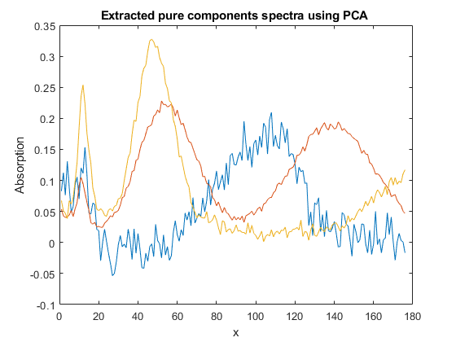
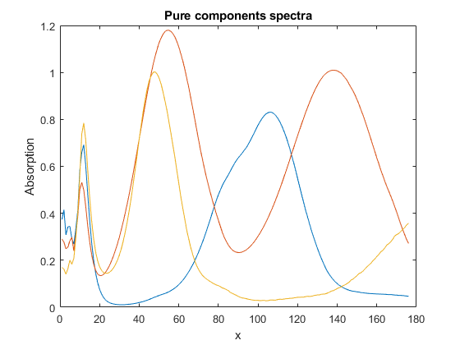

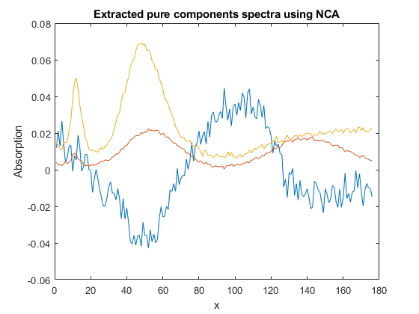
…………………………………………………………………………………………………………………………………………………………….
Question 2)
clc
clear variables
load yeastdata.mat
% you have to load NCA_Yeast_dataset using import data
Z=microarraydata;
[u1,s1,v1]=svd(Z,'econ');
A_est=u1(:,1:33)*s1(1:33,1:33);
P_est=(v1(:,1:33))';
% making the structure of A_est and Astruct same
M=[];
m=33;
for i =1:m
Ind_Zero_Ast=find(~Astruct(:,i));
%Apca(Ind_Zeros_Ast,:)*M(:,i)=0 solve this to get M(:,i)
A_1=A_est(Ind_Zero_Ast,:);
%can use svd to solve the equation Ax=0 as x is the null space of A
%therefore eigenvectors corresponding zeros singular value of A are the
%nullspace od A
[u1,s1,v1]=svd(A_1);
% do not do economic svd because array size will be different
M=[M;v1(:,m)];
A_1*v1(:,m) ;
end
% reshaping M matrix
M=reshape(M,[33,33]);
% using this M calculating M^-1*P
P=(M^-1)*P_est;
% calculating A
A=A_est*M;
% calculating variance of all tfs one by one
VAR=zeros(33,1);
indices=zeros(11,1);
for i=1:33
VAR(i)=var(P(i,:));
end
Max=maxk(VAR,11);
%finding indices of those elements
for i =1:11
for j =1:33
if VAR(j)==Max(i)
indices(i)=j;
end
end
end
% using NCA toolbox solving this
[Anca,Pnca,iter,ss]= gnca_fast(Z,A,P);
VAR=zeros(33,1);
indices1=zeros(11,1);
for i=1:33
VAR(i)=var(Pnca(i,:));
end
Max=maxk(VAR,11);
%finding indices of those elements
for i =1:11
for j =1:33
if VAR(j)==Max(i)
indices1(i)=j;
end
end
end
disp("P matrix using NCA");
disp(Pnca);
disp("Indices of the Tfs identified after applying NCA using the toolbox");
disp(indices1);
P matrix using NCA
Columns 1 through 7
0.8008 0.1822 -0.3372 -0.1343 -0.0922 0.4518 -0.0176
0.4311 0.1370 0.0040 -0.3882 -0.4467 -0.4433 -0.4963
-0.8159 -0.3273 -0.0873 0.1293 -0.1180 0.2045 0.0741
0.2608 0.7370 -0.1395 -0.4549 -0.5234 -0.9012 -0.3744
0.7480 0.8764 0.8912 0.5481 -0.0495 -0.0664 -0.2221
0.8594 0.6544 0.3733 0.3544 0.1511 0.0123 -0.0216
-0.6771 -0.8659 -0.8149 -1.1411 -0.3887 -0.3699 0.1880
0.2025 0.0111 0.1049 0.0720 -0.4679 -0.6269 -0.5132
0.2833 0.2327 -0.7674 -0.2749 -0.1268 0.3953 -0.1063
0.8085 0.9935 1.3621 1.1161 0.1052 -0.0607 -0.7645
-0.6933 -0.5287 -0.6516 -0.0800 -0.1552 0.1159 -0.2289
-0.5389 0.8801 0.4292 0.3199 0.1472 0.2953 -0.2543
0.9081 0.8472 0.3957 -0.0933 -0.3449 0.1648 -0.2007
0.0371 -0.6512 -0.3252 0.2289 0.3668 0.2697 0.1521
0.5476 0.5271 0.3586 -0.1448 -0.1869 -0.4971 -0.2006
0.0502 -0.7949 0.4210 1.2532 1.6294 1.5016 0.5821
0.8358 0.9049 0.2340 0.5189 0.1988 0.1310 0.1191
0.4979 0.4973 -1.4760 -0.9052 -0.7505 0.0463 -0.1298
0.0705 -0.0530 0.1457 0.0073 -0.0936 0.0845 -0.2149
0.1455 0.3045 0.2057 -0.2794 -0.3315 -0.6143 -0.5782
-0.0830 -0.2529 -0.1921 0.1037 0.5831 0.4139 0.4873
-0.3301 -0.2404 0.3233 0.1147 -0.0732 -0.7096 0.0249
0.0170 -0.4327 0.3262 0.8869 0.2438 0.0922 -0.4080
0.1699 0.0964 0.0437 0.2536 0.0256 0.1085 0.3322
0.1287 -1.0112 -0.5213 0.2796 -0.0943 0.1302 0.1669
0.1924 0.9908 -0.0681 -0.2970 -0.1900 0.2210 0.7103
-0.4979 -0.5611 0.0782 0.2374 0.1738 -0.0252 0.0045
-1.5078 -0.4094 -0.6762 0.3568 0.3021 0.7052 -0.0138
0.2884 0.2488 -0.4465 0.4278 0.6054 0.6716 0.0457
-0.5241 0.0919 -0.7905 -0.8603 -1.2960 -1.2008 -1.2988
0.0817 -0.4102 0.4261 0.5075 0.5192 -0.1186 -0.0018
1.1660 0.6515 0.8354 0.1015 0.1866 -0.2817 -0.0690
-0.1002 -0.8169 -0.0289 -0.0888 -0.1724 -0.1003 0.0585
Columns 8 through 14
0.2732 0.0365 0.2538 -0.3967 -0.2306 -0.1804 0.1989
-0.5447 -0.7343 -0.4652 0.2576 0.6684 0.6983 0.3795
0.0201 0.0700 0.0616 0.3443 0.3468 0.2505 -0.2421
-0.5197 -0.4014 0.5402 0.2875 0.6452 0.4373 0.1856
0.0258 0.0800 -0.0703 -0.1710 -0.2090 -0.4591 -0.4156
0.1263 0.2289 0.0374 -0.1741 -0.3737 -0.3719 -0.3980
0.2028 0.4231 0.1045 0.2608 0.0983 0.4273 0.5248
-0.4417 -0.3418 -0.1220 0.0571 0.5777 0.1412 0.3462
0.0462 -0.2199 -0.1632 -0.1242 0.0515 0.2204 0.4054
-0.6352 -0.9439 -0.1871 -0.1868 0.4265 0.0051 0.0786
0.0683 0.1075 0.3668 0.5811 0.3946 0.2349 0.0436
-0.5906 -0.7107 -0.0800 -0.1147 0.3751 0.2982 0.2609
-0.0615 -0.2606 -0.1541 -0.1830 -0.1283 -0.2961 0.0377
-0.1392 -0.4489 -0.4550 -0.7869 0.0590 0.2536 0.5833
-0.0858 0.0813 0.2103 0.0569 -0.0589 -0.2230 -0.2248
-0.1731 -1.3829 -1.4711 -1.4794 -0.2068 0.3838 0.6325
-0.0951 -0.1382 -0.6727 -0.4869 -0.5099 -0.1093 -0.2666
0.3652 0.1772 0.4727 0.0734 0.0083 -0.1197 0.0695
-0.1766 -0.2829 0.4036 -0.0519 0.1855 0.1163 -0.0513
-0.9343 -0.4864 0.4435 0.8629 0.8328 0.6805 0.0393
-0.0125 -0.1554 -0.0672 -0.3040 0.0034 0.0728 0.1273
-0.0643 0.5573 -0.1185 0.4210 -0.2853 -0.0021 -0.4512
-0.3736 -0.4275 -0.0711 0.2558 0.6030 0.2632 0.0265
0.3144 0.2726 -0.2350 -0.7554 -0.5497 -0.3904 -0.1027
0.3446 0.3613 0.3123 -0.2638 -0.1044 -0.3040 -0.0259
0.5335 0.1943 -0.6121 -1.0235 -0.6183 -0.2791 -0.0095
-0.5021 -0.5969 -0.4773 0.3451 0.6634 0.6418 0.0954
-0.1390 -0.4484 -0.1757 0.2481 0.5091 0.5219 0.7479
0.0612 -0.0903 -0.2222 -0.3348 -0.4694 -0.1771 0.2224
-1.0241 -0.7642 1.7737 2.1096 1.9288 1.1134 0.2106
-0.2940 -0.1069 -0.4378 0.1904 0.0617 0.3464 0.1679
-0.2338 -0.2437 0.1141 -0.0494 -0.2479 -0.2283 -0.3326
-0.3009 -0.1658 0.2891 0.0247 0.4377 0.1317 0.1510
Columns 15 through 21
-0.4811 -0.3669 0.0308 0.0399 1.4418 1.0825 0.7940
0.4078 0.2373 0.3529 -0.0808 -0.5802 0.5835 -0.0917
-0.1834 0.1569 -0.0801 0.1681 -0.1784 0.2953 0.1269
0.0107 -0.1686 0.0813 0.2577 -0.3176 -0.0657 -0.5789
-0.6457 -0.2077 -0.4796 -0.1101 0.3993 0.0527 -0.2895
-0.3753 -0.2223 -0.5909 -0.2067 0.5383 0.0818 0.0718
0.5747 0.3176 0.7327 0.3825 0.1344 -0.1089 -0.7440
0.0467 0.4091 0.1687 0.2674 -1.2627 -0.3801 -0.2961
0.1270 0.1672 -0.0920 -0.0451 -0.7143 -0.7269 -0.2643
-0.5766 -0.3956 -0.7392 -0.3922 -0.4595 0.6322 0.0963
0.1649 0.1614 -0.1051 0.1756 -0.2159 0.6453 0.7949
-0.0269 -0.1611 -0.1902 -0.3617 -0.3393 0.1898 0.0946
-0.1901 0.0122 -0.4327 -0.0765 0.2514 -0.0710 -0.6230
0.3765 0.3647 0.1392 0.0063 0.1235 0.3769 0.9264
-0.2154 -0.1005 -0.0138 0.1665 -0.2770 -0.5891 -1.0416
0.4653 0.1165 -0.4460 -1.0303 -0.8146 1.3194 2.7793
-0.0247 -0.3146 -0.0780 -0.2835 0.2103 0.4439 0.8325
-0.0079 0.2016 0.1902 0.5972 -0.6781 0.1181 -0.5364
-0.0855 -0.1099 0.0138 0.0697 -0.4317 -0.1392 0.1624
-0.0317 -0.4194 0.0663 -0.0185 0.1673 1.0939 0.3827
-0.0890 -0.0207 -0.2710 -0.3339 -0.6753 -0.0959 0.1520
0.4331 -0.0302 0.2142 0.2404 -0.0673 -0.2510 -0.1931
-0.2885 -0.1020 -0.4330 -0.1826 0.0947 1.2082 0.8981
0.0190 -0.0498 0.3349 0.0954 0.3099 -0.4683 0.2881
-0.4158 0.1691 0.3313 0.5212 0.4724 -0.1822 -0.1377
0.0807 0.1130 0.3408 -0.3210 -1.1310 -1.7998 -0.9426
0.5248 0.3896 -0.3392 -0.1939 -0.6316 1.0042 0.6159
0.4905 0.6188 -0.7029 -0.3753 0.0898 0.5655 0.7077
0.1209 -0.1112 -0.3094 -0.5031 0.9852 -0.5225 -0.2170
-0.1482 0.0199 -0.2621 0.8539 0.9605 1.0675 -0.9952
0.2675 -0.3576 -0.3365 -0.3714 0.2421 0.4019 0.3394
-0.4577 -0.4749 -0.2004 -0.1254 -0.2797 0.1231 0.4764
-0.0934 0.0784 0.3650 0.3561 0.8721 0.7203 0.1706
Columns 22 through 28
0.1538 -0.3793 -0.4569 -0.0420 -0.5191 -0.1580 0.5241
-0.7811 -0.3156 -0.8605 -0.6563 -1.2632 -0.3737 0.5647
-0.2005 -0.4020 -0.7799 -0.0428 -0.6996 0.0801 0.2465
-1.0293 -0.1535 0.2268 -0.0287 0.3765 1.2487 0.2684
-0.8829 -0.2337 -0.9599 0.0282 -0.3172 0.2987 -0.5401
-0.0252 0.1155 0.7071 0.9468 0.5111 0.0741 -0.7849
-0.5442 -0.3000 -0.4005 0.5663 0.9207 0.4382 0.4288
0.4912 0.7281 0.0614 0.5388 0.0923 0.4998 0.1964
0.1808 0.1050 0.6762 0.5845 0.1118 -0.2916 -0.6663
-0.5638 -0.0696 -0.1183 -0.1457 -0.1709 0.3015 0.2299
-0.0521 -0.1528 0.4151 -0.4084 0.0989 -0.8537 0.3421
0.4200 -0.4033 -0.9395 -0.6414 -0.4220 -0.7338 0.4455
0.0496 0.3603 0.2144 -0.7658 0.0068 -0.0483 0.2422
0.2710 -0.5337 0.4685 -0.9808 -0.3081 -1.7660 -0.1359
-0.5079 -0.1809 -0.0023 0.4677 1.3323 1.4913 0.4858
1.9705 0.6473 -0.2586 -0.9460 -1.2245 -1.7971 -0.2209
-0.0408 -0.4546 -0.2064 0.0799 -0.4160 -0.5117 -0.2461
-0.0103 -0.3498 0.2308 0.3472 0.4803 0.4459 0.4235
-0.3287 0.2532 -0.0755 -0.5751 0.0103 -0.0601 0.1065
-0.3232 -0.7957 -0.5866 -0.4525 -0.5383 -0.1949 1.1771
0.5455 -0.0729 -0.0667 -0.0294 -0.5002 0.1912 0.1364
0.6325 -0.4584 0.3329 -0.3012 0.7009 -0.1883 -0.0674
0.5063 -0.8100 -0.2831 -0.7290 -0.3948 -0.4222 0.6171
-0.0428 -0.0422 0.3803 -0.1980 0.4158 -0.5533 -0.0003
-0.2690 0.0932 0.1264 0.7127 0.8294 0.4573 -0.2703
0.6584 1.2792 1.2437 1.2599 0.3703 -0.0557 -1.2047
-0.0054 -0.0913 -0.0650 -1.0000 -0.5366 -0.7093 0.7694
0.4287 -0.4544 -0.7927 -1.3596 -0.9941 -0.4609 0.3116
0.4273 -0.2013 0.8238 -0.0505 1.0803 0.3999 -0.0300
-1.3844 -0.7741 -0.7640 -0.6499 -0.1404 1.4285 0.4488
0.2960 -0.4412 0.0891 0.2172 0.2222 -0.3690 -0.0884
-0.3930 0.3089 -0.8581 -0.1820 -0.8847 -0.3678 -0.5343
0.2037 -0.7742 0.3774 -0.6298 0.3150 -0.9377 0.9634
Columns 29 through 35
0.6176 -0.2193 0.2050 -0.0021 -0.7649 -0.1401 -0.5771
0.9305 0.7001 0.6308 0.3382 -0.0099 -0.4858 -0.0220
0.8954 0.5747 0.2355 -0.0484 0.2515 -0.3887 -0.6893
0.5531 0.5711 0.1993 -0.6718 0.2863 -0.2666 0.2717
0.4932 0.1150 0.2469 0.0935 0.2871 -0.5567 0.2404
-0.2555 -0.5568 -0.2702 -0.1128 -0.0704 0.3976 -0.0903
0.4614 -0.5712 -0.3891 -0.7034 -0.5336 -0.0954 0.1490
0.3856 0.1740 0.3857 -0.0785 0.4765 -0.4488 -0.1458
-0.0439 -0.3326 0.0324 -0.0638 0.2722 0.5238 0.5564
1.2067 -0.1276 0.8251 -0.3378 -0.3076 -0.4190 -0.3686
-0.2143 0.3076 0.0670 0.8417 0.2132 0.3255 -0.1247
-0.0007 0.4405 0.2507 0.5468 0.8650 0.2530 -0.2614
0.0692 -0.1934 -0.2871 -1.1202 0.1545 0.3102 0.0685
-0.3806 0.0655 -0.0530 0.1099 0.3280 0.8087 -0.0398
-0.1291 -0.8535 -0.2941 -0.2350 -0.5979 -0.4475 0.1009
-0.4989 0.7554 0.6440 1.4838 0.1778 0.0662 -0.2264
0.0556 0.3963 0.0936 -0.3920 -0.0907 -0.2655 -0.0548
-0.1447 -0.1862 -0.2713 -0.1976 -0.0431 -0.3729 0.1564
-0.0908 -0.1576 0.2475 0.4487 0.3086 0.1626 -0.4678
0.5381 0.7556 0.0709 0.0617 -0.4989 -0.1035 -1.3360
0.1192 0.2763 0.3200 0.4363 -0.0383 -0.0617 0.3515
-0.4218 0.0992 -0.4357 0.0864 0.2470 -0.0229 0.1104
0.4989 0.2232 0.3171 0.4855 -0.0733 -0.2804 -0.8806
-0.6209 0.4958 -0.3543 0.4520 -0.3456 0.4933 -0.2045
-0.3504 -0.0841 -0.4444 -0.2915 0.1715 0.0427 0.6093
-0.7782 0.0732 -0.3291 -0.2535 -0.6021 0.7773 1.1810
0.6846 0.8222 0.6894 0.7799 0.3551 -0.0673 -0.2736
0.7101 1.3077 0.8677 1.0315 -0.1758 -0.0905 -0.3475
-0.6394 -0.2489 -0.2820 -0.2755 0.1468 0.2401 -0.1557
1.1656 0.1757 0.1480 -0.5859 -0.6827 -1.0130 -0.5310
0.0873 0.2000 -0.0289 0.3250 -0.3252 -0.6447 0.6981
0.5291 0.3908 0.3864 -0.2677 0.4445 -0.4722 0.5879
-0.0647 0.0090 -0.5778 0.4384 -0.7160 0.5755 -1.0504
Columns 36 through 42
-0.4003 -0.7559 -0.3640 -0.5902 0.6025 0.0990 -0.0039
-0.5915 -0.0812 0.0752 0.5564 0.5745 0.6615 0.5679
-0.5365 0.0616 0.4546 0.5106 0.5008 -0.3184 0.2183
-0.1492 0.1758 -0.2805 0.6810 -0.7352 -0.0561 -0.5140
-0.3452 0.5390 1.0467 0.7277 -0.4058 0.1450 0.1168
0.0094 -0.4806 -0.4537 0.1532 -0.3135 -0.4708 -0.0328
0.6775 0.0383 1.7316 0.1819 -0.3666 -0.1719 -0.4275
-0.6067 0.3670 0.0300 -0.0621 -0.2360 -0.1657 -0.5660
0.6323 -0.0181 -0.0349 -0.3900 -0.3937 -0.2271 0.4311
-0.3070 -0.0568 0.0311 0.7142 -0.3744 0.0566 -0.3329
-0.1153 -0.6694 -0.8558 -0.8248 0.0797 -0.1778 0.1447
0.0917 -0.4883 0.4884 0.0683 -0.0350 0.2209 0.1019
-0.0577 -0.2797 -0.1791 0.2846 0.4563 0.4360 0.6946
0.1036 -0.8160 -0.3158 -0.1785 0.6042 0.7078 0.1943
0.0959 0.7431 0.5032 0.5052 -0.1440 -0.3763 -0.1018
-0.7750 -1.2285 -0.6143 -1.0542 -0.4496 -0.0300 0.2516
-0.1534 0.2813 -0.5023 -0.2265 0.4312 0.0505 0.6489
0.0171 0.2633 -0.1277 0.1431 0.4018 0.2017 -0.3000
0.0821 -0.2030 -0.1227 0.3571 -0.2392 0.0440 0.5486
-0.1390 -0.6303 -0.6423 0.0005 1.1007 0.1590 0.6126
-0.3067 -0.2053 -0.6625 -0.1423 0.3597 -0.0064 -0.0216
0.3752 -0.0441 -0.4524 0.1083 -0.2848 -0.0401 0.3661
-0.7136 -0.8511 0.3349 -0.5419 0.6679 0.0578 -0.1044
0.3028 -0.3707 -1.0059 -0.9412 0.3848 0.6922 0.7903
0.2178 0.8111 -0.1395 -0.3323 -0.7144 -0.9810 -0.5348
1.0539 1.1007 -0.3143 -0.0915 -1.0317 -0.2483 -0.1016
-0.7088 -0.2094 -1.2773 0.4800 0.0568 -0.4762 -0.4874
-0.6144 -0.7205 -0.4473 -0.6553 0.3748 0.2629 0.3316
0.5796 -0.3317 -0.5315 -0.6774 -0.4743 0.1436 -0.2130
-0.2229 0.4173 0.5905 1.1718 -0.0625 -0.0355 -0.0864
-0.1660 -0.2996 -0.3151 -0.2186 -0.5488 0.3457 0.1407
-0.2833 0.0617 1.0530 0.3716 -0.5641 0.4577 0.4221
0.3147 -1.3004 -0.2918 -0.7923 1.0716 0.4469 0.4708
Columns 43 through 49
1.4389 2.0689 0.8155 0.9457 0.6033 0.1736 -0.4847
0.7135 0.1452 0.0228 -0.3757 -0.3638 -0.5933 -0.6744
-0.3298 -0.9968 -0.8754 -0.2713 -0.0143 0.2042 0.0172
0.7046 -0.2978 0.1400 -0.3441 -0.2681 -0.4814 -0.2469
-0.0160 -0.1773 -0.6256 0.1062 0.1539 0.2979 0.2070
0.5802 0.1358 0.9801 0.5275 0.1233 -0.1852 -0.3956
-0.5825 -0.2739 -0.3161 -0.5433 0.0299 0.0087 0.0729
-1.5738 -0.8295 -0.4914 -0.2775 -0.2513 0.1315 0.3930
0.4438 0.0699 -0.7338 -0.3348 -0.2389 0.0313 -0.0698
-0.0288 0.1771 0.5001 0.8343 0.6529 0.4438 -0.0131
-0.4175 -0.1280 0.2952 0.0460 -0.0596 0.0958 0.2118
-0.3856 -0.3751 0.0895 -0.6427 -0.5563 -0.2852 0.0683
-0.1576 0.3455 0.3358 0.1920 0.2068 0.0656 0.0248
1.0356 0.5708 0.3601 0.1829 0.0121 -0.1050 -0.0648
0.5581 0.2100 0.0834 0.3271 -0.3245 -0.4585 -0.3362
0.1709 0.4267 0.3877 0.8370 1.0092 0.7605 0.6315
0.4492 0.3971 0.2051 0.0428 -0.1726 0.0316 -0.2097
-0.1188 -0.3544 0.5584 -0.0058 -0.1334 0.0741 -0.0211
-0.3514 0.3804 0.6900 0.1888 0.1755 0.0425 0.0495
-1.2064 -0.0289 0.3680 -0.3640 -0.1844 -0.1459 -0.3042
-0.6352 -0.4318 0.0534 -0.0725 -0.1782 -0.1398 -0.2698
-1.4353 -0.5176 -0.1477 0.2117 0.3852 0.4798 0.2795
-0.8179 -0.5440 0.1044 -0.2072 0.1070 0.3846 0.3223
0.1900 0.0300 0.5249 0.3436 0.4032 0.4267 0.2550
-0.1118 0.3269 0.3435 0.1600 0.0102 0.0753 -0.0404
-0.2813 -0.0767 -0.2758 -0.0603 0.1348 0.0757 0.1285
-1.0521 -1.9369 -0.8871 -0.2162 0.1018 0.3988 0.5596
1.0134 0.1621 -0.3724 -0.4911 -0.9118 -0.5830 -0.3130
-0.0828 0.3554 -0.0828 0.6580 0.3255 0.1961 -0.0256
0.1389 -1.0332 -0.1030 -0.9950 -0.8537 -0.7623 -0.6967
0.5359 0.8196 -0.9904 -0.2183 0.1778 0.3676 0.2602
1.2073 0.3945 -0.0323 0.0609 0.0054 -0.3201 -0.3705
-0.1806 -0.6802 -0.6585 -1.1264 -0.6744 -0.2828 -0.2755
Columns 50 through 56
-0.9203 -1.0268 -0.9700 -0.5429 -1.1502 -0.4917 -0.5088
-0.6917 -0.4153 -0.1981 0.2837 0.5216 0.8478 0.7932
0.2462 0.1582 0.2742 0.3358 0.3721 0.4371 0.4490
-0.3350 -0.0405 0.0274 0.2663 0.4268 0.0419 0.4737
0.1452 -0.0581 -0.0791 0.0214 -0.0172 -0.0094 0.0070
-0.2467 -0.2082 -0.1540 -0.2445 -0.5095 -0.5080 0.1199
0.1961 0.3674 0.3326 0.3038 0.2910 0.2122 -0.0940
0.3229 0.4084 0.8294 0.3428 0.5246 0.1091 0.3761
-0.1368 -0.2262 -0.0082 0.4119 0.1655 0.4060 0.2187
-0.2957 -0.4409 -0.2581 -0.4670 -0.7159 -0.5291 0.1559
0.0442 -0.1019 0.1684 0.3312 -0.0655 -0.3469 -0.0579
0.4478 0.3040 0.2333 0.1837 0.3305 0.3793 0.2062
-0.0513 -0.4089 -0.2809 -0.0112 -0.2133 -0.0005 -0.0670
-0.0500 -0.0377 -0.1679 -0.3284 -0.5153 -0.5672 -0.3088
-0.3236 0.0937 -0.0339 -0.4138 0.1716 0.1603 0.3201
0.1833 -0.3415 -0.5234 -0.5691 -1.1565 -1.2264 -0.6042
-0.0588 -0.0358 -0.0948 -0.3746 -0.1313 0.1271 -0.1668
-0.1325 -0.1471 0.2632 0.4389 -0.0728 -0.2718 -0.0307
-0.1315 -0.3252 -0.2866 0.0259 -0.2107 -0.2633 0.0287
0.0905 0.1183 0.3471 0.0564 0.3611 0.4455 0.4618
0.0995 0.2691 0.3666 0.0172 0.2377 0.2621 0.4233
0.2809 0.1791 0.2731 -0.0221 0.1271 -0.0697 -0.0280
0.1840 -0.0204 0.2132 0.4584 -0.0164 -0.1764 0.0347
0.0798 -0.1357 -0.1534 -0.1700 -0.5161 -0.7737 -0.5216
-0.1983 -0.1142 0.2373 -0.2141 -0.1248 -0.1479 -0.1838
0.2150 0.0869 0.2198 0.0977 -0.1274 -0.3339 0.1689
0.6906 0.6229 0.8516 0.2670 0.3455 -0.2394 0.5280
0.0437 0.0029 0.0391 -0.0855 0.4914 0.6773 0.3493
-0.1852 -0.4575 -0.3049 -0.3169 -0.2689 0.2016 -0.0088
-0.7400 -0.2180 0.2902 0.7669 1.5598 1.4747 1.3171
-0.0285 -0.1114 -0.2909 0.0587 -0.0093 -0.2001 -0.4150
-0.3728 -0.1154 -0.4978 -0.3188 0.1367 0.3739 -0.1812
0.2346 0.5887 0.5519 0.3989 0.8235 0.9096 0.3774
Indices of the Tfs identified after applying NCA using the toolbox
16
30
26
1
28
27
33
20
2
10
7

…………………………………………………………………………………………………………………………………………………………….
Question 3)
clear variables
clc
load Inorfull.mat
% no. of pure species is known in this case which=3
%setting negative absorbance in DATA matrix =0
Z=DATA;
[nm,nw]=size(DATA);
for i=1:nm
for j=1:nw
if Z(i,j)<0
Z(i,j)=0;
end
end
end
% so Z contains only non negative absorption data
% calculating the initial estimate of NMF using PCA
[u,s,v]=svd(Z/nm^0.5);
% Z=A*P therefore using first 3 pc can be
%written as A=scacle*u1*s1 and P=v1'
A_pca=(nm^0.5)*u(:,1:3)*s(1:3,1:3);
P_usingpca=v(:,1:3);
A_pca=abs(A_pca);
P_usingpca=abs(P_usingpca);
% in above matlab code estimated non negative matrices are calculated using
% pca, now calculating on the mixture of all types that is 26
Z_new=Z(1:5:130,:);
[u1,s1,v1]=svd(Z_new/26^0.5);
A_pca_new=(26^0.5)*u1(:,1:3)*s1(1:3,1:3);
P_usingpca_new=v1(:,1:3)';
A_pca_new=abs(A_pca_new);
P_usingpca_new=abs(P_usingpca_new);
disp("Mixing matrix A using PCA");
disp(A_pca_new)
%Now calculating the NMF using the function nmf
[A_nmf,P_nmf]=nmf(Z_new,A_pca_new,P_usingpca_new,0.01,3,10000);
% calculating correlation and determining which components are extracted
% well
B=[PureCo;PureCr;PureNi];
correlation1=[];
% because do not know which correspond to which so have to iteratee over
% all the possible combinations
for i=1:3
for j=1:3
c1=cov(B(i,:)');
c2=cov(P_nmf(j,:)');
c3=cov(B(i,:)',P_nmf(j,:)');
correlation1=[correlation1;c3(1,2)/sqrt(c1(1,1)*c2(1,1))];
end
end
disp("........................................................")
disp("Correlation matrix using NMF without averaging");
correlation1=reshape(correlation1,[3,3]);
disp(correlation1)
% from correlation matrix can identify which corresponds to Ni,Cr,Co
figure
plot(WAV,P_nmf(1,:))
hold on
plot(WAV,P_nmf(2,:))
plot(WAV,P_nmf(3,:))
xlabel("Wavelengths");
ylabel("Absorption")
title("Extracted pure components spectra using NMF without averaging");
figure
plot(WAV,PureCr)
hold on
plot(WAV,PureCo)
plot(WAV,PureNi)
legend('Cr','Co','Ni')
xlabel("Wavelengths");
ylabel("Absorption")
title("Pure components absorption spectra");
hold off
% now using average and doing the calculation
for i =0:25
Z_new(i+1,:)=(Z(5*i+1,:)+Z(5*i+2,:)+Z(5*i+3,:)+Z(5*i+4,:)+Z(5*i+5,:))/5;
end
[u1,s1,v1]=svd(Z_new/26^0.5);
A_pca_new=u1(:,1:3)*s1(1:3,1:3);
P_usingpca_new=(26^0.5)*v1(:,1:3)';
A_pca_new=abs(A_pca_new);
P_usingpca_new=abs(P_usingpca_new);
[A_nmf,P_nmf]=nmf(Z_new,A_pca_new,P_usingpca_new,0.0001,5000,10000);
B=[PureCo;PureCr;PureNi];
correlation2=[];
for i=1:3
for j=1:3
c1=cov(B(i,:)');
c2=cov(P_nmf(j,:)');
c3=cov(B(i,:)',P_nmf(j,:)');
correlation2=[correlation2;c3(1,2)/sqrt(c1*c2)];
end
end
correlation2=reshape(correlation2,[3,3]);
disp("........................................................")
disp("Correlation matrix using NMF after averaging");
disp(correlation2)
figure
plot(WAV,P_nmf(1,:))
hold on
plot(WAV,P_nmf(2,:))
plot(WAV,P_nmf(3,:))
xlabel("Wavelengths");
ylabel("Absorption")
title("Extracted pure components spectra using NMF and averaging");
figure
plot(WAV,PureCo)
hold on
plot(WAV,P_nmf(2,:))
legend('Pure Co','Estimated Co');
xlabel("Wavelengths");
ylabel("Absorption")
hold off
figure
plot(WAV,PureCr)
hold on
plot(WAV,P_nmf(3,:))
legend('Pure Cr','Estimated Cr');
xlabel("Wavelengths");
ylabel("Absorption")
hold off
figure
plot(WAV,PureNi)
hold on
plot(WAV,P_nmf(1,:))
legend('Pure Ni','Estimated Ni');
xlabel("Wavelengths");
ylabel("Absorption")
hold off
Mixing matrix A using PCA
0.9437 0.0723 0.2268
1.0420 0.3081 0.1980
1.3952 0.6069 0.4392
1.4688 0.2441 0.3093
1.6834 0.0798 0.4153
2.1176 0.2255 0.8509
2.1281 0.6764 0.2293
2.2152 0.4492 0.1469
2.4514 0.1156 0.1576
1.5946 0.0416 0.0684
1.7844 0.4177 0.1390
2.1122 0.6896 0.0929
2.0282 0.3462 0.1224
2.3702 0.0509 0.1090
2.5727 0.3605 0.0895
2.8499 0.6347 0.2061
2.9499 0.3603 0.1345
3.1538 0.0766 0.0280
2.2336 0.0235 0.1540
2.6525 0.5577 0.1285
2.6676 0.6986 0.2791
2.7487 0.3209 0.5134
3.0754 0.0734 0.0762
3.0419 0.3431 0.5432
3.2995 0.6357 0.3282
3.8199 0.0813 0.2722
Init gradient norm 30.646214
Iter = 7 Final proj-grad norm 0.038974
........................................................
Correlation matrix using NMF without averaging
-0.4736 0.7141 0.8340
0.7347 -0.1993 -0.6261
0.1321 -0.4252 0.1324
Init gradient norm 22.416231
.....................
Iter = 213 Final proj-grad norm 0.002050
........................................................
Correlation matrix using NMF after averaging
-0.5370 0.5746 0.9038
0.8525 -0.6269 -0.2951
0.1449 0.5012 -0.5178
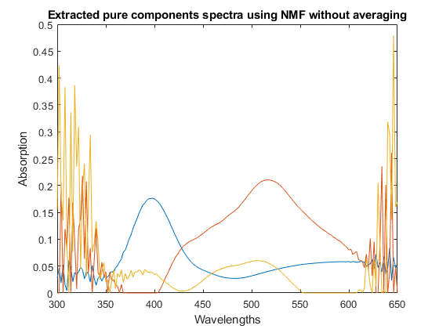
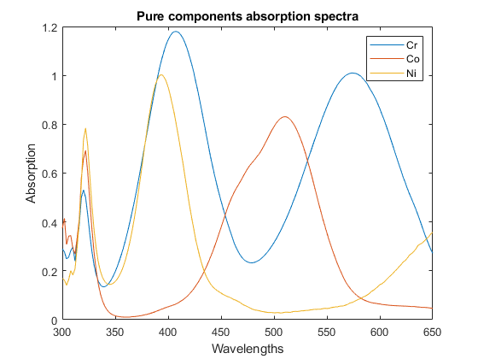
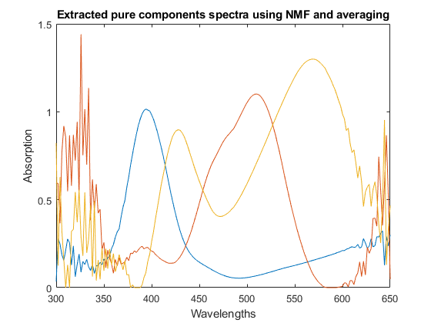
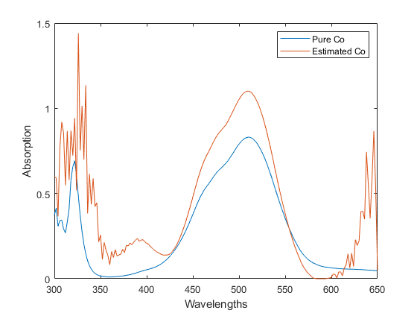
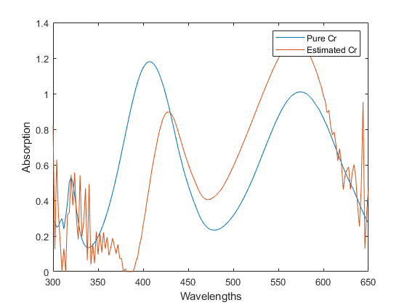
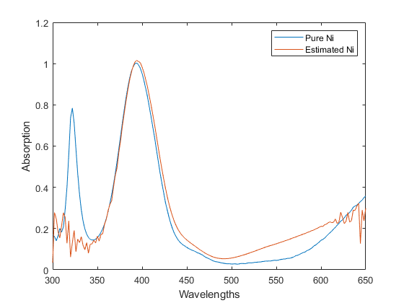
Published with MATLAB® R2019a

…………………………………………………………………………………………………………………………………………………………….
Question 4)
clear variables
clc
% wish to factorize Z=A*P
% calculating W*
load ncadata.mat
Z=measabs;
%specifying Astruct
Astruct=[1 1 0;1 0 1;0 1 1;1 0 1; 1 1 0;1 0 1;0 1 1];
% specifying rank of p
p=3;
% calling the function fastNCA written by me
[A,P]=fastNCA(Z,Astruct,p);
% doing analysis
i=1:176;
plot(i,P(1,:))
hold on
plot(i,P(2,:))
plot(i,-P(3,:))
xlabel("x");
ylabel("Absorption")
title("Extracted Pure components spectra using fast NCA");
figure
plot(i,pureabs(1,:))
hold on
plot(i,pureabs(2,:))
plot(i,pureabs(3,:))
xlabel("x");
ylabel("Absorption")
title("Pure components specta");
% it is observed P(3,:) entries are all negative making them positive
P(3,:)=-P(3,:);
% calculating correlations
correlation1=[];
for i=1:3
c1=cov(pureabs(i,:)');
c2=cov(P(i,:)');
c3=cov(pureabs(i,:)',P(i,:)');
correlation1=[correlation1;c3(1,2)/sqrt(c1(1,1)*c2(1,1))];
end
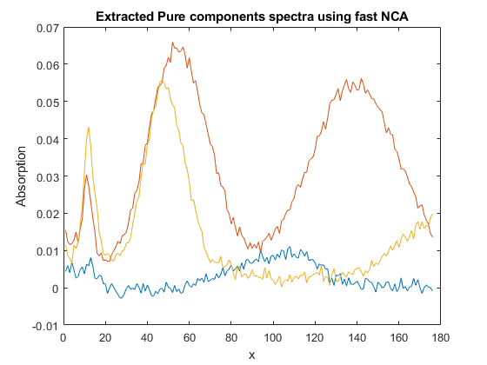
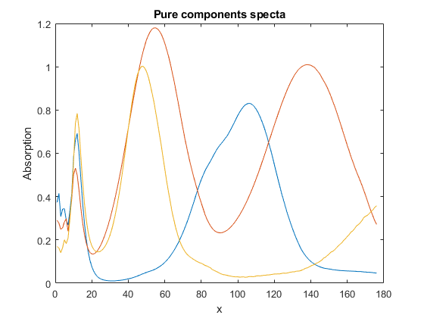
Published with MATLAB® R2019a

Published with MATLAB® R2019a

FAST NCA function written by me
function [A,P] = fastNCA(Z,Astruct,p)
%fastNCA code
% Step1 :finding W* first lets name it just W.
[u,s,v]= svd(Z,'econ');
W=u(:,1:p);
[n,~]=size(Z);
% find S that is a projection matrix, but first has to calculate Wr
% doing here for just 1 column that is k=1 but have to do it for all three
% columns of A
a=zeros(n,p);
for k=1:p
[Wc,Wr]=rearrange(W, Astruct, k);
[u1,s1,v1]=svd(Wr);
S=v1(:,p);
[u2,s2,v2]=svd(Wc*S);
% take j representing j no. of nonzero entries have to assign those
% only as if try to assign other then it will throw error because size
% of u2 is different
j=size(u2(:,1));
for l=1:j
a(l,k)=u2(l,1);
end
end
[A]=reconstitute(a,Astruct);
P=pinv(A)*Z;
end
Published with MATLAB® R2019a

