INT217

INTRODUCTION TO DATA MANAGEMENT

PROJECT REPORT

(Project Semester January-April 2025)

“Video Game Sales Dashboard”

Submitted by

B Devendranadh Venkat

Registration No- 12301888

Program and Section- B.Tech CSE- K23GN

Course Code- INT217

Under the Guidance of

Ms.Ashu

Discipline of CSE/IT

Lovely School of Computer Science and Engineering

Lovely Professional University, Phagwara



DECLARATION

I, B Devendranadh Venkat student of B.Tech Computer Science Engineering under CSE/IT Discipline at, Lovely Professional University, Punjab, hereby declare that all the information furnished in this project report is based on my own intensive work and is genuine.

Date: 15/04/2025

Signature: B Devendranadh venkat

Registration No. 12301888

Name of the student: B Devendranadh Venkat

CERTIFICATE

This is to certify that B Devendranadh Venkat bearing Registration no. 12301888 has completed INT217 project titled, “Retail and Warehouse Sales Dashboard Report” under my guidance and supervision. To the best of my knowledge, the present work is the result of his/her original development, effort and study.

Signature and Name of the Supervisor

Designation of the Supervisor

School of Computer Science and Engineering

Lovely Professional University Phagwara, Punjab.

Date: 15/04/2025

ACKNOWLEDGEMENT

I would like to express my sincere gratitude to [Ashu] for their guidance, support, and valuable insights throughout the completion of this project. Their encouragement and expertise greatly contributed to the successful development of the dashboard and analysis.

I would also like to thank [Lovely Professional University] for providing the opportunity and resources to work on this project, which enhanced my understanding of data analysis, visualization, and business intelligence tools.

Lastly, I extend my appreciation to my peers, friends, and family for their continuous support and motivation during this project.

TABLE OF CONTENTS

* 1. Introduction
  2. Source of Dataset
  3. Data Pre-Processing
  4. Analysis on Data
  5. Conclusion
  6. Scope for Future Enhancement
  7. References

1. **Introduction**

The video game industry has seen tremendous growth over the past few decades, influencing entertainment culture globally. With sales data spread across various platforms, regions, and game genres, understanding trends in this industry can be both insightful and strategic.

This project aims to provide a comprehensive and interactive dashboard in Microsoft Excel, enabling users to analyze key metrics such as global and regional sales, top-performing platforms, best-selling games, and sales trends over time.

The dashboard was created using features such as PivotTables, PivotCharts, slicers, and timelines to give users full control over the analysis and exploration of video game sales data.

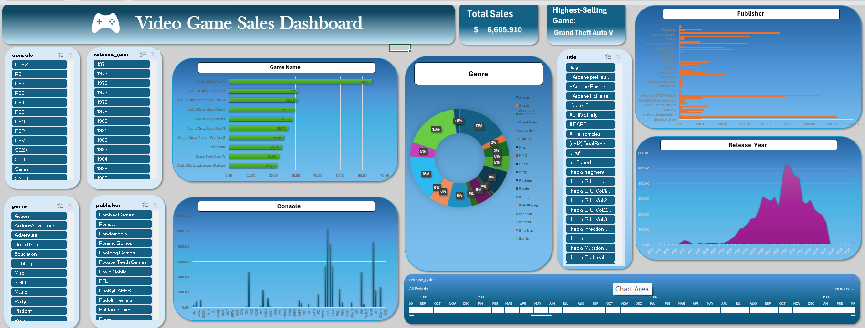

1. **Source of Dataset**

The dataset was sourced from VGChartz.com, a reliable website that provides historical sales data for video games across multiple regions and platforms. The dataset includes information about:

* Game Name
* Platform (e.g., PS2, Wii, Xbox 360)
* Release Year
* Publisher
* Genre (Action, Sports, etc.)
* Sales in Millions across four major regions:
  + North America (NA_Sales)
  + Europe (EU_Sales)
  + Japan (JP_Sales)
  + Other Regions (Other_Sales)

These figures are presented in millions of units sold, which makes it easy to compare across markets.

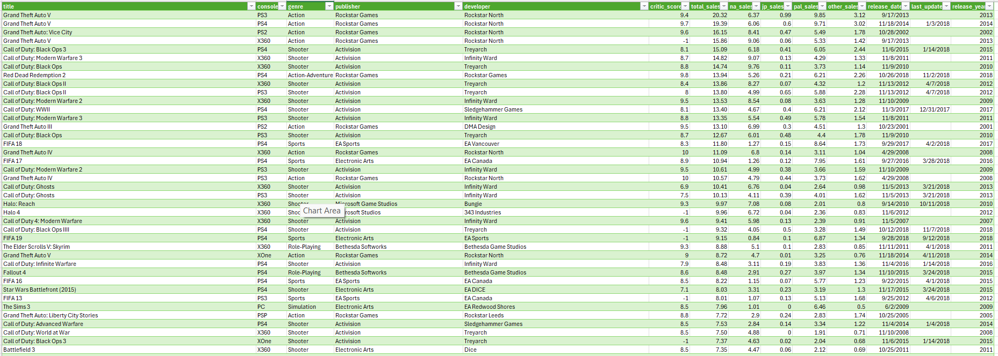

1. **Data Pre-Processing**

To ensure meaningful analysis, the dataset was cleaned and pre-processed using the following steps:

Steps Taken:

* Handled Missing Values: Removed rows with empty or non-numeric entries in important fields such as sales or year.
* Standardized Columns: Ensured consistent column headers like NA_Sales, EU_Sales, etc.
* Created a New Column – Total_Sales: Calculated by summing all regional sales.

ini

CopyEdit

Total_Sales = NA_Sales + EU_Sales + JP_Sales + Other_Sales

* Converted Data Types: Ensured Year was treated as numeric for time-based analysis.
* Removed Duplicates: Ensured no repeated entries for the same game title.

1. **Analysis on Data**

The Excel dashboard features multiple visual components that allow deep data exploration. The following insights were derived through PivotTables and visualized using PivotCharts:

**🔹 A. Sales by Platform**

This bar chart reveals which gaming platforms have generated the most sales.

Insights:

* The PlayStation 2 (PS2) and Nintendo Wii platforms dominate in global sales.
* Older consoles like the NES and PS1 also had strong performances.

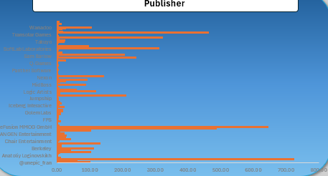

**🔹 B. Sales Trend by Year**

A line chart tracks how global sales evolved over time.

Insights:

* Peak sales years: 2006 to 2009, aligning with console launches and popular franchises.
* There’s a steady decline in later years as the market became saturated.

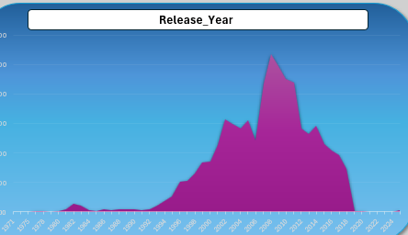

**🔹 C. Genre-wise Sales Distribution**

This section analyzes sales performance by genre using a pie or bar chart.

Insights:

* Action and Sports games are the top-selling genres globally.
* Genres like Shooter, Racing, and Platformer also performed well.

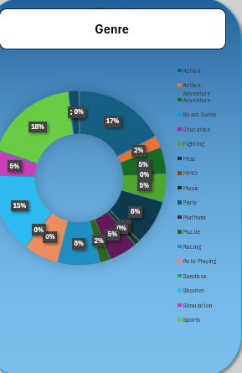

🔹 D. Top 10 Best-Selling Games

This visual ranks the top 10 video games by global sales.

Insights:

* Games like Wii Sports, Grand Theft Auto V, and Mario Kart Wii top the list.
* Most top-sellers are published by Nintendo.

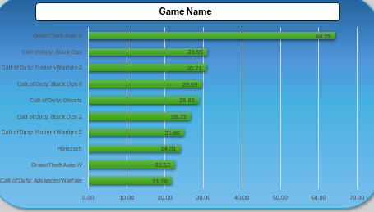

🔹 E. Regional Sales Comparison

A stacked column chart breaks down how different regions contributed to game sales.

Insights:

* North America (NA) leads in sales across most platforms and genres.
* Japan has strong regional preferences, especially for RPGs and Nintendo titles.

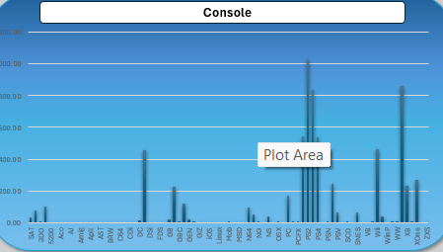

1. **Conclusion**

This Excel-based dashboard effectively summarizes and visualizes the video game sales landscape. Users can interactively filter data using slicers (by Year, Genre, Platform) and timelines to reveal custom insights.

Key Findings:

* PS2 is the most successful platform globally.
* Action games top in popularity and sales.
* Peak years: 2006–2009 for most video game releases and sales.
* Regional differences influence genre and game performance.

The dashboard demonstrates how Excel can be used not only for basic analysis but also for creating powerful data-driven visual stories.

**6. Scope for Future Enhancement**

While the current version of the dashboard is interactive and insightful, it can be further enhanced by:

* Migrating to Power BI or Tableau for advanced interactivity and modern visuals.
* Adding machine learning for sales forecasting based on trends.
* Including financial performance metrics such as revenue and profit.
* Embedding dynamic storytelling features (e.g., PowerPoint-like summaries).
* Enabling data refresh using live APIs or Power Query.
  1. **References**
* VGChartz.com – <https://www.vgchartz.com/>
* Microsoft Excel – Official Documentation
* Dashboard Design Principles – [Microsoft Learn](https://learn.microsoft.com/)
* Data Visualization Best Practices – [Storytelling with Data](https://www.storytellingwithdata.com/)