Quick look: HDFS

Hadoop Distributed File System (HDFS) is a distributed file system designed to run on commodity hardware.

HDFS is highly fault-tolerant and is designed to be deployed on low-cost hardware.

HDFS provides high throughput access to application data and is suitable for applications that have large data sets.

HDFS relaxes a few POSIX requirements to enable streaming access to file system data. HDFS was originally built as infrastructure for the Apache Nutch web search engine project.

Assumptions and Goals

Hardware Failure

Streaming Data Access

Large Datasets

Simple Coherency Model

“Moving Computation is Cheaper than Moving Data”

Portability Across Heterogeneous Hardware and Software Platforms

Daemons are resident programs which constitute to hadoop running.

Hadoop Daemons include,

Namenode

Datanode

Secondary Namenode

Job Tracker

Task Tracker
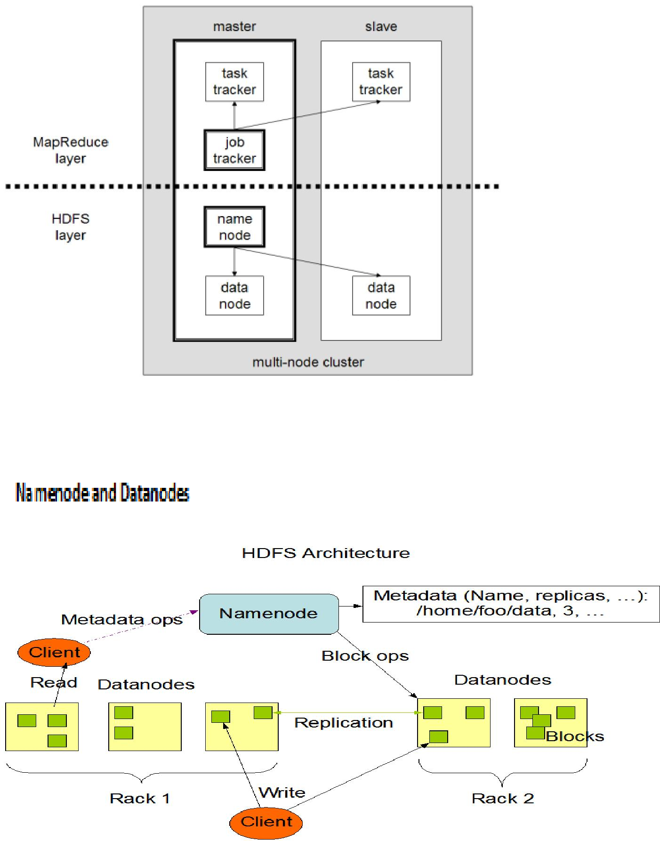
HDFS has a master/slave architecture.

HDFS exposes a file system namespace and allows user data to be stored in files. Internally, a file is split into one or more blocks and these blocks are stored in a set of Datanodes.

Namenode and Datanode are pieces of software designed to run on commodity machines which typically run on GNU/Linux OS.

Usage of the highly portable Java language means that HDFS can be deployed on a wide range of machines.

A typical deployment has a dedicated machine that runs only the Namenode software. Each of the other machines in the cluster runs one instance of the Datanode software.

Namenode

- Master server that manages file system namespace.

- Executes file system namespace operations like opening, closing, and renaming files and directories.

- Determines the mapping of blocks to Datanodes.

- It is the arbitrator and repository for all HDFS metadata.

Datanode

- Manages storage attached to the nodes.

- Responsible for serving read and write requests from the file system’s clients.

- Performs block creation, deletion, and replication upon instruction from the Namenode.

The existence of a single Namenode in a cluster greatly simplifies the architecture of the system. It is designed in such a way that user data never flows through the Namenode.

The File System Namespace

HDFS supports a traditional hierarchical file organization which means a user or an application can create directories and store files inside these directories.

The file system namespace hierarchy is similar to most other existing file systems; one can create and remove files, move a file from one directory to another, or rename a file.

HDFS does not yet implement user quotas. HDFS does not support hard links or soft links.

Namenode maintains file system namespace and any changes to file system or its properties is recorded in Namenode.

Data Replication for fault tolerance

HDFS stores each file as a sequence of blocks; all blocks in a file except the last block are the same size. The block size and replication factor are configurable per file.

Files in HDFS are write-once and have strictly one writer at any time. Namenode makes all decisions regarding replication of blocks.

- It periodically receives a Heartbeat and a Blockreport from each of the Datanodes in the

cluster.

- Receipt of a Heartbeat implies that the Datanode is functioning properly.

- A Blockreport contains a list of all blocks on a Datanode.

Data Replication for fault tolerance

Replica Placement

Replica Selection

Safemode

Accessibility

HDFS can be accessed from applications in many ways,

- Java API

- C language wrapper for Java API
- Browser Interface
FS Shell
Action |  |  | Command
Create a directory named /foodir |  | bin/hadoop dfs -mkdir /foodir
Remove a directory named /foodir |  | bin/hadoop dfs -rmr /foodir
View the contents of a file named |  | bin/hadoop dfs -cat
/foodir/myfile.txt |  | /foodir/myfile.txt

DFSAdmin

Action | Command
Put the cluster in Safemode | bin/hadoop dfsadmin -safemode enter
Generate a list of DataNodes | bin/hadoop dfsadmin | -report
Recommission or decommission DataNode(s) | bin/hadoop dfsadmin | -refreshNodes

Space Reclamation

File Delete and Undelete (restore)

Decrease Replication Factor

