Experiment 04
Router: Interconnecting Multiple LANs and Static Routing
Name: Deven UID: 24BCF10060
Aim
To study the working of a Router as a Layer 3 networking device, to interconnect multiple LANs using a router with appropriately configured default gateways, and to configure static routing between multiple routers so that hosts on different networks can communicate with each other, using Cisco Packet Tracer.
Objectives
- Understand the basic working principle of a Router and how it differs from a Switch/Hub.
- Create two independent LANs and interconnect them using a single router.
- Configure default gateways on end devices so that inter-LAN traffic can be routed.
- Extend the topology to a multi-router (multi-LAN) network connected through serial links.
- Identify the need for static routing and configure static routes so that routers can forward packets to networks they are not directly connected to.
Router: Theory
- A router is a networking device that forwards data packets between different computer networks — i.e., between two or more different LANs.
- A router is connected to at least two networks — commonly two LANs, two WANs, or a LAN and its ISP's network.
- It is a Layer 3 (Network Layer) device.
- Like a switch, a router also has memory, but it uses this memory to store the routes it knows about in a Routing Table.
Part A: Interconnecting Two LANs Using a Single Router
Procedure
- Create LAN 1 using a switch: Network 10.0.0.0, Subnet Mask 255.0.0.0. Take 1 switch and 3 PCs, and assign IP addresses 10.0.0.1, 10.0.0.2 and 10.0.0.3 to PC0, PC1 and PC2 respectively. Verify LAN 1 by sending a PDU from 10.0.0.1 to 10.0.0.3.
- Create LAN 2 using a switch: Network 192.168.1.0, Subnet Mask 255.255.255.0. Take 1 switch and 3 PCs, and assign IP addresses 192.168.1.1, 192.168.1.2 and 192.168.1.3 to PC3, PC4 and PC5 respectively. Verify LAN 2 by sending a PDU from 192.168.1.1 to 192.168.1.3.
- Take a router (Router 2911). This router provides three interfaces — GigabitEthernet 0/0, GigabitEthernet 0/1 and GigabitEthernet 0/2 — which means up to three different LANs can be connected to it using these interfaces.
- Connect the switch of LAN 1 to the router's GigabitEthernet 0/0 interface, and the switch of LAN 2 to the router's GigabitEthernet 0/1 interface.
- To allow communication between the two LANs (for example, from PC0 to PC5), configure a default gateway on every PC of both LANs: 10.0.0.4 for the PCs in LAN 1, and 192.168.1.4 for the PCs in LAN 2. This is done by opening each PC → Desktop → IP Configuration → and entering the Default Gateway address.
IP Addressing Table
Device | Interface | IP Address | Subnet Mask
Router1 (2911) | GigabitEthernet 0/0 | 10.0.0.4 | 255.0.0.0
Router1 (2911) | GigabitEthernet 0/1 | 192.168.1.4 | 255.255.255.0
PC0 / PC1 / PC2 | LAN 1 (via Switch0) | 10.0.0.1 / .2 / .3 | 255.0.0.0
PC3 / PC4 / PC5 | LAN 2 (via Switch1) | 192.168.1.1 / .2 / .3 | 255.255.255.0
Topology
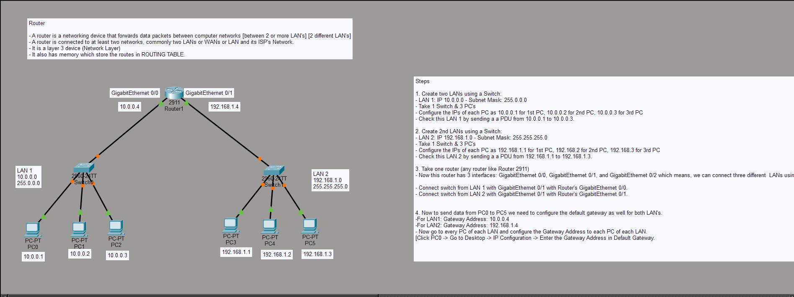
Fig. 4.1 — Two LANs (10.0.0.0/8 and 192.168.1.0/24) interconnected through a single router with default gateways configured on every PC
Part B: Extending to a Multi-Router (Multi-LAN) Network
The same idea can be extended to a larger network with more than one router, where routers are connected to each other through serial (WAN) links and each router additionally supports its own local LAN through a switch. Below, three routers (1841) are connected in series, each hosting its own LAN of 2 PCs.
Router | LAN (Switch) Network | Serial Link IP(s)
Router0 | 192.168.1.0/24 — PC0: 192.168.1.1, PC1: 192.168.1.2 (Gateway 192.168.1.3) | 192.168.3.1 (to Router1)
Router1 | 192.168.2.0/24 — PC2: 192.168.2.1, PC3: 192.168.2.2 (Gateway 192.168.2.3) | 192.168.3.2 (to Router0), 192.168.5.1 (to Router2)
Router2 | 192.168.4.0/24 — PC2(1): 192.168.4.1, PC3(1): 192.168.4.2 (Gateway 192.168.4.3) | 192.168.5.2 (to Router1)
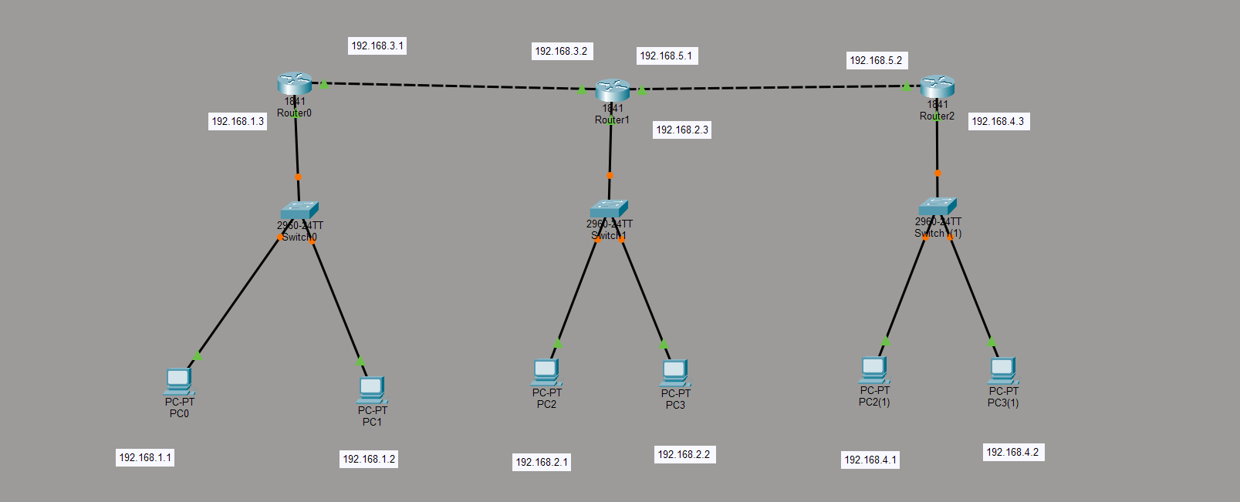
Fig. 4.2 — Three routers connected in series through serial links, each supporting its own LAN
With this topology, each router only knows about the networks directly connected to it. A router cannot, by default, forward a packet to a network it is not directly connected to — this is exactly the problem that routing (static or dynamic) is required to solve, as explored in Part C.
Part C: Static Routing
Problem
Consider two routers (2911), each connected to its own LAN (Switch0 with PC0/PC1 on 192.168.1.0/24 behind Router0, and Switch1 with PC2/PC3 on 192.168.2.0/24 behind Router1), interconnected through a serial link (192.168.3.1 – 192.168.3.2). After assigning IP addresses to the PCs, the routers, and configuring the default gateways, testing connectivity between a PC in LAN 1 and a PC in LAN 2 fails with a “destination host unreachable” error. This happens because when a router receives a packet for a network it is not directly connected to, it does not know where to forward that packet — it simply has no entry for that destination network in its routing table.
Solution: Configuring Static Routes
- Assign IP addresses to the PCs, to the router interfaces, and configure the default gateways as usual.
- On Router0, go to Config → Static, and add a static route as follows: Network field — the network address of LAN 2 (where PC2/PC3 are connected); Mask field — the subnet mask of that network; Next Hop — Router1's IP address (192.168.3.2), since Router1 is the next hop needed to reach LAN 2.
- Repeat the same process symmetrically on Router1 — add a static route for LAN 1's network with Router0's IP address (192.168.3.1) as the next hop, so that Router1 also knows how to send return traffic back to LAN 1.
- Once static routes are configured on both routers, connectivity between the two LANs succeeds and PDUs are delivered successfully.
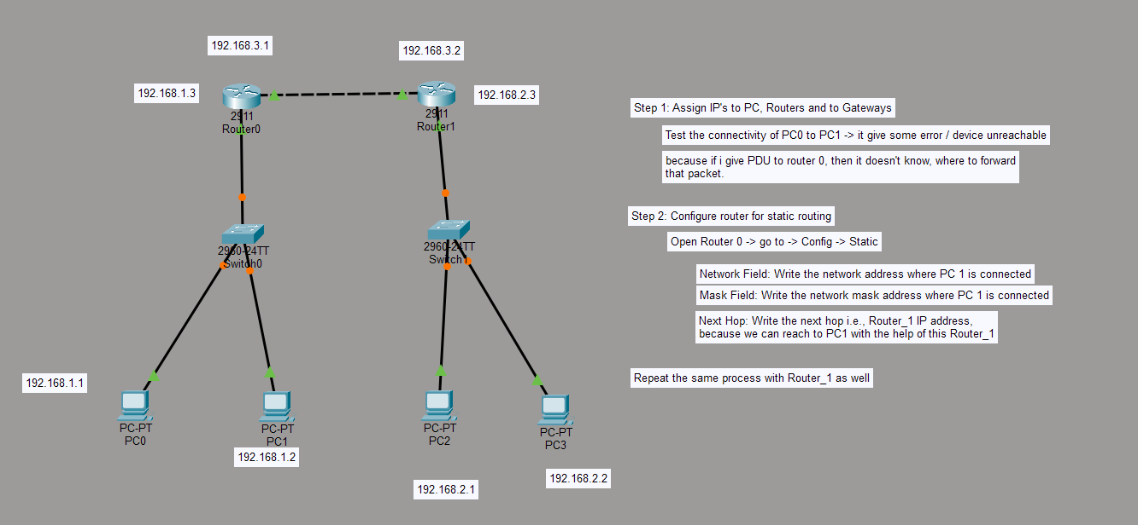
Fig. 4.3 — Two routers interconnected via a serial link, configured with static routes so that LAN 1 and LAN 2 can reach each other
Part D: Practice Exercise — Larger Serial Network
As a home/practice exercise, the same static routing concept was extended to a larger chain of four routers (2911), each supporting its own LAN of 2 PCs, connected serially. To achieve full connectivity between all four LANs in this topology, static routes must be configured on every router for every remote network that is not directly connected to it (or alternatively, a dynamic routing protocol may be used).
Router | LAN (Switch) Network | Serial Link IP(s)
Router6 | 192.168.1.0/24 — PC0: .1, PC1: .2 (Gateway 192.168.1.3) | 192.168.5.1 (to Router7)
Router7 | 192.168.2.0/24 — PC2: .1, PC3: .2 (Gateway 192.168.2.3) | 192.168.5.2 (to Router6), 192.168.6.1 (to Router8)
Router8 | 192.168.3.0/24 — PC4: .1, PC5: .2 (Gateway 192.168.3.3) | 192.168.6.2 (to Router7), 192.168.7.1 (to Router9)
Router9 | 192.168.4.0/24 — PC6: .1, PC7: .2 (Gateway 192.168.4.3) | 192.168.7.2 (to Router8)
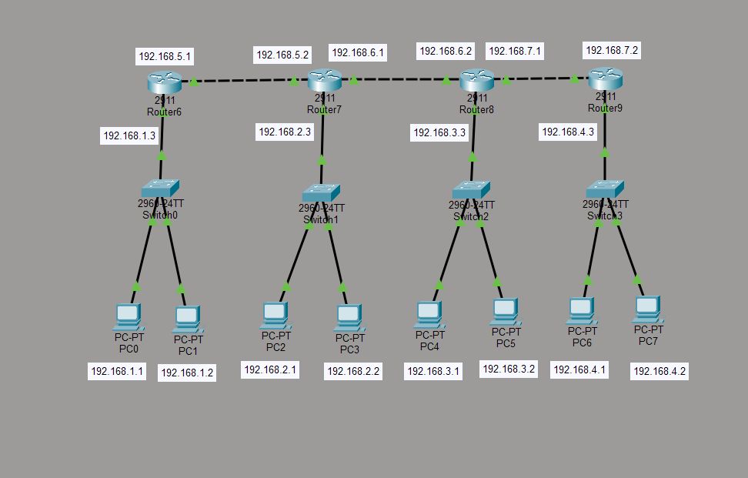
Fig. 4.4 — Four routers connected in series, each hosting its own LAN, used to practice static routing across a larger network
Observation
Without static (or dynamic) routing, a router can only forward packets to networks that are directly connected to one of its own interfaces; requests for any other network fail with a destination-unreachable error. Once appropriate static routes — specifying the destination network, its subnet mask, and the correct next-hop router — were configured on each router, every PC was able to successfully exchange PDUs with PCs on remote LANs across the routed network.
Learning Outcome
- Understood the working principle of a Router as a Layer 3 device and how it differs from a Switch/Hub.
- Learned how to design and connect two or more independent LANs to a single router using its multiple interfaces.
- Understood the purpose of a default gateway and configured it on end devices to enable inter-LAN communication.
- Extended a single-router design into a multi-router topology connected via serial (WAN) links.
- Understood why a router cannot reach a non-directly-connected network without a routing entry, and learned to configure static routes (network, mask, and next hop) to solve this problem.
- Gained practical, hands-on exposure to designing, addressing, and troubleshooting multi-LAN, multi-router networks in Cisco Packet Tracer.

