PROJECT ASSIGNMENT 1

COSC612/AIT624: Software Engineering Fundamentals

2023 Fall Semester

Formula 1 LLC

* Oladiran Apara
* Cara Galingana
* Devere Weaver
* Swadha Bhatt
* Victoria George

September 25, 2023

Table of Contents

**Section 1. Project Team Details** 4

**Section 2. Brief Resumes and Teamwork Basics Summary** 5

I. Brief Resumes 5

II. Teamwork Basics Summary 7

A. Ground Rules 7

B. Hints for Handling Difficult Behavior 8

C. Hints for Handling Group Problems 8

D. Personal Experiences in Working in Groups 8

**Section 3. Project Planning and Scheduling** 10

I. Work Breakdown Structure 10

II. GitHub Readme 11

III. GitHub Kanban Board 12

**Section 4. Problem Statement** 13

I. Background 13

II. Business Need 13

III. Competition 14

IV. User Requirements 15

V. Functional and Non-Functional Requirements 15

VI. Technical Feasibility 18

**Section 5. System Requirements** 20

# **Section 1. Project Team Details**

|  |  |
| --- | --- |
| Name of the project | Formula 1 Information Management System (F1 IMS) |
| Semester | 2023 Fall Semester |
| Group Number | 1 |
| Team Members | Oladiran Apara  Cara Galingana  Devere Weaver  Swadha Bhatt  Victoria George |
| Date of Submission | September 25, 2023 |

# **Section 2. Brief Resumes and Teamwork Basics Summary**

## Brief Resumes

|  |  |  |  |
| --- | --- | --- | --- |
| Team Members | PERSONAL PROFILE | RESEARCH INTERESTS & technical skills | Hobbies & INTERESTS |
| Oladiran Apara | I am an IT Management Specialist with US DOS. I led technical programs, with diverse skills and expertise in system development, engineering, management and operational support of Enterprise application systems. I led efforts to strengthen the security of systems to mitigate the impacts of Cyber-Threat exposure. I led an operations review board where I evaluated the security and deployment risk of all engineering activities. Served as a Data-center SME, where I provided engineering support and oversight to lT personnel and collaborated on Enterprise engineering project deployments. Led a working group to analyze and provide recommendations to secure business systems from Cyber-Threat exposure. | * AI/ML * Cybersecurity * Systems networking * Distributed database technology * Application dev. | * Music * Fine Art * Sports |
| Cara Galingana | I am a technology researcher and a passionate advocate for strengthening health information systems (HIS) in the Philippines. Over the past four years, my engagement with the Philippine Primary Care Studies program under the University of the Philippines has enabled me to play a pivotal role in developing electronic health records in urban, rural, and remote facilities in my country. While most of my work entails piloting socio-technical solutions for HIS development, I am proud of authoring scholarly literature on primary care strengthening. | * Technology usage and acceptance; Human-computer interaction; Electronic health records * HTML, CSS & JavaScript, React.js, Java, Microsoft SQL, Oracle, BMI SPSS, AWS | * Brewing specialty coffee * Collecting vinyl * Playing with my 2 small dogs |
| Devere WeaveR | I am currently a Computer Science Master’s student. Previously I worked in the U.S. Army for three years as a signals intelligence analyst at NSA Washington and five years at 7th Special Forces Group as an operator on a SOT-A team doing tactical signals collection in foreign countries. In undergrad I tutored the C++ Programming and Algorithm Design courses for the Computer Science department. | * Familiar with various programming languages (C, C++, Python, MATLAB) * Study areas of interest include mathematical analysis and numerical analysis | * Also into manual brew coffee techniques * Motorcycling |
| Swadha Bhatt | I'm currently a data analyst intern for the US Army. In this position, I get to clean, analyze, and visualize data for our clients. I use tools like Tableau Prep, excel, or Python through this cleaning process. For data visualization, our department likes to use Tableau. In addition to the internship, I have also worked alongside Dr. McGuire on a data analyst project. We take data related to Baltimore City and analyze it via Python to understand what the data helps us conclude about the city. Before my position at the government, I used to work for Towson University as an intern for the data management team, where we were the primary holder for all the types of data that the university had. Our job was to ensure the influx of data was stored in some database and regulated or not regularly. | * Computer: Microsoft Office Suite (Excel, PowerPoint), macOS, Power BI, Tableau, Visio, Google Suite, Informatica, Oracle * Coding Languages: C++, Java, SQL, Matlab, Python (Pandas) | * Painting * Going on walks * Catching the sunrise and sunsets whenever possible |
| Victoria George | In my current role at Amazon, I serve as a Logistics Manager. Despite lacking formal technical experience, my responsibilities have provided me with valuable exposure to AWS (Amazon Web Services) and interactions with program and product managers. My keen interest within the technology domain lies in the areas of software architecture and cloud security. | * I have novice understanding of java and C++. * Enterprise architecture cloud computing, data modeling. | * Trying new restaurants and binging SouthPark |

## Teamwork Basics Summary

### Ground Rules

When working on a project as a team, some basic ground rules must be set at the very beginning to ensure that the task at hand gets accomplished and the satisfaction of the team members is high throughout the project's journey. Five ground rules/norms must be established before attacking the project.

The first is work norms. Work norms include all the logistics of attacking the project. So, for example, under this, the team members should discuss how the project will be divided. What are the internal and external deadlines? Will there be some checks and balances method? Additionally, the team should discuss the consequences if someone does not fulfill their assigned commitment.

Facilitator norms describe the rules and regulations of what the facilitator will do and who will be the group facilitator. In simple terms, the facilitator is the one who makes sure that the group is going in the right direction. Some of the responsibilities the facilitator should be:

* Getting the input of all the team members on a project decision.
* Keeping the team accountable for the agreed internal and external deadlines.
* Navigate the confrontation of problems that might occur during the project's duration.
* Making sure that the team is focused during the task.

The third set of norms is the communication norms. This entails how the group will communicate during the project's duration and how often the group will communicate.

The fourth set is the meeting norms. As the term describes, these are rules and regulations of what will be discussed during the group meetings. This section also includes coordinating a reasonable time when all the group members can meet virtually or in person. Lastly, the team should discuss what will happen if a group member fails to attend many meetings.

Last but not least is the consideration norms. These are norms that go over standard human etiquette. For example, is the person allowed to eat during meetings, or are there changes in any rules if someone feels that the limitations set are not precisely applicable as the project goes on? Along with setting some ground rules, it is also essential that the team members discuss what they want to get out of this course. It is only sometimes good to assume that everybody in the group wants to get an A in the class. Sometimes, as time goes on and priorities change, it is recommended to keep communicating amongst the group what the goals are for everyone.

### Hints for Handling Difficult Behavior

Dealing with difficult behavior could easily affect team productivity. This may include a member who is overly talkative, too quiet, likes to argue, or complains a lot. To address this, another member should be able to confront them in a professional and respectful manner. The group's assigned meeting facilitator may tell an overly talkative member that while her point is appreciated, it is important to consider the input of the other members of the group. The facilitator may also reassure a member who is too quiet that their opinion on the group project is just as valuable as the others. A person who likes to argue may be asked to clarify and outline their feedback for it to be helpful in improving the project. A member who complains a lot may be asked to join another team member to resolve the issue they were complaining about.

### Hints for Handling Group Problems

In the hints for handling group problems section, we learn what to do when a team hits a rough patch. If our group’s struggling, we should try making a to-do list and chatting about our goals to get back on track. When the conversation drifts away from the main topic, steer it gently. Don't rush into decisions; let everyone have their say and aim for an agreement. If the agreement's tough, use tricks like voting or Plan A to sort things out together. Always keep in mind that choices should be good for the whole team, not just one person. Managing a group well means staying cool, talking it out, and staying on target, without rushing or getting sidetracked.

### Personal Experiences in Working in Groups

1. Unfortunately, I've had many bad experiences with group projects. However, experience and a problem that keeps returning to haunt me every single time is the need for people to put more effort into their portion of the project. When I'm doing group projects, I often become the group leader because nobody wants to take ownership or leadership when it comes to leading the project. Because of the lack of supervision, the group often doesn't have a direction to go into. When I take the group's leadership, it helps me take charge, but also it gives us an idea of how I want to distribute the work. Another problem with the lack of effort people put into their work is that people tend to miss deadlines, and the quality of their work could be better. To solve this issue, I ask people about their strengths and distribute the work according to their strengths. I will also set strict internal deadlines and hold them accountable for their work. And if I don't like something, I will ask them to redo it. When I had individuals responsible for work, people often felt pressure to do well because they knew they were accountable for their part of the project.
2. When I was a sophomore in college, I enrolled in an education class where we were organized into groups of four for a semester-long project. In our group meetings, I observed that two members were close friends who often engaged in off-topic discussions, which disrupted the group's focus and hindered our overall productivity.
3. I had an experience with a group member who cannot take criticism. I tried confronting them in the best way possible by drafting my message a couple of times to make sure that I was being respectful but direct at the same time. In the end, my message was still seen as passive aggressive. My professor suggested that it would be best if we would no longer work on the succeeding assignments together due to our differences in work ethic.
4. I have been a member of various teams, with positive and negative experiences, and I have also led functional teams. In my experience, I have found that there needs to be good leadership for the team to be successful. The leader doesn’t have to be a formal leader or the same person leading all the time. The leader is someone who realizes that every team member must add value. They need to figure out what are the strengths and weaknesses of each team member. Engagement, collaboration, and knowledge sharing on the team needs to be encouraged. They need to ensure equal time is given to each person and make sure one person is not dominating the conversation or all activities. A leader needs to understand that people on a team have different perspectives and motivations. Some are dealing with family concerns, financial pressures, or cultural influences. A team leader needs to be competent and empathic.

# **Section 3. Project Planning and Scheduling**

## Work Breakdown Structure

|  |  |  |  |  |  |
| --- | --- | --- | --- | --- | --- |
| **Assignee Name/ Email (@students.towson.edu)** | **Task** | **Duration (hours)** | **Dependency** | **Due Date** | **Note** |
| * Oladiran Apara /  oapara1 | * Propose project idea * Fill out brief resume table * Upload screenshots | * 1 * 1 * 0.5 | * Initial grp meeting * Draft outline * Setup GitHub | * 09/16 * 09/22 * 09/22 |  |
| Cara Galingana /  cgaling1 | * Propose project idea * Format the outline of the report document * Fill out brief resume table * Write up of Section 2. TW Basics, Part B. * Write up of Section 4. User Rqts and Funct/Non-F Rqts * Write up of Section 4. Technical Feasibility * Format report for final submission | * 1 * 0.5 * 0.25 * 0.5 * 2 * 1 * 0.5 | * Initial grp meeting * Shared OneDrive folder * Draft outline * “ * “ * “ * Copyedit of draft | * 09/16 * 09/17 * 09/22 * 09/22 * 09/22 * 09/22 * 09/25 |  |
| Devere Weaver /  dweave8 | * Propose project idea * Create GitHub repository & Kanban board * Create shared OneDrive folder * Fill out brief resume table * Write up of Section 5. System Requirements * Copyedit report for final submission | * 1 * 0.5 * 0.25 * 0.25 * 0.5 * 0.5 | * Initial grp meeting * “ * “ * Draft outline * “ * Completion of write ups | * 09/16 * 09/16 * 09/16 * 09/22 * 09/24 * 09/25 | * Send the links of repository and shared OneDrive to the grp |
| Swadha Bhatt /  sbhatt8 | * Propose project idea * Fill out brief resume table * Write up of Section 2. TW Basics, Part A. * Write up of Section 4. Competition | * 1 * .25 * .75 * 2 | * Initial grp meeting * Draft outline * “ * “ | * 09/16 * 09/22 * 09/22 * 09/22 |  |
| Victoria George /  vgeorg2 | * Propose project idea * Fill out brief resume table * Write up of Section 2. TW Basics, Part C. * Write up of Section 4. Background & Business Need | * 1 * 1 * 1 * 1 | * Initial grp meeting * Draft outline * “ * “ | * 09/16 * 09/22 * 09/22 * 09/22 |  |

* Group coordinator for Assignment 1

## GitHub Readme

## GitHub Kanban Board

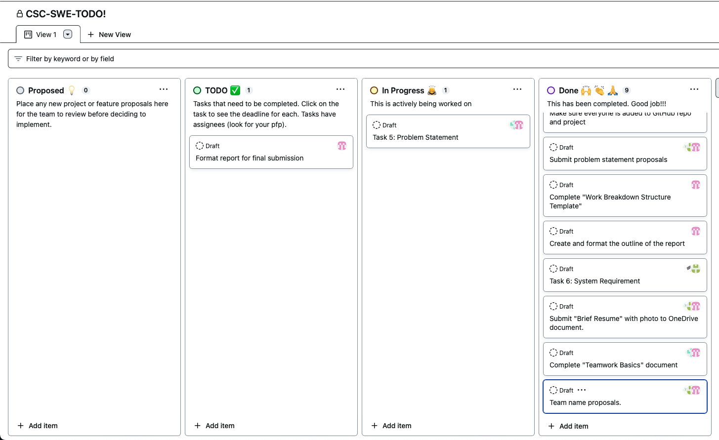

# **Section 4. Problem Statement**

## Background

Our project is creating an inventory management system for micro to small-scale businesses. This system enables businesses to efficiently track and manage their products, monitor stock levels, streamline ordering processes, and generate reports for informed decision-making.

## Business Need

**What is your product, on a high level**: The product on a high level is an interactive inventory management system that is specifically designed for micro to small-scale businesses. This product is aimed at helping these businesses efficiently handle their inventory-related tasks, which include tracking products, monitoring stock/inventory levels, simplifying the ordering process, and generating reports for decision-making.

**Who is it for**: The product is for F1 Cafe Coffee.

**What problem does it solve:** This system will improve inventory accuracy, reduce operational costs, and enhance overall business productivity. Inefficient inventory management practices plague businesses, leading to overstocking, understocking, operational inefficiencies, and increased costs. Manual record-keeping and disjointed inventory processes hinder the ability to make data-driven decisions. The absence of a centralized, interactive inventory system limits businesses from optimizing stock levels, responding to market demands, and reducing operational complexities. The need for an innovative solution that seamlessly tracks, manages, and reports on inventory data in real-time is paramount for businesses striving to enhance accuracy, reduce operational expenses, and elevate overall productivity.

Describe the top-level objectives, differentiators, target customers, and scope of your product:

* **Top-level objectives:**
  + Utilize Artificial Intelligence and Machine Learning to track historical sales and predict future demand
  + Utilize Artificial Intelligence and Machine Learning to optimize the inventory of a small-scale business
* **Target Customers:** Our target customers are micro to small-scale businesses, such as the F1 Café, that aim to digitally transform their manual record-keeping inventory and point-of-sale systems into
* **Differentiators:** The biggest differentiator of our inventory management system is it provides real-time demand forecasts, unlike traditional systems that rely solely on historical data or manual predictions. Our system utilizes cutting edge AI and machine learning to analyze and predict supply and demand trends.
* **Scope of my product:** The scope of the inventory management system includes streamlining the point-of-sale and inventory managing workflows of micro to small-scale businesses. These workflows include real-time inventory tracking for all products, batch tracking or expiration date tracking, generating of reports and maintaining a list of approved suppliers with contact information.

## Competition

There are many inventory management apps out in the market; however, there are two main competitors that we, as a startup company, need to be aware of. The first software application is called Shortly. This app deals with auditing, budgeting, and forecasting the items in the business. It also has a feature to give daily activity and inventory summary reports. However, one of the most significant differences between our web application and Shortly would be that it is more of a generic inventory management system not precisely designed for food industries, unlike our inventory management system, which is highly designed for only restaurants and food industries.

Our next main competitor is called Posist. Now, this software application is not only designed for the food industry but also manages the front end of the house along with the back end of the house and even gives analytics to make informed decisions. However, while researching the application and reading the reviews, the users have stated because the web application provides so many different products for all kinds of restaurants, sometimes the software application needs to catch up with many users. Unlike the web application we plan to design, which only focuses on the back end of the restaurant and little bit of the front end, the probability of the web application lagging in any form is improbable. Thus, our application would be perfect for a bustling restaurant with no time to deal with technical problems such as software lag because it specializes in inventory management. Another reason our application is better than Posist is that we are incorporating AI/machine learning to provide detailed data insights and predict the number of inventories that might be needed according to how much is being used by the restaurant daily.

## User Requirements

1. Intuitive User Interface

The Formula 1 (F1) Inventory Management System (IMS) should provide an intuitive and easy-to-adopt interface that the café staff can use to manage restaurant orders, food stocks, sales histories, and aims to replace the manual spreadsheet inventory system. The F1 IMS enables the F1 Cafe’s staff to access an overview of each business aspect and customize the periods of time a trend needs to be analyzed.

1. AI-Driven Features
   1. Demand Forecasting

The F1 IMS must be able to assess customer demands from the cumulative usage of its point-of-sale system. Purchasing patterns during public holidays, school breaks, and changes in season should be considered by this AI-driven system to accurately forecast customer orders. The system should be able to predict peak hours/days/seasons as it gathers more data over time. It provides F1 Cafe its sales target every Monday of the week.

* 1. Stock Optimization

The F1 IMS must be able to calculate and optimize the stock levels of food items based on the sales history of F1 Cafe. The food item’s shelf life must be carefully considered by the system to minimize food waste and comply with food safety standards. Aggregated data on prices can also be entered for the system to predict when specific food items will have the best price (e.g., food items are in season). The staff members will be able to indicate a food item’s minimum and maximum stock threshold for the system to assess whether an item needs to be restocked immediately or can last a few more weeks, all considering customer demand.

1. Real-time Notifications and Alerts

The F1 IMS must be able to send real-time notifications and alerts to the F1 Cafe staff when stock levels are low or out of stock and when a food item is about to expire or has already expired. It should also send reminders for peak events when the demand is forecast to increase.

## Functional and Non-Functional Requirements

1. Functional Requirements

The functional requirements listed below describe the processes the system must perform and the information it will contain.

|  |  |
| --- | --- |
| **FR #** | **Functional Requirement Statement** |
| 1 | The system must be integrated with Oracle Micros Simphony Point of Sale System |
| 2 | The system must authenticate user login using authorized accounts |
| 3 | The system must enable the administrator to manage user privileges of staff |
| 4 | The system must be able to add staff members |
| 5 | The system must be able to display a list of staff members |
| 6 | The system must be able to update the information of a staff member |
| 7 | The system must be able to inactivate a staff member |
| 8 | The system must be able to add food categories |
| 9 | The system must be able to display a list of food categories |
| 10 | The system must be able to update the information of a food category |
| 11 | The system must be able to inactivate a food category |
| 12 | The system must be able to add food items |
| 13 | The system must be able to display a list of food items |
| 14 | The system must be able to update the information of a food item (includes expiry, maximum and minimum stock threshold, price) |
| 15 | The system must be able to inactivate a food item |
| 16 | The system must be able to add orders |
| 17 | The system must be able to display a list of orders |
| 18 | The system must be able to update the information of an order (fulfill/unfulfilled) |
| 19 | The system must be able to inactivate an order |
| 20 | The system must be able to add a supplier |
| 21 | The system must be able to display a list of suppliers |
| 22 | The system must be able to update the information of a supplier (fulfill/unfulfilled) |
| 23 | The system must be able to inactivate a supplier |
| 24 | The system must be able to notify a staff member when an order is received |
| 25 | The system must be able to notify a staff member when a food item is about to reach its minimum stock threshold |
| 26 | The system must be able to notify a staff member when a food item has reached its minimum stock threshold |
| 27 | The system must be able to notify a staff member when a food item’s demand is forecasted to increase |
| 28 | The system must be able to notify a staff member when a food item’s demand is forecasted to decrease |
| 29 | The system must be able to notify a staff member when a food item is about to reach its expiry |
| 30 | The system must be able to notify a staff member when a food item has reached its expiry |
| 31 | The system must be able to generate sales forecast reports |
| 32 | The system must be able to generate food waste reports |
| 33 | The system must be able to generate sales history reports |
| 34 | The system must be able to generate food price trend reports |

1. Non-Functional Requirements

The following is a detailed list of information pertaining to the system’s behavior such as compatibility, security and performance.

|  |  |
| --- | --- |
| **NFR #** | **Non-Functional Requirement Statement** |
| 1 | The system should be web based |
| 2 | The system should run on a 2020 or later versions of Google Chrome web browser |
| 3 | The system should be utilizing Amazon Web Services features |
| 4 | The system must perform without failure in 95% of use cases in the span of two months |
| 5 | The system must provide response time of 2 seconds or less |
| 6 | The system must be available to access 24/7 |
| 7 | The system must follow a date format of MM/DD/YYYY |
| 11 | The system must follow a time format of hh:mm:ss in Eastern Standard Time |
| 12 | The system must use a name format of First Name, Last Name |
| 13 | The system must reflect modified data in the database within 2 second for all users accessing it |
| 14 | The system must store all inactivated entities for a maximum of 5 years |
| 15 | The system will not exceed 90% of its available memory without garbage collection |
| 16 | The system will run automated incremental backups and full backups every Sunday of the week |
| 17 | The system must be under maintenance for a maximum of 3 hours, in case the service becomes unavailable |
| 18 | The system will automatically log-out after 15 minutes of the staff’s indicated work hours |
| 19 | The system must have a third-party certification |
| 20 | The system must have all the data encrypted |

## Technical Feasibility

Formula 1 LLC has assessed the technical feasibility of integrating a café management system tool with AI. It is vital to consider the café’s existing technology dedicated for managing the point-of-sale (POS) transactions and the kitchen inventory before implementing the new system.

1. Transitioning to an AI-driven management system

The café has been using Microsoft Excel spreadsheets to track each food item’s expiry, price, and stock information. While this serves its purpose for the initial tracking of the café’s food items, it fails to centralize the information from various spreadsheets done by different staff members.

The project will involve assessing the information captured on the spreadsheet to optimize the data fields that will be included on the web application. One of the main risks involved with the migration from spreadsheet to a web application system is data accuracy. During the initial migration, the data on spreadsheets will be at-risk from errors and data loss incurred from data conversion and data mapping. The data needs to be reviewed and validated carefully as it is being migrated onto the new system.

1. System Management and Security

The overall manager of the system will be the administrator, who is responsible for assigning privileges to the staff members. Formula 1 LLC provides a system feature for defining role-based activities to protect sensitive data and enhance staff accountability. It also ensures secure data storage and exchange by utilizing a cloud service provider’s security features. The system may be at-risk if accounts are not properly managed by the administrator and an automated log-out function will not be implemented.

Being a web application run on a cloud service, its instance should be on the nearest availability zone to lower the risk of data breaches and unauthorized access. An automated back-up plan and recover plan must be put in place.

1. Integration with Third-party Systems

The F1 IMS can be a technically feasible solution for the F1 Café, provided that its integration with a POS system Oracle Micros Simphony is well-organized. Oracle Micros Simphony streamlines the ordering processes and inventory tracking in compliance with food safety standards. Proper testing should take place to make necessary adjustments prior to full migration. Once compatibility of systems and data are ensured, F1 IMS should be able to work seamlessly.

1. Scalability

Partnering with Oracle Micros Simphony, the F1 IMS should be able to adapt to the customer demands of the F1 Café. It must be able to track the increase of food items as the menu starts to expand. It should also be able to accommodate purchasing transaction volumes during peak seasons.

# **Section 5. System Requirements**

The goal is to identify the components/modules that will interact with our primary system. Using the context model and the proposal write up, we were able to identify eight possible systems that will interact for the entirety of our product (See Figure 1).

The rationale for choosing these different systems was for each individual one to have a specific purpose. While each has a unique primary functionality, there are some areas of overlap since many of these systems will need to communicate to work.

The systems identified are:

1. Inventory Management System (IMS)
   1. The main system that is the actual inventory management system product with which all other systems communicate with
2. Transaction or Sales system
   1. This component of the IMS will automatically keep track of all POS transactions at the actual establishment
3. Ordering system
   1. This component will communicate with the inventory database and the supplier system to either manually reorder product as needed or allow the user to set automatic reorders via some kind of user-defined decision rule
4. Reporting system
   1. This component will communicate with the transaction, inventory database, ordering system, and prediction system to generate reports that will allow for informed decision making; this can include automated or manually pulled reports
5. Prediction system
   1. The machine learning component of the entire product that will communicate with inventory database, transaction, or accounting system to generate a forecast of sales or recommended inventory levels based on previous data
6. Supplier system
   1. This will keep track of the suppliers and what products the user gets from them
7. Accounting system
   1. This is used as the bookkeeping system that will keep track of the business' financials. This will have to communicate with the transaction and ordering system
8. Database
   1. This is a database that contains different tables to store all data for the product, each other system will need to communicate with this for them to function

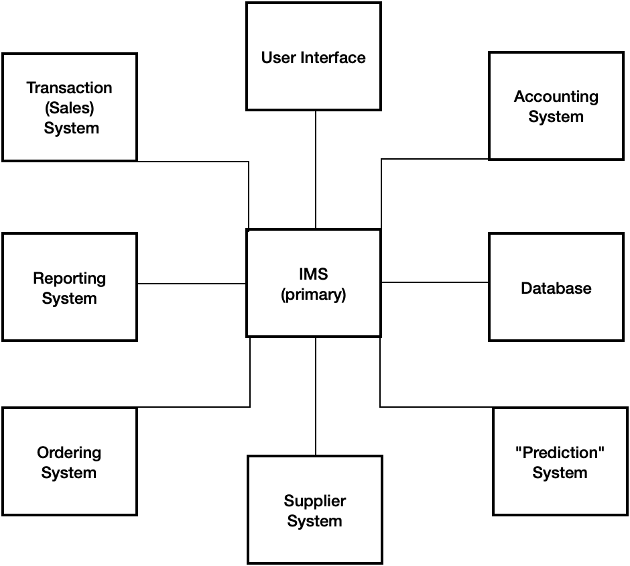

Figure 1. The eight system interactions of the F1 Inventory Management System