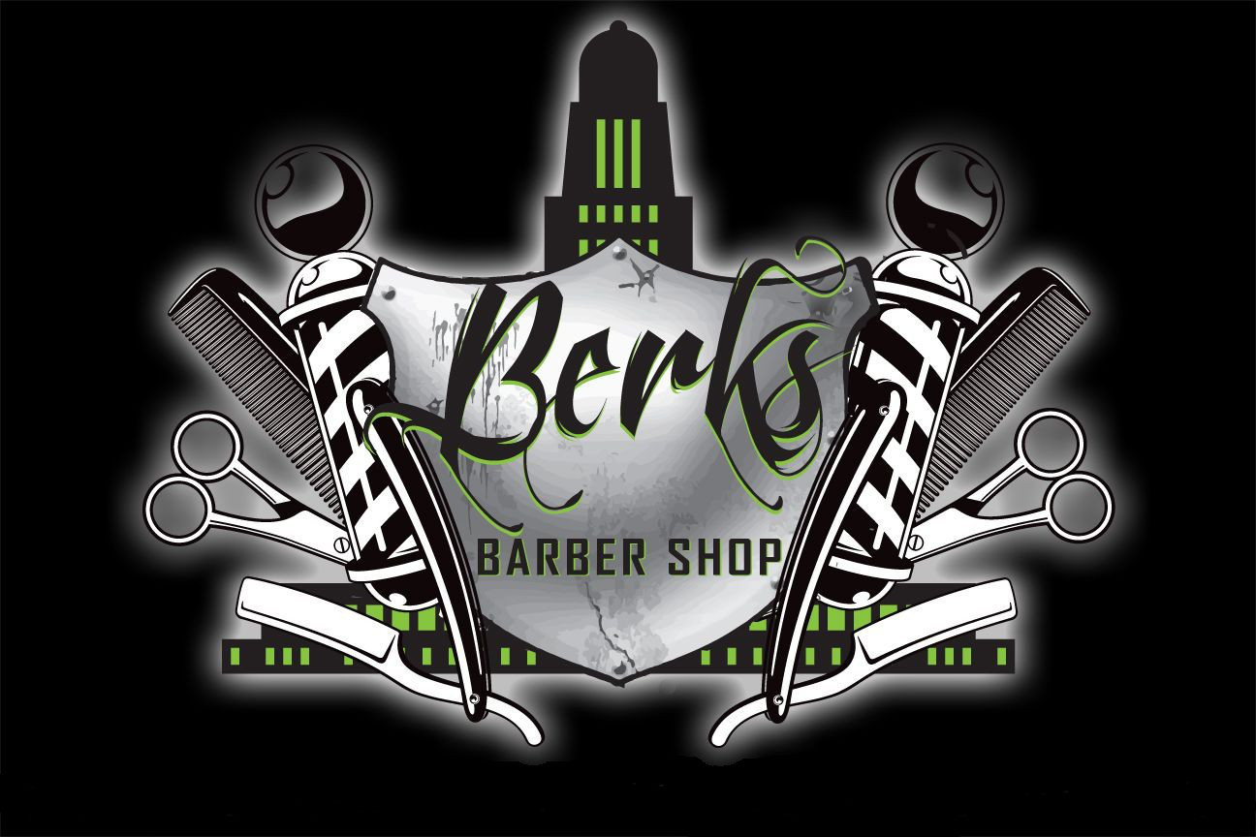

Open Mon-Fri 10am-6pm
- As an added bonus to our appointment customers, Berks Barber Shop will begin a rewards program.
- Each appointment will be rewarded a star.
- After 10 stars are collected, you receive a voucher for a free haircut.
- Sign up with your barber by providing your phone number and email during checkout.

906 L St, Lincoln Ne 68508
BERKSBARBERSHOP.COM
NOW INTRODUCING ONLINE BOOKING

