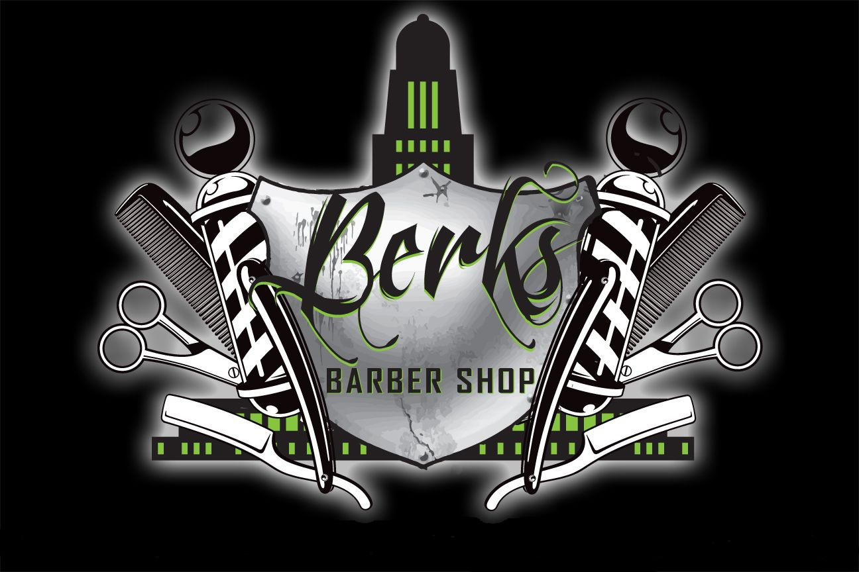

As an added bonus to our appointment customers, Berks Barber Shop will begin a rewards program.

Each appointment will be rewarded a star.

After 10 stars are collected, you receive a voucher for a free haircut.

Sign up by providing your phone number and email during online checkout or in the shop after signing your receipt.

BERKSBARBERSHOP.COM

NOW INTRODUCING ONLINE BOOKING

### Open Mon-Fri 10am-6pm

### 906 L St, Lincoln Ne 68508