|  |
| --- |
| CS-611 principles of programming language |
| **Assignment 3(GitHub)** |
| Submitted by: Rathore Devershi Date:(2nd-nov-2016) |
|  |

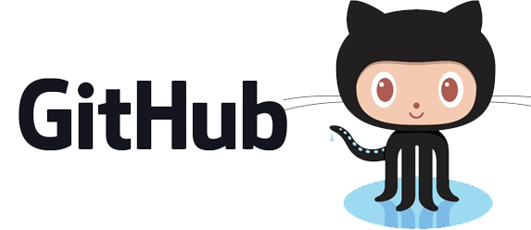

Assignment: 3

Part 3:

What is GitHub? When was it created? Why? By who? What similar platforms exist? Why would you use such a platform? (Answer between 5 and 10 lines)

Git is a version control system, similar but better than the many alternatives available ALLURA, KILN, CODEPLANE, BITBUCKET. Git is a command-line tool, but the center around which all things involving Git revolve – effectively, the Hub, is GitHub.com, where developers can store their projects and network with likeminded people. Git is an open-source version control system that was started by Linus Trovalds – the same person who created Linux, and was created in 1st October 2007.

Part 4:

Screenshot 1: git init

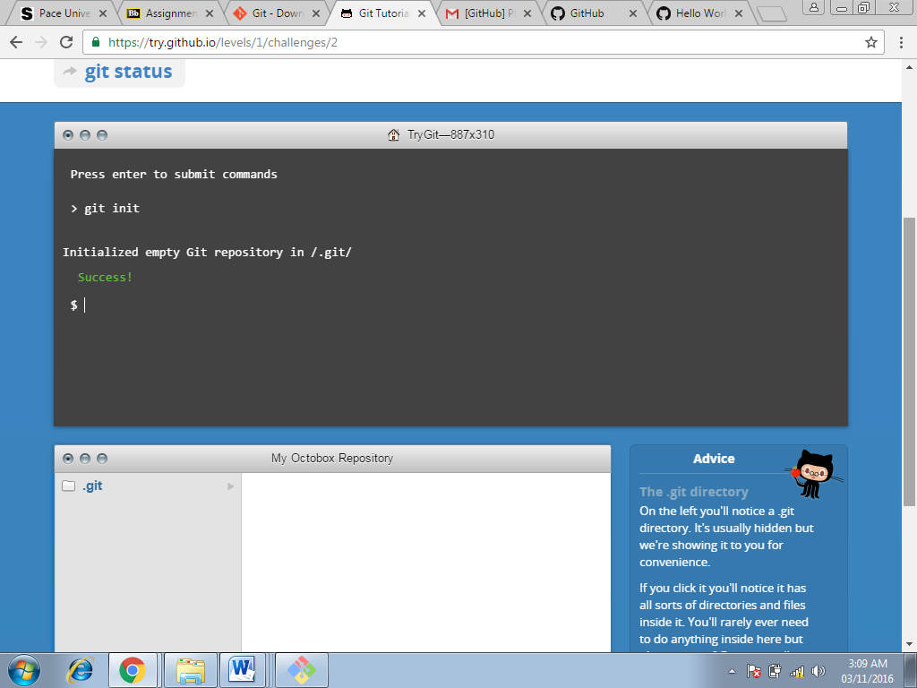

Screenshot 2: git status

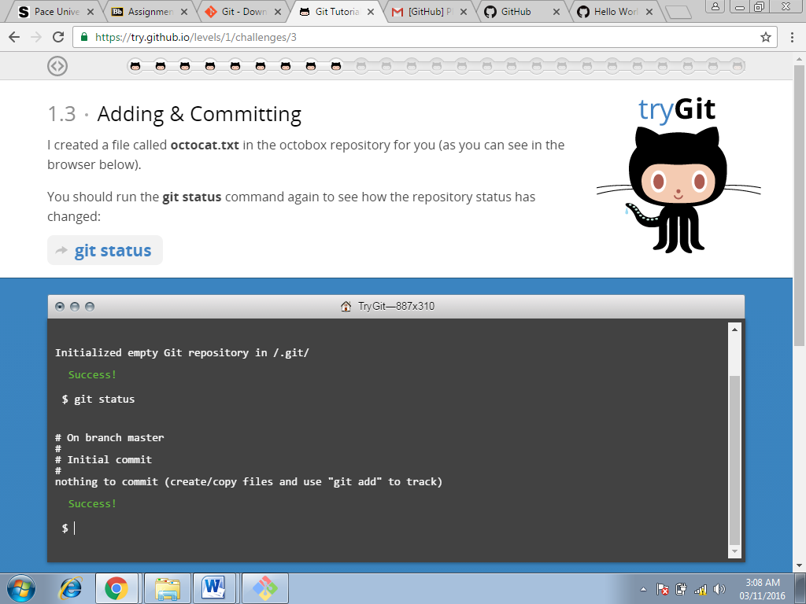

Screenshot 3: git add octocat.txt

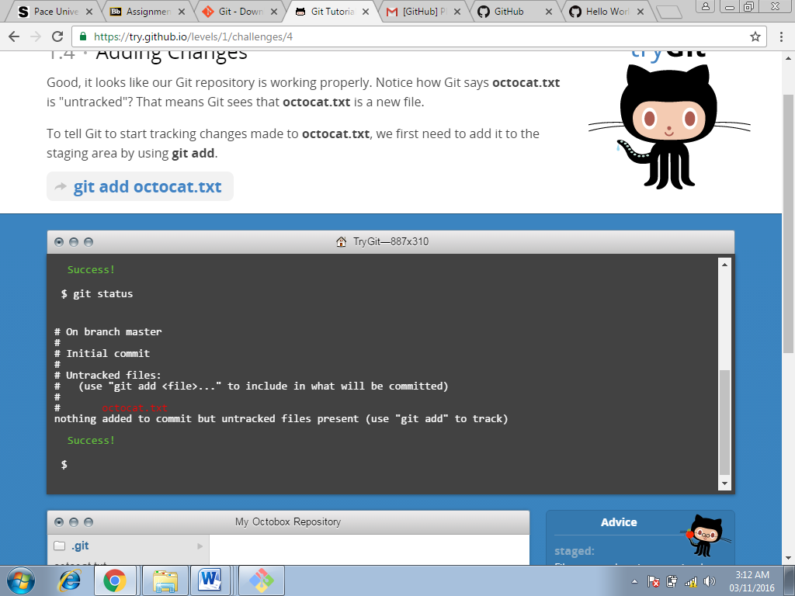

Screenshot 4: git add octocat.txt

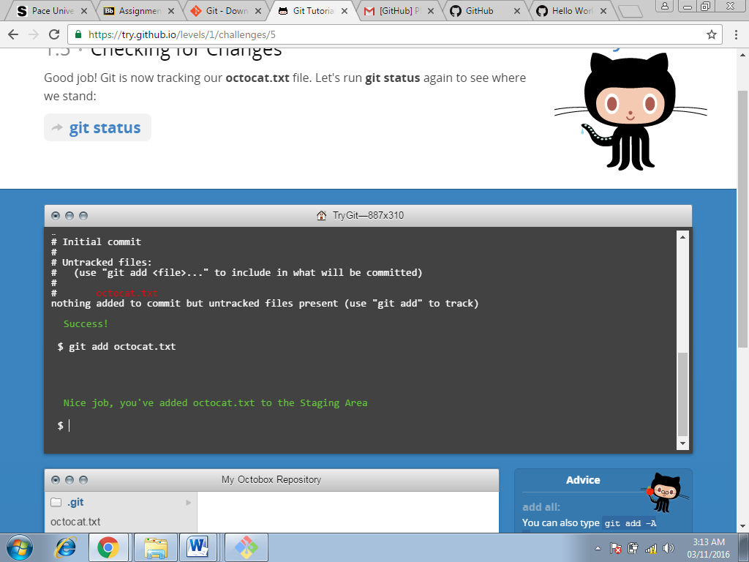

Screenshot 5: git status

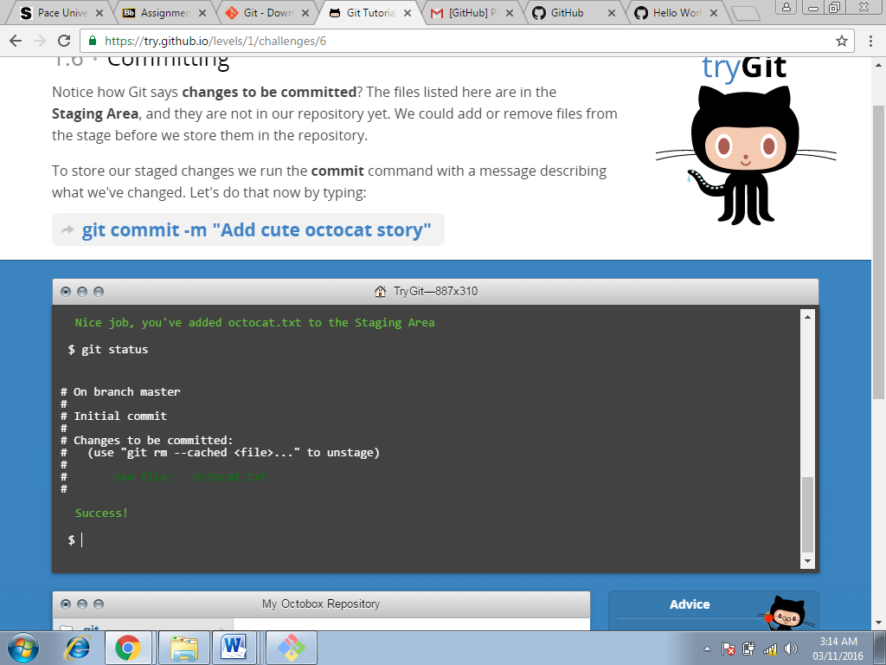

Screenshot 6: git commit -m

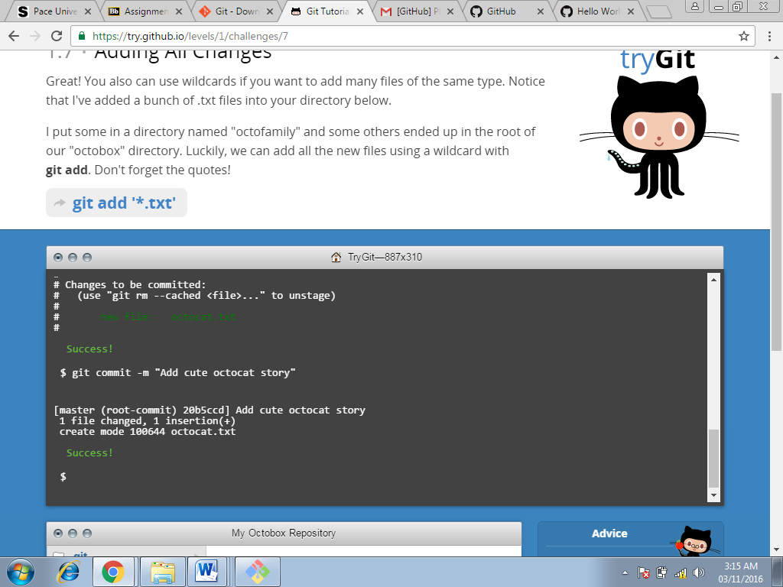

Screenshot 7: git add

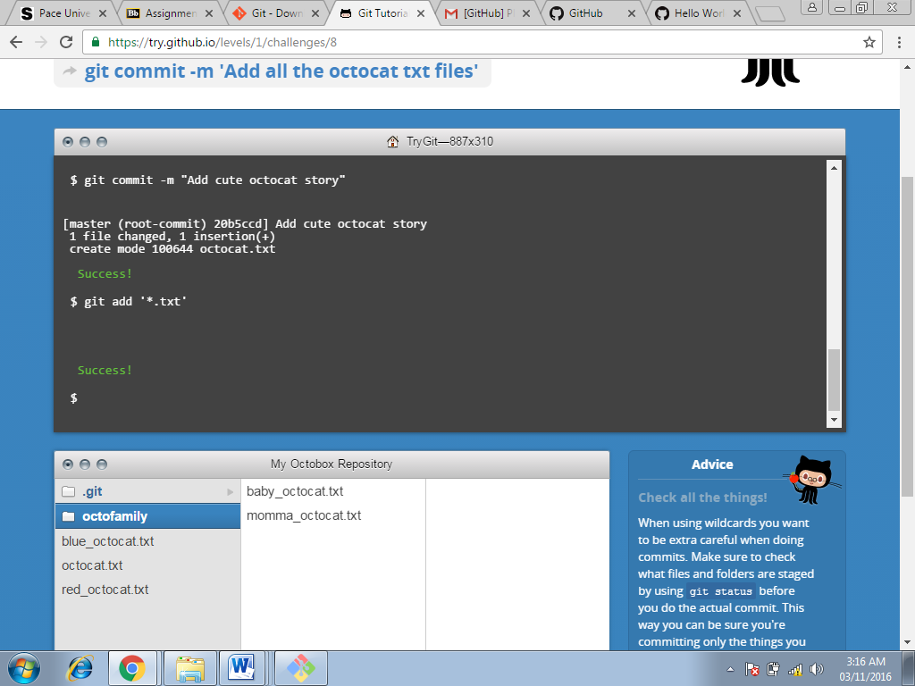

Screenshot 8: git log

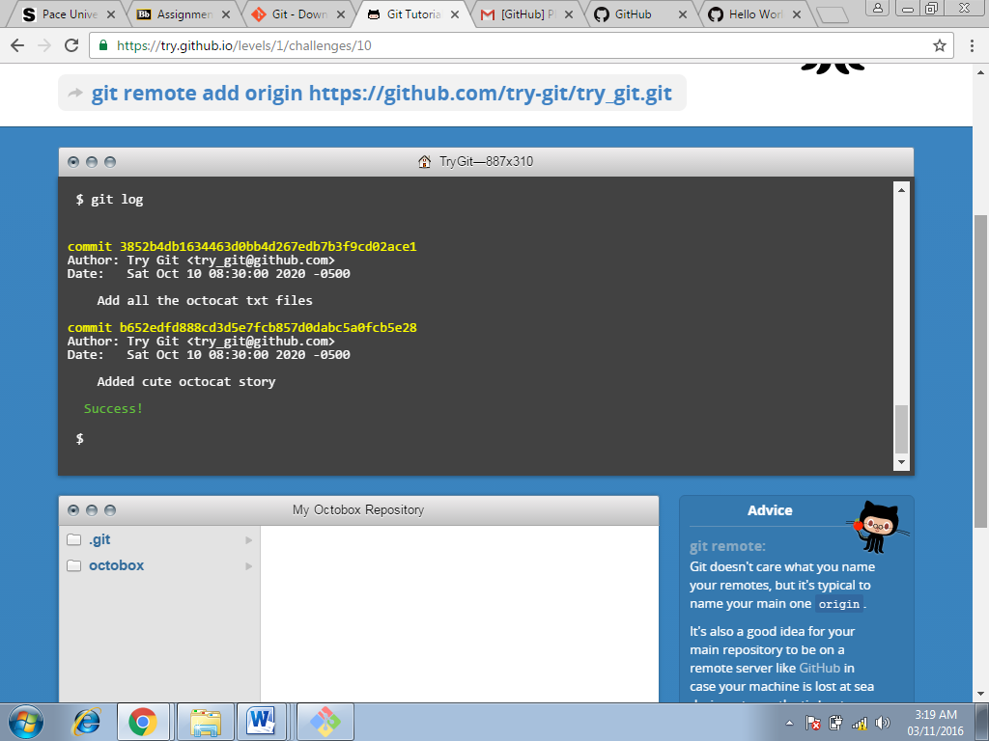

Screenshot 9: git remote add origin

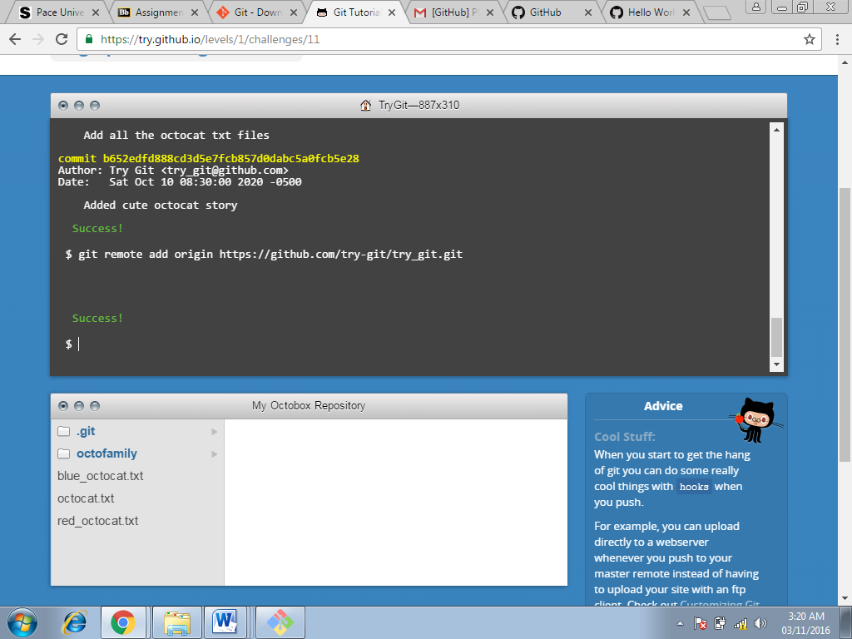

Screenshot 10: git push –u origin master

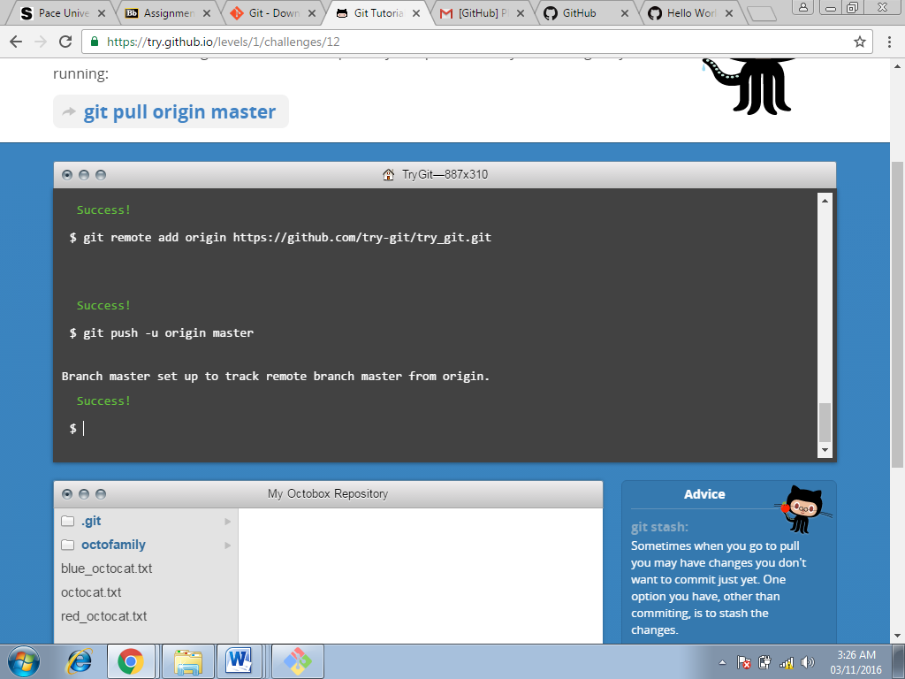

Screenshot 11: git pull origin master

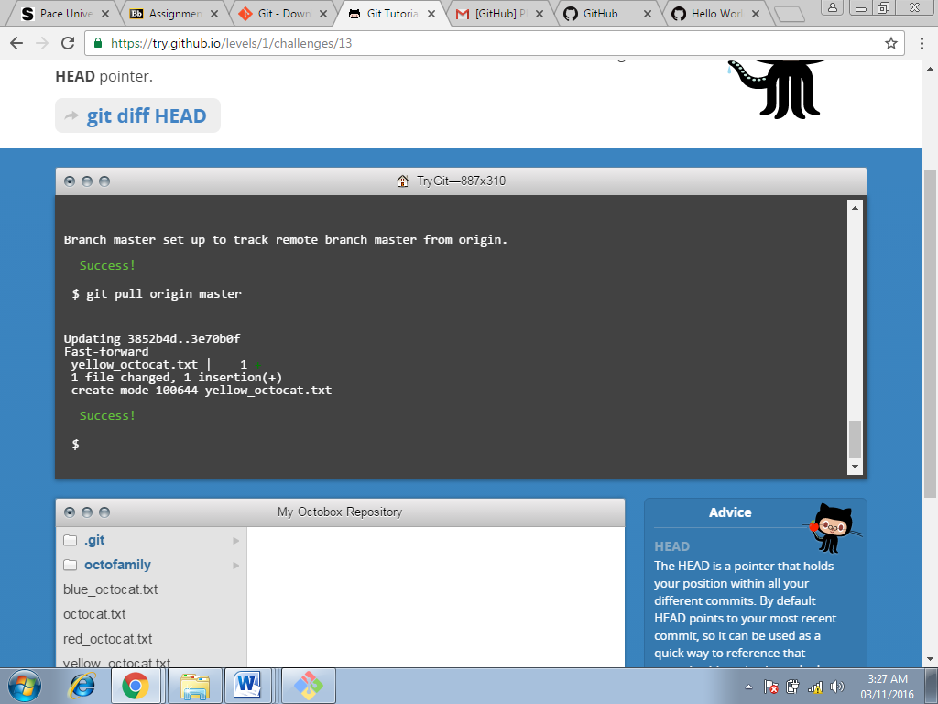

Screenshot 12: git diff HEAD

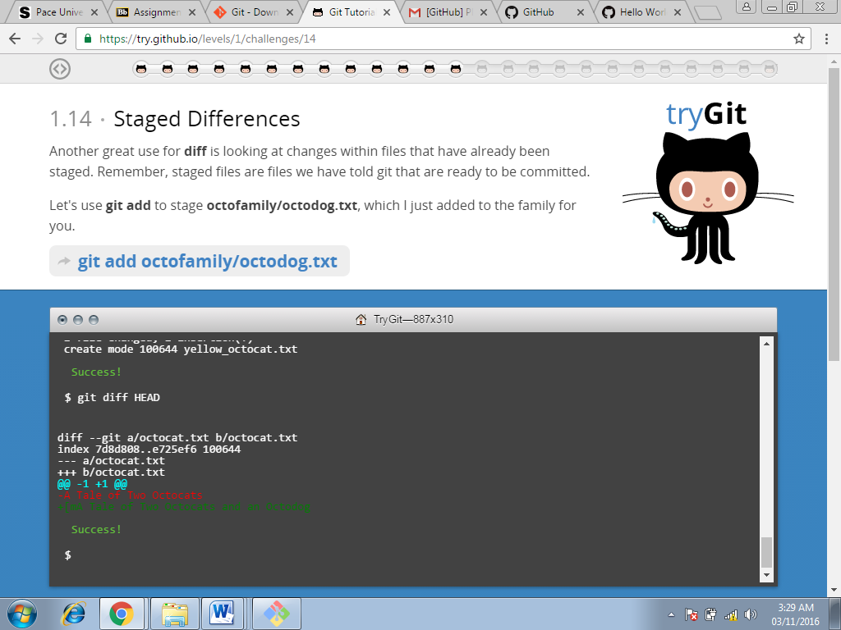

Screenshot 13: git add octofamily/octodog.txt

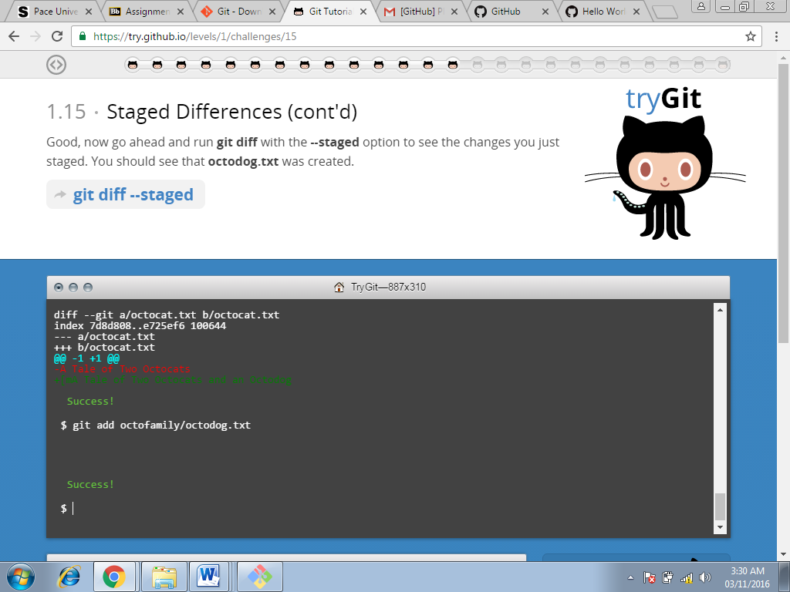

Screenshot 14: git diff --staged

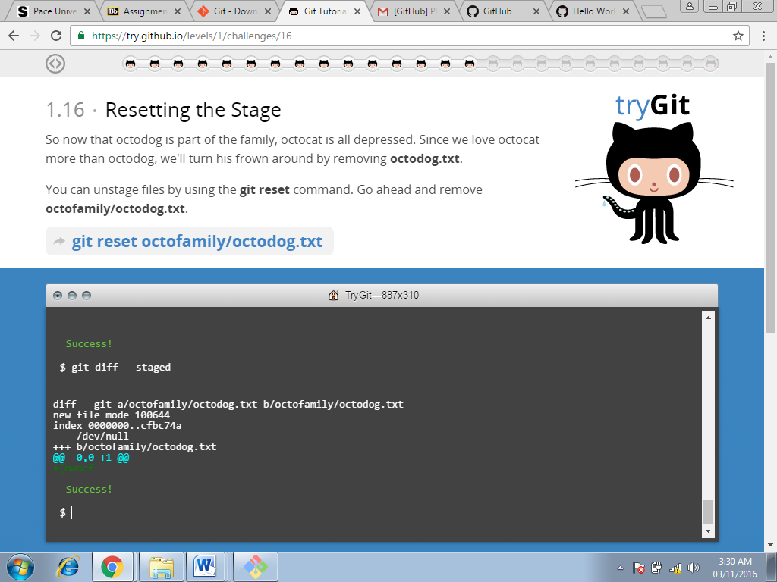

Screenshot 15 : git reset octofamily/octodog.txt

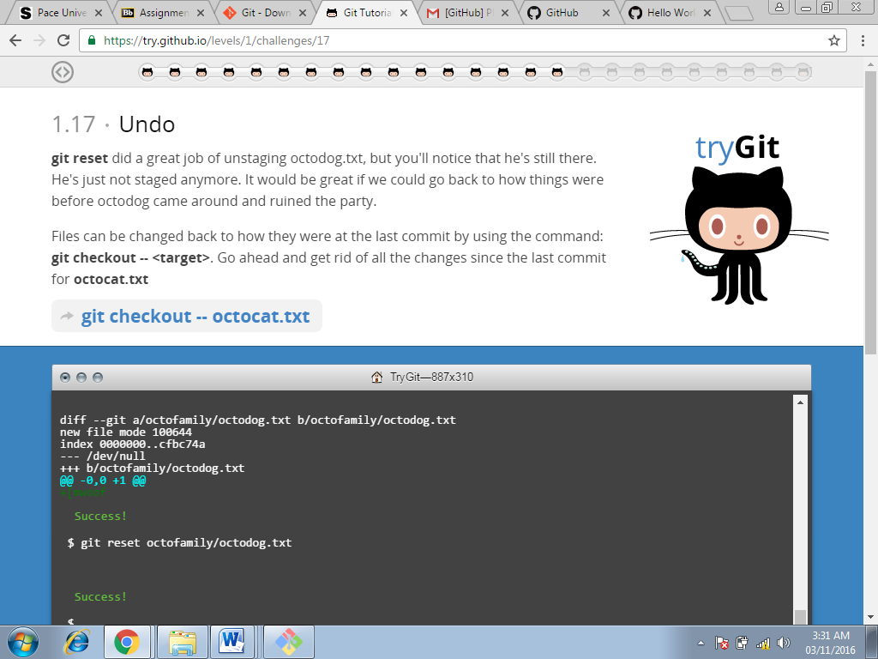

Screenshot 16: git checkout

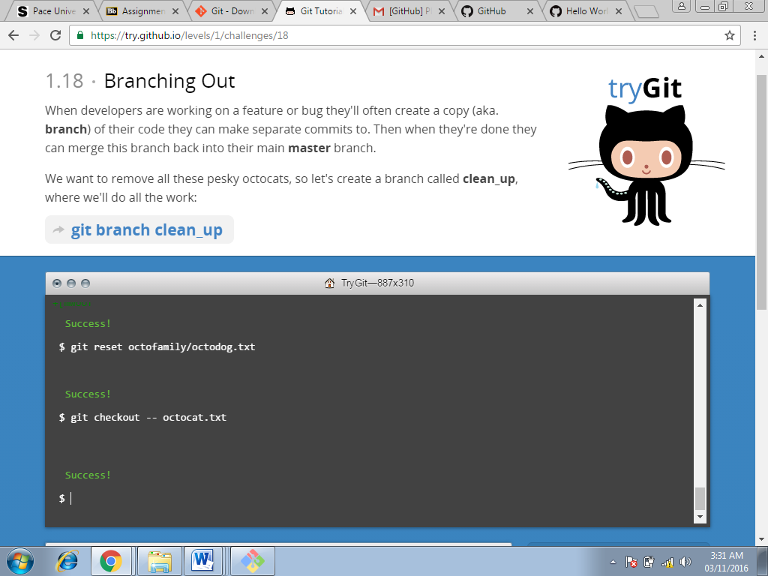

Screenshot 17: git branch clean_up

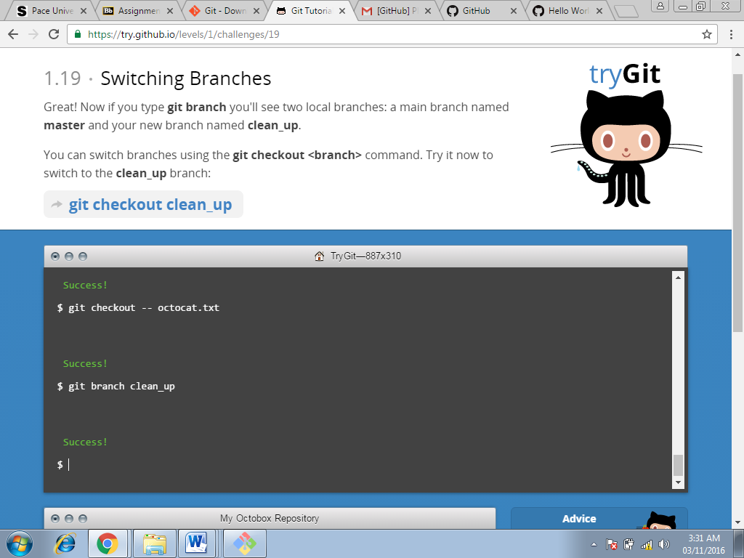

Screenshot 18: checkout clean_up

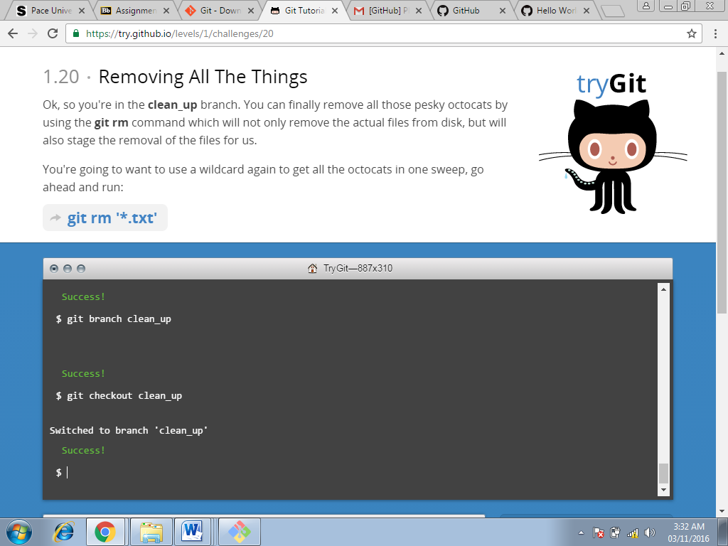

Screenshot 19: git rm ‘*.txt’

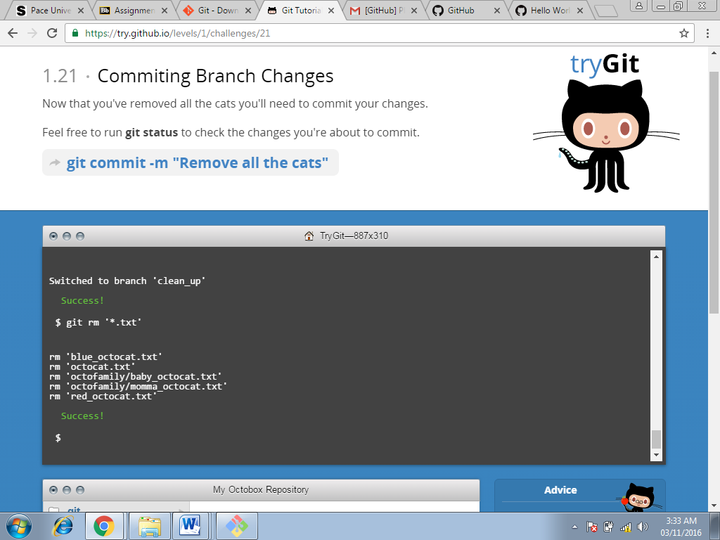

Screenshot 20: git commit -m

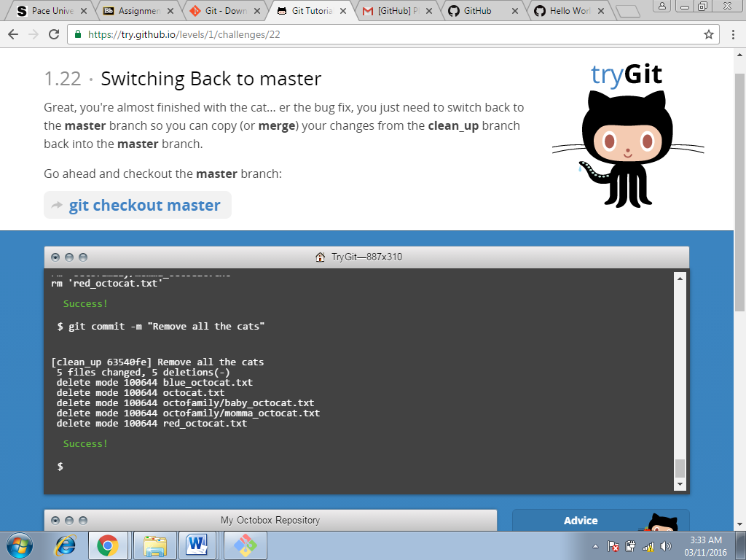

Screenshot 21: git checkout master

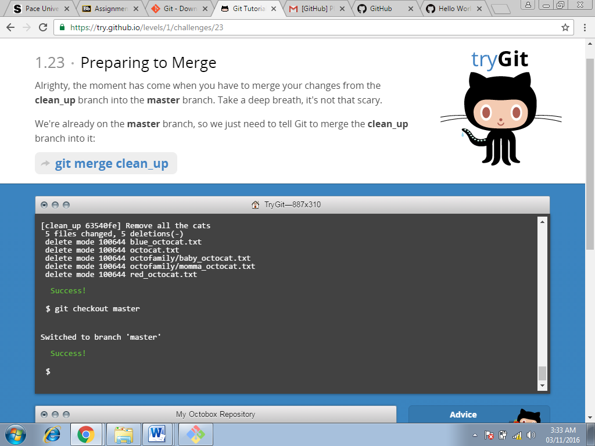

Screenshot 22: git branch –d clean_up

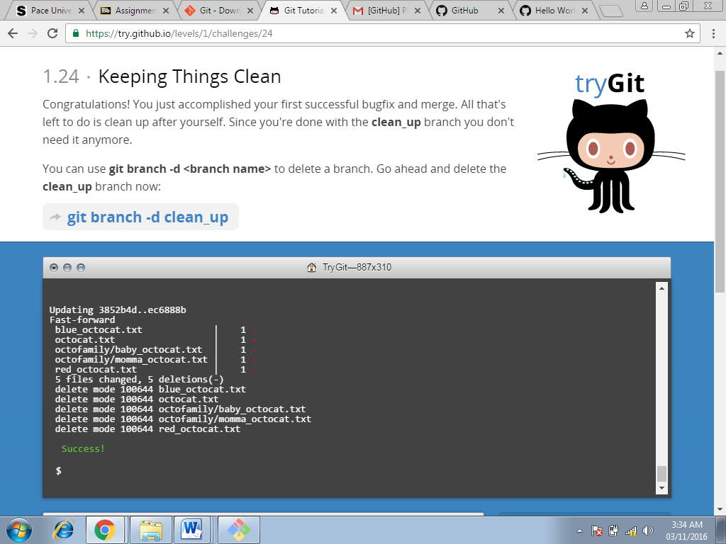

Screenshot 23: git push

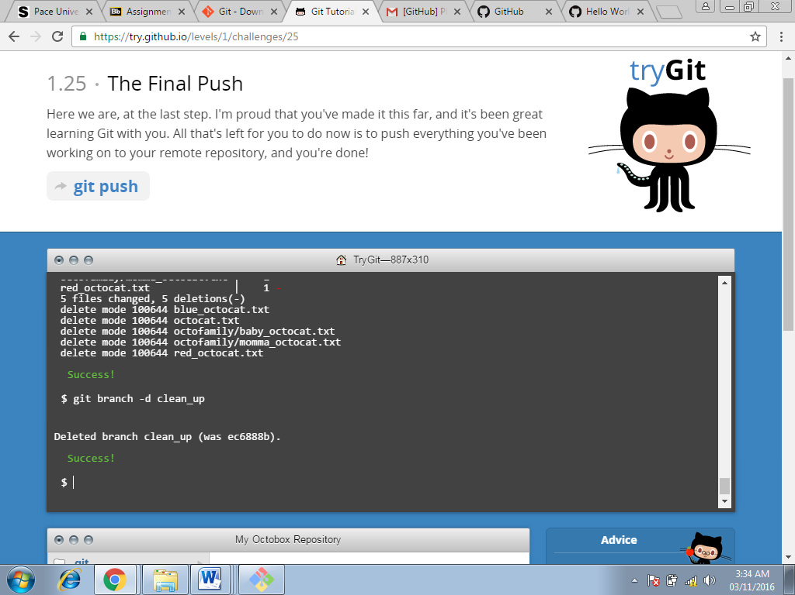

Screenshot 24: git push

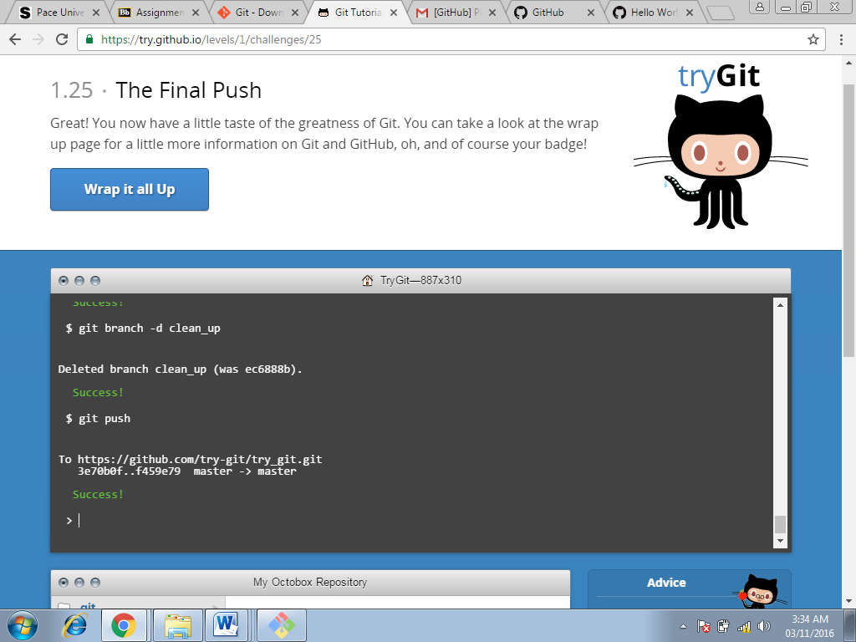

Screenshot 25: earned a cute little badge

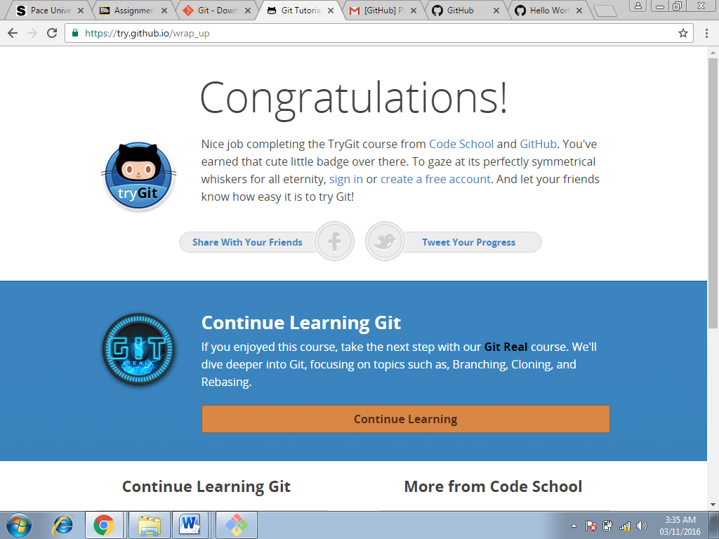

Part 5:

* Repository:

A repository is a location where all the files for a particular project are stored, usually abbreviated to “repo.” Each project will have its own repo, and can be accessed by a unique URL.

* Commit

A commit, is an individual change to a file (or set of files). It's like when you save a file, except with Git, every time you save it creates a unique ID that allows you to keep record of what changes were made when and by who.

* Push

Pushing refers to sending your committed changes to a remote repository such as GitHub.com. For instance, if you change something locally, you'd want to then push those changes so that others may access them.

* Branch

A branch is a parallel version of a repository. It is contained within the repository, but does not affect the primary or master branch allowing you to work freely without disrupting the "live" version.

* Fork

A fork is a personal copy of another user's repository that lives on your account. Forks allow you to freely make changes to a project without affecting the original.

* Merge

Merging takes the changes from one branch (in the same repository or from a fork), and applies them into another. This often happens as a Pull Request (which can be thought of as a request to merge), or via the command line

* Clone

A clone is a copy of a repository that lives on your computer instead of on a website's server somewhere, or the act of making that copy.

* Pull

Pull refers to when you are fetching in changes and merging them. For instance, if someone has edited the remote file you're both working on, you'll want to pull in those changes to your local copy so that it's up to date.

* Pull request

Pull requests are proposed changes to a repository submitted by a user and accepted or rejected by a repository's collaborators.

Part 7:

Commands and strategies for updating README.MD:

1. Firstly, I headed to the pace university courses page and clicked on the ‘README.MD’ in the repository.
2. Then selected the EDIT option of the repository.
3. A new page gets opened with the README.MD file.
4. Then I updated the file with the format given i.e. last name, first name, time and date.
5. And then requested for the file updating.
6. Then I created a new pull request and add comment to the pull request.
7. And then submitted the pull request.
8. Then the push request would be merged with the main repository and then the file will be updated as ‘README.MD’.