**MINI PROJECT REPORT**

**RAILWAY RESERVATION**



Submitted by:

**Devesh Sharma**

**2020B0101194**

Submitted to:

**Department of computer Science & Engineering**

ABES ENGINEERING COLLEGE

GHAZIABAD

**DECLARARTION**

I hereby declare that the Report entitled **“Railway Reservation”** is an authentic record of my own work as requirements of Mini Project during the period of 15-12-2021 to 15-01-2022 for the award of degree of B.Tech.(Computer Science & Engineering), ABES Engineering College, Ghaziabad, under the guidance of **Prof. (Dr.) Santosh Kumar and Ms. Aditi Arora.**

The matter embodied in this project work has not been submitted earlier for award of any degree or the diploma to the best of our knowledge and belief.

**Devesh Sharma**

**2020B0101194**

**Date: 20/01/2022**

**ACKNOWLEDGEMENT**

We would like to express my deep and sincere gratitude to our supervisor **Prof. (Dr.) Santosh Kumar and Ms. Aditi Arora** who gave me his full support and encouraged us to work in an innovative and challenging project for the educational field. His wide knowledge and logical thinking gave us the right direction all the time.

We are deeply grateful to our **Dr. Divya Mishra (HOD) Computer Science and Engineering** for his/her help and support provided at every step of the project.

We also are very thankful and grateful to our friends, family and colleagues by whom continuous support and dedication we came this far are able to complete our project on time.

**Tables of Contents**

Chapter 1: Introduction to project

* 1. Objective
  2. Uses
  3. Aims

Chapter 2: Tools and Technology Used

2.1 Functioning of Technology in Project

2.2 Objective for Using

Chapter 3: Railway Reservation

3.1 C Code

3.2 To Book a Ticket

3.3 To Cancel a Ticket

3.4 To Check Trains

3.5 Data Handling

3.6 Ticket Confirmation

3.7 Logout

Chapter 4: Result And Discussion

Chapter 5: Conclusion And Future Scope

5.1 References

Page no: 1

**Chapter 1**

**Introduction To Project**

Railway reservation project is based on the idea how the railway reservation site work on very large scale as this project is to understand the basic concepts and working flow of reservations tickets here in the project we have used Data Handling rather than using any Backend structure. Here one can put the basic details to confirm a ticket and can book a ticket and can also cancel a ticket once booked and this project is also capable to check trains from a source to destination. It is a dummy project for booking a tickets.

**1.1 Objective:**

Basic objective is to perform basic task of railway like booking a ticket, cancelling a ticket, and to check a train from a source to destination. It gives the basic idea and service to the customers.

**1.2 Uses:**

Although this model was designed with a specific purpose of performing basic tasks like booking of railway tickets. The basic structure of this program model can be further upgraded in future according to the aspects of uses and services similarly the design of the program can also be improved by adding Graphics library in c program.

**1.3 Aims:**

The model was designed with a basic aim to book tickets, cancel ticket, to check trains availability from source to destination as this program provide very simple interface to the user to perform these basic activities.

Page no: 2

**Chapter 2**

**Tools and Technology Used**

This program is entirely designed with the help of C Language and its in built libraries and data handling is also playing a vital role in this program as all the information regarding the trains like their availability, charges, time, and their names is stored in txt files can using data handling these information is being read by the complier during the run time of this program. The specific function of these are specified below:

**2.1 Functioning of Technology in Project**

* The code is written in C language which is facilitated by the in built libraries which have specific functions and these libraries help user to work efficiently and faster.
* Data Handling is also one of the most important feature of the this language which stores the information in txt files and these can be read during the execution of the program, it reduces the length of the program.
* Inbuilt Libraries are also included in this program which can be used to do certain operations and manipulation and functions in the program to make it more efficient.

Page no: 3

**Chapter 3**

**Railway Reservation**

**3.0 C Code**

**3.1 Library Intialisation**

# include <stdio.h>

# include <string.h>

# include <stdlib.h>

**3.2 Array of Structure**

struct book_tickets

{

char number[40];

char firstname[50];

char middlename[50];

char lastname[50];

char email[50];

};

**3.3 Personal Information of customer**

Page no: 4

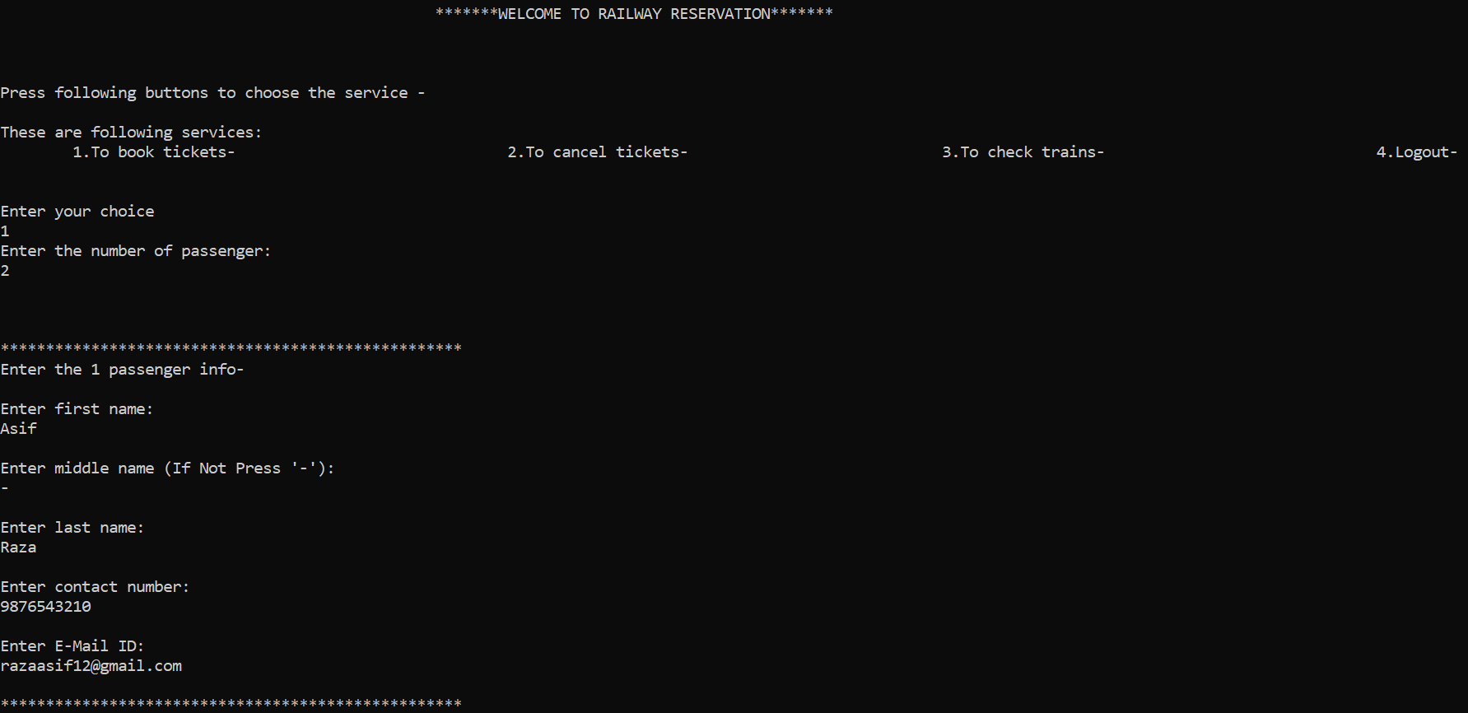

**Code Behind This**

void personal_info (struct book_tickets p[],char from[],char to[],char dates[],int passenger,char car[])

{

for(int i=0;i<passenger;i++)

{

printf("\n\n");

printf("%d. passenger info-\n",i+1);

printf("Passenger Name: %s %s %s\n",p[i].firstname,p[i].middlename,p[i].lastname);

printf("Passenger E-Mail ID: %s\n",p[i].email);

printf("Passenger Contact Number: %s\n",p[i].number);

printf("Travel Class: %s \n",car);

printf("Date Of Booking: %s\n",dates);

printf("From Station: %s\n",from);

printf("To Station: %s\n",to);

printf("%d Adult, 0 children\n",passenger);

printf("\n\n");

}

Page no: 5

printf("\t\t\t\t\t**************THANKS FOR BOOKING AND HAVE A SAFE TRIP**************");

}

**3.4 Various Train Information in TXT files**

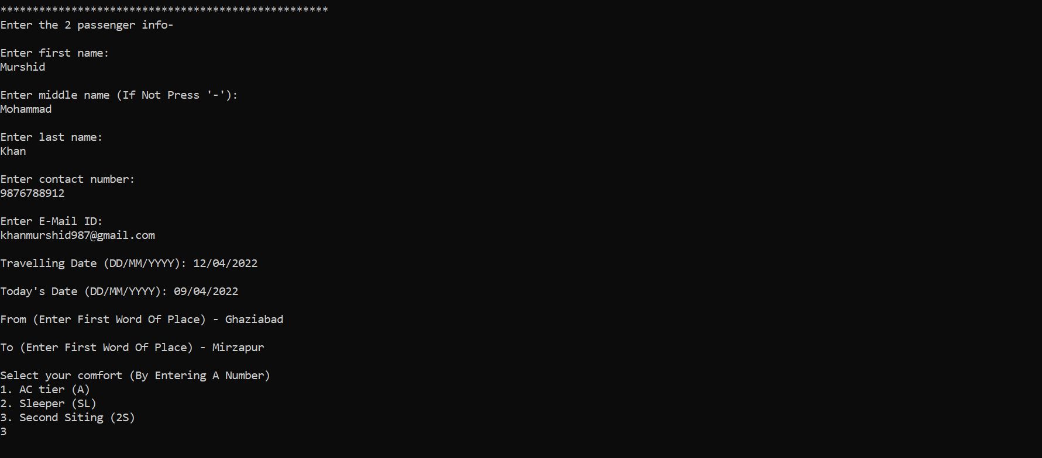

**Code Behind This**

void rajori_express (struct book_tickets p[],char from[],char to[],char date[],int passenger,char dates[])

{

printf("**********************************************************************************************************************************************************\n");

printf("\t\t\t\t\t\t\tCongratulation! Your Ticket Got Successfully Booked\n\n");

char car[30]="AC tier (A)";

FILE *fp1;

char ch1;

fp1=fopen("rajori express.txt","r");

ch1=getc(fp1);

while(ch1!=EOF)

{

printf("%c",ch1);

ch1=getc(fp1);

Page no: 6

}

fclose(fp1);

personal_info (p,from,to,dates,passenger,car);

}

**3.5 Various Train Information**

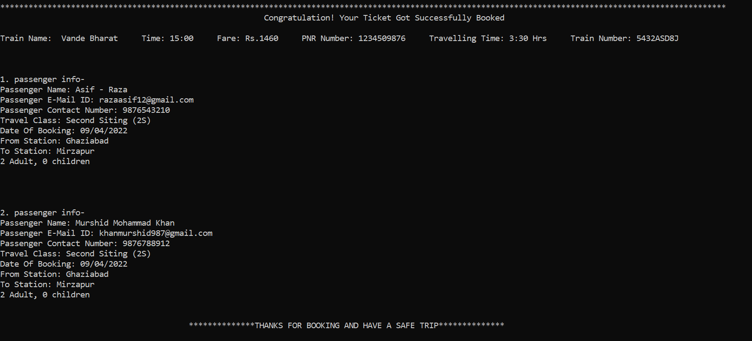

**Code Behind This**

void chennai_express (struct book_tickets p[],char from[],char to[],char date[],int passenger,char dates[])

{

printf("**********************************************************************************************************************************************************\n");

printf("\t\t\t\t\t\t\tCongratulation! Your Ticket Got Successfully Booked\n\n");

char car[30]="AC tier (A)";

FILE *fp1;

char ch1;

fp1=fopen("chennai express.txt","r");

ch1=getc(fp1);

while(ch1!=EOF)

{

Page no: 7

printf("%c",ch1);

ch1=getc(fp1);

}

fclose(fp1);

personal_info (p,from,to,dates,passenger,car);

}

**3.6 Reading Train info Using Data Handling**

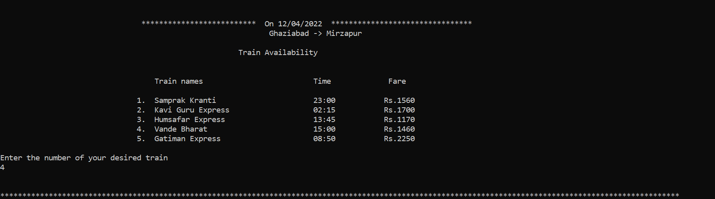

**Code Behind This**

void friyangyu_tez (struct book_tickets p[],char from[],char to[],char date[],int passenger,char dates[])

{

printf("**********************************************************************************************************************************************************\n");

printf("\t\t\t\t\t\t\tCongratulation! Your Ticket Got Successfully Booked\n\n");

char car[30]="AC tier (A)";

FILE *fp1;

char ch1;

fp1=fopen("friyangyu tez.txt","r");

ch1=getc(fp1);

while(ch1!=EOF)

{

printf("%c",ch1);

ch1=getc(fp1);

Page no: 8

}

fclose(fp1);

personal_info (p,from,to,dates,passenger,car);

}

void rajoriya_gadi (struct book_tickets p[],char from[],char to[],char date[],int passenger,char dates[])

{

printf("**********************************************************************************************************************************************************\n");

printf("\t\t\t\t\t\t\tCongratulation! Your Ticket Got Successfully Booked\n\n");

char car[30]="AC tier (A)";

FILE *fp1;

char ch1;

fp1=fopen("rajoriya gadi.txt","r");

ch1=getc(fp1);

while(ch1!=EOF)

{

printf("%c",ch1);

ch1=getc(fp1);

}

fclose(fp1);

personal_info (p,from,to,dates,passenger,car);

}

**3.7 Various Trains Available**

Page no: 9

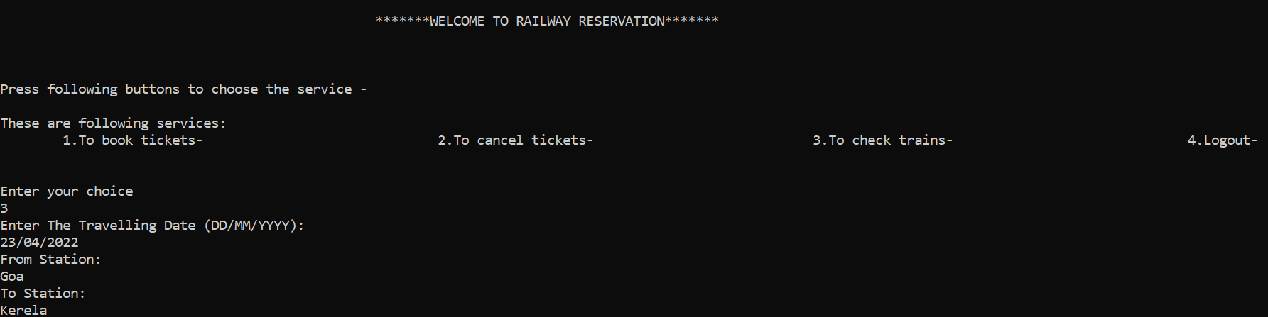

**Code Behind This**

void emporium_super_express (struct book_tickets p[],char from[],char to[],char date[],int passenger,char dates[]){ printf("**********************************************************************************************************************************************************\n");

printf("\t\t\t\t\t\t\tCongratulation! Your Ticket Got Successfully Booked\n\n");

char car[30]="AC tier (A)";

FILE *fp1;

char ch1;

fp1=fopen("emporium_super_express.txt","r");

ch1=getc(fp1);

while(ch1!=EOF)

{

printf("%c",ch1);

ch1=getc(fp1);

}

fclose(fp1);

personal_info (p,from,to,dates,passenger,car);

}

void shatabdi_express (struct book_tickets p[],char from[],char to[],char date[],int passenger,char dates[])

{

printf("*********************************************************************

Page no: 10

*************************************************************************************\n");

printf("\t\t\t\t\t\t\tCongratulation! Your Ticket Got Successfully Booked\n\n");

char car[30]="Sleeper (SL)";

FILE *fp1;

char ch1;

fp1=fopen("shatabdi_express.txt","r");

ch1=getc(fp1);

while(ch1!=EOF)

{

printf("%c",ch1);

ch1=getc(fp1);

}

fclose(fp1);

personal_info (p,from,to,dates,passenger,car);

}

**3.8 Various Trains Available on Date**

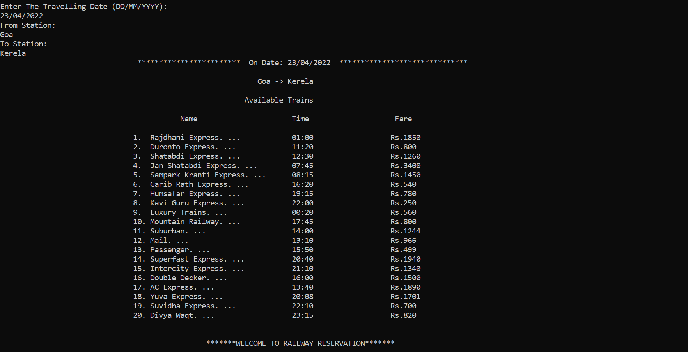

**Code Behind This**

Page no: 11

void rajdhani_express (struct book_tickets p[],char from[],char to[],char date[],int passenger,char dates[])

{

printf("**********************************************************************************************************************************************************\n");

printf("\t\t\t\t\t\t\tCongratulation! Your Ticket Got Successfully Booked\n\n");

char car[30]="Sleeper (SL)";

FILE *fp1;

char ch1;

fp1=fopen("rajdhani_express.txt","r");

ch1=getc(fp1);

while(ch1!=EOF)

{

printf("%c",ch1);

ch1=getc(fp1);

}

fclose(fp1);

personal_info (p,from,to,dates,passenger,car);

}

void mahamana_vivek (struct book_tickets p[],char from[],char to[],char date[],int passenger,char dates[])

{

printf("**********************************************************************************************************************************************************\n");

printf("\t\t\t\t\t\t\tCongratulation! Your Ticket Got Successfully Booked\n\n");

char car[30]="Sleeper (SL)";

FILE *fp1;

Page no: 12

char ch1;

fp1=fopen("mahamana_vivek.txt","r");

ch1=getc(fp1);

while(ch1!=EOF)

{

printf("%c",ch1);

ch1=getc(fp1);

}

fclose(fp1);

personal_info (p,from,to,dates,passenger,car);

}

void rajoriya_kranti (struct book_tickets p[],char from[],char to[],char date[],int passenger,char dates[])

{

printf("**********************************************************************************************************************************************************\n");

printf("\t\t\t\t\t\t\tCongratulation! Your Ticket Got Successfully Booked\n\n");

char car[30]="Sleeper (SL)";

FILE *fp1;

char ch1;

fp1=fopen("rajoriya_kranti.txt","r");

ch1=getc(fp1);

while(ch1!=EOF)

{

printf("%c",ch1);

ch1=getc(fp1);

}

fclose(fp1);

Page no: 13

personal_info (p,from,to,dates,passenger,car);

}

**3.9 Various Train Information**

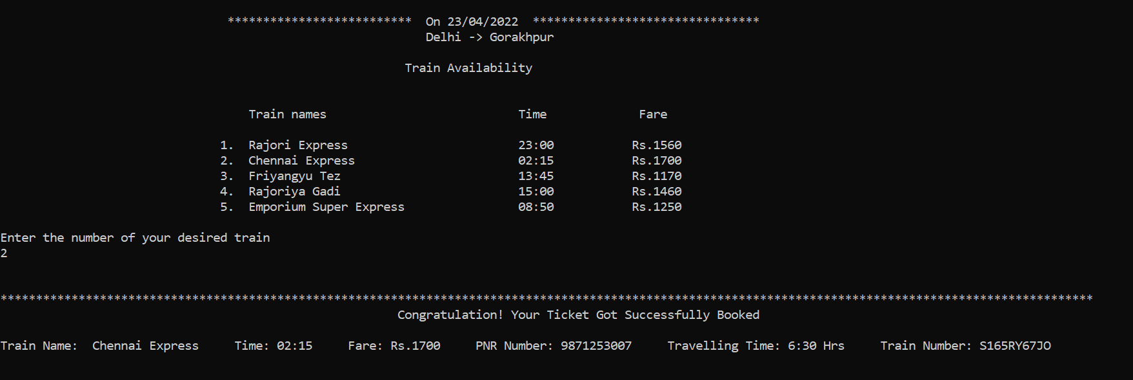

**Code Behind This**

void tejas_rath_express (struct book_tickets p[],char from[],char to[],char date[],int passenger,char dates[])

{

printf("**********************************************************************************************************************************************************\n");

printf("\t\t\t\t\t\t\tCongratulation! Your Ticket Got Successfully Booked\n\n");

char car[30]="Sleeper (SL)";

FILE *fp1;

char ch1;

fp1=fopen("tejas_rath_express.txt","r");

ch1=getc(fp1);

while(ch1!=EOF)

{

printf("%c",ch1);

ch1=getc(fp1);

}

fclose(fp1);

personal_info (p,from,to,dates,passenger,car);}

Page no: 14

void sampark_krati (struct book_tickets p[],char from[],char to[],char date[],int passenger,char dates[])

{

printf("**********************************************************************************************************************************************************\n");

printf("\t\t\t\t\t\t\tCongratulation! Your Ticket Got Successfully Booked\n\n");

char car[30]="Second Siting (2S)";

FILE *fp1;

char ch1;

fp1=fopen("sampark_kranti.txt","r");

ch1=getc(fp1);

while(ch1!=EOF)

{

printf("%c",ch1);

ch1=getc(fp1);

}

fclose(fp1);

personal_info (p,from,to,dates,passenger,car);

}

void kavi_guru_express (struct book_tickets p[],char from[],char to[],char date[],int passenger,char dates[])

{

printf("**********************************************************************************************************************************************************\n");

printf("\t\t\t\t\t\t\tCongratulation! Your Ticket Got Successfully Booked\n\n"); char car[30]="Second Siting (2S)";

Page no: 15

FILE *fp1;

char ch1;

fp1=fopen("kavi_guru_express.txt","r");

ch1=getc(fp1);

while(ch1!=EOF)

{

printf("%c",ch1);

ch1=getc(fp1);

}

fclose(fp1);

personal_info (p,from,to,dates,passenger,car);

}

void humsafar_express (struct book_tickets p[],char from[],char to[],char date[],int passenger,char dates[])

{

printf("**********************************************************************************************************************************************************\n");

printf("\t\t\t\t\t\t\tCongratulation! Your Ticket Got Successfully Booked\n\n");

char car[30]="Second Siting (2S)";

FILE *fp1;

char ch1;

fp1=fopen("humsafar_express.txt","r");

ch1=getc(fp1);

while(ch1!=EOF)

{

printf("%c",ch1);

ch1=getc(fp1);

}

Page no: 16

fclose(fp1);

personal_info (p,from,to,dates,passenger,car);

}

**3.10 Various Train Information**



**Code Behind This**

void vande_bharat (struct book_tickets p[],char from[],char to[],char date[],int passenger,char dates[])

{

printf("**********************************************************************************************************************************************************\n");

printf("\t\t\t\t\t\t\tCongratulation! Your Ticket Got Successfully Booked\n\n");

char car[30]="Second Siting (2S)";

FILE *fp1;

char ch1;

fp1=fopen("vande_bharat.txt","r");

ch1=getc(fp1);

while(ch1!=EOF)

{

printf("%c",ch1);

ch1=getc(fp1);

}

fclose(fp1);

personal_info (p,from,to,dates,passenger,car);}

Page no: 17

void gatiman_express (struct book_tickets p[],char from[],char to[],char date[],int passenger,char dates[])

{

printf("**********************************************************************************************************************************************************\n");

printf("\t\t\t\t\t\t\tCongratulation! Your Ticket Got Successfully Booked\n\n");

char car[30]="Second Siting (2S)";

FILE *fp1;

char ch1;

fp1=fopen("gatiman_express.txt","r");

ch1=getc(fp1);

while(ch1!=EOF)

{

printf("%c",ch1);

ch1=getc(fp1);

}

fclose(fp1);

personal_info (p,from,to,dates,passenger,car);

}

**3.11 Cancellation of Ticket**

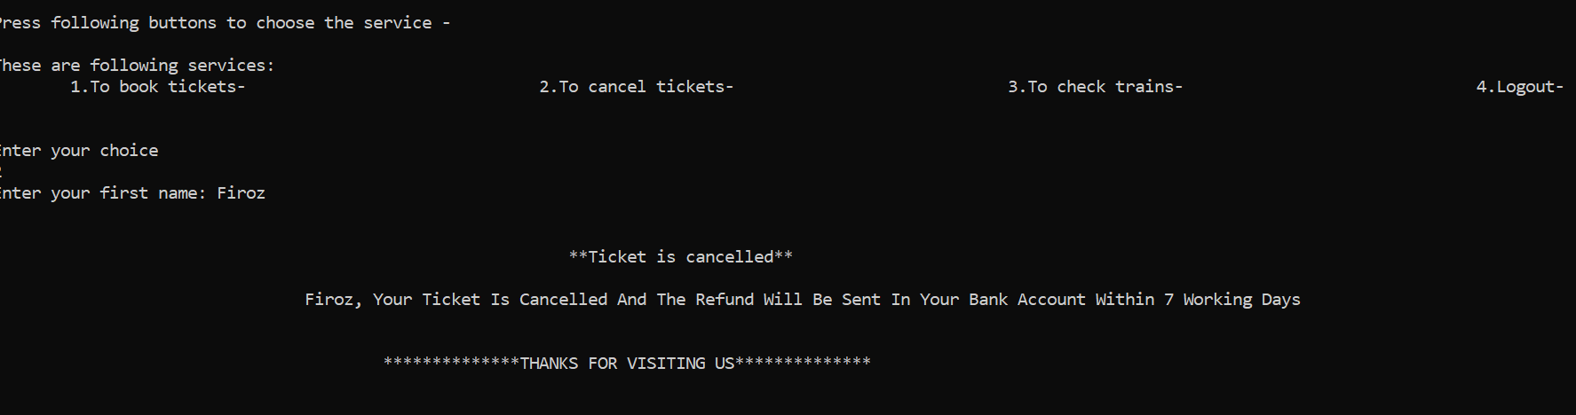

**Code Behind This**

void ac (struct book_tickets p[],char from[],char to[],char date[],int passenger,char dates[])

{

Page no: 18

printf("\t\t\t\t************************** On %s ********************************\n",date);

printf("\t\t\t\t\t\t\t %s -> %s",from,to);

char ch;

int choice;

FILE *fp;

fp=fopen("ac1.txt","r");

ch=getc(fp);

while(ch!=EOF)

{

printf("%c",ch);

ch=getc(fp);

}

fclose(fp);

printf("Enter the number of your desired train\n");

scanf("%d",&choice);

printf("\n\n");

switch(choice)

{

case 1:

{

rajori_express(p,from,to,date,passenger,dates);

break;

}

case 2:

{

chennai_express(p,from,to,date,passenger,dates);

break;

Page no: 19

}

case 3:

{

friyangyu_tez(p,from,to,date,passenger,dates);

break;

}

case 4:

{

rajoriya_gadi(p,from,to,date,passenger,dates);

break;

}

case 5:

{

emporium_super_express(p,from,to,date,passenger,dates);

break;

}

default:

{

printf("Invalid option\n");

break;

}

}

printf("\n\n\n");

}

void ac2 (struct book_tickets p[],char from[],char to[],char date[],int passenger,char dates[])

{

printf("\t\t\t\t************************** On %s ********************************\n",date);

Page no: 20

printf("\t\t\t\t\t\t\t %s -> %s",from,to);

char ch;

int choice;

FILE *fp;

fp=fopen("ac2.txt","r");

ch=getc(fp);

while(ch!=EOF)

{

printf("%c",ch);

ch=getc(fp);

}

fclose(fp);

printf("Enter the number of your desired train\n");

scanf("%d",&choice);

printf("\n\n");

switch(choice)

{

case 1:

{

shatabdi_express(p,from,to,date,passenger,dates);

break;

}

case 2:

{

rajdhani_express(p,from,to,date,passenger,dates);

break;

}

Page no: 21

case 3:

{

mahamana_vivek(p,from,to,date,passenger,dates);

break;

}

case 4:

{

rajoriya_kranti(p,from,to,date,passenger,dates);

break;

}

case 5:

{

tejas_rath_express(p,from,to,date,passenger,dates);

break;

}

default:

{

printf("Invalid option\n");

break;

}

}

printf("\n\n\n");

}

**3.12 Display of ticket**

Page no: 22

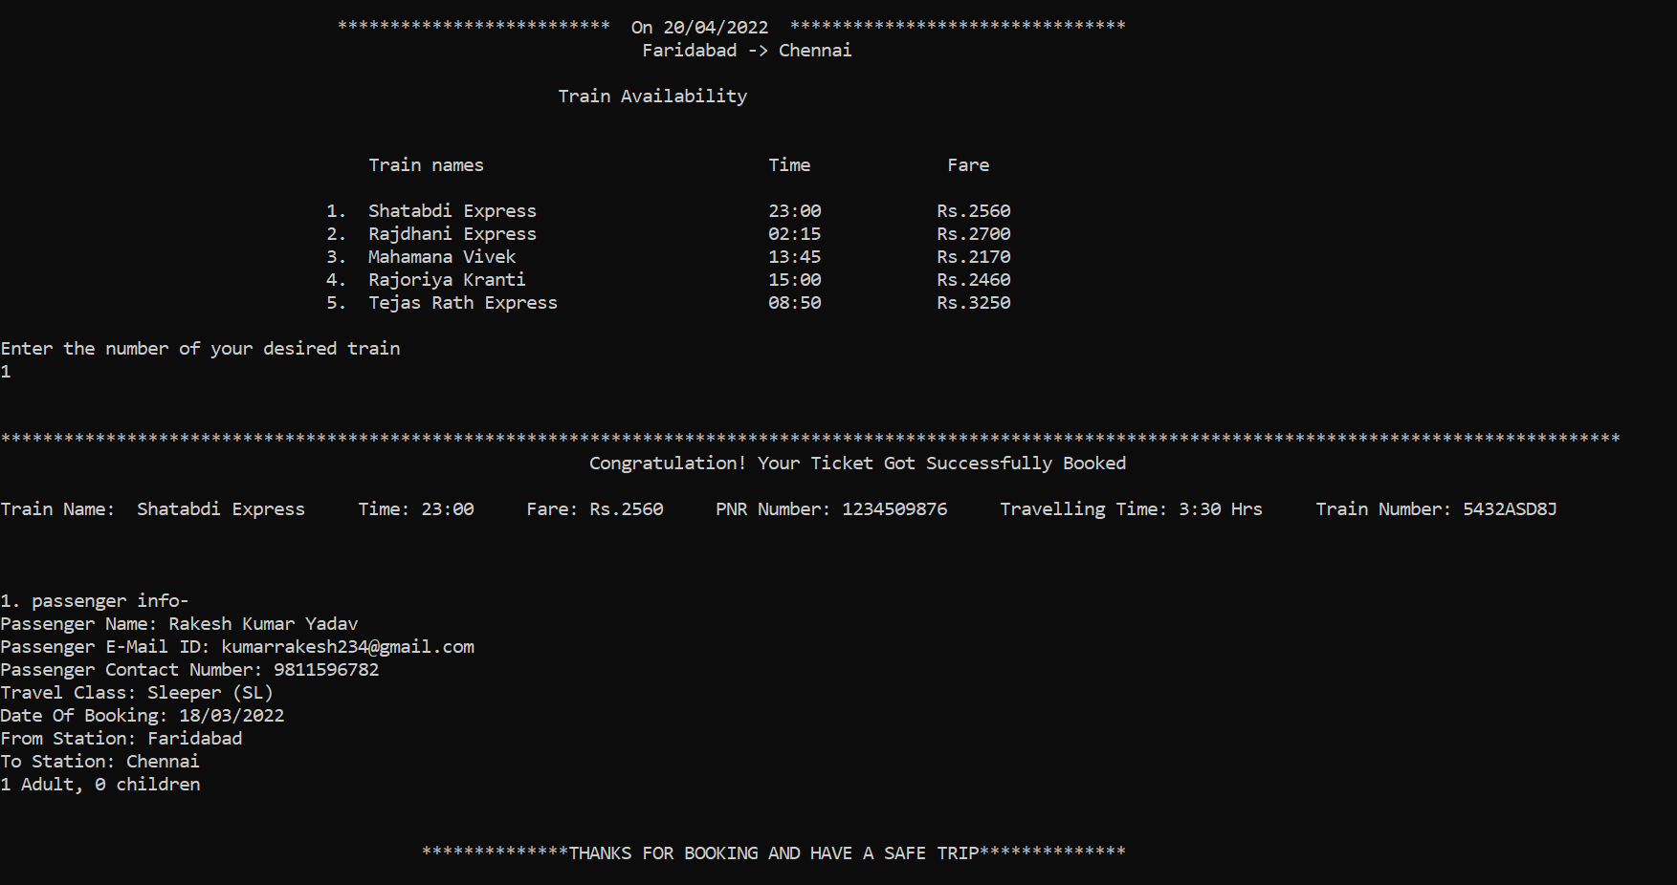

**Code Behind This**

void general (struct book_tickets p[],char from[],char to[],char date[],int passenger,char dates[])

{

printf("\t\t\t\t************************** On %s ********************************\n",date);

printf("\t\t\t\t\t\t\t %s -> %s",from,to);

char ch;

int choice;

FILE *fp;

fp=fopen("general.txt","r");

ch=getc(fp);

while(ch!=EOF)

{

printf("%c",ch);

ch=getc(fp);

}

fclose(fp);

printf("Enter the number of your desired train\n");

Page no: 23

scanf("%d",&choice);

printf("\n\n");

switch(choice)

{

case 1:

{

sampark_krati(p,from,to,date,passenger,dates);

break;

}

case 2:

{

kavi_guru_express(p,from,to,date,passenger,dates);

break;

}

case 3:

{

humsafar_express(p,from,to,date,passenger,dates);

break;

}

case 4:

{

vande_bharat(p,from,to,date,passenger,dates);

break;

}

case 5:

{

gatiman_express(p,from,to,date,passenger,dates);

Page no: 24

break;

}

default:

{

printf("Invalid option\n");

break;

}

}

printf("\n\n\n");

}

**3.13 For Booking of Ticket**

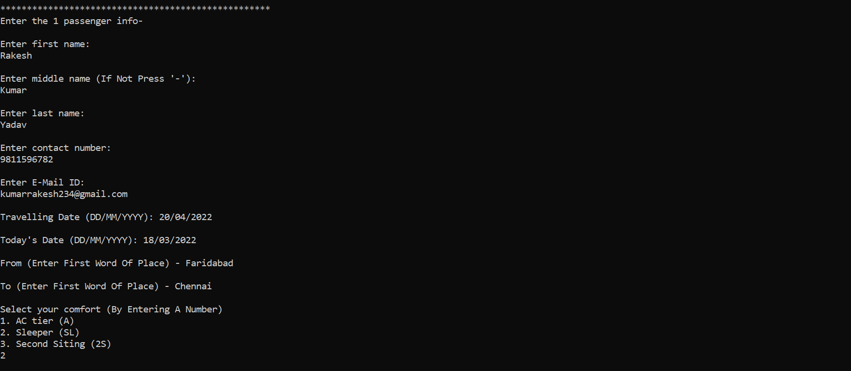

**Code Behind This**

void book_tickets(struct book_tickets p[])

{

int passenger,ch;

char date[20],from[20],to[20],dates[20];

printf("Enter the number of passenger:\n");

scanf("%d",&passenger);

printf("\n\n\n");

Page no: 25

for(int i=0;i<passenger;i++)

{

printf("***************************************************\n");

printf("Enter the %d passenger info-\n",i+1);

printf("\nEnter first name:\n");

scanf("%s",&p[i].firstname);

printf("\nEnter middle name (If Not Press '-'):\n");

scanf("%s",&p[i].middlename);

printf("\nEnter last name:\n");

scanf("%s",&p[i].lastname);

printf("\nEnter contact number:\n");

scanf("%s",&p[i].number);

printf("\nEnter E-Mail ID:\n");

scanf("%s",&p[i].email);

printf("\n");

}

printf("Travelling Date (DD/MM/YYYY): ");

scanf("%s",date);

printf("\nToday's Date (DD/MM/YYYY): ");

scanf("%s",dates);

printf("\nFrom (Enter First Word Of Place) - ");

scanf("%s",from);

printf("\nTo (Enter First Word Of Place) - ");

scanf("%s",to);

printf("\nSelect your comfort (By Entering A Number)\n");

printf("1. AC tier (A)\n");

printf("2. Sleeper (SL)\n");

printf("3. Second Siting (2S)\n");

scanf("%d",&ch);

Page no: 26

printf("\n\n");

switch (ch)

{

case 1:

{

ac(p,from,to,date,passenger,dates);

break;

}

case 2:

{

ac2(p,from,to,date,passenger,dates);

break;

}

case 3:

{

general(p,from,to,date,passenger,dates);

break;

}

default:

{

printf("Invalid Option\n");

break;

}

}

printf("\n\n\n");

}

**3.14 For Cancelling Tickets**

Page no: 27

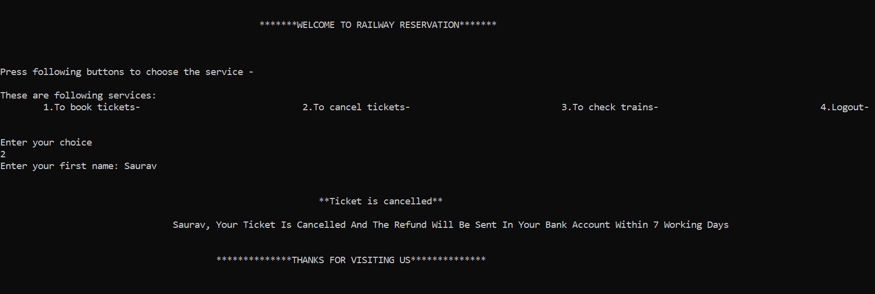

**Code Behind This**

void cancel_tickets ()

{

int pnr,num;

char name[30];

printf("Enter your first name: ");

scanf("%s",name);

printf("\n\n");

printf("\t\t\t\t\t\t\t **Ticket is cancelled**\n\n");

printf("\t\t\t\t%s, Your Ticket Is Cancelled And The Refund Will Be Sent In Your Bank Account Within 7 Working Days\n\n\n",name);

printf("\t\t\t\t\t**************THANKS FOR VISITING US**************");

printf("\n\n\n");

}

**3.15 For Checking Trains**

Page no: 28

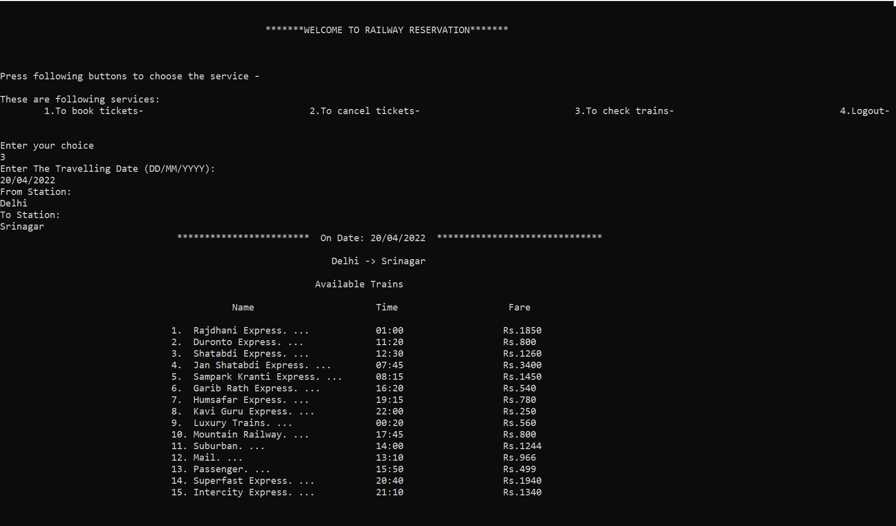

**Code Behind This**

void check_trains()

{

char from[30],to[30],date[30];

printf("Enter The Travelling Date (DD/MM/YYYY):\n");

scanf("%s",date);

printf("From Station:\n");

scanf("%s",from);

printf("To Station:\n");

scanf("%s",to);

printf("\t\t\t\t************************ On Date: %s ******************************\n\n",date);

printf("\t\t\t\t\t\t\t %s -> %s",from,to);

printf("\n\n");

char c;

FILE *f;

f=fopen("train_list.txt","r");

c=getc(f);

Page no: 29

while(c!=EOF)

{

printf("%c",c);

c=getc(f);

}

fclose(f);

}

**3.16 Initialising of main function**

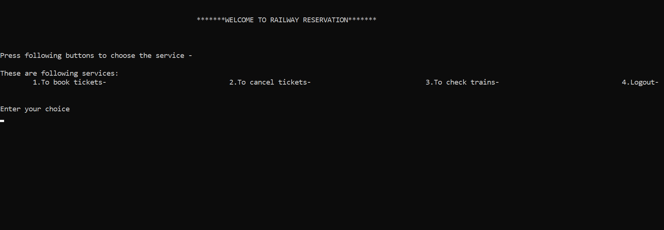

**Code Behind This :**

int main()

{

int num,ch,y=10;

while(y--)

{

struct book_tickets p[20];

printf("\n\n\t\t\t\t\t\t*******WELCOME TO RAILWAY RESERVATION*******");

printf("\n\n\n\nPress following buttons to choose the service -\n");

printf("\nThese are following services:\n");

printf("\t1.To book tickets-\t\t\t\t2.To cancel tickets-\t\t\t\t3.To check trains-\t\t\t\t4.Logout- \n");

printf("\n\nEnter your choice\n");

scanf("%d",&ch);

Page no: 30

switch(ch)

{

case 1:

{

book_tickets(p);

break;

}

case 2:

{

cancel_tickets();

break;

}

case 3:

{

check_trains();

break;

}

case 4:

{

exit(0);

}

default:

{

printf("Invalid Option\n");

break;

}

}

}

return 0;}

Page no: 31

**Chapter 4**

**Result And Discussion**

After Observing and discussing certain points in the project we become aware of that the project need further modification such as additional libraries like graphics which will make the console screen colourful and attractive that gives the user better and interesting interface to connect to the model and it also include different shape and size of the confirmation tickets so that it would look decent after further upgrade. After discussion the result of it came that decide all the hold some smaller task but can eb modified further to hold and support better user experience. These modification is to be done in the project:

* Additional libraries is to added for better interface.
* Additional data handling should be performed for holding further information.
* Certain code of blocks should be eliminated to one such function so to reduce the length of the code.

Page no: 32

**Chapter 5**

**Conclusion and Reference**

This program model id designed and developed under the guidance of our Project head and all the friends, by their we came this far in development of this program and we are dedicated to make it better in future days by continuously working on it. The credit of this model also goes to

* Department of Computer Science and Engineering ,ABES Engineering College
* Head of Department, CSE
* Youtube Tutorial of Data Handling

**References:**

* Tutorialspoint [www.tutorialpoint.com](http://www.tutorialpoint.com)
* Freecodecamp [www.freecodecamp.org](http://www.freecodecamp.org)
* Easytuts4u <https://www.easytuts4u.com/>