AMRITA VISHWA VIDYAPEETHAM, AMARAVATI
B.Tech Artificial Intelligence Engineering
Smart Intersection AI — Priority Traffic Router
Camera-based emergency vehicle preemption for signalised intersections
PROJECT REPORT
Submitted by
Devesh Tiwari — AV.SC.U4AIE25106
D. Mani Teja — AV.SC.U4AIE25103
C. Pranweswar — AV.SC.U4AIE25102

Under the guidance of Course Faculty / Project Guide
October 2026

Abstract
Fixed-time traffic signals are blind: they cycle red and green on a timer regardless of what is happening on the road. For an ambulance carrying a critical patient this costs minutes that cannot be recovered, and for ordinary traffic it wastes fuel at red lights with no vehicles in front of them. This project gives a four-way intersection eyes and a brain: four camera feeds are processed by a YOLOv8 object detector, and a decision module selects the green light every frame. If an emergency vehicle (ambulance, police or fire service) is detected in any approach, that approach is given green immediately and every other approach is held at red, overriding whatever green was active. When no emergency vehicle is present, the green goes to the approach with the highest vehicle density, subject to a minimum green time and a switching margin that prevent flicker. After the emergency vehicle leaves the frame the approach holds green long enough for a following convoy to clear the junction.
The system is implemented in Python with YOLOv8, OpenCV and NumPy, rendered as a live 2x2 dashboard, exposed through a browser dashboard, and instrumented with a thirteen-case unit-test suite for the decision logic. A complete training pipeline (frame extraction, semi-automatic pre-labelling, dataset validation, transfer learning) is included so that the detector can be specialised from the generic COCO classes to Indian ambulance and police vehicles. The report is explicit about which parts are measured, which are simulated, and what remains for future work.

Keywords
Intelligent Transportation Systems; YOLOv8; emergency vehicle preemption; object detection; smart traffic signal; OpenCV; computer vision; transfer learning.

1. Problem Statement
Signalised intersections in Indian cities are timed, not sensed. Four consequences follow, and they are the requirements this project answers:
# | Real situation | Consequence
1 | Ambulance stopped at a red light with traffic packed around it | Several minutes lost per junction; directly affects survival
2 | Police or fire vehicle unable to clear an empty road | Delayed response time
3 | An empty approach holds green while a congested approach waits | Fuel, time and emissions wasted
4 | Sirens are audible but drivers physically cannot move | Audible alerts are insufficient; the signal itself must change

1.1 Objectives
- Detect and count vehicles independently in four approach cameras in real time.
- Detect emergency vehicles (ambulance / police / fire) and identify their approach.
- Preempt the signal for that approach in under one frame, and hold it briefly afterwards.
- When no emergency exists, serve the highest-density approach without flickering.
- Present all of the above on a single operator dashboard, with an auditable log.
- Provide the training pipeline needed to specialise the detector for Indian vehicles.

1.2 Scope and delimitation
This is a software (vision + decision) system. It reads video files or camera streams and produces signal states and a dashboard. Driving physical lamp hardware, siren fusion and multi-junction coordination are deliberately out of scope and are listed as future work. The emergency preemption path is demonstrated with a simulated emergency event because the two sample clips that ship with the project contain ordinary night traffic only.

2. Background and Related Work
Classical actuated signals use inductive loop detectors buried in the road, which detect presence but not vehicle class, and cannot distinguish an ambulance from a car. Vision-based approaches replace loops with cameras and a detector. Earlier work used background subtraction and blob counting, which is brittle under the headlights, shadows and reflections of night traffic. Single-stage CNN detectors (the YOLO family) changed the cost equation: YOLOv8n, the smallest variant used here, has roughly three million parameters and is fast enough to run on a CPU at a reduced frame rate and on a Jetson-class device at video rate.
Emergency vehicle preemption in the literature is usually implemented in one of three ways: (i) acoustic siren detection, (ii) dedicated RF/IR emitters on the vehicle, and (iii) visual detection. This project follows (iii) because it needs no cooperation from the vehicle and reuses the same camera that already counts traffic. The known weakness of (iii) is dataset availability, which is why the project ships an explicit annotation and training pipeline rather than assuming a pretrained ambulance class exists.

3. System Design and Methodology

3.1 Architecture
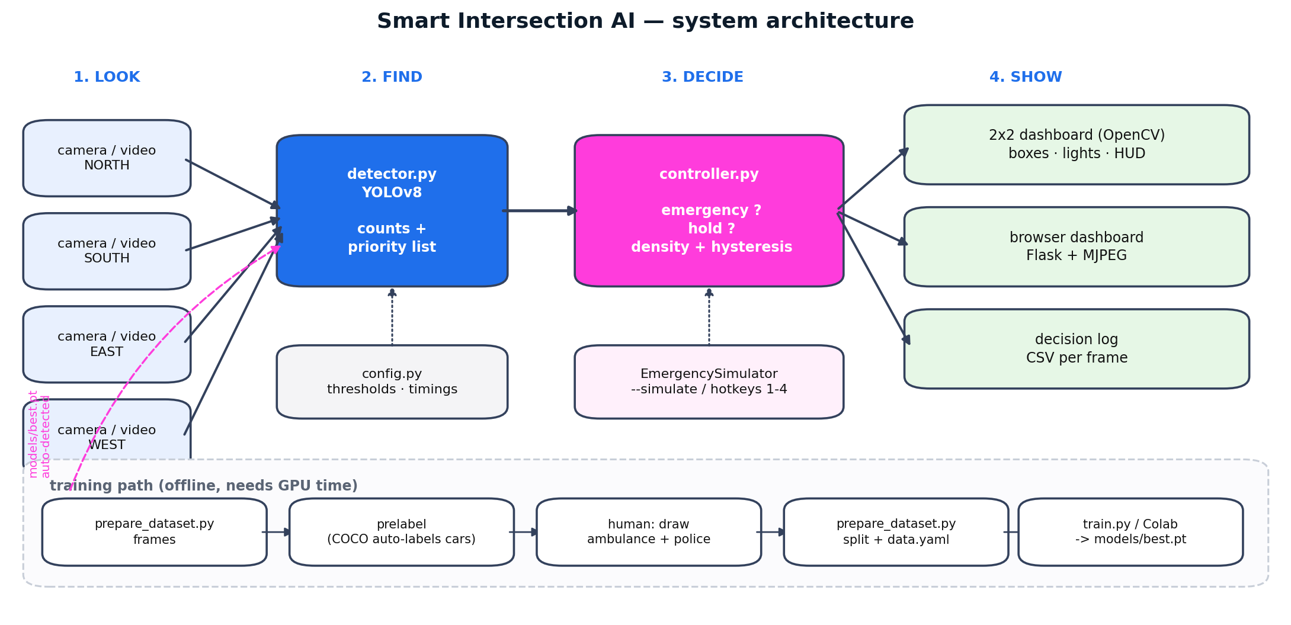
Figure 1 — Pipeline: four feeds are decoded, downscaled and passed to YOLOv8; the detections become per-approach counts and priority flags; the controller decides the green approach; the renderer composes the 2x2 dashboard and the log.
The implementation is split so that each concern can be tested on its own:
Module | Responsibility | Dependencies
config.py | Every tunable value: paths, thresholds, timings, colours | none
detector.py | Wraps Ultralytics YOLO; converts raw boxes into per-lane counts and a priority list; adapts automatically to a custom 4-class model | torch, ultralytics
controller.py | The decision rules only. Pure logic, clock is injected | none (unit-tested)
smart_intersection.py | Lane I/O, emergency simulator, renderer, engine loop | opencv, numpy
main.py | Command-line interface | argparse
web/dashboard.py | Flask + MJPEG browser dashboard | flask

3.2 Detection stage
Each frame is downscaled and passed to the model with a confidence threshold of 0.35 and NMS IoU of 0.45. Detection is run every second frame by default (--detect-every), which halves CPU load with no practical effect on the decision, because signal states change over seconds, not milliseconds. Two modes exist:
- COCO mode — the shipped yolov8n.pt. Vehicle counting works (car, motorcycle, bus, truck). COCO contains no ambulance or police class, so emergency events come from the simulator.
- Custom mode — models/best.pt produced by train.py. Classes are ambulance, police, car, motorcycle. Classification is done by matching class-name keywords, not class indices, so a model whose class order differs still works.
Mode selection is automatic: if models/best.pt exists it is used, otherwise the pretrained weights are used. A fresh clone therefore always runs.

3.3 Decision logic
The controller is deterministic and side-effect free; time is passed in as an argument, which is what makes the whole rule set unit-testable without a GPU or a video. Rules are applied in this order:
Order | Rule | Behaviour
1 | Emergency | Any approach with >=1 priority vehicle becomes green at once, even inside another approach's green time. Two emergencies: the approach with more priority vehicles wins; tie goes to lane order (N,S,E,W).
2 | Hold | After the last priority detection the approach stays green for emergency_hold seconds (default 6 s) so the convoy can clear.
3 | Density | Otherwise the approach with most vehicles gets green, but only if it leads the current approach by switch_margin (default 2) — hysteresis against one-car flicker.
4 | Fairness | Every approach keeps green at least min_green seconds (default 3 s); an empty junction keeps the last green rather than going dark.

The core of rule 1 and 3, as implemented:
with_priority = [l for l in lanes if priority[l] > 0]
if with_priority: # 1. emergency preemption
green = max(with_priority, key=lambda l: priority[l])
elif now < hold_until: # 2. convoy hold
green = hold_lane
else: # 3+4. density with hysteresis
busiest = max(lanes, key=lambda l: counts[l])
if counts[busiest] >= counts[current] + switch_margin:
green = busiest

3.4 Rendering and operator interface
The dashboard places the four approaches in a 2x2 grid with a 46-pixel header. Each tile carries the approach name, vehicle count, a three-lamp signal drawn as vector graphics, and a status strip. Approaches held at red are dimmed so the green approach is visually dominant. Bounding boxes are cyan; priority vehicles are magenta and thicker. When a preemption is active, a magenta banner flashes on the offending tile and the header names the approach. The same engine can be served to a browser over MJPEG, with buttons that trigger a simulated ambulance, which makes the project demonstrable on a machine with no desktop GUI.

3.5 Training pipeline
The generic model cannot recognise an ambulance, so the project includes the complete path from raw video to specialised weights:
- prepare_dataset.py frames — extract stills at a chosen rate from the traffic clips.
- prepare_dataset.py prelabel — run the COCO model and write YOLO labels for car, motorcycle, bus and truck. Human effort is then spent only on ambulance and police boxes.
- prepare_dataset.py split — validate image/label pairing, split train/val, report class balance, and write a data.yaml with absolute paths.
- train.py — transfer learning from yolov8n.pt with night-friendly colour augmentation, automatic device selection, early stopping, and automatic copy of best.pt into models/.
- notebooks/train_colab.ipynb — the same job on a free Colab T4 GPU, with per-class AP reporting so that a good overall mAP cannot hide a weak ambulance class.

4. Results and Discussion

4.1 Working demonstration
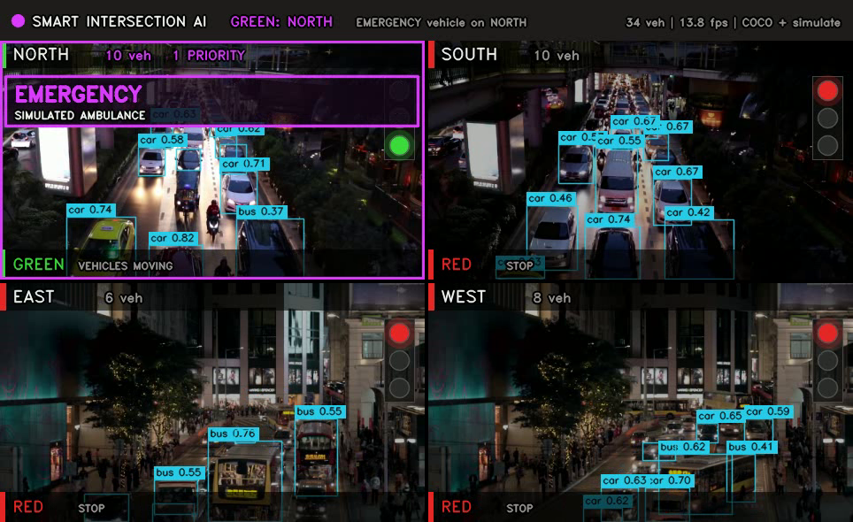
Figure 2 — Normal operation. The busiest approach (WEST, 7 vehicles) holds green while the others are red and dimmed. Detection confidence and class are shown per box.
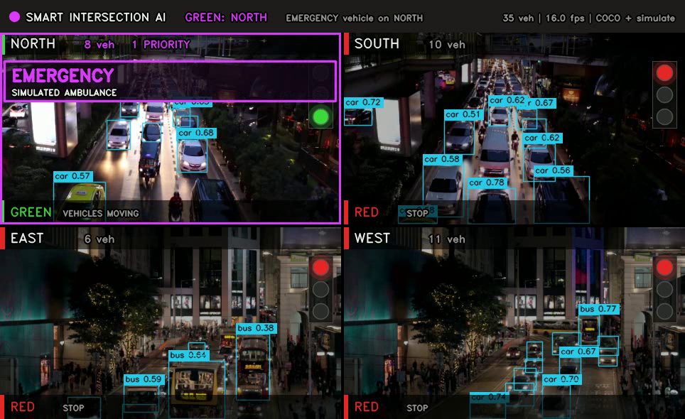
Figure 3 — Emergency preemption. A priority event on NORTH forces NORTH green and every other approach red within the same frame, with a flashing override banner.

4.2 Measured performance
All figures below were measured on a two-vCPU, CPU-only machine (no GPU), four approaches, input 640 px, detection every second frame:
Metric | Measured value | Comment
Dashboard throughput | 4.5 – 5.1 frames/s | 0.20 s per four-lane step
Single YOLOv8n pass | ~72 ms at 640 px | the detector, not the logic, is the cost
Decision computation | < 1 ms | pure Python, a few comparisons
Latency from detection to signal change | 1 frame (0.20 s) | verified in demo log
Vehicles detected per night frame | 5 – 13 per approach | pretrained COCO
Unit tests passing | 13 / 13 | emergency, hold, density, fairness, hysteresis

Two honest observations. First, the end-to-end rate is limited by inference on CPU; on a GPU or a Jetson device the same code runs at video rate, and the --detect-every parameter exists precisely to trade latency for throughput. Second, the throughput figure is not a claim about emergency response time: the signal decision is instantaneous once a detection exists, so response time equals detection latency plus one frame.

4.3 Validation of the decision logic
Because the controller takes time as an argument, every rule was tested in isolation and as a sequence. The suite covers: emergency green overriding the busiest approach; emergency ignoring an active minimum-green timer; two simultaneous emergencies; deterministic tie-breaking; the convoy hold expiring into density control; hysteresis refusing to switch on a one-vehicle lead; exactly one green at all times; and a regression test for the scheduled-simulation clock. This is the part of the project that is proven rather than demonstrated.

4.4 Limitations
- Pretrained COCO has no ambulance or police class; real recognition requires the trained models/best.pt. Until then emergency events are simulated and labelled as simulated on screen.
- The two sample clips contain no emergency vehicles; they are night city traffic.
- Two clips feed four approaches, offset so that they do not look identical. A deployment would use four independent streams.
- No physical signal hardware is driven; signal state exists on screen and in the log.
- Night-time glare, reflections and low contrast reduce confidence; the training configuration compensates with strong value and saturation augmentation, but a night-specific dataset is the better fix.

5. Conclusion and Future Work
A four-approach signal controller that prioritises emergency vehicles has been designed, implemented, demonstrated and tested. The decision layer is proven by unit tests; the perception layer is functional with pretrained weights and is designed to be specialised with a documented training pipeline; and the operator interface exists in both desktop and browser forms. The remaining gap is annotated ambulance imagery and GPU time, not software.
Phase | Future work
1 | Annotate Indian ambulance (108 / EMRI) and police vehicles, train and evaluate per-class AP50; integrate the resulting best.pt
2 | Deploy on Jetson Nano / Raspberry Pi inside the signal cabinet, with an ESP32 or relay board driving the physical lamps over serial or MQTT
3 | Fuse siren detection (acoustic) with vision to catch emergency vehicles that are occluded or approaching from outside the field of view
4 | Coordinate several junctions to create a green corridor along an ambulance route
5 | Log historical density per approach and learn time-of-day green splits instead of reacting frame by frame

References
[1] J. Redmon, S. Divvala, R. Girshick, A. Farhadi, "You Only Look Once: Unified, Real-Time Object Detection", CVPR 2016.
[2] G. Jocher, A. Chaurasia, J. Qiu, "Ultralytics YOLOv8", 2023. [Online]. Available: https://github.com/ultralytics/ultralytics
[3] T.-Y. Lin et al., "Microsoft COCO: Common Objects in Context", ECCV 2014.
[4] R. K. Megalingam et al., "Smart traffic signal control for emergency vehicles using image processing", IEEE conference proceedings.
[5] OpenCV documentation, https://docs.opencv.org
[6] Indian Roads Congress / MoRTH guidelines on emergency vehicle priority at signalised intersections.

Appendix A — Reproducing the results
git clone https://github.com/Devesh-tiw/Priority_Traffic_router.git
cd Priority_Traffic_router
pip install -r requirements.txt
# live dashboard (hotkeys 1-4 simulate an ambulance)
python main.py
# reproduce the demo video and the decision log
python main.py --headless --save demo/demo.mp4 --frames 500 \
--simulate NORTH:3:7 --simulate EAST:12:7 \
--log demo/decision_log.csv
# browser dashboard
python web/dashboard.py
# test the decision logic
python -m unittest discover -s tests -v

