Grayn AEO: Comprehensive Technical Architecture & Integration Guide
This document serves as the absolute source of truth for the Grayn Answer Engine Optimization (AEO) backend. It covers the architectural flow, database connection protocols, Railway deployment lifecycle, and an exhaustive guide on integrating the system with Slack.

1. Backend Network Architecture Flowchart
The following diagram illustrates how the client frontend, Slack applications, database, and third-party AI APIs connect through our central Railway-hosted FastAPI infrastructure.
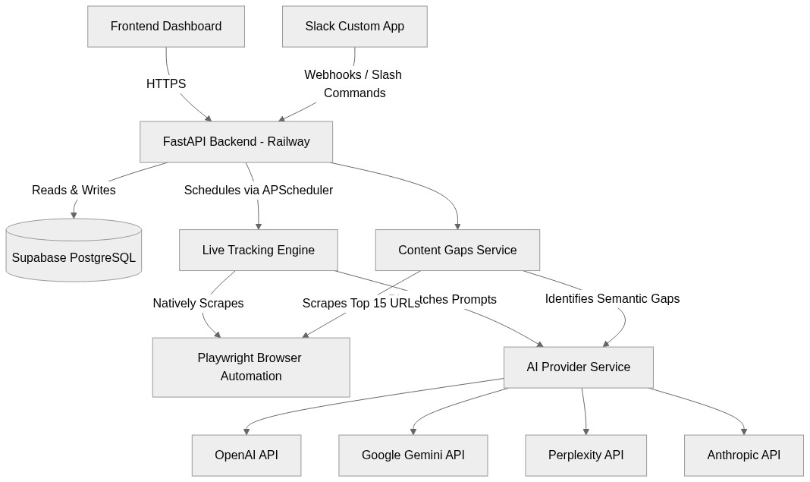

2. In-Depth Backend Structure

A. The FastAPI Core (app/main.py)
The heart of the application is a highly asynchronous FastAPI server. It is responsible for handling all incoming HTTP requests. Upon startup, it initializes the CORS middleware, connects to the Supabase client, and spins up the APScheduler which manages background tracking batches.

B. Routing Layer (app/routers/)
• /internal.py: These routes are consumed specifically by the Next.js frontend dashboard (e.g., creating workspaces, managing billing, fetching detailed charts).
• /v1.py: This is the public-facing API version 1. It contains endpoints for external integrations, including the dedicated `/v1/slack/` webhook routes.

C. Business Logic Services (app/services/)
• tracking.py: When a user triggers a tracking run, this service dispatches the target keyword to up to 7 different AI engines concurrently. It uses Playwright to navigate sites where API access isn't sufficient.
• content_analyzer.py: Powers the 'Content Gaps Studio'. It scrapes the top 15 domains that the AIs cited, aggregates their text, and feeds it into OpenAI (gpt-4o) or Gemini to generate Markdown strategic briefs.
• scoring.py: Houses the mathematical models for calculating 'AI Visibility Percentage' and 'Share of Voice' across competitors.

3. Deployment Lifecycle & Connection Strings

A. Deploying to Railway
The backend is containerized using Docker and is built to be deployed on Railway.app. To deploy:
- 1. Connect the GitHub repository to a new Railway project.
- 2. Railway will automatically detect the Dockerfile in the /backend directory.
- 3. In the Railway project settings, map the internal PORT (usually 8000) and generate a Public Domain (e.g., grayn-api.railway.app).

B. Critical Environment Variables
You must define the following variables inside the Railway 'Variables' tab. The application will crash or severely limit functionality if these are missing.
Variable Name | Purpose | Example / Format
SUPABASE_URL | Database connection URL | https://xyz.supabase.co
SUPABASE_SERVICE_KEY | Bypasses Row Level Security for backend operations | eyJhbGciOiJIUzI1NiIsInR5c...
OPENAI_API_KEY | Primary AI orchestration & fallback gap analysis | sk-proj-...
GEMINI_API_KEY | Used for high-context scraping limits | AIzaSy...

4. Complete Slack Integration Guide
To pipe Grayn AEO data into your team's Slack, you will need to create a custom Slack App via api.slack.com/apps and connect it to the Railway public URLs.

Step 1: Create the Slack App
- 1. Go to https://api.slack.com/apps and click 'Create New App'.
- 2. Choose 'From scratch', name it 'Grayn AEO', and select your workspace.

Step 2: Connect the Webhooks
Grayn AEO endpoints output native Slack 'Block Kit' JSON payloads (`SlackPayload`). This means your middleware or serverless function just needs to GET data from Grayn and POST it directly to Slack without any formatting.
You have 5 dedicated webhooks available:
• GET /v1/slack/daily?persona=exec: Ideal for a daily cron job. Returns the overall Visibility % and weekly delta.
• GET /v1/slack/content-ideas: Returns the top 5 missing topic clusters.
• GET /v1/slack/standing: Returns the competitive Share of Voice leaderboard.
• GET /v1/slack/competitor-sources: Returns domains the AIs cite for your competitors.

Step 3: Setting up the /aeo Slash Command
We have a dedicated routing endpoint designed explicitly for Slack Slash Commands:
Target: POST /v1/slack/query
- How to configure it:
- 1. In your Slack App settings, go to 'Slash Commands' and create `/aeo`.
- 2. Slack will send a URL-encoded payload containing a `text` field whenever a user types `/aeo visibility`.
- 3. Because Grayn AEO requires standard JSON and an Authorization Bearer token, you should use an API Gateway, Zapier, or a tiny serverless wrapper to intercept Slack's POST, convert the `text` field into the JSON format `{"question": "[TEXT]"}`, add your Grayn `Authorization: Bearer <API_KEY>` header, and forward the request to the Railway URL.

Step 4: Authentication Middle-layer
Crucially, every request hitting the Grayn AEO `/v1/` routes REQUIRES authentication. Because Slack does not natively allow you to inject custom HTTP Headers into its outgoing Slash Command webhooks, you MUST use a middleware layer (like Make.com, Zapier, or a lightweight AWS Lambda / Vercel Edge function) to catch the Slack payload, inject the `Authorization: Bearer <KEY>` header, and proxy it to the Railway backend.

