**Experiment-2**

**Sub: Build and Release Management**

**Name: Devesh yadav**

**Roll: R171218038**

**Aim: Write a program in java to find sum of two numbers and test this unit with JUnit tool.**

**Step1:** program in java to find sum of two numbers

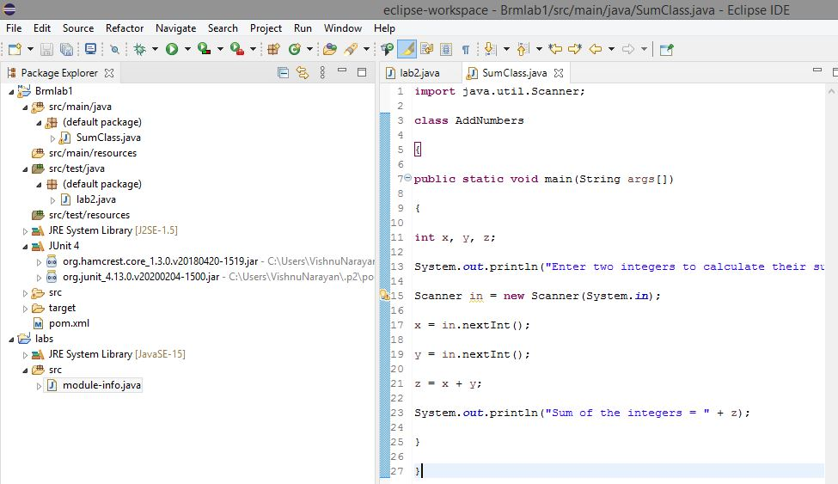

**Step2:** creating a test case for assertion of logic through **Junit test case**



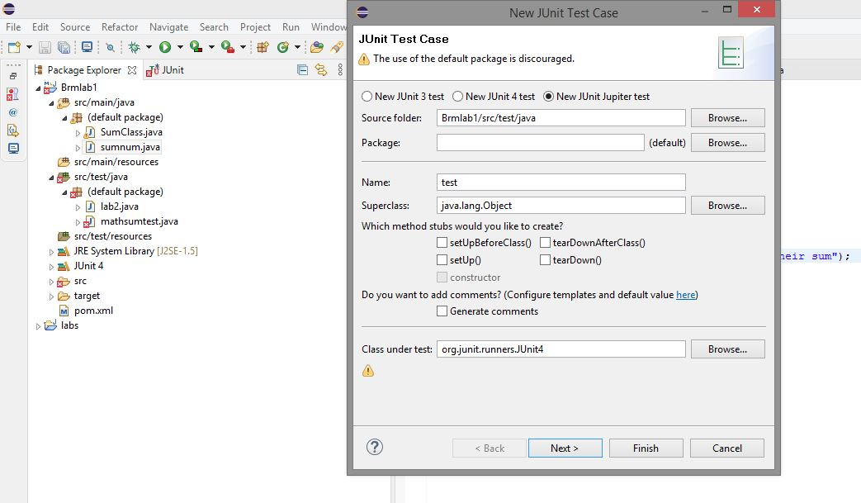

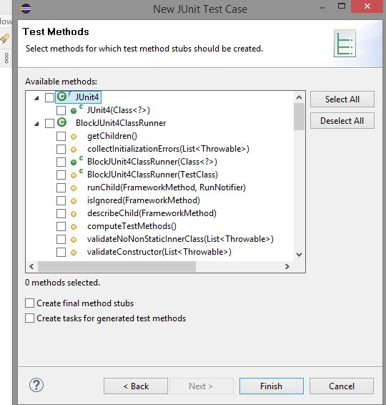

**Step3**: verifying the test case in the original logic code

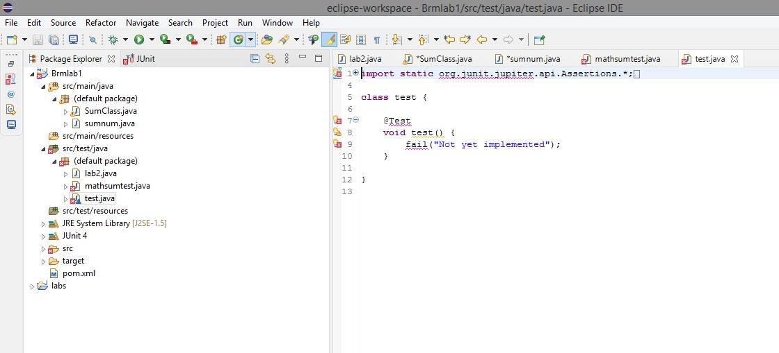

**Step4:** Assertion errors found during formation of case test to be rectified.

