EXPERIMENT 13: CNN BASED DIGIT CLASSIFICATION
1. PYTHON SOURCE CODE
Cell 1: CNN Model Training, Evaluation, and Confusion Matrix
import tensorflow as tf
from tensorflow.keras import datasets, layers, models
import numpy as np
import matplotlib.pyplot as plt
from sklearn.metrics import confusion_matrix, ConfusionMatrixDisplay
(x_train, y_train), (x_test, y_test) = datasets.mnist.load_data()
# 1. Normalize pixel values
x_train = x_train / 255.0
x_test = x_test / 255.0
# 3. Add channel dimension
x_train = x_train.reshape(-1, 28, 28, 1)
x_test = x_test.reshape(-1, 28, 28, 1)
# 4. Create CNN model
model = models.Sequential([
layers.Conv2D(32, (3, 3), activation='relu',
input_shape=(28, 28, 1)),
layers.MaxPooling2D((2, 2)),
layers.Conv2D(64, (3, 3), activation='relu'),
layers.MaxPooling2D((2, 2)),
layers.Flatten(),
layers.Dense(64, activation='relu'),
layers.Dense(10, activation='softmax')
])
# 5. Compile the model
model.compile(
optimizer='adam',
loss='sparse_categorical_crossentropy',
metrics=['accuracy']
)
# 6. Train the model
model.fit(
x_train,
y_train,
epochs=5,
validation_data=(x_test, y_test)
)
# 7. Evaluate the model
test_loss, test_accuracy = model.evaluate(x_test, y_test)
print("\nTest Accuracy:", test_accuracy)
# 8. Predict test images
y_probability = model.predict(x_test)
# Convert probabilities to predicted class
y_pred = np.argmax(y_probability, axis=1)
# 9. Print actual and predicted digit
print("Actual Digit:", y_test[0])
print("Predicted Digit:", y_pred[0])
# 10. Create confusion matrix
cm = confusion_matrix(y_test, y_pred)
print("\nConfusion Matrix:")
print(cm)
# 11. Display confusion matrix
disp = ConfusionMatrixDisplay(
confusion_matrix=cm,
display_labels=np.arange(10)
)
disp.plot(cmap='Blues')
plt.title("CNN Digit Classification - Confusion Matrix")
plt.xlabel("Predicted Digit")
plt.ylabel("Actual Digit")
plt.show()

Cell 2: Testing Time Calculation
import time
# Start testing time
start_time = time.time()
# Predict test images
y_probability = model.predict(x_test, verbose=0)
# End testing time
end_time = time.time()
testing_time = end_time - start_time
print("Testing Time:", testing_time, "seconds")
print("Average Time per Image:", testing_time / len(x_test), "seconds")

2. EXPERIMENTAL OUTPUT SCREENSHOTS (CROPPED)
Output 1: 5-Epoch Training Log, Test Accuracy, and Sample Prediction
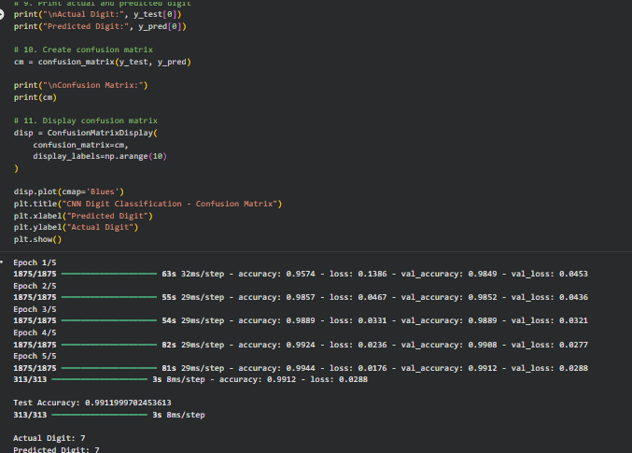
Output 2: CNN Digit Classification - Confusion Matrix
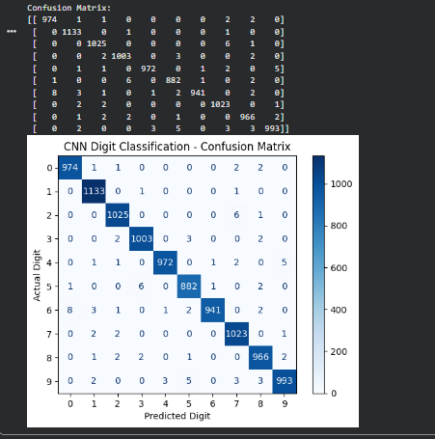
Output 3: Testing Time and Average Time per Image
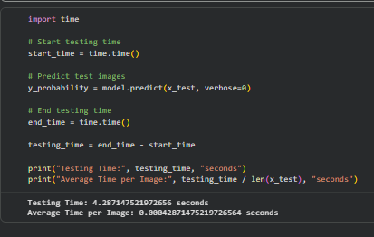
3. EXPERIMENTAL TABULAR RESULTS
Table 1: Epoch-wise Training and Validation Results
Epoch | Training Accuracy | Training Loss | Validation Accuracy | Validation Loss
1 | 0.9574 | 0.1386 | 0.9849 | 0.0453
2 | 0.9857 | 0.0467 | 0.9852 | 0.0436
3 | 0.9889 | 0.0331 | 0.9889 | 0.0321
4 | 0.9924 | 0.0236 | 0.9908 | 0.0277
5 | 0.9944 | 0.0176 | 0.9912 | 0.0288

Table 2: Testing Performance
Parameter | Value
Test Accuracy | 0.9911999702453613
Testing Time | 4.287147521972656 seconds
Average Time per Image | 0.00042871475219726564 seconds
Actual Digit | 7
Predicted Digit | 7

Table 3: Confusion Matrix
Actual \ Predicted | 0 | 1 | 2 | 3 | 4 | 5 | 6 | 7 | 8 | 9
0 | 974 | 1 | 1 | 0 | 0 | 0 | 0 | 2 | 2 | 0
1 | 0 | 1133 | 0 | 1 | 0 | 0 | 0 | 1 | 0 | 0
2 | 0 | 0 | 1025 | 0 | 0 | 0 | 0 | 6 | 1 | 0
3 | 0 | 0 | 2 | 1003 | 0 | 3 | 0 | 0 | 2 | 0
4 | 0 | 1 | 1 | 0 | 972 | 0 | 1 | 2 | 0 | 5
5 | 1 | 0 | 0 | 6 | 0 | 882 | 1 | 0 | 2 | 0
6 | 8 | 3 | 1 | 0 | 1 | 2 | 941 | 0 | 2 | 0
7 | 0 | 2 | 2 | 0 | 0 | 0 | 0 | 1023 | 0 | 1
8 | 0 | 1 | 2 | 2 | 0 | 1 | 0 | 0 | 966 | 2
9 | 0 | 2 | 0 | 0 | 3 | 5 | 0 | 3 | 3 | 993
RESULT: The CNN model was trained for 5 epochs on the MNIST dataset. The recorded test accuracy was 0.9911999702453613. The testing time was 4.287147521972656 seconds, and the average time per image was 0.00042871475219726564 seconds. The displayed sample prediction was Actual Digit: 7 and Predicted Digit: 7.

