3. Use at least one built-in module such as fs, path, or os in your application.
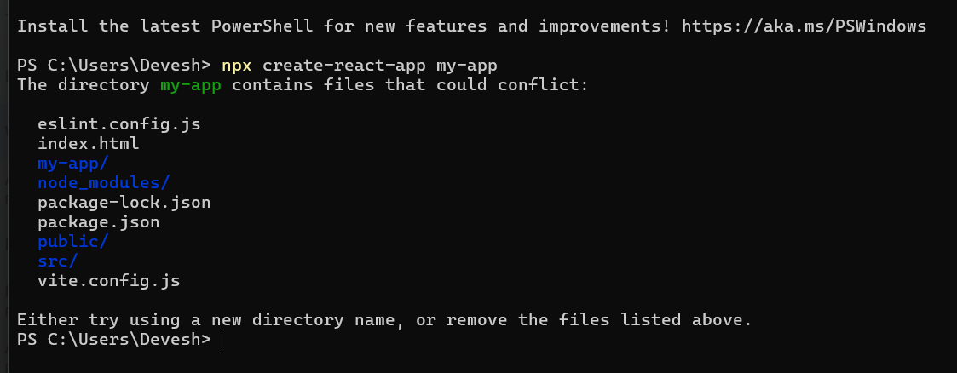
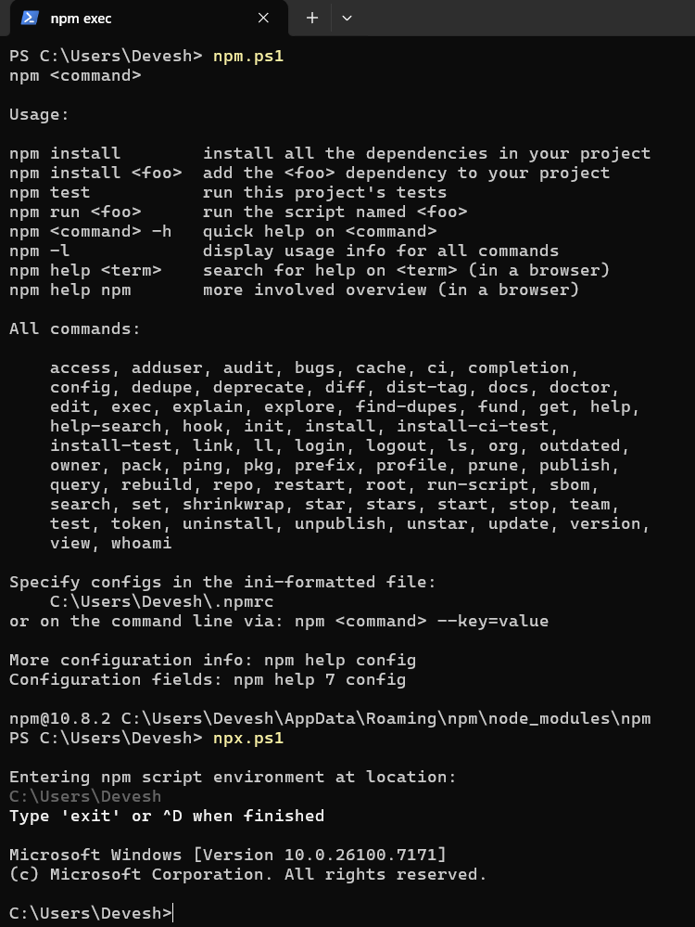
4. Create a class component (e.g., LifecycleDemo.js) to implement lifecycle methods.

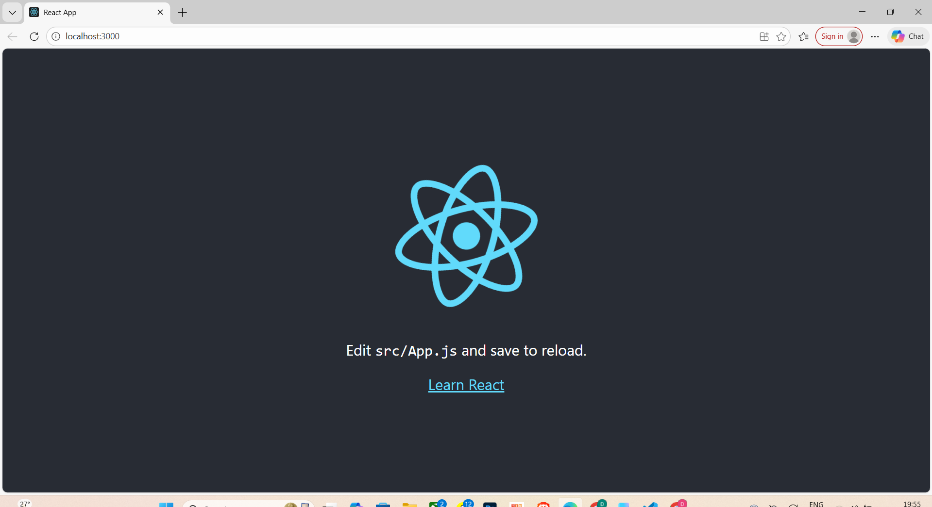

5.Delete the file using fs.unlink() and show the console output.

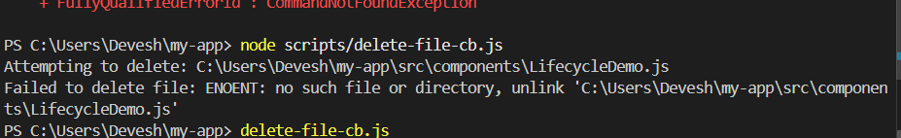

7.Create an application to implement state and props.
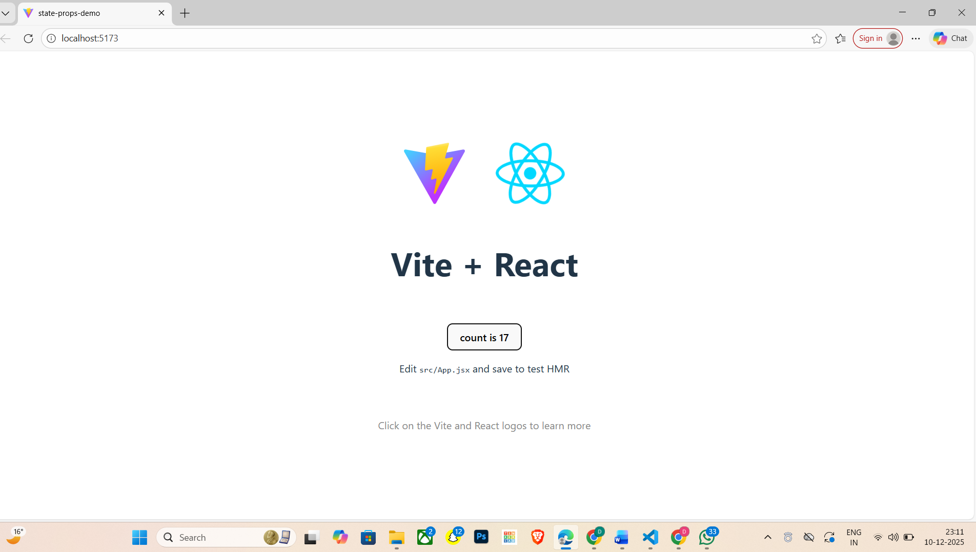

31.Import both Welcome and Greeting components into App.js and render them together.

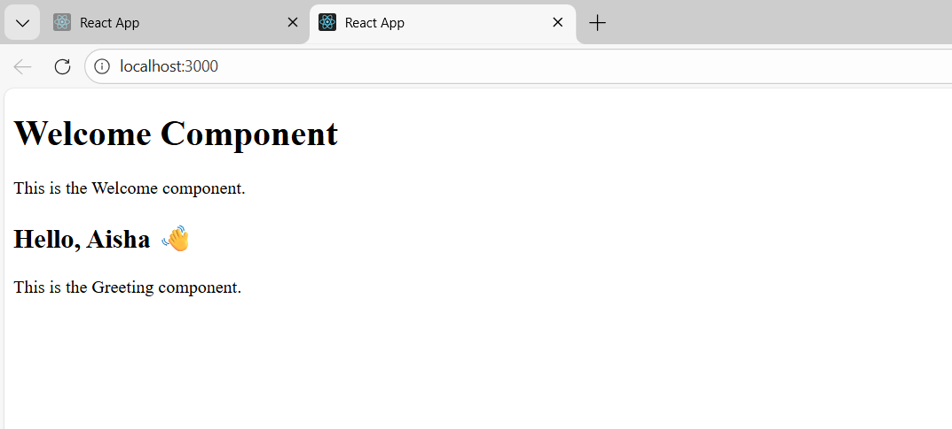
30.Pass a message prop to the Greeting functional component and display it.
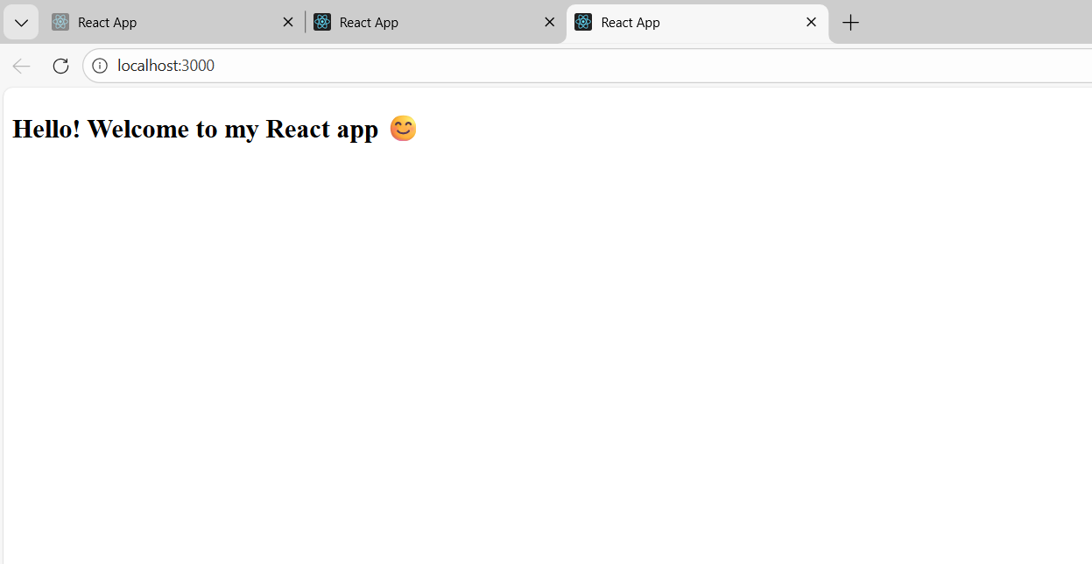

29. Create a Welcome.js class component that displays a welcome message.
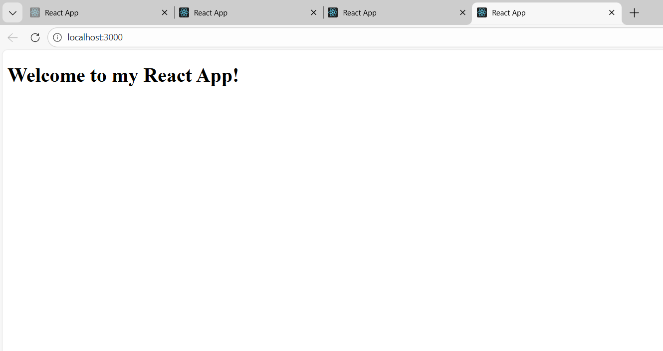

28. Create two components: Home.js and About.js. Configure routes so that / shows Home
and /about shows About.
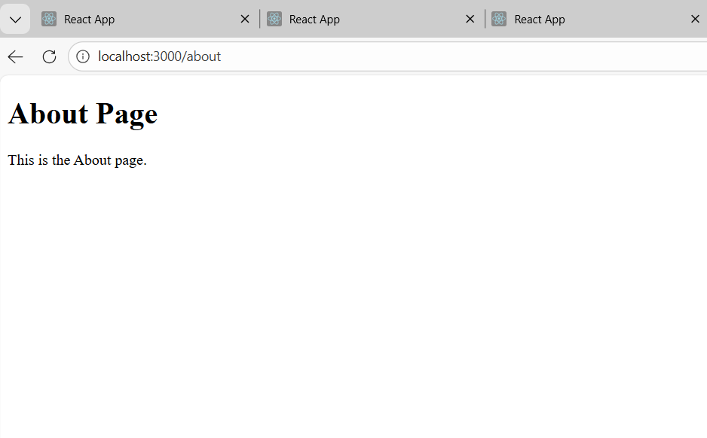
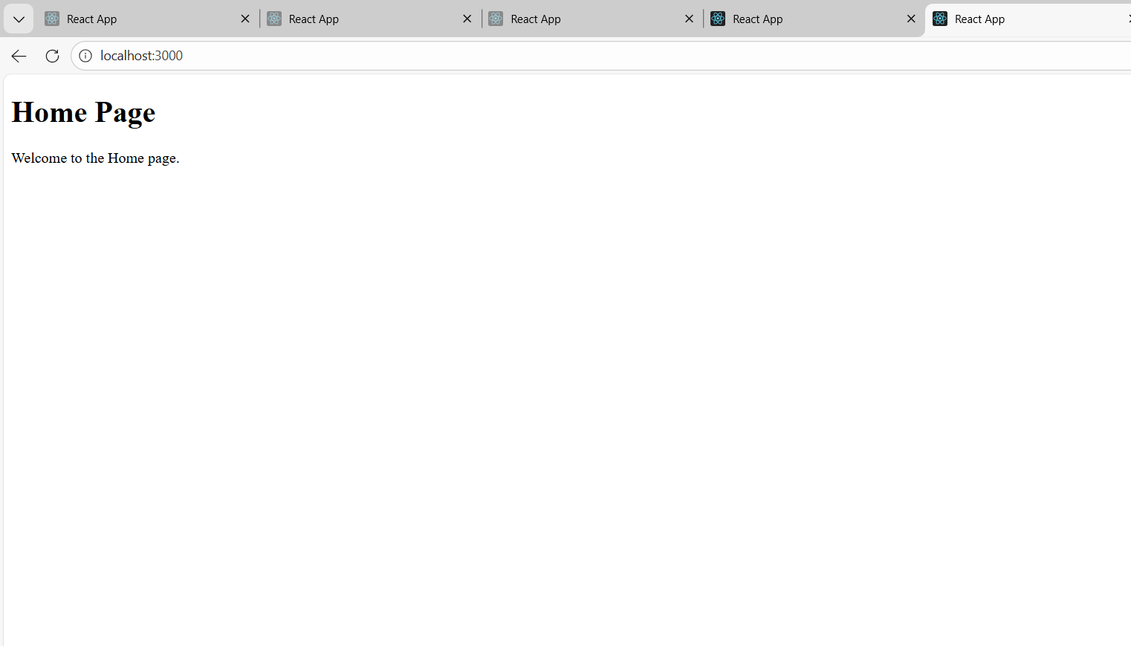

27. Create a custom hook useWindowWidth that returns the current window width. Display
it in the app.

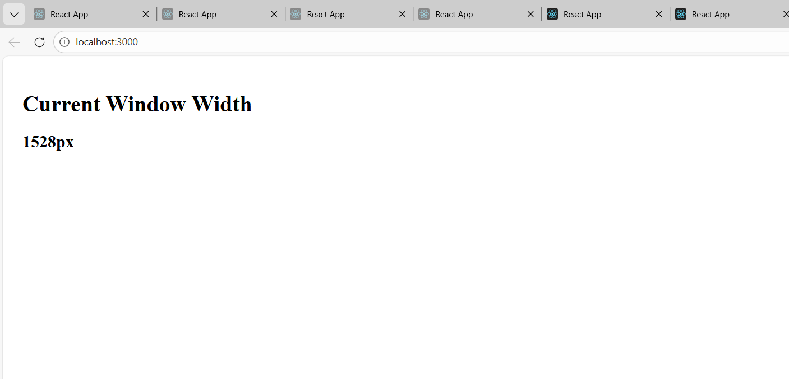
26. Create a ThemeContext to toggle between light and dark themes.
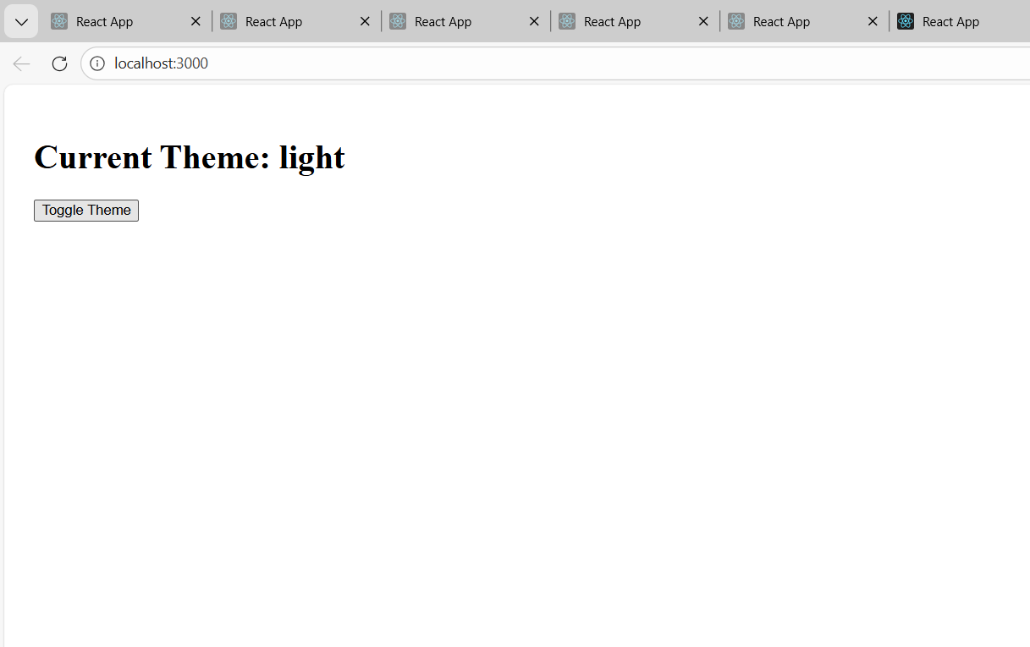
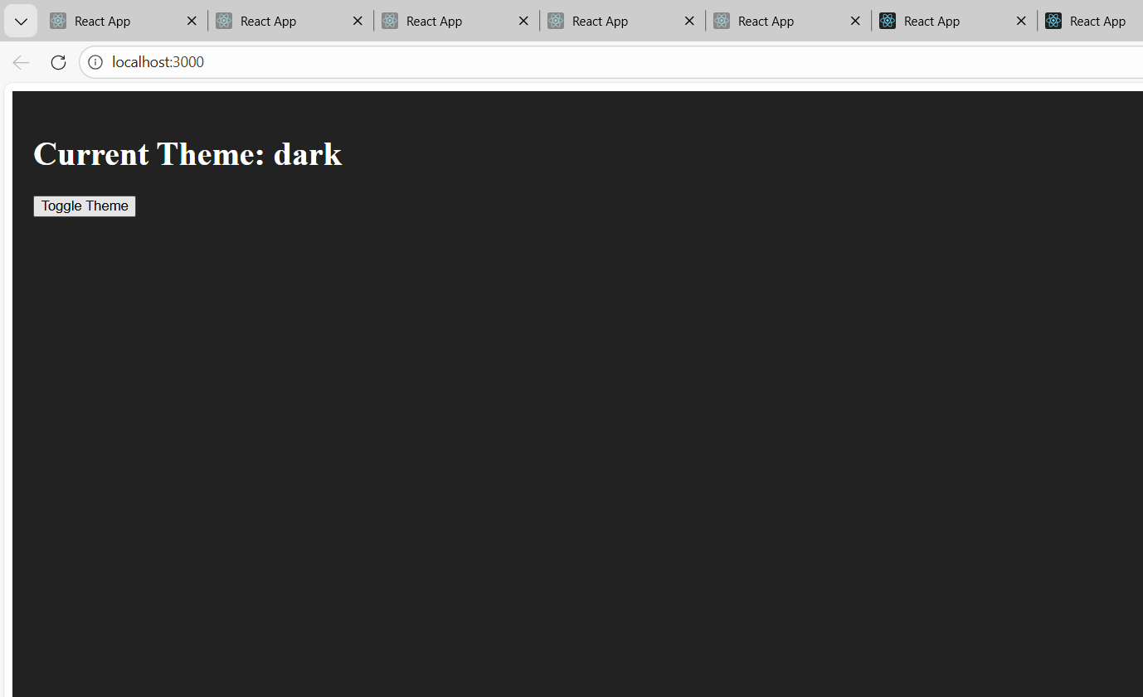
25. Create a Greeting.js functional component that displays a greeting message.

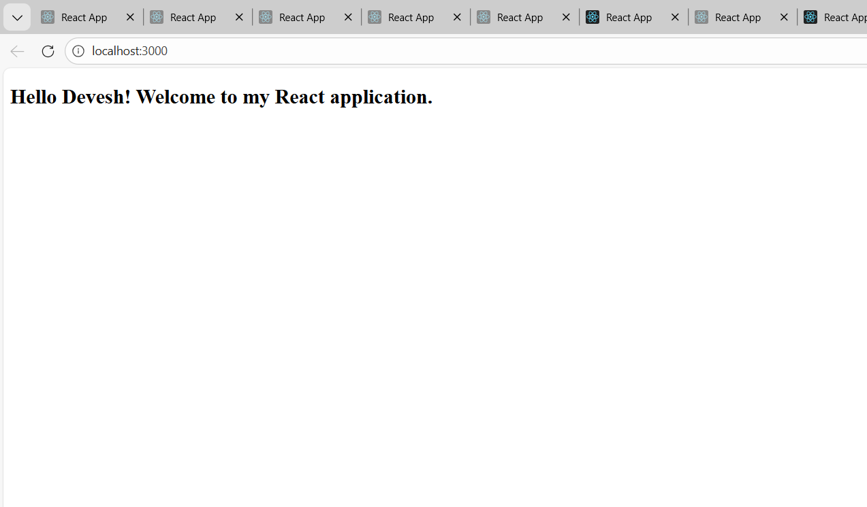

24. Create an application in ReactJS to use DOM events.

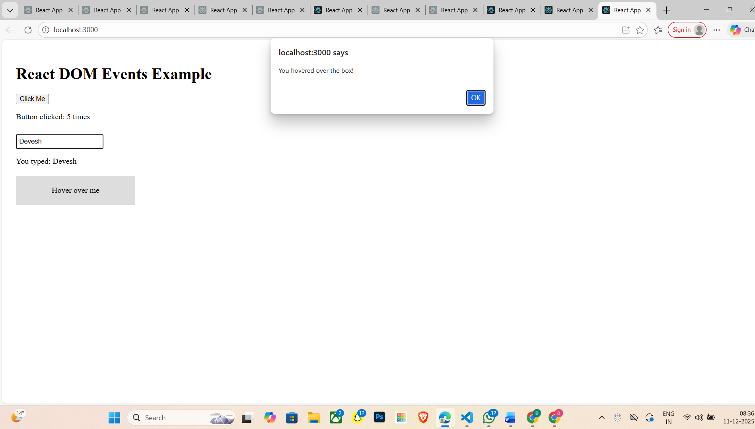
23. Create a form with fields: username, email, and password.
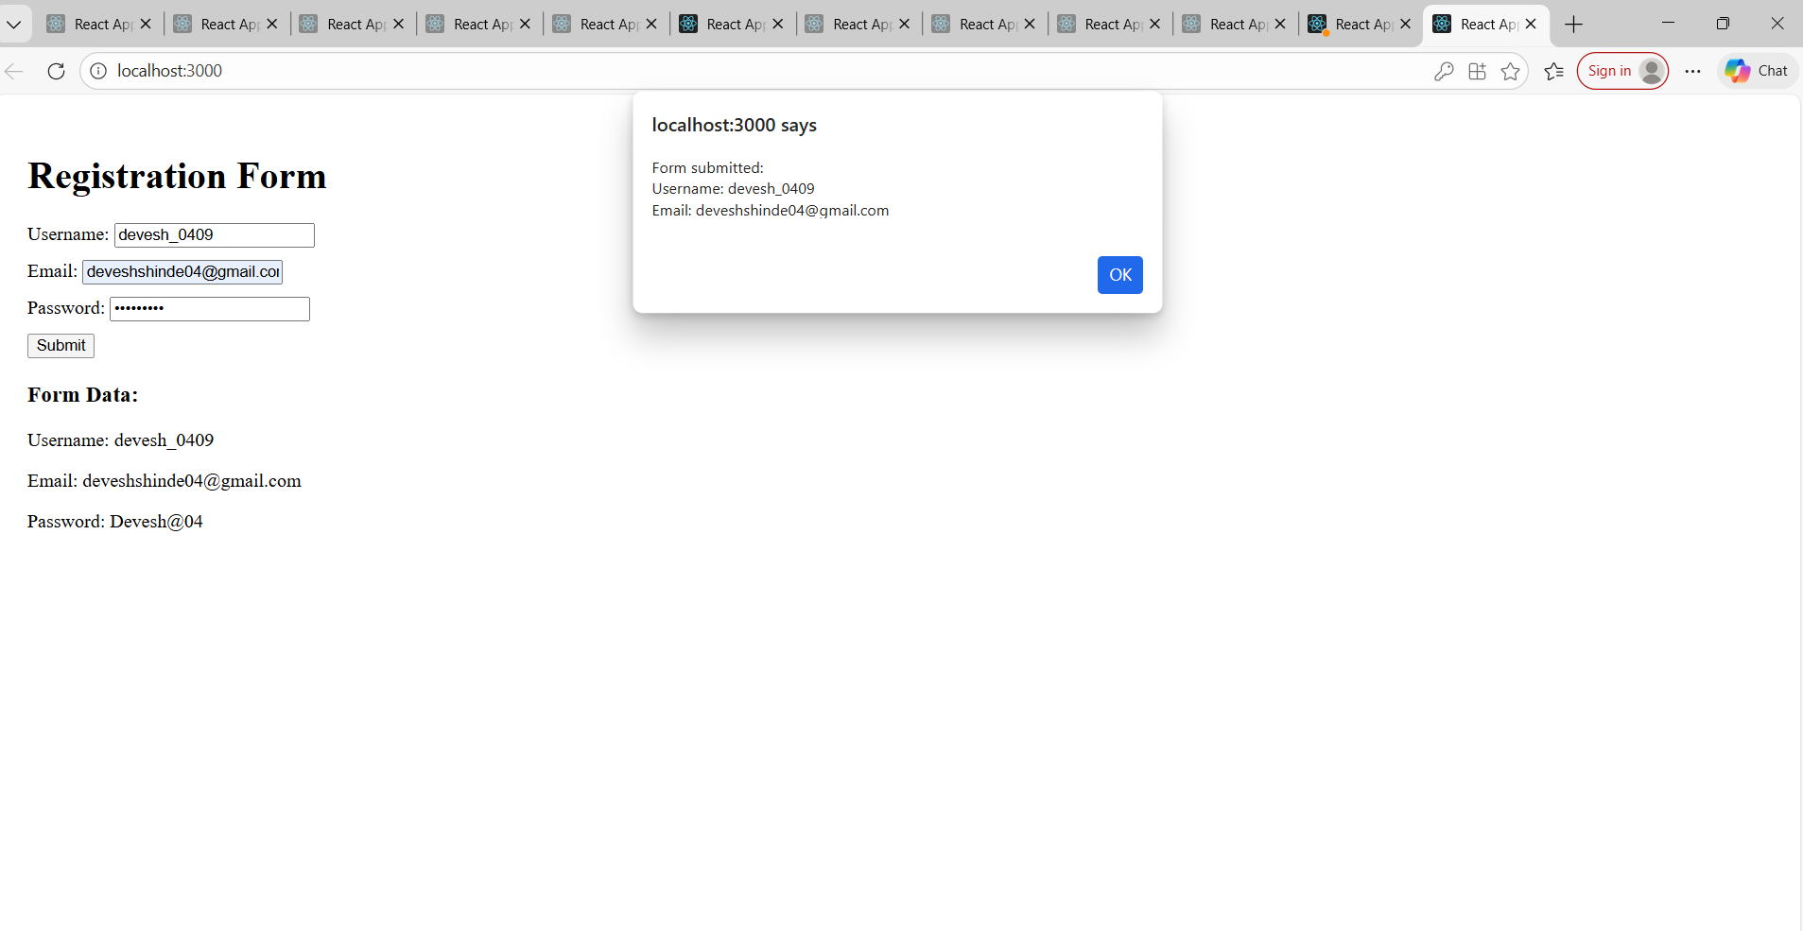
22. Create a counter component with two buttons: Increment and Decrement, using onClick
events to update state.
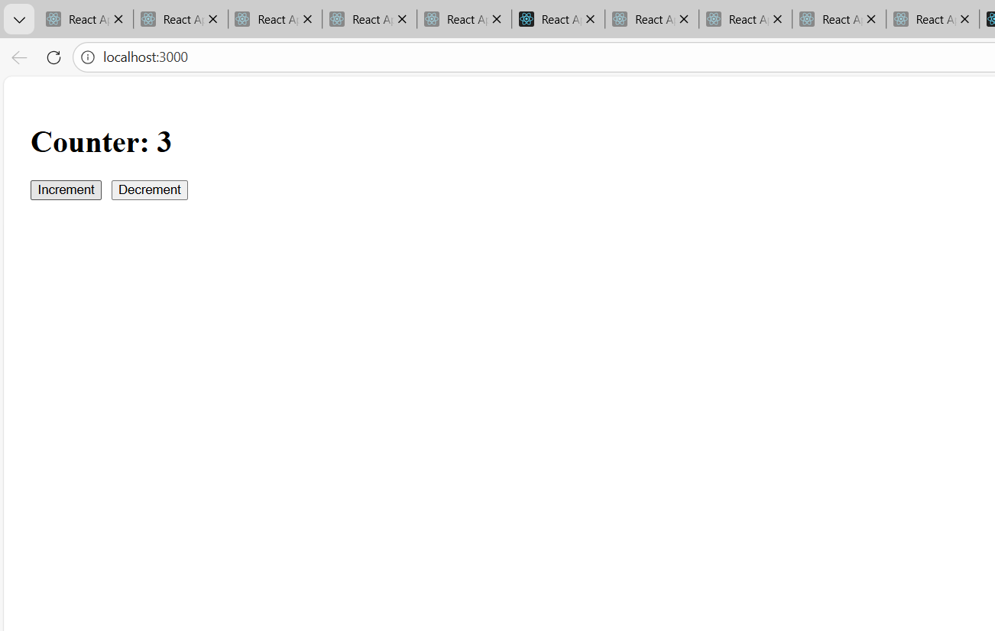
20. Create a button in App.js and attach an onClick event that shows an alert message.
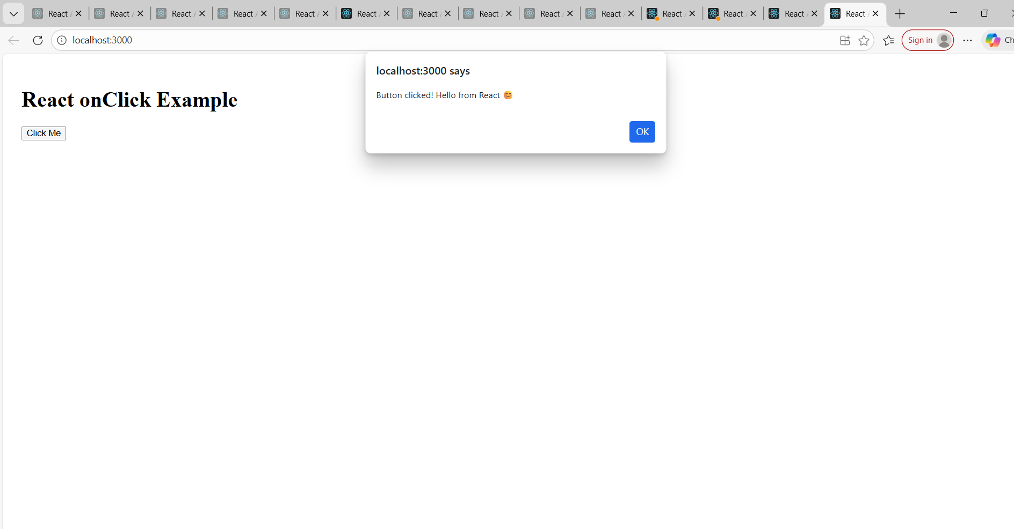
19. Create an application to implement class and functional component in ReactJS.
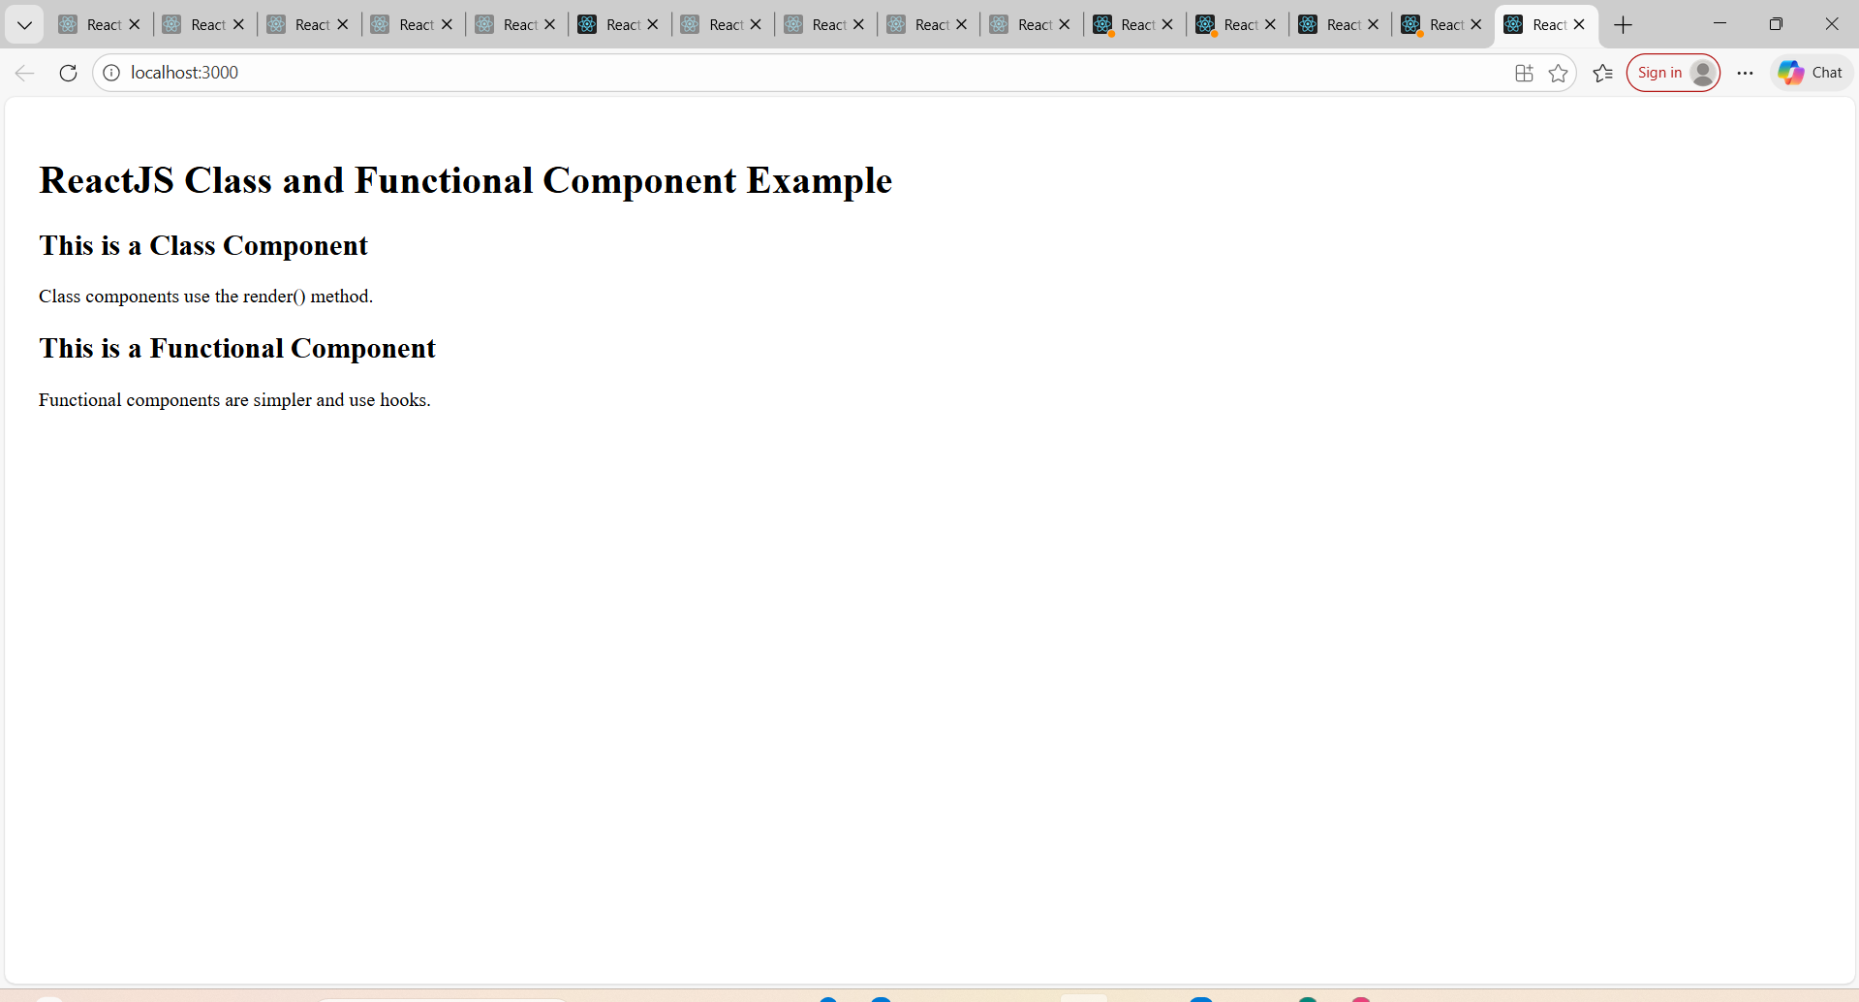

16. Create an HTTP server using http.createServer() and display a simple message like
“Server Running”.
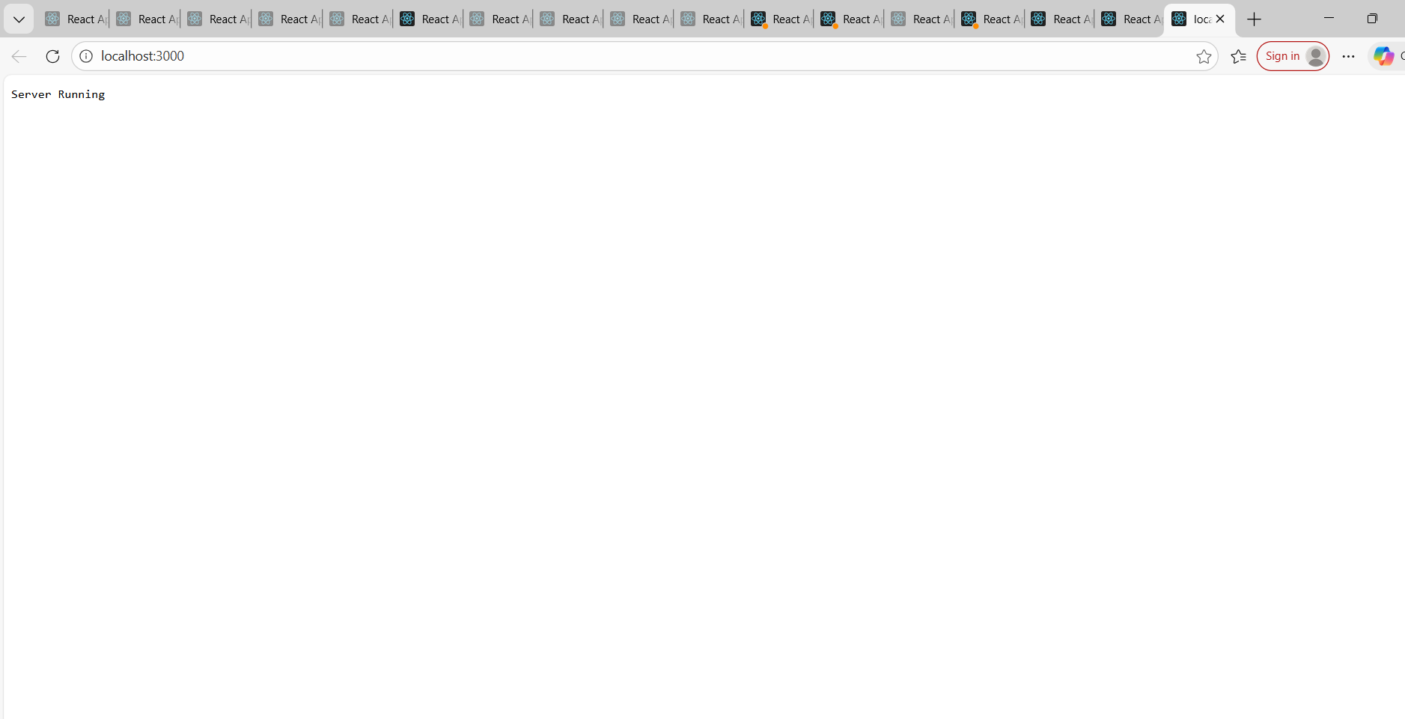

14. Write a program to create a new file using fs.writeFile() or fs.open().
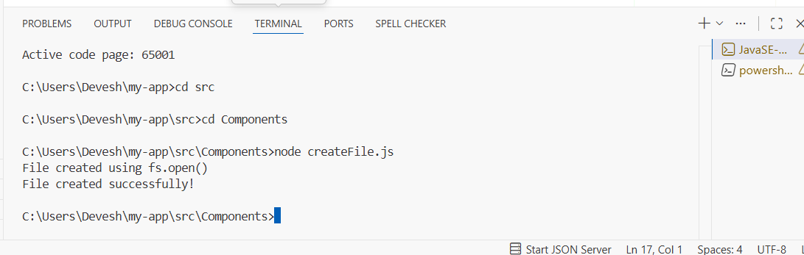

13. Create a Footer.js component in a separate folder called components.
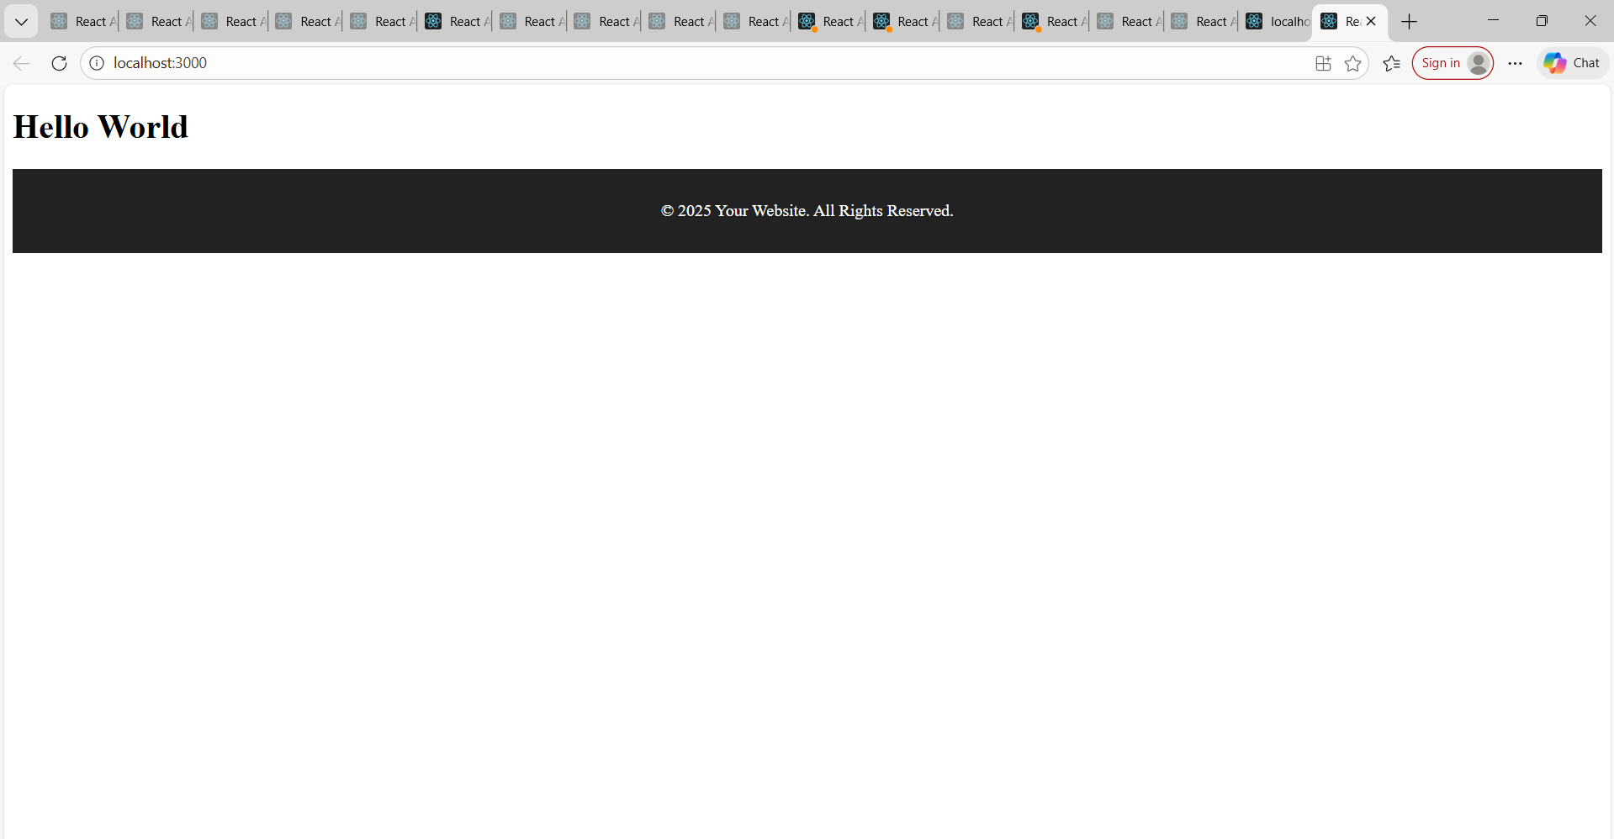

12. Demonstrate removing an event listener using removeListener() or off().
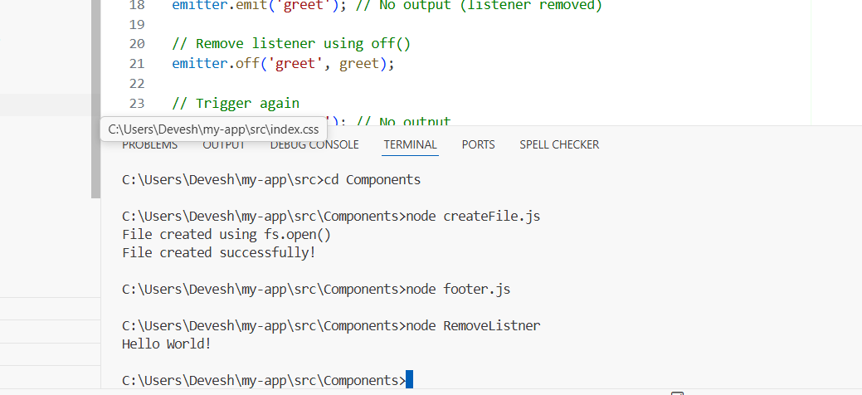

11. Write a program to Pass data (props) from App.js to the imported components and
display it.
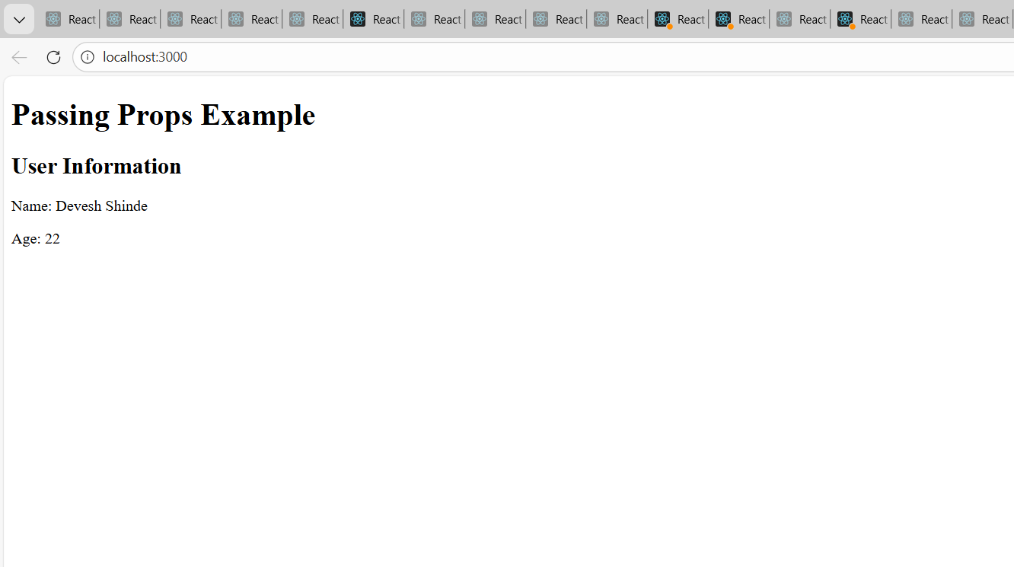
10. Create an event that is executed only once using once() and show its output.
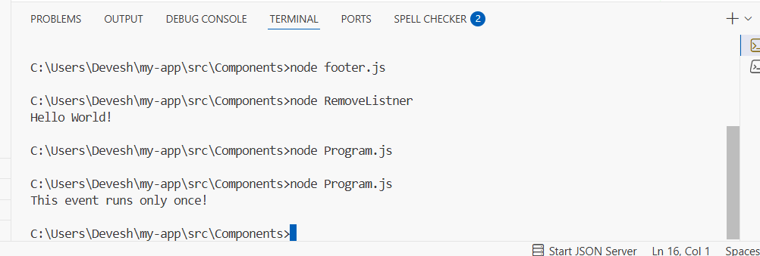

9. Trigger the custom events using the emit () method and display output in the console.

