Temporal RAG Digital Twin for Siemens MindSphere: A Production Thesis
Author: Principal Cloud Architect and Lead Data Engineer
Date: 2026-07-17
Target publication: Medium.com

Abstract
This thesis presents a production-ready Temporal Retrieval-Augmented Generation (RAG) system that solves the industrial dark-data problem by unifying time-series telemetry and historical maintenance narratives. The solution is designed for Siemens MindSphere (Insights Hub) use cases across power and aerospace verticals. It uses Snowflake for telemetry storage and temporal analytics, dbt for semantic modeling, Cortex Search and Cortex Complete for retrieval and reasoning, and Streamlit for operator and leadership visibility. The system provides grounded recommendations for closed-loop operational adjustments, with governance guardrails including role-based access control (RBAC), masking policies, safety validation, and auditable traceability.

Keywords
Industrial IoT, Digital Twin, Temporal RAG, Snowflake Cortex, dbt, Predictive Maintenance, Closed-Loop Control

1. Business Problem and Motivation
Industrial organizations produce massive telemetry and maintenance text data, but this data remains underutilized in daily operations. Operators often diagnose abnormal conditions without efficiently connecting current sensor behavior to analogous historical interventions. This project addresses that gap by creating a temporal evidence engine that converts telemetry + maintenance history into explainable operational recommendations.

2. Objectives
- Integrate telemetry and maintenance narratives in a single temporal analytics fabric.
- Build retrieval-grounded recommendations that align with historical failure patterns.
- Enforce recommendation safety checks and auditability for enterprise governance.
- Deliver a visual leadership-ready cockpit for operational and program progress insights.

3. Technical Architecture
The architecture is organized into five layers: ingestion/storage, temporal transformation, retrieval/generation, governance, and presentation. Snowflake is used as the execution plane for both analytics and AI primitives.

4. Implementation Components

4.1 Data Layer
Snowflake schemas RAW and ANALYTICS store telemetry and maintenance logs. Synthetic 30-day turbine data simulates progressive thermal friction anomalies.

4.2 Temporal Engine
SQL views compute rolling hourly metrics including moving averages, variance, and deltas. Temporal state chunks flatten metrics for retrieval matching.

4.3 RAG Backend
The backend class retrieves recent state, performs semantic search against maintenance history, composes chronological context, generates recommendations, and applies safety controls.

4.4 dbt Semantic Layer
Source, staging, and mart models establish a governed analytics contract for production reporting and quality tests.

4.5 Governance and Audit
RBAC roles, masking policy for technician notes, and persistent recommendation audit logs support enterprise controls and compliance.

4.6 Frontend Cockpit
Streamlit provides operational decision support, advancement tracking, and governance observability in a single interface.

5. Diagrams and Visual Explanations
All generated project visuals are embedded below with accessibility alt text.

Figure 1
File: docs/media/mindsphere_product_icon.png
Alt Text: MindSphere Temporal Twin product icon featuring turbine hub and concentric telemetry rings.


Figure 2
File: docs/media/architecture_diagram.png
Alt Text: System architecture showing ingestion, Snowflake/dbt analytics, RAG engine, governance controls, and Streamlit cockpit.
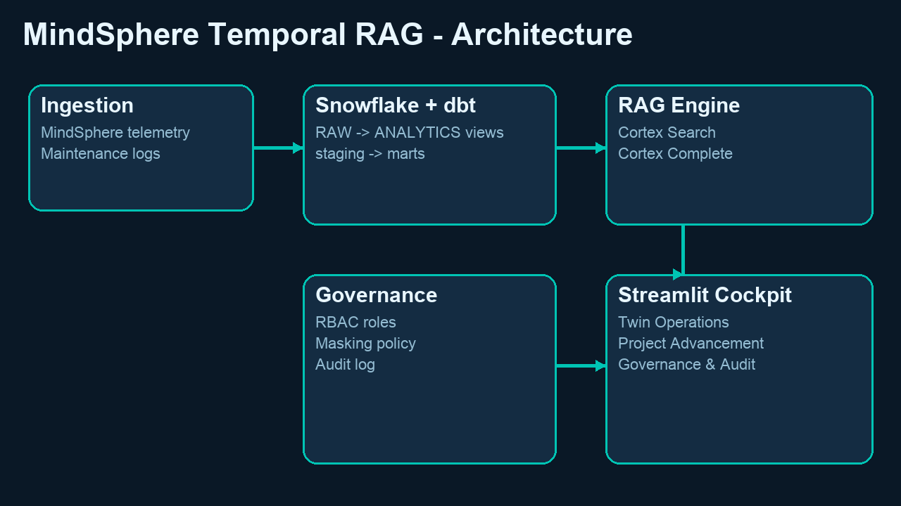

Figure 3
File: docs/media/data_flow_diagram.png
Alt Text: Data flow from telemetry and maintenance logs through temporal transformations and retrieval-augmented recommendation generation.
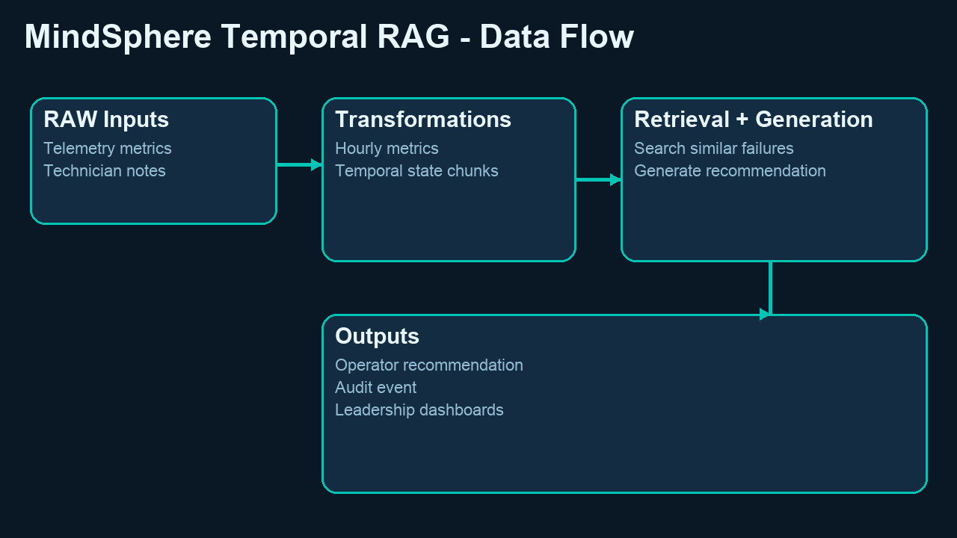

Figure 4
File: docs/media/call_flow_diagram.png
Alt Text: Runtime call sequence from operator question to context retrieval, LLM generation, safety validation, and audit logging.
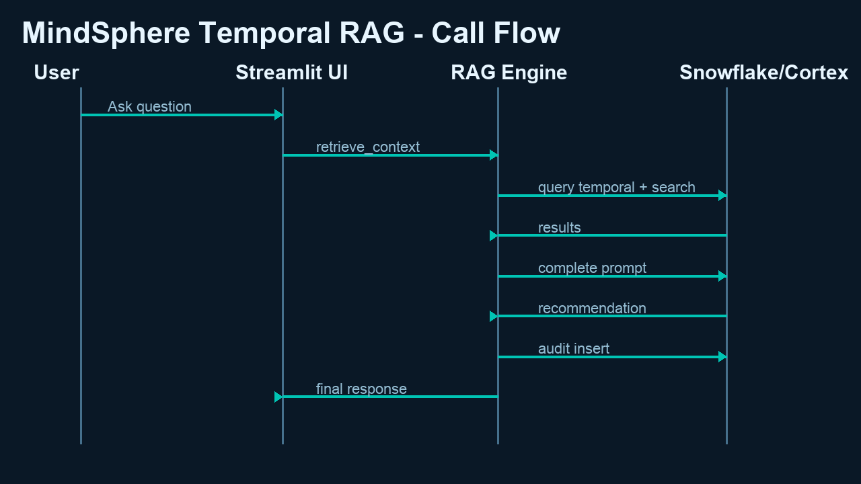

Figure 5
File: docs/media/architecture_overview.gif
Alt Text: Animated architecture explainer highlighting platform layers and trust controls.
Note: GIF files are attached by reference for Medium assets; Word preview behavior depends on client support.

Figure 6
File: docs/media/data_flow.gif
Alt Text: Animated data flow explainer describing the dark-data to closed-loop recommendation pipeline.
Note: GIF files are attached by reference for Medium assets; Word preview behavior depends on client support.

Figure 7
File: docs/media/call_flow.gif
Alt Text: Animated call flow explainer illustrating request-response interactions across components.
Note: GIF files are attached by reference for Medium assets; Word preview behavior depends on client support.

Figure 8
File: docs/media/ui_walkthrough.gif
Alt Text: Animated UI walkthrough of operations, project advancement, and governance tabs in the Streamlit cockpit.
Note: GIF files are attached by reference for Medium assets; Word preview behavior depends on client support.

6. Experimental Demo Results
The offline deterministic demo engine was executed to validate behavior without cloud credentials. Observed output showed retrieval quality score 0.95 (PASS), two historical maintenance matches, and a five-part recommendation covering risk, component at risk, immediate control-loop adjustment, 24-hour monitoring plan, and maintenance follow-up.

7. Safety and Trustworthiness
- Evidence grounding: responses are built from temporal telemetry context and nearest historical maintenance events.
- Safety validation: generated recommendations are checked for mandatory structure and banned unsafe phrases.
- Fail-safe mode: blocked responses return a safe fallback instruction set.
- Auditability: each recommendation event can be persisted with quality and safety metadata.

8. Leadership Demonstration Strategy
- Begin with architecture GIF to explain system boundaries and value chain.
- Show data flow GIF to establish lineage from raw telemetry to actionable recommendation.
- Run DEMO_MODE in Streamlit and ask the high-temperature spike question.
- Highlight retrieval quality, historical evidence rows, and generated control-loop guidance.
- Close with governance tab showing safety status and audit history for executive confidence.

9. Medium Publication Notes
When publishing to Medium, export this Word document as HTML/Markdown using your preferred editor if needed. Upload PNG/GIF assets directly in the same sequence as Section 5. Reuse each Alt Text line verbatim to ensure accessibility compliance and SEO discoverability.

10. Conclusion
This project demonstrates that temporal AI over industrial telemetry and maintenance text can produce explainable, high-utility operational guidance while meeting enterprise governance requirements. The resulting platform supports both frontline engineering decisions and leadership-level confidence through transparent quality, safety, and audit controls.

