Automotive Adaptive Cruise Control System using Matlab Simulink

Name and Unique ID: Devesh Pedapudi,

2005562

Introduction:

Adaptive cruise control (ACC) is a system designed to help vehicles maintain a safe following distance and stay within the speed limit. This system adjusts a car's speed automatically so drivers don't have to. It is an automotive feature that allows vehicle’s cruise control system to adapt the vehicle’s speed to traffic environment.

Control is based on sensor information from on-board sensors. Such systems may use a radar or laser sensor or a camera setup allowing the vehicle to brake when it detects the car is approaching another vehicle ahead, then accelerate when traffic allows it to. ACC technology is widely regarded as a key component of future generations of intelligent cars. They impact driver safety and convenience as well as increasing road capacity by maintaining optimal separation between vehicles and reducing driver errors. Vehicles with autonomous cruise control are considered a Level 1 autonomous car, as defined by SAE International. When combined with another driver assist feature such as lane centering, the vehicle is considered a Level 2 autonomous car.

Adaptive cruise control does not provide full autonomy: the system only provides some help to the driver, but does not drive the car by itself.

Physical Overview:

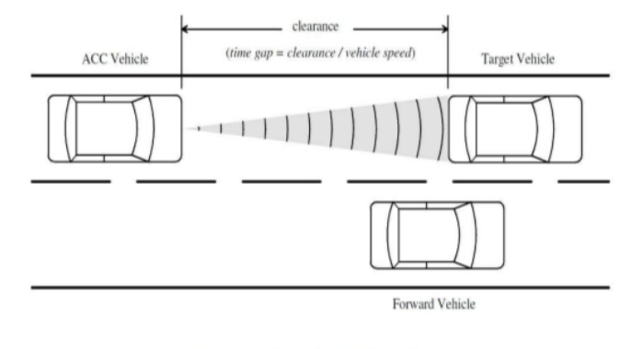

Above shown is a typical view of a 2-car-system to understand how Adaptive Cruise Control system works. The 2 cars namely Target/ Leading vehicle and ACC/Following vehicle are considered while designing an ACC system for the Following vehicle.

Terminologies:
- Lead/Target Vehicle: It is one of the forward vehicles which is in the path of ACC equipped vehicle and is closest to ACC vehicle.

- ACC/Following Vehicle: It is the subject vehicle which is equipped with the ACC system and follows the Leading vehicle.

- Inter-Vehicular Distance/ Clearance: It is the distance from leading vehicle’s trailing surface and following vehicle’s leading surface.

- Set Speed: It is the desired cruise control speed set by the driver and is the maximum desired speed of the vehicle while under ACC control.

- Time Gap: It is the time interval between the leading vehicle and following vehicle.

Operating Principle:
When a slow-moving leading vehicle is detected, the ACC system will slow down the vehicle and control the clearance or time gap between the leading vehicle and the following vehicle. If the system detects that the leading vehicle is no longer in the path of following vehicle, the ACC vehicle will accelerate the vehicle back to its set cruise control speed. This operation allows the ACC vehicle to autonomously slow down and speed up the traffic without intervention from the driver. The method by which following vehicle speed is controlled is via engine throttle control and limited brake operation.

ACC Using Matlab Simulink:

The ACC system for the following vehicle w.r.t leading vehicle can be designed using the Model Based Design in Simulink. Model Block Diagram is created for both the vehicles according to their individual mechanical dynamics. For both leading and following vehicles, the dynamics between acceleration and velocity can be modelled using,
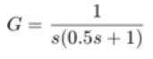
A Transfer Function block is used which takes acceleration as input and gives speed as output according to transfer function mentioned above.
Acceleration-Speed dynamic model is created for both the vehicles in similar fashion. Integrating the Speed, we can get the distance covered by both the vehicles.
The difference between the distances of the vehicles gives the relative distance or Clearance between the vehicles. This is the factor which enables the ACC to make decisions w.r.t acceleration and deceleration of the following vehicle.
An ACC MPC (Model Prediction Controller) is used to generate the acceleration for the following vehicle. Following are the inputs to the MPC:
- Time Gap
- Relative Distance/ Clearance
- Set Speed
- Following Vehicle Speed
- Relative Speed b/w the vehicles

Few snaps of the models are shown below:

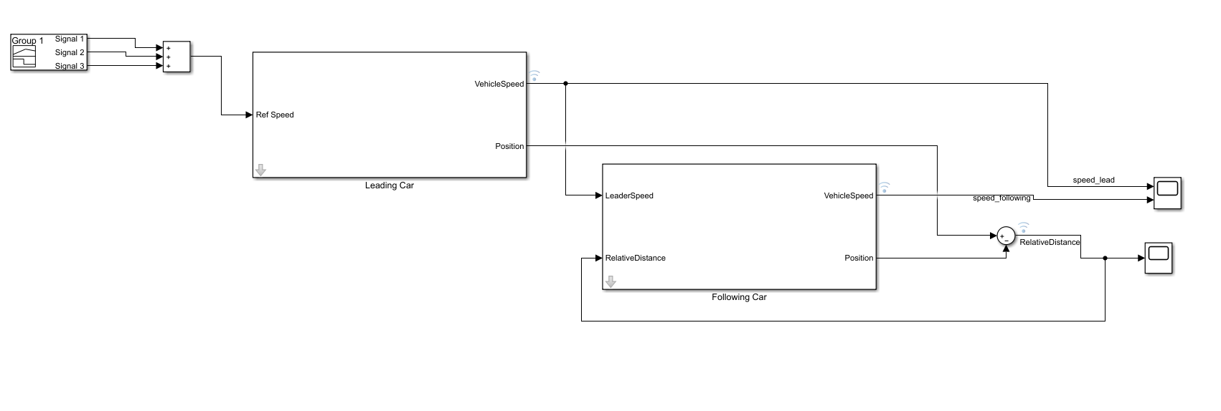
Above figure shows the block diagram of overall system.

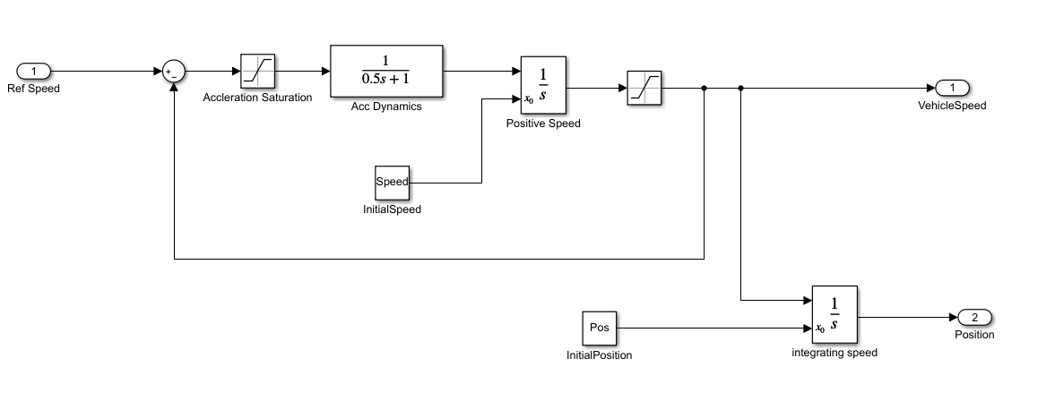
The figure above shows the Dynamics modelled for the leading vehicle.

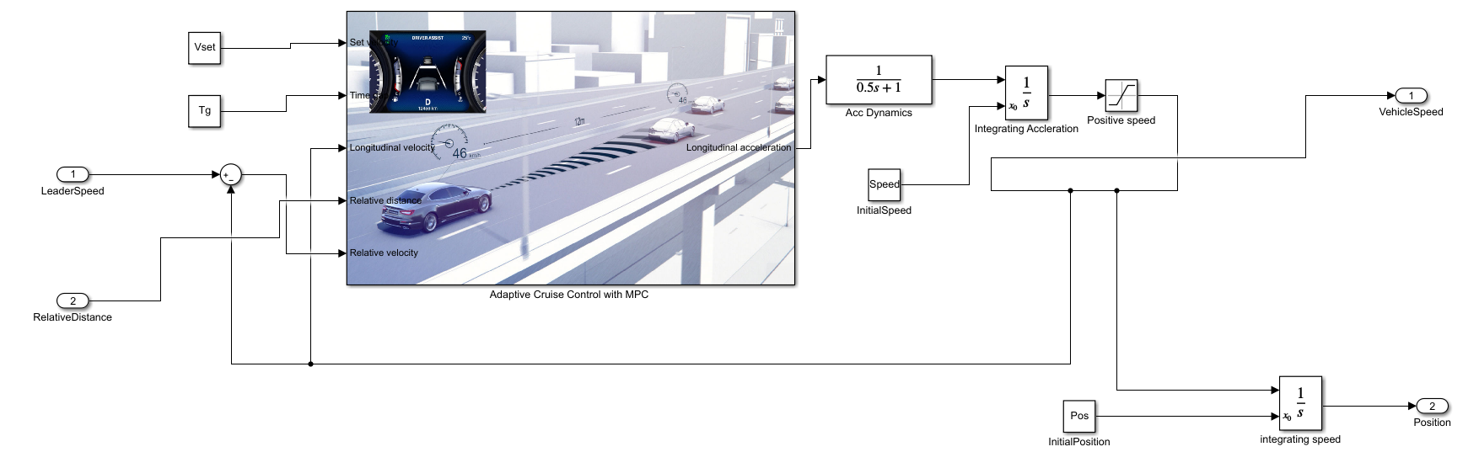
The figure above is the model for the following vehicle.

Initial position and speed are the generic initial conditions given to models of both systems.
The model is then simulated with signal generated from the signal builder, which in this case is a staircase type signal and by tuning the MPC, appropriate output is obtained.

The figure below shows the staircase input given to the system to test its functionality:
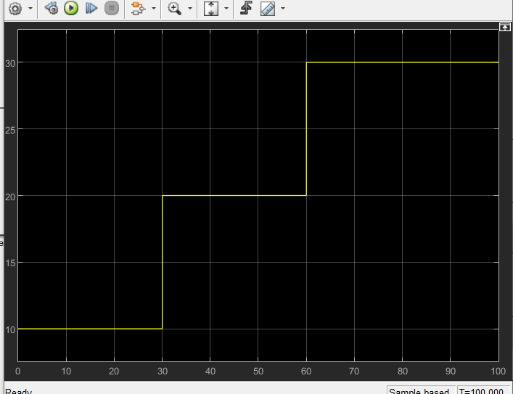

The graph below shows the output of relative distance between the vehicles for the given input:
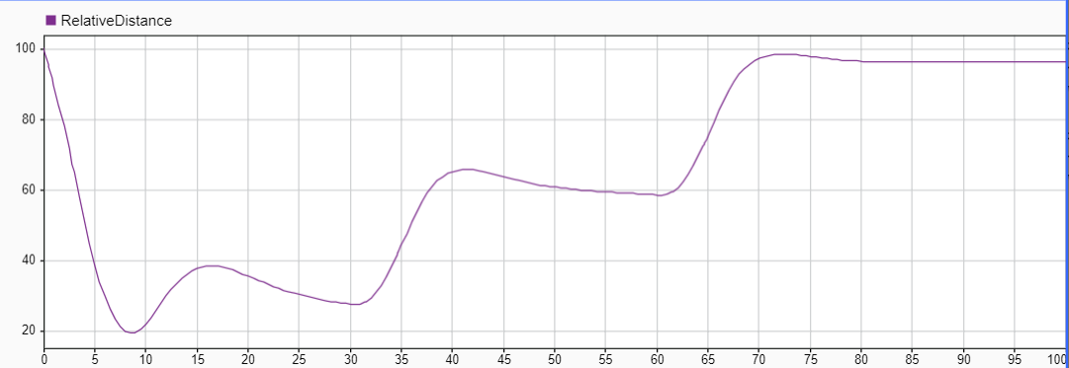
It is observed that the least distance between the vehicles was 20m which can be considered appropriate distance between 2 vehicles. The plot also indicates, never did the distance fell to zero or less than zero which implies there was no collision between the vehicles.
The plot below shows the speeds of both the vehicles w.r.t the input:
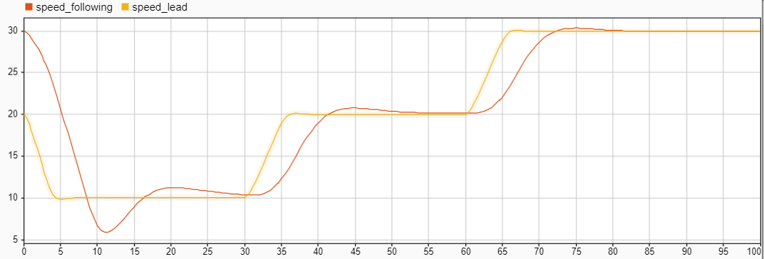
It can be observed that initially there was slight deviation in the speed of following vehicle w.r.t that of leading vehicle, but with changing inputs, the speed of following vehicle almost follows the speed of leading vehicle with a slight delay.
Hence it can be concluded that desired output is obtained.

Skills Used while Modelling:
- Call-backs: Call-back function is used to initialize the parameters of the blocks.
- Data Inspector: The output data is logged and all the runs of the model is displayed in the data inspector.
- Signal Builder: Signal Builder is used to generate the staircase function which is given as the test input to the system.
- Look-Up Table: There is no lookup table used in the model as there is no statically dependent parameter in the system and all the parameters are dynamic.
- Solver Selection: The model is simulated using ode45 i.e., Dormand-Prince Algorithm which is accurate and precise in handling such real-time systems.
Conclusion:
Adaptive Cruise Control system is designed considering 2 vehicles, leading and following. The system is designed using Model Based Design and is modelled using Matlab Simulink. Different features of Matlab Simulink are used to model the system and simulate it and trace the output for every simulation. The MPC is appropriately tuned to get the desired output. A test input generated from signal builder is given to the system to test its functionality, and the response seems appropriate for the given input.

References:
[1]https://in.mathworks.com/help/mpc/ug/adaptive-cruise-control-using-model-predictive-controller.html
[2] https://www.slideshare.net/nikhilkashyap125/adaptive-cruise-control-system-by-nikhil-r
[3] https://en.wikipedia.org/wiki/Adaptive_cruise_control

