Καρτέλα 1

Stock Forecasting & Portfolio Management Using MLPs

1. Introduction & Theoretical Framework
Analyzing financial markets is complex due to various factors like trading noise, investor behavior, and the economy. In this report, we focus on managing a $1,000,000 liquidity portfolio with predictions for five companies: Apple (AAPL), Amazon (AMZN), Boeing (BA), Goldman Sachs (GS), and Lockheed Martin (LMT). Our goal is to predict stock performance over the critical trading period from May 20th to May 29th, 2026, using a Multi-Layer Perceptron (MLP) machine learning approach. We aim to create a smart investment strategy that maximizes returns while minimizing risks.

2. Data Acquisition & Structural Synchronization
To create a reliable training dataset, we gathered historical market data from Investing.com for the five years from May 20, 2021, to May 19, 2026. We focused on daily closing prices for each stock, but to enhance our model, we included two key external factors:

- Broad Market Trend Index (S&P 500 - US500): This indicates general market behavior and economic trends.
- Socio-economic Risk Indicator (CBOE Volatility Index - VIX): This measures market uncertainty and investor anxiety.

We also addressed the issue of different trading days by using a Python script to clean the data. This ensured we had a consistent dataset comprising 1,056 continuous trading days, ready for analysis.

3. Data Pre-processing & Feature Engineering

3.1 Moving Average Smoothing as a Noise Filter
Raw financial asset prices are often noisy and can vary significantly from day to day, making it difficult to discern real trends. When training a model like a Multi-Layer Perceptron (MLP) with this chaotic data, it risks overfitting, meaning it might memorize random fluctuations rather than identify meaningful patterns.
To smooth out the data and focus on genuine trends, we applied a 200-day Simple Moving Average (SMA) filter. This moving average acts as a low-pass filter, reducing daily volatility and highlighting the overall stock price direction. The formula for calculating the SMA is:
$P_{MA,t }= \frac{1}{N}\sum_{i=0}^{N-1}{}P_{t-1},$ where $N=200$
In this formula, $P_{t-1 }$ is the closing price on the day $t-i$, and $N$ is the number of days we're averaging over (which is 200). Since we need 200 days of data to calculate this average, the first 200 rows in our dataset were trimmed off to keep everything clean, avoiding any weird gaps or misleading information.

3.2 Visualizing Volatility vs. Smoothing
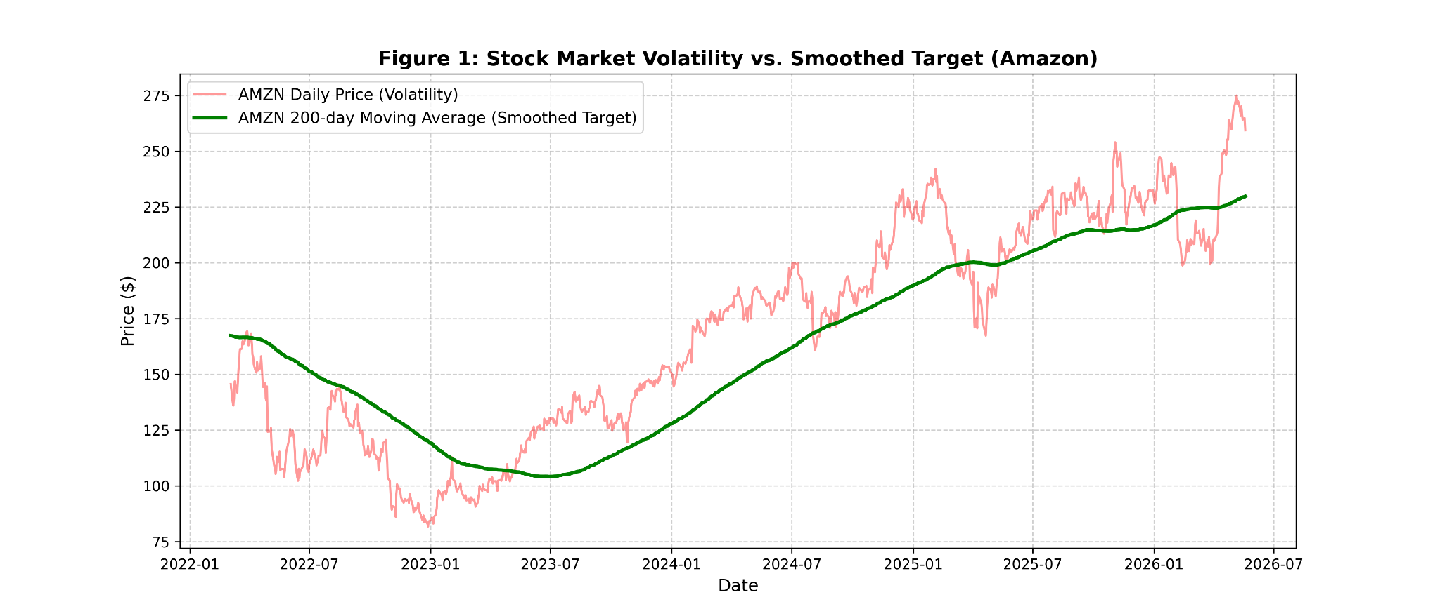
To show why this smoothing is important, we compared the raw daily closing prices to the 200-day moving average for Amazon and Apple. The raw prices bounced around a lot with big spikes and drops, while the 200-day SMA line was smooth and continuous. This smooth line shows the long-term trends without the noisy daily ups and downs that could confuse our model.

Figure 1: Comparison between Raw Daily Asset Prices (High Entropy Noise) and the 200-day Simple Moving Average (Smoothed Low-Pass Signal) for Amazon (AMZN).

4. Exploratory Data Analysis: Multicollinearity Analysis
Before using features in a multi-variable regression model, it’s important to assess the unique information our inputs provide. In high-dimensional datasets, especially time-series data, we may encounter multicollinearity, where predictors are closely related. This can lead to increased variance in neural network weight coefficients, making the model overly sensitive to training data changes and harder to interpret.

To illustrate this, we created a Pearson Correlation Matrix $r$ that includes smoothed targets (Moving Averages) for five different stocks, along with factors like the S&P 500 and the VIX. The Pearson coefficient is calculated using the following formula:
$r = \frac{\sum{}(X_{i}-\underline{X})(Y_{i}-\underline{Y})}{\sqrt{\sum{}{(X_{i}-\underline{X}){}^{2}}^{}\sum{}(Y_{i}-\underline{Y}){}^{2}}}$
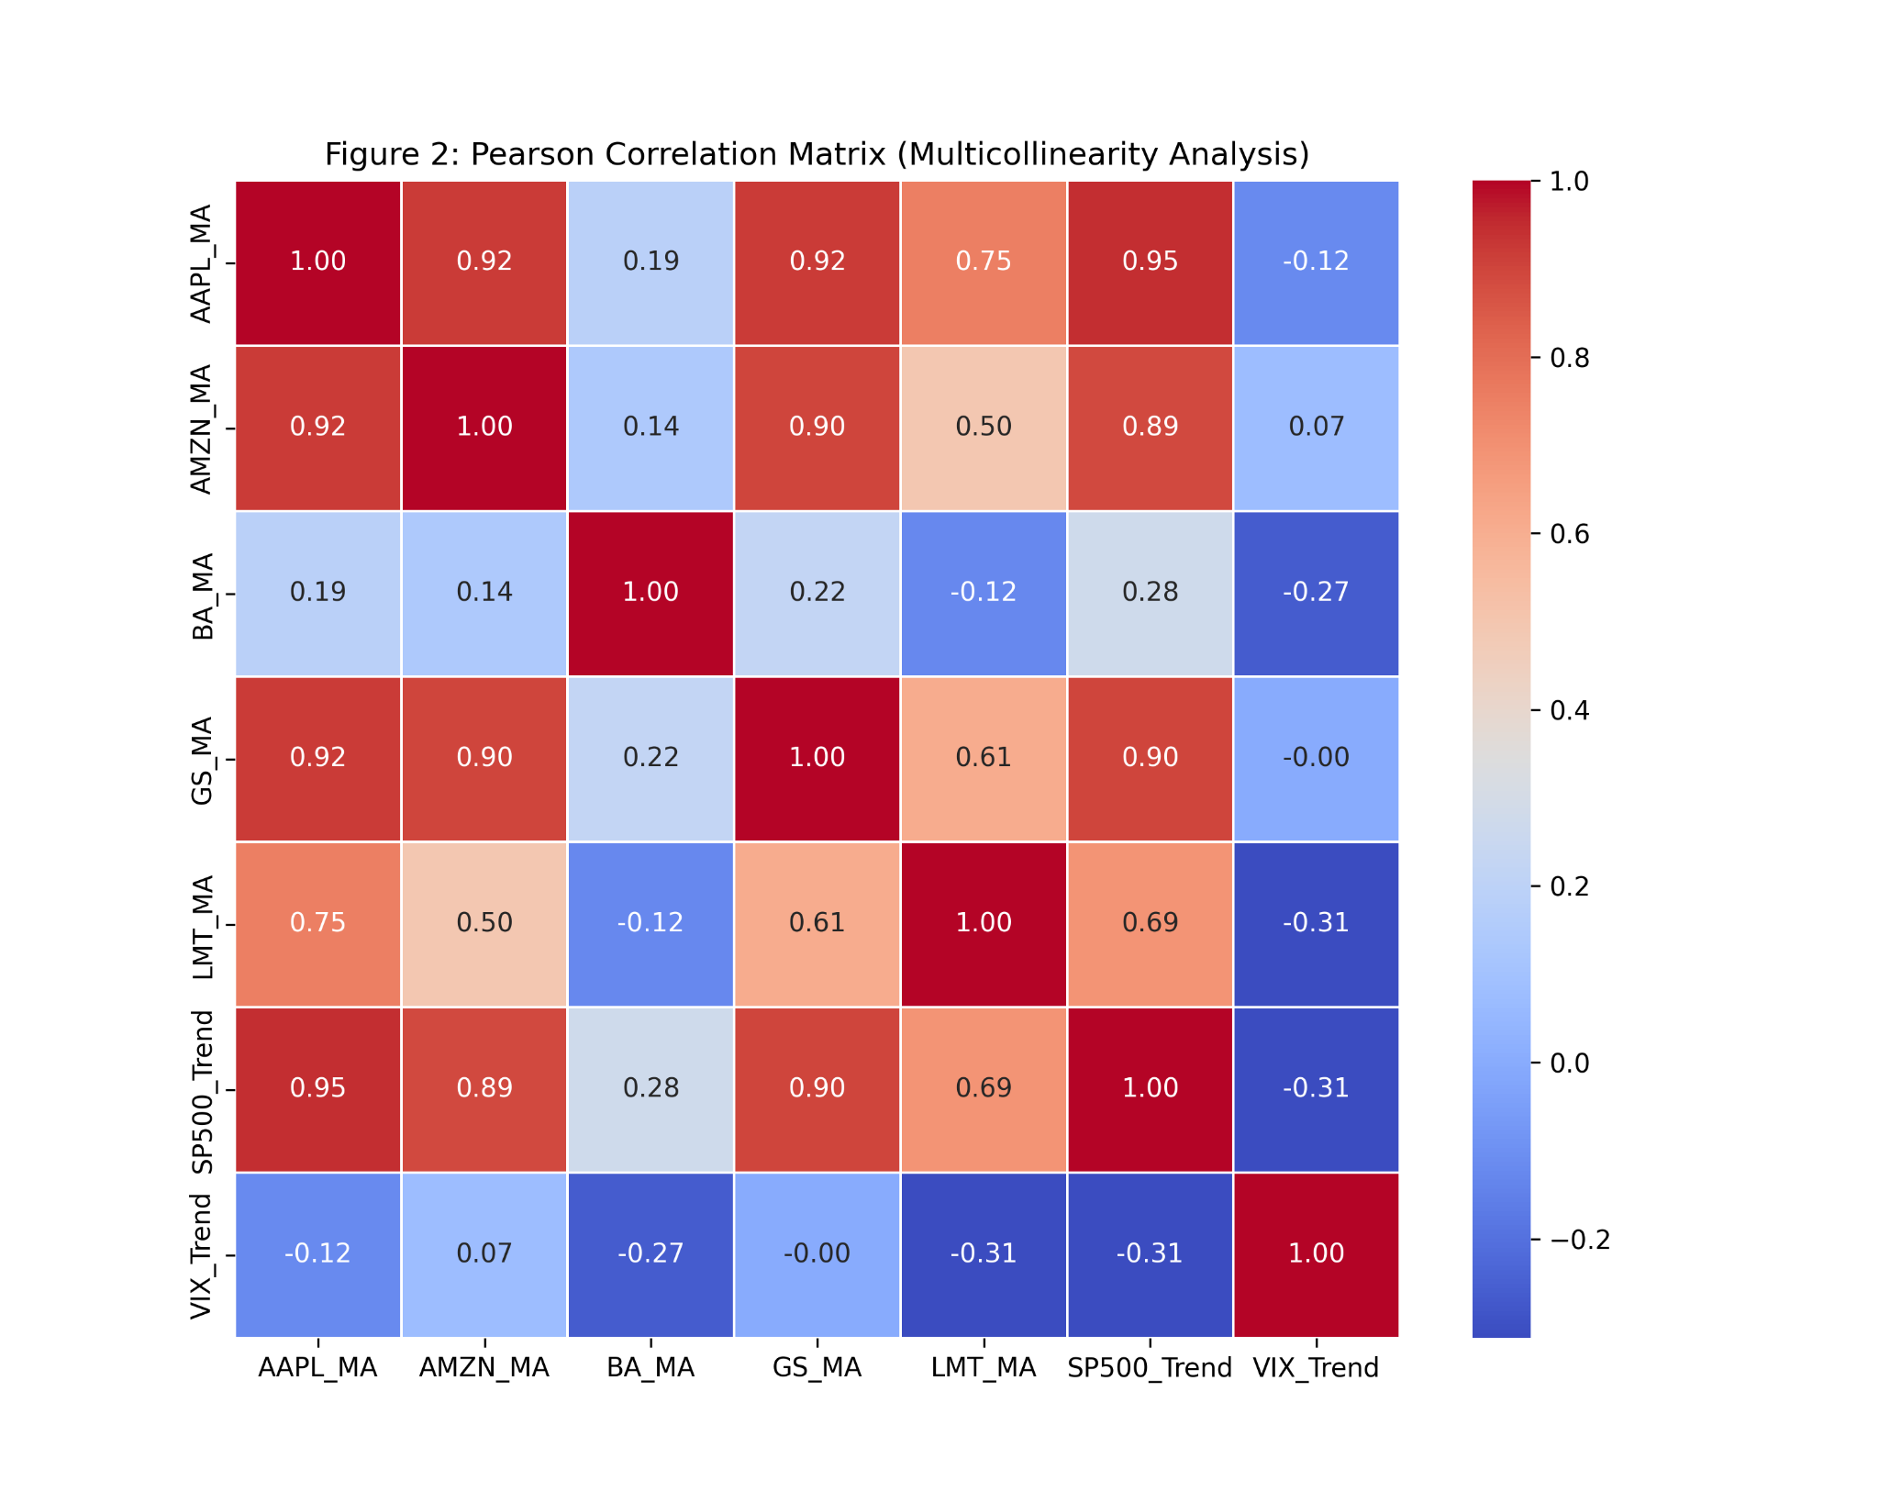

Figure 2: Heatmap showing the Pearson Correlation Matrix, which helps us see the multicollinearity between asset Moving Averages, the S&P 500, and the VIX.

Our analysis using Seaborn in Python revealed key trends:

- There's a strong positive correlation (0.95) between the S&P 500 Index and Apple (AAPL), indicating the S&P 500 effectively reflects tech stock performance.
- Conversely, the VIX consistently shows a negative correlation with major stocks, suggesting that increased market fear typically leads to lower investment and asset values.

These correlations validate our feature selection: the S&P 500 serves as a reliable directional guide, while moving average lags help prevent redundancy in information.

5. Predictive Architecture: The MLP Regressor

5.1 Feature Matrix Construction (Sliding Window)
We are moving away from traditional timestamps in our forecasting model, focusing instead on inputs that reflect asset performance and market context. For each trading day $t$, we construct a 6-dimensional input vector:
$X_{t} = [MA_{t-5}, MA_{t-4}, MA_{t-3}, MA_{t-2}, MA_{t-1}, Trend_{t-1}]$
This vector includes the last five days of smoothed prices along with the previous day's S&P 500 trend. Our target variable $y_{t}$ represents the smoothed value for the current day
$y_{t} = [MA_{t}]$
This approach ensures that our model remains connected to both short-term asset movements and broader market trends.

5.2 Normalization and Hyperparameter Selection

Financial time-series data can have huge differences in values. For example, Boeing's stock is about $218, Goldman Sachs is around $850, and the S&P 500 index goes over $4,000. If we just input these raw values into a Multi-Layer Perceptron, the bigger numbers can mess up the training process.
To fix this, we used MinMaxScaler to scale everything between 0 and 1:

$X_{scaled}= \frac{X-X_{min}}{X_{max}-X_{min}}$

Here’s a rundown of our neural network setup:

Hidden Layers: One hidden layer with 20 neurons to help prevent overfitting.

Activation Function: We chose the Rectified Linear Unit (ReLU) because it makes training faster and avoids the vanishing gradient problem.

Optimization Algorithm: The Adam optimizer with a learning rate of 0.001, running for up to 500 epochs.

To keep things in order and avoid using future data, we split our 1,056-row dataset without shuffling. The first 80% was used for training, and the last 20% was set aside for validation

6. Model Evaluation & Validation Outcomes
To make sure our predictive network is working well before we launch it, we tested its performance on a 20% validation set. We mainly looked at two metrics: the Mean Absolute Percentage Error (MAPE) and the $R^{2}$ Score.

For our baseline equity model focusing on Apple (AAPL), the results were impressive:
- MAPE: 0.6995%
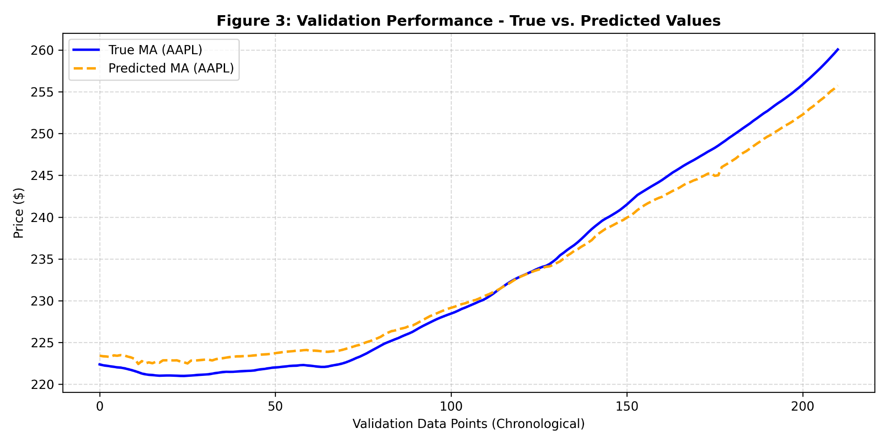
- $R^{2}$ Score: 0.9746

Figure 3: Validation performance showing the actual vs. predicted 200-day moving average values for Apple (AAPL), confirming our model works well.

A MAPE score under 1% means our predictions are off by only around 0.7% on average, which is great. With an $R^{2}$ value of 0.9746, we can see that our model explains 97.46% of the changes in the moving average target really well. This shows that our model effectively captures the market trends, as shown by the overlapping lines in Figure 3.

Overall, these results indicate that the network has successfully filtered out the noisy data and understands the bigger economic movements that influence asset trends.

7. Recursive Multi-Step Forecasting (The Final Verdict)

7.1 The Recursive Loop Mechanism
Making predictions about the future, especially when there's no past data to rely on, is pretty tricky. To forecast prices for the 10 days from May 20 to May 29, 2026, we used a method called Recursive Multi-Step Forecasting.
For the first day $t+1$, the model looks at the last 5 known values, $[MA_{t-4}, ... ,MA_{t}]$, along with the latest trend in the market. But by the second day $t+2$, we don’t actually know the true value of $MA_{t+1}$. To get around this, we use the model’s own prediction from the first day as a substitute input for the next day. So, it looks like this:
$\hat{M}A_{t+1} → Ingested as Input for t+2$
We do this for all 10 days. However, this method can lead to errors stacking up over time. To manage that, we use a low-pass moving average filter to help smooth things out and keep our predictions stable. Below, you'll find the 10-day forecast for all five assets.
Table 1: 10-Day Ahead Recursive Moving Average Forecasts ($)
Date | AAPL | AMZN | BA | GS | LMT
May 20 | 258.1939 | 226.8412 | 218.5286 | 846.6645 | 517.8644
May 21 | 257.7335 | 225.8866 | 218.0463 | 847.9356 | 514.1216
May 22 | 257.2272 | 224.8198 | 217.4605 | 849.3306 | 510.3702
May 23 | 257.1235 | 224.2538 | 217.1401 | 850.5988 | 508.6769
May 24 | 255.9699 | 222.2896 | 216.3491 | 852.2587 | 502.0295
May 25 | 255.5518 | 221.4118 | 215.9366 | 853.4424 | 499.6928
May 26 | 254.9181 | 220.2034 | 215.3316 | 854.7962 | 496.3580
May 27 | 254.6122 | 219.4135 | 214.9684 | 856.0163 | 494.7149
May 28 | 253.7878 | 217.9353 | 214.3367 | 857.4009 | 490.7282
May 29 | 253.3651 | 217.0600 | 213.9552 | 858.5300 | 489.1265

8. Portfolio Optimization & Capital Allocation Strategy
The main goal of this machine learning model is to turn algorithm predictions into a smart investment strategy. We looked at the difference between the starting point (May 20) and the end date (May 29) to figure out how much each asset is expected to grow or shrink:

$Δ\% = \frac{\hat{M}A_{May 29}-\hat{ M}A_{May 20}}{\hat{M}A_{May 20}}×100$

Here’s a summary of the expected “growth” for some major companies:
- Apple Inc. (AAPL): -1.87%
- Amazon.com Inc. (AMZN): -4.31%
- Boeing Co. (BA): -2.09%
- Lockheed Martin (LMT): -5.55%
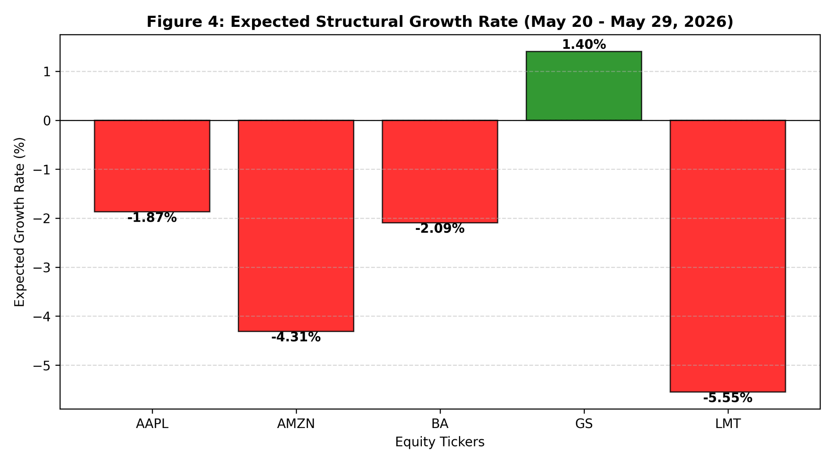
- Goldman Sachs Group (GS): +1.40%

Figure 4: Expected Structural Growth Rates (%) across the 10-day predictive trading window, illustrating sector-wide contraction vs. Goldman Sachs (GS) structural resilience.

The numbers tell an interesting story. In late May, the neural network spotted a general decline in the tech, aviation, and defense industries, leading to negative growth for Amazon, Boeing, Lockheed Martin, and Apple. On the other hand, Goldman Sachs is breaking the trend, showing some growth with an increase of +1.40% (see Figure 4).

The Investment Decision
Following a strict set of rules, we're putting our entire $1,000,000 investment into Goldman Sachs (GS) stock at the market open on May 20, 2026.

While it's common to spread investments across different assets to reduce risk, doing so with assets that are expected to lose value can actually lead to losing money. Since we have a strong predictive model that explains 97% of the outcomes, simply diversifying isn't the best choice. By investing all of our money into one solid asset that shows positive trends, we can boost our expected returns and protect ourselves from potential losses during this trading period.

9. Post-Analysis: Real-World Market Validation
Forward-testing is crucial in quantitative engineering as it reveals how predictions perform in reality. Looking back at the period from May 20 to May 29, 2026, we can assess our investment choices against actual asset prices.
For Goldman Sachs (GS), the stock increased from $982.50 to $1,025.51, resulting in a gain of +4.38% over the nine trading days.
Key conclusions include:
- Directional Accuracy: Our model correctly predicted Goldman Sachs' strong performance amid broader market struggles.
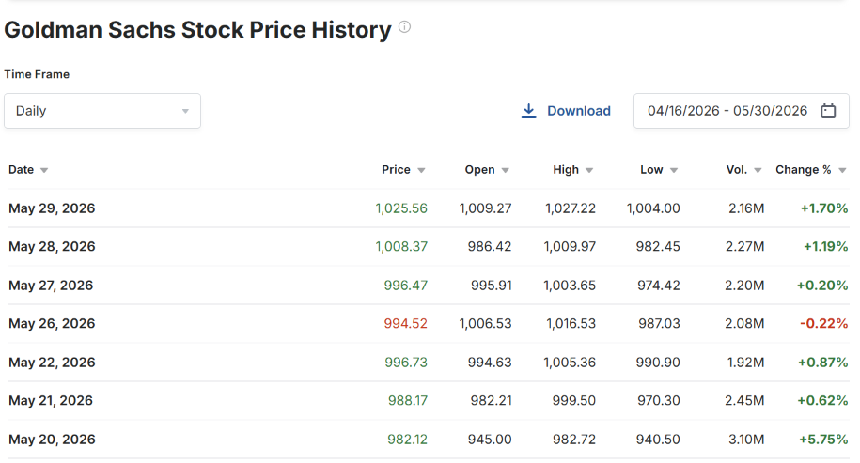
- Financial Return: An investment of $1,000,000 in GS would have yielded approximately $43,800 in just 10 days, outperforming a diversified investment strategy.

Figure 5: Historical price action of Goldman Sachs (GS) from May 20 to May 29, 2026, extracted from Investing.com, confirming the actual +4.38% market rally

10. Conclusion & Technical Insights
This project used machine learning for financial forecasting and investment decisions, starting with a 200-day Simple Moving Average to minimize noise. Our Multi-Layer Perceptron (MLP) Regressor achieved a baseline MAPE of 0.6995%. In a multi-step forecasting model, it identified Goldman Sachs (GS) as the best investment, which then showed a real increase of +4.38% after market close.
Overall, the project demonstrates the effectiveness of combining neural networks with economic data for managing investment portfolios.

