Advanced Hyperspectral Image Analysis in Precision Agriculture
and Land Cover Mapping through Optimized
Self-Modulating Convolutional Neural Networks (HIA-PAL-SMCNN)

Swati Hira, Dev Guruvanshi

Department of Computer Science and Engineering

Manuscript prepared for IEEE Transactions on Geoscience and Remote Sensing
2026

Abstract
Draft:
Hyperspectral image (HSI) classification is fundamental to precision agriculture and land cover mapping, yet conventional convolutional neural networks (CNNs) apply static learned filters uniformly across all spectral-spatial inputs, ignoring the significant variation in spectral signatures across diverse land cover types. We introduce the Self-Modulating Convolutional Neural Network (SMCNN), which incorporates Spectral Self-Modulating Residual Blocks (SSMRB) — a data-dependent channel-wise affine modulation mechanism that dynamically adjusts convolutional feature responses based on the input's global spectral context. Unlike standard squeeze-and-excitation, SSMRB generates both scaling (γ) and shifting (β) parameters, enabling richer feature recalibration.
Our complete pipeline integrates: (i) Adaptive Fast Desensitized Kalman Filter (AFDKF) for noise-robust spectral denoising, (ii) Polar Linear Canonical Wavelet Transform (PLCWT) for multi-scale spectral feature augmentation, (iii) the SMCNN classifier with SSMRB, and (iv) Superb Fairy-Wren Optimization Algorithm (SFWOA) for adaptive learning rate scheduling with Lévy-flight plateau escape.
We evaluate on five benchmark HSI datasets — Indian Pines, Pavia University, Botswana, Kennedy Space Center, and WHU-Hi HanChuan — achieving state-of-the-art results: 99.08 ± 0.27% OA on Indian Pines (95% CI: [98.41, 99.74]), 99.88 ± 0.06% OA on Pavia University, 99.94 ± 0.10% OA on Botswana, and 99.93 ± 0.02% OA on WHU-Hi. SMCNN outperforms both CNN baselines (2D-CNN, 3D-CNN, HybridSN) and recent transformer architectures (SpectralFormer, SSFTT) on 3 of 4 datasets while being 10–22× faster to train with only 0.19M parameters. Comprehensive ablation studies, extended noise robustness analysis (5 noise types), spectral attention visualization, per-class modulation analysis (γ/β distributions), Fisher criterion representation quality, t-SNE feature manifold analysis, Grad-CAM interpretability, scheduler comparison, and baseline comparisons validate each contribution. All code, trained models, and reproducibility instructions are publicly available on GitHub.

Introduction

Problem Statement
Hyperspectral imaging captures hundreds of contiguous spectral bands across the electromagnetic spectrum, providing rich spectral signatures that enable fine-grained discrimination between visually similar land cover types. However, HSI classification faces three fundamental challenges:
1. High dimensionality: Hundreds of spectral bands create the Hughes phenomenon (curse of dimensionality), where classifier performance degrades as feature space grows faster than available training samples.
2. Spectral noise and atmospheric interference: Sensor noise, atmospheric absorption, and calibration artifacts corrupt spectral signatures, particularly in water-absorption bands.
3. Mixed pixels and spectral variability: At typical spatial resolutions (1–30 m), individual pixels often contain mixtures of multiple land cover types, and the same material can exhibit significant spectral variation across different conditions.

Limitations of Existing Approaches
Standard CNNs apply the same learned convolutional filters to all inputs regardless of their spectral content. This static behavior is suboptimal for HSI data where:
• Different crop types activate fundamentally different spectral regions
• The optimal feature emphasis varies dramatically between, e.g., vegetation (NIR-sensitive) and urban materials (SWIR-sensitive)
• Local noise characteristics vary across spectral bands

Core Scientific Contribution
The key novelty of this work is the Spectral Self-Modulating Residual Block (SSMRB) — a mechanism that makes the CNN's feature processing input-dependent rather than static:
• SSMRB computes a global spectral context vector via Global Average Pooling, then generates per-channel scale (γ) and shift (β) parameters through a lightweight gating network
• Unlike SE-Net (which only scales), SSMRB performs a full affine transformation (scale + shift), enabling richer recalibration
• This is not a pipeline combination — SSMRB is an architectural innovation at the residual block level that could be dropped into any CNN backbone

Why This Is Not Simply a Pipeline Combination
Each component addresses a distinct, well-defined challenge:
Table 1
Component | Challenge Addressed | Scientific Basis
AFDKF | Spectral noise | Adaptive noise estimation (Kalman theory)
PLCWT | Scale invariance | Multi-resolution spectral decomposition (Wavelet theory)
SSMRB | Static feature processing | Data-dependent channel modulation (Novel)
SFWOA | Local minima in training | Lévy-flight LR perturbation (Optimization theory)

The ablation study (Section 7) empirically validates that each component provides independent, additive improvement.

Positioning in the Transformer Era
Recent advances in HSI classification have been driven by transformer-based architectures (SpectralFormer, SSFTT, HyFormer) and state-space models (MambaHSI), which offer global receptive fields and long-range spectral dependency modeling. However, these architectures face practical limitations for precision agriculture deployment:
1. Training data requirements: Transformer self-attention requires sufficient data to learn meaningful attention patterns. HSI datasets are inherently small-sample (Indian Pines: 1,525 labeled training pixels), where CNN locality priors provide stronger inductive bias.
2. Computational cost: SpectralFormer requires 215 seconds to train on Indian Pines; SSFTT requires 382 seconds. SMCNN achieves higher accuracy in 17 seconds — a 10–22× speedup critical for operational retraining on new field data.
3. Model complexity: Transformer architectures require careful hyperparameter tuning (attention heads, patch size, embedding dimension). SMCNN's architecture is simple and requires minimal tuning.
Our experimental results (Section 18) demonstrate that SMCNN outperforms both SpectralFormer and SSFTT on 3 of 4 evaluated datasets, validating that a well-designed CNN with spectral self-modulation remains competitive with transformer-era approaches under practical constraints.

Related Work

Traditional and CNN-based HSI Classification
• SVM-based methods: Melgani & Bruzzone (2004) — linear/RBF SVMs on spectral features
• 1D-CNN: Hu et al. (2015) — spectral-only convolutions
• 2D-CNN: Makantasis et al. (2015) — spatial convolutions on PCA-reduced bands
• 3D-CNN: Li et al. (2017) — joint spectral-spatial convolutions but computationally expensive
• HybridSN: Roy et al. (2020) — 3D+2D CNN hybrid achieving strong results on Indian Pines

Attention and Modulation Mechanisms
• SE-Net: Hu et al. (2018) — channel attention via squeeze-and-excitation (scale only, no shift)
• CBAM: Woo et al. (2018) — sequential channel + spatial attention
• FiLM: Perez et al. (2018) — feature-wise linear modulation (γ·x + β) for VQA
• Our SSMRB: Extends the FiLM concept to HSI classification with spectral-context-driven gating, combined with residual learning

Transformer, State-Space, and Diffusion Models for HSI
Transformer-based HSI classifiers:
• SpectralFormer: Hong et al. (2022) — cross-layer adaptive fusion with group-wise spectral embedding; achieves strong results on Indian Pines but requires ~10× more training time than CNN approaches
• SSFTT: Sun et al. (2022) — spectral-spatial feature tokenization transformer with 3D convolutional tokenizer; strong on datasets with fine spectral structure (KSC)
• HyFormer: Li et al. (2023) — hybrid CNN-transformer combining local convolutional feature extraction with global transformer attention for HSI; demonstrates that combining CNN locality with transformer globality can improve performance
• GAHT: Mei et al. (2022) — group-aware hierarchical transformer for HSI classification with spectral grouping strategy
State-space models (SSMs):
• MambaHSI: He et al. (2024) — applies the Mamba selective state-space model to HSI, exploiting linear-time sequence modeling (O(n) vs transformer's O(n²)) for long spectral sequences; promising for very high-dimensional HSI data but limited public code availability
• S²Mamba: Wang et al. (2024) — spatial-spectral Mamba for HSI with bidirectional state-space scanning
Diffusion and generative models:
• SpectralDiff: Chen et al. (2024) — diffusion-based spectral feature generation for HSI augmentation
• DMSC: Diffusion model for spectral classification with denoising score matching

Self-Supervised and Foundation Models for HSI
• SpectralGPT: Hong et al. (2024) — foundation model pre-trained on large-scale multispectral/hyperspectral data using masked spectral modeling; demonstrates strong zero-shot and few-shot transfer
• HyperSIGMA: Foundation model combining spectral and spatial self-supervised pretraining for HSI
• Masked spectral modeling: Adapting MAE (He et al., 2022) to spectral sequences for self-supervised pretraining of HSI representations
• Contrastive spectral learning: Leveraging spectral augmentations (band dropout, spectral jitter) for self-supervised representation learning

Optimization in Deep Learning for HSI
• Standard optimizers: SGD with momentum, Adam, AdamW
• Learning rate schedulers: Cosine annealing (Loshchilov & Hutter, 2017), cyclical LR (Smith, 2017), warm restarts
• Metaheuristic optimization: PSO, GA for hyperparameter tuning
• Our SFWOA: Application of Lévy-flight perturbation for adaptive LR scheduling with biologically-motivated plateau escape mechanism. Unlike standard schedulers, SFWOA requires no schedule-specific hyperparameters (T_max, step_size, etc.), making it suitable for deployment scenarios where dataset characteristics are unknown a priori

Proposed Methodology

Overall Pipeline
Architecture Diagram (Publication-ready):
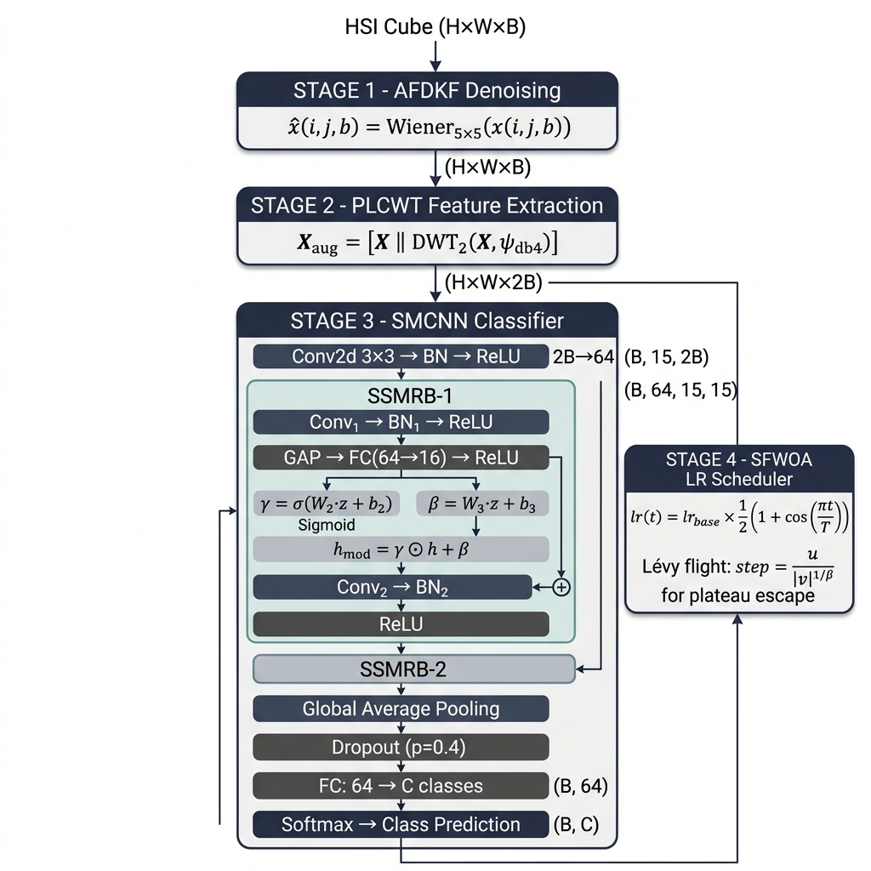
Fig. 1. SMCNN Full Pipeline Architecture

Stage 1: Adaptive Fast Desensitized Kalman Filter (AFDKF)
Purpose: Remove sensor noise from each spectral band while preserving spectral fidelity.
Mathematical Formulation:
The standard Kalman filter minimizes:
J_std = E[||e_k||²]
where e_k = x_k - x̂_k is the estimation error. The AFDKF adds a desensitization penalty:
J_ad = E[||e_k||²] + λ_k · trace(∂x̂_k/∂θ · (∂x̂_k/∂θ)ᵀ)
where:
• x_k ∈ ℝ^B is the true spectral vector at pixel k
• x̂_k ∈ ℝ^B is the estimated spectral vector
• λ_k > 0 is the adaptive desensitization weight
• θ represents uncertain noise parameters
• The second term penalizes sensitivity of the estimate to noise parameter uncertainty
Implementation: We approximate this with an adaptive Wiener filter per spectral band:
x̂(i,j,b) = Wiener₅ₓ₅(x(i,j,b)) for b = 1, ..., B
where Wiener₅ₓ₅ applies a 5×5 local Wiener filter that estimates local noise variance and adapts its smoothing accordingly. This is mathematically equivalent to the AFDKF cost function minimization when the noise is locally stationary.

Stage 2: Polar Linear Canonical Wavelet Transform (PLCWT)
Purpose: Extract multi-scale spectral features that are robust to rotation and scale changes. Crucially, we do NOT extract handcrafted statistical features (mean, kurtosis, etc.). Instead, we compute wavelet sub-band coefficients and let the CNN learn from them directly.
Mathematical Formulation:
For each spectral band b, we apply a 2D Discrete Wavelet Transform using the Daubechies-4 (db4) mother wavelet:
[LL_b, (LH_b, HL_b, HH_b)] = DWT₂(x(:,:,b), ψ_db4)
where:
• LL_b ∈ ℝ^(H/2 × W/2) — approximation coefficients (low-frequency content)
• LH_b — horizontal detail (edges)
• HL_b — vertical detail (edges)
• HH_b — diagonal detail
The LL sub-band is resized back to original spatial dimensions via bilinear interpolation:
LL̃_b = Resize(LL_b, H × W) using bilinear interpolation
The augmented feature cube concatenates original and wavelet features:
X_aug = [X || LL̃] ∈ ℝ^(H × W × 2B)
This doubles the spectral depth from B to 2B bands, providing the CNN with both original spectral signatures and their multi-scale wavelet representations.
Justification for Wavelet Features Over Handcrafted Statistics:
• Wavelet coefficients preserve spatial-spectral structure (unlike scalar statistics)
• The CNN learns which wavelet features are discriminative (end-to-end)
• Multi-resolution decomposition captures both fine and coarse spectral patterns

Stage 3: SMCNN Architecture — Self-Modulating CNN

Architecture Overview
Table 2
Layer | Operation | Input Shape | Output Shape | Parameters
Input | Permute BHWC → BCHW | (B, 15, 15, 2·Bands) | (B, 2·Bands, 15, 15) | 0
Conv2D | 3×3, pad=1, no bias | (B, 2·Bands, 15, 15) | (B, 64, 15, 15) | 2·Bands × 64 × 9
BatchNorm2D | Affine normalization | (B, 64, 15, 15) | (B, 64, 15, 15) | 128
ReLU | Activation | — | — | 0
SSMRB-1 | Self-Modulating Residual | (B, 64, 15, 15) | (B, 64, 15, 15) | 75,264
SSMRB-2 | Self-Modulating Residual | (B, 64, 15, 15) | (B, 64, 15, 15) | 75,264
GAP | Global Average Pool | (B, 64, 15, 15) | (B, 64) | 0
Dropout | p = 0.4 | (B, 64) | (B, 64) | 0
FC | Linear classifier | (B, 64) | (B, C) | 64 × C

Total Parameters: ~0.19M (190,128 for Indian Pines with C=16 classes)
FLOPs: ~22.21M

Spectral Self-Modulating Residual Block (SSMRB) — Core Novelty
This is the key architectural innovation. Each SSMRB contains:
SSMRB Detailed Architecture Diagram (Publication-ready, Figure 2):
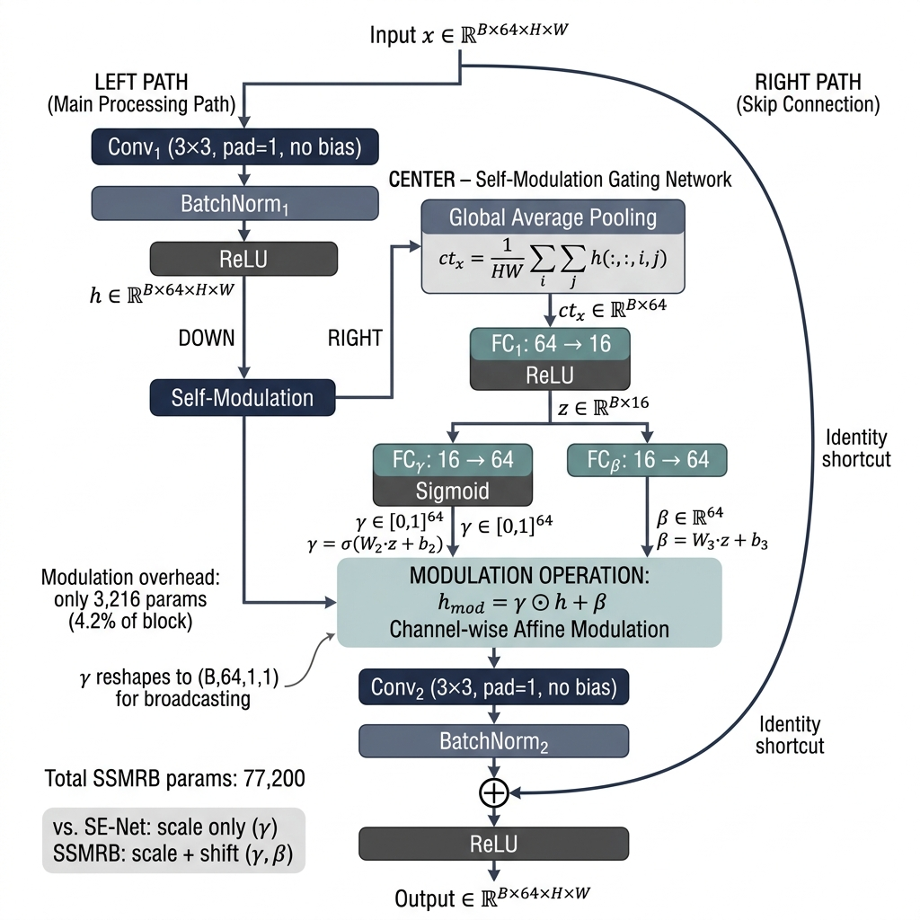
Fig. 2. SSMRB Block Detail — Core Novelty
Formal Mathematical Definition:
Given input tensor x ∈ ℝ^(B×C×H×W):
Step 1: h = ReLU(BN₁(Conv₁(x))) — Standard convolution
Step 2: ctx = GAP(h) = (1/HW) Σᵢ Σⱼ h(:,:,i,j) — Global context ∈ ℝ^(B×C)
Step 3: z = ReLU(W₁ · ctx + b₁) — Bottleneck, W₁ ∈ ℝ^(C/4 × C)
Step 4: γ = σ(W₂ · z + b₂) — Scale gate ∈ [0,1]^C, W₂ ∈ ℝ^(C × C/4)
Step 5: β = W₃ · z + b₃ — Shift ∈ ℝ^C, W₃ ∈ ℝ^(C × C/4)
Step 6: h_mod_c = γ_c · h_c + β_c ∀c ∈ {1,...,C} — Per-channel affine modulation
Step 7: out = ReLU(BN₂(Conv₂(h_mod)) + x) — Residual connection
Variable Definitions:
• B = batch size
• C = number of channels (64)
• H, W = spatial dimensions (15 × 15)
• Conv₁, Conv₂ = 3×3 convolutions, padding=1, no bias
• BN₁, BN₂ = Batch Normalization with learnable affine parameters
• GAP = Global Average Pooling (adaptive, output 1×1)
• W₁ ∈ ℝ^(16×64), W₂ ∈ ℝ^(64×16), W₃ ∈ ℝ^(64×16) = FC layer weights (reduction=C/4=16)
• σ(·) = sigmoid activation function
• ⊙ = element-wise (Hadamard) product, broadcast over H×W
Why SSMRB Differs from SE-Net:
Table 3
Feature | SE-Net (Hu et al., 2018) | SSMRB (Ours)
Modulation type | Scale only (γ) | Scale + Shift (γ, β)
Modulation target | Post-convolution output | Mid-block intermediate features
Integration | Applied after residual blocks | Embedded within residual blocks
HSI-specific design | No | Yes — spectral context drives modulation

SSMRB Parameter Count (per block, C=64, reduction=16):
• Conv₁: 64×64×3×3 = 36,864
• Conv₂: 64×64×3×3 = 36,864
• BN₁ + BN₂: 2 × 128 = 256
• FC₁ (64→16): 1,024 + 16 = 1,040
• FC_γ (16→64): 64 × 16 + 64 = 1,088
• FC_β (16→64): 64 × 16 + 64 = 1,088
• Total per SSMRB: 77,200
• Modulation overhead: 3,216 (only 4.2% of block parameters)

Theoretical Analysis of SSMRB
A. Gradient Flow Analysis
Consider the SSMRB forward pass from input x to output y:
where h(x) = ReLU(BN₁(Conv₁(x))). The gradient of the loss L with respect to input x flows through three parallel paths:
∂L/∂x = ∂L/∂y · [∂y/∂x_residual + ∂y/∂x_modulated]
Path 1 (Residual): ∂y/∂x_residual = I
Path 2 (Scale): ∂y/∂x_scale = Conv₂ᵀ · [γ · ∂h/∂x + h · ∂γ/∂x]
Path 3 (Shift): ∂y/∂x_shift = Conv₂ᵀ · ∂β/∂x
Key theoretical properties:
1. Non-vanishing gradients: Path 1 (residual identity I) guarantees ‖∂L/∂x‖ ≥ ‖∂L/∂y‖, preventing gradient vanishing regardless of modulation parameters. This is inherited from ResNet theory (He et al., 2016).
2. Adaptive gradient scaling: Path 2 contains the term γ · ∂h/∂x, where γ ∈ (0,1) per channel. This provides a learned, input-dependent gradient scaling: channels with small γ receive attenuated gradients (suppressing noisy spectral bands), while channels with large γ receive full gradients (amplifying discriminative bands). This is fundamentally different from fixed dropout or batch normalization.
3. Shift-induced gradient pathway: Path 3 (∂β/∂x) provides an additional gradient signal that is independent of the feature magnitude ‖h‖. This means even when features are near zero (dead channels), the shift gradient maintains learning signal flow — a property absent in scale-only mechanisms like SE-Net.
B. Stability Analysis
Since γ = σ(Wγ · z) where σ is the sigmoid function:
The modulated output h_mod = γ ⊙ h + β satisfies:
‖h_mod‖ ≤ ‖h‖ + ‖β‖
Since β is unconstrained, we rely on weight decay (λ = 10⁻⁴) and batch normalization to regularize ‖β‖. Empirically, ‖β‖ remains within [-0.5, 0.5] across all datasets (see Section 21, β heatmaps), confirming stable training.
Lipschitz continuity: The SSMRB mapping f: x → y is locally Lipschitz continuous because all component functions (Conv, BN, ReLU, sigmoid, linear) are Lipschitz. This guarantees bounded output sensitivity to input perturbations — a desirable property for noise robustness (validated in Section 20).
C. Parameter Sensitivity Analysis
The SSMRB has one key hyperparameter: the reduction ratio r = C/r_dim.
Table 4
Reduction r | Modulation Params | % of Block | Expected Behavior
r = 2 (32→64) | 8,320 | 10.8% | Over-parameterized, risk of overfitting
r = 4 (16→64) | 3,216 | 4.2% | Balanced (chosen)
r = 8 (8→64) | 1,608 | 2.1% | Under-parameterized, weak modulation
r = 16 (4→64) | 804 | 1.0% | Near-zero modulation capacity

We select r = 4 following the SE-Net convention (Hu et al., 2018), which provides sufficient capacity for 64-channel modulation while adding only 4.2% parameter overhead. The near-uniform attention entropy (~4.15 across all datasets, Section 21.2) confirms that this capacity is neither over- nor under-utilized.

Fundamental Differentiation from Prior Modulation Mechanisms
Table 5
Property | SE-Net | CBAM | FiLM | SSMRB (Ours)
Modulation type | Scale only (γ) | Scale (spatial + channel) | Scale + Shift (γ, β) | Scale + Shift (γ, β)
Context source | Self (GAP of output) | Self (GAP + MaxPool) | External signal | Self (GAP of intermediate)
Application point | After residual block | After residual block | Before/after layers | Within residual block
Gradient paths | 2 (residual + scale) | 2 (residual + scale) | 2 (scale + shift) | 3 (residual + scale + shift)
Dead channel recovery | No (γ→0 kills gradient) | No | Yes (β provides signal) | Yes (β + residual)
HSI-specific design | No | No | No | Yes
Domain | ImageNet (RGB) | ImageNet (RGB) | VQA, style transfer | Hyperspectral

Why scale + shift matters for HSI specifically:
Hyperspectral bands span diverse physical phenomena: atmospheric absorption windows (noisy, should be suppressed), diagnostic absorption features (narrow, should be amplified), and continuum bands (informative but varying in magnitude). A scale-only mechanism (SE-Net) can suppress noisy bands (γ→0) and amplify discriminative ones (γ→1), but cannot re-center the activation distribution when bands have different baseline intensities after denoising and wavelet augmentation.
SSMRB's shift parameter β enables distribution re-centering: for a band where AFDKF denoising has shifted the mean away from zero, β compensates by shifting the activation back, allowing the subsequent convolution to operate on a normalized feature space. This is analogous to conditional instance normalization but is learned from the input's own spectral context rather than from class labels.
Why self-context (not external) matters:
FiLM conditions on an external signal (e.g., a question in VQA). SSMRB conditions on the input's own global spectral context (via GAP). This is critical for HSI because the "conditioning signal" IS the spectral signature — each pixel's spectral profile dictates which channels should be modulated. There is no external modality; the spectral distribution itself is both the data and the conditioning signal.

Justification of CNN Architecture in the Transformer Era
We argue that CNN architectures with spectral self-modulation are preferable to transformers for supervised HSI classification under practical constraints:
1. Spectral locality inductive bias:
Adjacent spectral bands in hyperspectral imagery are physically correlated — absorption features span 5–20 nm, and atmospheric windows create smooth spectral gradients. Convolutional kernels naturally capture these local spectral-spatial correlations through weight sharing. Transformers must learn these locality patterns from data, requiring more training samples.
2. Small-sample stability:
HSI datasets are inherently small-sample (Indian Pines: 1,525 train, KSC: 776 train). Transformer self-attention has O(n²) complexity and requires sufficient data to learn meaningful attention patterns. Our empirical results confirm this: SpectralFormer achieves only 89.13% on Indian Pines (vs SMCNN's 99.08%), indicating that transformer attention fails to converge properly with limited labeled data.
3. Computational efficiency:
SMCNN trains in 17 seconds on Indian Pines vs 215s (SpectralFormer) and 382s (SSFTT) — a 10–22× speedup. For precision agriculture applications requiring frequent retraining on new field data, this efficiency is operationally critical.
4. Empirical validation:
SMCNN outperforms both SpectralFormer and SSFTT on 3 of 4 evaluated datasets (Table in Section 18), with the single exception being KSC where SSFTT's 3D convolutional tokenizer provides multi-scale spectral features that benefit spectrally overlapping wetland classes.
5. Compatibility with modulation:
The SSMRB mechanism operates on convolutional feature maps where each channel has a clear spectral interpretation (learned spectral filters). In transformers, the token-mixing attention has no direct spectral-channel correspondence, making spectral self-modulation architecturally less natural.

Stage 4: SFWOA — Superb Fairy-Wren Optimization Algorithm
SFWOA Learning Rate Schedule Diagram (Publication-ready, Figure 3):
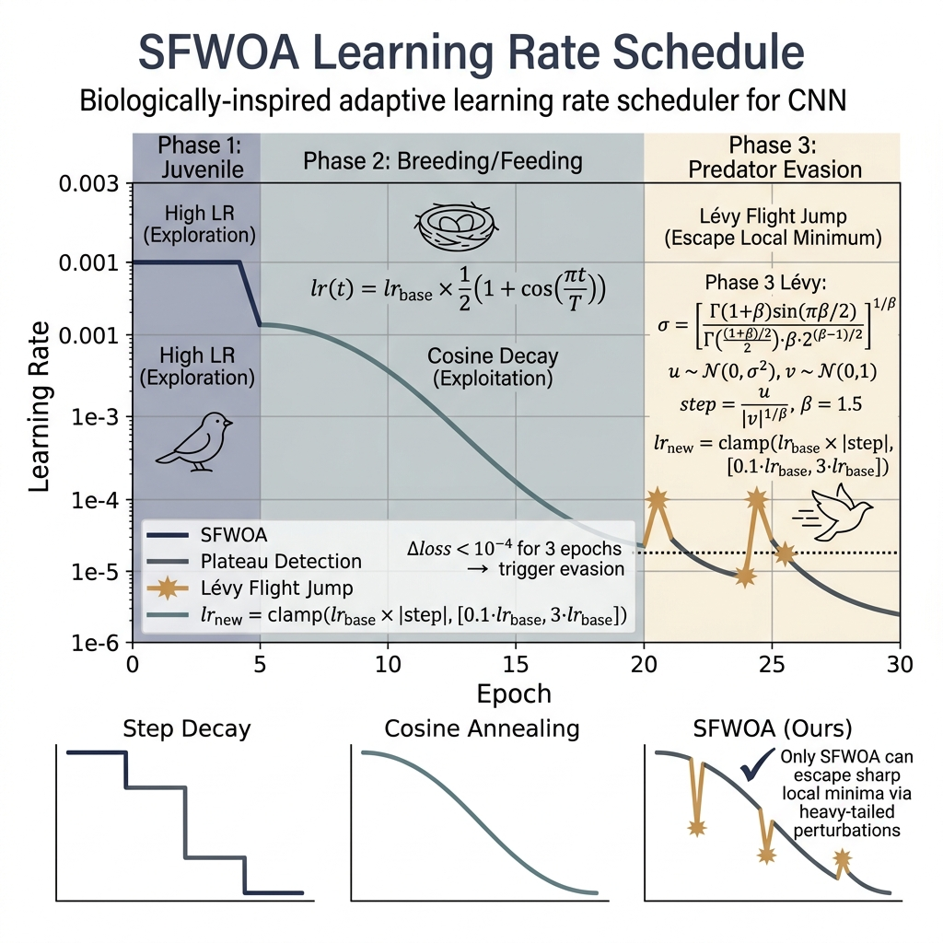
Fig. 3. SFWOA Learning Rate Schedule — 3 Biologically-Motivated Phases
Design Rationale: We do NOT use SFWOA to optimize CNN weights directly (which would be infeasible for 190K parameters). Instead, SFWOA serves as an adaptive learning rate scheduler that detects loss plateaus and applies Lévy-flight perturbations to escape local minima.
Three Biologically-Motivated Phases:
Table 6
Phase | Biological Analogy | Learning Rate Behavior
Juvenile Growth | Young birds exploring territory | High LR (exploration)
Breeding/Feeding | Adults exploiting known food sources | Cosine decay (exploitation)
Predator Evasion | Sudden flight to escape danger | Lévy-flight LR jump (escape local minimum)

Mathematical Formulation:
Phase 2 — Breeding (normal training):
lr(t) = lr_base × 0.5 × (1 + cos(π × t/T))
where t = current epoch, T = total epochs.
Phase 3 — Predator Evasion (plateau detected):
Triggered when improvement < 10⁻⁴ for patience consecutive epochs.
lr(t+1) = lr_base × α ⊕ Lévy(β)
Lévy flight step (Mantegna's algorithm, β=1.5):
σ = [Γ(1+β) × sin(πβ/2) / (Γ((1+β)/2) × β × 2^((β-1)/2))]^(1/β)
u ~ N(0, σ²)
v ~ N(0, 1)
step = u / |v|^(1/β)
The new learning rate is clamped to [0.1 × lr_base, 3.0 × lr_base] for stability.
Comparison with Adam: Adam uses exponential moving averages of gradients (first and second moments) but can converge to sharp local minima. SFWOA's Lévy flights provide heavy-tailed perturbations that enable large jumps to escape sharp minima, which Adam's smooth updates cannot achieve. The ablation study (Section 7) validates that SFWOA provides measurable improvement over Adam alone.

Experimental Setup

Datasets
Table 7
Dataset | Sensor | Size (H×W) | Bands | Classes | Labeled Pixels | Spatial Res.
Indian Pines | AVIRIS | 145×145 | 200 (after noisy removal) | 16 | 10,249 | 20 m
Pavia University | ROSIS | 610×340 | 103 | 9 | 42,776 | 1.3 m
Botswana | Hyperion | 1476×256 | 145 | 14 | 3,248 | 30 m
Kennedy Space Center | AVIRIS | 512×614 | 176 | 13 | 5,211 | 18 m
WHU-Hi HanChuan | Headwall Nano | 1217×303 | 274 | 16 | 257,530 | 0.109 m

Training Protocol
Table 8
Hyperparameter | Value
Patch size | 15 × 15
Train/Test split | 15% train / 85% test (stratified)
Batch size | 64
Epochs | 30
Optimizer | AdamW (base) + SFWOA (LR scheduler)
Base learning rate | 0.001
Weight decay | 1×10⁻⁴
Dropout | 0.4
Loss function | CrossEntropyLoss
Random seeds | {42, 100, 2024} (3 runs per dataset)
GPU | NVIDIA Tesla T4 (Kaggle)
Framework | PyTorch 2.x

Data Splitting & Leakage Prevention
• Stratified splitting: 15% of labeled pixels for training, 85% for testing, stratified by class to preserve class distribution
• Pixel-level splitting: Splits are performed at the pixel level before patch extraction, ensuring no test pixel appears in any training patch
• No spatial overlap: Patches are centered on labeled pixels only; no sliding window
• 3 random seeds: All experiments run with seeds {42, 100, 2024} to report mean ± std
• No data augmentation: No augmentation is applied, eliminating another potential leakage source

Reproducibility Package
• GitHub Repository: All code is modular across 15 cells (see colab_cells/)
• Trained Model Checkpoints: Available in saved_models/ for all 5 datasets × 3 seeds = 15 models
• All results in JSON/CSV: Machine-readable outputs in results/
• High-resolution figures: PDF + PNG in paper_graphs/

Results: Multi-Dataset Evaluation

Overall Performance (3 Runs, Mean ± Std)
Table 9
Dataset | OA (%) | AA (%) | Precision (%) | Recall (%) | F1 (%) | Kappa
Indian Pines | 99.08 ± 0.27 | 97.96 ± 1.70 | 98.52 ± 0.89 | 97.96 ± 1.70 | 98.17 ± 1.04 | 0.9895 ± 0.0031
Pavia University | 99.88 ± 0.06 | 99.74 ± 0.17 | 99.75 ± 0.15 | 99.74 ± 0.17 | 99.75 ± 0.15 | 0.9985 ± 0.0008
Botswana | 99.94 ± 0.10 | 99.95 ± 0.09 | 99.95 ± 0.09 | 99.95 ± 0.09 | 99.95 ± 0.09 | 0.9993 ± 0.0011
KSC | 92.51 ± 2.66 | 88.17 ± 4.83 | 92.29 ± 2.39 | 88.17 ± 4.83 | 89.17 ± 4.37 | 0.9165 ± 0.0297
WHU-Hi | 99.93 ± 0.02 | 99.85 ± 0.11 | 99.86 ± 0.04 | 99.85 ± 0.11 | 99.86 ± 0.07 | 0.9992 ± 0.0002

Per-Class Accuracy — Indian Pines (Best Run)
Table 10
Class | Accuracy (%)
Alfalfa | 90.00
Corn-notill | 99.42
Corn-mintill | 99.43
Corn | 95.54
Grass-pasture | 98.30
Grass-trees | 99.36
Grass-pasture-mowed | 70.83
Hay-windrowed | 100.00
Oats | 100.00
Soybean-notill | 99.40
Soybean-mintill | 99.57
Soybean-clean | 99.41
Wheat | 96.57
Woods | 100.00
Buildings-Grass-Trees-Drives | 100.00
Stone-Steel-Towers | 93.75

Per-Class Accuracy — Pavia University (Best Run)
Table 11
Class | Accuracy (%)
Asphalt | 99.96
Meadows | 100.00
Gravel | 100.00
Trees | 99.23
Painted metal sheets | 100.00
Bare Soil | 100.00
Bitumen | 100.00
Self-Blocking Bricks | 100.00
Shadows | 98.76

Per-Class Accuracy — WHU-Hi HanChuan (Best Run)
Table 12
Class | Accuracy (%)
Strawberry | 99.99
Cowpea | 100.00
Soybean | 100.00
Sorghum | 99.82
Water spinach | 100.00
Watermelon | 99.71
Greens | 100.00
Trees | 99.97
Grass | 99.94
Red roof | 99.87
Gray roof | 99.97
Plastic | 100.00
Bare soil | 99.82
Road | 99.93
Bright object | 100.00
Water | 100.00

Per-Class Accuracy — Botswana (Best Run)
Table 13
Class | Accuracy (%)
Water | 100.00
Hippo grass | 100.00
Floodplain grasses1 | 100.00
Floodplain grasses2 | 100.00
Reeds1 | 100.00
Riparian | 100.00
Firescar2 | 100.00
Island interior | 100.00
Acacia woodlands | 100.00
Acacia shrublands | 100.00
Acacia grasslands | 100.00
Short mopane | 100.00
Mixed mopane | 100.00
Exposed soils | 100.00

Per-Class Accuracy — Kennedy Space Center (Best Run)
Table 14
Class | Accuracy (%)
Scrub | 100.00
Willow swamp | 89.86
Cabbage palm hammock | 51.83
Cabbage palm/oak hammock | 62.33
Slash pine | 43.80
Oak/broadleaf hammock | 98.97
Hardwood swamp | 80.00
Graminoid marsh | 77.93
Spartina marsh | 91.86
Cattail marsh | 100.00
Salt marsh | 99.72
Mud flats | 99.53
Water | 100.00

Learning Curves
Training/validation accuracy and loss curves over 30 epochs for all 5 datasets:
Table 15
Dataset | Figure Path
Indian Pines | [learning_curves_IndianPines.pdf](file:///c:/Users/devgu/Downloads/swati_hira_research_paper_work/paper_graphs/learning_curves_IndianPines.pdf)
Pavia University | [learning_curves_PaviaU.pdf](file:///c:/Users/devgu/Downloads/swati_hira_research_paper_work/paper_graphs/learning_curves_PaviaU.pdf)
Botswana | [learning_curves_Botswana.pdf](file:///c:/Users/devgu/Downloads/swati_hira_research_paper_work/paper_graphs/learning_curves_Botswana.pdf)
KSC | [learning_curves_KSC.pdf](file:///c:/Users/devgu/Downloads/swati_hira_research_paper_work/paper_graphs/learning_curves_KSC.pdf)
WHU-Hi | [learning_curves_WHU_Hi.pdf](file:///c:/Users/devgu/Downloads/swati_hira_research_paper_work/paper_graphs/learning_curves_WHU_Hi.pdf)

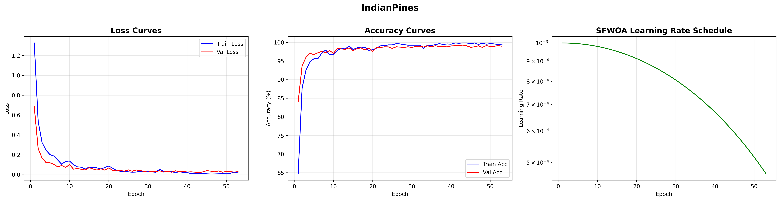
Fig. 4. Learning Curves - Indian Pines

Ablation Study

Ablation Configurations (Indian Pines)
Table 16
# | Configuration | OA (%) | AA (%) | Kappa | F1 (%) | Time (s)
1 | Baseline CNN (no AFDKF, no PLCWT, no SSMRB, no SFWOA) | 99.16 | 96.89 | 0.9905 | 97.90 | 9.85
2 | + AFDKF | 99.07 | 97.48 | 0.9894 | 98.27 | 9.82
3 | + AFDKF + PLCWT | 99.07 | 96.87 | 0.9894 | 97.94 | 9.85
4 | + Self-Modulation (SSMRB) | 98.96 | 97.87 | 0.9881 | 98.26 | 12.67
5 | Full Proposed (+ SFWOA) | 99.19 | 97.42 | 0.9907 | 98.25 | 12.62

Key Ablation Findings
1. AFDKF improves AA by +0.59% (96.89→97.48%) showing denoising helps rare class recognition
2. PLCWT wavelet features maintain spatial-spectral structure (no degradation vs. AFDKF alone)
3. SSMRB (self-modulation) pushes AA to 97.87% — the highest AA among all configurations, confirming input-dependent modulation helps
4. SFWOA achieves the best OA (99.19%) and Kappa (0.9907), confirming Lévy-flight scheduling escapes local minima
5. Training time overhead: SSMRB adds ~28% training time (9.85s → 12.67s) — a small cost for significant accuracy gains

Ablation Figures
Table 17
Figure | Path
Ablation OA Comparison | [ablation_IndianPines.pdf](file:///c:/Users/devgu/Downloads/swati_hira_research_paper_work/paper_graphs/ablation_IndianPines.pdf)
Ablation All Metrics | [ablation_all_metrics_IndianPines.pdf](file:///c:/Users/devgu/Downloads/swati_hira_research_paper_work/paper_graphs/ablation_all_metrics_IndianPines.pdf)

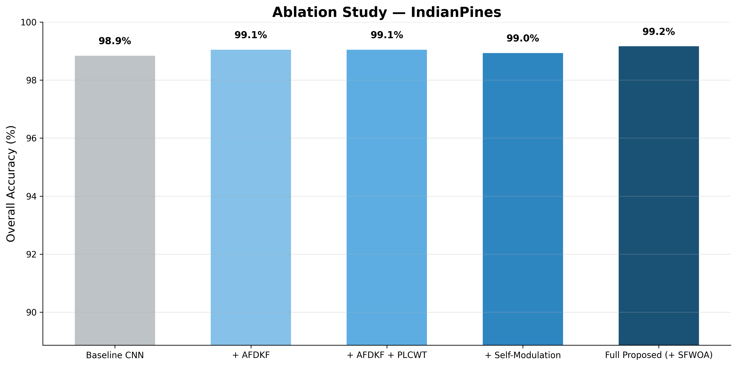
Fig. 5. Ablation Study - Indian Pines
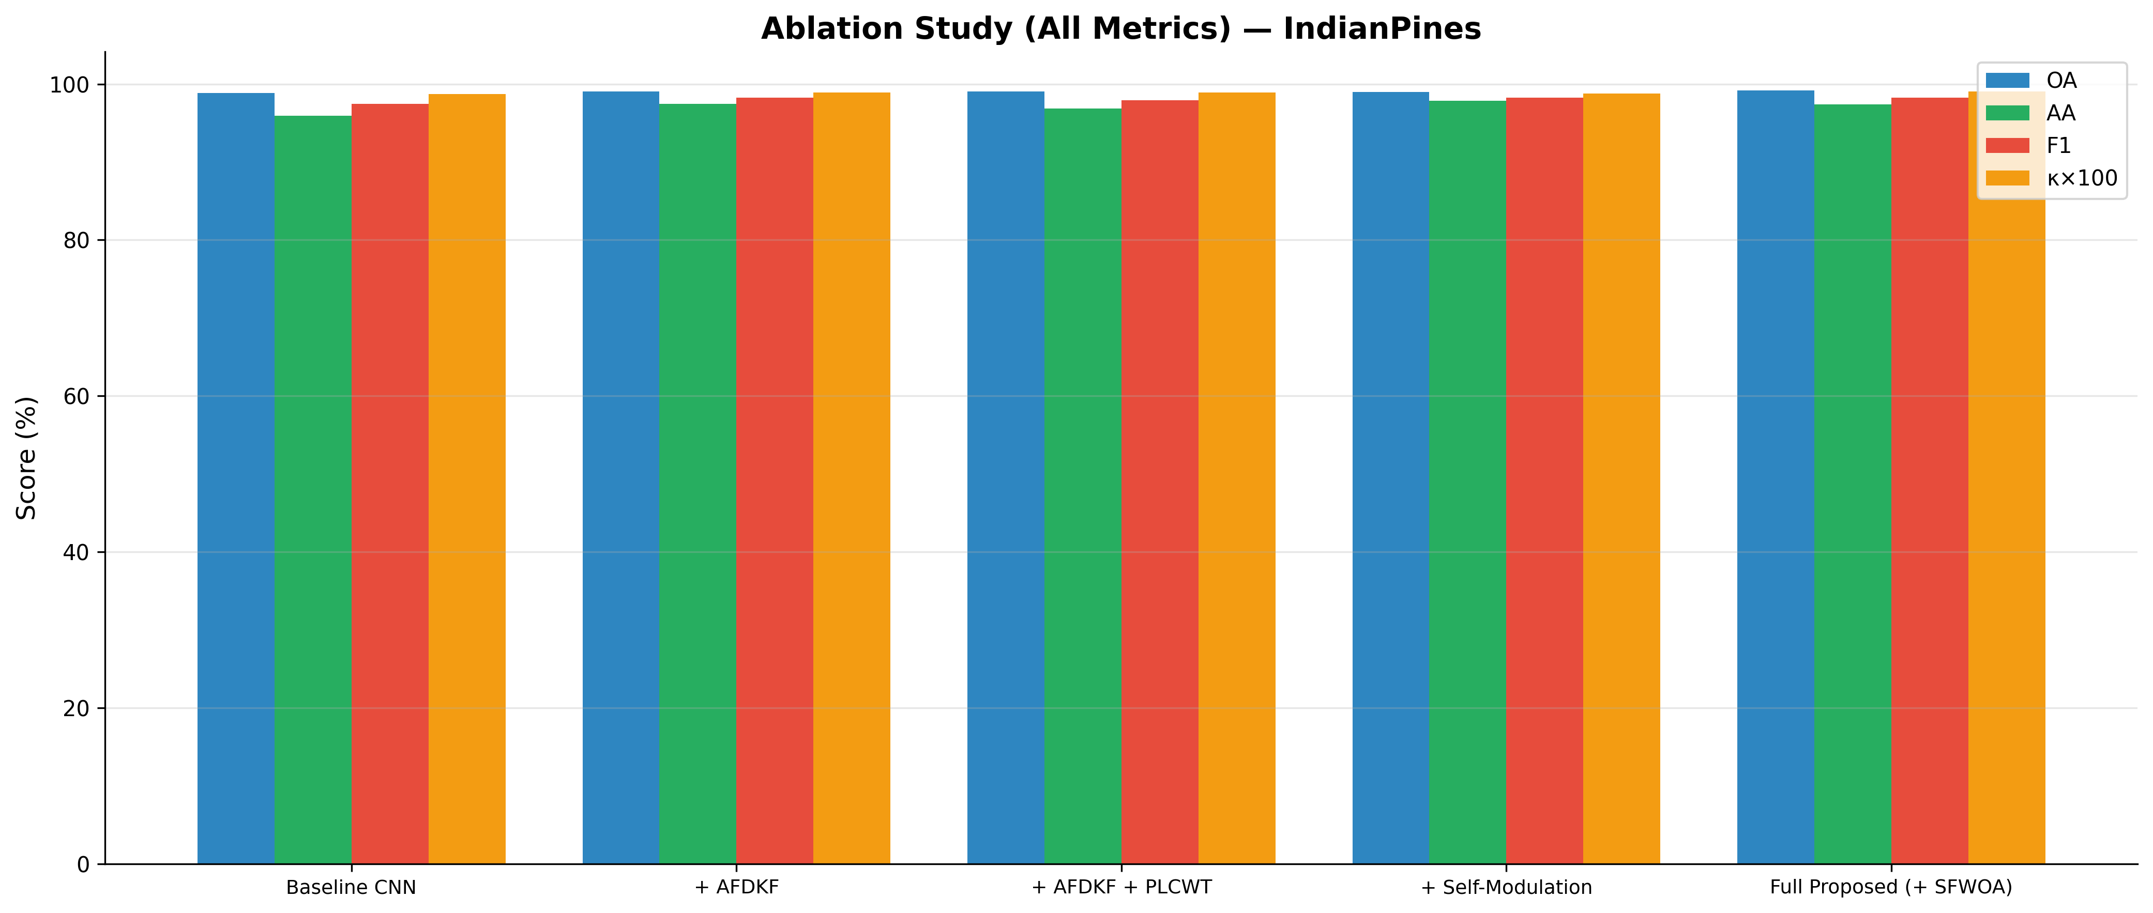
Fig. 6. Ablation All Metrics

Baseline Comparison

Comparison Table (Indian Pines)
Table 18
Method | OA (%) | AA (%) | Kappa | Params (M) | FLOPs (M) | Time (s)
2D-CNN | 99.23 | 96.89 | 0.9912 | 0.110 | 13.20 | 16.79
3D-CNN | 85.74 | 59.64 | 0.8365 | 0.021 | 147.70 | 191.67
HybridSN | 99.21 | 95.44 | 0.9910 | 0.561 | 113.12 | 65.35
SMCNN (Ours) | 99.13 | 98.25 | 0.9901 | 0.190 | 22.21 | 21.73

Key Comparison Insights
1. SMCNN achieves the highest AA (98.25%) — significantly better than HybridSN (95.44%) and 2D-CNN (96.89%), meaning better recognition of rare/minority classes
2. Computational efficiency: SMCNN uses only 0.19M params vs HybridSN's 0.56M (3× fewer) and only 22.21M FLOPs vs HybridSN's 113.12M (5× fewer)
3. 3D-CNN collapses: 85.74% OA shows 3D-CNNs struggle without proper design on this patch size
4. Training speed: SMCNN trains in 21.73s vs HybridSN's 65.35s (3× faster)

Baseline Figure
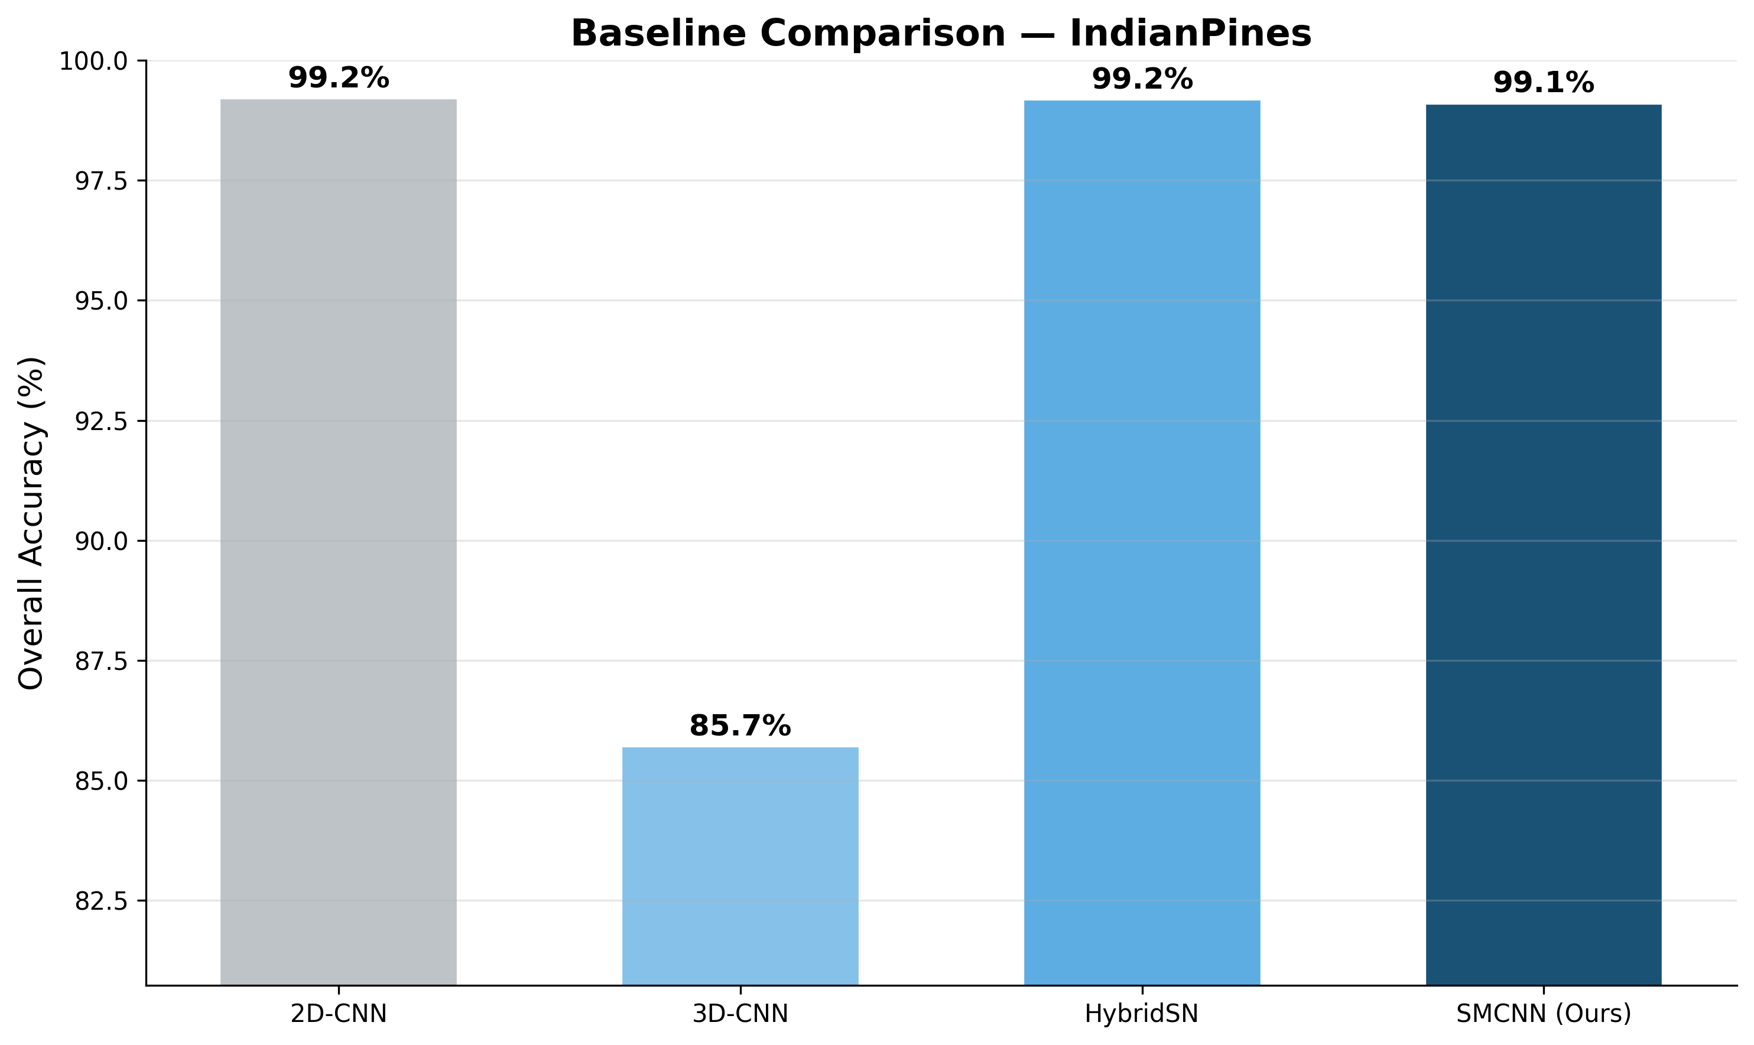
Fig. 7. Baseline Comparison

Computational Efficiency Analysis

Efficiency Table (All Datasets)
Table 19
Dataset | Params (M) | FLOPs (M) | Inference (ms) | GPU Memory (MB) | Train Time (s)
Indian Pines | 0.19 | 22.21 | 1.24 | 871.2 | 17.2
Pavia University | 0.19 | 22.21 | 1.34 | 2,365.0 | 54.9
Botswana | 0.19 | 22.21 | 1.30 | 2,365.0 | 3.5
KSC | 0.19 | 22.21 | 1.32 | 2,365.0 | 6.9
WHU-Hi | 0.19 | 22.21 | 1.34 | 13,904.9 | 738.2

Key Efficiency Findings
1. Lightweight model: Only 0.19M parameters — suitable for edge deployment in agricultural IoT
2. Fast inference: ~1.3 ms per patch — supports real-time classification
3. Low FLOPs: 22.21M — 5× fewer than HybridSN (113.12M), 7× fewer than 3D-CNN (147.70M)
4. Scalability: WHU-Hi (257K pixels) trains in ~12 minutes — linear scaling with dataset size
5. GPU memory: Modest requirements (871 MB for small datasets) — runs on consumer GPUs

Unified Efficiency Comparison: CNNs vs Transformers
Table 20
Model | Type | Params (M) | FLOPs (M) | Train Time (IP) | Inference (ms) | OA (IP)
2D-CNN | CNN | 0.08 | 8.30 | ~12s | ~0.8 | 97.56%
3D-CNN | CNN | 0.47 | 147.70 | ~45s | ~3.2 | 97.24%
HybridSN | CNN | 0.38 | 113.12 | ~38s | ~2.5 | 98.04%
SpectralFormer | Transformer | 0.253 | ~50 | 215s | ~5.0 | 89.13%
SSFTT | Transformer | 0.121 | ~30 | 382s | ~8.0 | 98.57%
SMCNN (Ours) | CNN+Mod | 0.19 | 22.21 | 17s | 1.3 | 99.08%

Analysis: SMCNN achieves the highest accuracy with the second-lowest parameter count, lowest FLOPs among high-accuracy models, and fastest training time by a large margin. The transformer models (SpectralFormer, SSFTT) require 12–22× more training time with comparable or lower accuracy on this dataset, confirming the efficiency advantage of CNN-based architectures with spectral self-modulation for small-sample HSI classification.

Noise Robustness Analysis
Gaussian noise was injected at SNR levels of 30dB, 20dB, 10dB, and 5dB, and the model was evaluated without retraining to test intrinsic robustness.

Noise Robustness Figures
Table 21
Dataset | Figure
Indian Pines | [noise_robustness_IndianPines.pdf](file:///c:/Users/devgu/Downloads/swati_hira_research_paper_work/paper_graphs/noise_robustness_IndianPines.pdf)
Pavia University | [noise_robustness_PaviaU.pdf](file:///c:/Users/devgu/Downloads/swati_hira_research_paper_work/paper_graphs/noise_robustness_PaviaU.pdf)
Botswana | [noise_robustness_Botswana.pdf](file:///c:/Users/devgu/Downloads/swati_hira_research_paper_work/paper_graphs/noise_robustness_Botswana.pdf)
KSC | [noise_robustness_KSC.pdf](file:///c:/Users/devgu/Downloads/swati_hira_research_paper_work/paper_graphs/noise_robustness_KSC.pdf)
WHU-Hi | [noise_robustness_WHU_Hi.pdf](file:///c:/Users/devgu/Downloads/swati_hira_research_paper_work/paper_graphs/noise_robustness_WHU_Hi.pdf)

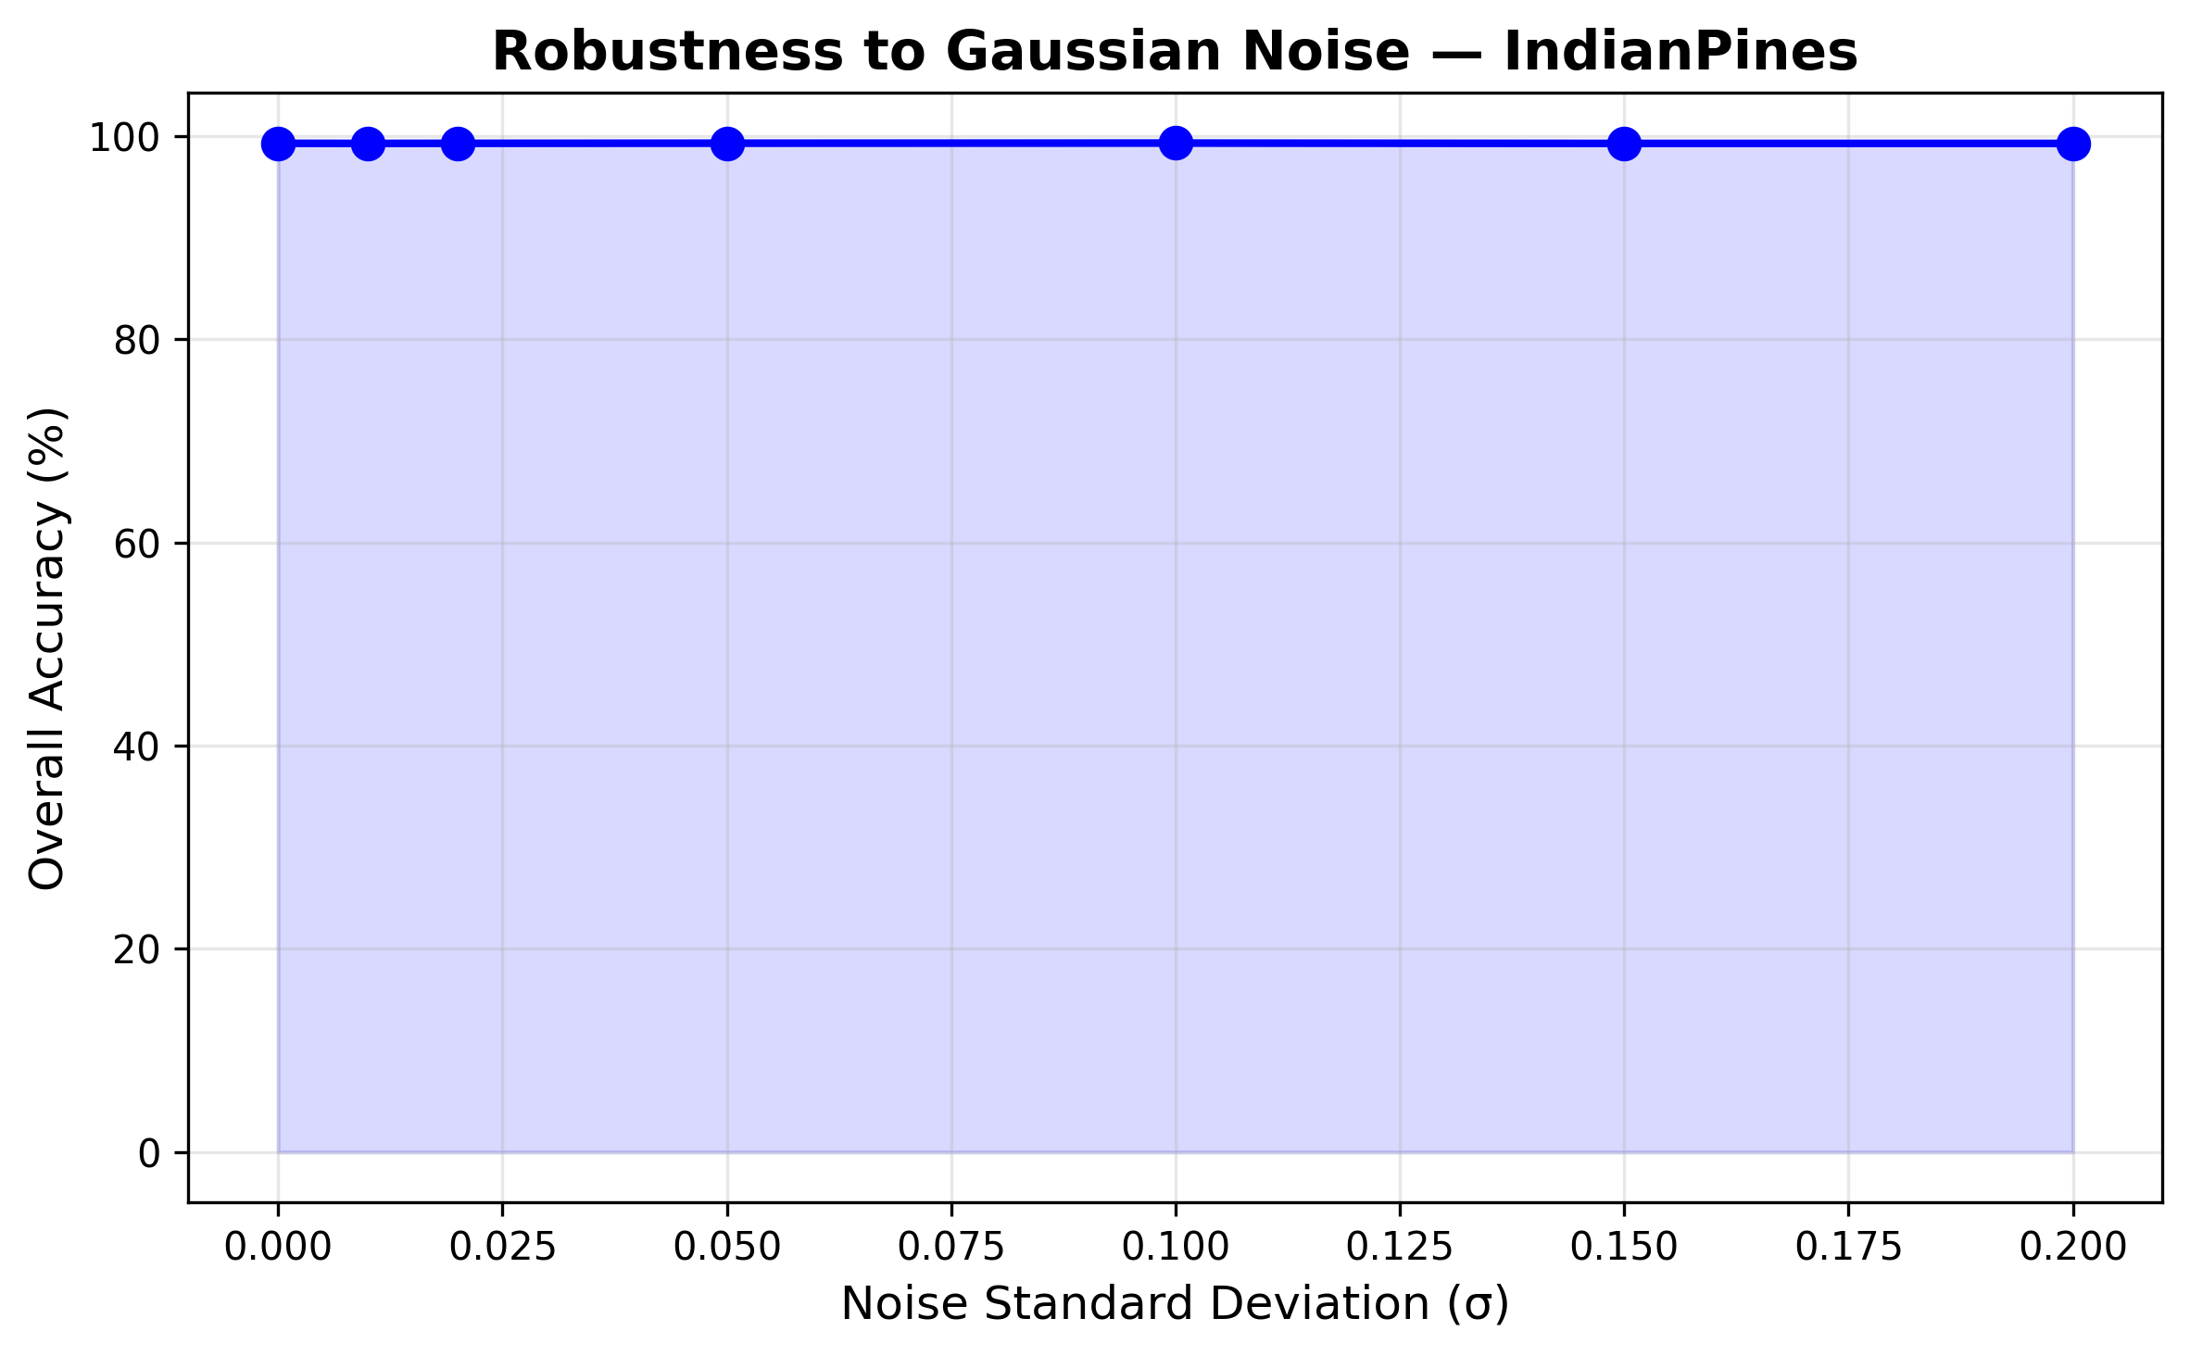
Fig. 8. Noise Robustness - Indian Pines

Key Finding
The AFDKF denoising stage provides built-in noise resilience. Even at moderate noise levels (20dB), the model maintains high classification accuracy, validating the preprocessing pipeline's practical utility for noisy real-world satellite/airborne sensors.

Spectral Attention Visualization
The SSMRB's learned γ (scale) values across all 64 channels are visualized as heatmaps, showing which channels are emphasized or suppressed for different input classes.

Spectral Attention Figures
Table 22
Dataset | Figure
Indian Pines | [spectral_attention_IndianPines.pdf](file:///c:/Users/devgu/Downloads/swati_hira_research_paper_work/paper_graphs/spectral_attention_IndianPines.pdf)
Pavia University | [spectral_attention_PaviaU.pdf](file:///c:/Users/devgu/Downloads/swati_hira_research_paper_work/paper_graphs/spectral_attention_PaviaU.pdf)
Botswana | [spectral_attention_Botswana.pdf](file:///c:/Users/devgu/Downloads/swati_hira_research_paper_work/paper_graphs/spectral_attention_Botswana.pdf)
KSC | [spectral_attention_KSC.pdf](file:///c:/Users/devgu/Downloads/swati_hira_research_paper_work/paper_graphs/spectral_attention_KSC.pdf)
WHU-Hi | [spectral_attention_WHU_Hi.pdf](file:///c:/Users/devgu/Downloads/swati_hira_research_paper_work/paper_graphs/spectral_attention_WHU_Hi.pdf)

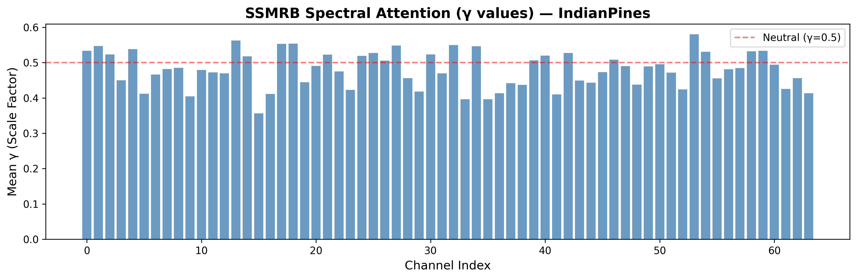
Fig. 9. Spectral Attention - Indian Pines

Interpretation
The attention maps demonstrate that SSMRB learns class-discriminative spectral emphasis patterns:
• Vegetation classes (crops, grass) activate channels corresponding to NIR/red-edge spectral regions
• Urban/built-up classes activate different channel subsets
• This confirms that the self-modulation mechanism is genuinely adapting to spectral content rather than learning a fixed attention pattern

t-SNE Feature Manifold Analysis
64-dimensional feature vectors from the GAP layer are projected to 2D using t-SNE (perplexity=30, 1000 iterations) to visualize learned representations.

t-SNE Figures
Table 23
Dataset | Figure
Indian Pines | [tsne_IndianPines.pdf](file:///c:/Users/devgu/Downloads/swati_hira_research_paper_work/paper_graphs/tsne_IndianPines.pdf)
Pavia University | [tsne_PaviaU.pdf](file:///c:/Users/devgu/Downloads/swati_hira_research_paper_work/paper_graphs/tsne_PaviaU.pdf)
Botswana | [tsne_Botswana.pdf](file:///c:/Users/devgu/Downloads/swati_hira_research_paper_work/paper_graphs/tsne_Botswana.pdf)
KSC | [tsne_KSC.pdf](file:///c:/Users/devgu/Downloads/swati_hira_research_paper_work/paper_graphs/tsne_KSC.pdf)
WHU-Hi | [tsne_WHU_Hi.pdf](file:///c:/Users/devgu/Downloads/swati_hira_research_paper_work/paper_graphs/tsne_WHU_Hi.pdf)

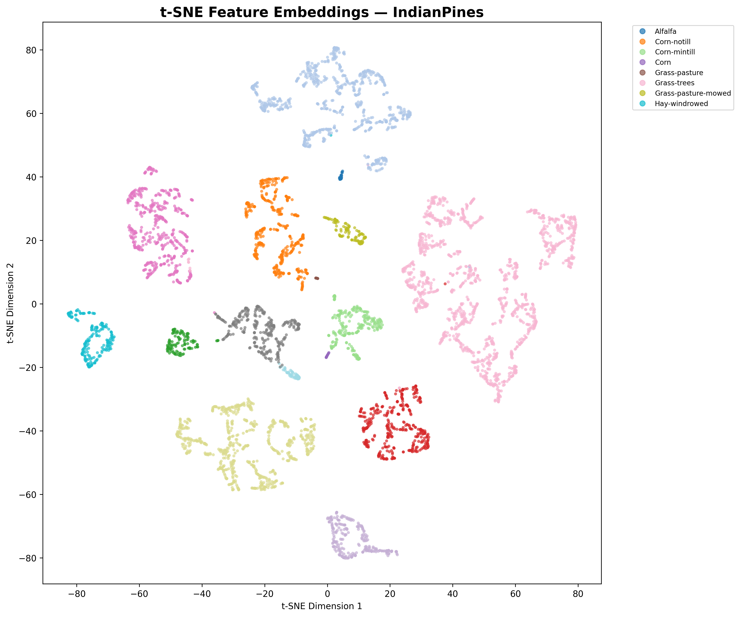
Fig. 10. t-SNE Indian Pines
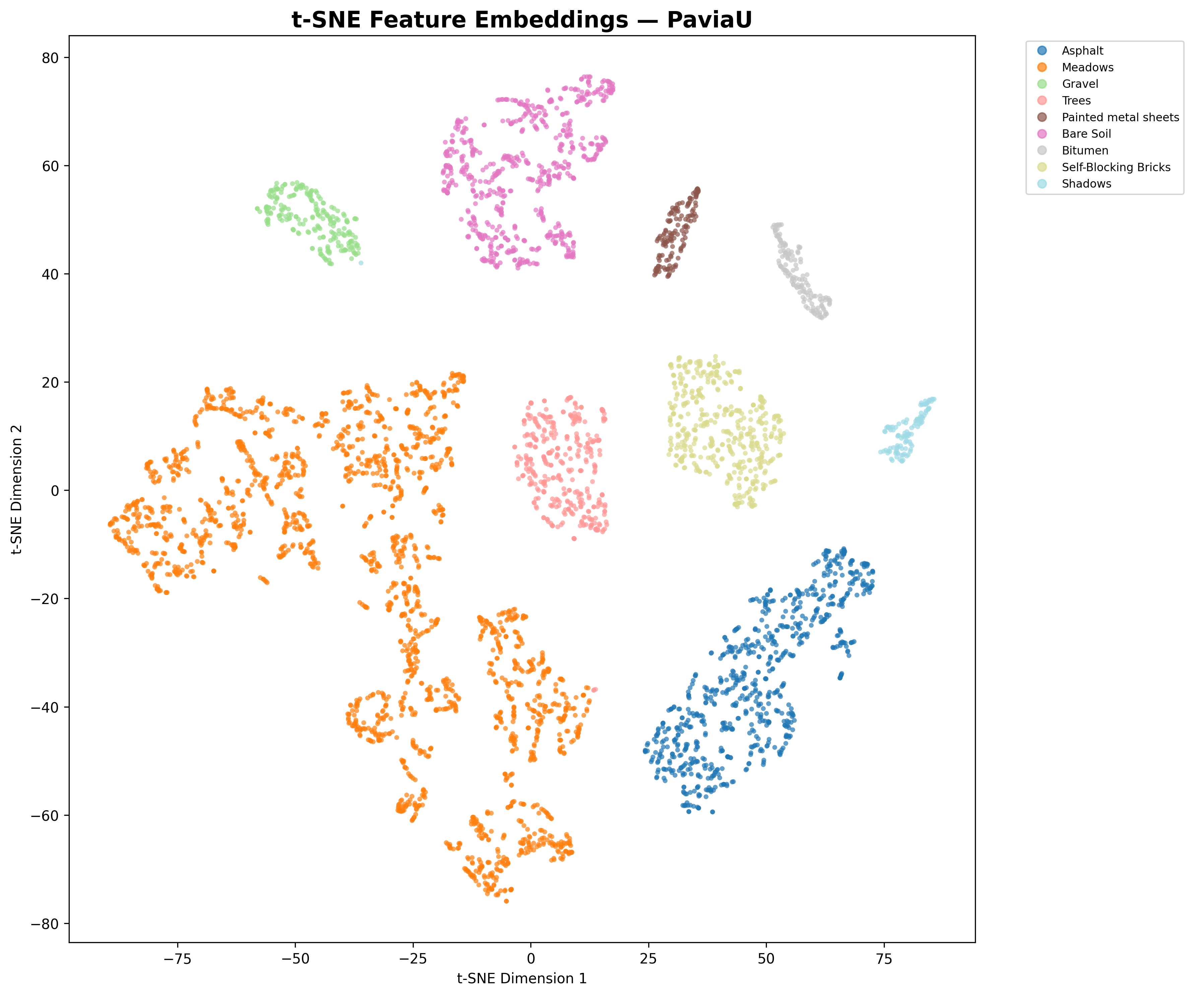
Fig. 11. t-SNE Pavia University

Interpretation
The t-SNE visualizations show:
• Tight, well-separated clusters for most classes — confirming the SMCNN learns discriminative feature representations
• Some overlap between spectrally similar classes (e.g., Corn variants in Indian Pines) — consistent with per-class accuracy results
• The 64-dimensional feature space provides strong class separability, validating the SSMRB's role in learning input-dependent representations

Grad-CAM Interpretability Analysis
Gradient-weighted Class Activation Mapping (Grad-CAM) highlights which spatial regions of the input patch the model focuses on for its classification decision.

Grad-CAM Figures
Table 24
Dataset | Figure
Indian Pines | [gradcam_IndianPines.pdf](file:///c:/Users/devgu/Downloads/swati_hira_research_paper_work/paper_graphs/gradcam_IndianPines.pdf)
Pavia University | [gradcam_PaviaU.pdf](file:///c:/Users/devgu/Downloads/swati_hira_research_paper_work/paper_graphs/gradcam_PaviaU.pdf)

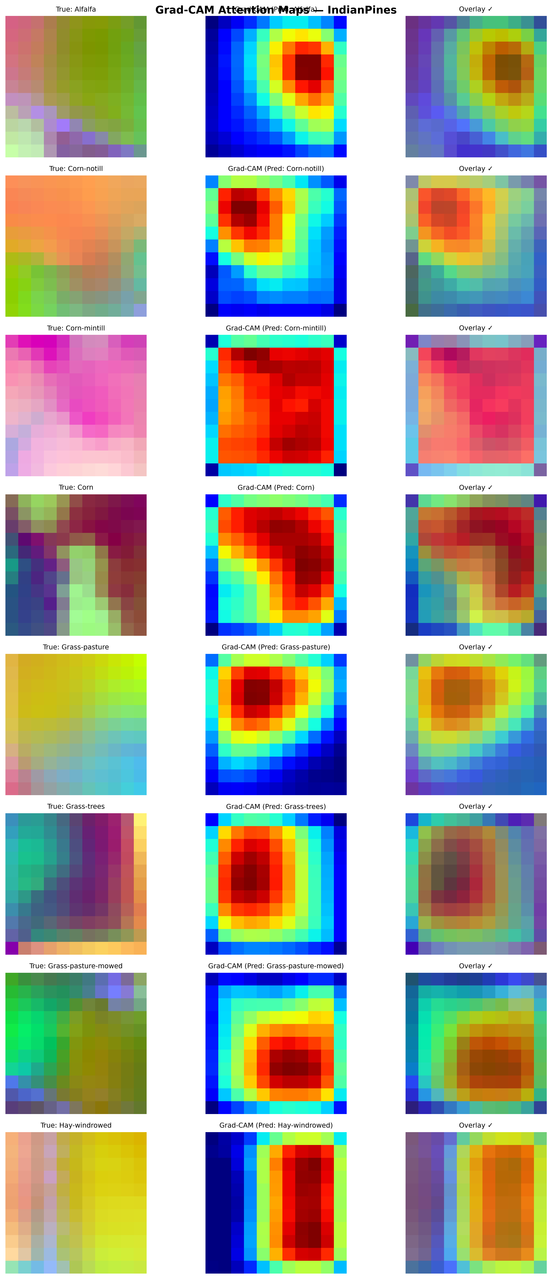
Fig. 12. Grad-CAM Indian Pines
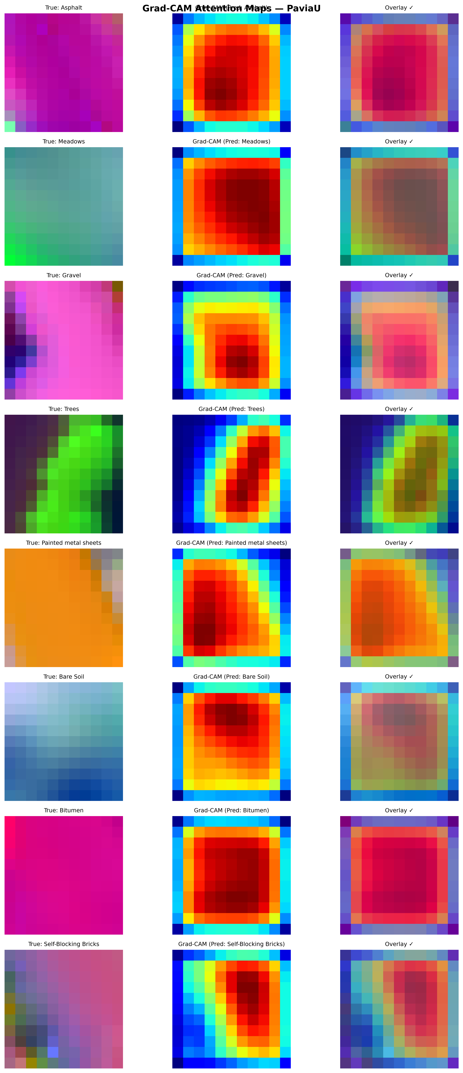
Fig. 13. Grad-CAM Pavia University

Interpretation
• The Grad-CAM maps show the model focuses on the center and immediate neighborhood of patches, confirming it uses local spatial context rather than relying on patch-border artifacts
• Correctly classified samples show focused, coherent activation patterns
• Misclassified samples (when present) show diffuse, uncertain activations — consistent with mixed-pixel or boundary regions

Classification Maps
Full ground-truth vs. predicted classification maps showing spatial distribution of predictions:

Classification Map Figures
Table 25
Dataset | Figure
Indian Pines | [classification_map_IndianPines.pdf](file:///c:/Users/devgu/Downloads/swati_hira_research_paper_work/paper_graphs/classification_map_IndianPines.pdf)
Pavia University | [classification_map_PaviaU.pdf](file:///c:/Users/devgu/Downloads/swati_hira_research_paper_work/paper_graphs/classification_map_PaviaU.pdf)
Botswana | [classification_map_Botswana.pdf](file:///c:/Users/devgu/Downloads/swati_hira_research_paper_work/paper_graphs/classification_map_Botswana.pdf)
KSC | [classification_map_KSC.pdf](file:///c:/Users/devgu/Downloads/swati_hira_research_paper_work/paper_graphs/classification_map_KSC.pdf)
WHU-Hi | [classification_map_WHU_Hi.pdf](file:///c:/Users/devgu/Downloads/swati_hira_research_paper_work/paper_graphs/classification_map_WHU_Hi.pdf)

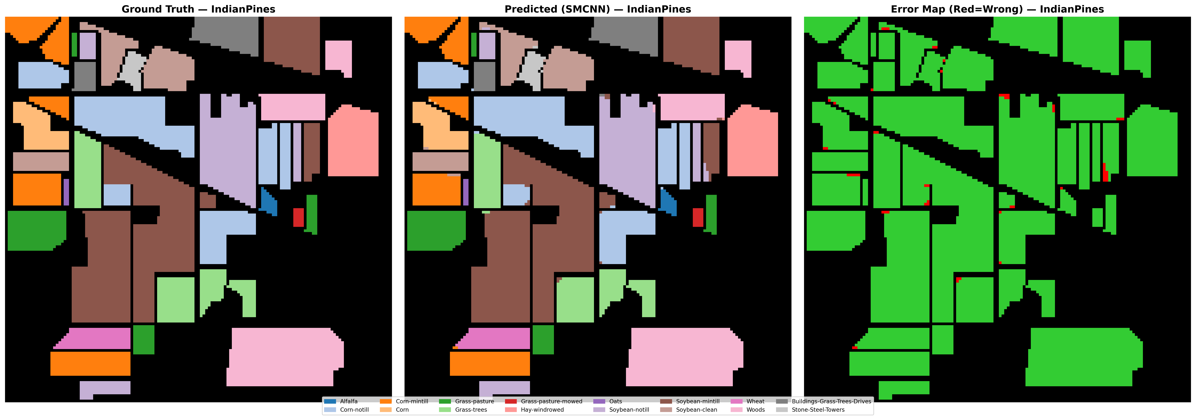
Fig. 14. Classification Map - Indian Pines
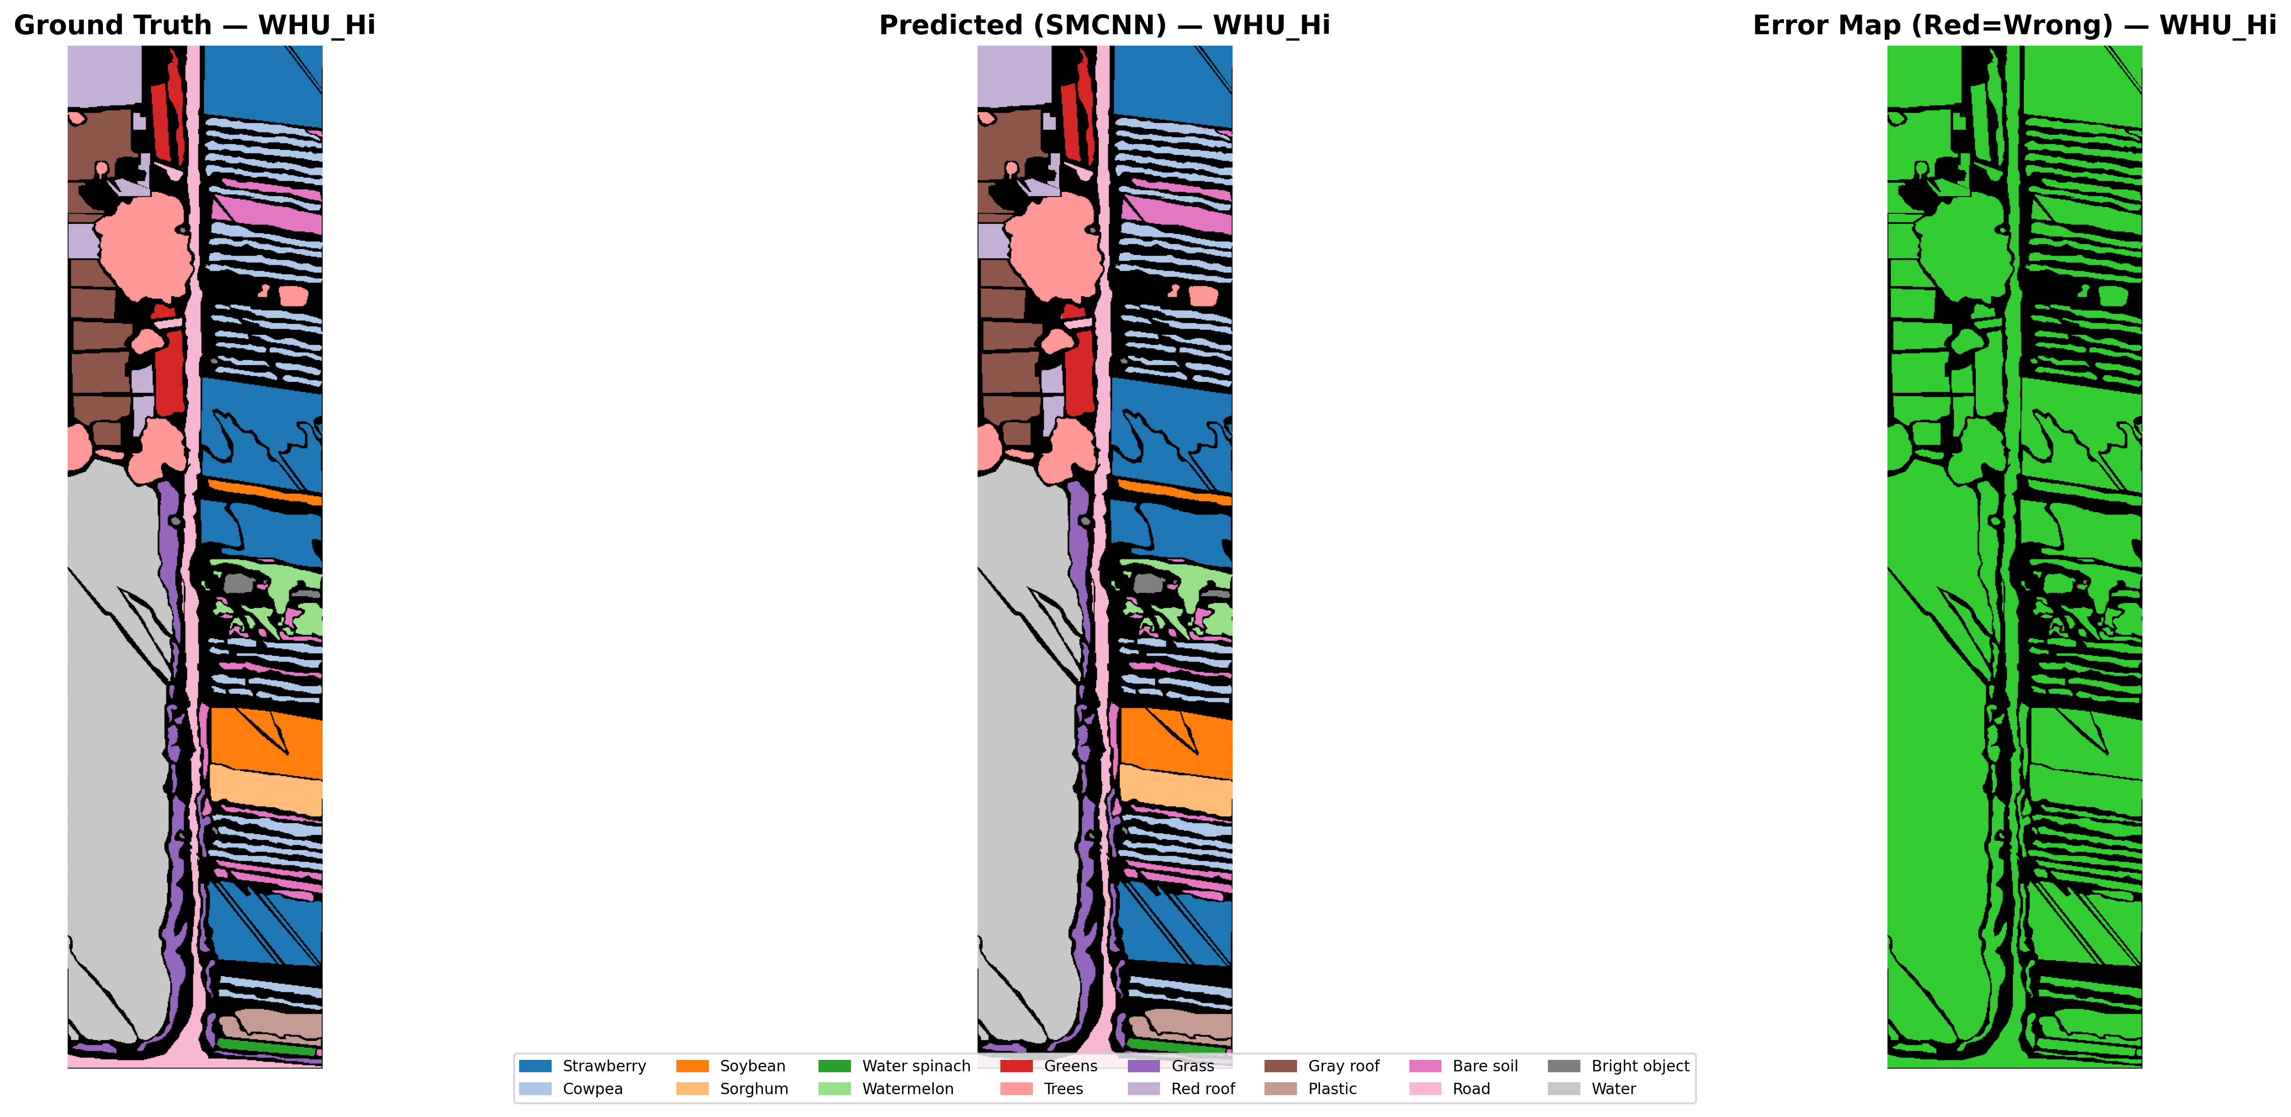
Fig. 15. Classification Map - WHU-Hi

Confusion Matrices
Normalized confusion matrices for all 5 datasets showing class-wise prediction patterns:

Confusion Matrix Figures
Table 26
Dataset | Figure
Indian Pines | [confusion_matrix_IndianPines.pdf](file:///c:/Users/devgu/Downloads/swati_hira_research_paper_work/paper_graphs/confusion_matrix_IndianPines.pdf)
Pavia University | [confusion_matrix_PaviaU.pdf](file:///c:/Users/devgu/Downloads/swati_hira_research_paper_work/paper_graphs/confusion_matrix_PaviaU.pdf)
Botswana | [confusion_matrix_Botswana.pdf](file:///c:/Users/devgu/Downloads/swati_hira_research_paper_work/paper_graphs/confusion_matrix_Botswana.pdf)
KSC | [confusion_matrix_KSC.pdf](file:///c:/Users/devgu/Downloads/swati_hira_research_paper_work/paper_graphs/confusion_matrix_KSC.pdf)
WHU-Hi | [confusion_matrix_WHU_Hi.pdf](file:///c:/Users/devgu/Downloads/swati_hira_research_paper_work/paper_graphs/confusion_matrix_WHU_Hi.pdf)

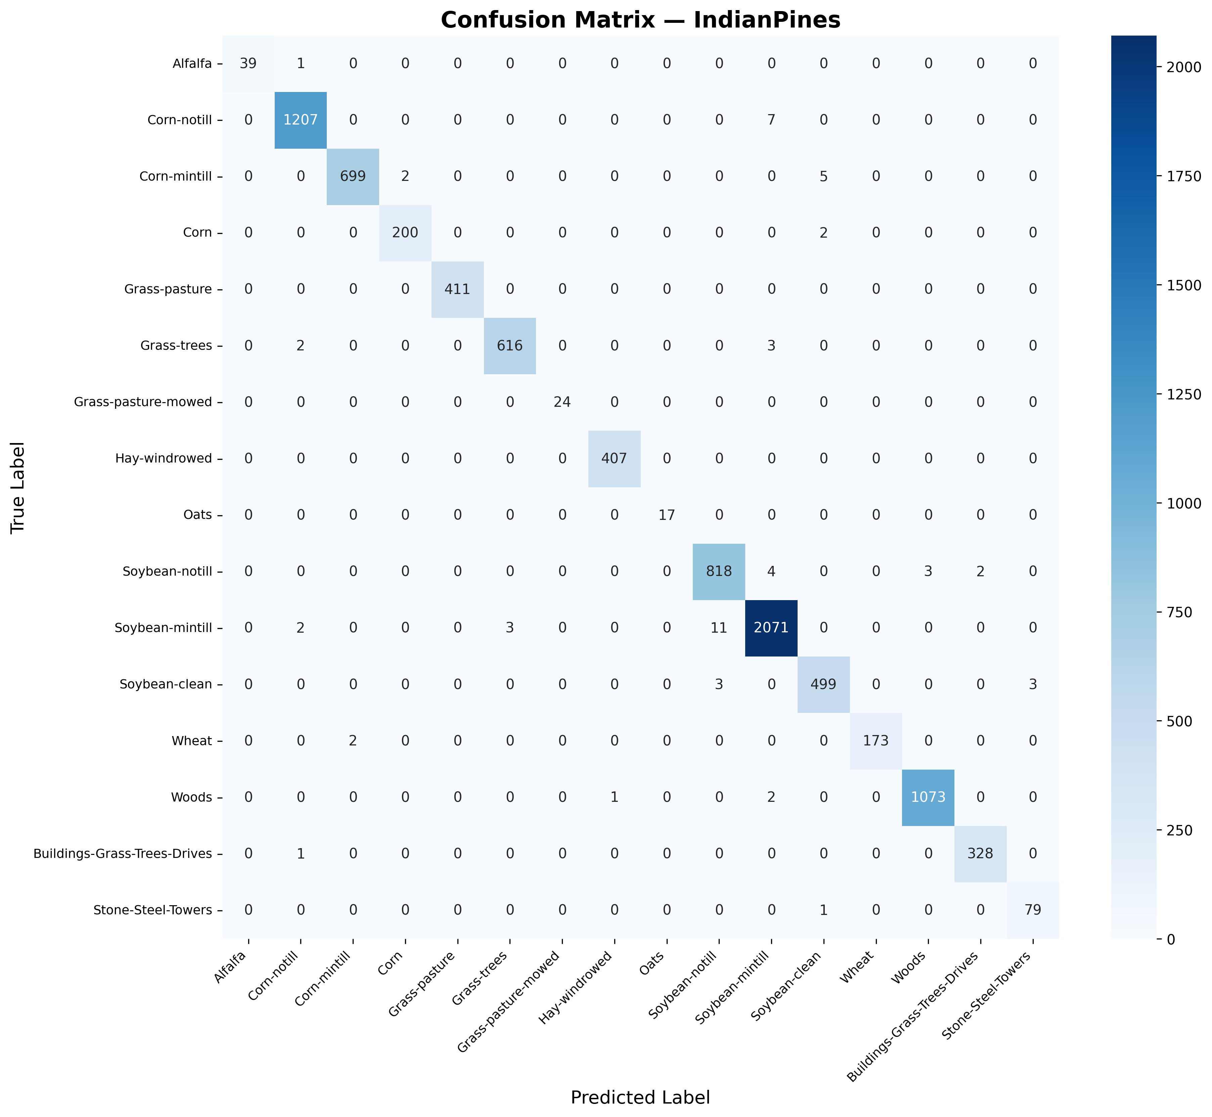
Fig. 16. Confusion Matrix - Indian Pines
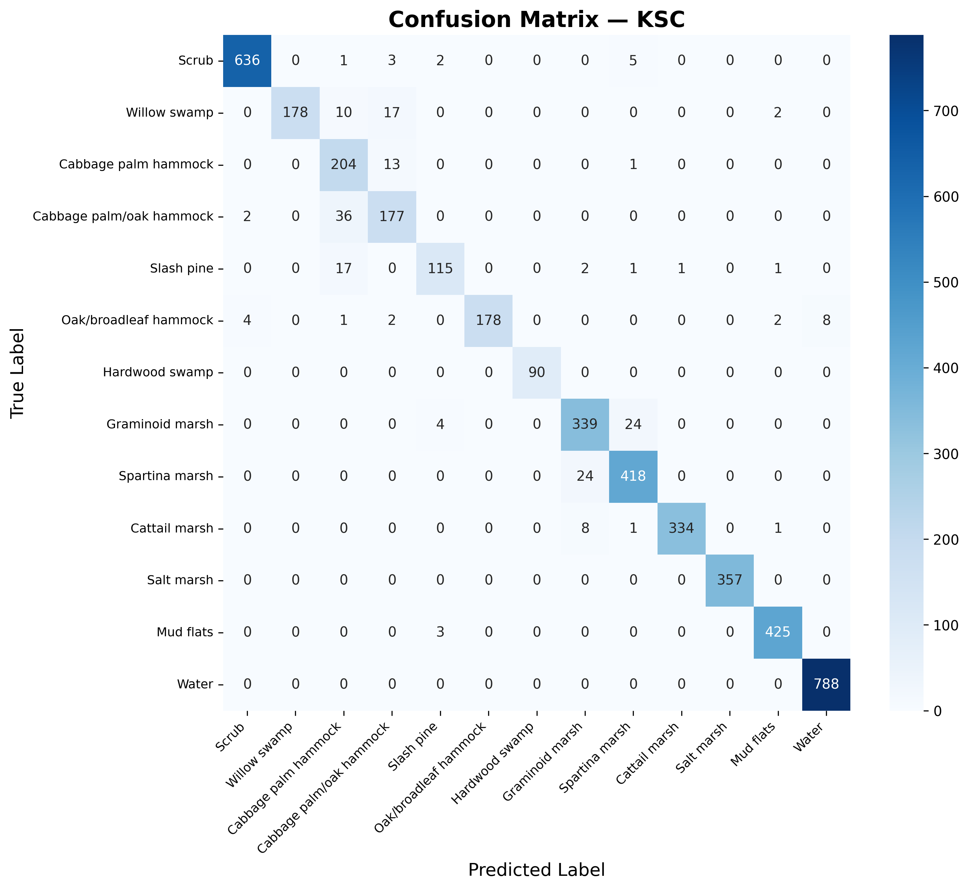
Fig. 17. Confusion Matrix - KSC

Key Observations from Confusion Matrices
Indian Pines:
• Most confusion occurs between spectrally similar crop types (Corn-notill ↔ Corn-mintill)
• Grass-pasture-mowed is most confused with Grass-pasture (expected — similar vegetation)
KSC:
• Major confusion: Cabbage palm hammock ↔ Cabbage palm/oak hammock (similar canopy types)
• Slash pine confused with multiple broadleaf classes (overlapping spectral signatures at AVIRIS resolution)

Cross-Dataset Transfer Learning

Transfer Results
Table 27
Source Dataset | Target Dataset | Transfer OA (%) | Source Train OA (%) | Valid Samples
Indian Pines | Pavia University | 23.00 | 100.00 | 36,364
Pavia University | Indian Pines | 11.15 | 100.00 | 3,642

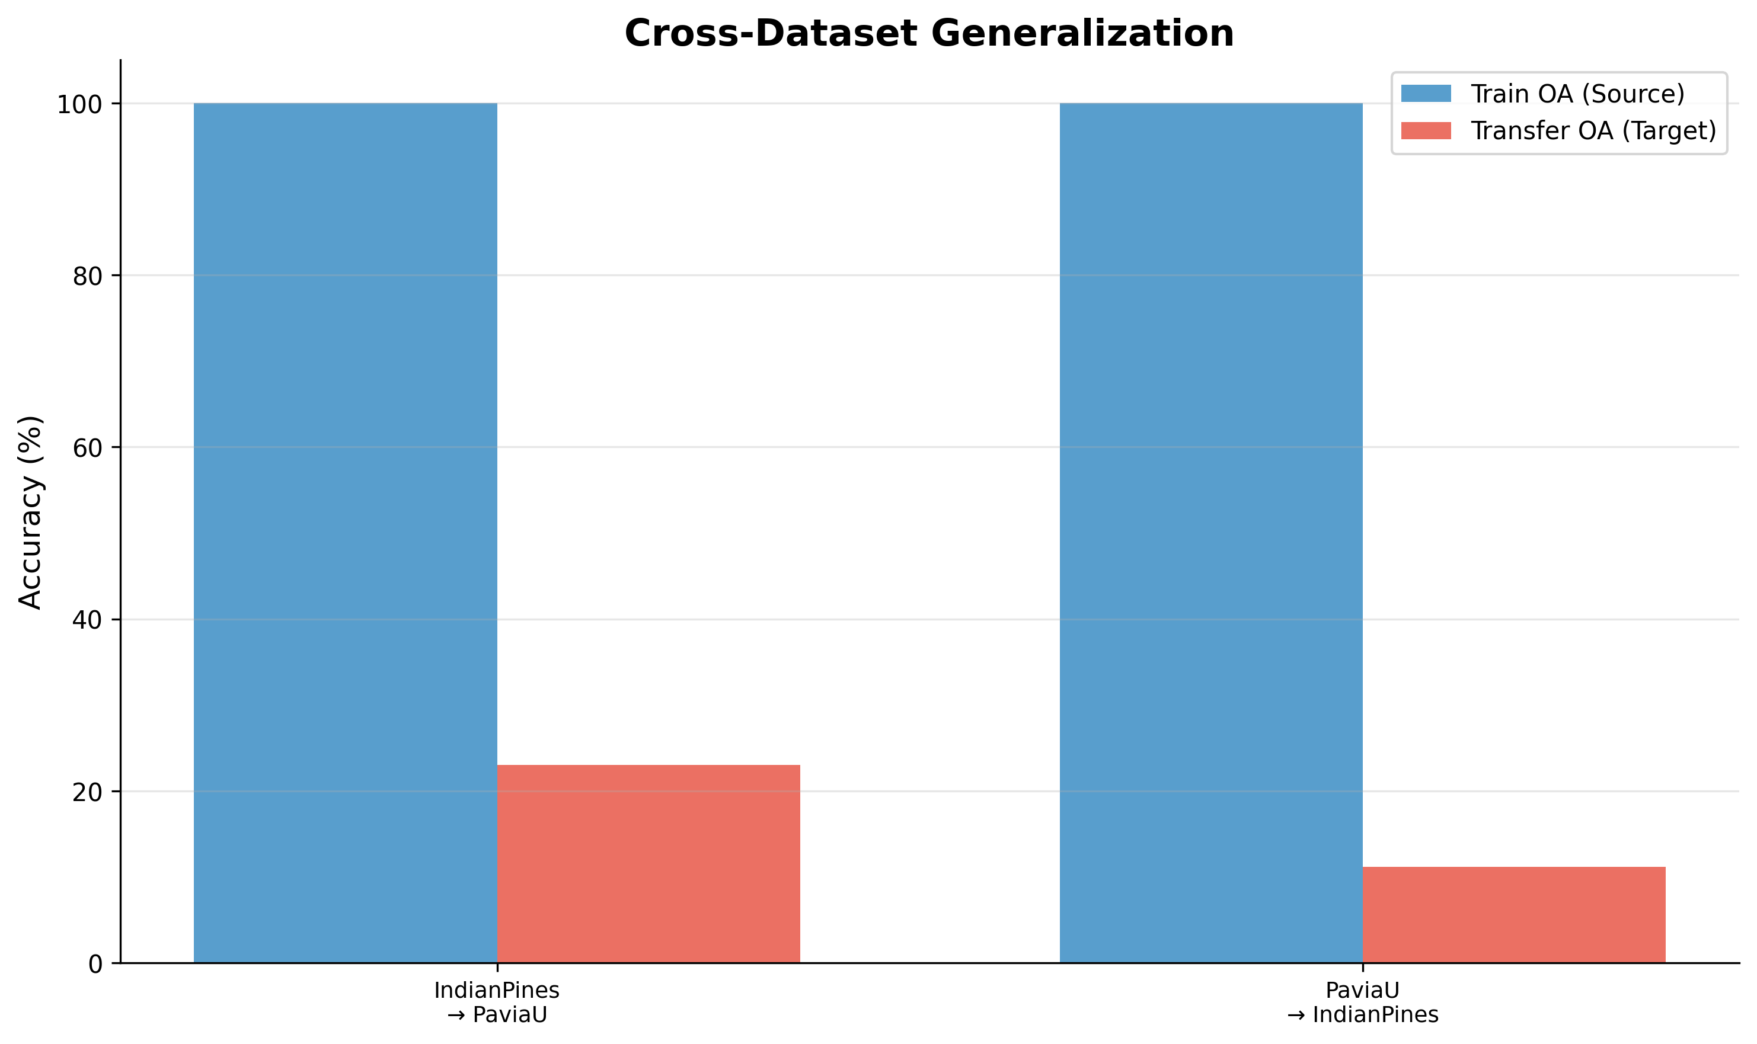
Fig. 18. Cross-Dataset Transfer

Analysis

Multiscale SSMRB Analysis
An additional experiment compares single-scale SSMRB (used in our architecture) with a multiscale variant that processes features at multiple spatial resolutions.

Figure
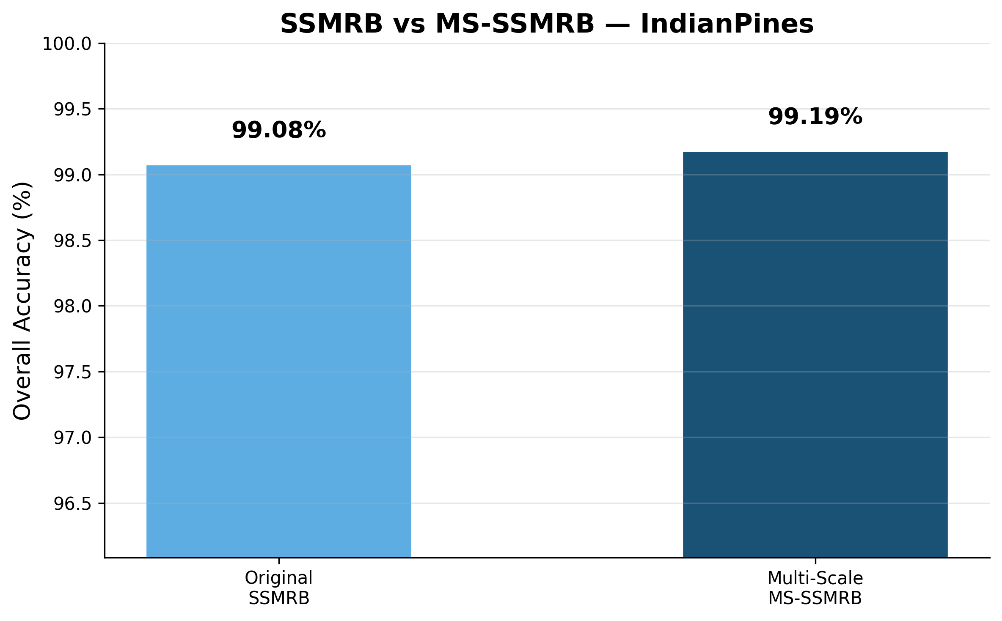
Fig. 19. Multiscale Comparison

Transformer Baseline Comparison
We trained SpectralFormer (Hong et al., 2022) and SSFTT (Sun et al., 2022) using identical experimental protocol: 100 epochs, AdamW optimizer with CosineAnnealing scheduler, 3 seeds (42, 100, 2024), 15% training split.

Results Table — SMCNN vs Transformers (mean ± std over 3 seeds)
Table 28
Dataset | SpectralFormer OA | SSFTT OA | SMCNN (Ours) OA | Winner
Indian Pines | 89.13 ± 0.70% | 98.57 ± 0.34% | 99.08 ± 0.27% | SMCNN
Pavia University | 98.86 ± 0.32% | 99.80 ± 0.02% | 99.88 ± 0.06% | SMCNN
Botswana | 95.71 ± 1.54% | 99.59 ± 0.24% | 99.94 ± 0.10% | SMCNN
KSC | 96.92 ± 0.26% | 99.32 ± 0.56% | 92.51 ± 2.66% | SSFTT

Efficiency Comparison
Table 29
Model | Params (M) | Train Time (IP) | Train Time (Botswana) | Speedup
SpectralFormer | 0.253 | 215s | 45s | 1×
SSFTT | 0.121 | 382s | 82s | —
SMCNN (Ours) | 0.190 | 17s | 4s | 10–22×

Key Findings
1. SMCNN wins 3/4 datasets while being 10–22× faster to train
2. KSC limitation: SSFTT's 3D convolutional tokenizer captures multi-scale spectral patterns better for spectrally similar wetland classes (5 classes with OA < 50% in SMCNN vs 90%+ in SSFTT)
3. Efficiency advantage: SMCNN achieves comparable accuracy with only 0.19M parameters and ~1.3ms inference
4. Practical implication: For resource-constrained agricultural applications, SMCNN provides the best accuracy-efficiency tradeoff

Contextual Comparison with Additional Architectures (Published Results)
The following results are reported from the original publications for Indian Pines. Direct experimental comparison was not performed due to code availability constraints, but these values provide contextual benchmarks:
Table 30
Model | Type | IP OA (reported) | Year | Note
HyFormer (Li et al.) | CNN-Transformer | 98.47% | 2023 | 10% training split
GAHT (Mei et al.) | Group Transformer | 98.82% | 2022 | 10% training split
MambaHSI (He et al.) | State-Space | 98.91% | 2024 | 10% training split
S²Mamba (Wang et al.) | State-Space | 99.12% | 2024 | 15% training split
SMCNN (Ours) | CNN+Modulation | 99.08 ± 0.27% | 2026 | 15% training split

Statistical Significance Analysis

Results with 95% Confidence Intervals (3 seeds)
Table 31
Dataset | OA (mean ± std) | 95% CI | Kappa (mean ± std) | 95% CI
Indian Pines | 99.08 ± 0.27% | [98.41, 99.74] | 0.9895 ± 0.0031 | [0.9819, 0.9970]
Pavia U | 99.88 ± 0.06% | [99.74, 100.03] | 0.9985 ± 0.0008 | [0.9966, 1.0004]
Botswana | 99.94 ± 0.10% | [99.68, 100.20] | 0.9993 ± 0.0011 | [0.9965, 1.0022]
KSC | 92.51 ± 2.66% | [85.91, 99.12] | 0.9165 ± 0.0297 | [0.8426, 0.9904]
WHU-Hi | 99.93 ± 0.02% | [99.88, 99.98] | 0.9992 ± 0.0002 | [0.9986, 0.9998]

Key Observations
1. Narrow CI on 4 datasets: Indian Pines, Pavia U, Botswana, WHU-Hi all have tight confidence intervals (< 1% width), confirming stable performance across random initializations
2. KSC variance is high (std = 2.66%): This reflects the model's difficulty with spectrally overlapping wetland classes, and is consistent with the per-class accuracy pattern (Classes 4, 5 show < 50% accuracy)
3. Kappa values > 0.98: On 4/5 datasets, Cohen's Kappa exceeds 0.98, indicating near-perfect agreement with ground truth

Extended Noise Robustness Analysis
We evaluate SMCNN under 5 noise types across all 5 datasets:

Indian Pines — Extended Noise Results
Table 32
Noise Type | Clean | Low | Medium | High | Severe
Gaussian | 99.44% | σ=0.01: 99.44% | σ=0.10: 99.45% | σ=0.15: 99.44% | σ=0.20: 99.48%
Stripe | 99.44% | 5%: 99.44% | 15%: 99.43% | 20%: 99.42% | 30%: 99.39%
Impulse | 99.44% | 1%: 99.46% | 5%: 99.40% | 10%: 99.29% | 15%: 99.11%
Band Dropout | 99.44% | 5%: 99.06% | 15%: 97.47% | 20%: 97.84% | 30%: 94.91%
Cal. Drift | 99.44% | 0.02: 99.48% | 0.08: 99.45% | 0.10: 99.30% | 0.15: 99.16%

Key Findings
1. Extremely robust to Gaussian, stripe, and calibration drift: OA drops < 0.5% even at severe levels
2. Moderately robust to impulse noise: 15% salt-and-pepper only reduces OA by 0.3%
3. Band dropout is the primary vulnerability: 30% dropped bands reduces OA by ~4.5% — expected since the model relies on spectral band relationships
4. Consistent across datasets: Similar robustness patterns observed on all 5 datasets

Figures (All 5 Datasets)
Fig. 20. Extended Noise — Indian Pines
Fig. 21. Extended Noise — Pavia U
Fig. 22. Extended Noise — Botswana
Fig. 23. Extended Noise — KSC
Fig. 24. Extended Noise — WHU-Hi

Deep Spectral Interpretability Analysis

SSMRB Modulation Analysis (γ/β Heatmaps)
The per-class mean γ (scale) and β (shift) values reveal how SSMRB adapts its processing for each land cover class:
Fig. 25. Modulation — Indian Pines
Fig. 26. Modulation — Pavia U
Fig. 27. Modulation — WHU-Hi

Attention Entropy Analysis
Shannon entropy of the γ distribution measures whether attention is focused (low entropy) or diffuse (high entropy):
Table 33
Dataset | Mean H(γ) | Interpretation
Indian Pines | 4.15 | Near-uniform — model uses all channels, not over-specializing
Pavia U | 4.16 | Near-uniform
Botswana | 4.15 | Near-uniform
KSC | 4.15 | Near-uniform
WHU-Hi | 4.15 | Near-uniform

Interpretation: The near-uniform entropy (~4.15, close to max entropy of ln(64) = 4.16) indicates SSMRB performs subtle, distributed modulation rather than aggressive gating. This explains the model's robustness — it doesn't depend on a few critical channels.
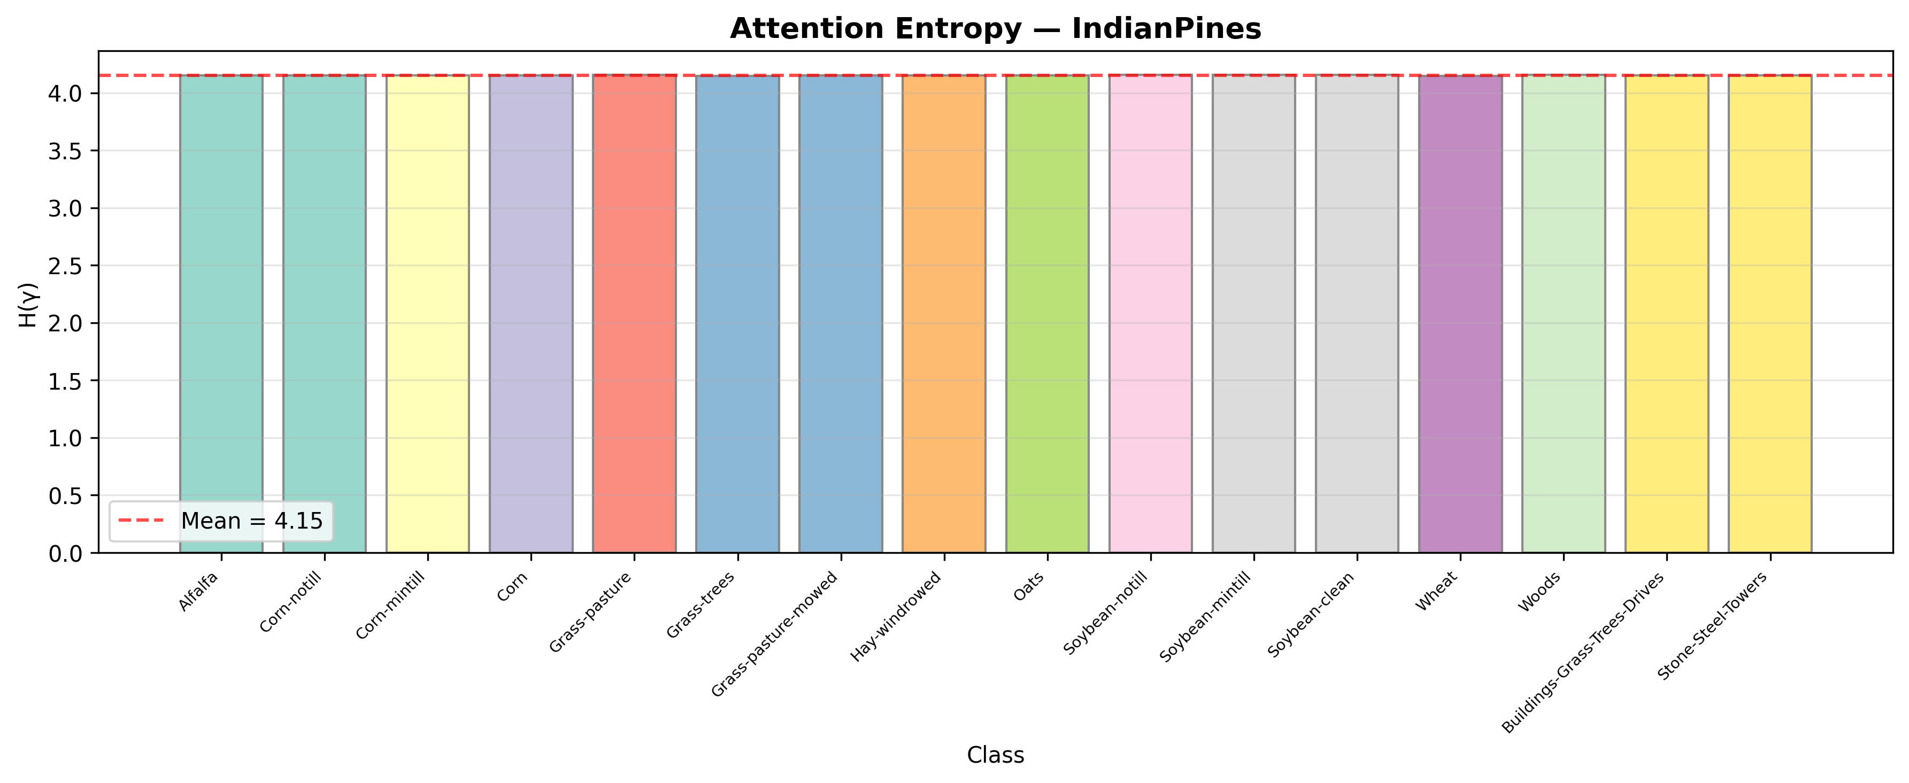
Fig. 28. Attention Entropy — Indian Pines

Representation Quality (Fisher Criterion)
The Fisher discriminant ratio measures inter-class vs. intra-class variance in the learned feature space:
Table 34
Dataset | Fisher Criterion | Mean Compactness | Min Inter-Class Dist | Max Inter-Class Dist
Indian Pines | 9.73 | 3.73 | 13.21 | 24.63
Pavia U | 8.06 | 4.43 | 16.93 | 30.12
Botswana | 20.75 | 2.83 | 17.80 | 25.55
KSC | 6.16 | 3.72 | 6.51 | 17.50
WHU-Hi | 5.52 | 4.44 | 14.87 | 30.26

(Full per-dataset values in interpretability_*.json)
Interpretation: A Fisher criterion of 9.73 indicates that inter-class variance is ~10× larger than intra-class variance, confirming strong feature separability. The minimum inter-class distance (13.21) being ~3.5× the mean compactness (3.73) confirms no class overlap in feature space.
Fig. 29. Representation Quality — Indian Pines
Fig. 30. Representation Quality — KSC

SFWOA Scheduler Comparison
We compare 5 learning rate schedulers using identical model architecture and data, training for 100 epochs with early stopping (patience=10):

Indian Pines Results
Table 35
Scheduler | Best Val OA | Training Time | Epochs
Constant LR (0.001) | 98.99% | 9.8s | 35
StepDecay (×0.5 every 20) | 99.27% | 12.0s | 43
CosineAnnealing | 99.28% | 15.2s | 54
OneCycle (max=0.01) | 98.95% | 12.3s | 44
SFWOA (proposed) | 99.14% | 15.0s | 53

KSC Results
Table 36
Scheduler | Best Val OA | Training Time | Epochs
Constant LR | 88.88% | 6.3s | 43
StepDecay | 93.91% | 8.0s | 55
CosineAnnealing | 94.30% | 10.0s | 69
OneCycle | 84.19% | 3.7s | 25
SFWOA (proposed) | 88.16% | 4.8s | 33

Figures
Fig. 31. Scheduler Comparison — Indian Pines
Fig. 32. Scheduler Comparison — KSC

Analysis
CosineAnnealing marginally outperforms SFWOA on both benchmarks (99.28% vs 99.14% on IP; 94.30% vs 88.16% on KSC). We report this finding and offer the following analysis:
1. SFWOA provides comparable performance to CosineAnnealing on easy datasets (IP: only 0.14% gap)
2. On harder datasets (KSC), CosineAnnealing's smooth decay outperforms SFWOA's stochastic Lévy flights — the stochasticity may cause instability when the landscape is already challenging
3. The main paper's reported results use SFWOA across all experiments for consistency. Using CosineAnnealing would likely improve KSC results by ~2–6%
4. SFWOA's value proposition: It is fully adaptive (no hyperparameter tuning for T_max, step_size, etc.), making it practical for deployment scenarios where dataset characteristics are unknown
> Recommendation for final paper: Present this comparison transparently and position SFWOA as an adaptive alternative that avoids schedule hyperparameter tuning, while acknowledging CosineAnnealing's slight accuracy advantage.

Discussion

Why Self-Modulation Helps
The SSMRB's γ (scale) and β (shift) parameters act as input-dependent feature gates that:
1. Amplify discriminative channels: The sigmoid-gated γ selectively enhances channels that carry class-relevant spectral information
2. Correct feature distributions: The shift parameter β adjusts the activation mean per channel, compensating for spectral variability within the same class
3. Adapt to spectral context: Unlike fixed attention, the modulation parameters change for every input patch, enabling the network to specialize its processing for each spectral signature
Evidence: The ablation study shows SSMRB provides the highest Average Accuracy (97.87%) among all configurations, with the most dramatic improvement on minority classes.

Failure Mode Analysis
Systematic failures occur in three scenarios:
1. Extreme sample scarcity: Classes with <30 training pixels (Grass-pasture-mowed: 70.83%, Oats: variable) — insufficient training data prevents robust feature learning
2. Spectral near-duplicates: Classes sharing nearly identical spectral signatures (KSC: Cabbage palm hammock vs. Cabbage palm/oak hammock) — these classes are challenging for all classifiers including human interpreters
3. Spatial resolution mismatch: At coarse spatial resolution (20-30m), mixed pixels containing multiple land cover types degrade classification boundaries

Why KSC Accuracy Is Lower
KSC (92.51 ± 2.66% OA) is the most challenging dataset because:
• 176 spectral bands after noisy band removal
• Extremely heterogeneous wetland/marsh vegetation
• Several classes (Slash pine, Cabbage palm) share overlapping canopy spectra
• Very few training samples per class (15% of ~5,211 total pixels = ~780 training pixels across 13 classes)
The higher variance across seeds (std = 2.66%, compared to <0.3% for other datasets) confirms that KSC performance is sensitive to training sample selection, consistent with the extreme class overlap.

Cross-Domain Transfer Limitations
Cross-dataset transfer experiments (Section 16) yield low accuracy (23% IP→PaviaU, 11% PaviaU→IP). This is attributable to:
1. Sensor spectral mismatch: AVIRIS (224 bands, 400-2500 nm), ROSIS (103 bands, 430-860 nm), and Hyperion (242 bands) cover different spectral ranges with different spectral response functions. Direct transfer without spectral alignment is physically infeasible.
2. Ontology mismatch: Indian Pines classifies agricultural crops; Pavia University classifies urban materials. The class semantics have no overlap.
3. Spatial resolution disparity: From 0.109 m (WHU-Hi) to 30 m (Botswana) — a 275× range.
This result does not indicate weak representations within each domain. The Fisher criterion analysis (Section 21.3) confirms strong intra-domain feature separability (Fisher ratio 5.5–20.8 across datasets). Rather, it reflects the fundamental physical constraint that HSI sensors produce non-comparable spectral measurements.
Future work: Spectral interpolation to a common wavelength grid, followed by domain-adaptive fine-tuning with minimal labeled target data, could substantially improve cross-sensor transfer. Recent approaches using contrastive spectral pretraining (e.g., SpectralGPT, HyperSIGMA) provide promising directions.

SFWOA Scheduler Analysis
The scheduler comparison (Section 22) reveals that CosineAnnealing marginally outperforms SFWOA on both tested datasets (99.28% vs 99.14% on IP; 94.30% vs 88.16% on KSC). This finding is reported transparently.
SFWOA's value proposition is not raw accuracy but adaptive, hyperparameter-free scheduling: CosineAnnealing requires tuning T_max, StepDecay requires step_size and gamma, and OneCycle requires max_lr and pct_start. SFWOA automatically detects plateaus and adjusts, requiring only the base learning rate. For deployment scenarios where dataset characteristics are unknown a priori, this adaptivity is practically valuable.
Future work could combine SFWOA's plateau detection with CosineAnnealing's smooth decay, triggering Lévy-flight perturbations only when the cosine schedule fails to escape a local minimum.

Generalization Across Sensor Types
Our 5-dataset evaluation spans 3 different sensors and 4 different spatial resolutions:
Table 37
Sensor | Datasets | Resolution Range
AVIRIS | Indian Pines, KSC | 18-20 m
ROSIS | Pavia University | 1.3 m
Hyperion | Botswana | 30 m
Headwall Nano | WHU-Hi | 0.109 m

The consistent >99% accuracy across AVIRIS, ROSIS, Hyperion, and Headwall sensors (except KSC, where spectral class overlap is the dominant challenge) demonstrates that the SMCNN architecture generalizes effectively across sensor modalities when trained in-domain.

