Helium alerts count and its total duration
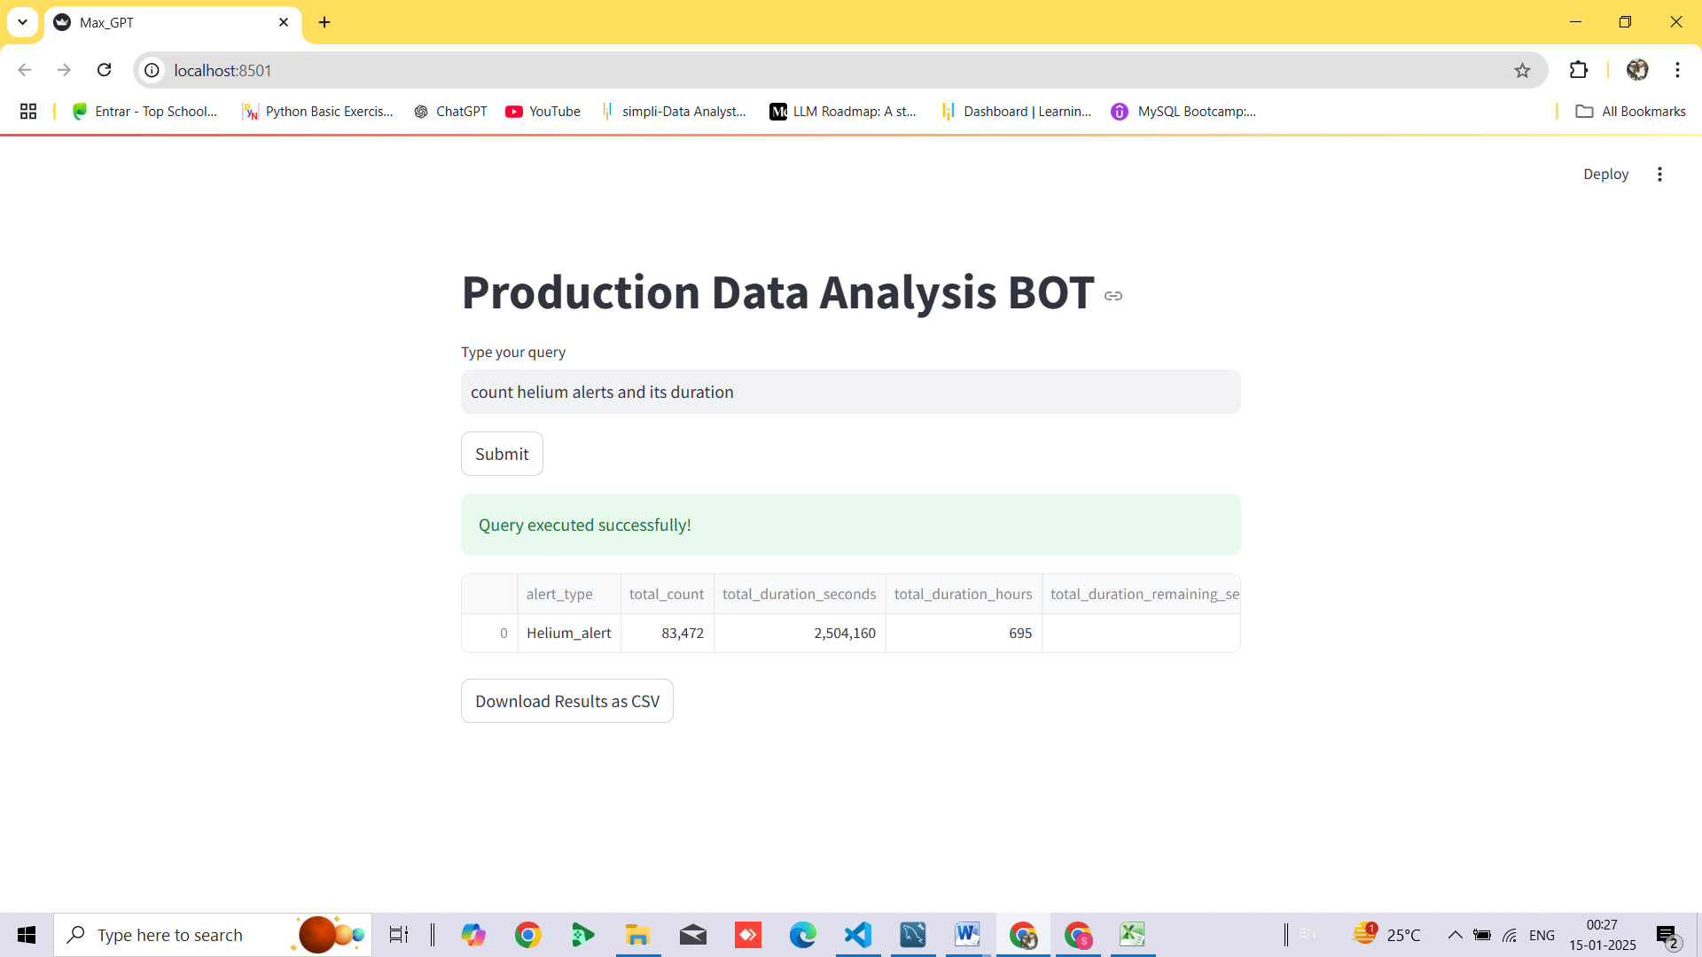
ATO count and its total duration

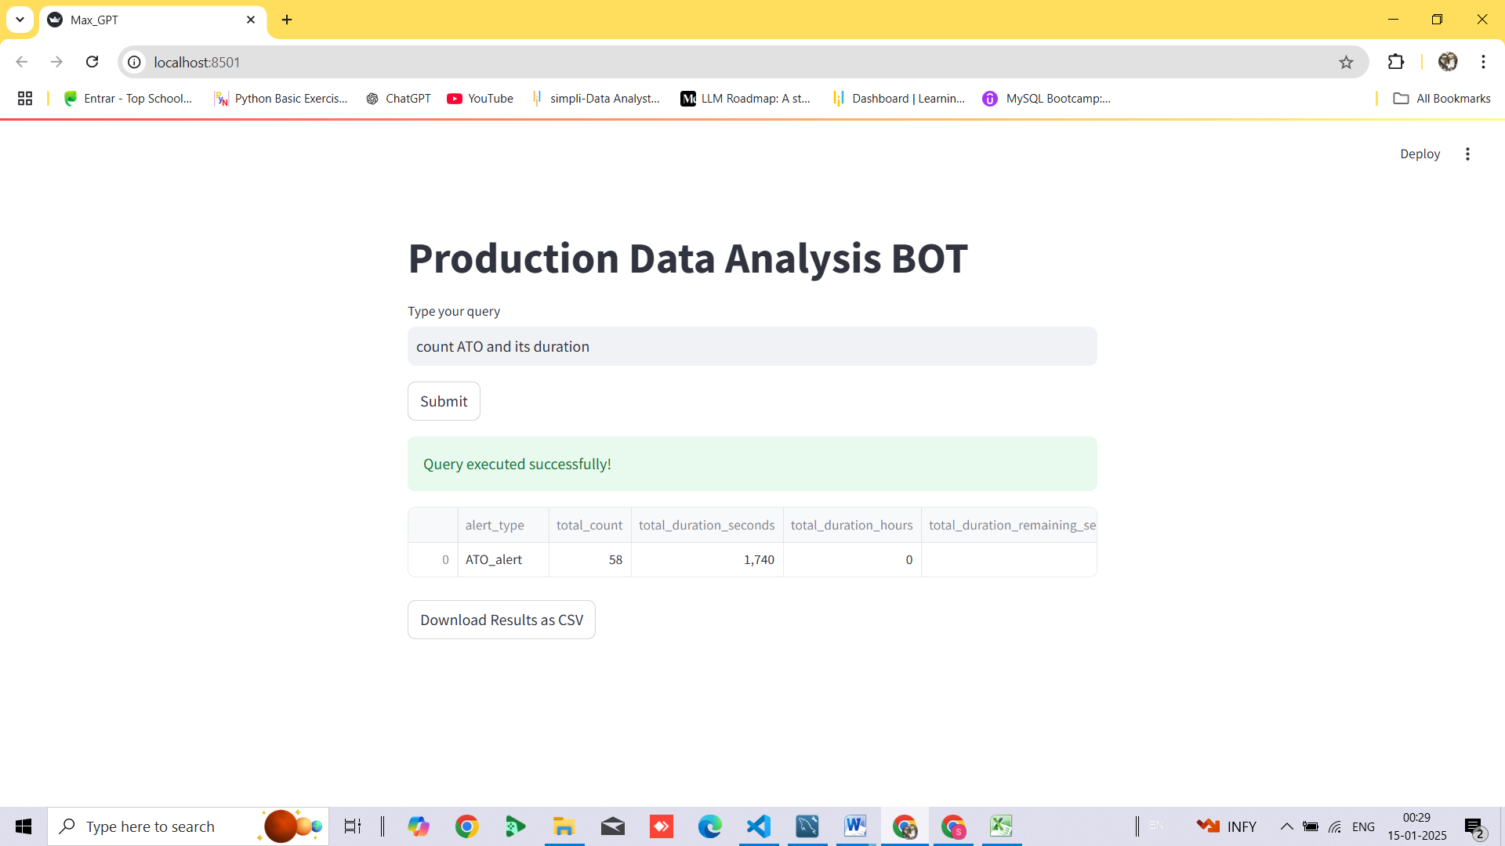

ATI alert from 29th september to 2nd october

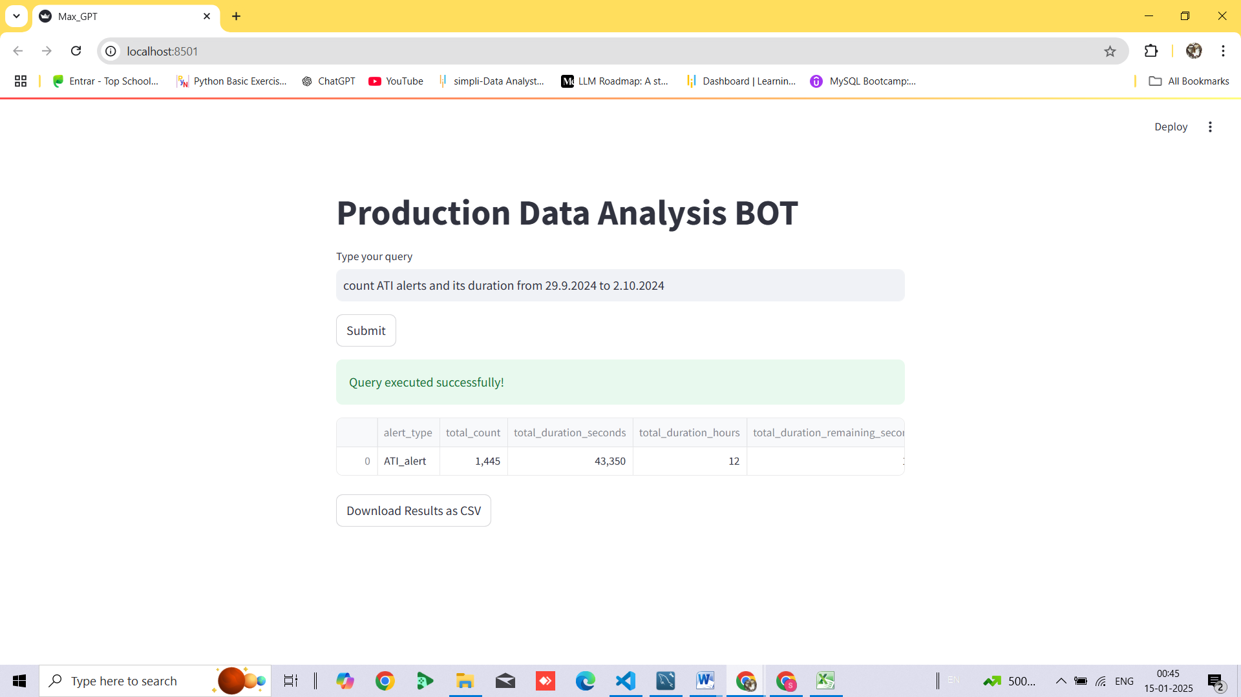
Count ATI alerts and its total duration

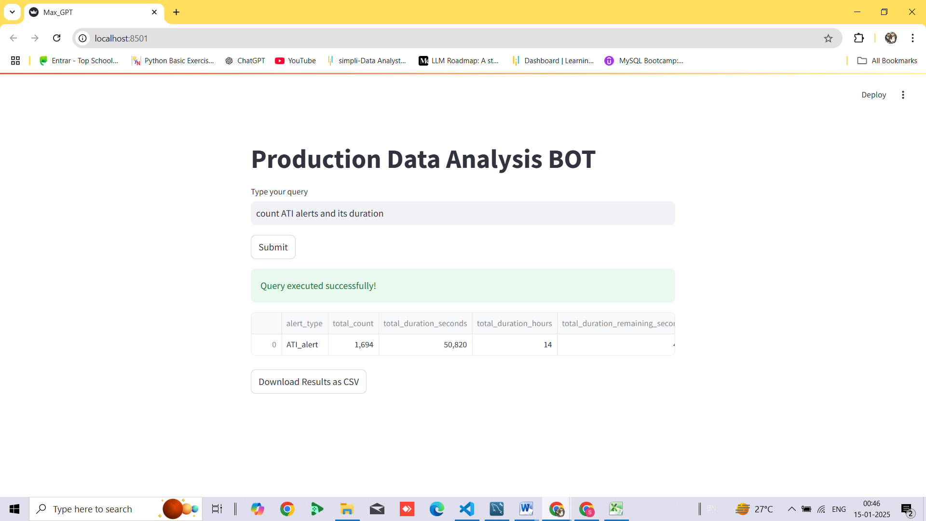
P1 alerts count and its total duration

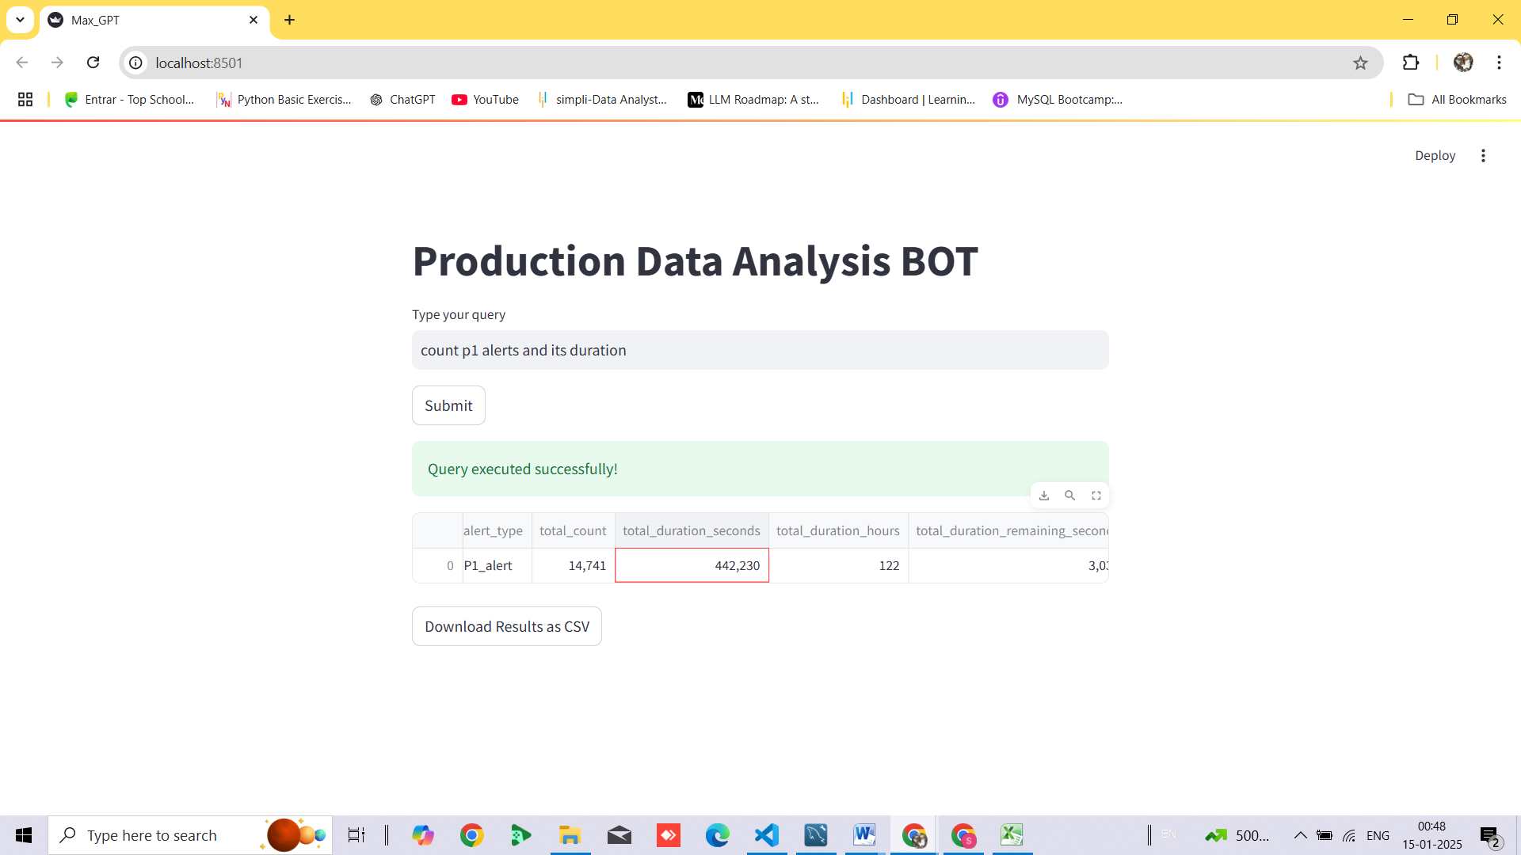
minimum and maximum P1 Actual Pressure

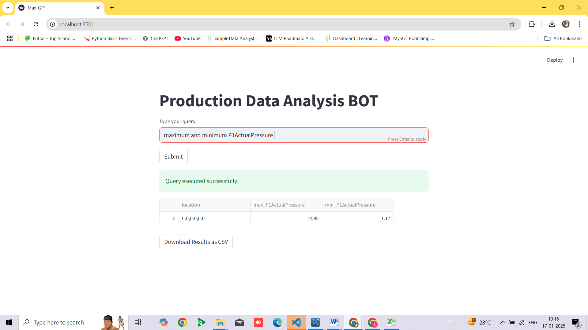
Helium_purityPercentage in descending order.
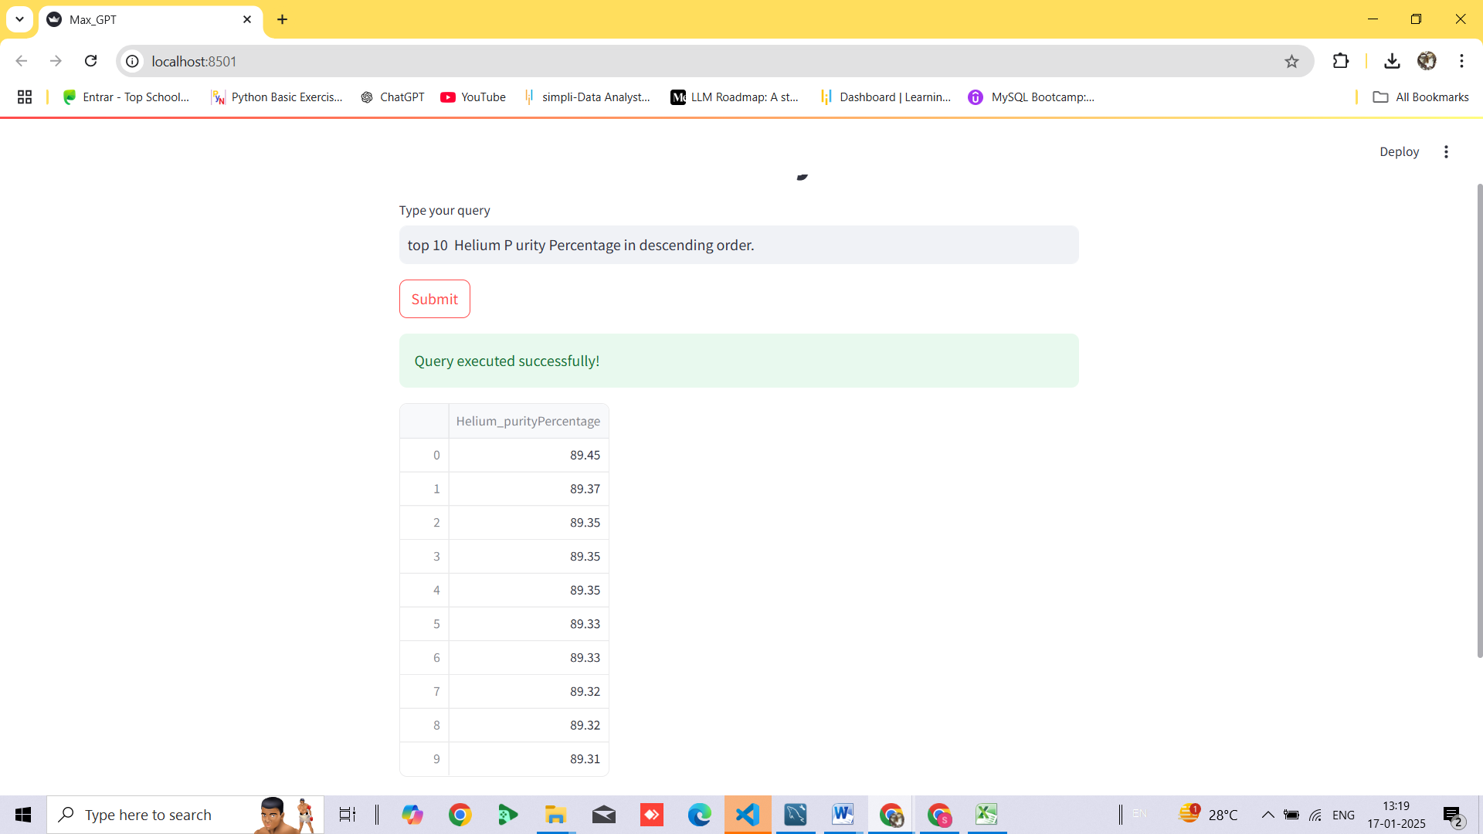
What’s the average of compressor body temperature?
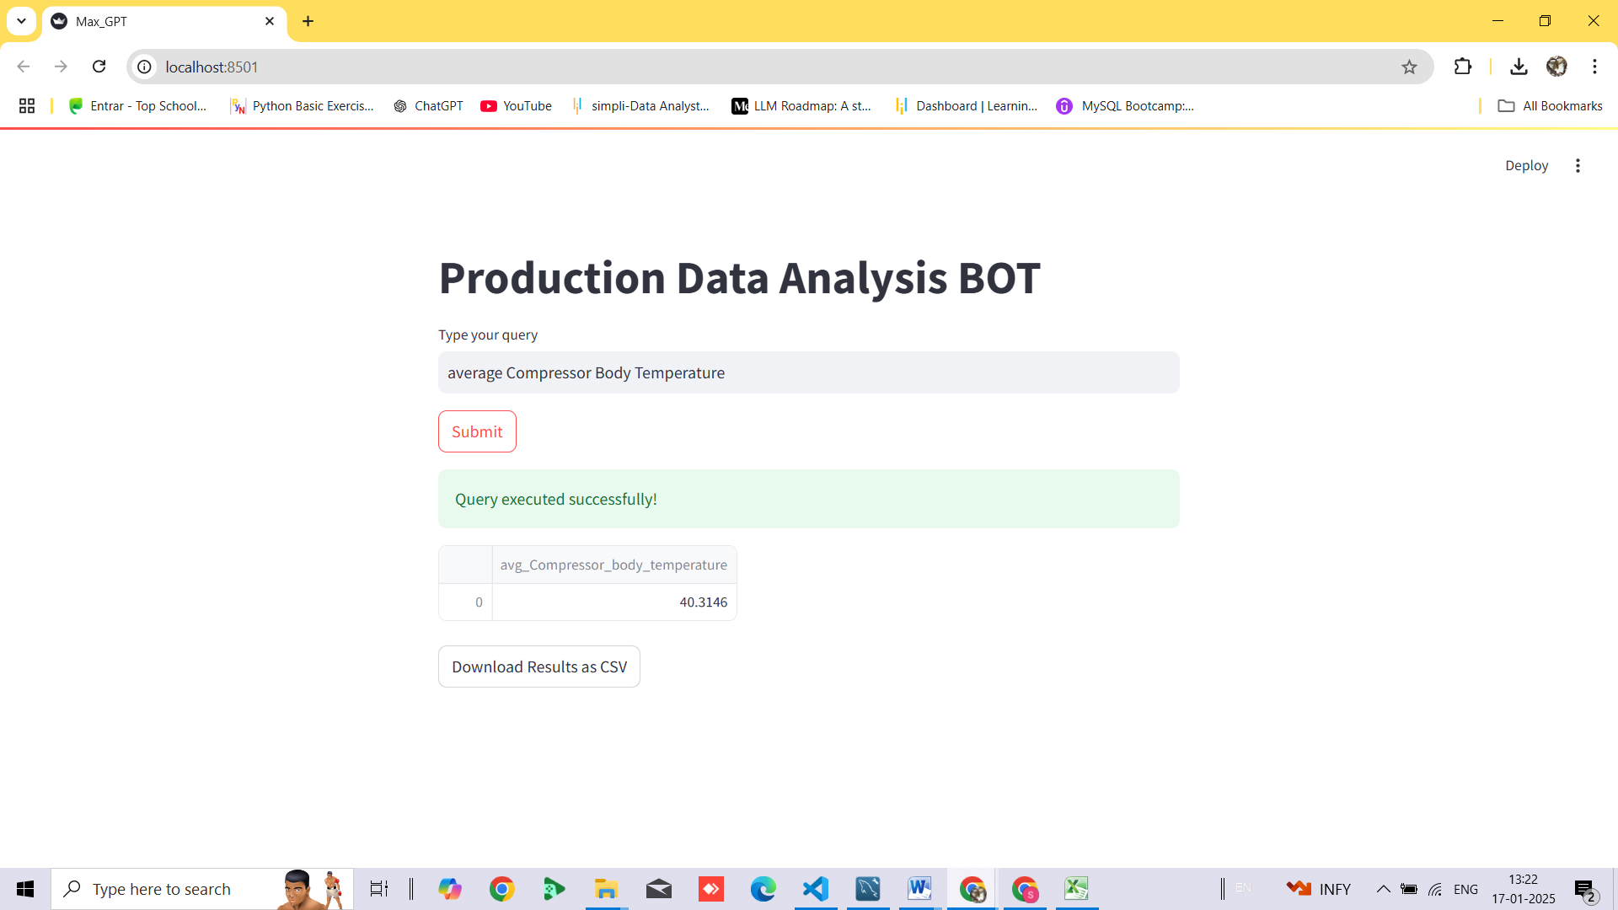

Identify entries with multiple alert triggers
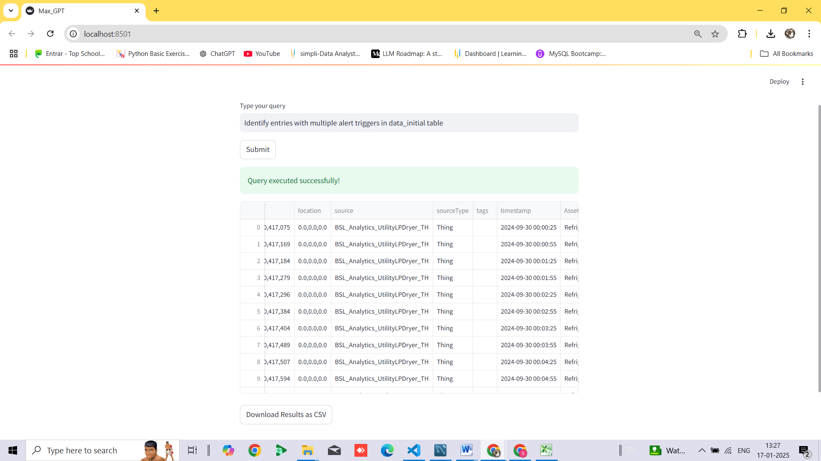
Cluster assets based on Dew Point and Air Pressure Outlet readings.
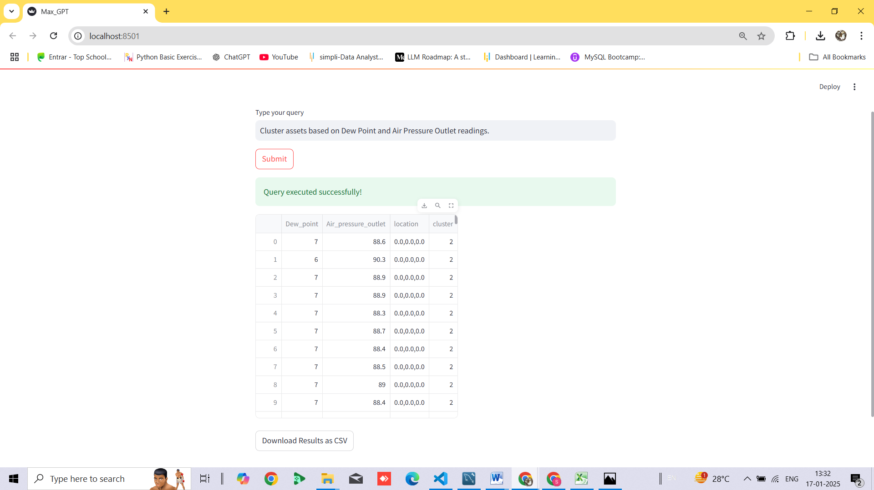
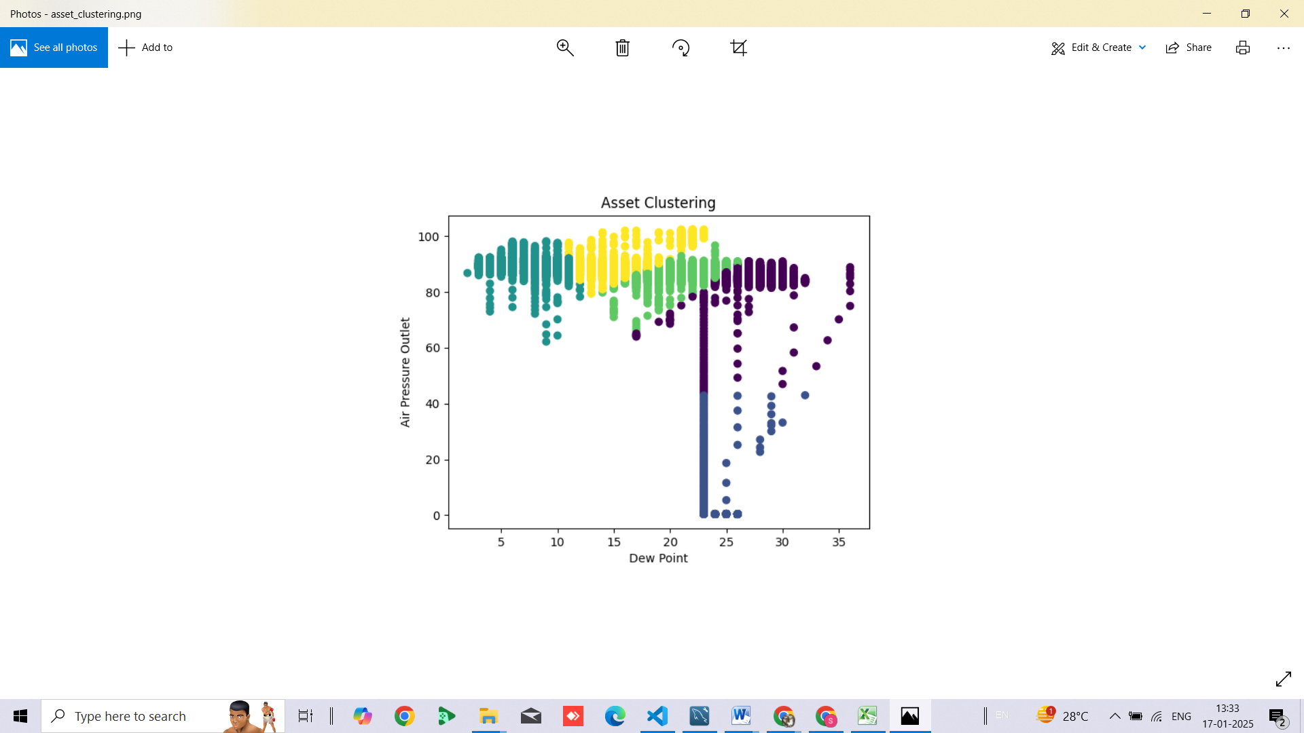

BIBYE.J@MAXBYTETECH.COM

