**COLLEGE CODE:1105**

**COLLEGE NAME:GOJAN SCHOOL OF BUSINESS AND TECHNOLOGY**

**DEPARTMENT: MEDICAL ELECTRONICS**

**STUDENT NM-ID:9C133B267DDCF45922E46857DA7C074F**

**ROLL NO:110523119006**

**DATE:05/05/2025**

AI-ENERGY EFFICIENCY OPTIMIZATION

**SUBMITTED BY,**

**B.ARUNTHATHI**

**S.BARATH**

**P.DEVI**

**K.JANANI**

**V.THRISHA**

**Title**:AI-Based Energy Efficiency Optimization System

**Abstract**:

The AI-Based Energy Efficiency Optimization System focuses on reducing energy consumption across residential, commercial, and industrial sectors by combining Artificial Intelligence, Machine Learning, and IoT technologies. The system analyzes real-time energy usage data, identifies inefficiencies, and provides actionable recommendations. It supports scalability, integration with existing energy management systems, and ensures data privacy and security. This final phase presents the working system demo, documentation, performance metrics, and future scope. Visuals such as diagrams and code snapshots will be included.

**1.Project** **Demonstration**

**Overview**:

The system demonstration showcases real-time energy usage monitoring, predictive analytics for optimization, and automated device control.

**Demonstration** **Details**:

* **Live** **Walkthrough**: User interface interaction showing energy dashboard, reports, and alerts.
* **AI** **Recommendations**: Insights based on patterns like peak usage times and idle device energy waste.
* **IoT Integration**: Smart plugs/sensors data streamed live from multiple environments.
* **Performance** **Metrics**: Low-latency response, scalability across multiple locations, and real-time analytics.
* **Security**: Encrypted data transmission and user authentication methods.

**Outcome**:

Stakeholders will observe how AI and IoT reduce energy costs and environmental impact in real-time.

**2.Project** **Documentation**

**Overview**:

Complete technical details covering design, development, deployment, and usage.

**Documentation** **Sections**:

* **System** **Architecture**: Diagrams showing data flow between IoT devices, cloud, and AI engine.
* **Codebase** **Overview**: AI model scripts, IoT APIs, and dashboard backend.
* **User** **Guide**: Instructions for users to track consumption, set goals, and view reports.
* **Admin** **Guide**: System configuration, device onboarding, and performance tuning.
* **Testing** **Reports**: Load test results, latency analysis, and optimization success rate.

**Outcome**:

Comprehensive reference for developers and end-users to maintain and extend the system.

**3.Feedback** **and** **Final** **Adjustments**

**Overview**:

Post-demonstration insights from faculty, users, and technical reviewers used for refinement.

**Steps**:

* **Collect** **Feedback**: Surveys and session recordings.
* **Analyze** & **Refine**: Address issues like false optimization alerts or UI confusion.
* **Final** **Test** **Run**: Ensure consistent performance and bug-free operation.

**Outcome**:

Final polished version of the system, ready for deployment and wider testing.

**4.Final** **Project** **Report** **Submission**

**Overview**:

Summarizes the full journey, accomplishments, and learnings.

**Report** **Sections**:

* **Executive** **Summary**: Brief project goals and achievements.
* **Phase** **Breakdown**: Data acquisition, AI model tuning, and IoT setup.
* **Challenges** & **Solutions**: For example, syncing multiple IoT devices and reducing false positives.
* **Outcomes**: Demonstrated energy savings, improved usability, and readiness for commercial use.

**Outcome**:

Complete documentation submitted as proof of concept and execution quality.

**5.Project** **Handover** **and** **Future** Works

**Overview**:

Smooth handover with notes on future development paths.

**Handover** **Details**:

* **Next** **Steps**: Expand to smart cities, integrate with renewable energy sources, and add multi-language support.
* **Maintenance** **Guide**: For ongoing monitoring, AI re-training, and system scaling.

**Outcome**:

Project officially concluded with a plan for future evolution.

**INPUT:**

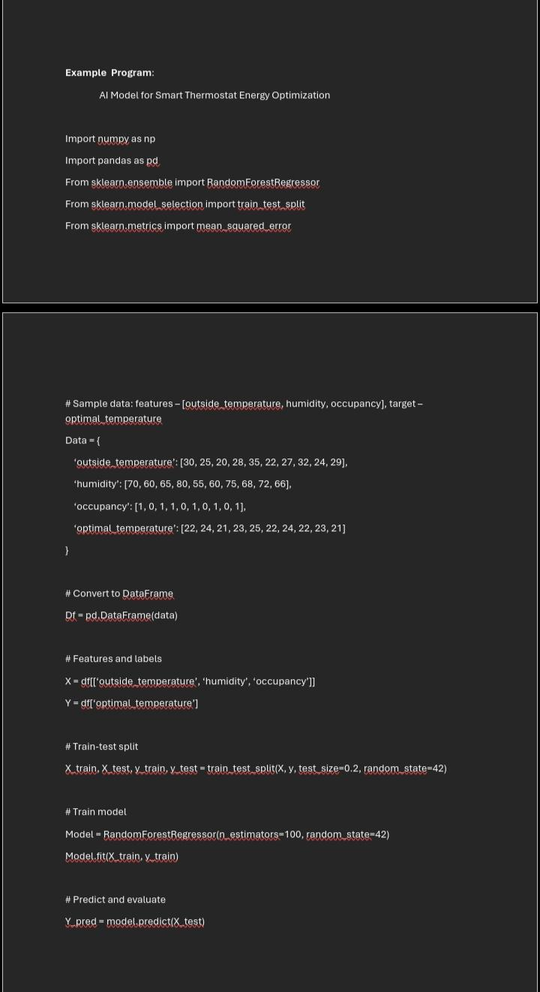

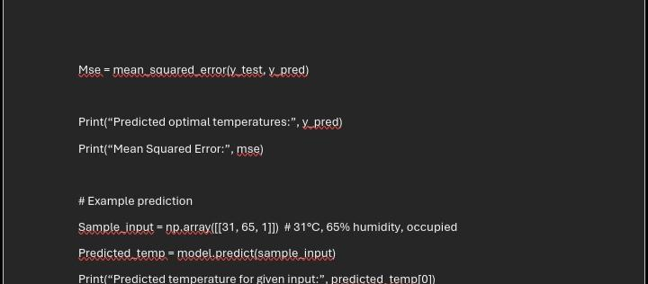

**OUTPUT:**

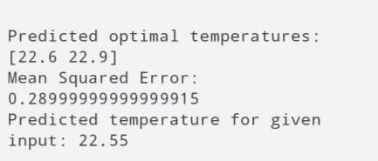

**SOURCE CODE:**

