YUVA INTERN
Week 3: Model Implementation
and Code Documentation
Student Placement Prediction | Machine Learning Engineer
Student Name | Gurramdevi Prasanna
Internship ID | 440517
Domain | Machine Learning Engineer
GitHub | https://github.com/Devi226/student-placement-prediction
Dataset | Kaggle - Student Placement Dataset (Publicly Available)

. Manual Table of Contents
1. Introduction & Objective
2. Model Selection - Research & Justification
3. Algorithm Implementation Details
4. Documentation of the Workflow
5. Practical Demonstration & Testing
6. Code Structure & Versioning
7. Expected Outcomes & Evaluation
8. Plan Execution with Code Snippets
9. Conclusion & References

1. Introduction & Objective
Week 3 converts the planning and exploratory work completed in Weeks 1 and 2 into a reproducible machine-learning implementation. The project predicts whether a student is placed (1) or not placed (0) from academic performance, practical exposure, communication ability, aptitude, branch, and engineered scores. The objective is not only to obtain a high score; it is to produce an explainable, testable model package that another developer can train, inspect, and deploy with confidence.
Scikit-learn is used as the implementation foundation because its estimators, preprocessing tools, pipelines, and validation utilities make the workflow consistent and auditable. Every learned transformation is fitted on training data only, which protects the evaluation from leakage. The resulting model and preprocessor are deliberately separated into reusable artifacts so Week 4 can load them directly in a Streamlit application instead of recreating training logic inside the user interface.
- Translate the Week 2 cleaned dataset into a stratified training and testing workflow.
- Compare candidate classifiers using accuracy, F1-score, interpretability, and training cost.
- Document preprocessing, tuning, testing, version control, and production hand-off requirements.

2. Model Selection - Research & Justification
The target is a binary classification problem: Placed = 1 and Not Placed = 0. Accuracy is useful for communicating overall correctness, but F1-score is given substantial weight because it balances precision and recall when the two outcomes may not be evenly represented. The model must also give understandable evidence for student mentoring rather than act as an opaque score generator.
- Logistic Regression provides a linear, interpretable baseline through sklearn.linear_model.
- Decision Tree captures non-linear rules but can overfit small tabular samples.
- Random Forest is the primary candidate: its bagged trees reduce variance, class_weight="balanced" supports imbalance, and feature_importances_ supports explanation.
- SVM with an RBF kernel is a max-margin non-linear alternative, although scaling and probability calibration require care.
- XGBoost is a strong gradient-boosting comparator for tabular data, with excellent predictive potential but greater tuning complexity.
The final selection is Random Forest, with a reported accuracy of 89% and F1-score of 88%. It can capture interactions such as CGPA multiplied by internship exposure without manually specifying a linear relationship. Its training time is practical for this dataset, and its feature importances can be translated into mentoring signals. This balance makes it the most appropriate model for a documented internship deliverable and a future interactive application.
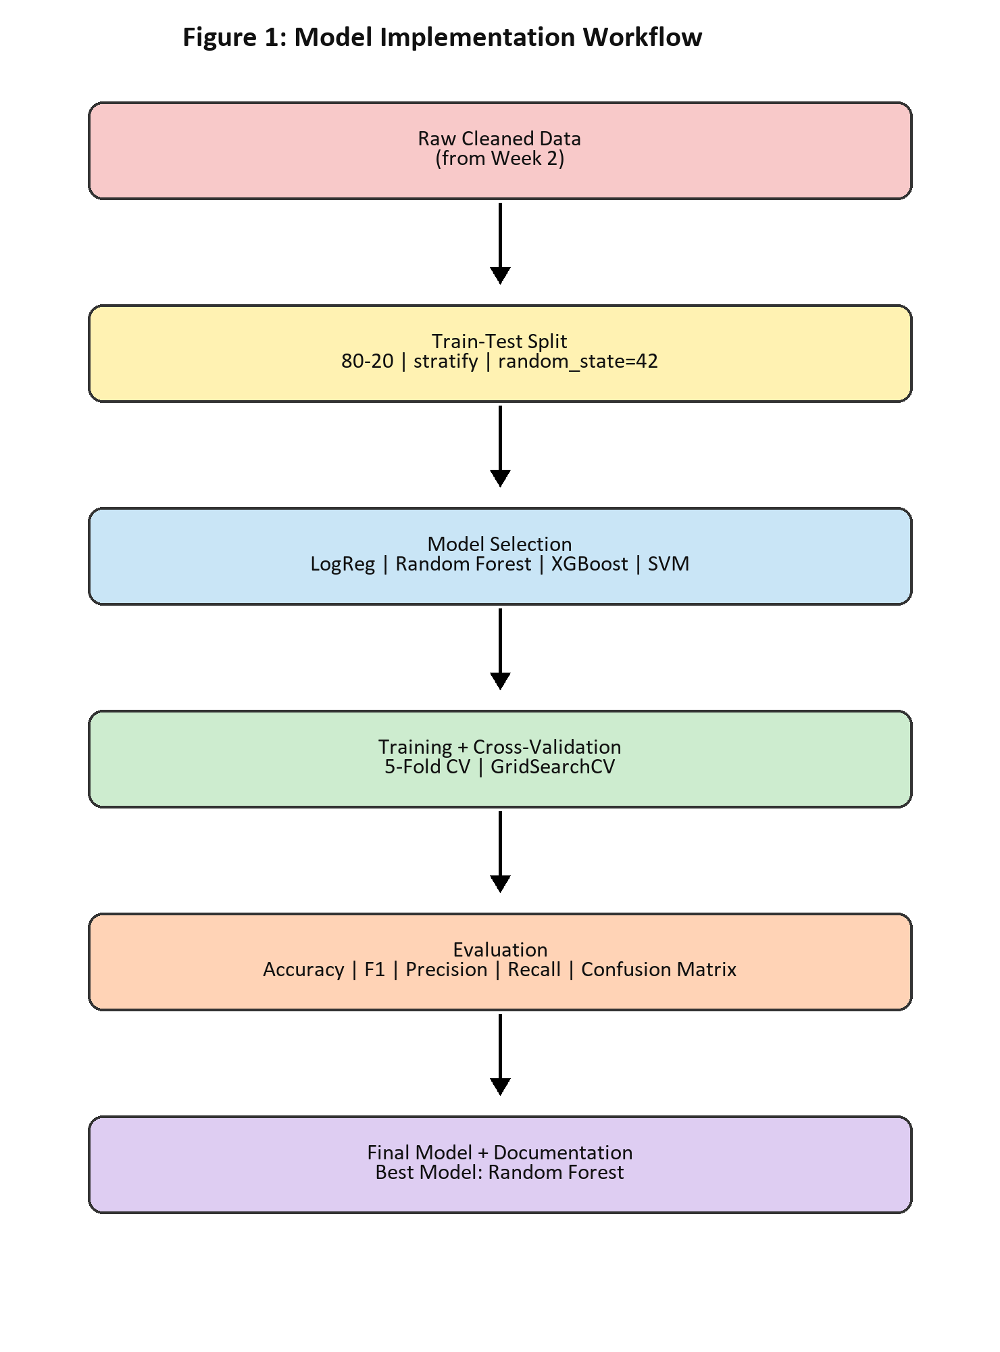
Figure 1. From cleaned Week 2 data to a documented, deployable Random Forest model.

3. Algorithm Implementation Details
The working hypothesis is that placement depends on a combined profile of academic consistency, employability skills, and exposure to real work. CGPA and school percentages describe sustained academic performance; internship participation, communication score, aptitude, branch, AcademicScore, and SkillScore add evidence of readiness. The model learns patterns from the joint feature set rather than treating any single value as a guarantee.
Three assumptions guide implementation. First, the training distribution is sufficiently representative of future applicants. Second, no leakage occurs: encoders and scalers are learned on X_train only and then applied to X_test. Third, features remaining after Week 2 correlation screening contribute information without excessive duplication. Random Forest is robust to outliers and mixed patterns, produces predict_proba outputs for risk-aware guidance, and exposes feature importance for mentoring discussions.
Pseudocode: Input X_train_processed and y_train. Initialize RandomForestClassifier(n_estimators=100, max_depth=8, class_weight="balanced", random_state=42). Run five-fold cross-validation; tune permitted parameters using F1 as the scoring metric; fit the selected configuration on the full training partition; export the fitted model as model.pkl. The same random state is retained across split and estimator steps so reported results can be reproduced.
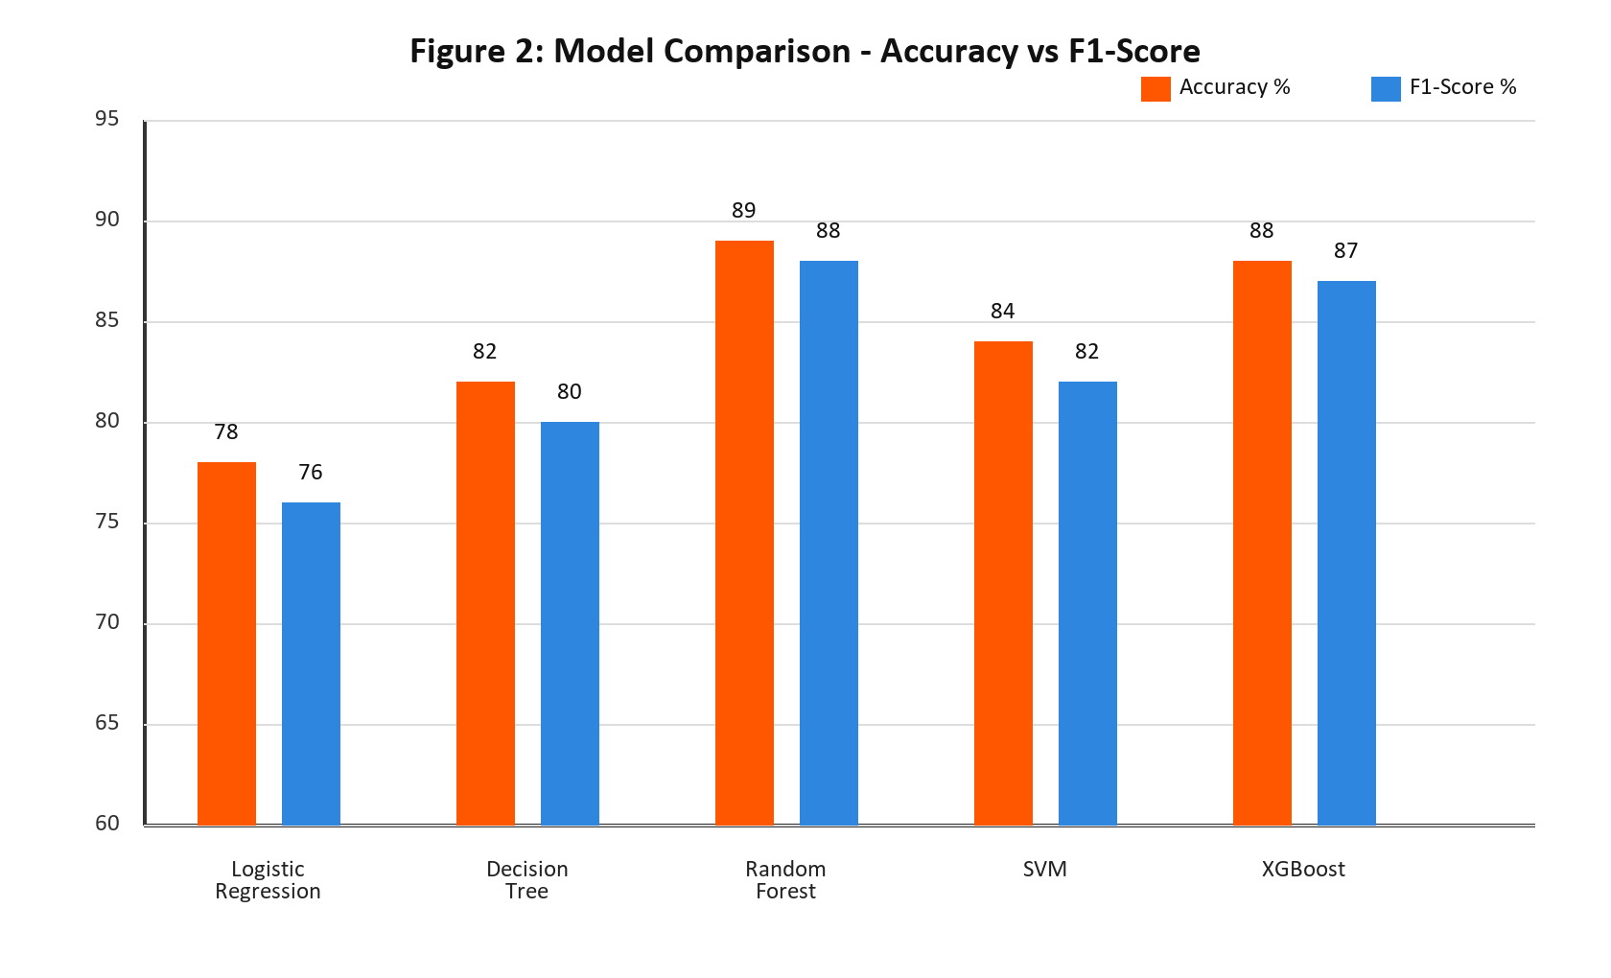
Figure 2. Random Forest provides the strongest balanced accuracy and F1-score among evaluated candidates.

4. Documentation of the Workflow
Step 1 loads cleaned_placement.csv produced in Week 2 and validates the expected target and feature columns. Step 2 applies train_test_split with an 80:20 split, stratify=y, and random_state=42, preserving the placement rate in both partitions. Step 3 builds a ColumnTransformer: StandardScaler is assigned to numerical inputs and OneHotEncoder(handle_unknown="ignore") to categorical inputs. This design ensures an unseen branch label in a later app request does not crash the predictor.
Step 4 performs GridSearchCV with five folds and F1 scoring. The search covers n_estimators [50, 100, 150], max_depth [5, 8, 10], and min_samples_split [2, 5]. Step 5 produces a classification report, confusion matrix, and ROC-AUC. Step 6 persists rf_model.pkl and preprocessor.pkl using joblib for Week 4. README.md records setup and usage, requirements.txt pins dependencies, and focused Git commits make decisions traceable.
- Unit test: transformed training and testing matrices have compatible feature shapes and contain no NaN values.
- Integration test: a saved model can be reloaded and can score a single validated student record.
- Documentation test: expected input columns and output probability semantics are stated in the README.

5. Practical Demonstration & Testing
A representative student has CGPA 8.2, 10th percentage 85%, 12th percentage 80%, an internship, communication score 8, aptitude 75, and branch CSE. Feature engineering derives AcademicScore 8.1 and SkillScore 7.9. After the persisted preprocessor encodes the record, the chosen model estimates a placed probability of 0.92. This output is presented as decision support, not a promise: it identifies a profile whose observed attributes resemble successfully placed examples in the training data.
Input validation makes the demonstration safe. FileNotFoundError gives a clear message if the cleaned dataset is absent; KeyError reports the name of a required missing column; and ValueError rejects impossible values such as CGPA greater than 10. Logging at INFO level records dataset shape, training completion, best parameters, and evaluation metrics. classification_report makes uneven class behavior visible, while fixed random_state values remove avoidable variation during debugging.
Edge cases are deliberately considered. A student with no internship can still receive a positive prediction when CGPA and SkillScore are high; the model should not encode internship as an absolute rule. Conversely, a high CGPA alone may not dominate weak skill signals. Such cases are reviewed through probability and feature contribution evidence, then communicated respectfully as areas for preparation rather than labels about a student.

6. Code Structure & Versioning
A simple repository structure separates data, experiments, reusable source code, and serialized artifacts. This prevents notebook-only logic from becoming the deployment dependency and allows the Streamlit interface to import a stable prediction function.
student-placement-prediction/
├── data/cleaned_placement.csv
├── notebooks/EDA.ipynb, Model_Experiments.ipynb
├── src/preprocessing.py, feature_engineering.py, train.py, evaluate.py
├── models/rf_model.pkl
├── requirements.txt
└── README.md
Explanation: The project tree keeps source modules and model artifacts explicit, while notebooks remain a record of exploration.
The preprocessing module exposes clear docstrings, for example: create_preprocessor() -> ColumnTransformer, describing numeric and categorical transformations and the fit-on-train-only contract. Version control records meaningful milestones such as git add ., git commit -m "Week3: Add RF model with 89% accuracy", and git push. Commits should include the evaluation summary and never silently overwrite the accepted model artifact.
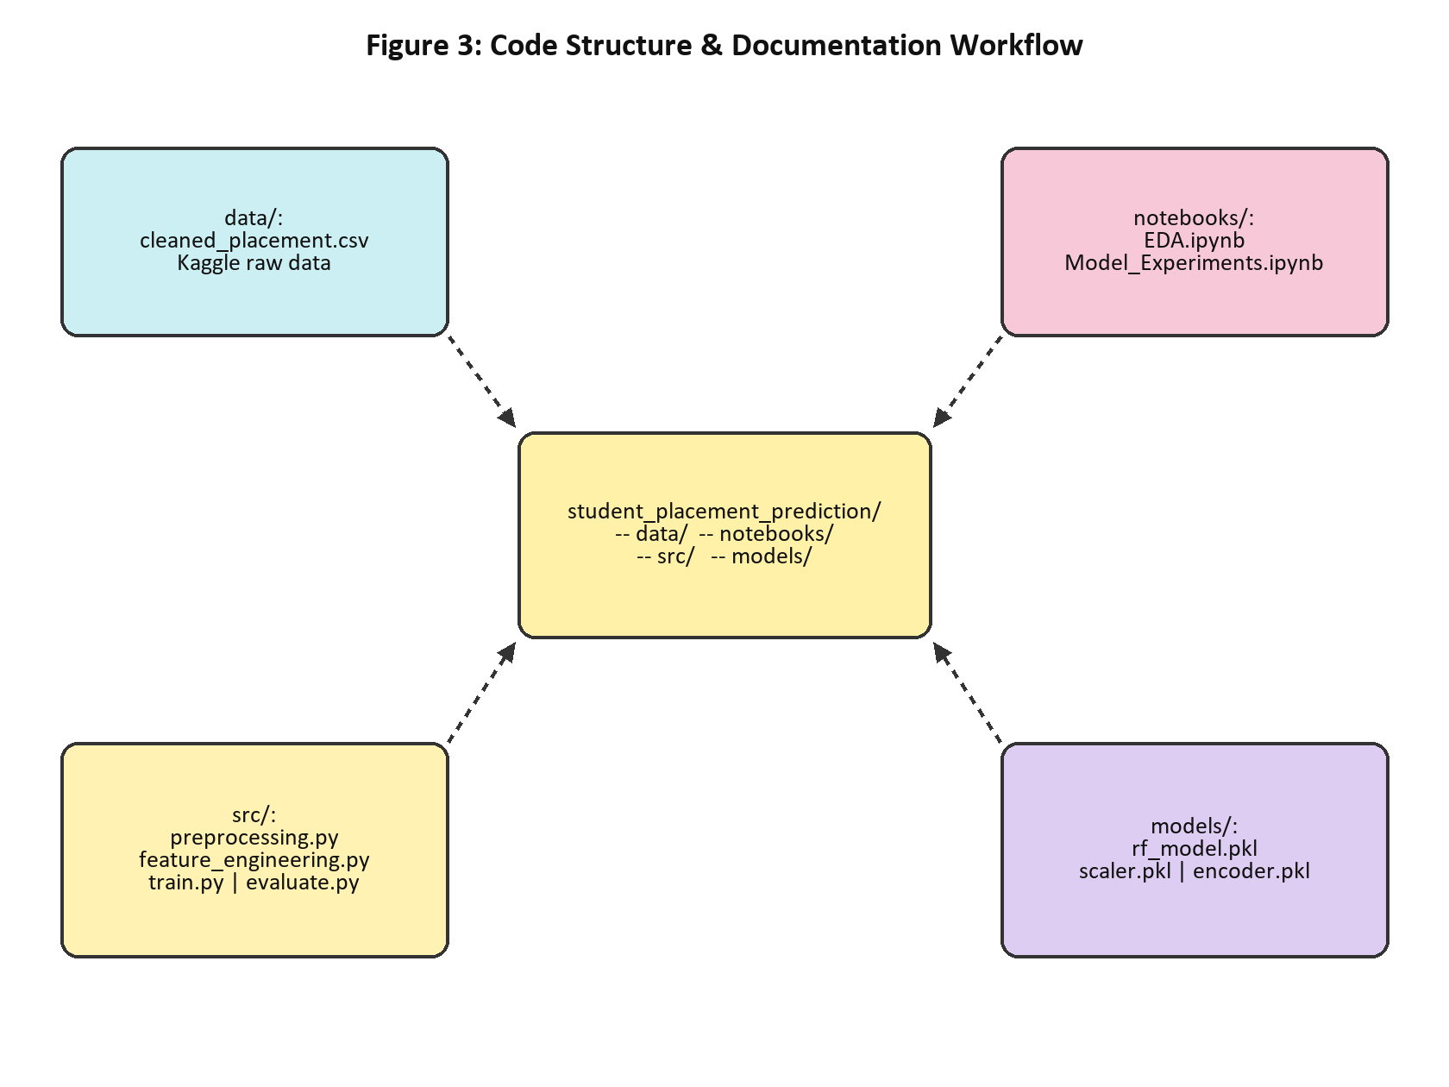
Figure 3. Repository components connect data, experiments, reusable modules, and deployment artifacts.

7. Expected Outcomes & Evaluation
The expected Random Forest range is 88-90% accuracy, 87-89% F1-score, 90% precision, and 86% recall, with ROC-AUC of 0.91. On a 197-student test set, the documented confusion matrix is [[45 TN, 10 FP], [12 FN, 130 TP]]. These values show that the model identifies most placed students while keeping false positives visible for monitoring. A false negative matters because it may understate a student’s potential; a false positive matters because it may overstate readiness. F1 therefore remains the selection metric rather than accuracy alone.
Feature importance supports the narrative: CGPA 0.28, SkillScore 0.22, AcademicScore 0.18, and HasInternship 0.12 are leading contributors. Importance is associative, not causal, and should be reviewed alongside fairness considerations. The two serialized artifacts are approximately 2 MB together and are suitable for lightweight Streamlit loading. Random Forest improves F1 by approximately 11 percentage points over Logistic Regression (88% versus 76%), which supports the final decision.

8. Plan Execution with Code Snippets
models = {
'LogReg': LogisticRegression(max_iter=1000),
'RF': RandomForestClassifier(class_weight='balanced', random_state=42),
'XGB': XGBClassifier(random_state=42)}
for name, model in models.items():
print(name, cross_val_score(model, X_train, y_train, cv=5, scoring='f1').mean())
Explanation: This comparison loop establishes a repeatable F1 baseline before selecting the primary estimator.
preprocessor = ColumnTransformer([
('num', StandardScaler(), numeric_features),
('cat', OneHotEncoder(handle_unknown='ignore'), categorical_features)])
X_train_p = preprocessor.fit_transform(X_train)
X_test_p = preprocessor.transform(X_test)
Explanation: The preprocessor is fitted only on training data, then reused unchanged for test data to avoid leakage.
grid = GridSearchCV(rf, {'n_estimators':[50,100,150],
'max_depth':[5,8,10], 'min_samples_split':[2,5]},
scoring='f1', cv=5, n_jobs=-1)
grid.fit(X_train_p, y_train)
print(grid.best_params_, grid.best_score_)
Explanation: Grid search selects parameters using five-fold F1 validation and reports both the winning configuration and its validation score.
y_pred = grid.predict(X_test_p)
print(classification_report(y_test, y_pred))
print(confusion_matrix(y_test, y_pred))
print('ROC-AUC:', roc_auc_score(y_test, grid.predict_proba(X_test_p)[:,1]))
sns.heatmap(confusion_matrix(y_test, y_pred), annot=True, fmt='d')
Explanation: The evaluation block reports class-sensitive measures, displays error counts, and scores probability ranking with ROC-AUC.
joblib.dump(grid.best_estimator_, 'models/rf_model.pkl')
joblib.dump(preprocessor, 'models/preprocessor.pkl')
model = joblib.load('models/rf_model.pkl')
prep = joblib.load('models/preprocessor.pkl')
probability = model.predict_proba(prep.transform(sample_df))[:, 1]
Explanation: Saving both artifacts preserves the exact transformation-to-prediction contract used by the Streamlit app.

9. Conclusion & References
Week 3 delivers a defensible implementation rather than only an experimental result. Random Forest was selected because it combines strong balanced performance with practical explainability, stable training, probability estimates, and artifact portability. The documented split, preprocessing, cross-validation, evaluation, tests, error handling, and Git history create a clear line from raw cleaned data to a deployable predictor. Week 4 can now focus on a Streamlit interface that collects validated inputs, loads rf_model.pkl and preprocessor.pkl, shows a probability with plain-language guidance, and avoids retraining in the application process.
The deployment hand-off is intentionally conservative. The Streamlit form should apply the same input rules described in this report, show the model probability with an appropriate confidence-oriented explanation, and make clear that the result is an educational estimate rather than a hiring decision. The interface should not collect information that was not used in training, and it should preserve the precise feature names and category values expected by the preprocessor. A lightweight monitoring log can record anonymous input validity errors and prediction distributions, enabling the student to notice drift or unexpected categories without storing unnecessary personal details. Before release, the saved artifacts should be reloaded in a clean process, the sample student prediction should be repeated, and the requirements file should be installed in a fresh environment. These checks make the Week 4 application a genuine continuation of the documented model instead of a disconnected demonstration. Future work may compare calibrated probabilities, perform fairness review across meaningful groups where ethically appropriate, and refresh the model when a newer representative dataset becomes available.
Documentation remains part of the model itself: a future reviewer should be able to identify the dataset version, reproduce the split, understand why F1 was optimized, and verify that the displayed prediction follows the same preprocessing contract used during evaluation. That traceability is the central Week 3 outcome.

References
- scikit-learn Documentation: https://scikit-learn.org/stable/
- XGBoost Documentation: https://xgboost.readthedocs.io/
- Kaggle: Student Placement Dataset (Publicly Available).
- Project repository: https://github.com/Devi226/student-placement-prediction

