Week 1 Task: Project Planning and Strategy for ML Pipeline
Student Placement Prediction System
Gurramdevi Prasanna| ID: 440517 | Yuva Intern | 02-09-2026
Table of Contents
1. Introduction .......................................................... 1
2. Problem Statement & Flowchart ................................. 2
3. Objectives .............................................................. 3
4. Timeline and Gantt Chart .......................................... 4
5. System Architecture ................................................. 5
6. Resource Requirements ............................................ 6
7. Risk Management ..................................................... 7
8. Strategic Roadmap ................................................... 8
9. Conclusion .............................................................. 9

1. Introduction
The Student Placement Prediction System is a machine-learning project designed to estimate whether a student is likely to receive a placement offer. It converts academic, aptitude, training, and profile information into an evidence-based prediction that can support early mentoring and targeted preparation. The proposed ML pipeline gives the project a repeatable path from raw data to an accessible application. Each stage is planned to preserve data quality, test model performance, and present results clearly. The first week establishes the scope, data approach, success metrics, resources, and delivery plan required for reliable implementation.

2. Problem Statement
Placement teams often need to review many student profiles while time for individual guidance is limited. Important indicators such as academic performance, technical skills, internships, aptitude scores, and communication readiness may be distributed across different files or reported inconsistently. Without a structured approach, students who need additional support can be identified too late. This project addresses that gap by building a supervised classification pipeline that processes student data and predicts a Yes or No placement outcome. The system is intended as a decision-support tool, not an automatic final decision maker; faculty judgment and ethical review remain essential.
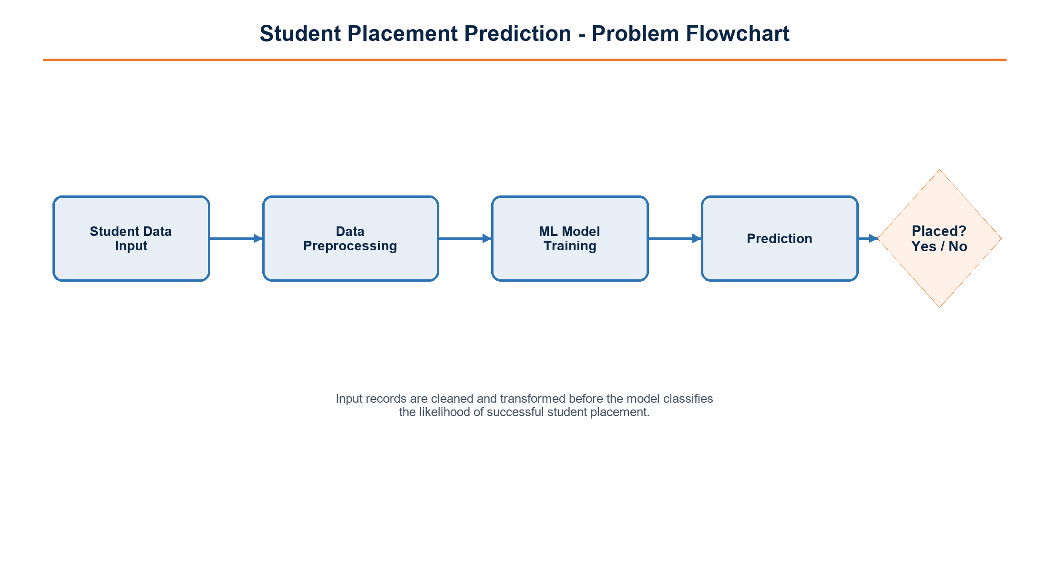
Fig 1: Problem Flowchart

3. Objectives
- Define a clean, privacy-aware dataset schema for student placement records.
- Prepare reproducible preprocessing and feature-engineering steps using pandas.
- Compare Logistic Regression and Random Forest against clear evaluation metrics.
- Develop an interpretable placement prediction interface using Streamlit.
- Deliver a documented project report, demonstration, and improvement backlog by the internship deadline.

4. Detailed Timeline
The six-week schedule begins on 14 August 2026 and concludes with the final submission on 25 September 2026. Each week has a visible outcome so progress can be reviewed early and corrective action can be taken before final deployment. Model work begins only after data checks are complete; this reduces the risk of optimizing a model on unreliable features.
Week | Dates | Primary Activity | Deliverable
W1 | 14-20 Aug | Planning, dataset study, problem framing | Approved project plan
W2 | 21-27 Aug | Data cleaning, missing-value review, exploratory analysis | Cleaned dataset and EDA notes
W3 | 28 Aug-3 Sep | Feature engineering and train/test preparation | Feature set and baseline
W4 | 4-10 Sep | Logistic Regression and Random Forest training | Model comparison
W5 | 11-17 Sep | Evaluation, tuning, validation, Streamlit prototype | Validated prototype
W6 | 18-25 Sep | Deployment, documentation, final review | Final report and demo
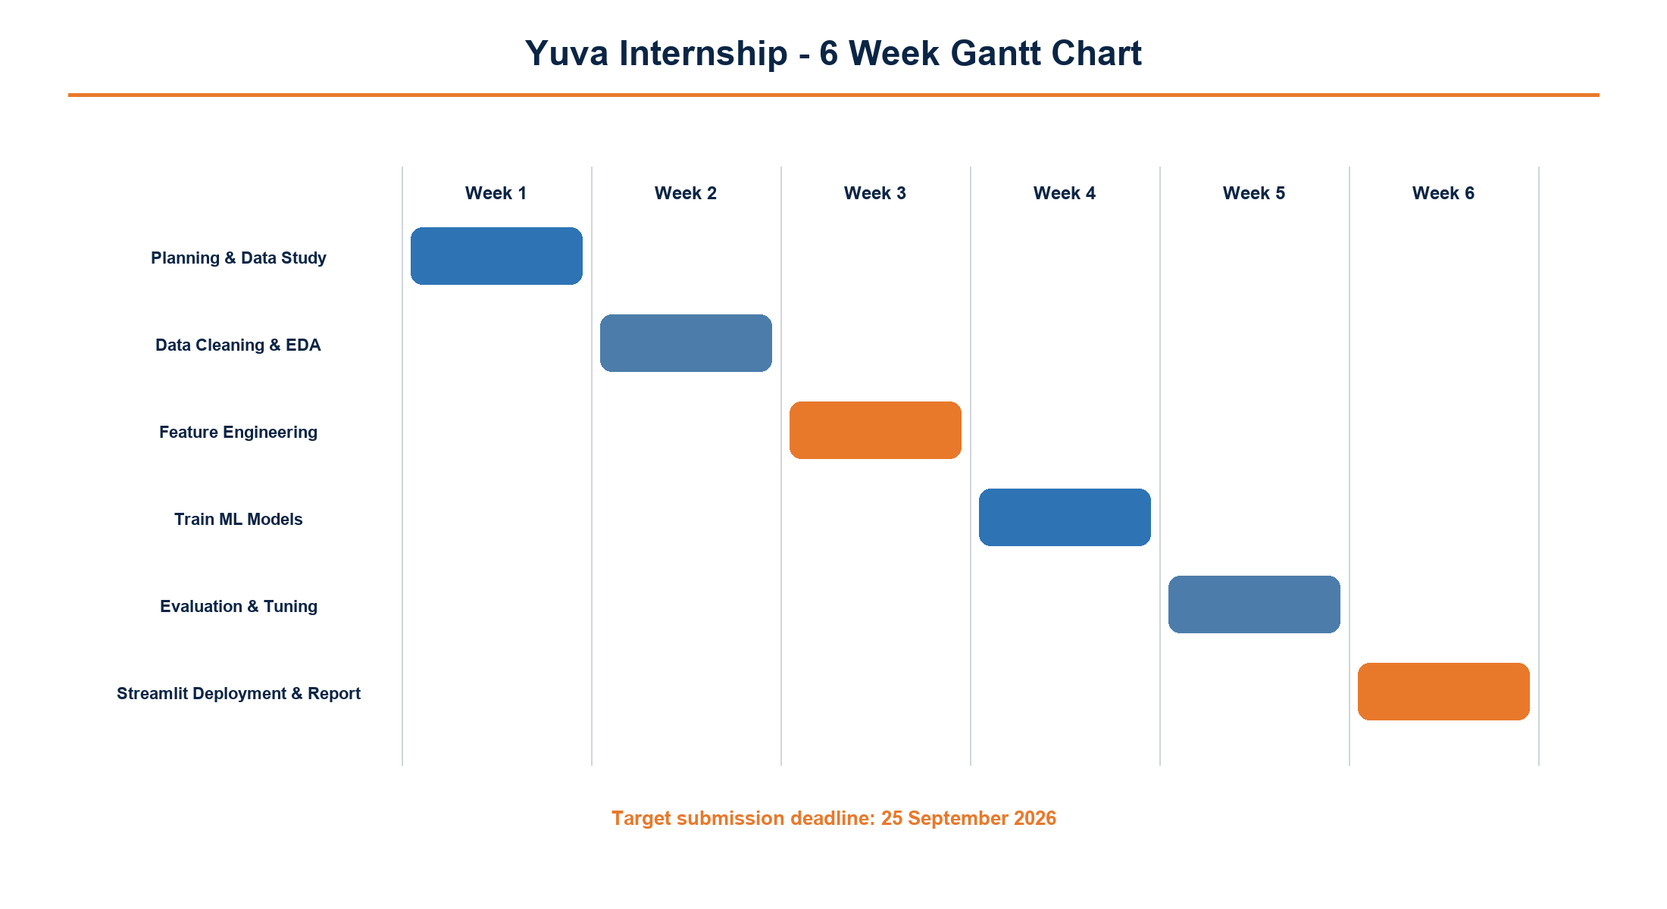
Fig 2: Gantt Chart Timeline

5. System Architecture
The architecture separates the pipeline into accountable stages so that data changes, feature choices, model experiments, and deployment decisions can be reviewed independently. Raw Kaggle data is first profiled for completeness and consistency. pandas is used to standardize formats, remove duplicates, handle missing values, and encode suitable categorical fields. Feature engineering then derives meaningful indicators such as aggregate academic performance, skill exposure, project activity, and internship experience. Two models — Logistic Regression and Random Forest — are trained to provide a transparent baseline and a non-linear comparison. Evaluation examines accuracy, precision, recall, F1-score, and a confusion matrix before the selected model is exposed through Streamlit.
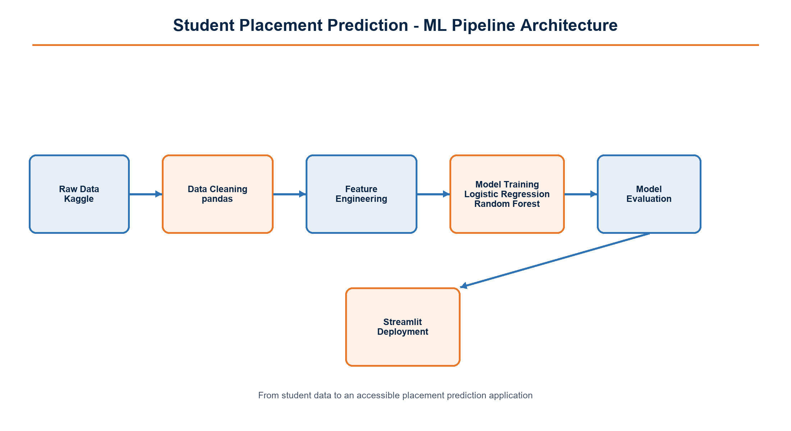
Fig 3: ML Pipeline Architecture
The Streamlit layer should display a clear prediction outcome, a confidence-oriented explanation where appropriate, and a reminder that the tool supports guidance rather than replacing human placement decisions. Versioned datasets, saved model artifacts, and documented assumptions will make the work easier to reproduce during later internship weeks.

6. Resource Requirements
The initial resource plan favors widely available software so the system can be developed, reviewed, and demonstrated on a typical student laptop. Cloud deployment is not required for the first milestone; local Streamlit execution is sufficient while the interface and data contract are validated.
Category | Requirement | Purpose
Software | Python 3.11, VS Code, Jupyter Notebook | Development, experiments, documentation
Libraries | pandas, scikit-learn, NumPy, matplotlib, Streamlit | Data processing, modeling, visualization, interface
Hardware | Laptop with 8 GB RAM, dual-core processor, stable internet | Dataset work, local training, Kaggle access
Data | Kaggle placement dataset with anonymized fields | Training, validation, and exploratory analysis

7. Risk Management
Risk management will be reviewed at the end of each week. The mitigation actions below keep the project focused on reliable data, fair interpretation, and a deliverable that can be demonstrated by the deadline.
Risk | Impact | Mitigation
Incomplete or biased data | High | Profile the dataset early; document exclusions and avoid sensitive attributes.
Overfitting on a small dataset | High | Use train/test splits, cross-validation, and compare a simple baseline.
Low model interpretability | Medium | Retain Logistic Regression baseline and explain key features carefully.
Timeline delays | Medium | Review weekly deliverables; keep a minimum viable Streamlit interface.
Dependency or setup issues | Low | Pin package versions and maintain a reproducible requirements file.

8. Strategic Roadmap
Phase 1 establishes the project charter, stakeholder expectations, ethical boundaries, and dataset inventory. Phase 2 converts raw files into a documented, analysis-ready dataset and creates a baseline view of placement patterns. Phase 3 engineers features and trains the two proposed models using consistent validation splits. Phase 4 evaluates results, selects an appropriate model, and develops the Streamlit interface with understandable output. Phase 5 completes user testing, documentation, demo preparation, and final review against the 25 September deadline. This roadmap keeps technical work aligned with the internship objective: delivering a practical, transparent system that can help placement teams identify where student support may be most useful.

