Week 2 Task: Data Preprocessing and Feature Engineering Strategy
Student Placement Prediction System
Student: Gurramdevi Prasanna | ID: 440517
Domain: Machine Learning Engineer Internship (N.S.D.C & Yuva Intern)
GitHub: https://github.com/Devi226/student-placement-prediction
Date: 02-09-2026
Dataset: Kaggle Public - Student Placement Dataset

Table of Contents
Update field in Word
This automatic Word table of contents will populate page numbers when fields are updated.

1. Introduction & Importance of Data Preprocessing
Data preprocessing is the reliability layer of the Student Placement Prediction System. A predictive model can only learn useful patterns when its input records are complete, consistent, and representative of the placement process. The Kaggle Public Student Placement Dataset may contain a mixture of examination scores, academic indicators, internship evidence, aptitude measures, categorical profile fields, and the target placement outcome. Preprocessing ensures that these fields have usable formats before any estimator is trained. It also provides an audit trail for how raw values become model inputs. This is particularly important in placement use cases because the output may influence mentoring priorities; incorrect handling of data can amplify accidental bias or give false confidence. The strategy therefore combines exploratory analysis, transparent cleaning rules, robust transformation, and validation checks rather than treating preprocessing as a one-time mechanical task.

2. Dataset Understanding & EDA Strategy
The work begins with a structured exploratory data analysis (EDA) pass using pandas. df.describe() provides distribution statistics for numerical fields and helps reveal surprising ranges. df.info() identifies column types and non-null counts, while isnull().sum() quantifies missingness field by field. duplicated().sum() checks whether repeated student records could bias class frequencies. For categorical fields, value_counts() shows uncommon categories, spelling inconsistencies, and potential data-entry issues. Visual checks such as missingness heatmaps and boxplots will complement these commands by exposing patterns that a single summary table can hide. The rationale is to distinguish a genuine data characteristic from an error before choosing a repair method. For example, a missing CGPA may require numeric imputation, whereas a missing specialization may be better represented by its mode or an explicit unknown category.

3. Data Cleaning Techniques
Cleaning decisions will be selected according to variable meaning and distribution. Median imputation is preferred for skewed numerical variables such as aptitude scores because it is less sensitive to extreme observations than the mean. Mode imputation is appropriate for categorical values when the most common label is a reasonable default, while an explicit “Unknown” category will be considered if absence carries meaning. drop_duplicates() will remove repeated records after confirming that the duplication is not an intentional repeated assessment. Outliers will be reviewed with the interquartile range (IQR) method. Values below Q1 - 1.5×IQR or above Q3 + 1.5×IQR will be investigated, then capped or winsorized only when evidence indicates that the extreme value is implausible rather than a valid high performer. pandas supplies the inspection and cleaning operations, while documented decisions preserve reproducibility.
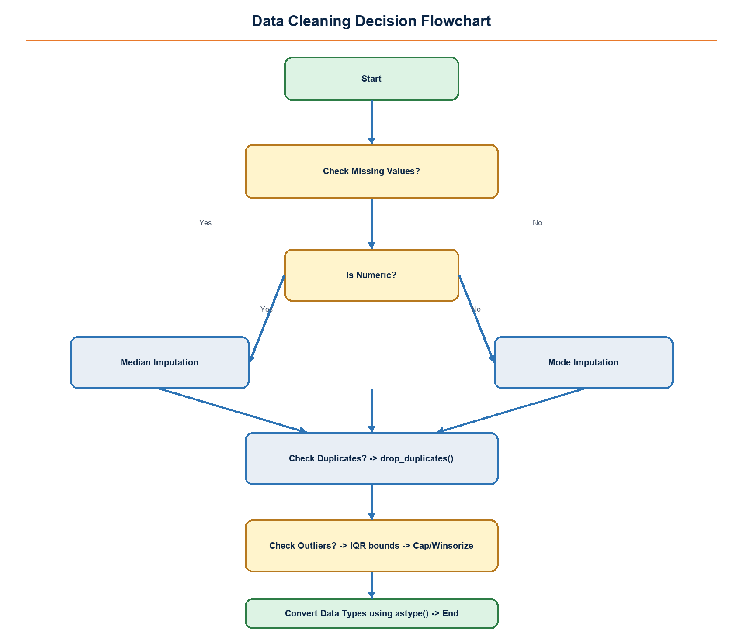
Figure 3: Data Cleaning Decision Flowchart

4. Normalization & Transformation
Different feature scales can distort distance-sensitive models and make model coefficients difficult to compare. StandardScaler will center and scale numerical features for algorithms that benefit from standardized distributions, while MinMaxScaler remains an option when values must be constrained to a 0-1 interval. Categorical variables will be transformed through OneHotEncoder so that models receive explicit binary indicators rather than artificial numeric ordering. sklearn.preprocessing and ColumnTransformer will keep the numerical and categorical paths separate and repeatable. Crucially, transformers are fitted only on the training split and then applied to validation or test data. This avoids data leakage, where statistics from future evaluation records influence model preparation. The result is a consistent feature matrix suitable for Logistic Regression, Random Forest, and later comparison experiments.
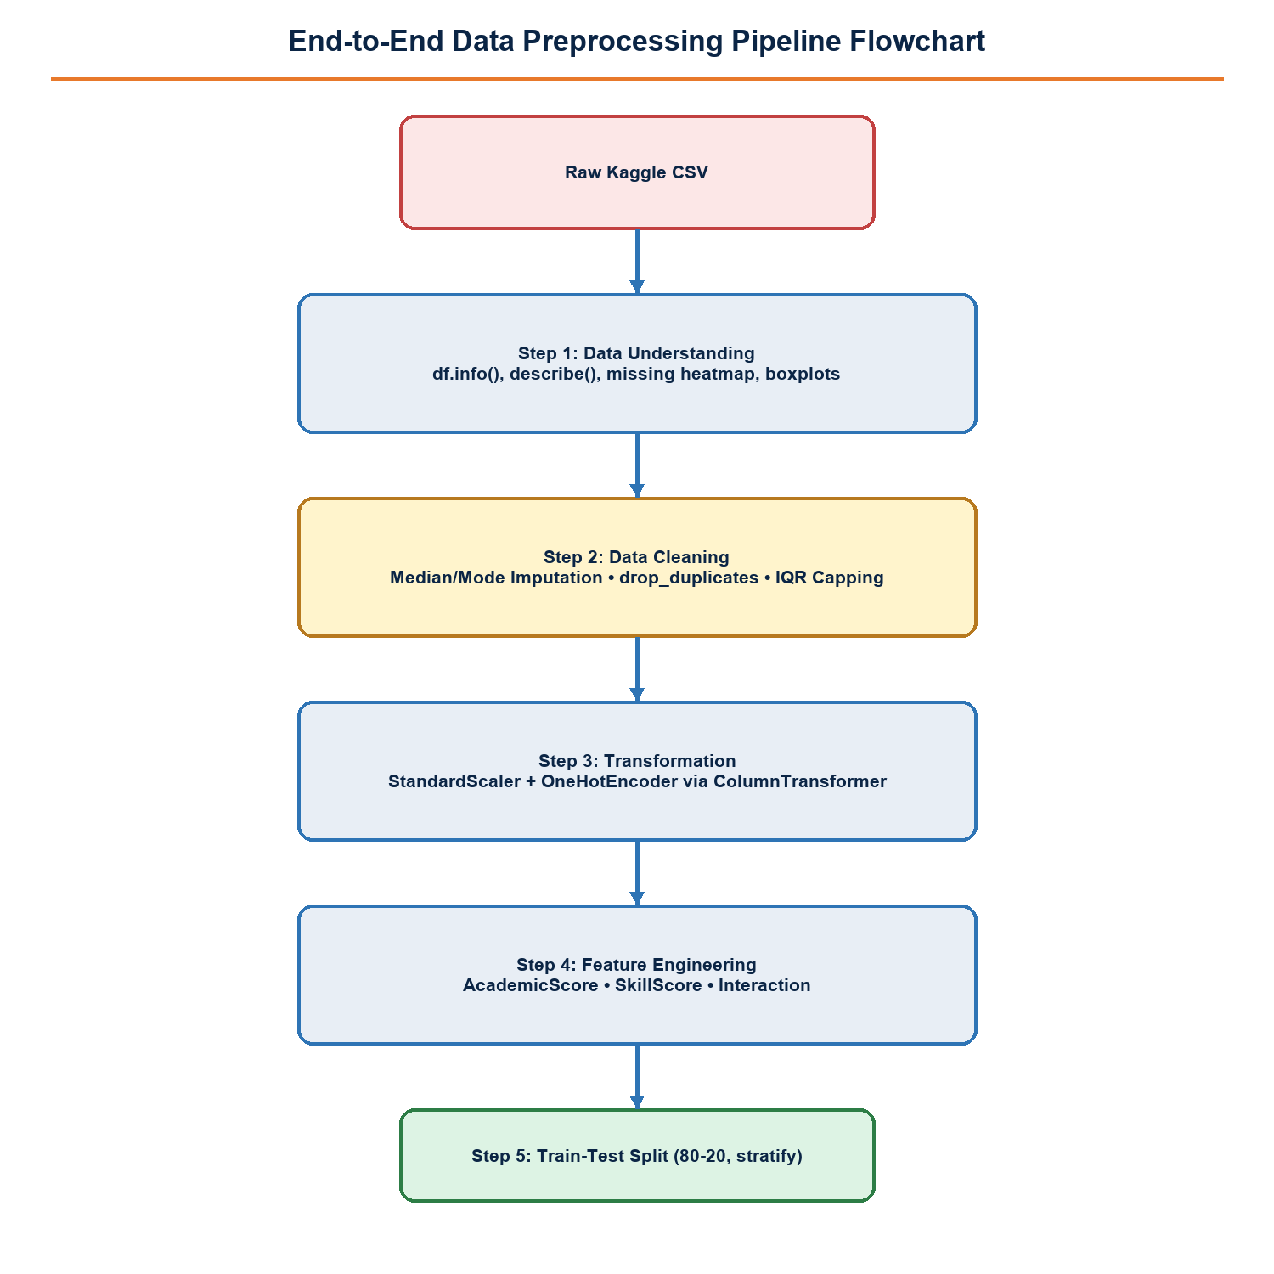
Figure 1: End-to-End Data Preprocessing Pipeline Flowchart

5. Feature Engineering & Selection
Feature engineering converts raw academic and employability signals into compact indicators that may reflect the placement process more clearly. AcademicScore can combine CGPA, 10th percentage, and 12th percentage using pre-declared weights. SkillScore can summarize communication and aptitude measurements, while HasInternship captures whether practical exposure is present. An interaction such as CGPA_Intern examines whether strong academic performance and internship experience work differently together than independently. Each engineered feature will be justified and tested rather than assumed useful. Selection methods then control redundancy and complexity: correlation screening removes near-duplicate variables, SelectKBest ranks features against the target, Recursive Feature Elimination (RFE) tests model-driven subsets, and Random Forest importance provides a non-linear comparison. The final top-ten feature set must improve validation quality without hiding the interpretation of the prediction.
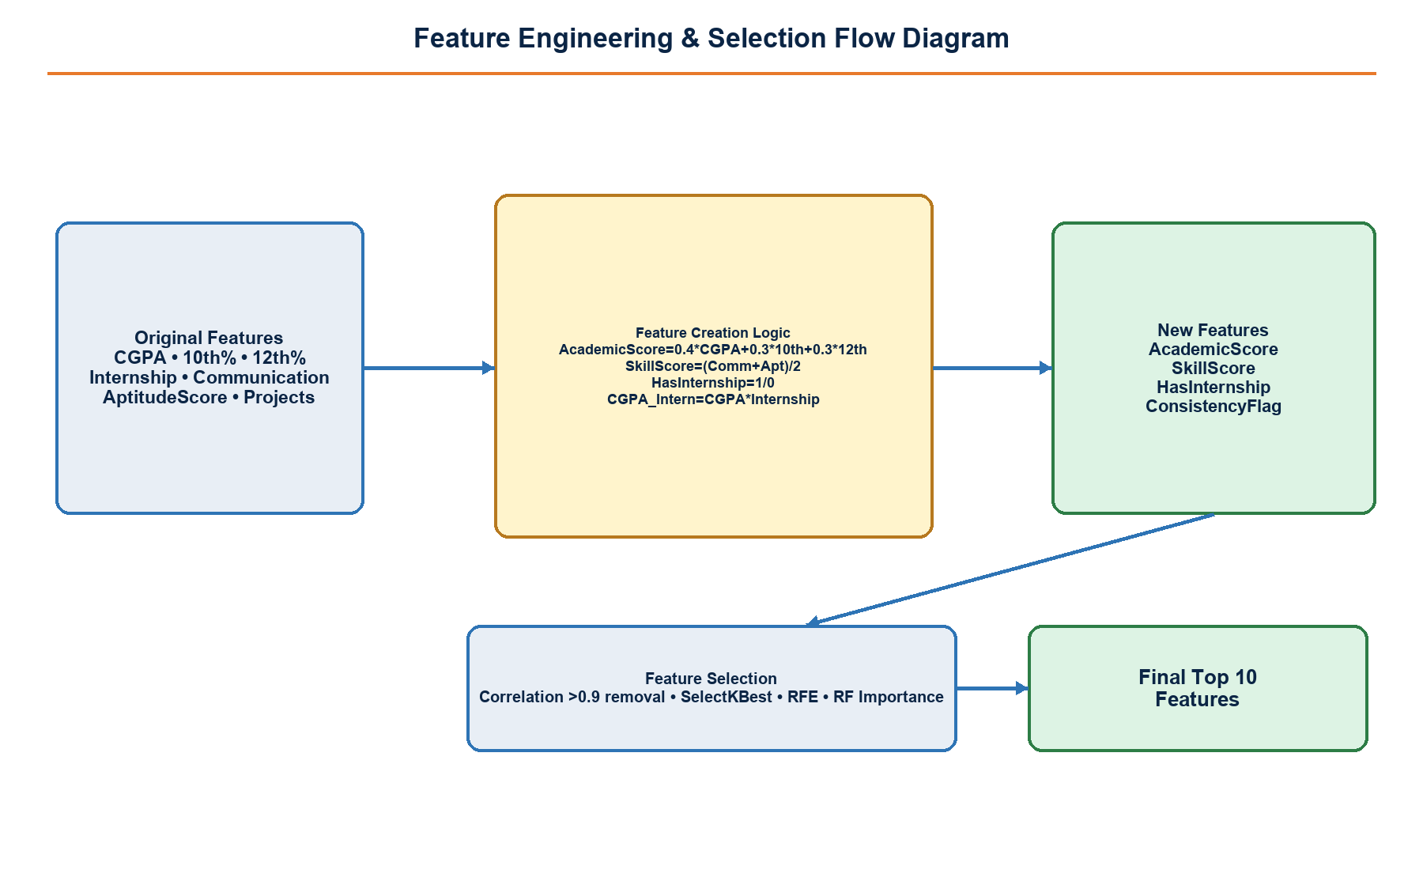
Figure 2: Feature Engineering & Selection Flow Diagram

6. Handling Imbalanced Data
If placed and not-placed classes occur at different frequencies, simple accuracy can be misleading. The project will preserve class proportions with stratified splitting and report precision, recall, F1-score, and a confusion matrix. SMOTE from imblearn may create synthetic minority-class examples, but it will be applied only to the training partition after the train-test split. Applying SMOTE before the split would leak generated information into testing and exaggerate expected performance. The test set remains untouched until final evaluation. This strategy supports a model that learns from the minority outcome without overstating its practical reliability. Threshold selection will also be considered: a placement-support tool may value recall for students who could benefit from mentoring, while still requiring adequate precision to avoid excessive false alerts.

7. Plan Execution with Python Code Snippets
The following blocks are the planned implementation sequence. The document generator itself uses python-docx and programmatic diagram rendering; a standard environment can use matplotlib.pyplot and matplotlib.patches to create the same figure styles. The modeling workflow uses pandas, scikit-learn.preprocessing, and imblearn in controlled steps.
import pandas as pd
from docx import Document
import matplotlib.pyplot as plt
from matplotlib import patches
df = pd.read_csv('student_placement.csv')
print(df.shape); print(df.head()); df.info()
print(df.isnull().sum())
Expected output: Dataset dimensions, preview, data types, and missing-value counts are displayed.
from sklearn.impute import SimpleImputer
num_imp = SimpleImputer(strategy='median')
df[numeric_cols] = num_imp.fit_transform(df[numeric_cols])
df[categorical_cols] = df[categorical_cols].fillna(df[categorical_cols].mode().iloc[0])
df = df.drop_duplicates()
q1, q3 = df['CGPA'].quantile([.25, .75]); iqr = q3-q1
Expected output: Missing values are repaired, duplicates removed, and IQR bounds prepared for review.
df['AcademicScore'] = .4*df['CGPA'] + .3*df['10th%'] + .3*df['12th%']
df['SkillScore'] = (df['Communication'] + df['AptitudeScore']) / 2
df['HasInternship'] = df['Internship'].eq('Yes').astype(int)
df['CGPA_Intern'] = df['CGPA'] * df['HasInternship']
Expected output: Four documented engineered features are added to the dataframe.
from sklearn.compose import ColumnTransformer
from sklearn.preprocessing import StandardScaler, OneHotEncoder
from sklearn.model_selection import train_test_split
X_train, X_test, y_train, y_test = train_test_split(X, y, test_size=.20, stratify=y, random_state=42)
prep = ColumnTransformer([('num', StandardScaler(), numeric_cols), ('cat', OneHotEncoder(handle_unknown='ignore'), categorical_cols)])
X_train_p = prep.fit_transform(X_train); X_test_p = prep.transform(X_test)
Expected output: Training data fit the scaler and encoder; test data are transformed without leakage.
from sklearn.ensemble import RandomForestClassifier
from sklearn.feature_selection import SelectKBest, f_classif
rf = RandomForestClassifier(random_state=42).fit(X_train_p, y_train)
importance = rf.feature_importances_
selector = SelectKBest(f_classif, k=10).fit(X_train_p, y_train)
Expected output: Feature importances and a ten-feature statistical selection are available for comparison.

8. Expected Outputs & Validation
Expected outputs include a cleaned analytical dataset, a preprocessing pipeline object, an engineering log, selected features, and evaluation reports for baseline and tuned models. Validation is more than checking that code runs. The dataframe will be checked for remaining null values, duplicated records, invalid ranges, and unexpected categories. Split sizes and target proportions will be logged to confirm stratification. Transformation output will be inspected for consistent column counts between training and test data. Model validation will compare F1-score across Logistic Regression and Random Forest, review the confusion matrix, and test whether feature selection improves generalization rather than merely training performance. A final reproducibility check will rerun the pipeline from raw CSV to predictions using the same random seed and saved configuration.
Quality assurance will also include feature-level checks. Numeric columns must have no non-finite values after transformation, one-hot categories observed only in the test set must be handled safely, and engineered formulas must be recalculated for a small manually verified sample. Model reports will be retained alongside the selected feature names, random seed, data version, and preprocessing configuration. This evidence makes it possible to explain a result during review and to detect whether a later change improved real validation performance or simply changed the evaluation conditions. Any unexpectedly large performance gap between training and test F1-score will trigger a review of leakage, overfitting, and class-distribution assumptions before deployment proceeds.

9. Conclusion & References
This Week 2 strategy defines a disciplined path from raw Kaggle records to clean, explainable model-ready data. It prioritizes meaningful cleaning rules, leakage-safe transformations, deliberate feature creation, and validation metrics that remain reliable when class frequencies differ. By separating fitting, transformation, selection, and evaluation, the project creates a foundation for later modeling and Streamlit deployment. The expected result is not simply a higher score, but a transparent pipeline that can be inspected, repeated, and improved responsibly.
The process also supports fairer technical decisions. Variables should be retained because they are stable, relevant, and validated, not because they create an attractive but brittle score. The resulting documentation will allow mentors and reviewers to understand what was changed, why it was changed, and what evidence supports the final model-ready dataset.
References: pandas documentation; scikit-learn preprocessing, feature selection, and model evaluation documentation; imbalanced-learn SMOTE documentation; Kaggle Public Student Placement Dataset; GitHub repository: https://github.com/Devi226/student-placement-prediction

