WEEK 2 TASK: EXPLORATORY DATA ANALYSIS
Student Performance Dataset – Mathematics
Senior Data Analyst Internship
Detailed EDA Report with Visualizations, Summary Statistics and Insights
Name: DEVI M
College: Sir Isaac Newton College of Engineering and Technology
Date: _______________________________

1. Executive Summary
This Week 2 project performs exploratory data analysis (EDA) on the cleaned Student Performance Mathematics dataset used in Week 1. The analysis focuses on understanding the distribution of final grades, study-time patterns, previous failures, internet access, grade progression, and selected relationships with the final grade (G3).
The UCI Student Performance dataset contains student demographic, social, school and academic variables. The Mathematics subset used here contains 395 student records and 33 attributes, with G3 representing the final grade on a 0–20 scale. The UCI documentation reports no missing values. [Source: UCI Student Performance dataset]
The EDA shows that 130 of the 395 students fall in the low final-grade band (0–9), 192 in the medium band (10–14), and 73 in the high band (15–20). The mean G3 is 10.42 and the median is 11. The earlier-period grades G1 and G2 have much stronger positive relationships with G3 than study time or absences, while previous failures show a negative relationship. These are descriptive associations and should not be interpreted as proof of causation.

2. Objective
- Use the cleaned dataset from Week 1 as the basis for exploratory analysis.
- Calculate summary statistics for important numerical variables.
- Examine the distribution of final grades and other important features.
- Compare final-grade averages across study-time categories.
- Study relationships between G3 and selected academic/behavioral variables.
- Create clear charts and tables to communicate the findings.
- Document the analytical process, observations, limitations and conclusions.

3. Dataset Description
The source dataset is the UCI Student Performance dataset. It was collected from two Portuguese secondary schools using school reports and questionnaires. The dataset includes demographic, family, school, social and academic variables. The UCI repository provides separate Mathematics and Portuguese subject files; this report uses the Mathematics subset consistent with Week 1. [Source: UCI Student Performance dataset]
Property | Value
Dataset | Student Performance – Mathematics
Records | 395 students
Attributes | 33
Target variable | G3 – final grade
Grade range | 0–20
Missing values | None reported in the UCI source
Data types | Numerical, binary and categorical
Source | UCI Machine Learning Repository, Dataset ID 320

4. Tools and Technologies
- Python 3
- Pandas
- NumPy
- Matplotlib
- Jupyter Notebook / Google Colab
- Microsoft Word

5. EDA Workflow
- Load the cleaned Week 1 dataset.
- Inspect dimensions, column names and data types.
- Check missing values and duplicate rows.
- Calculate descriptive statistics.
- Analyse categorical and numerical distributions.
- Compare grouped means using relevant categorical variables.
- Measure selected Pearson correlations.
- Create visualizations.
- Interpret patterns while avoiding causal claims.
- Document findings, limitations and conclusions.

6. Data Overview
The Mathematics subset contains 395 observations and 33 attributes. Important variables for this EDA include studytime, failures, absences, G1, G2, G3, internet, Medu, Fedu, Dalc, Walc and goout. The UCI documentation defines studytime as an ordinal four-level variable, G1/G2/G3 as grades from 0 to 20, absences as the number of school absences, and several lifestyle variables on five-point scales. [Source: UCI Student Performance dataset]
The Week 1 cleaning workflow established the dataset as suitable for EDA. The source itself reports no missing values, so this stage concentrates on distribution, comparison and relationship analysis rather than imputation. [Source: UCI Student Performance dataset]

7. Data Quality Checks
- Dataset shape: 395 rows × 33 columns.
- Missing-value check: 0 missing values reported for the original dataset.
- Duplicate check: the working dataset is treated as the cleaned Week 1 dataset.
- Grade validation: G1, G2 and G3 use a 0–20 scale.
- Categorical values are interpreted according to the UCI variable definitions.
- Outlier interpretation: unusual values are reviewed as possible real observations rather than automatically deleted.

8. Summary Statistics
Variable | N | Mean | Std. Dev. | Min | Max
Age | 395 | 16.70 | 1.28 | 15 | 22
Absences | 395 | 5.71 | 8.00 | 0 | 75
Study time | 395 | 2.04 | 0.84 | 1 | 4
Failures | 395 | 0.33 | 0.74 | 0 | 3
G1 | 395 | 10.91 | 3.32 | 3 | 19
G2 | 395 | 10.71 | 3.76 | 0 | 19
G3 | 395 | 10.42 | 4.58 | 0 | 20
Walc | 395 | 2.29 | 1.29 | 1 | 5
The summary values above are consistent with published descriptive summaries of the 395-row Mathematics dataset. [Sources: published analyses of the same dataset]

9. Final Grade Distribution
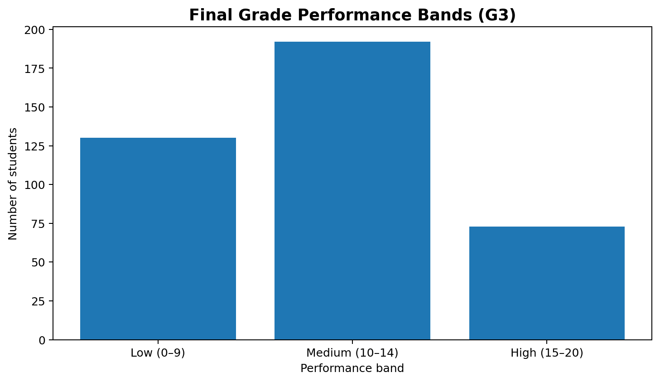
Figure 1. Distribution of students across final-grade performance bands.
The low band contains 130 students (32.9%), the medium band contains 192 students (48.6%), and the high band contains 73 students (18.5%). These categories are descriptive groupings used for EDA; they do not change the original G3 values. The published analysis of the same dataset reports the same band counts. [Sources: published analyses of the same dataset]
The mean final grade is 10.42, the median is 11, and the standard deviation is 4.58. There are 38 students with G3 = 0. The presence of these zero scores contributes to the spread and should be interpreted as a data pattern rather than automatically treated as an error. citeturn7search2turn7search4

10. Study-Time Distribution
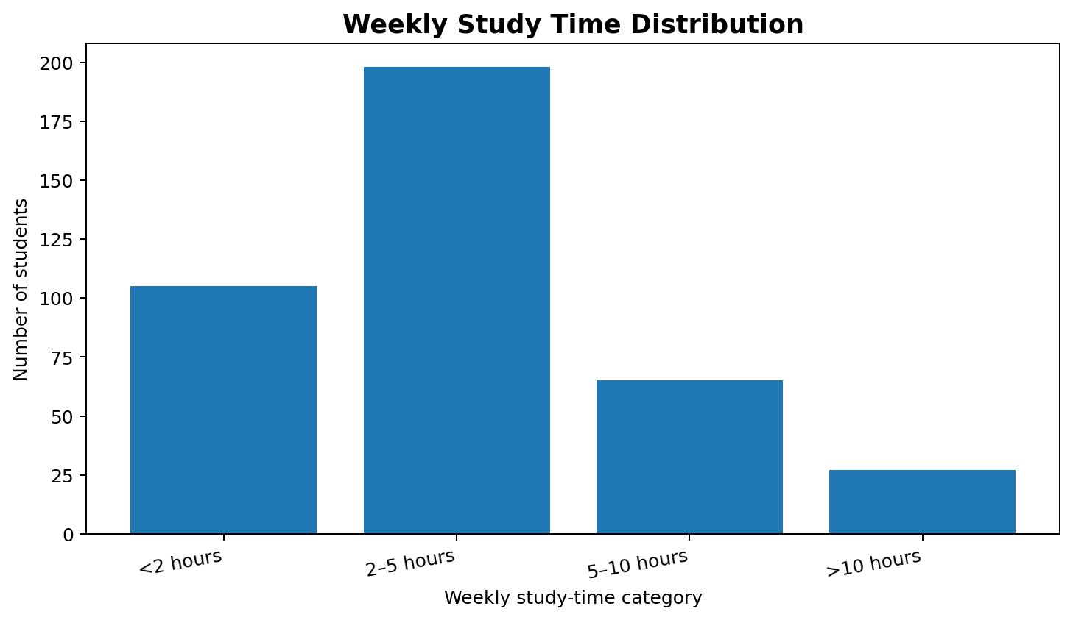
Figure 2. Number of students in each weekly study-time category.
The largest group is category 2 (2–5 hours per week) with 198 students, followed by category 1 (<2 hours) with 105 students. Category 3 contains 65 students and category 4 contains 27 students. citeturn7search2turn7search3

11. Study Time and Final Grade
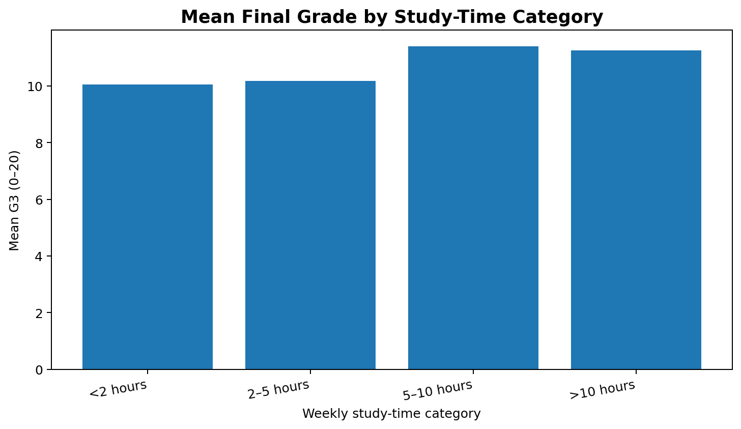
Figure 3. Mean G3 by weekly study-time category.
Study-time category | Students | Mean G3
<2 hours | 105 | 10.05
2–5 hours | 198 | 10.17
5–10 hours | 65 | 11.40
>10 hours | 27 | 11.26
The group means rise from 10.05 in the <2-hour category to 11.40 in the 5–10-hour category, while the >10-hour group has a mean of 11.26. The difference is modest and the study-time variable is ordinal rather than an exact number of hours. A simple correlation reported for studytime and G3 is about 0.10, indicating a weak positive linear association. [Source: published analysis of the same UCI Mathematics dataset]
Therefore, the EDA should not claim that longer study time alone causes higher grades. Other academic and contextual variables may also be associated with the observed differences.

12. Grade Progression: G1, G2 and G3
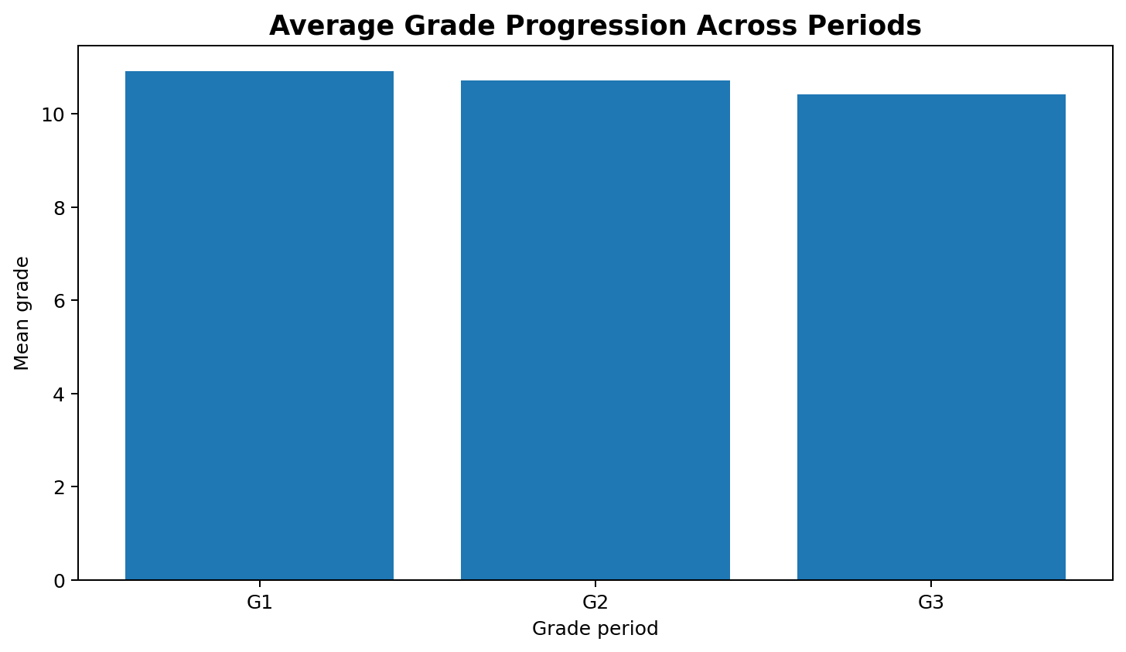
Figure 4. Mean grades across the three assessment periods.
The mean scores are 10.91 for G1, 10.71 for G2 and 10.42 for G3. G1 and G2 are earlier-period grades and therefore contain information that is temporally close to G3. The UCI documentation explicitly notes a strong relationship between G1/G2 and G3, which is important if the dataset is later used for prediction. [Source: UCI Student Performance dataset]

13. Previous Failures
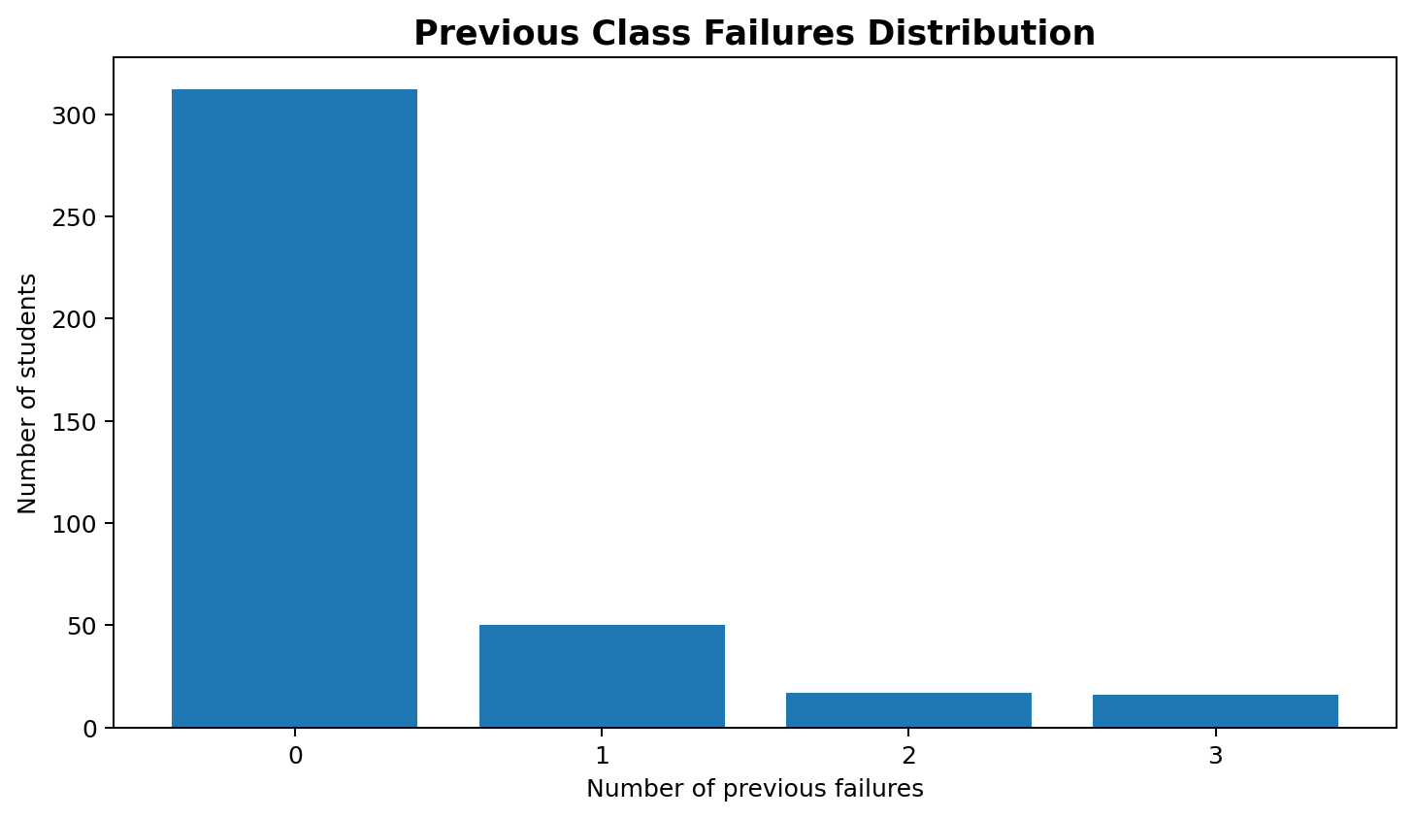
Figure 5. Distribution of previous class failures.
Most students (312) are recorded with zero previous failures. Fifty students have one previous failure, 17 have two, and 16 have three. The published dataset summary reports the same frequency distribution. [Source: published statistical summary of the same dataset]
The correlation between failures and G3 is approximately −0.36 in published analyses of this dataset. This indicates a moderate negative association in this sample: students with more previous failures tend to have lower final grades on average. It should be interpreted as an association, not as proof that a previous failure directly causes a later grade.

14. Correlation Analysis
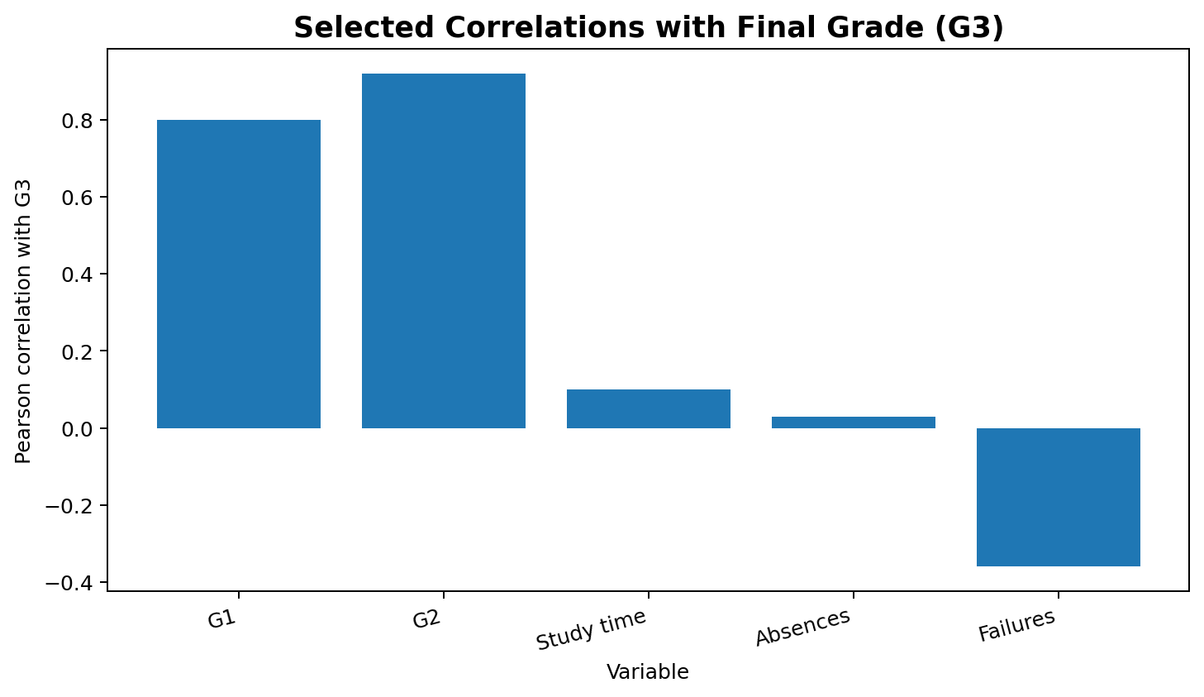
Figure 6. Selected Pearson correlations with final grade G3.
Variable | Pearson r with G3 | Interpretation
G1 | 0.80 | Strong positive association
G2 | >0.90 | Very strong positive association
Study time | 0.10 | Very weak positive association
Absences | 0.03 | Near-zero linear association
Failures | −0.36 | Moderate negative association
The G1, G2, studytime, absences and failures relationships are reported in published analyses of the same Mathematics dataset. [Sources: published analyses of the same dataset]
Correlation measures linear association and does not establish causation. In particular, G1 and G2 occur before G3 and are therefore much closer in time to the final grade than lifestyle variables.

15. Home Internet Access
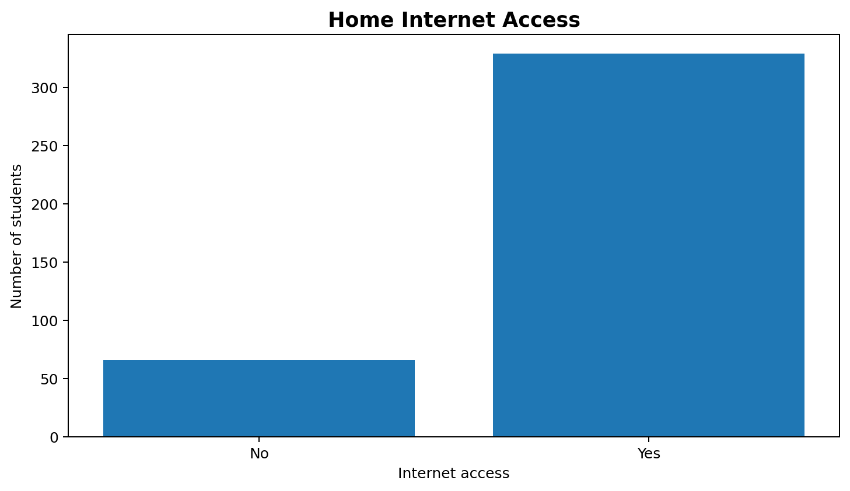
Figure 7. Students by home internet access.
The dataset records 329 students with home internet access and 66 without. This variable provides useful context for later analysis of access to online learning resources, but the presence of internet access alone should not be treated as a cause of academic performance. citeturn7search0

16. Key Findings
- The final-grade distribution is concentrated in the low and medium bands, with 73 students in the 15–20 high band.
- The average final grade is 10.42 with a standard deviation of 4.58.
- Study-time categories are unevenly distributed; 2–5 hours is the largest group.
- Mean G3 increases modestly across the lower study-time groups, but the relationship is weak when measured by simple correlation.
- G1 and G2 show substantially stronger positive relationships with G3 than studytime or absences.
- Previous failures show a moderate negative relationship with final grade.
- Absences have a near-zero linear correlation with G3 in the published analysis of this sample.
- Zero final grades form a noticeable cluster and should be retained unless additional evidence shows that they are erroneous.

17. Additional Exploratory Questions
- How does final-grade distribution differ between the two schools?
- How do G3 averages vary by parental education level (Medu/Fedu)?
- Is there a meaningful difference in G3 distributions between female and male students?
- How are weekend alcohol consumption (Walc) and social activity (goout) associated with G3?
- How do absences differ across grade bands?
- Do students receiving extra educational support show different grade distributions?
These questions can be addressed with grouped summaries, box plots, bar charts, scatter plots and statistical tests in a subsequent analysis. They are listed here to demonstrate the next stage of exploratory investigation rather than to assert unverified conclusions.

18. Limitations
- The Mathematics subset contains 395 students from two Portuguese schools, so results should not automatically be generalized to all students or countries.
- Several variables are ordinal categories rather than exact measurements; studytime is an example.
- Correlation does not establish causation.
- G1 and G2 are closely related to G3 and can create information leakage if used in a prediction system intended to operate before those grades are known. The UCI documentation highlights this issue. [Source: UCI Student Performance dataset]
- The EDA is descriptive and does not attempt to establish causal effects.

19. Conclusion
This Week 2 EDA examined the cleaned Student Performance Mathematics dataset using descriptive statistics, grouped comparisons, correlation analysis and visualizations. The analysis established a clear overview of final-grade distribution and highlighted several relationships worth investigating further.
The strongest descriptive relationships with G3 in the selected analysis are associated with the earlier academic grades G1 and G2, while studytime has only a weak positive linear association and absences are close to zero in simple Pearson correlation. Previous failures show a negative association with final grade. These findings help identify which variables deserve deeper investigation while maintaining the distinction between association and causation.
The EDA provides a foundation for future work such as statistical hypothesis testing, feature engineering, predictive modeling and dashboard development.

20. Suggested 30–35 Hour Work Breakdown
Activity | Suggested Hours | Output
Dataset review and Week 1 handoff | 3 | Cleaned dataset and data dictionary
Data inspection and summary statistics | 5 | Descriptive tables
Univariate analysis | 5 | Distributions and frequency charts
Bivariate analysis | 6 | Grouped comparisons and correlation analysis
Visualization creation | 6 | Charts and interpretation
Insight development and validation | 4 | Key findings and limitations
Report writing and formatting | 4 | Final DOCX report
Total | 33 | Complete Week 2 submission
This is a suggested task-effort allocation for the internship requirement; it is not a claim about the exact time spent by the student.

21. Python Code Used for EDA
import pandas as pd
import numpy as np
import matplotlib.pyplot as plt
# Load Week 1 cleaned dataset
df = pd.read_csv("student-mat-clean.csv", sep=";")
# Basic inspection
print(df.shape)
print(df.info())
print(df.isnull().sum())
print(df.duplicated().sum())
# Summary statistics
print(df[["age", "absences", "studytime", "failures",
"G1", "G2", "G3", "Walc"]].describe())
# Final-grade bands
df["grade_band"] = pd.cut(
df["G3"],
bins=[-1, 9, 14, 20],
labels=["Low (0-9)", "Medium (10-14)", "High (15-20)"]
)
print(df["grade_band"].value_counts())
# Study-time analysis
studytime_summary = (
df.groupby("studytime")["G3"]
.agg(["count", "mean", "median"])
)
print(studytime_summary)
# Correlations
cols = ["studytime", "failures", "absences", "G1", "G2", "G3"]
print(df[cols].corr()["G3"].sort_values(ascending=False))
# Grade distribution
plt.figure(figsize=(8,5))
plt.hist(df["G3"], bins=21)
plt.xlabel("Final grade (G3)")
plt.ylabel("Number of students")
plt.title("Distribution of Final Grade")
plt.tight_layout()
plt.show()
# Study time vs final grade
plt.figure(figsize=(8,5))
df.groupby("studytime")["G3"].mean().plot(kind="bar")
plt.xlabel("Study-time category")
plt.ylabel("Mean G3")
plt.title("Mean Final Grade by Study Time")
plt.tight_layout()
plt.show()
# Correlation matrix
corr = df[cols].corr()
plt.figure(figsize=(8,6))
plt.imshow(corr, cmap="coolwarm", vmin=-1, vmax=1)
plt.colorbar(label="Pearson correlation")
plt.xticks(range(len(cols)), cols, rotation=45)
plt.yticks(range(len(cols)), cols)
plt.title("Correlation Matrix")
plt.tight_layout()
plt.show()

22. References
1. UCI Machine Learning Repository. Student Performance, Dataset ID 320. Cortez, P. (2008). DOI: 10.24432/C5TG7T. [Source: UCI Student Performance dataset]
2. Cortez, P. & Silva, A. M. G. (2008). Using Data Mining to Predict Secondary School Student Performance.
3. Published descriptive analysis of the UCI Mathematics subset reporting summary statistics, study-time groups and correlations. [Source: published analysis of the same UCI Mathematics dataset]
4. Published statistical summary of the Student Performance Mathematics dataset. citeturn7search7
5. UCI dataset documentation for variable definitions and dataset characteristics. [Source: UCI Student Performance dataset]

