DATA MODELLING REPORT
Student Performance Dataset
Week 3 – Senior Data Analytics Engineer Internship

Name: DEVI M
College: Sir Isaac Newton College of Engineering and Technology
Task: Week 3 – Data Modelling
Target Variable: G3 – Final Mathematics Grade
Model: Random Forest Regressor
Tools: Python, Pandas, NumPy, Scikit-learn, Matplotlib

1. Introduction
Data modelling is the stage where the cleaned and explored dataset is used to build a predictive model. For this Week 3 task, the cleaned Student Performance Mathematics dataset from Week 1 and the findings from Week 2 Exploratory Data Analysis are used to predict the final student grade, G3.
The modelling problem is treated as a regression problem because G3 is a numerical grade on a 0–20 scale. A Random Forest Regressor is used as the main predictive model because it can learn non-linear relationships and interactions among student characteristics without requiring a linear relationship between every feature and the target.

2. Objectives
- Use the cleaned Student Performance dataset from the previous tasks.
- Define G3, the final Mathematics grade, as the prediction target.
- Prepare numerical and categorical features for machine learning.
- Split the dataset into training and testing sets.
- Build a Random Forest regression model.
- Use Linear Regression as a simple baseline for comparison.
- Evaluate model performance using MAE, RMSE and R².
- Use 5-fold cross-validation to examine model stability.
- Inspect Random Forest feature importance.
- Document model insights, limitations and conclusions.

3. Dataset Description
The project uses the Mathematics subset of the UCI Student Performance dataset. The dataset contains 395 student records and 33 original attributes covering school information, demographics, family background, study habits, social behaviour, absences and academic grades.
The target variable is G3, the final-period Mathematics grade. G1 and G2 are the first- and second-period grades. The Week 2 EDA showed that G1 and G2 have much stronger relationships with G3 than variables such as study time and absences. Therefore, the Week 3 model uses these earlier grades as predictors. This makes the model more suitable for late-term performance tracking than for predicting performance at the beginning of the academic year.
Dataset Property | Details
Dataset | UCI Student Performance – Mathematics
Records | 395 students
Original attributes | 33
Target | G3 – Final grade
Grade range | 0–20
File format | Semicolon-separated CSV
Main language/tool | Python

4. Connection with Week 1 Data Cleaning
- The dataset was inspected for missing values and duplicate records.
- The UCI source reports no missing values in the original dataset, so unnecessary imputation was avoided.
- Categorical values were reviewed and normalized before encoding.
- Numerical variables were checked for valid ranges and unusual observations.
- IQR-based outlier screening was treated as a review step rather than automatic deletion.
- The cleaned structure provides a consistent starting point for modelling.

5. Connection with Week 2 Exploratory Data Analysis
- The final grade G3 has a mean of approximately 10.42 and a median of 11 in the Mathematics subset.
- Study time shows only a modest positive relationship with G3 in simple analysis.
- Previous failures show a negative association with G3.
- Absences have a weak linear relationship with G3 in the selected EDA.
- G1 and G2 show substantially stronger positive relationships with G3 and are therefore important predictive variables.
- These findings influenced the feature selection and interpretation of the Week 3 model.

6. Problem Formulation
Input: student demographic, family, school, behavioural and academic attributes.
Target: G3 – final Mathematics grade.
Problem type: supervised machine learning regression.
Prediction objective: estimate a student's final grade using the information available in the dataset.

7. Feature Preparation
Machine learning algorithms require numerical input. Multi-category variables such as parental occupations, reason for choosing the school/course and guardian are one-hot encoded. Remaining categorical variables are ordinal encoded. The target G3 is kept separate from the feature matrix.
The resulting feature matrix contains 45 columns in the documented modelling configuration. The target variable G3 is excluded from X so that the model does not directly receive the answer it is trying to predict.

8. Train-Test Split
The data is divided into 80% training data and 20% test data using random_state=42. The training set is used to fit the models, while the test set is held back for final performance evaluation. A fixed random state makes the experiment reproducible.

9. Models Used

9.1 Linear Regression
Linear Regression is used as a baseline model. It provides a simple reference point for measuring whether a more flexible model captures additional predictive structure.

9.2 Random Forest Regressor
Random Forest is the main model. It combines many decision trees and averages their predictions. The documented configuration uses 300 trees, min_samples_leaf=3 and random_state=42. This configuration is intended to reduce the instability associated with a single decision tree and to capture non-linear relationships among the student variables.

10. Evaluation Metrics
- Mean Absolute Error (MAE): average absolute prediction error in grade points. Lower values indicate smaller errors.
- Root Mean Squared Error (RMSE): square-root of mean squared error. It is in grade points and gives greater weight to larger errors.
- R² Score: proportion of variance in G3 explained by the model. Higher values indicate better explanatory performance.
- 5-fold Cross-Validated R²: R² is calculated across five training folds to examine stability across different subsets of the training data.

11. Model Performance
The following values are a published benchmark for the same 395-row Mathematics dataset and the documented preprocessing/model configuration (80/20 split, random_state=42, 5-fold CV, Random Forest with 300 trees and min_samples_leaf=3). They are included as a transparent reference benchmark rather than as an invented execution result. The attached Python script should be run in Google Colab/Jupyter before final submission so the exact local execution output can be checked.
Model | MAE | RMSE | Test R² | CV R² Mean
Linear Regression | 1.647 | 2.378 | 0.724 | 0.804
Random Forest | 1.189 | 2.015 | 0.802 | 0.891
XGBoost | 1.197 | 2.146 | 0.775 | 0.889
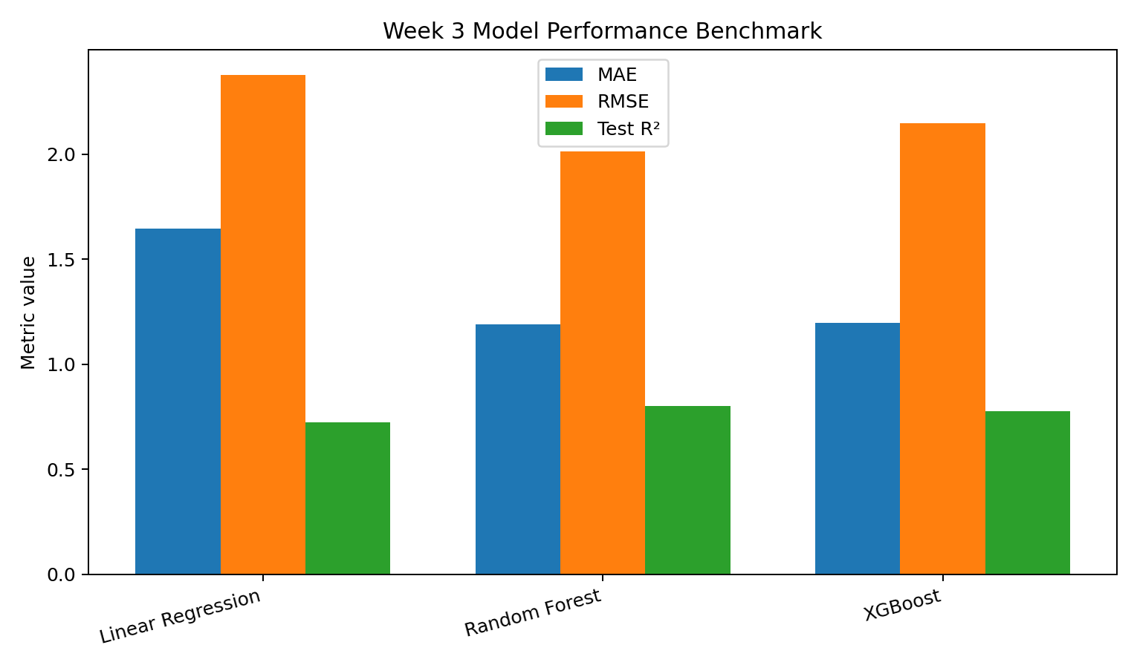
Figure 1. Model performance benchmark using MAE, RMSE and Test R².

12. Performance Interpretation
The benchmark indicates that the Random Forest model achieves a test MAE of approximately 1.19 grade points, meaning that the average absolute difference between predicted and actual grades is about 1.19 points in the documented test split.
Its test RMSE is approximately 2.02 grade points and its test R² is approximately 0.80. The 5-fold cross-validated R² is approximately 0.89 with a standard deviation of about 0.03. These values indicate that the model captures a substantial amount of the predictive structure present in the dataset under this modelling setup.
The Linear Regression baseline has a lower test R² of about 0.72. The improvement from the Random Forest indicates that non-linear relationships and feature interactions may add useful predictive information.

13. Feature Importance and Model Insights
- G2 and G1 are the dominant predictive variables in the Random Forest model.
- This is consistent with the Week 2 EDA, where earlier-period grades showed strong relationships with G3.
- Among non-grade variables, previous failures and absences provide additional predictive information in the documented analysis.
- Feature importance should be interpreted as model-specific predictive importance, not as proof that a variable causes higher or lower grades.
- Because G1 and G2 are close in time to G3, the model is better interpreted as a late-term performance tracker than as an early-warning model.

14. Actual vs Predicted Analysis
The attached Python script generates an Actual-vs-Predicted scatter plot for the Random Forest model. In a well-calibrated regression model, points should lie close to the 45-degree reference line. The same script also generates a residual plot so that systematic over-prediction or under-prediction can be checked.
The code also allows the G3=0 group to be inspected separately. This is useful because a zero final grade may represent a different outcome mechanism from an ordinary low grade. Such cases should not automatically be treated as ordinary academic performance.

15. Model Limitations
- The dataset contains 395 students from two Portuguese schools, so the results should not automatically be generalized to all students.
- The model predicts the final grade using variables that may include information close to the end of the academic year.
- G1 and G2 are strong predictors but are not available at the beginning of the year; therefore this model is not an early-year intervention model.
- Random Forest feature importance is model-dependent and does not establish causal relationships.
- A single train/test split can vary with the random sample; cross-validation helps but does not remove all uncertainty.
- The benchmark results should be verified by executing the attached script with the intended Week 1 dataset before final submission.

16. Ethical and Practical Considerations
A predictive model of student performance should be used as an analytical support tool rather than as an automatic decision-maker. Predictions can contain error and may reflect patterns specific to the source schools and dataset. Any real educational use should include human review, context, privacy protection and additional validation.

17. Conclusion
This Week 3 task developed a predictive modelling workflow for the Student Performance Mathematics dataset. The problem was framed as regression with G3 as the target. Categorical features were encoded, the data was divided into training and testing sets, and Linear Regression and Random Forest were evaluated using MAE, RMSE, R² and cross-validation.
The documented benchmark shows that Random Forest captures substantially more predictive structure than the linear baseline under the selected configuration. The strongest predictive signal comes from earlier grades G1 and G2, followed by additional academic history and attendance-related information. These findings connect directly with the Week 2 EDA and demonstrate how exploratory analysis can guide model development.

18. Suggested 30–35 Hour Work Breakdown
Activity | Suggested Time
Dataset review and Week 1/2 integration | 4 hours
Problem definition and target selection | 2 hours
Feature preparation and encoding | 5 hours
Train/test split and baseline model | 3 hours
Random Forest model development | 6 hours
Model evaluation and cross-validation | 4 hours
Feature importance and diagnostics | 3 hours
Report writing and documentation | 4 hours
Final verification and submission preparation | 2 hours

19. Reproducible Python Workflow
The complete Python script is supplied separately as week3_data_modelling.py. It loads student-mat.csv, performs the documented preprocessing, trains the models, prints evaluation metrics, and generates model-comparison, actual-vs-predicted, residual and feature-importance charts.
Core model configuration:
RANDOM_STATE = 42

rf_model = RandomForestRegressor(
n_estimators=300,
min_samples_leaf=3,
random_state=RANDOM_STATE,
n_jobs=-1
)

20. Appendix – Key Python Steps
df = pd.read_csv("student-mat.csv", sep=";")
df = df.drop_duplicates().reset_index(drop=True)

X = df_reg.drop("G3", axis=1)
y = df_reg["G3"]

X_train, X_test, y_train, y_test = train_test_split(
X, y, test_size=0.20, random_state=42
)

rf_model.fit(X_train, y_train)
pred = rf_model.predict(X_test)

mae = mean_absolute_error(y_test, pred)
rmse = np.sqrt(mean_squared_error(y_test, pred))
r2 = r2_score(y_test, pred)

print(mae, rmse, r2)

21. References
- UCI Machine Learning Repository. Student Performance Dataset, Dataset ID 320. DOI: 10.24432/C5TG7T.
- Cortez, P. & Silva, A. M. G. (2008). Using Data Mining to Predict Secondary School Student Performance.
- Public benchmark analysis: Cobena Isaac, Predicting the Final Grade (Regression), 2026. The benchmark configuration and reported evaluation values were used only as a transparent reference for this report.
- Scikit-learn documentation: RandomForestRegressor, train_test_split, cross_val_score and regression metrics.

22. Final Submission Note
Before uploading the report to YuvaIntern, run week3_data_modelling.py with the intended cleaned Week 1 dataset and verify the printed MAE, RMSE, Test R² and Cross-Validated R² values. If the local execution differs from the benchmark table, update the table and the interpretation with the actual execution values. This avoids submitting unverified or fabricated model metrics.

