**Identitas Tim**

|  |  |
| --- | --- |
| NIM | Nama |
| V3420028 | Devi Anggita Ambarwati |
| V3420042 | Ismaturrofiah |
| V3420046 | Muhammad Taufiq Alfathurrahman |
| M3118043 | Jos Andrian |

* **ERD**

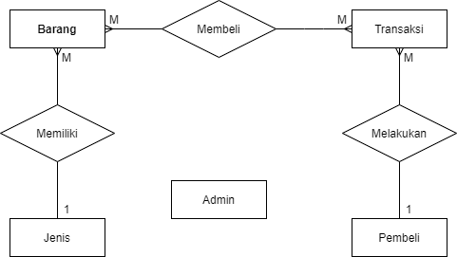

* **Relasi Antar Tabel**

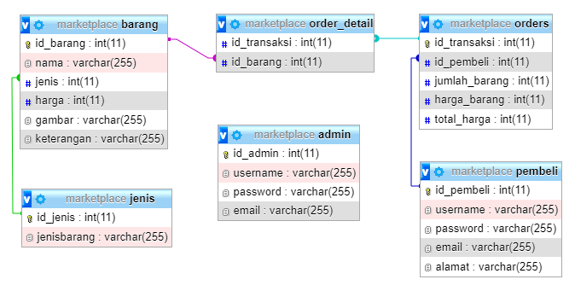

Design Database Projek

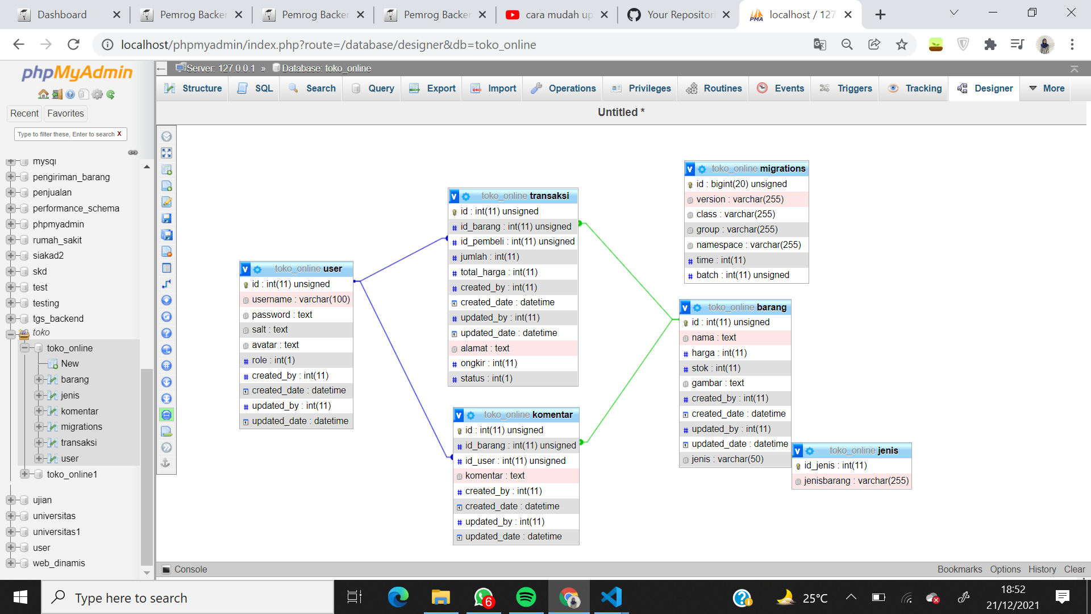

* **File database (sql)**

*Terlampir.*