**/* Assignment No: 2**

**\* Course No : COEN 275**

**\* Question 2 : UML Use Case**

**\* Version : 0.01**

**\* Date : 2/19/2013**

**\* Author : Devi Kandasamy**

**\* ID : 00001003221 */**

**UseCase1: High Level Diagram**

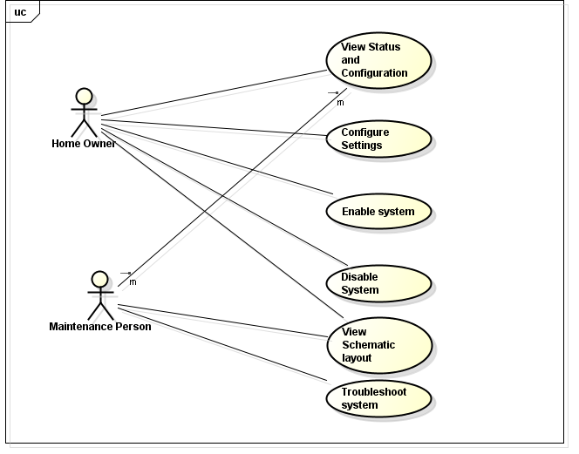

**UseCase2: View Status and Configuration of Water Sprinkler System**

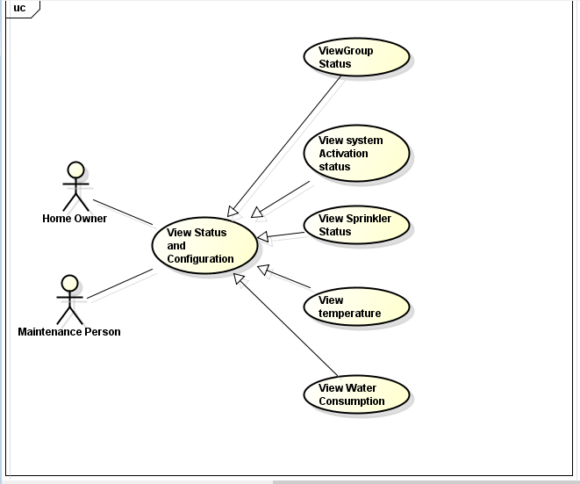

**UseCase3: Configure Sprinkler System**

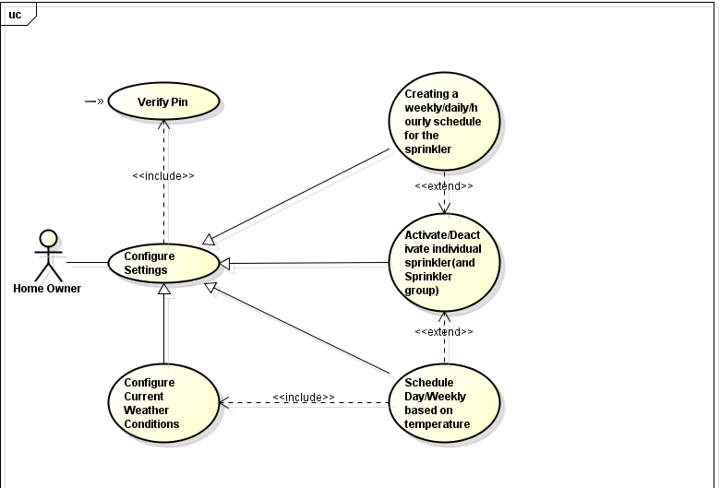

**UseCase4: Enable Sprinkler System**

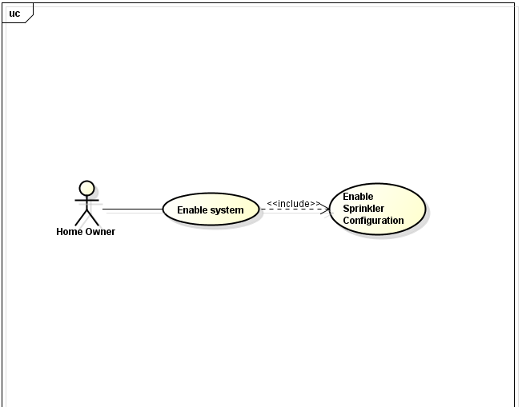

**UseCase5: Disable Sprinkler System**

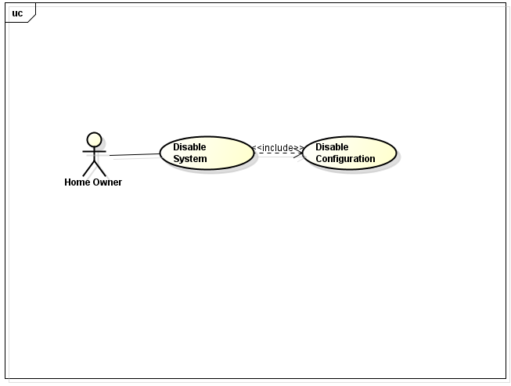

**UseCase6: View map and graph of the system**

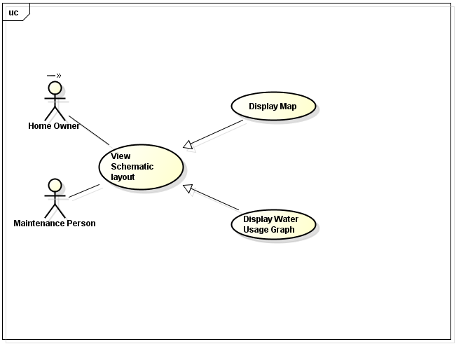

**UseCase7:Troubleshoot Sprinkler System**

